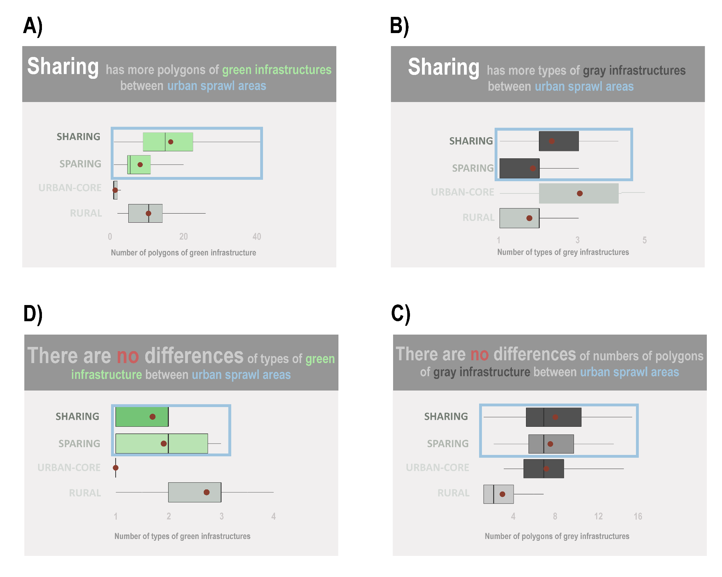
Online Resource 12 – Relationship between the studied sites and infrastructures by color in three lines of descriptive analysis. A) Number of polygons of green infrastructure by study sites; B) Number of types of gray infrastructures by study site; C) Number of types of green infrastructures by study sites; D) Number of polygons of gray infrastructure by study sites. The highlighted boxes indicate the existence of either relationship or not between the urban sprawl models.

