Online Resource 3 – Creating the random effects variable related to spatial autocorrelation

In order to insert the spatial autocorrelation effect in the predictive models, all the points were settled in a 10 x 10-hectare grid as shown in the figure below.

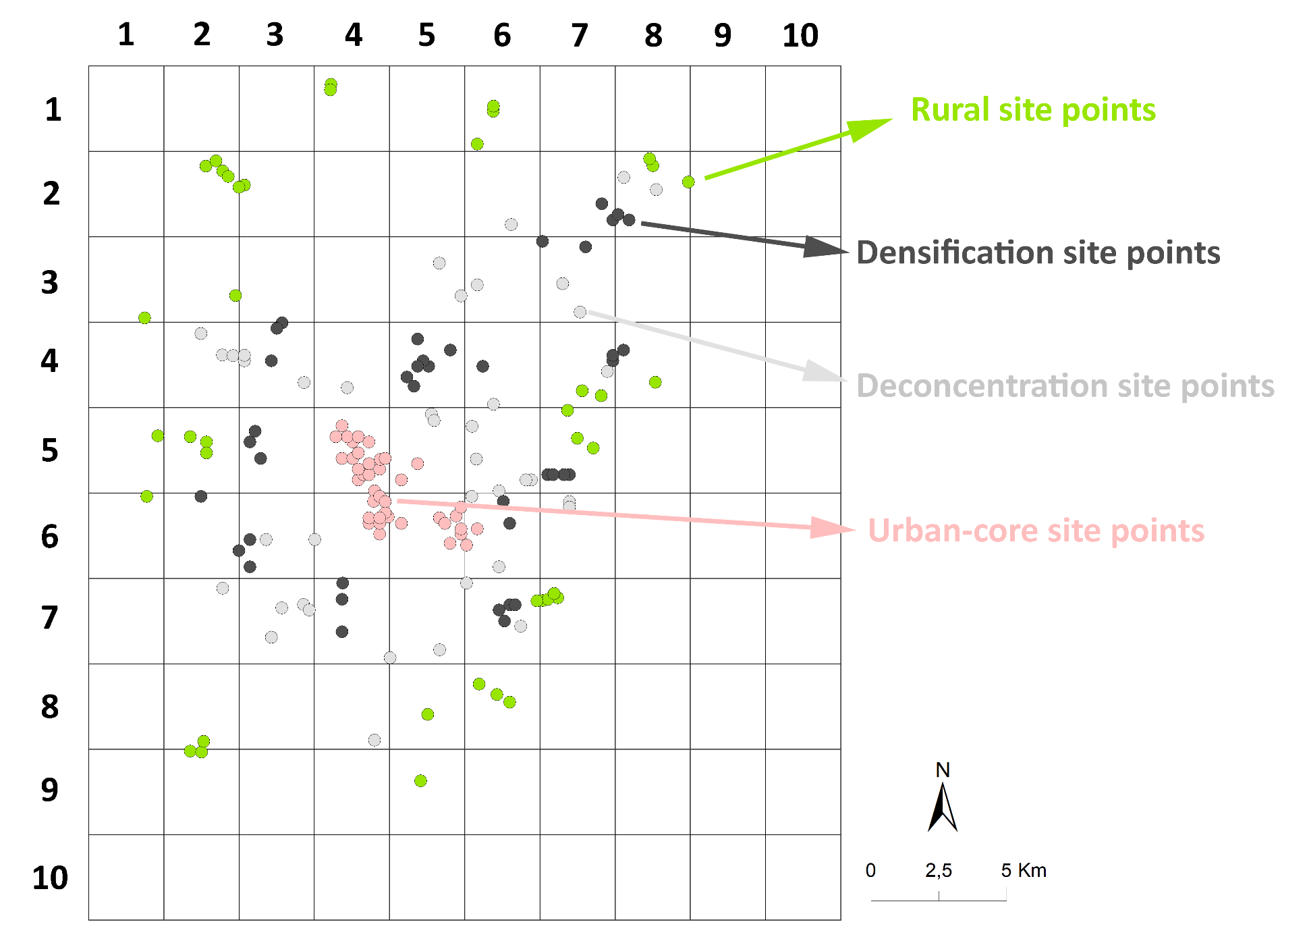

We assigned unique text values to each quadrant to designate them as categorical variables. In every predictive model, we input the corresponding sample point values associated with their respective quadrants, as depicted in the table below.

Quadrant name | Points | Lat | Lon
11 | qc_rural_1 | 7389969 | 241110
11 | qc_rural_5 | 7389932 | 241535
14 | qc_rural_4 | 7388871 | 249623
21 | qc_rural_8 | 7390321 | 241605
23 | qc_land_sharing_1 | 7390370 | 247911
24 | qc_rural_3 | 7391320 | 249883
25 | qd_rural_8 | 7392439 | 251774
25 | qd_rural_9 | 7392058 | 252437
25 | qd_rural_10 | 7391769 | 252910
31 | qc_land_sharing_6 | 7395969 | 242310
32 | qc_land_sharing_2 | 7395378 | 245296
32 | qc_land_sharing_4 | 7394170 | 244111
32 | qc_land_sharing_5 | 7395170 | 245511
32 | qc_land_sharing_7 | 7395246 | 244489
33 | qc_land_sparing_2 | 7396172 | 246734
33 | qc_land_sparing_3 | 7394369 | 246710
33 | qc_land_sparing_9 | 7395570 | 246710
34 | qc_land_sharing_3 | 7393702 | 250321
34 | qc_land_sharing_8 | 7393410 | 248488
35 | qd_rural_6 | 7395512 | 253913
35 | qd_land_sharing_5 | 7394569 | 253310
35 | qd_land_sharing_9 | 7396170 | 251310
35 | qd_land_sparing_5 | 7395169 | 252510
35 | qd_land_sparing_6 | 7395369 | 252910
35 | qd_land_sparing_7 | 7395369 | 253110
35 | qd_land_sparing_10 | 7394769 | 252710
36 | qd_rural_1 | 7395625 | 254681
36 | qd_rural_2 | 7395524 | 254123
36 | qd_rural_5 | 7395570 | 254315
36 | qd_rural_7 | 7395780 | 254548
40 | qc_rural_6 | 7399364 | 239505
41 | qc_land_sparing_5 | 7399370 | 241510
41 | qc_land_sparing_7 | 7397369 | 242911
42 | qc_land_sparing_4 | 7396769 | 243311
42 | qc_land_sparing_6 | 7397769 | 243310
42 | qc_land_sharing_9 | 7397769 | 243910
43 | urban_core_3 | 7397969 | 248110
43 | urban_core_5 | 7398369 | 247710
43 | urban_core_8 | 7398570 | 247711
43 | urban_core_9 | 7398370 | 248111
43 | urban_core_10 | 7398607 | 248417
43 | urban_core_15 | 7398769 | 248310
43 | urban_core_17 | 7399179 | 247878
43 | urban_core_18 | 7399370 | 248110
43 | urban_core_29 | 7399169 | 248310
43 | urban_core_40 | 7398569 | 248110
43 | qc_land_sharing_10 | 7397769 | 245710
44 | urban_core_1 | 7397634 | 250709
44 | urban_core_4 | 7397970 | 251111
44 | urban_core_6 | 7398170 | 251110
44 | urban_core_11 | 7398569 | 250310
44 | urban_core_12 | 7398370 | 250510
44 | urban_core_14 | 7398640 | 250935
44 | urban_core_16 | 7398970 | 251110
44 | urban_core_22 | 7398369 | 248910
45 | urban_core_2 | 7397569 | 251310
45 | urban_core_7 | 7398169 | 251710
45 | qd_land_sharing_6 | 7396769 | 252510
45 | qd_land_sharing_7 | 7399369 | 251510
45 | qd_land_sparing_8 | 7398369 | 252910
45 | qd_land_sparing_9 | 7399188 | 252670
46 | qd_land_sharing_3 | 7399170 | 255110
46 | qd_land_sharing_4 | 7398970 | 255110
50 | qc_rural_9 | 7401603 | 239918
51 | qc_rural_2 | 7401370 | 241710
51 | qc_rural_7 | 7400969 | 241711
51 | qc_rural_10 | 7401570 | 241111
52 | qc_land_sparing_1 | 7400770 | 243711
52 | qc_land_sparing_8 | 7401370 | 243310
52 | qc_land_sparing_10 | 7401769 | 243511
53 | urban_core_13 | 7399566 | 247912
53 | urban_core_20 | 7399970 | 247310
53 | urban_core_21 | 7400169 | 247510
53 | urban_core_23 | 7400169 | 247711
53 | urban_core_24 | 7400369 | 247311
53 | urban_core_25 | 7400369 | 248111
53 | urban_core_27 | 7400570 | 247710
53 | urban_core_28 | 7400732 | 248123
53 | urban_core_30 | 7400769 | 246711
53 | urban_core_31 | 7400770 | 247111
53 | urban_core_32 | 7400969 | 247310
53 | urban_core_33 | 7400770 | 248310
53 | urban_core_34 | 7401369 | 247110
53 | urban_core_35 | 7401569 | 246911
53 | urban_core_36 | 7401370 | 247710
53 | urban_core_37 | 7401564 | 246488
53 | urban_core_38 | 7401570 | 247311
53 | urban_core_39 | 7401970 | 246711
54 | urban_core_19 | 7399969 | 248910
54 | urban_core_26 | 7400569 | 249510
54 | qa_land_sharing_2 | 7402404 | 250017
54 | qa_land_sharing_8 | 7402169 | 250115
55 | qb_land_sharing_8 | 7401957 | 251522
55 | qd_land_sharing_1 | 7399969 | 253710
55 | qd_land_sharing_2 | 7399970 | 253510
55 | qd_land_sharing_8 | 7399569 | 252511
55 | qd_land_sharing_10 | 7400744 | 251676
56 | qb_rural_7 | 7402537 | 255045
56 | qd_rural_3 | 7401507 | 255407
56 | qd_rural_4 | 7401153 | 255991
56 | qd_land_sparing_1 | 7400169 | 255110
56 | qd_land_sparing_2 | 7400169 | 254910
56 | qd_land_sparing_3 | 7400169 | 254310
56 | qd_land_sparing_4 | 7400169 | 254510
61 | qa_land_sharing_1 | 7404581 | 242301
61 | qa_land_sharing_3 | 7404564 | 242697
61 | qa_land_sharing_7 | 7405369 | 241510
62 | qa_land_sparing_4 | 7405764 | 244500
62 | qa_land_sparing_7 | 7405569 | 244311
62 | qa_land_sparing_9 | 7404369 | 244110
62 | qa_land_sharing_4 | 7403570 | 245310
62 | qa_land_sharing_5 | 7404369 | 243110
62 | qa_land_sharing_6 | 7404570 | 243110
63 | qa_land_sharing_10 | 7403370 | 246910
64 | qa_land_sparing_1 | 7404169 | 249911
64 | qa_land_sparing_2 | 7405169 | 249510
64 | qa_land_sparing_3 | 7403769 | 249110
64 | qa_land_sparing_5 | 7404769 | 250710
64 | qa_land_sparing_6 | 7403433 | 249376
64 | qa_land_sparing_8 | 7404369 | 249710
64 | qa_land_sparing_10 | 7404169 | 249510
65 | qb_land_sparing_9 | 7404169 | 251911
65 | qb_land_sharing_2 | 7402770 | 252310
66 | qb_land_sparing_1 | 7404369 | 256710
66 | qb_land_sparing_3 | 7404567 | 256714
66 | qb_rural_1 | 7403258 | 255585
66 | qb_rural_9 | 7403086 | 256290
66 | qb_land_sharing_3 | 7403969 | 256510
67 | qb_land_sparing_2 | 7404769 | 257110
67 | qb_rural_3 | 7403582 | 258286
70 | qa_rural_6 | 7405946 | 239425
71 | qa_rural_1 | 7406779 | 242784
74 | qa_land_sharing_9 | 7407970 | 250310
74 | qb_land_sharing_10 | 7406769 | 251110
75 | qb_land_sharing_1 | 7407169 | 251710
76 | qb_land_sparing_4 | 7408769 | 254110
76 | qb_land_sparing_10 | 7408569 | 255710
76 | qb_land_sharing_4 | 7406169 | 255511
76 | qb_land_sharing_9 | 7407214 | 254858
81 | qa_rural_3 | 7411551 | 241691
81 | qa_rural_4 | 7411369 | 242310
81 | qa_rural_7 | 7411745 | 242061
81 | qa_rural_8 | 7410769 | 242910
81 | qa_rural_9 | 7411169 | 242511
82 | qa_rural_5 | 7410859 | 243115
85 | qb_land_sharing_5 | 7409395 | 252959
86 | qb_land_sparing_5 | 7409569 | 256710
86 | qb_land_sparing_8 | 7410169 | 256310
87 | qb_land_sparing_6 | 7409569 | 257310
87 | qb_land_sparing_7 | 7409769 | 256910
87 | qb_rural_2 | 7410969 | 259511
87 | qb_rural_5 | 7411566 | 258191
87 | qb_rural_6 | 7411821 | 258069
87 | qb_land_sharing_6 | 7411138 | 257117
87 | qb_land_sharing_7 | 7410684 | 258317
93 | qa_rural_2 | 7414569 | 246310
93 | qa_rural_10 | 7414363 | 246283
95 | qb_rural_4 | 7413576 | 252294
95 | qb_rural_8 | 7413769 | 252311
95 | qb_rural_10 | 7412369 | 251710

