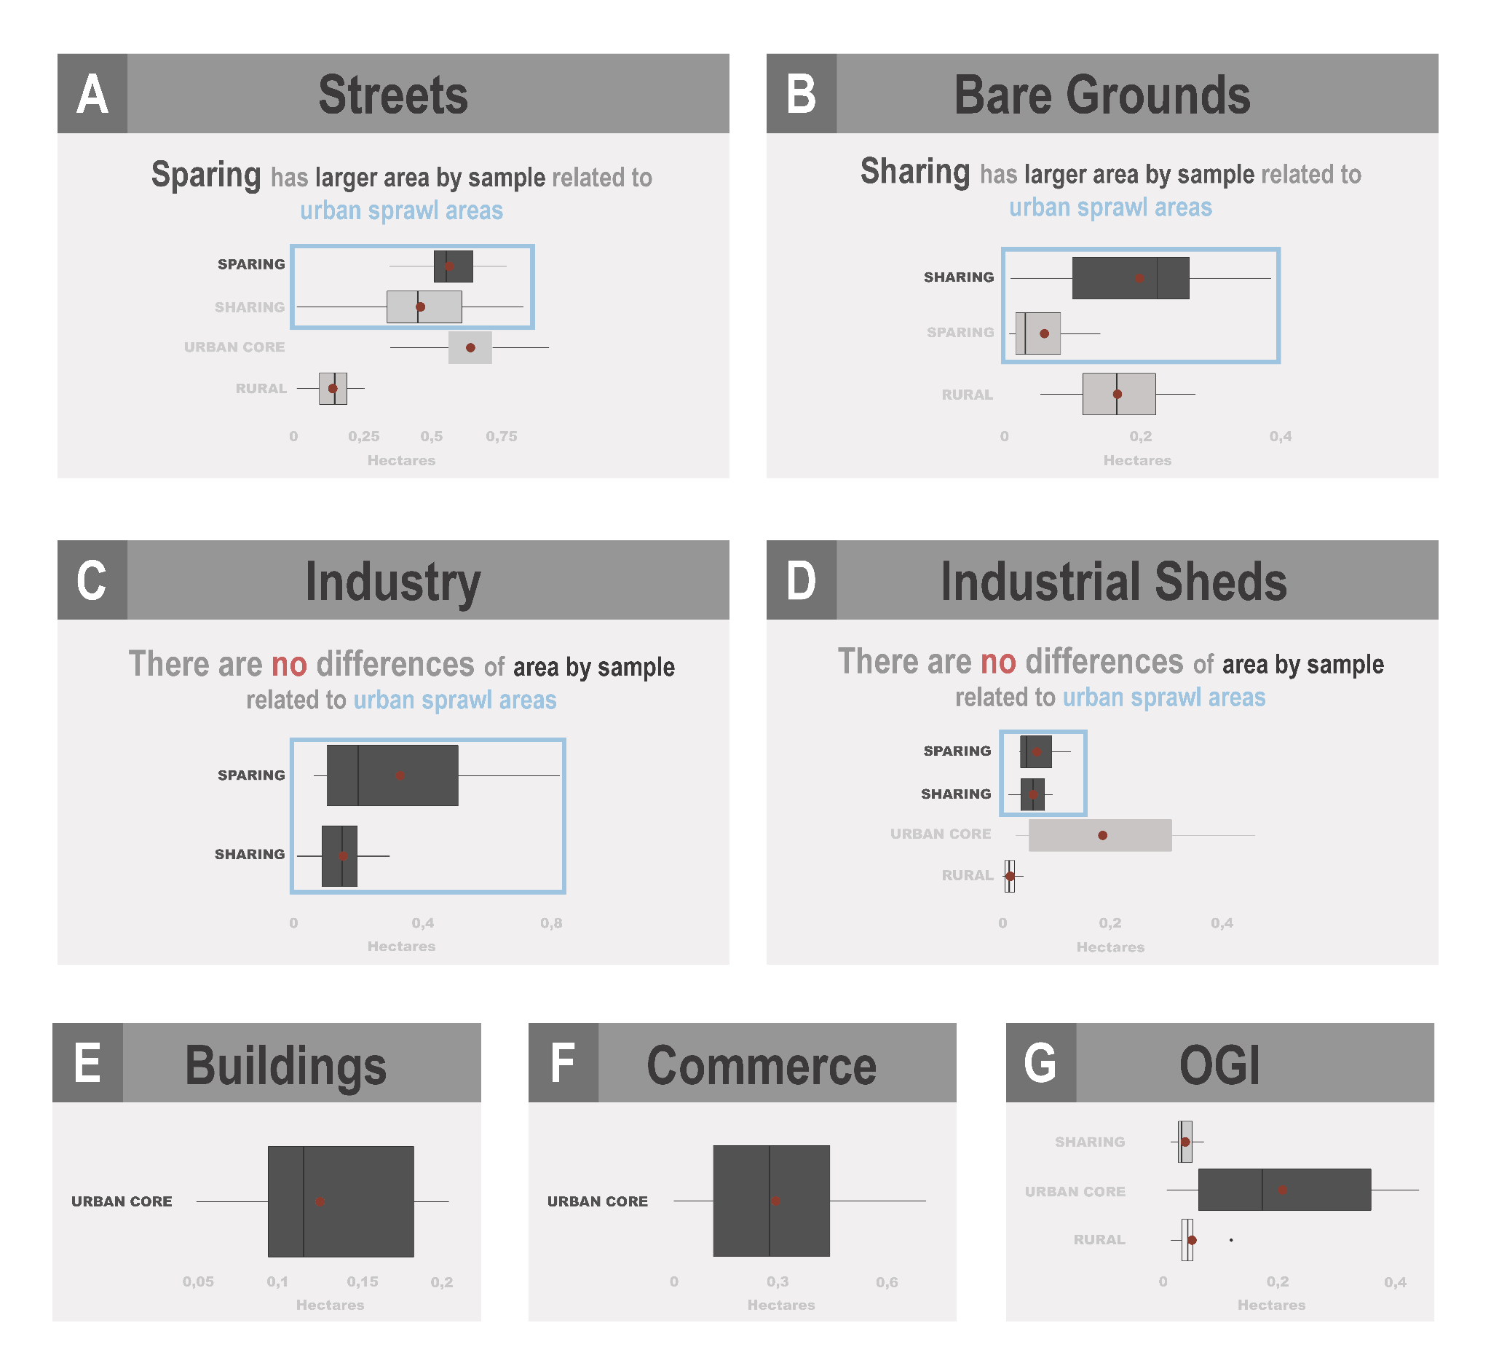
Online Resource 11 – Mean sampled area of gray land uses by sites. The highlighted boxes indicate the existence of relationship between the urban expansion models for the respective land use. A) Streets; B) Bare ground; C) Industry; D) Industrial sheds; E) Buildings; F) Commerce; G) OGI;

