Table 3 – Functional traits and their definitions. The range indicates the amount of units for each type of trait.
Type | Functional traits | Symbol | Range | Categories | Definition | Reference
Ecological | Diet |  | 4 | Invertebrate, FruiNect, Omnivore, PlantSeed | The predominant diet items consumed by bird species (e.g., nectar, fruits, seeds, plants, and invertebrates) | Wilman et al. (2014)
Ecological | Foraging stratum | 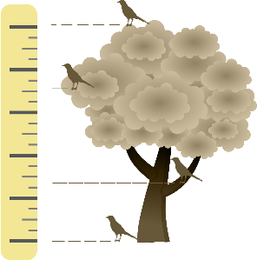 | 5 | Ground, Understory, Midhigh, Canopy, Mixed | The predominant foraging strata level used by the species, e.g., ground, underground, middle, canopy, aerials, water below the surface, water around the surface. | Wilman et al. (2014)
Ecological | Habitat | 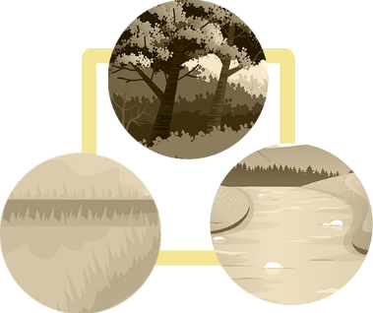 | 3 | Mixed, Non-Forest, Forest | The predominant habitat used by each species, i.e., forest, non-forest, water and a mixture of habitats. | Tobias et al. (2022)
Ecological | Distribution |  | 3 | Endemic, Non-endemic, Exotic | Bird species’ distribution | Vale et al. (2018); Sick (1997)
Ecological | Migratory | 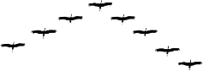 | 3 | Resi  dent, Partially migratory, Migratory | Reflects the recurrent and seasonal movement of individuals among their breeding and non-breeding sites | Somenzari et al. (2018)
Ecological | Nest Substrate |  | 4 | Palm leaves, Tree branch, Tree hollow, Tree hollow/Rufous Hornero's nest | Nest-site habitat selection | Simon and Pacheco (2005)
Ecological | Nest descriptions | 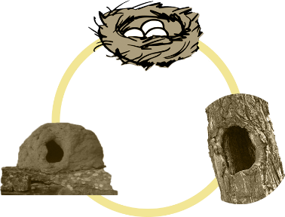 | 3 | Cavity, Closed, Cup | Refers to the type of the nest | Simon and Pacheco (2005)
Ecological | Cavity Dependence | 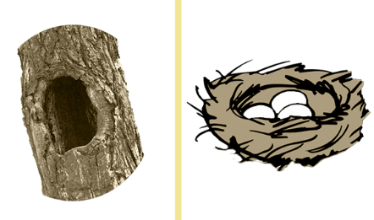 | 2 | Exploiter, Non-Cavity Dependent | Describe the dependence of the bird in nesting in cavity substrate | Bonaparte et al. (2020)
Ecological | Nest Strata | 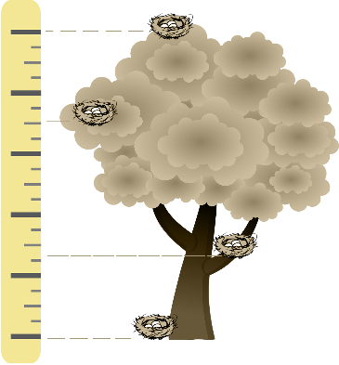 | 4 | Ground, understory, mid-story, canopy and brood parasite | The nesting strata level | WIKIAVES, 2022; Sick, 1997
Morphometric | Body Length | 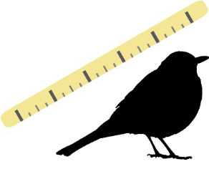 | 5 | 120-139, 140-159, 160-189, 190-219, >220 | Class of the average body length (cm) of each species | Rodrigues et al. (2019)
Morphometric | Bill Length | 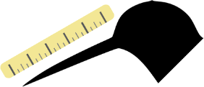 | 5 | 10-11, 12-13, 14-15, 19-20, >21 | Class of the average bill length size (mm) of each species | Rodrigues et al. (2019)
Morphometric | Gape width | 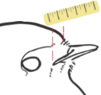 | 5 | 5-5.9, 8-99, 10-11, 12-139, >14 | Class of the average bill width size (mm) of each species | Rodrigues et al. (2019)
Morphometric | Wing Length | 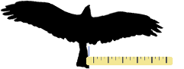 | 5 | 40-59, 60-79, 80-99, 100-119, >120 | Class of the average wing length size (mm) of each species | Rodrigues et al. (2019)
Morphometric | Body Mass | 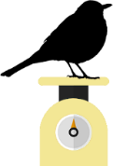 | 7 | 0-9, 10-19, 20-29, 30-39, 40-49, 50-99, >100 | Class of the average weight (g) of each species | Rodrigues et al. (2019)

