Supporting Information
pH-responsive Nanosystems for Targeted Drug Delivery to Glioblastoma Multiforme and MRI-facilitated Monitoring of Content Release
Mirjana Mundžić,¹ Amelia Ultimo,² Jelena Lazović,³ Minja Mladenović,¹ Aleksandra Pavlović,¹ Oliviero L. Gobbo,^{2,4} Eduardo Ruiz-Hernandez,^{2,4} Maria Jose Santos-Martinez^{2,4,5}, Nikola Ž. Knežević^{1*}
¹BioSense Institute, University of Novi Sad, Dr Zorana Djindjica 1, 21000 Novi Sad, Serbia.
²School of Pharmacy and Pharmaceutical Sciences, Panoz Institute, Trinity College Dublin, D02PN40, Dublin, Ireland
³Max Planck Institute for Intelligent Systems, Heisenbergstrasse 3, 70569 Stuttgart, Germany
⁴Trinity St. James’s Cancer Institute, St James’s Hospital, D08 NHY1, Dublin, Ireland.
⁵School of Medicine, Trinity College Dublin, D02 E8C0 Dublin, Ireland

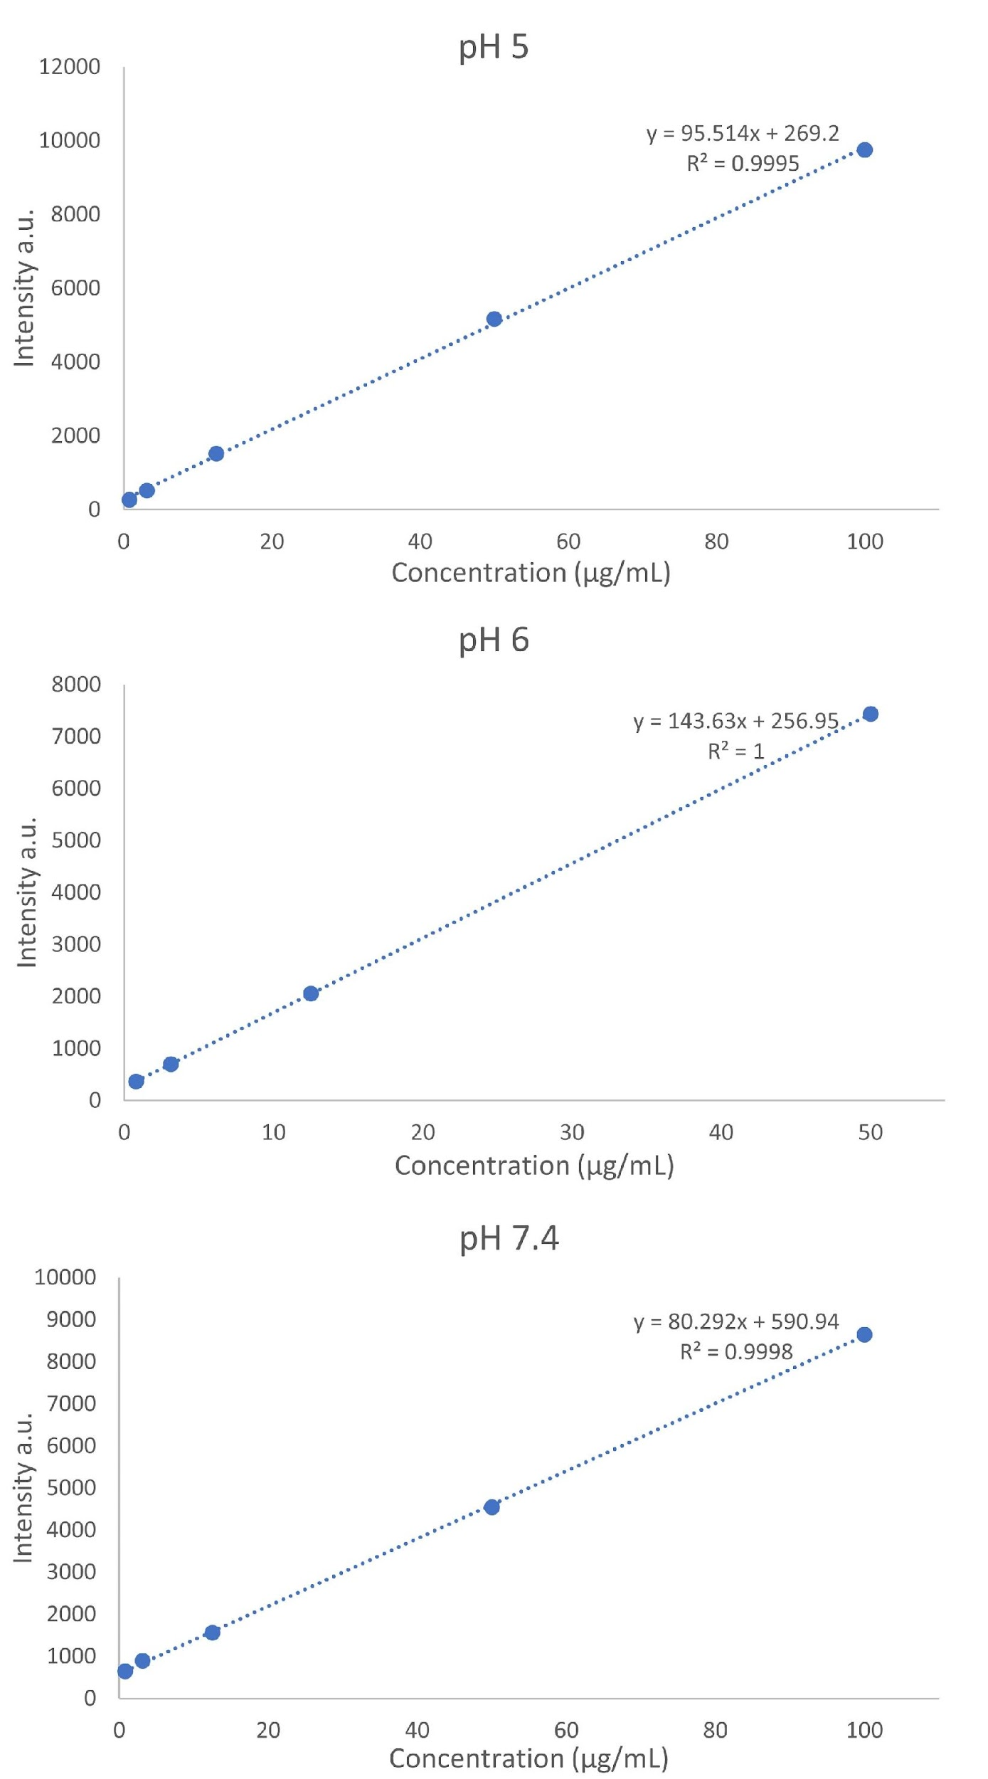
Figure S1. Calibration curves for gadobutrol fluorescence (exc. 280 nm/ em. 312 nm) at different pH.

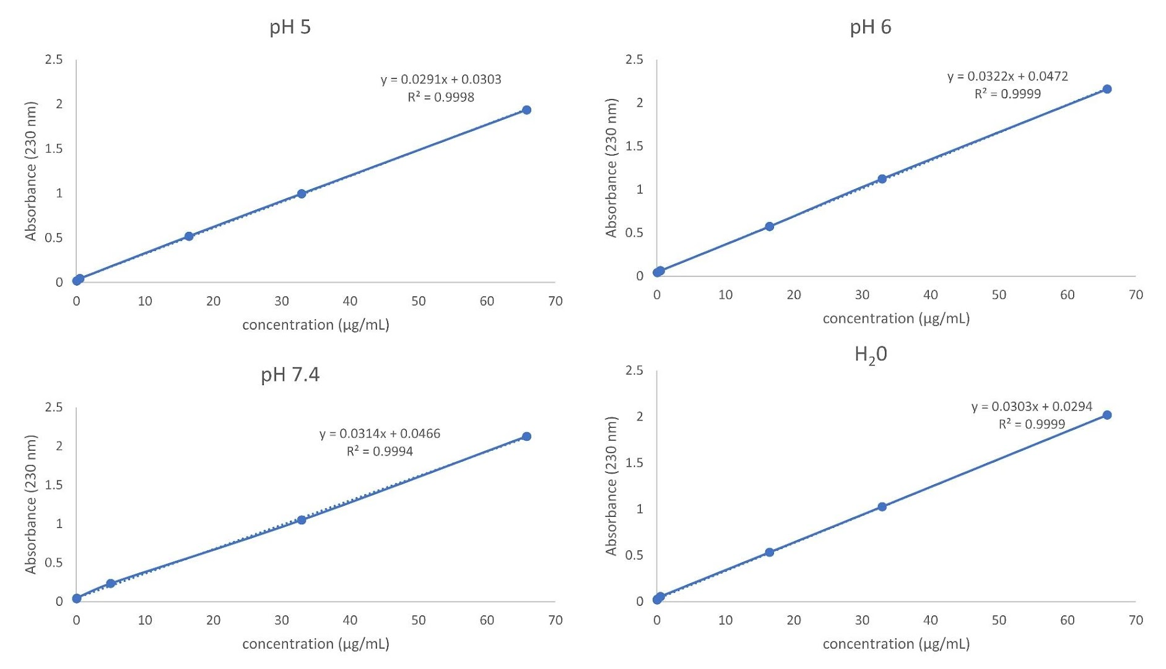
Figure S2. Calibration curves for Paclitaxel aqueous solution containing 65.8% of methanol (absorbance at 230 nm) at different pH.
Figure S3. TGA and DSC of MPMSN and BMPH-MPMSN.

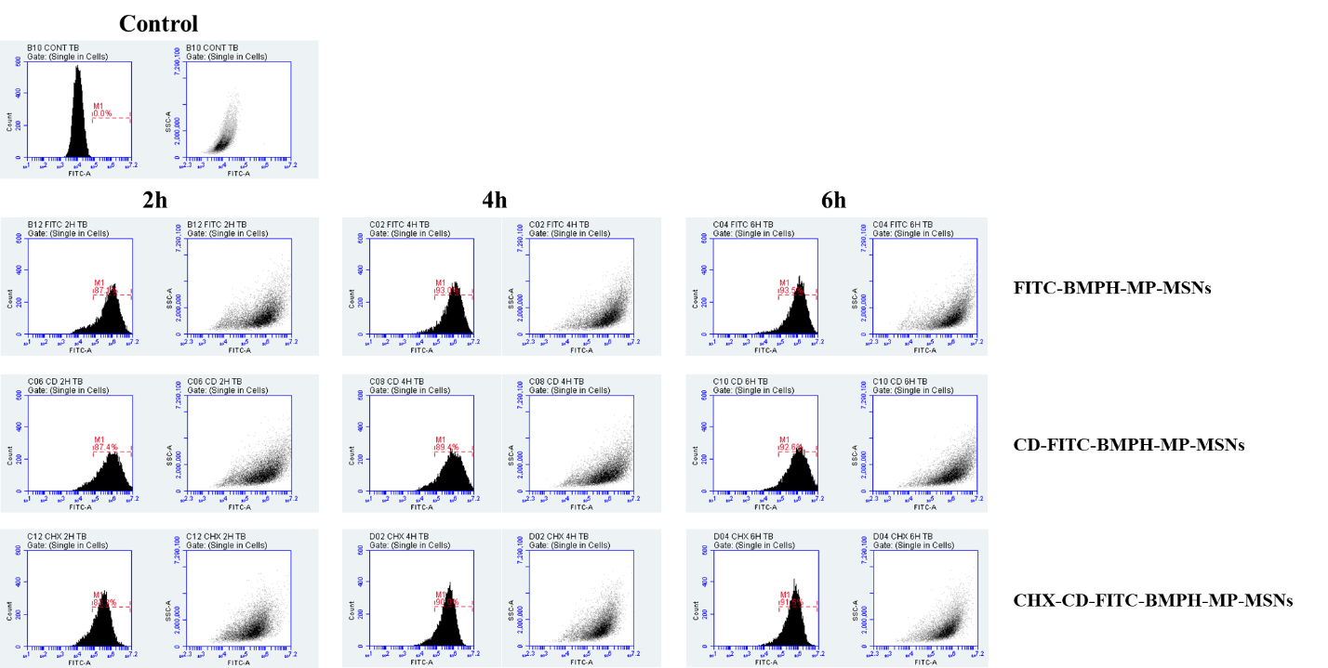
Figure S4. Representative histograms and dot plots showing FITC-BMPH-MP-MSNs, CD-FITC-BMPH-MPMSN and CHX-CD-FITC-BMPH-MPMSN internalization in U87 cells at different time points.

a)
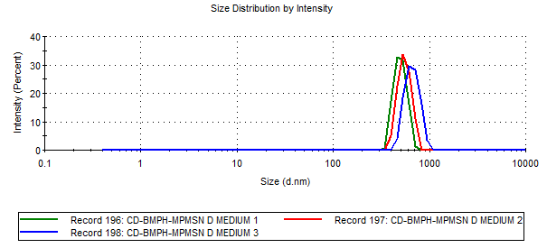
b)
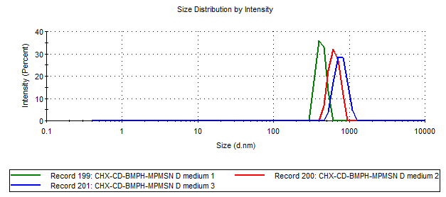
Figure S5. DLS size measurements (in triplicate) in cell medium at 0.1 mg/mL concentration immediately after dispersing: a) CD-BMPH-MPMSN and b) CDX-CD-BMPH-MPMSN

a)
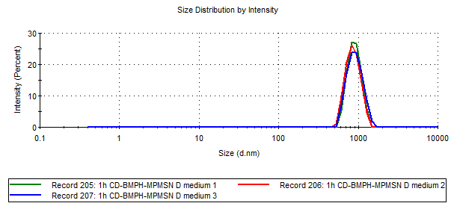
b)
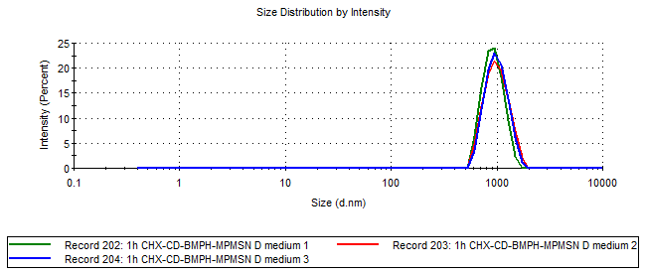
Figure S6. DLS size measurements (in triplicate) in cell medium at 0.1 mg/mL concentration 1h after dispersing: a) CD-BMPH-MPMSN and b) CDX-CD-BMPH-MPMSN

a)
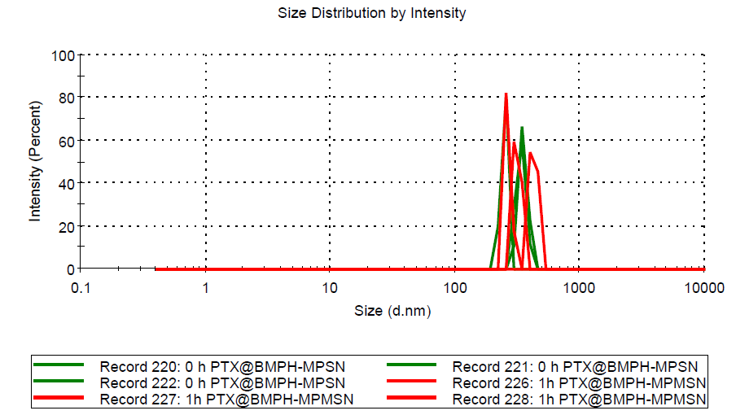
b)
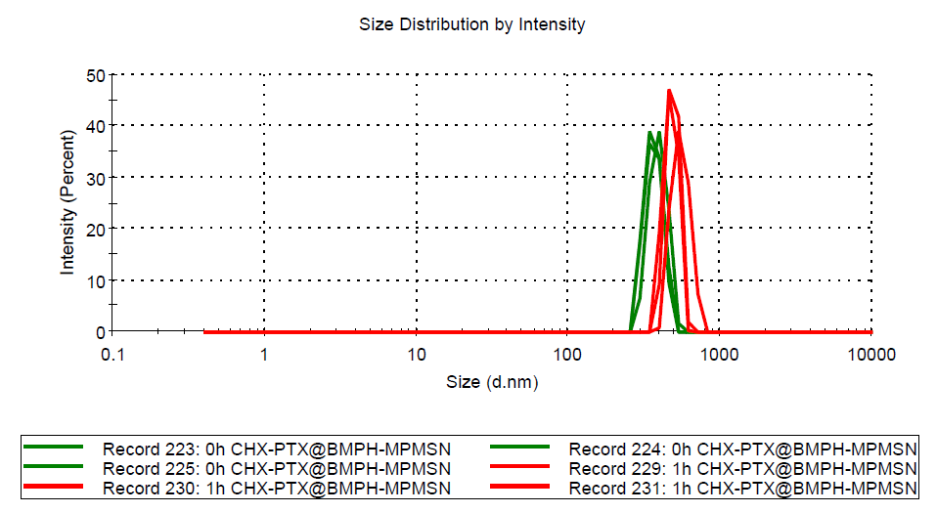
Figure S7. DLS size measurements in triplicate, in PBS at 0.05 mg/mL concentration immediately after dispersing (green) and after 1h of incubation (red) of: a) PTX@BMPH-MPMSN and b) CHX-PTX@BMPH-MPMSN

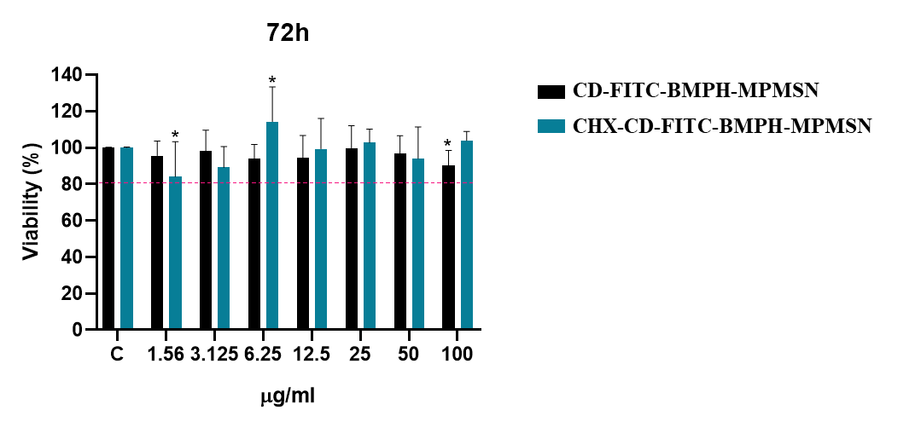
Figure S8. U87 cells viability after 72 h of incubation with different concentrations of CD-FITC-BMPH-MP-MSNs or CHX-CD-FITC-BMPH-MP-MSNs. Cell viability was analyzed by measuring absorbance at 450 nm with the CCK-8 reagent. Data are expressed as mean ± SD. Two-way ANOVA and Sidak’s multiple comparisons test were applied (* p < 0.05 vs control).

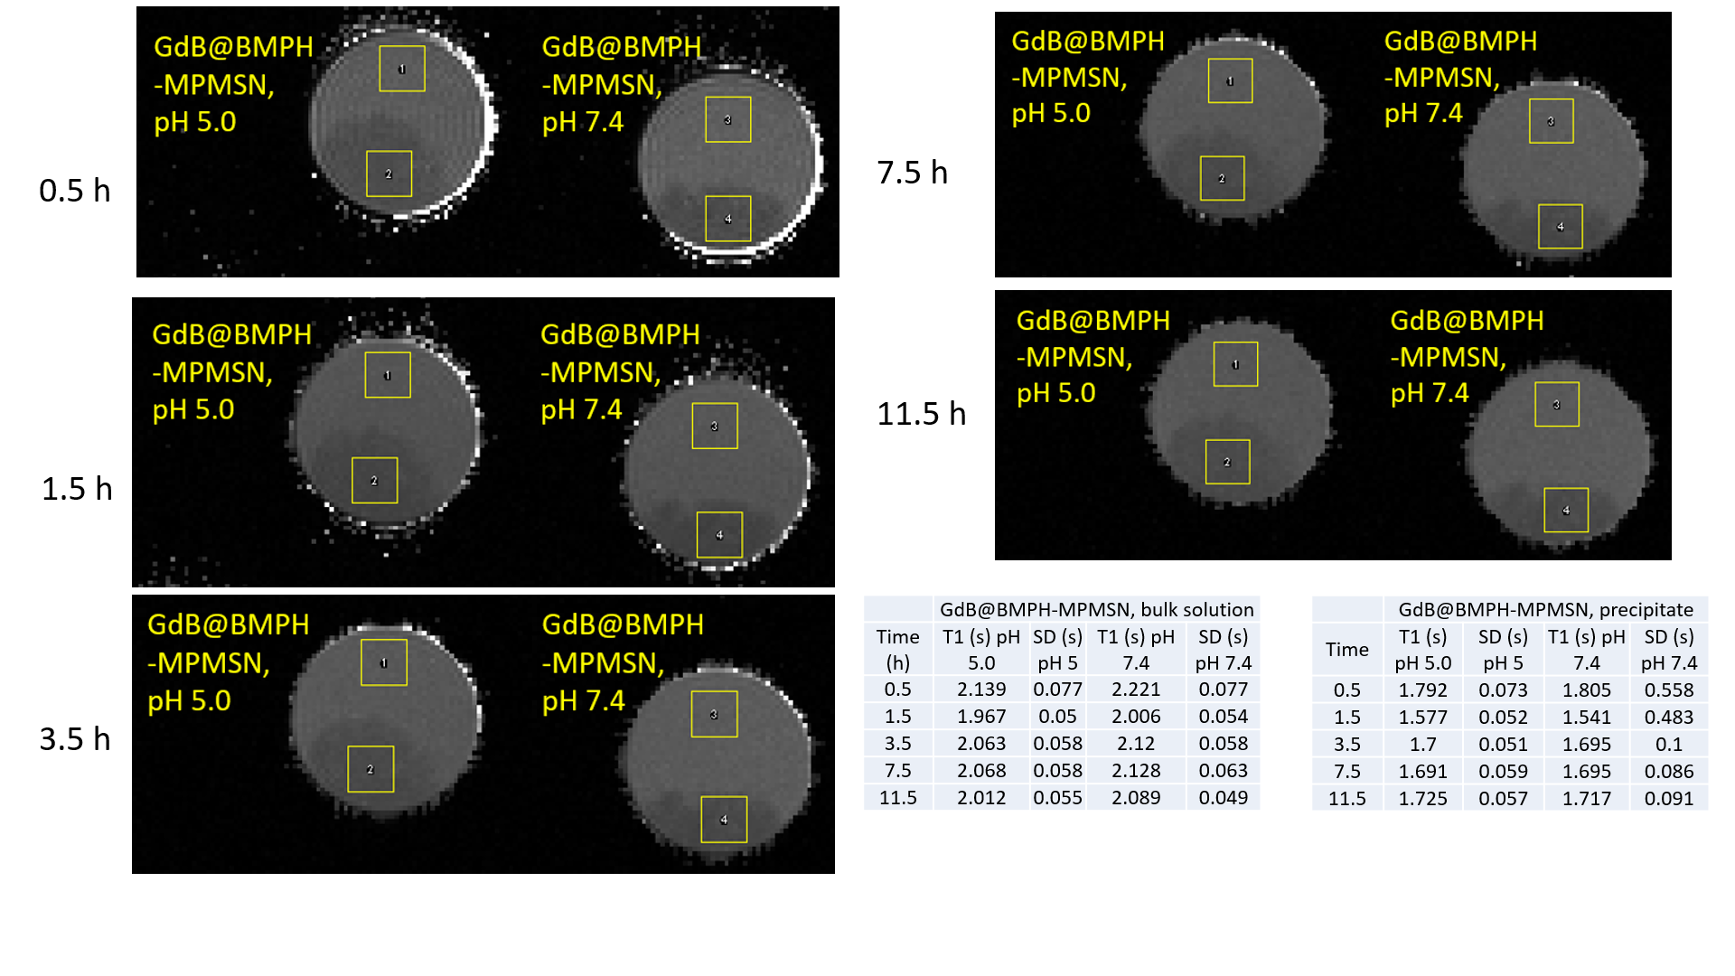
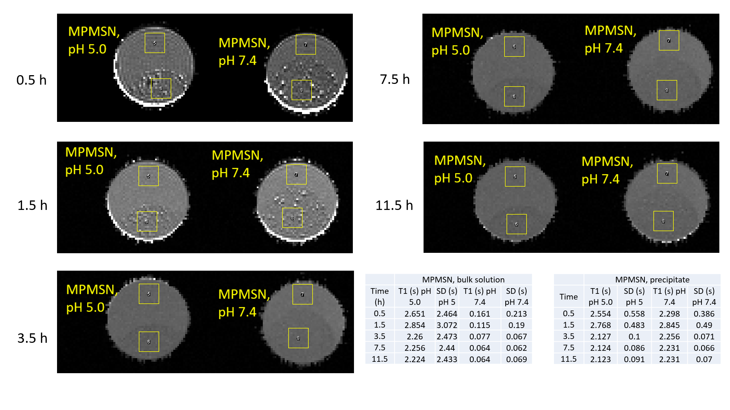
Figure S9. As measured MRI images of the GdB@BMPH-MPMSN and MPMSN materials. Region of interest (ROI) of the area 10x10 pixels was utilized by ImageJ software for measuring T1 mean and standard deviation (SD) in the areas of precipitates as well as in the areas of bulk solution above the precipitates as marked by the yellow squares. The values of the obtain mean T1 and SD are given in the tables.

Figure S10. Values of longitudinal relaxation times (T1) of suspensions of GdB@BMPH-MPMSN and MPMSN at pH 7.4 and pH 5, as measured in a) bulk solution and b) precipitate.

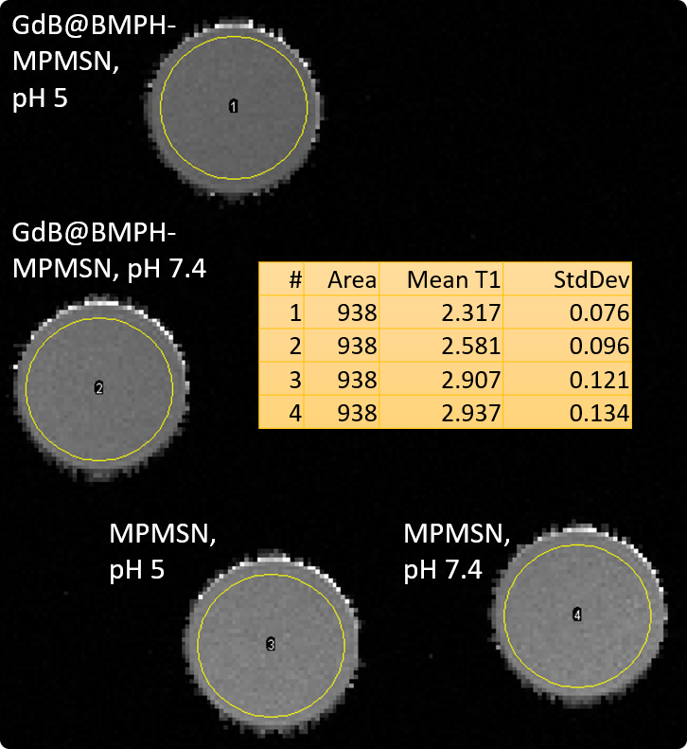
Figure S11. As measured MRI images of the supernatants after centrifugation of GdB@BMPH-MPMSN and MPMSN materials after 48 h of incubation. Region of interest (ROIS) of the area 938 pixels was utilized by ImageJ software for measuring T1 mean and standard deviation (SD) in all samples as marked by the yellow circles. The values of the obtain mean T1 and SD are given in the table.

