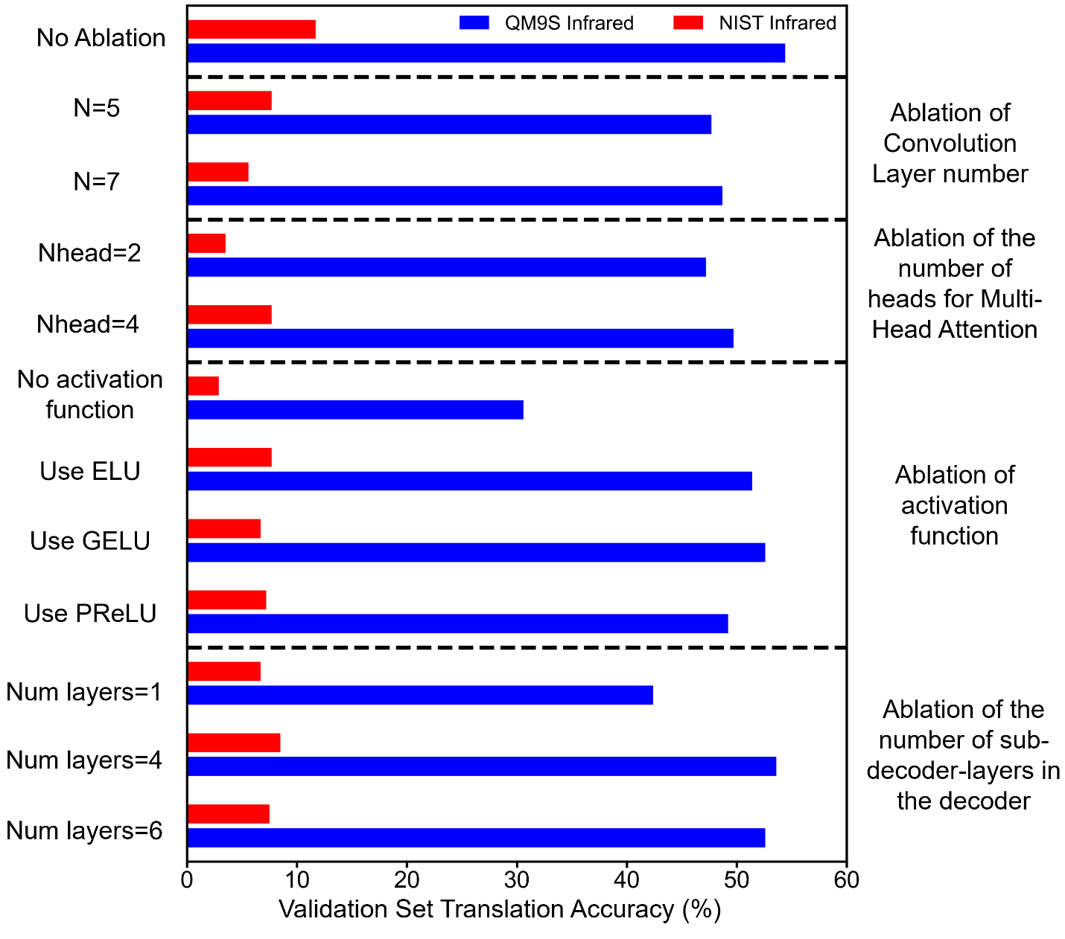
Extended Data Fig. 1|Ablation studies of TranSpec. Ablation experiments were performed to test the number of convolutional layers, the number of heads of multi-head attention, the activation function, and the number of decoder layers, The model has the best performance with parameter values of N=6, Nhead=8, use ReLU, Num layer=2.

Functional groups | No. and proportion of the molecules that contains the functional groups
Functional groups | No. of the molecules that include the groups in QM9S | Proportion of the molecules that include the groups in QM9S (%) | No. of the molecules that include the groups in NIST | Proportion of the molecules that include the groups in NIST (%)
alkane | 121823 | 95.57 | 4755 | 72.88
alkene | 16234 | 12.74 | 839 | 12.86
alkyne | 15623 | 12.26 | 118 | 1.81
aromatics | 21509 | 16.87 | 3475 | 53.26
alcohols | 40958 | 32.13 | 1324 | 20.29
aldehydes | 13407 | 10.52 | 162 | 2.48
ketones | 14572 | 11.43 | 566 | 8.68
esters | 4515 | 3.54 | 638 | 9.78
ether | 56453 | 44.29 | 1557 | 23.87
amides | 8704 | 6.83 | 343 | 5.26
nitriles | 15776 | 12.38 | 280 | 4.29
amine | 38594 | 30.28 | 782 | 11.99

Extended Data Fig. 2| The numbers and proportions of the molecules that contains the 12 most common functional groups in QM9S and NIST datasets.

