Physiologically-based pharmacokinetic models versus allometric scaling for prediction of tyrosine-kinase inhibitor exposure from adults to children
Maddalena Centanni¹, Omar Zaher¹, David Elhad¹, Mats O. Karlsson¹, Lena E. Friberg¹*

Affiliations
1. Department of Pharmacy, Uppsala University, Uppsala, Sweden.

*Corresponding author:
Lena E. Friberg
Dept of Pharmacy
Uppsala University, Box 580
751 23 Uppsala
Sweden
lena.friberg@farmaci.uu.se
ORCID ID: 0000-0002-2979-679X

Imatinib
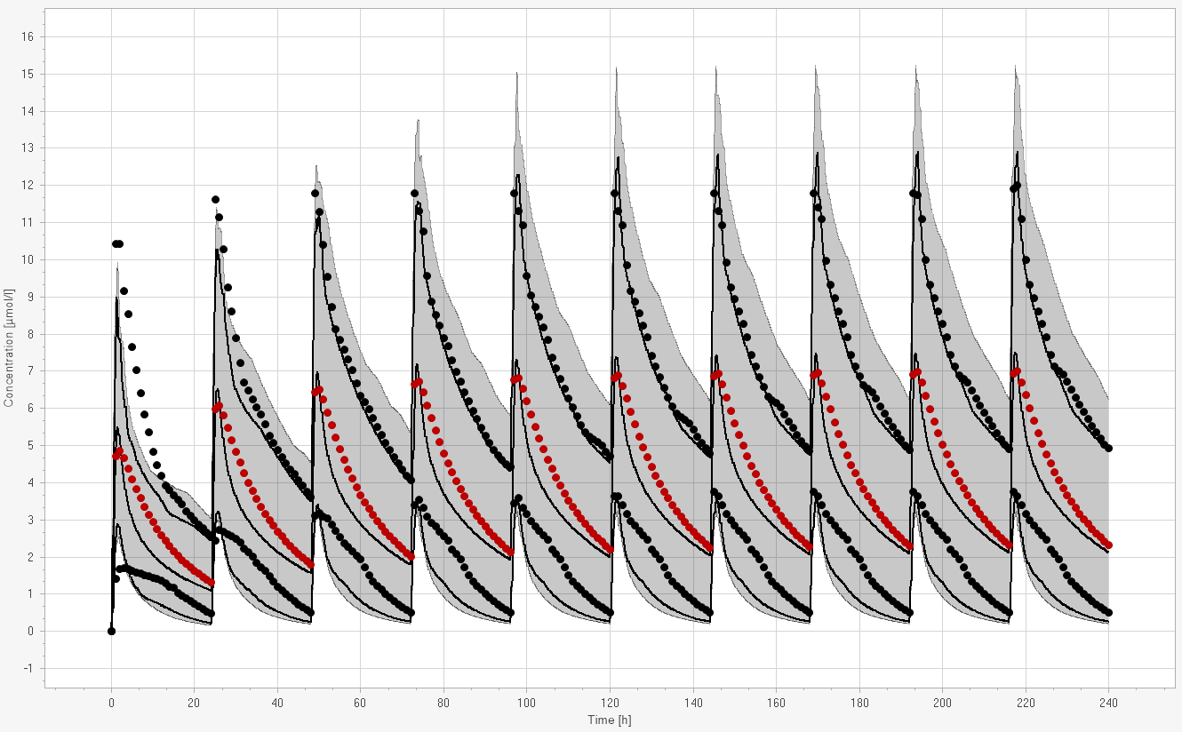
NDMI 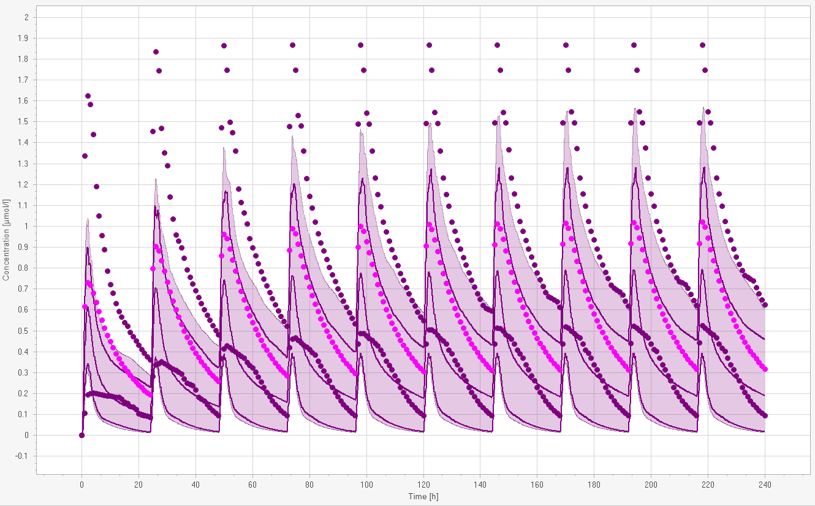

Sunitinib
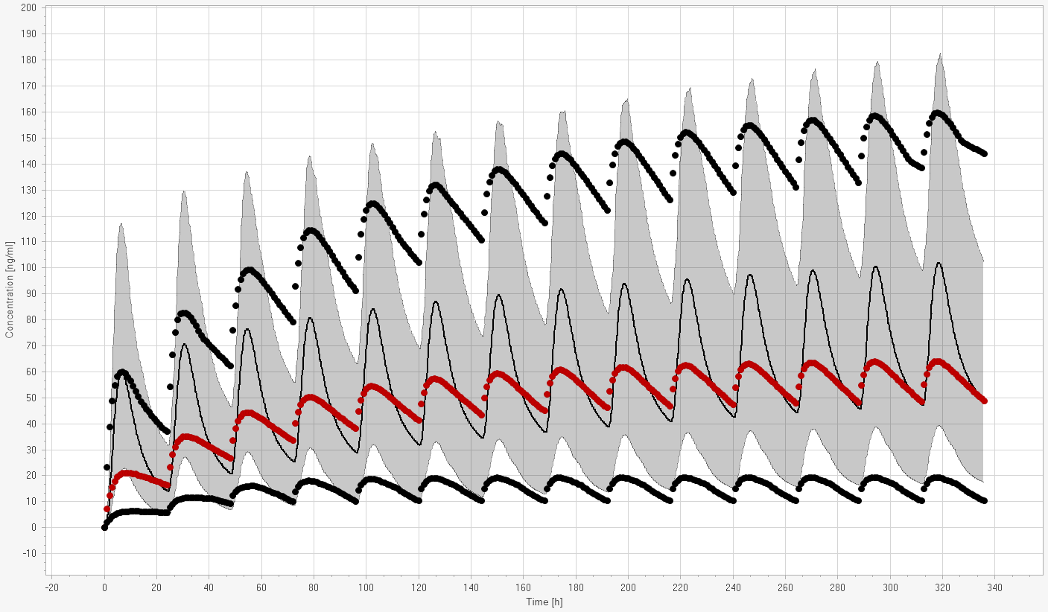
SU12662
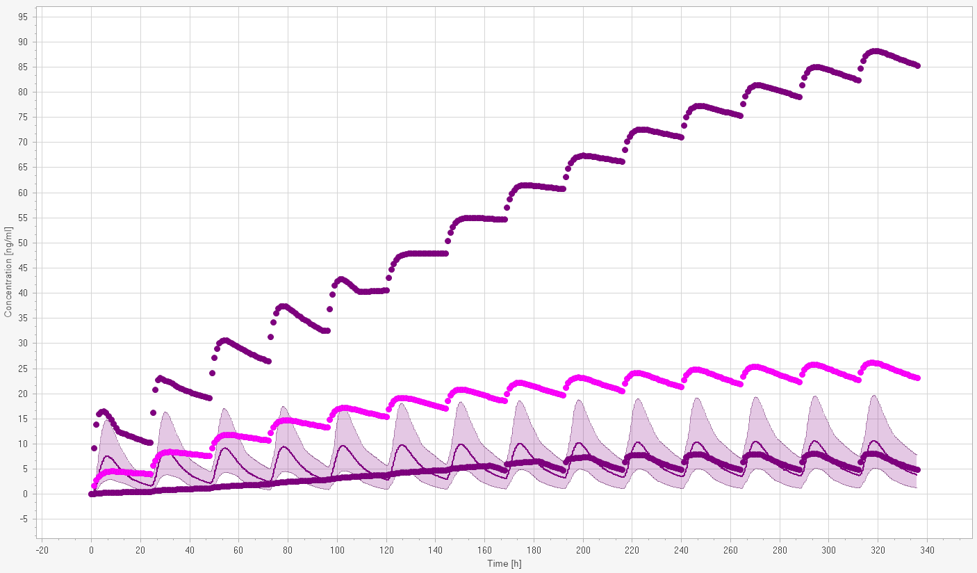

Pazopanib (200 mg)
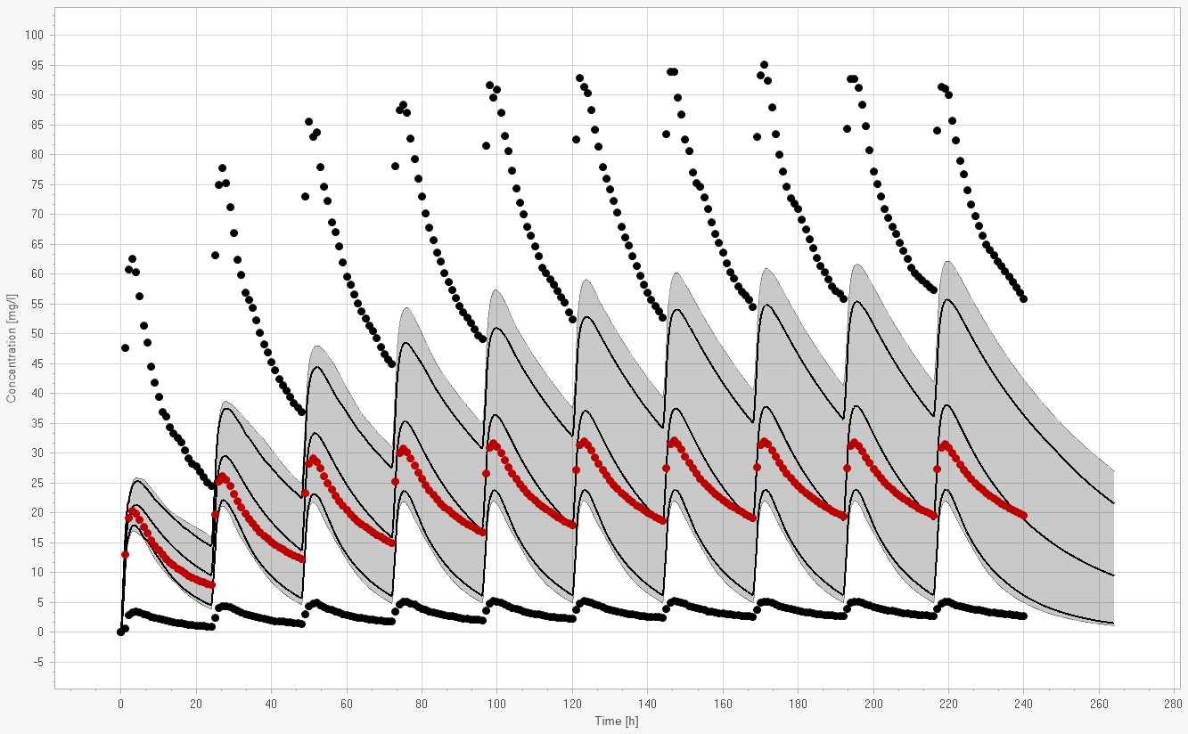
Pazopanib (400 mg)
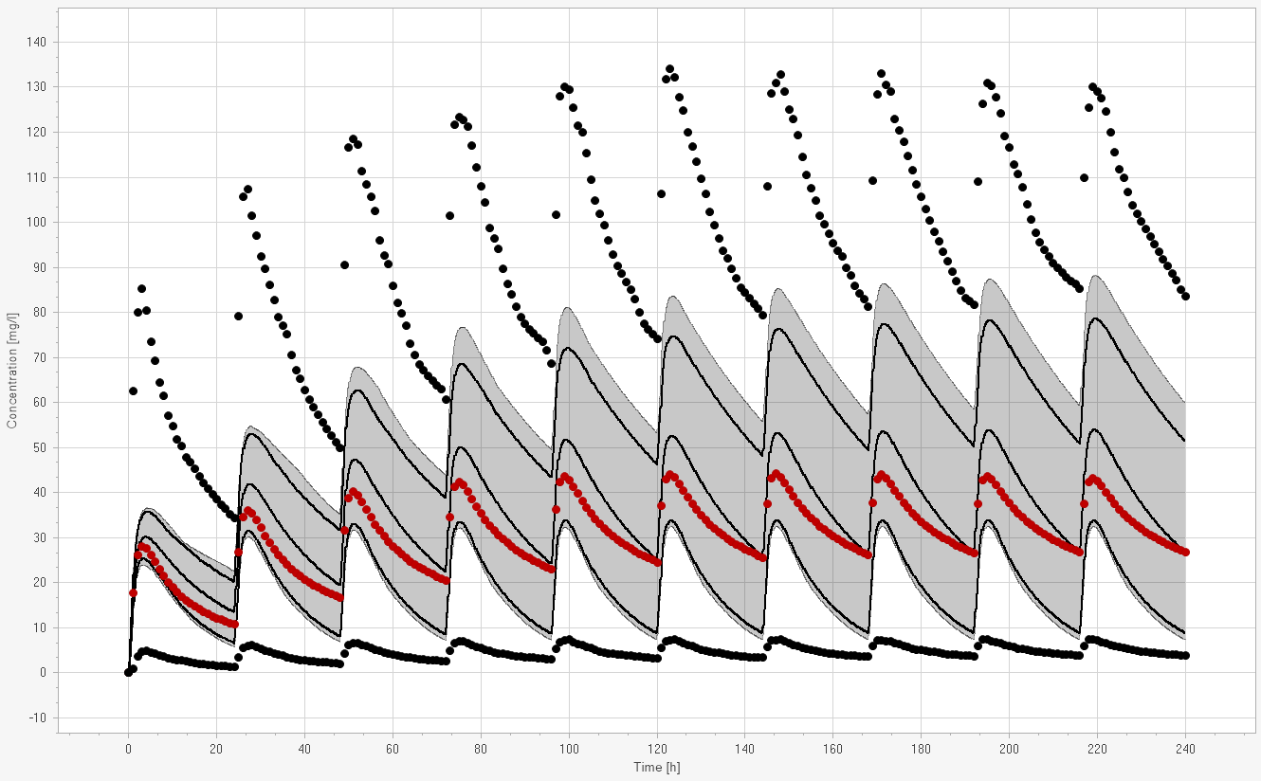

Pazopanib (800 mg)
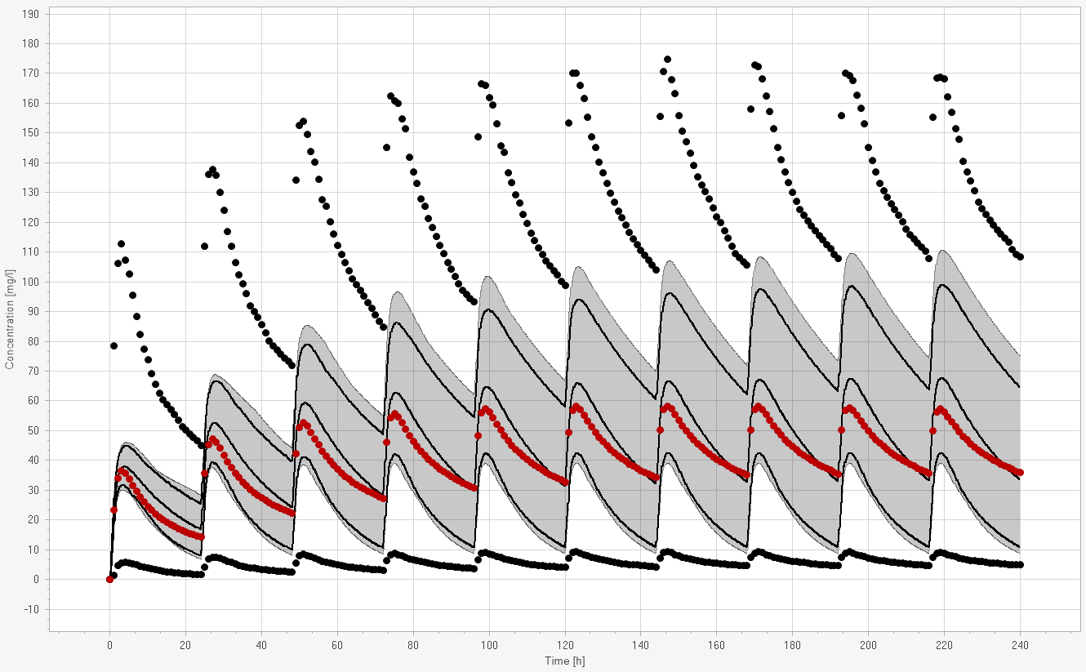
Online Resource 1: Simulated and observed concentration for the adult PBPK models. The solid circles (•) represent observed (simulated with adult popPK model) mean, 2.5th and 97.5th percentiles. The solid lines (---) are the simulated mean (with PBPK model), 2.5th and 97.5th percentiles of the observed data. The shaded areas correspond to the simulated (with PBPK model) 95% confidence intervals (n = 100). PBPK physiologically-based pharmacokinetic mode.

