Extrachromosomal DNA Couples with ATM-mediated DNA Damage Response for Genome Instability in Tumors

Xing Kang^{1,11}, Xinran Li^{1,11}, Jiaqi Zhou^{1,11}, Yang Zhang^{1,11}, Suili Hu^{1,2}, Zhiwen Deng³, Yuchun Wu^{1,4}, Nan Wang¹, Liangming Chen¹, Yajing Xu^{1,2}, Jinyi Chen^{1,5}, Zhen Yue¹, Yuan Yao¹, Xinran Yang¹, Sitong Yao^{1,2}, Congcong Tian¹, Qin Wen¹, Xiaoyan Liang¹, Lixia Yan¹, Olivia M. Depies⁶, Kuiming Chan⁷, Xiaohuan Liang², Junbiao Dai⁸, Zhiquan Wang⁶, Chuanhe Yu⁹, Gang Li¹⁰, Xiangyu Liu³, Haiyun Gan¹*
1. Shenzhen Key Laboratory of Synthetic Genomics, Guangdong Provincial Key Laboratory of Synthetic Genomics, Key Laboratory of Quantitative Synthetic Biology, Shenzhen Institute of Synthetic Biology, Shenzhen Institute of Advanced Technology, Chinese Academy of Sciences, Shenzhen, China
2. College of Veterinary Medicine, South China Agricultural University, Guangzhou, China
3. Guangdong Provincial Key Laboratory of Regional Immunity and Diseases, International Cancer Center, Marshall Laboratory of Biomedical Engineering, Shenzhen University Health Science Center, Shenzhen, China
4. School of Basic medical, Qingdao University Pathology and pathophysiology, Qingdao University, Qingdao, China
5. Guangdong Provincial Key Laboratory of Research and Development of Natural Drugs, and School of Pharmacy, Guangdong Medical University, Guangdong Medical University Key Laboratory of Research and Development of New Medical Materials, Dongguan, China
6. Division of Hematology, Department of Medicine, Mayo Clinic, Rochester, MN, USA
7. Department of Biomedical Sciences, City University of Hong Kong, Hong Kong, China
8. CAS Key Laboratory of Quantitative Engineering Biology, Guangdong Provincial Key Laboratory of Synthetic Genomics and Shenzhen Key Laboratory of Synthetic Genomics, Shenzhen Institute of Synthetic Biology, Shenzhen Institute of Advanced Technology, Chinese Academy of Sciences, Shenzhen, China; Shenzhen Branch, Guangdong Laboratory for Lingnan Modern Agriculture, Key Laboratory of Synthetic Biology, Ministry of Agriculture and Rural Affairs, Agricultural Genomics Institute at Shenzhen, Chinese Academy of Agricultural Sciences, Shenzhen, China
9. Hormel Institute, University of Minnesota, Austin, MN, USA
10. Centre of Reproduction, Development and Aging, Institute of Translational Medicine, Faculty of Health Sciences, University of Macau, Macau, China
11. These authors contributed equally: Xing Kang, Xinran Li, Jiaqi Zhou, and Yang Zhang.
E-mail: hy.gan@siat.ac.cn

SUPPLEMENTARY FIGURES:
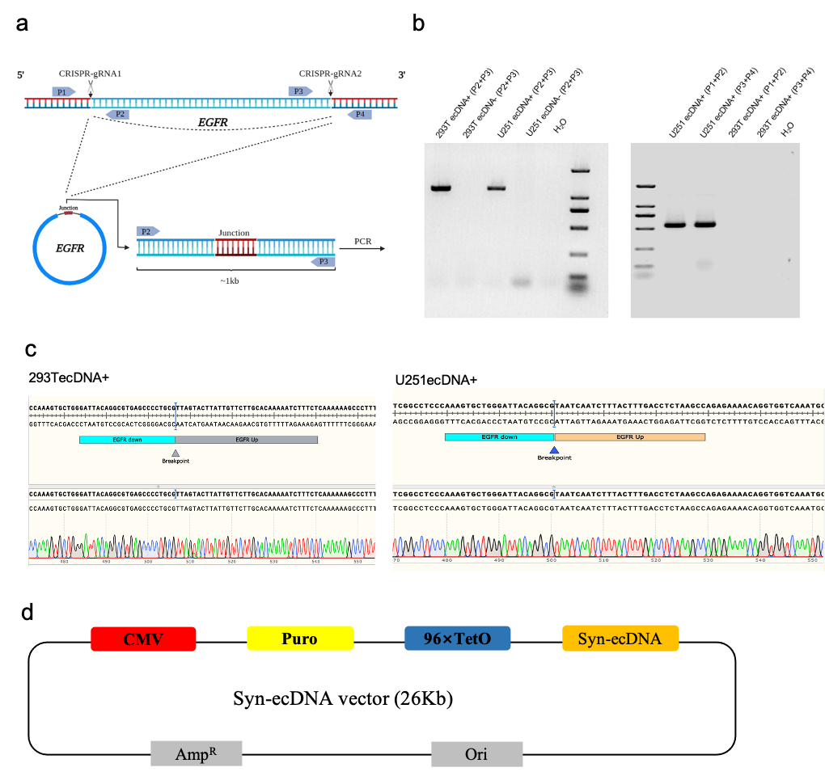

Supplementary Fig. 1 Construct ecDNA+ model in U251 and 293T cell lines

a, Depiction of CRISPR-C strategy used to generate a single ecDNA in U251 and 293T cells containing the ecEGFR.

b, PCR detect the EGFR gene sequence cyclization after cutting with CRISPR-C using agar gel electrophoresis.

c, Sanger sequencing confirms EGFR sequence cyclization with 5’-UTR connected to 3’-UTR sequences.

d, Diagram of syn-ecDNA vector, including the regulatory CMV, puromycin and BFP.
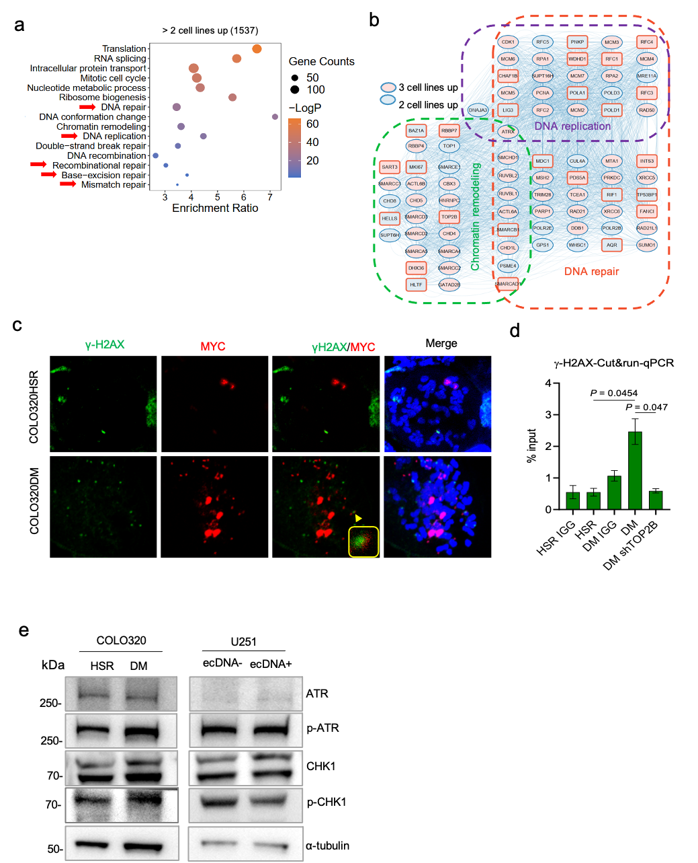

Supplementary Fig. 2 ecDNA replication and maintenance associated with DDR

a, Gene Ontology-Biological Process (GO-BP) analysis on the EdU-labeled difference proteins enriched in the genes of at least 2 ecDNA+ cell lines. The X-axis is the ratio of the enrichment associated with each GO term given on the left. The 15 statistically significant GO terms were displayed. Red arrows represent DNA repair-related pathways.

b, Network analysis of selected GO cellular component terms for up-regulation in 2 or 3 ecDNA+ cell lines. The ecDNA replication-related proteins mainly enriched in the pathways of DNA replication, DNA repair and chromatin remodeling.

c, Representative image of γH2AX immunofluorescence staining colocalized with FISH foci

were shown. Arrowheads point to ecMYC and γH2AX immunofluorescence on both. Scale

bar=10 μm.

d, CUT&run-qPCR for γH2AX occupancy at selected regions in COLO320DM, COLO320DM shTOP2B and COLO320HSR cells. Data are presented as mean values±S.D. and correspond to n=3 independent experiments. Analyses with indicated P-values above the plots were performed using two-side Student’s t-test.

e, Representative immunoblot of COLO320 and U251 cell lines analyzed with the indicated antibodies. ATR, CHK1, p-ATR and p-CHK1 were normalized to α-tubulin. MW in kDa left.

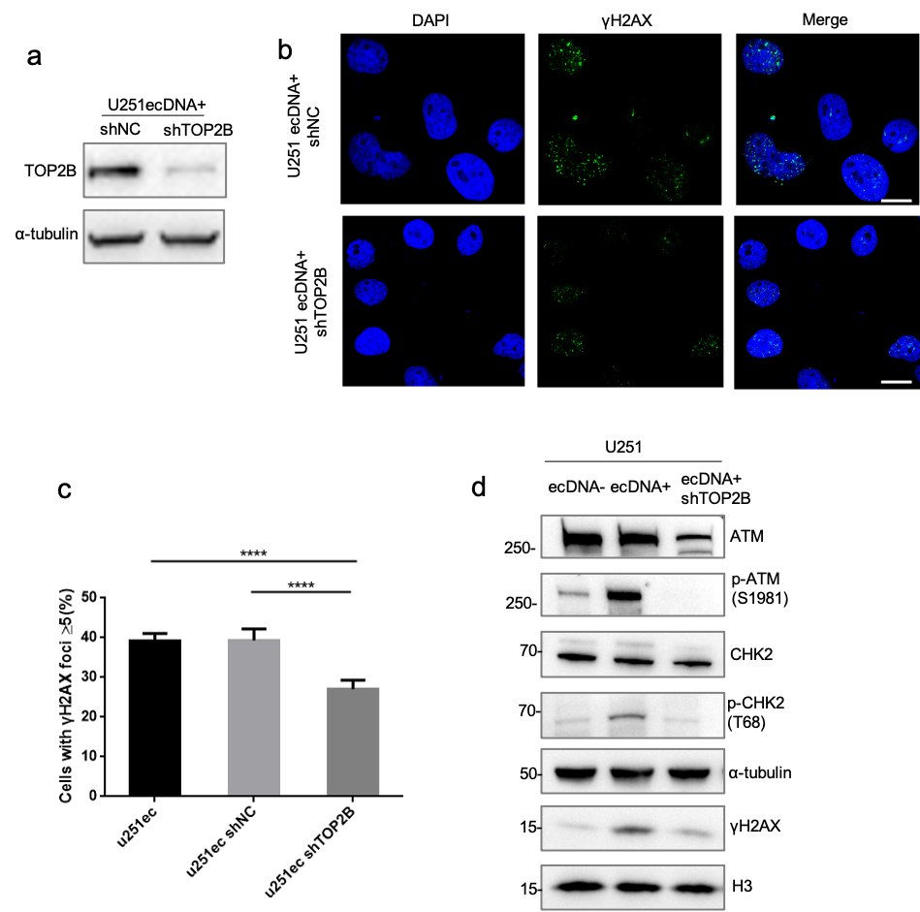

Supplementary Fig. 3 TOP2B involved in ecDNA caused ATM-mediated DDR in U251 cells

a, U251ecDNA+ cells were stable transfected with either shNC or TOP2B-specific shRNA (shTOP2B), and the level of endogenous TOP2B was analyzed by immunoblot. α-tubulin is a loading control (n=2 independent biological replicates).

b, Immunofluorescence staining was performed to detect γH2AX level in U251ecDNA+ TOP2B knockdown cell line. Representative images of γH2AX foci were shown. Nucleus is stained with DAPI (blue). Scale bar=10 μm.

c, Quantification of the percentage of γH2AX foci+ (n＞5) was shown as mean values±S.D. for the shTOP2B knockdown cell lines (at least 100 cells for the statistics) examined (**** represents P-value <0.0001, Student’s t-test, two-tailed).

d, Representative immunoblot of U251ecDNA+ cells was analyzed with indicated antibodies after TOP2B protein knockdown. ATM, CHK2, p-ATM and p-CHK2 were normalized to α-tubulin, while γH2AX was normalized to histone H3. MW in kDa left.

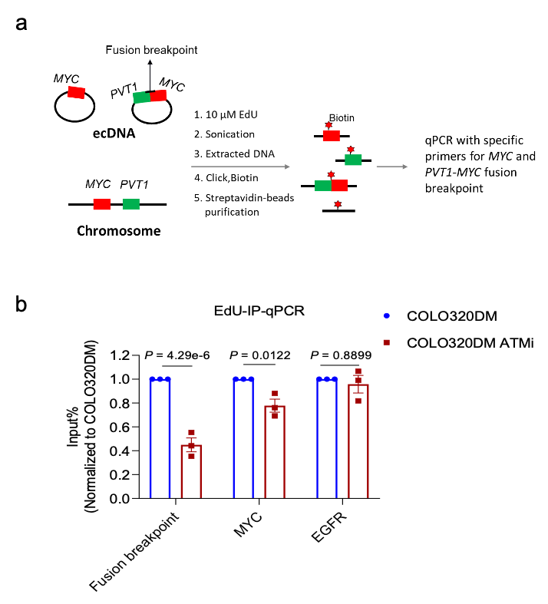

Supplementary Fig. 4 EdU-IP qPCR for MYC-PVT1 Fusion-breakpoint, MYC and EGFR gene

regions

a, Schematic drawing depicting the EdU-IP-qPCR strategy used to detect ecDNA replication.

b, Treatment with ATM inhibitor KU55933, EdU-IP was performed for EdU-Biotin and subsequently qPCR was performed at the positive regions (MYC-PVT1 Fusion-breakpoint, MYC gene loci) and negative region (EGFR gene loci) in COLO320DM and COLO320HSR cells, respectively. Data were represented as mean values±S.E.M and correspond to n=3 independent experiments. Analyses with indicated P-values above the plots were performed using two-side Student’s t-test.

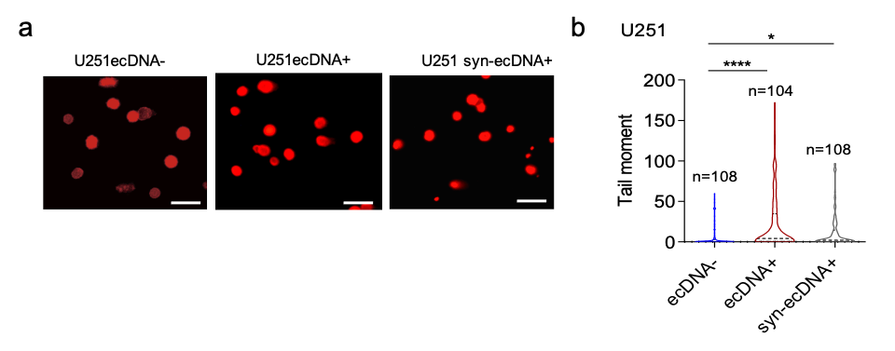

Supplementary Fig. 5 Comet assay in U251 cells

a, Representative images of the alkaline comet assay performed using U251ecDNA+ and U251 syn-ecDNA+ cell lines. Scale Bar=25 μm.

b, Quantification of average comet tail length (μm) was shown as mean values±S.D. for U251 cell line examined. The number of cells (n) is indicated. Two-tailed unpaired Student’s t-test was used for statistical analysis (* represents P-value <0.05, **** represents P-value <0.0001).

