Supplementary Materials

Supporting Information Table. 1
Primer Sequences used for qRT-PCR
Genes （Rat） | Forward primer | Reverse primer
GPX4 | TGCGAATTCGTGCATGGA | ACGAGTTCCTGGGCTTGTGT
SLC7A11 | ATTCTGGAGGTCTTTGGT | GCTGACACTCGTGCTATT
cGAS | AGCTACCAAGGTGCTGTCAA | CCACGGTGACATCTGTATCTTTG
STING | GGGTTTGGGGGCATCTTGAAA | AAAGGGCAGACAGCAGTCACA
IL-6 | CCACCAGGAACGAAAGTCAAC | TTGCGGAGAGAAACTTCATAGCT
IL-8 | TGACCATGAGACACTGTGGC | GAAGAGCACGGGTCCTTTGA
IL-1β | CACCTCTCAAGCAGAGCACAG | GGGTTCCATGGTGAAGTCAAC
PINK1 | ACTACCTATGCCCATCCATCTA | CTCGGTGACAGCTAAGTCATC
Parkin | TCAGACAAGGACACATCAG | CGGTGGTTACATTGGAAG
GAPDH | CACATTGGGGGTAGGAACAC | AACTTTGGCATTGTGGAAGG
MT-ND1 | ATGGCCTTCCTCACCCTAGT | CTTAGGGGGCGTATGGGTTC
MT-Dloop | TCCCCAAGCATATAAGCATGTAA | TGGTGCATGTCTAATAACACAGA
18S | GTAAACCCGTTGAACCCCATT | CCATCCAATCGGTAGTAGCG

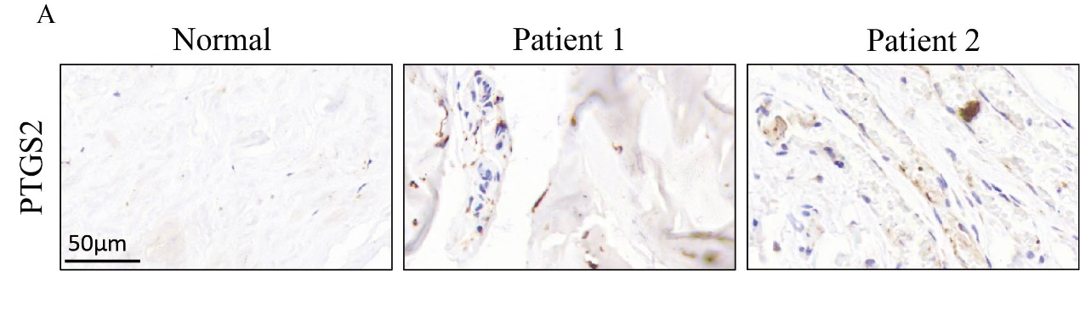
Supporting Information Fig. 1
Observation of clinical sample results. High expression of the ferroptosis marker protein PTGS2 was observed in patients with tendon injury compared with normal tendon tissue (All patients were fully informed and signed the surgical informed consent).

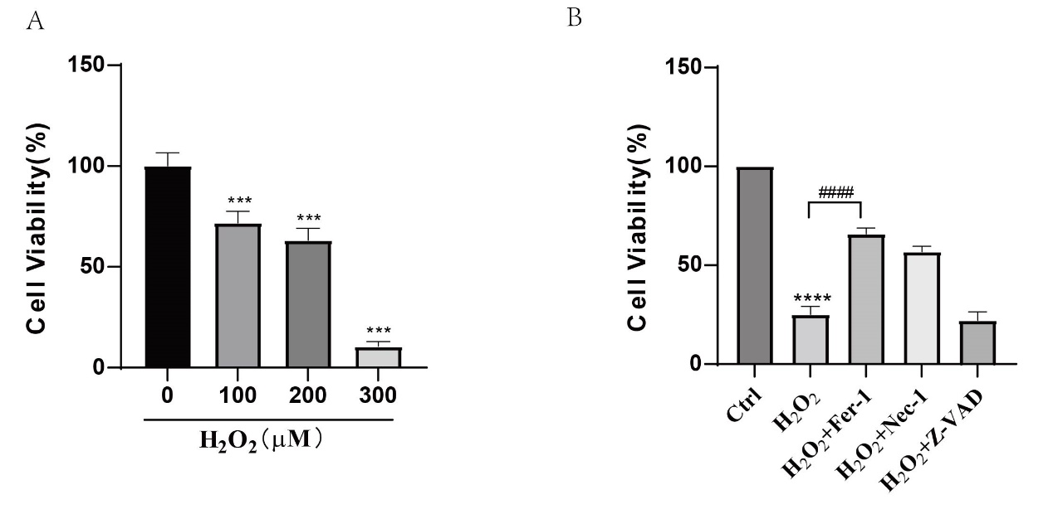
Supporting Information Fig. 2
H₂O₂ promoted TSCs ferroptosis in vitro. TSCs were treated with H₂O₂ (100 μM) for 24 h. Cell viability was tested through CCK8 experiment. (A) For 24 h, gradient concentrations of H₂O₂ were introduced to the TSC cells' growing media. (B) TSCs cells were pretreated with Ferrostatin-1 (5 μM), Necrostatin-1 (10 μM), ZVAD-FMK (10 μM) for 2 h and then H₂O₂ were used to stimulate the TSC cells. (n=3); ***p < 0.001, ****p < 0.0001, ####p < 0.0001.

