Fig1 D
SLC7A11（groups：Ctrl、H₂O₂、Fer-1、H₂O₂+Fer-1）three times repeat
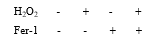

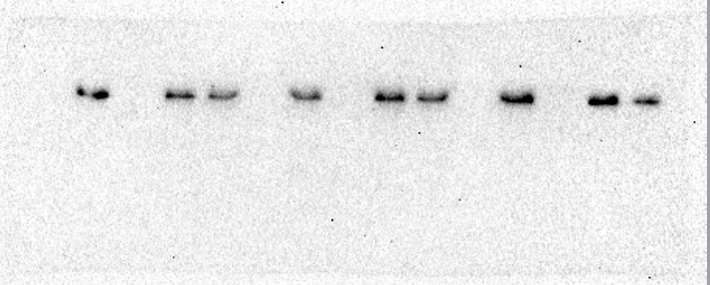

GPX4（groups：Ctrl、H₂O₂、Fer-1、H₂O₂+Fer-1）three times repeat
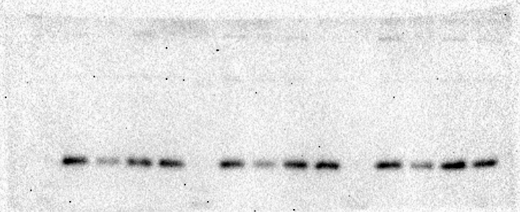
β-actin（groups：Ctrl、H₂O₂、Fer-1、H₂O₂+Fer-1）three times repeat

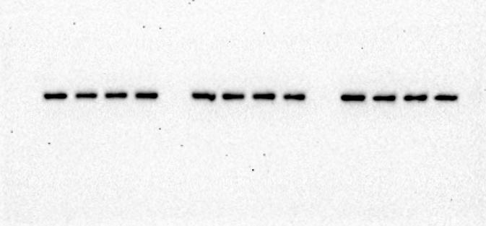

Fig1 K
Tnmd（groups：Ctrl、H₂O₂、Fer-1、H₂O₂+Fer-1）three times repeat
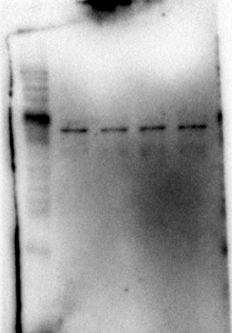
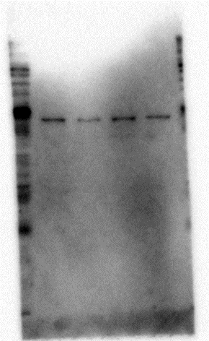
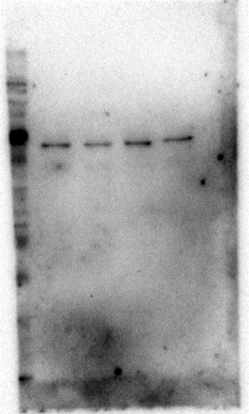

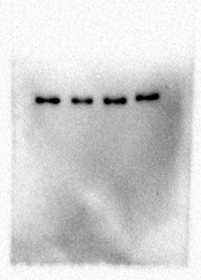
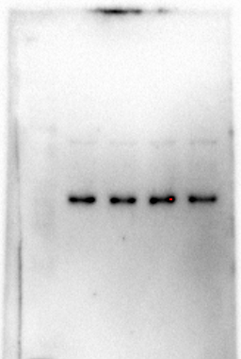
β-actin（groups：Ctrl、H₂O₂、Fer-1、H₂O₂+Fer-1）three times repeat
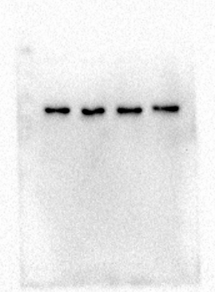

Fig2 F
P62 Parkin
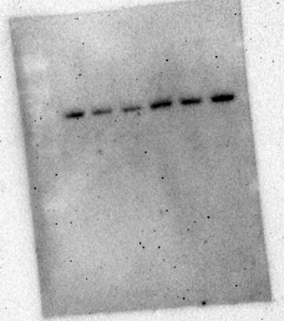
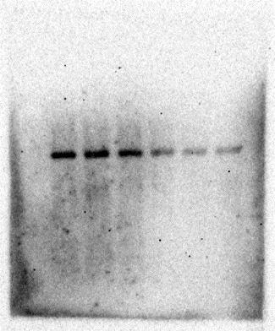

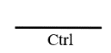
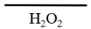

LC3I/II β-actin
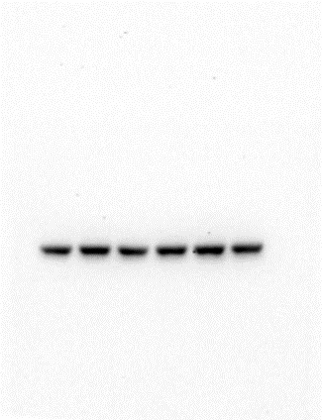
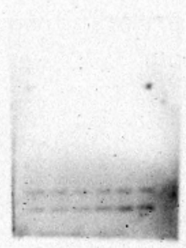

TOMM20
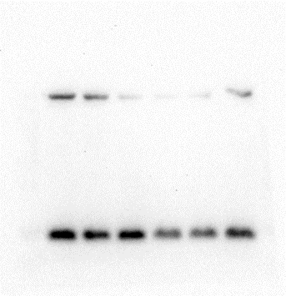

PINK1
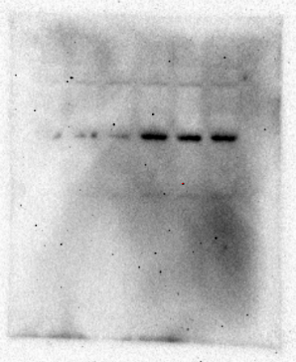

Fig3 I
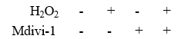
β-actin（groups：Ctrl、H₂O₂、Mdivi-1、H₂O₂+Mdivi-1）three times repeat

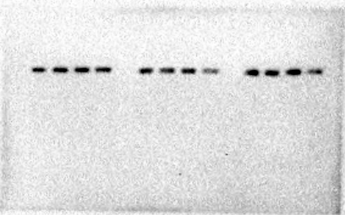

Tnmd（groups：Ctrl、H₂O₂、Mdivi-1、H₂O₂+Mdivi-1）three times repeat
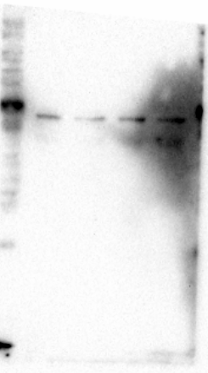
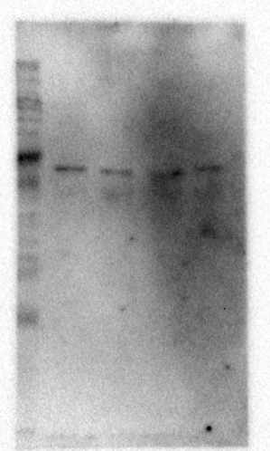
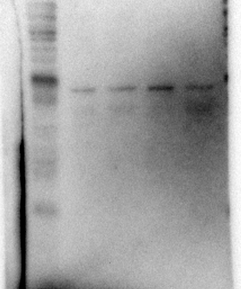
Fig4 A
TBK1 cGAS
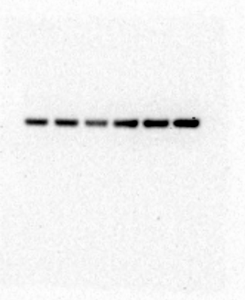
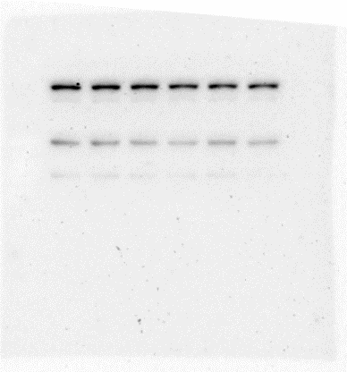

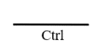
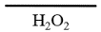

P-TBK1 STING
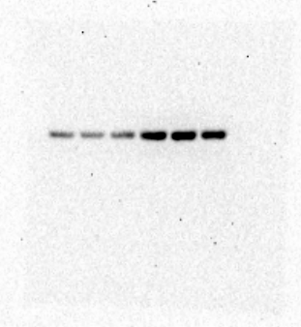
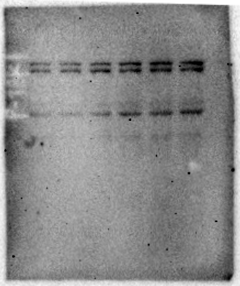

IRF3（Ctrl、Ctrl、Ctrl、H₂O₂、H₂O₂、H₂O₂） β-actin （Ctrl、Ctrl、Ctrl、H₂O₂、H₂O₂、H₂O₂）
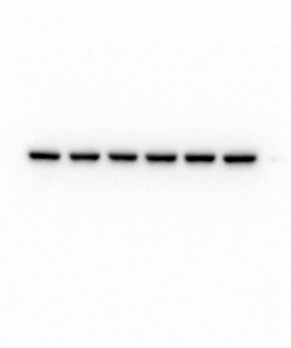
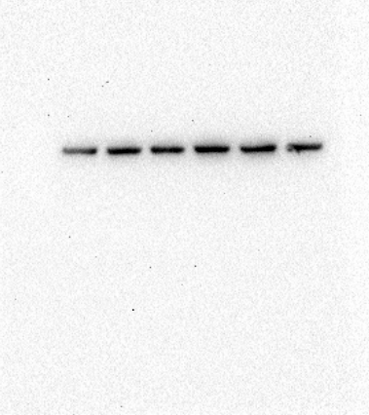

P-IRF3（Ctrl、Ctrl、Ctrl、H₂O₂、H₂O₂、H₂O₂）
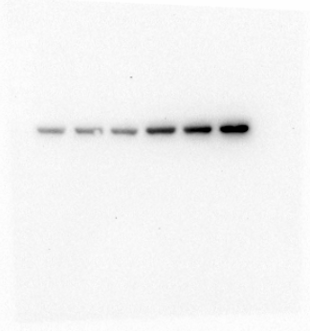
Fig4 F
IL6（Ctrl、Ctrl、Ctrl、H₂O₂、H₂O₂、H₂O₂）
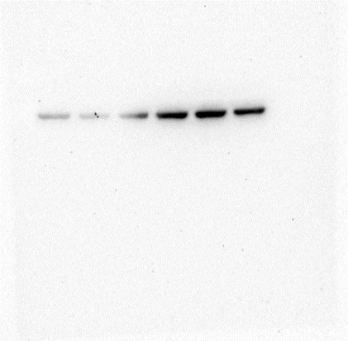

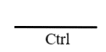

IL-1β（Ctrl、Ctrl、Ctrl、H₂O₂、H₂O₂、H₂O₂）
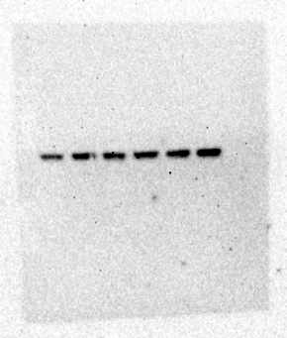

IL8（Ctrl、Ctrl、Ctrl、H₂O₂、H₂O₂、H₂O₂）
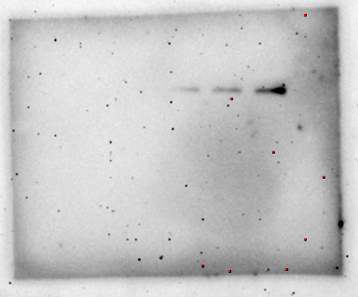

β-actin（Ctrl、Ctrl、Ctrl、H₂O₂、H₂O₂、H₂O₂）
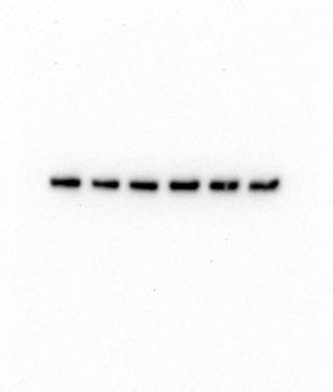

Fig5 A
cGAS（groups：siCtrl、siCtrl+H₂O₂、siCGAS、sicGAS+ H₂O₂ ）three times repeat
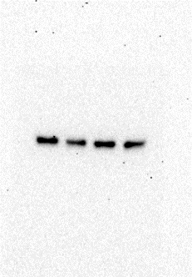
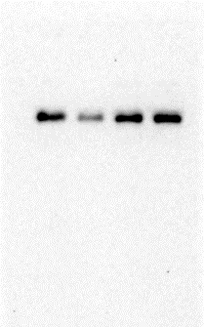
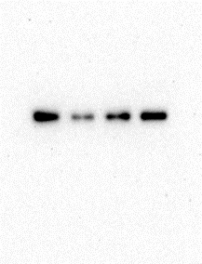

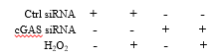
‘

’
β-actin（groups：siCtrl、siCtrl+H₂O₂、siCGAS、sicGAS+ H₂O₂ ）three times repeat
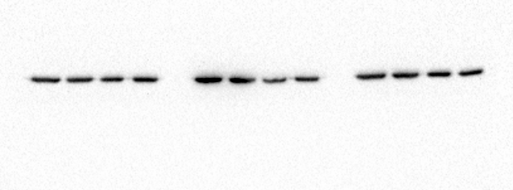

Fig5 D
Parkin（groups：siCtrl、siCtrl+H₂O₂、siCGAS、sicGAS+ H₂O₂ ）three times repeat
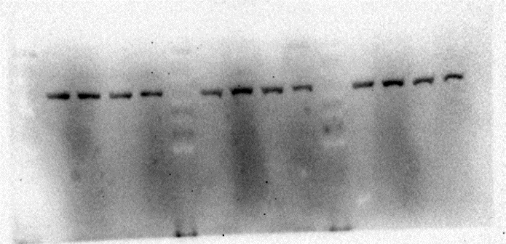

PINK1 （groups：siCtrl、siCtrl+H₂O₂、siCGAS、sicGAS+ H₂O₂ ）three times repeat
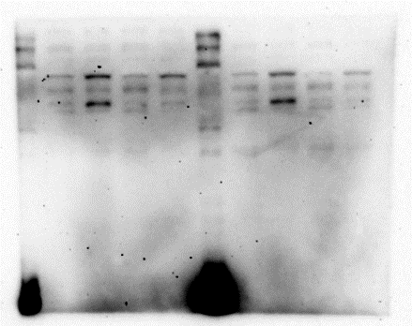
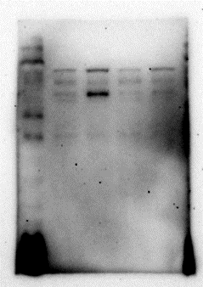

TOMM20（groups：siCtrl、siCtrl+H₂O₂、siCGAS、sicGAS+ H₂O₂ ）three times repeat
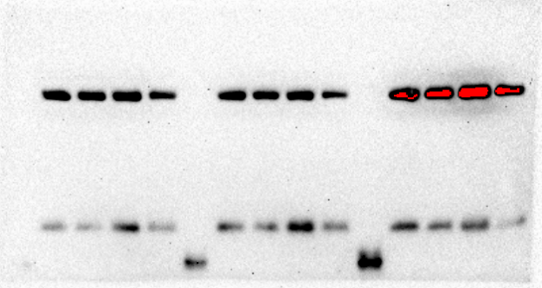

β-actin（groups：siCtrl、siCtrl+H₂O₂、siCGAS、sicGAS+ H₂O₂ ）three times repeat
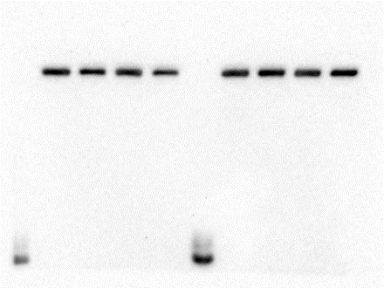
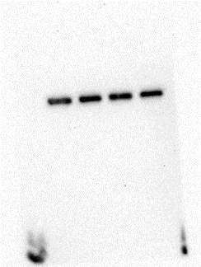

Fig6 I
Tnmd（groups：siCtrl、siCtrl+H₂O₂、siCGAS、sicGAS+ H₂O₂ ）three times repeat
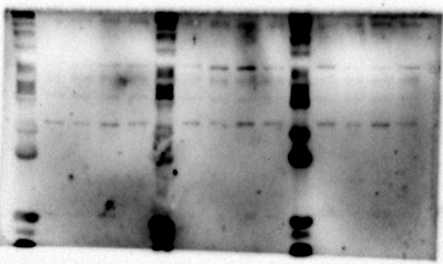

β-actin（groups：siCtrl、siCtrl+H₂O₂、siCGAS、sicGAS+ H₂O₂ ）three times repeat
