Supporting Information

Cartilage–targeting and Autophagy–activating of A Lubricin–inspired Polyzwitterion for Osteoarthritis Therapy

Peng Yu¹, Xu Peng², Hui Sun¹, Qiangwei Xin¹, Han Kang³, Peng Wang¹, Yao Zhao¹, Xinyuan Xu¹, Gungwu Zhou⁴, Jing Xie¹*, Jianshu Li^{1,5,6}*
¹ College of Polymer Science and Engineering, State Key Laboratory of Polymer Materials Engineering, Med–X Center for Materials, Sichuan University, Chengdu 610065, P.R. China
² Experimental and Research Animal Institute, Sichuan University, Chengdu 610065, China
³ Life Science Core Facilities, College of Life Sciences, Sichuan University, Chengdu 610065, P.R. China
⁴ School of Aeronautics and Astronautics, Sichuan University, Chengdu 610065, P.R. China
⁵ State Key Laboratory of Oral Diseases, West China Hospital of Stomatology, Sichuan University, Chengdu 610041, P.R. China
* Co–corresponding authors: Jing Xie (xiej@scu.edu.cn) and Jianshu Li (fredca2005@163.com and jianshu_li@scu.edu.cn)

Content
S1 Experimental section 3
S1.1 Materials 3
S1.2 Molecular docking 4
S1.3 Specific targeting to Col II 5
S1.3.1 Targeting to biomacromolecules of cartilage matrix 5
S1.3.2 Ex vivo targeting to cartilage 5
S 1.4 Tribology test 5
S1.5 Anti–oxidation evaluation of PSP 6
S1.5.1 ROS scavenging 6
S1.5.2 RNS scavenging 7
S1.6 In vitro anti–fouling properties of PSP copolymer modified cartilage slices 8
S1.6.1 Synthesis of BSA–FITC 8
S1.6.2 Preparation of cartilage slices 8
S1.4.3 Anti–fouling determination 9
S1.7 Cell studies 9
S1.7.1 Isolation of chondrocytes/BMSCs 9
S1.7.2 Cytocompatibility 10
S1.7.3 Col II–targeting 11
S1.7.4 Histological staining 11
S1.8 Animal studies 12
S1.8.1 Microcomputed tomography (micro–CT) assessment 12
S1.8.2 Histological and immunohistochemical analysis 12
S1.8.3 Histopathology assessment of OA therapy of PSP 13
S1.9 Statistical analysis 13
S2. Supplementary results and discussion 14
S2.1 Synthesis and characterization of methacrylic acid N–hydroxysuccinimide ester (NHSMA) 14
S2.2 Col II–targeting property of WYRGRL 14
S2.3 Anti–friction properties of PSP as lubricants 14
S2.4 Targeted lubrication properties of PSP on the cartilage surfaces in knee joints 15
S2.5 PSP protects cartilage matrix against degradation enzymes 15
S2.6 Biocompatibility of PSP 15
S2.7 PSP alleviates inflammation response 17
S3. Supplementary Figures 18
S4. Supplementary Tables 44
S5. Reference 49

S1 Experimental section

S1.1 Materials
Col II–target peptide (WYRGRL, purity > 98%) was obtained from Apeptide Co., Ltd (Shanghai, China). GGGGD peptide (purity > 95%) was provided by Shanghai Boti Biological Pharmaceutic Enterprise (Shanghai, China). Sulfobetaine methacrylate (SBMA), N–hydroxysuccinimide (NHS), triethylamine, nitrotetrazolium blue chloride (NBT), phenazine methosulfate (PMS), nicotinamide adenine dinucleotide disodium salt (NADH), 2–phenyl–4,4,5,5–tetramethylimidazoline–3–oxide–1–oxyl (PTIO), 1,1–diphenyl–2–picrylhydrazyl (DPPH) and 2,2'–azinobis (3–ethylbenzothiazoline–6–sulfonic acid ammonium salt) (ABTS) were bought form Aladdin (Shanghai, China). 4–cyano–4–(phenylcarbonothioylthio)pentanoic acid (CPAD), L–ascorbic acid, L–proline, sodium pyruvate and azodiisobutyronitrile (AIBN) were bought from J&K Scientific (Beijing, China). AIBN was further purified through recrystallization before use. Methacryloyl chloride was bought from TCI (Shanghai) Development Co., Ltd. (China). Trifluoroethanol (TFE) was obtained from Macklin (Shanghai, China). Dichloromethane (DCM), ethyl acetate (EA), hydrogen peroxide (H₂O₂) and n–hexane were bought from Xilong Chemical Co., Ltd (Shanghai, China). Bovine serum albumin, collagen type II (Col II), chondroitin sulfate (CS), hyaluronic acid (HA), collagenase II (Colase II), hyaluronidase (HAase) and purified terephthalic acid (PTA) were obtained from Shanghai yuanye Bio–Technology Co., Ltd (China). Fluorescein isothiocyanate (FITC) and fluorescein diacetate (FDA) was provided by Sigma–Aldrich (USA). Fetal bovine serum (FBS) was obtained from Gibico (South Ameica). Penicillin–streptomycin and tyrisin were bought from HyClone (USA). Phosphate buffered saline (PBS) were provided by Gibico (USA). Cell counting kit (CCK–8) was obtained by MCE (USA). Propidium iodide (PI), 4’,6–diamidino–2–phenylindole (DAPI), lipopolysaccharides (LPS) from Escherichia coli, Enhanced BCA Protein Assay Kit, Periodic Acid–Schiff Staining Kit, Alcian Blue Staining Kit, Annexin V–FITC Apoptosis Detection Kit, Hoechst 33342., Hoechst 33358, 2', 7'–dichlorodihydrofluorescein diacetate (DCFH–DA), dihydroethidium (DHE), 3–Amino,4–aminomethyl–2’,7’–difluorescein, diacetate (DAF–FM), Griess reagent, Autophagy Staining Assay Kit with monodansylcadaverine (MDC)/PI (MDC/PI), Total Antioxidant Capacity Assay Kit with FRAP method (T–AOC Assay Kit), and Earle's Balanced Salt Solution (EBSS) were obtained from Beyotime (Shanghai, China). Dexamethasone, fluorescein isothiocyanate (FITC) and transforming growth factor–beta 3 (TGF–β3) were provided by Sigma–Aldrich (USA). TRITC Phalloidin and Hydrogen Peroxide (H₂O₂) Content Assay Kit were provided by Beijing Solarbio Science & Technology Co., Ltd. (Beijing, China). Insulin–transferrin–selenium (ITS) was provided by ScienCell Research Laboratories (USA). Enzyme–linked immunosorbent assay (ELISA) kits of prostaglandin E2 (PGE–2), interleukin–6 (IL–6), tumor necrosis factor–alpha (TNF–α), collagen type II (Col II), and aggrecan (ACAN) were bought from Jiangsu Meimian Industrial Co., Ltd (Jiangsu, China). RAW 264.7 cell line and synovial mesenchymal stem cells (SMSCs) were obtained from Procell Life Science&Technology Co.,Ltd (Wuhan, China). Ultrapure water fabricated from the Milly–Q (Elix™ Essential 5, Merck Millipore, France) was used in all experiments. The chemical agents were used directly otherwise special statement.

S1.2 Molecular docking
The ColBP, PSB and PSP were subjected to molecular docking analysis. The protein structure of collagen type II (Col II) was obtained from PDB (https://www. Rcsb.org/). The molecular structures of ColBP, PSB, PSP, chondroitin sulfate (CS) and hyaluronic acid (HA) were drawn using ChemBio3D. AutoDockTools was adopted for docking analysis to calculate affinity energy. The UCSF PyMol software was applied to create the 3D images.

S1.3 Specific targeting to Col II

S1.3.1 Targeting to biomacromolecules of cartilage matrix
The WYRGRL hexapeptide were labelled by FITC at first. In brief, hexapeptide (10 mg) was dissolved in PBS (pH = 7.2~7.4, 5 mL), then FITC solution (200 μL) was added. The reaction was kept in ice bath with mild stirring for 24 h. Finally, dialysis (MWCO 1,000 Da, 3 d) and lyophilization were performed to obtain the product, which was kept at –20 °C until use.
The Col II, CS and HA solutions were prepared at the concentration of 1 mg/mL. Next, they were incubated with FITC–labelled hexapeptide solution (1 mg/mL) at 37 °C in the dark for 24 h. The mixtures were dialyzed against water (MWCO 2,000 Da) for 3 d. Finally, the fluorescence intensity as scanned using a fluorescence spectrophotometry (RF–6000, SHIMADZU, Japan). The excitation wavelength was 488 nm, the emission wavelength was within the range of 500~600 nm. Meanwhile, the fluorescent images of three solutions under the irradiation of ultraviolet light at 365 nm were recorded using a camera.

S1.3.2 Ex vivo targeting to cartilage
The femurs were collected from SD rats and then incubated with FITC–labelled PSBG and PSP solutions for 24 h. The targeting efficiency were calculated according to formula (1).
$TE \left(\%\right)=\frac{({FL}_{original}-{FL}_{post-incubation})}{{FL}_{original}}×100$ (1)
where the FL_{original} and FL_{post–incubation} were the fluorescence intensity of the original polymer solution and post–incubated solutions with cartilage, respectively.

S 1.4 Tribology test
The lubrication behavior of PSB and PSP (1 mg/mL) were analyzed using a universal materials tester (UMTtribolab, Bruker, Germany) with reciprocating sliding through ball–to–plate models. All the test were conducted with a Al₂O₃ sphere (d = 8 mm) as the ball and (PTFE) as the plate. The oscillation amplitude was 5 mm. The frequency was 0.5, 1 and 1.5 Hz, respectively. The loading force was 1, 2, and 3 N respectively. The measurement time was 300 s. The polymer–free solution was also tested as a control.

S1.5 Anti–oxidation evaluation of PSP

S1.5.1 ROS scavenging
Hydrogen peroxide (H₂O₂), ·OH, superoxide anion radicals (O·– 2) and PTIO were selected as three indicators to evaluate the ROS scavenging ability of PSB and PSP.
As for H₂O₂ scavenging, H₂O₂ solution (1 mM) were incubated with polymers (PSB and PSP, 1 mg/mL) for 6 h at 37 ºC, then the remaining H₂O₂ concentration was determined using Hydrogen Peroxide Assay Kit with the guideline of manufactures’ instructions. The absorbance around 415 nm was recorded using UV–vis spectrophotometer. The scavenging ratio was calculated through formula (2):
$H_{2}O_{2} scavenging ratio \left(\%\right)=\frac{A_{0}-A_{t}}{A_{0}}×100$ (2)
where A₀ and A_{t} refer to the absorbance of the original H₂O₂ solution and the remaining H₂O₂ concentration after incubating with PSP (or PSP) for predetermined time (6 h). respectively.
In terms of ·OH scavenging, the polymers (1 mg/mL) were mixed with H₂O₂ solution (1 mM) with supplementary of PTA (0.5 wt%). After incubation at 37 ºC in the dark for 12 h, fluorescent intensity (400–600 nm) of the mixed solution was recording using a fluorescence spectrophotometry (RF–6000, SHIMADZU, Japan) with extraction wavelength at 315 nm.
The scavenging ratio of superoxide anion radicals (O·– 2) was explored as follows: a mixed solution consisting of nicotinamide adenine dinucleotide disodium salt (NADH, 78 μM), phenazine methosulfate (PMS, 10 μM) and nitrotetrazolium blue chloride (NBT, 50 μM) was prepared as the working solution, then PSP (or PSB) was dissolved in the working solution at a concentration of 1 mg/mL for 0.5 h of incubation at 37 ºC. The absorbance at 560 nm was scanned using UV–vis spectrophotometer. The scavenging ratio was calculated through formula (3):
$O_{2}^{·-} scavenging ratio \left(\%\right)=\frac{A_{0}-A_{t}}{A_{0}}×100$ (3)
where A₀ and A_{t} refer to the absorbance of the working solution without or with polymer incubation, respectively.
Regarding PTIO test, the polymers were dissolved in PTIO solution (0.015 wt%) at the concentration of 1 mg/mL and incubated at 37 ºC for 2 h. The absorbance at 557 nm was recorded using UV–vis spectrophotometer to assess the ROS scavenging ability. The PTIO scavenging ratio was calculated through formula (4):
$PTIO scavenging ratio \left(\%\right)=\frac{A_{0}-A_{t}}{A_{0}}×100$ (4)
where A₀ and A_{t} refer to the absorbance of the original and residual PTIO solution after incubating with PSP (or PSP), respectively.
The total superoxide dismutase (SOD)–like anti–oxidation activity was investigated using Total Antioxidant Capacity Assay Kit with FRAP method (T–AOC Assay Kit). In brief, PSP (or PSB, 5 μL) solution was added to FRAP working solution (180 μL) with a final polymer concentration of 1 mg/mL. After incubating at 37 ºC for 5 min, the optical density (OD) at 593 nm value was recorded using a micro–plate reader (SpectraMax® ABS Plus). The total anti–oxidation activity was calculated through formula (5):
$Total anti-oxidation acticity=\frac{{OD}_{c}-{OD}_{t}}{{OD}_{c}}$ (5)
where OC_{c} and OD_{t} refer to the absorbance of the FeSO₄ solution (1 mM) and polymer solution, respectively.

S1.5.2 RNS scavenging
DPPH and ABTS assays were carried out to evaluate the RNS scavenging ability of PSB and PSP.
For DPPH assay, 3 mg of PSB or PSP were dissolved in DPPH solution (3 mL) and incubated in the dark at room temperature for 0.5 h, then the absorbance at 517 nm were recorded using a UV–vis spectrophotometer. The DPPH scavenging ratio was calculated according to formula (6):
$DPPH scavenging ratio \left(\%\right)=\frac{A_{0}-A_{t}}{A_{0}}×100$ (6)
where A₀ and A_{t} refer to the absorbance of the DPPH solution without or with polymer incubation, respectively.
In regard to ABTS assays, a mixture containing ABTS (7.5 mM) and (NH₄)₂S₂O₈ (2.5 mM) was incubated in the dark at room temperature to prepare the ABTS cation radicals (ABTS⁺). Then the ABTS⁺ was diluted to an absorbance (734 nm) of around 0.7. The polymers were dissolved in ABTS⁺ solution (with a final concentration of 1 mg/mL) for 0.5 h of incubation in the dark. Finally, the absorbance (550–800 nm) was recorded using a UV–vis spectrophotometer. The scavenging ratio of ABTS⁺ was calculated through formula (7)
${ABTS}^{+} scavenging ratio \left(\%\right)=\frac{A_{0}-A_{t}}{A_{0}}×100$ (7)
where A₀ and A_{t} refer to the absorbance of the ABTS⁺ solution without or with polymer incubation, respectively.

S1.6 In vitro anti–fouling properties of PSP copolymer modified cartilage slices

S1.6.1 Synthesis of BSA–FITC
The FITC labeled BSA were synthesized according to a literature study. Briefly, the FITC solution in DMSO (1 mg/mL) was added into BSA aqueous solution (10 mg/mL). The reaction was kept at 0 ºC for 12 h in the dark. Then then solution was under dialysis for 3 days, followed by dry–freezing. The BSA–FITC product were kept at –20 ºC until use.

S1.6.2 Preparation of cartilage slices
Femur was bought from the supermarket nearby. After separation of bone and other connected tissues such as ligaments and muscles, the cartilage was cut into cylindric slices (3 mm in diameters and 1 mm in height).

S1.4.3 Anti–fouling determination
The cartilage slices were immersed into polymer solution (PSB–macroCAT and PSB–b–PCOLBP, 1 mg/mL) at 37 ºC for 12 h. Then the modified slices were incubated in BSA–FITC aqueous solution (100 μg/mL) at 37 ºC for 12 h in the dark. Then the slices were removed and the fluorescence intensity of residual solution were detected using a fluorescence spectrophotometer. The anti–fouling ability of zwitterionic were calculated according to formula (1):

S1.7 Cell studies
The culture medium for chondrocytes was DMEM/F12 medium supplemented by 10% of FBS and 1% of penicillin–streptomycin (P/S) solution, while the DMEM medium containing 10% of FBS and 1% of P/S were utilized for the cell culture of BMSCs, SMSCs and RAW264.7 cells. The chondrogenic induction medium was complement of dexamethasone (0.1 μM), l–ascorbic acid (50 μg/mL), l–proline (40 μg/mL), sodium pyruvate (100 μg/mL), TGF–β3 (10 ng/mL) and insulin–transferrin–selenic acid (IFS, 1%).

S1.7.1 Isolation of chondrocytes/BMSCs
Chondrocytes were isolated from male SD rats (one week old). In brief, the rats were euthanized by intraperitoneal injection of over–dose chloral hydrate (10%). Then they were sterilized with povidone iodine for 5 min. After exposing the knee joints, the hyaline cartilage was harvested and cut into piece (almost 1 mm³). The fragments were incubated into collagenase II (Colase II) solution (0.2%, 0.5 h), trypsin solution (0.25%, 0.5 h) and Colase solution (0.2%, 2 h) at 37 ºC, respectively. The last supernatant was centrifuged at 3000 r/min for 5 min and the obtained chondrocytes were suspended in complete DMEM/F12 medium. Cell passage was carried out when the culture dish was covered by chondrocytes. In terms of isolation of BMSCs, the collection of femurs was similar to the measurements in isolation of chondrocytes. Next, the bone marrow aspirate from femur was extracted and incubated in a culture dish (d=10 cm) containing complete DMEM medium after filtration through Corning 70 Micrometer Cell Strainer. After culture for 3 d, the nonadherent cells (main blood red cells) in the culture medium were removed directly. Then the culture medium was refreshed every 2 days until almost 80% of confluent.

S1.7.2 Cytocompatibility
CCK–8 assay: Chondrocytes, BMSCs and SMSCs were seeded in 96–well plate at the density of 5,000 cells/well, 3,000 cells/well and 5,000 cells/well, respectively. After 24 h for cell attachment, the zwitterionic polymers (PSB or PSP) were added in the culture medium. At 24 and 72 h, the culture medium was freshened by CCK–8–supplemented medium (10 vol%) for 3 h of incubation. The optical density (OD) of each well were recorded using a microplate reader (KH 360, China). The cell viability of chondrocytes, BMSCs and SMSCs was calculated by the following formula (8):
$Cell viability \left(\%\right)=\frac{{OD}_{e}-{OD}_{eb}}{{OD}_{c}-{OD}_{cb}}×100$ (8)
where OD_{e} is the OD value of cells incubated with PSB or PSP (experiment group), ODc is the OD value of the free cells (control group), OD_{eb} and OD_{cb} are the OD values of experiment group and control groups, respectively.
Live/dead staining: The procedure of culture was similar to that of CCK–8 assay. At 24 and 72 h, the cells were stained by a mixture solution of FDA (50 μg/mL) and PI (10 μg/mL) for 15 min. Then live/dead cells were observed using a fluorescence microscope (Olympus X17, Japan).
Cell morphology staining: At the predetermined time (24 and 72 h), the cells were fixed by 4% paraformaldehyde for 15 min and then treated by Triton X–100 (0.5 vol%) for 5 min to increase the permeability of cell membrane. After washing with PBS for three times, the cells were stained by FITC–labelled phalloidin for 30 min and DAPI solution for 10 min, respectively. The F–actin and nuclei were observed using a fluorescence microscope.
Flow cytometry: When chondrocytes were incubated with PSB or PSP for 24 h, the cells were digested and collected through centrifugation (2,000 r/min, 4 min). The cells were suspended in binding buffer and labelled by Annexin V–FITC/PI with the guideline of Annexin V–FITC Apoptosis Detection Kit (Beyotime, China). The live, apoptotic and dead cells were quantitatively analyzed using a flow cytometer (Millipore Guava EasyCyte 5, France).
Apoptotic staining: The apoptotic chondrocytes were characterized by Hoechst 33358 staining. In brief, chondrocytes post coculture with polymer–containing medium were fixed. Then the cells were stained by Hoechst 33358 (Beyotime, China) for 20 min and observed using a fluorescence microscope.

S1.7.3 Col II–targeting
Apart from chondrocytes and SMSCs that were noted for secreting Col II and Col I, respectively, BMSCs were cultured by chondro–inducive medium for two weeks. Then 0.5 mL of cell suspension (100 million cells) were mixture with 0.5 mL of FITC–PSP solution (2 mg/mL) for 30 min, the cells and the targeted FITC–PSP were removed by centrifugation (3,000 r/min, 10 min). The supernatant was diluted with PBS and detected using a fluorescence spectrophotometer with the extraction/emission wavelength at 490/520 nm, respectively. The same procedures with FITC–PSD were carried out as a comparison. The targeting efficiency (TE) was calculated through the following formula:

S1.7.4 Histological staining
After LPS induction and incubation with polymers (PSB and PSP), the chondrocytes were fixed by paraformaldehyde (4 %) and then stained by periodic acid–schiff (PAS) staining solution according to the guideline of specification. The images were recorded using an optical microscope.
Similarly, Alcian blue staining was also carried to characterization of the biosynthesis of HA.

S1.8 Animal studies

S1.8.1 Microcomputed tomography (micro–CT) assessment
Micro CT was applied to evaluate the repaired femurs. The femur specimens were scanned using micro–CT (VGS tudio Max software) with a scanning current of 130 μA and a voltage of 70 kV. The details for femur were analyzed by reconstructing three–dimensional (3D) structures and calculating the osteophyte volumes.

S1.8.2 Histological and immunohistochemical analysis
The femurs and major organs (heart, liver, spleen, lung and kidney) of rats were harvested to evaluate the therapeutic effect on OA and systematic biosafety. All the samples were fixed in 10% formalin solution. All femurs specimen, decalcification was carried out for following measurements. Then samples were embedded in paraffin and cut into slices.
H&E staining: The sections (femurs and major organs) were stained by hematoxylin and washed by H₂O and EtOH (95%), respectively. Then they were stained by erosin Y solution (1%, 3 min).
Masson staining: The sections were stained using the Masson’s Trichrome Stain Kit according to the manufactures’ instructions.
Safranin–O/fast green staining: The sections of femurs were stained with Weigert’s hematoxylin solution (10 min), and then stained with fast green solution (5 min). After being rinsed by acetic acid (1%), the sections were further stained with Safranin–O solution (0.1%, 5 min).
IHC staining: The IHC staining of Col II were performed with similar measurements to that in cell study described above.

S1.8.3 Histopathology assessment of OA therapy of PSP
The histologic grading of Osteoarthritis Research Society International (OARSI) and Mankin’s method (including structures, cells, matrix and total evaluation) were scored to evaluate the cartilage destruction. The macroscopic appearance from International Cartilage Repair Society (ICRS) scoring systems was utilized to assess the integrity of repaired cartilage.

S1.9 Statistical analysis
All data were shown as mean ± standard deviation (SD) and all experiments were repeated at least 3 times. An unpaired two–tailed t–test was performed to analyze the significance of difference between two groups, and one–way analysis of variance (ANOVA) was utilized to calculate significant difference among multiple comparisons (>2). A p<0.05 was considered different statistically. The Statistical analysis was performed using Graphpad Prism 8.02.

S2. Supplementary results and discussion

S2.1 Synthesis and characterization of methacrylic acid N–hydroxysuccinimide ester (NHSMA)
The chemical shift at 2.85 ppm corresponds to the methene of NHS ester, while peaks at 6.39 nm and 5.86 nm indicate the presence of double bonds, with the peak at 2.04 ppm indicating a methyl group (Fig. S1b). In the ¹³C NMR spectra, the appearance of chemical shifts at 19, 131, 132 and 170 ppm further confirm the successful synthesis of NHSMA (Fig. S1c). FT–IR spectra (Fig. S1d–e) reveals bands at 944 cm^{–1} and 981 cm^{–1}, referring to C–H (in R–CH=CH(CH₃)) out–of–plane deformation vibration, 1632 cm^{–1} indicative of C=C stretching vibration, and 3003 cm^{–1} signifying C–H stretching vibration of vinyl ester. These spectral features collectively affirm the successful chemical modification of NHS with methacrylic acid ester.

S2.2 Col II–targeting property of WYRGRL
The FITC–labelled ColBP exhibits a stronger bond with Col II compared to HA and CS, as evidenced by of higher fluorescence intensity (Fig. S7). Molecular docking studies further support this observation, revealing binding affinities of –6.11 kcal/mol, –3.79 kcal/mol and –3.97 kcal/mol for WYRGRL to Col II, CS and HA, respectively (Fig. S8). These findings underscore the special targeting property of WYRGRL toward Col II within the cartilage matrix.¹

S2.3 Anti–friction properties of PSP as lubricants
Under low loading force (1 N) and a sliding frequency of 0.5 Hz, the COF is observed to be the lowest, approximately at ~0.034. In the case of PSB, the polymer chains exhibit a tendency to tangle together, promoting the formation of intramolecular and intermolecular ionic bonds and hydrogen bonds. However, there are no additional interactions to enhance the interface binding to the PTFE plate and Al₃O₂ ball. Therefore, the hydration ability of the polymers is reduced, leading to an increased COF with an increment in sliding frequency. Notably, the introduction of ColBP in PSP results in hydrophobic interactions and metal–phenol interaction, contributing to the formation of a stable hydration layer. This leads to minimal fluctuations in COF with changes in sliding frequency in the PSP group, suggesting that PSP exhibits characteristics consistent with boundary lubrication. These data affirm that PSP represents a promising candidate for restoring the lubrication capacity of damaged cartilage induced by OA.

S2.4 Targeted lubrication properties of PSP on the cartilage surfaces in knee joints
In knee joint cartilages, the COF is observed to be the highest across all sliding frequencies (Figure S11). Following pre–incubated with PSBG, which adheres to the surface through multiple weak interactions, there is a slight decrease in the COF of the modified cartilages. Notably, cartilages targeted with PSP show the lowest COF ranging from 0.016 to 0.021.

S2.5 PSP protects cartilage matrix against degradation enzymes
Benefiting from the chondroprotection conferred by targeted PSP, both HAase and Colase II prove ineffective in degrading the matrix. Consequently, the cartilage is shielded from abnormal friction forces, ensuring the preservation of its smooth surface through effective degradation resistance. Immunohistochemical staining of Col II (Fig. S24) and histological staining of HA (Fig. S25) visually confirm matrix loss in cartilages treated with catabolic enzymes or pretreated with PSB, whereas cartilage pretreated with PSP exhibit a normal matrix composition.

S2.6 Biocompatibility of PSP
Cell studies has been performed to evaluate the biocompatibility of lubricin–inspired PSP using chondrocytes, BMSCs and SMSCs. The CCK–8 assays reveal the good cell viability (>83.60%) and normal proliferation of chondrocytes/BMSCs/SMSCs when co–cultured with PSB and PSP (Fig. S26a, S27a and S28a). Live/dead staining images (Fig. S26b, S27b and S28b) reveal numerous green cells with almost negligible red cells, suggesting that incubation with PSB and PSP does not induce cell death. Moreover, the spread morphology of cells (Fig. S26c, S27c and S28c) indicates the normal expression of F–actin, essential for biological activities and cell movements. The assessment of lactic dehydrogenase (LDH) release, an indicator for biocompatibility,² exhibit no difference, indicating intact cell membrane for both PSB and PSP (Fig. S29). Flow cytometry analysis further details the state of cell growth, revealing that while there are apoptotic and dead cells in PSB and PSP groups, the majority remains in the early apoptosis state, with the apoptotic/dead cell ratio significantly smaller than that of live cells (Fig. S30). Collectively, these findings confirm the desirable biocompatibility of PSB and PSP.
As shown in Fig. S31a, chondrocytes in the OA joint are commonly influenced by inflammatory cells. Therefore, a co–culture system based on a transwell setup has been developed to evaluate the biocompatibility of PSP in simulative OA microenvironments. In the presence of RAW264.7 cells, which exert adverse effects, the cell viability of chondrocytes and SMSCs reduces to 72% and 52%, respectively (Fig. S31b–c). While PSB exhibits good biocompatibility, it fails to alleviate the inflammation invasion of RAW 264.6 cells due to its ineffective anti–oxidation/degradation–resistance properties, resulting in fairly low cell viability (73% and 69% for chondrocytes and SMSCs, respectively). Based on these findings, PSP is anticipated to not only repel inflammatory cytokines secreted by RAW 264.7 cells but also scavenge overproduced ROS/RNS, leading to a tight influence on chondrocytes and SMSCs in the co–culture system, with significantly higher cell viability (>84%) compared to PSB group, as well as a greater number of live cells (Fig. S31d). In short, the synergistical effect of ColBP and sulfobetaine polymers has enhanced the biocompatibility of PSP in the inflammatory microenvironment.

S2.7 PSP alleviates inflammation response
Interleukin–6 (IL–6) is acknowledged as a proinflammatory cytokine implicated in the degradation of cartilage matrix, thereby compromising the structural integrity of cartilage through the up–regulating the expression of MMPs.³ Accordingly, various inflammatory factors such as prostaglandin–2 (PGE–2) and tumor necrosis factor–alpha (TNF–α) are significantly upregulated. PEG–2 induces intercellular cAMP accumulation, leading to increased osteoclast generation and accelerated chondrocytes apoptosis, ultimately contributing to joint pain.⁴ TNF–α triggers a cascade amplification reaction, promoting cartilage degradation, disrupting joint homeostasis and exacerbating OA.⁵ As shown in Fig. S35, LPS has heightened the expression of IL–6, PGE–2 and TNF–α in chondrocytes, while incubation with PSP relieves inflammation response slightly. The addition of PSP, with its capacity to scavenge ROS/RNS and repel catabolic enzymes, effectively inhibits the inflammation response, as evidenced by the expression of inflammation cytokines comparable to the control group. Consequently, PSP works as a protective shield to alleviate the catabolic pathological process associated with inflammation response.

S3. Supplementary Figures
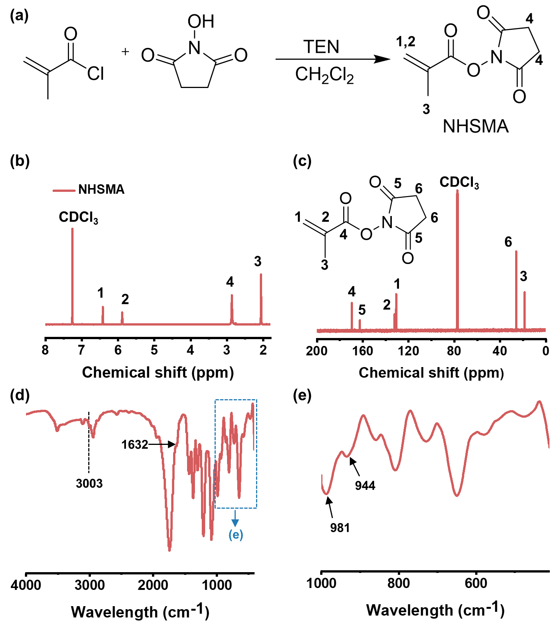
Fig. S1 Synthesis of NHSMA. (a) Scheme of chemical reaction, (b) ¹H and (c) ¹³C NMR spectra, and (d) FT–IR spectra.
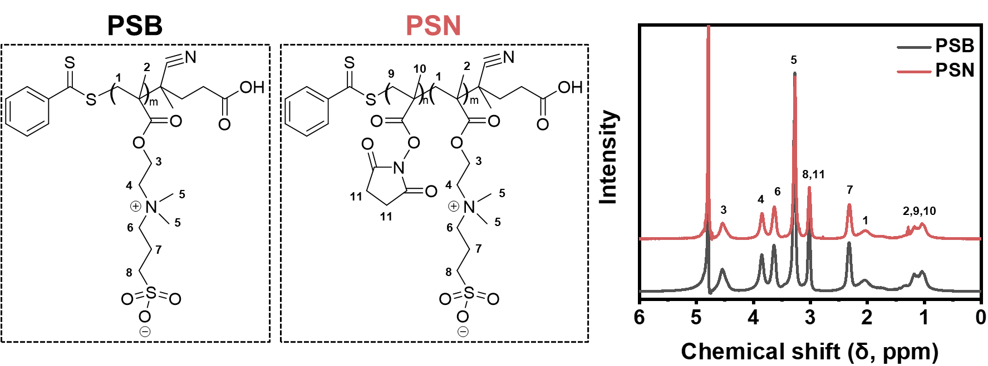
Fig. S2 ¹H NMR spectra of PSB and PSN.
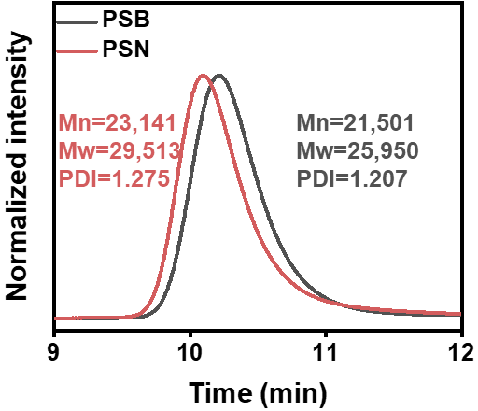
Fig. S3 GPC curves of PSB–macroCTA (PSB) and PSB–b–PNHS (PSN).

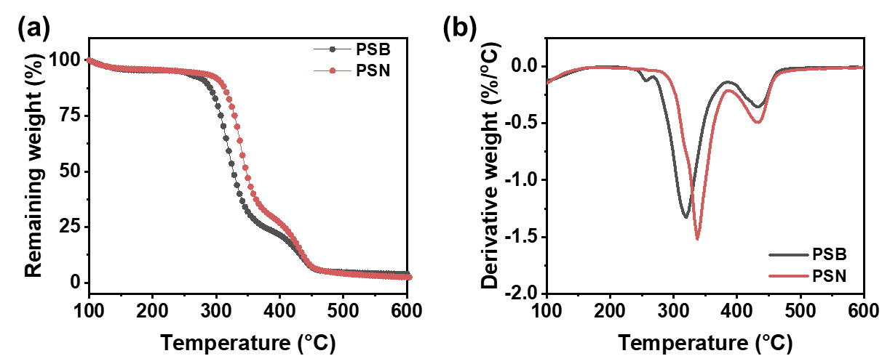
Fig. S4 (a) The thermogravimetry analysis (TGA) curves, and (b) derivative thermogravimetry (DTG) curves of PSB and PSN.

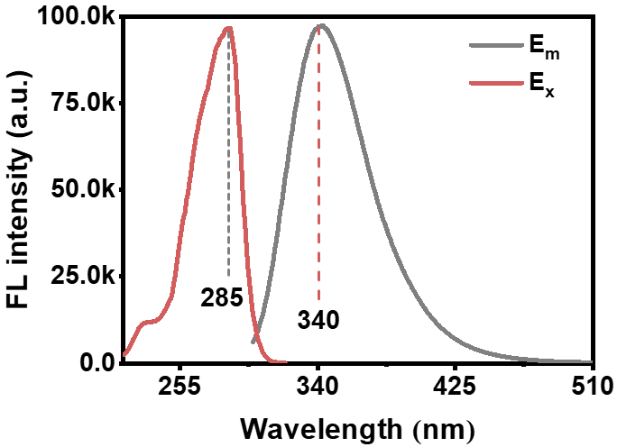
Fig. S5 The fluorescence intensity of WYRGRL hexapeptide: excitation wavelength at 285 nm and emission wavelength at 340 nm.

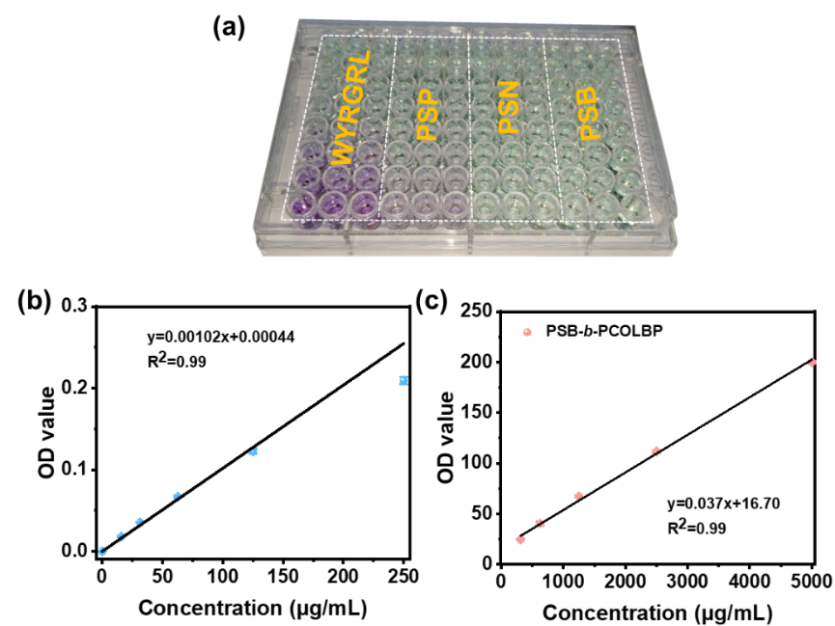
Fig. S6 (a) The chromogenic reaction of WYRGRL hexapeptide through BCA Assay Kit. (b) The standard curve of WYRGRL and (c) the quantitative analysis of ColBP content in PSP.

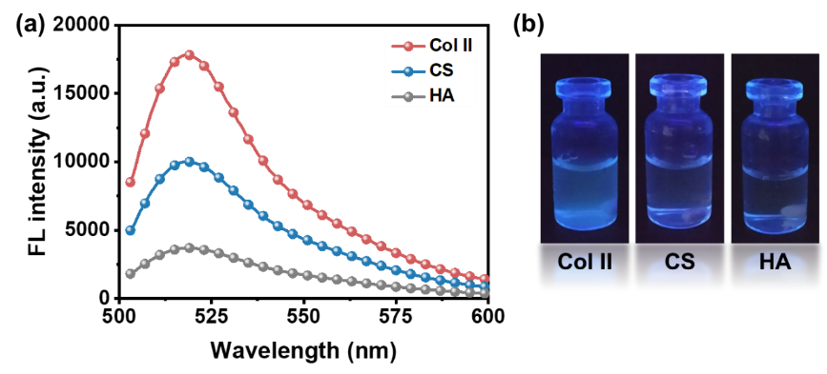
Fig. S7 The selective binding of FITC–labelled ColBP to Col II. (a) Fluorescence intensity of Col II, CS and HA solution which were pre–interacted with FITC–labelled ColBP. (b) The corresponding photographs.

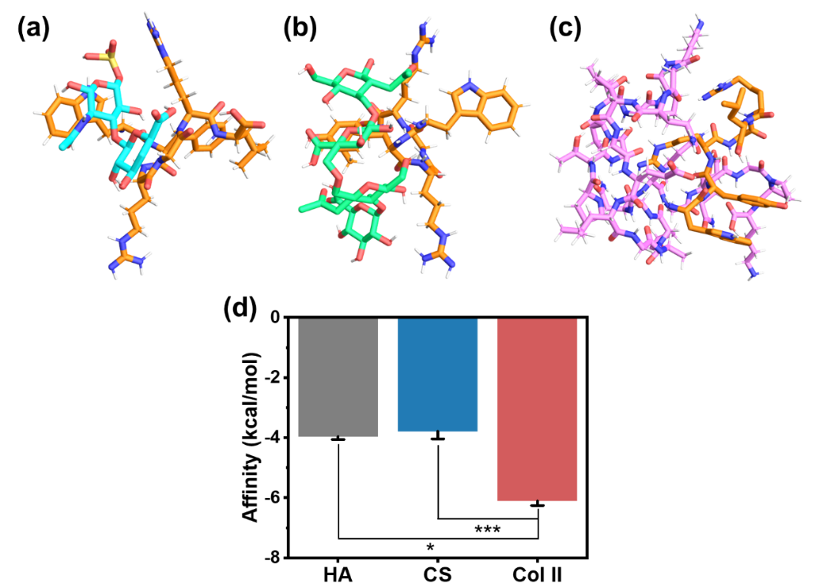
Fig. S8 Molecular docking between WYRGRL peptide and biomacromolecules in cartilage matrix: (a) WYRGRL and hyaluronic acid (HA), (b) WYRGRL and chondroitin sulfate (CS), (c) WYRGRL and Col II, and (d) quantitative affinity. * (p<0.05) and *** (p<0.001) suggest significant difference.

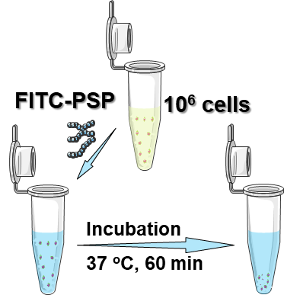
Scheme S1 The illustration of procedures for determining the targeting efficiency to two copolymers (PSBG and PSP).

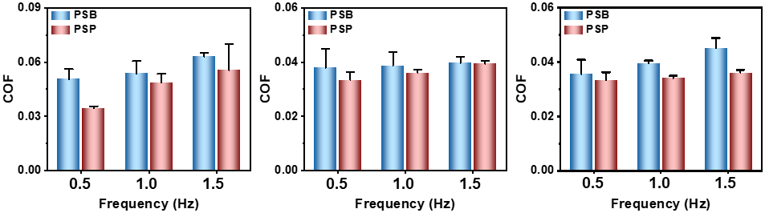
Fig. S9 The coefficient of friction (COF) of PSB and PSP as biolubricants with the load forces at 1 N, 2 N and 3 N.

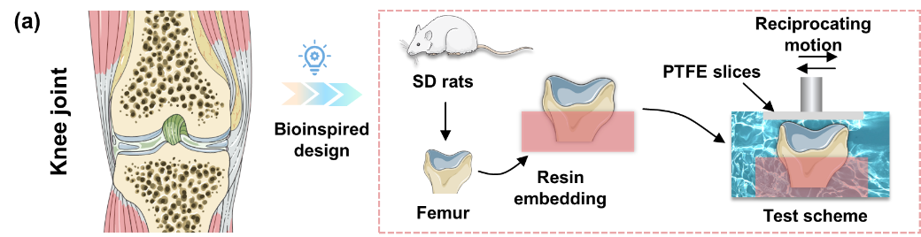
Scheme S2 The ex vivo COF tests using femurs.
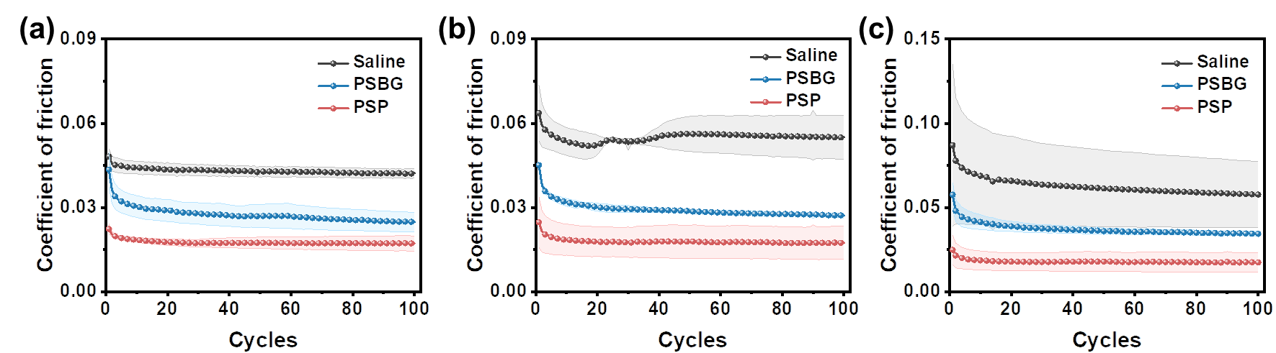
Fig. S10 The changes of coefficient of friction of femur pretreated with saline, PSBG and PSP. The sliding frequensy is (a) 0.5 Hz, (b) 1.0 Hz and (c) 1.5 Hz.

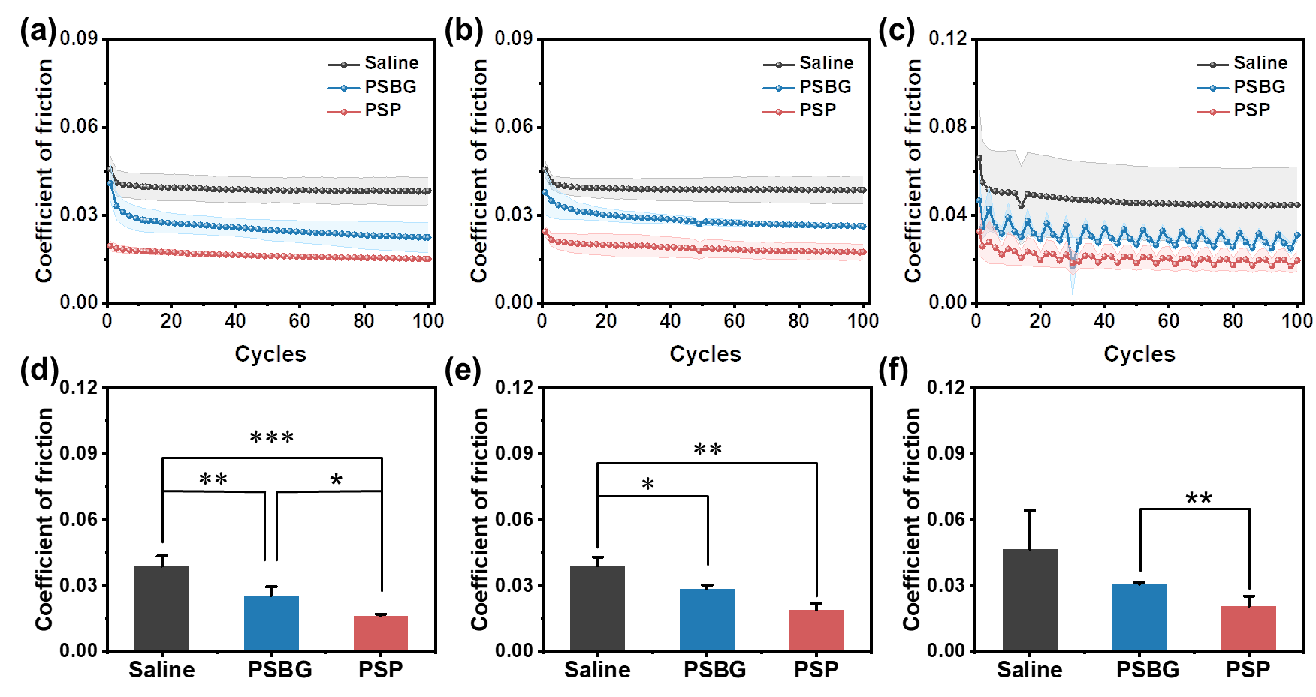
Fig. S11 The changes of COF and the average COF of PSP–targeted femur with the sliding frequency as (a, d) 0.5 Hz, (b, e) 1.0 Hz and (c, f)1.5 Hz. * (p < 0.05), ** (p < 0.01) and *** (p < 0.001) indicate the significant difference in comparison to the saline groups. * (p < 0.05) and ** (p < 0.01) imply statistical difference between PSBG and PSP.
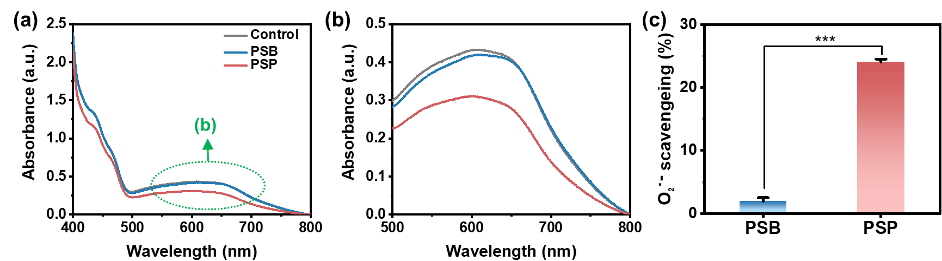
Fig. S12 O·– 2 scavenging ability of PSB and PSB. The UV–vis spectra within the range of (a) 400–800 nm and (b) 500–800 nm. (c) The O·– 2 scavenging ratio of PSB and PSP. *** p < 0.001 refers to the significant difference.
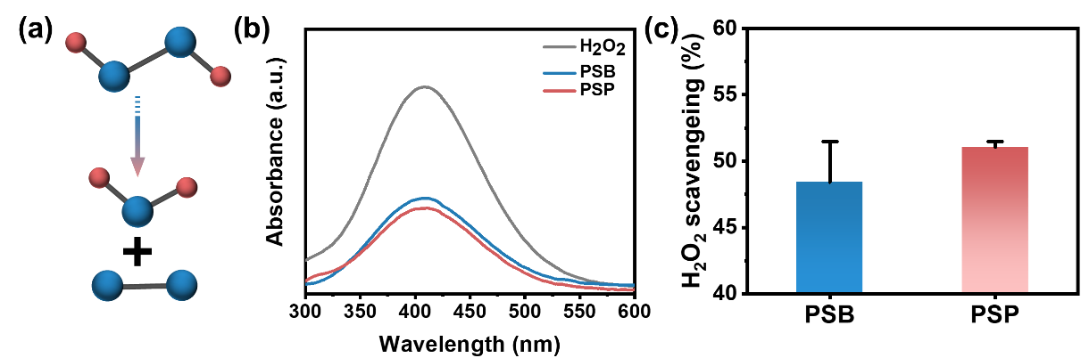
Fig. S13 The CAT–like activity of PSB and PSP to scavenge H₂O₂. (a) Scavenging mechanism and (b) UV–vis spectra between 300 to 600 nm. (c) The H₂O₂ scavenging ratio of PSB and PSP.

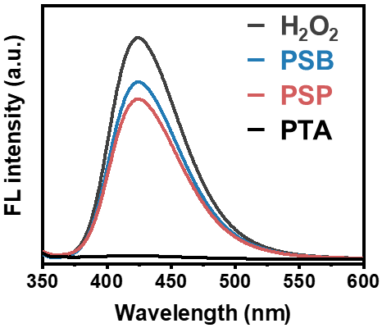
Fig. S14 The ·OH scavenging capacity of PSB and PSP.
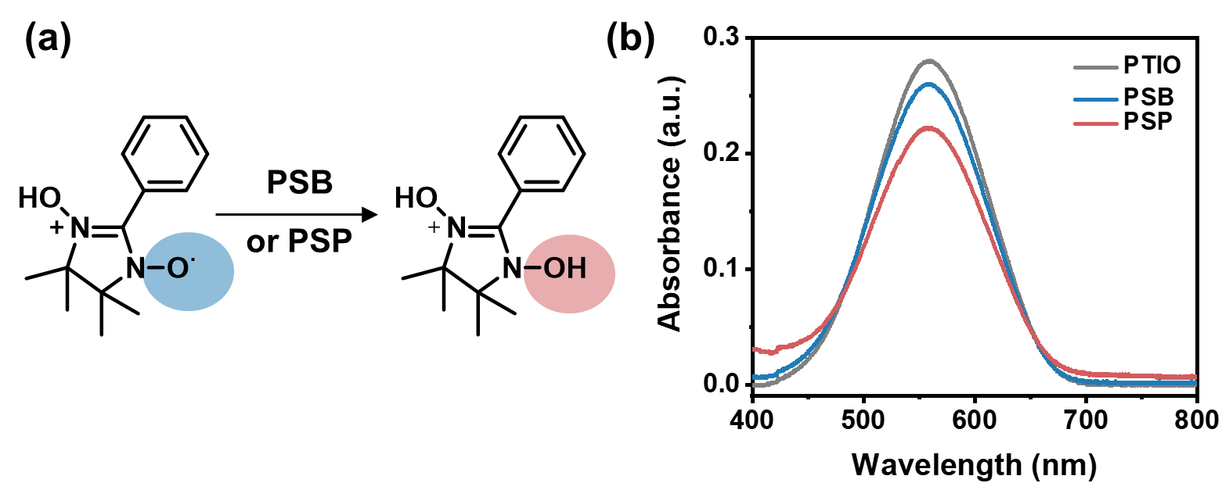
Fig. S15 The PTIO scavenging ability of PSB and PSP. (a) The chemical mechanism of scavenging radical and (b) UV–vis spectra between 400 to 800 nm.

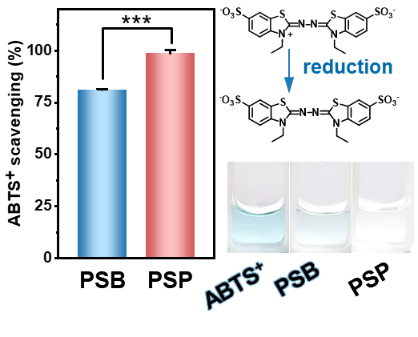
Fig. S16 The ABTS⁺ scavenging property of PSB and PSP.

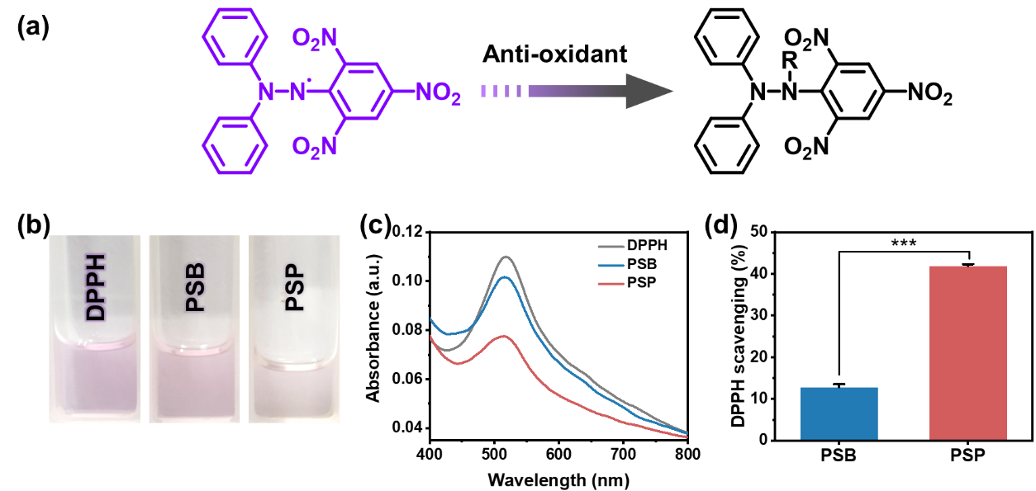
Fig. S17 The DPPH scavenging ability of PSB and PSP. (a) Scavenging mechanism, (b) visual photographs, (c) UV–vis spectra between 400 to 800 nm and (d) quantitative DPPH scavenging ratio. ***(p<0.001) indicates significant difference.
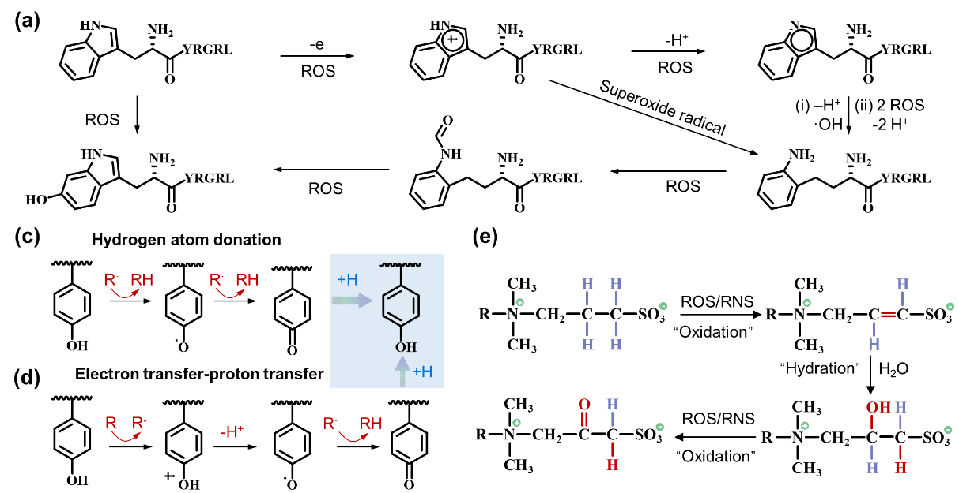
Scheme S3 The chemical mechanism of antioxidation of PSP.
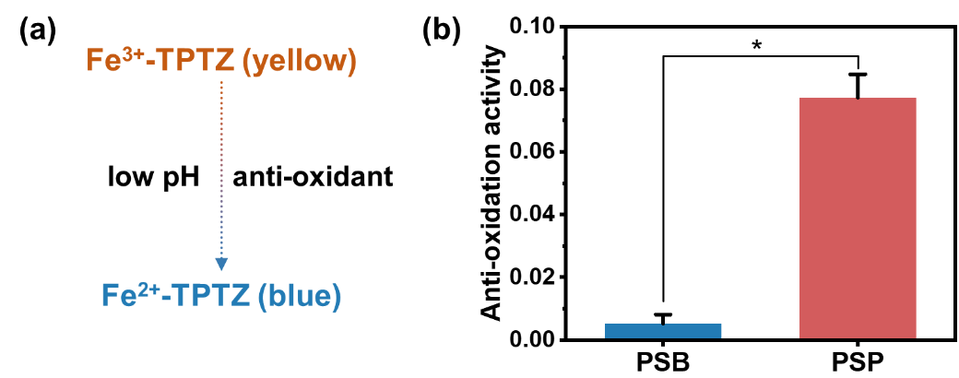
Fig. S18 The total anti–oxidation activity of PSB and PSP at low pH. (a) anti–oxidation mechanism and (b) anti–oxidation activity. * (p < 0.05) implies statistical difference.
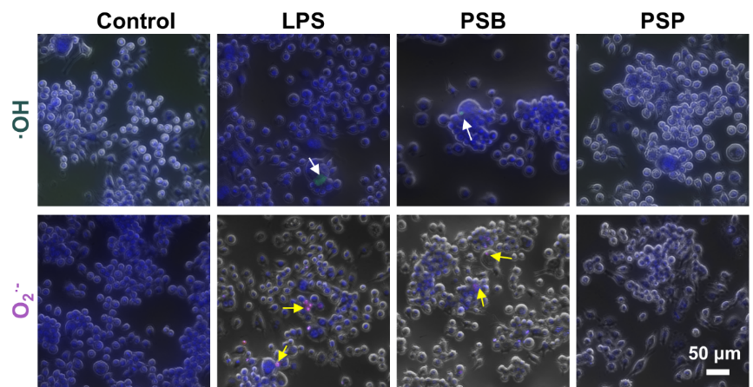
Fig. S19 The ·OH and O·– 2 expression of RAW264.7 cells in control, LPS, PSB and PSP groups. The white arrows represent ·OH radicals, and the yellow arrows indicate O·– 2 radicals.
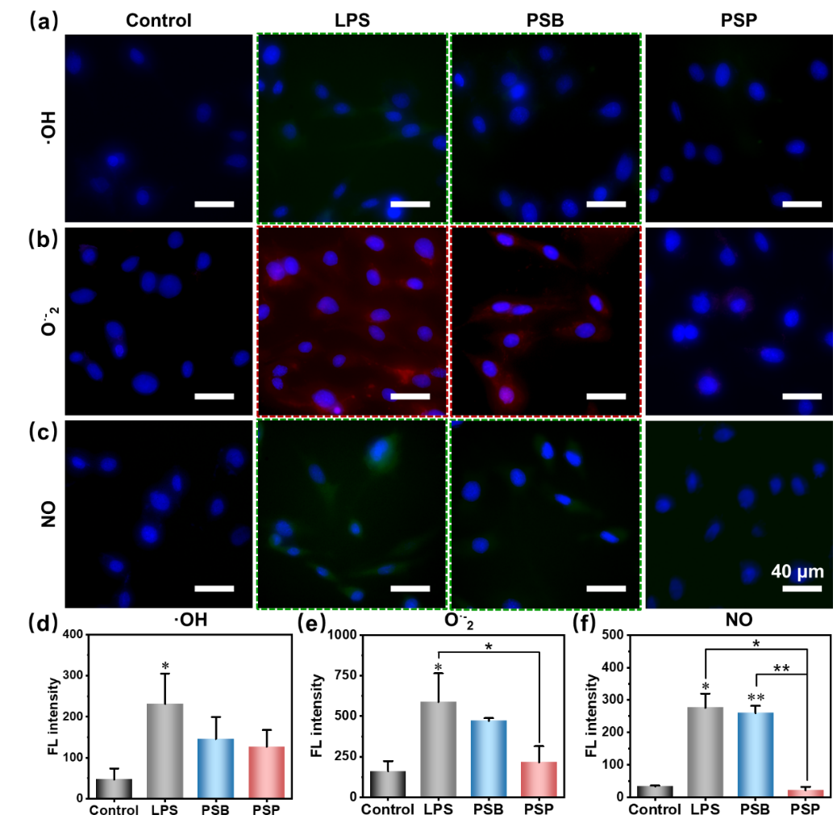
Fig. S20 Anti–oxidation effect of PSP on chondrocytes stimulated by LPS. Intracellular (a) ·OH, (b) O·– 2 and (c) NO stained by DCFH–DA, DHE and DAF–FM dyes, respectively. (d–f) The corresponding fluorescence (FL) intensity to (a–c).

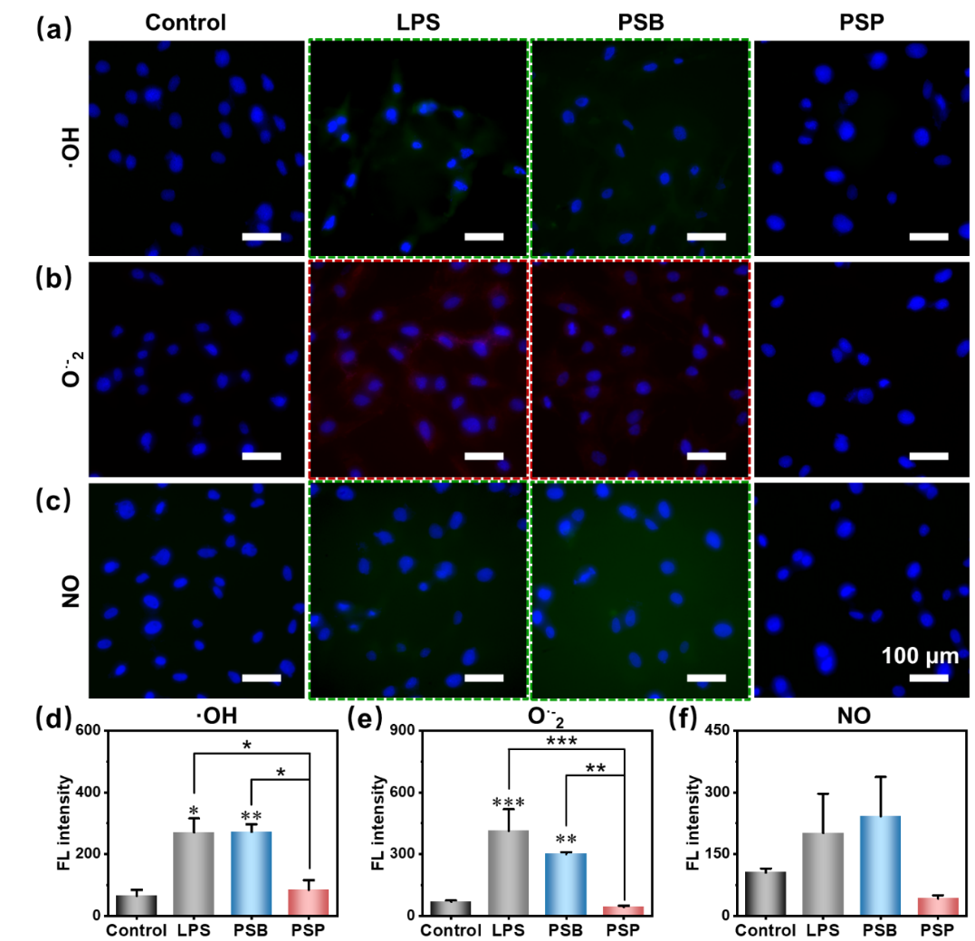
Fig. S21 Anti–oxidation effect of PSP on SMSCs stimulated by LPS. Intracellular (a) ·OH, (b) O·– 2 and (c) NO stained by DCFH–DA, DHE and DAF–FM dyes, respectively. (d–f) The corresponding fluorescence (FL) intensity to (a–c).

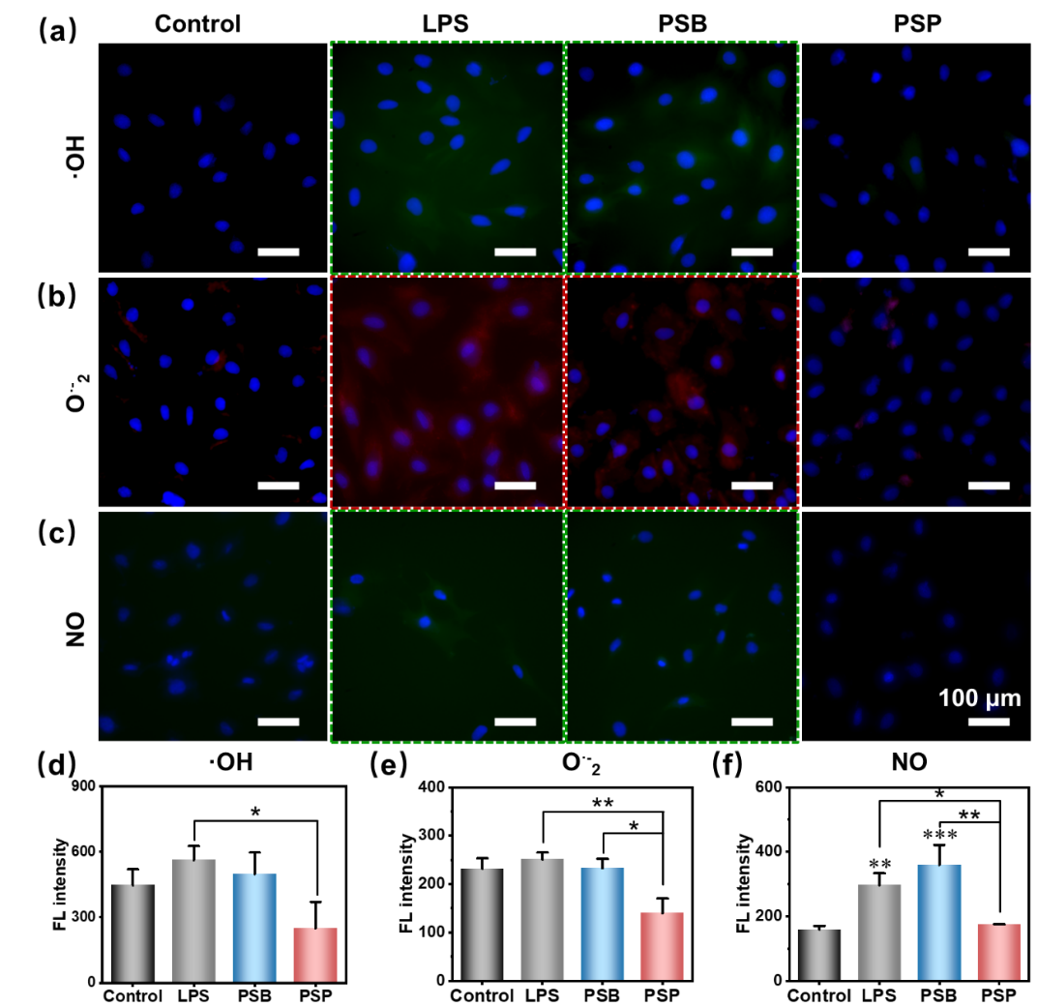
Fig. S22 Anti–oxidation effect of PSP on BMSCs stimulated by LPS. Intracellular (a) ·OH, (b) O·– 2 and (c) NO stained by DCFH–DA, DHE and DAF–FM dyes, respectively. (d–f) The corresponding fluorescence (FL) intensity to (a–c).

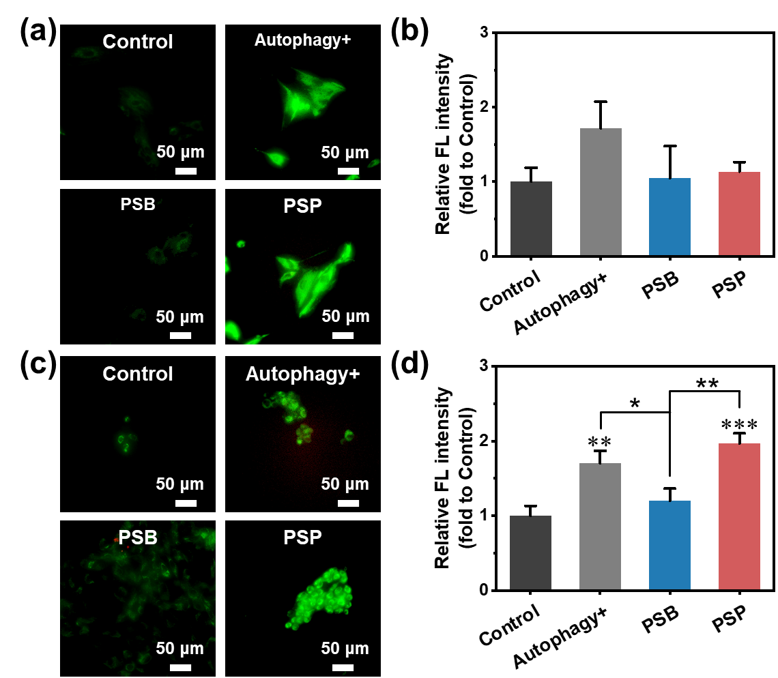
Fig. S23 The activation of autophagy. (a) MDC/PI staining and (b) the relative fluorescence intensity of BMSCs. (c) MDC/PI staining and (d) the relative fluorescence intensity of SMSCs. The green color in (a) and (c) indicate cells with activated autophagy, and the red spots in (a) and (c) represent dead cells.

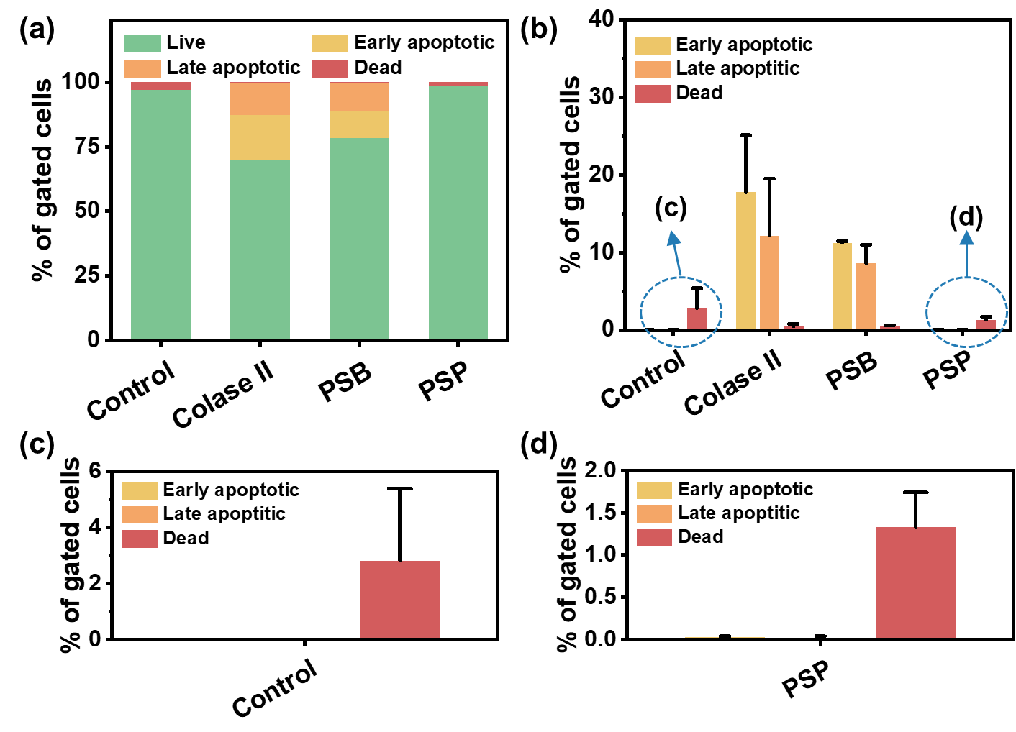
Fig. S24 The flow cytometry analysis of chondrocytes incubated with PSB and PSP followed by Colase II invasion. (a) Percentage of live, early apoptotic, late apoptotic and dead cells, and (b) the quantitative illustration of percentage of apoptotic cells. (c) The details of dead of apoptotic cells of control group. (d) The details of dead of apoptotic cells of PSP group.

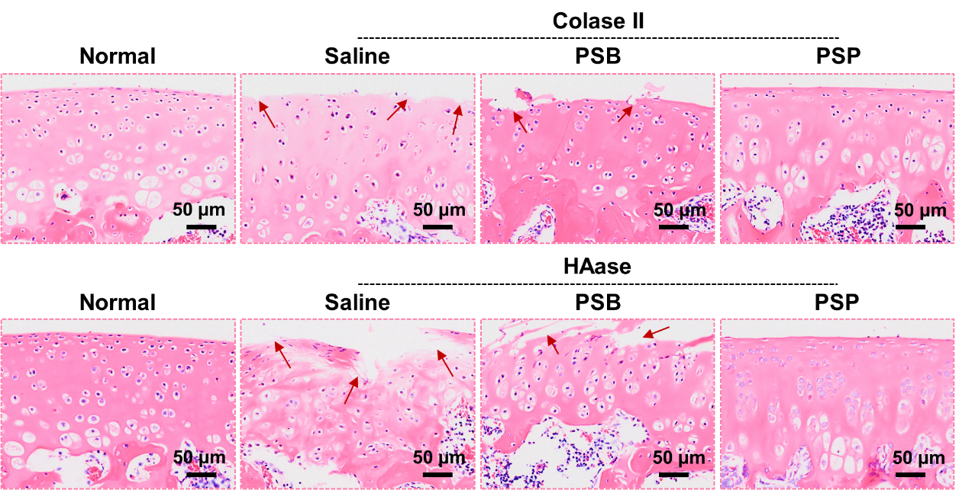
Fig. S25 H&E staining slices of femur treated with zwitterionic polymers (PSB and PSP) and catabolic enzymes (Colase II and HAase), respectively. The red arrows indicate fissures of cartilage surface.

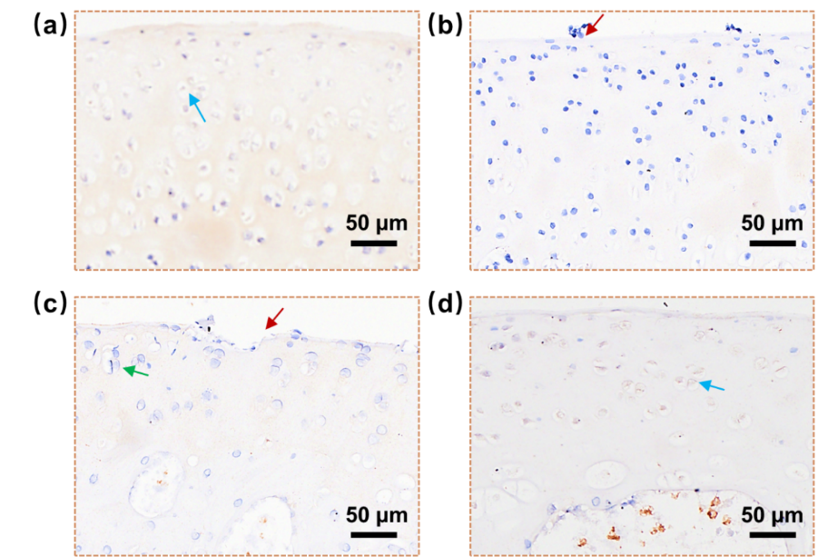
Fig. S26 Immunohistochemical staining of Col II: (a) normal, (b) Colase II, (c) PSB and (d) PSP treated. The blue arrows indicate chondrocytes with positive expression of Col II, the red arrows refer to fissures of cartilage and clusters of chondrocytes, and the green arrow suggests chondrocytes with negative expression of Col II.

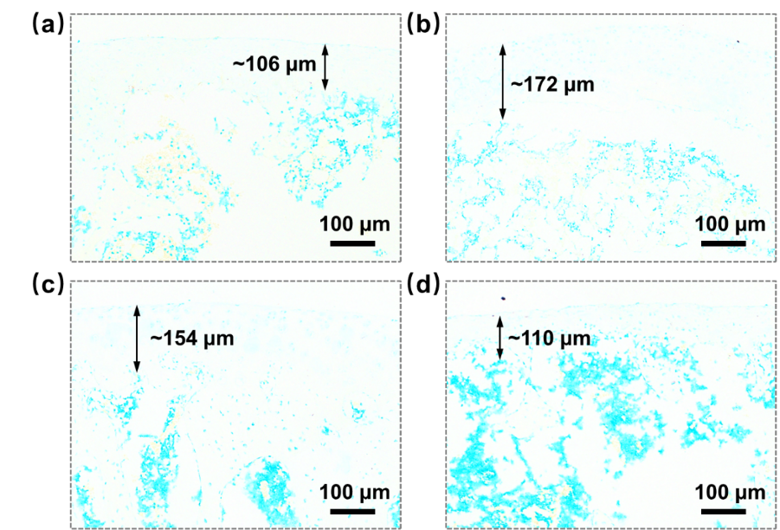
Fig. S27 HA staining slices of femur: (a) normal, (b) Colase II, (c) PSB and (d) PSP treated. The distance of absent HA staining of normal, HAsae, PSB and PSP is 106 μm, 172 μm, 154 μm and 110 μm, respectively.

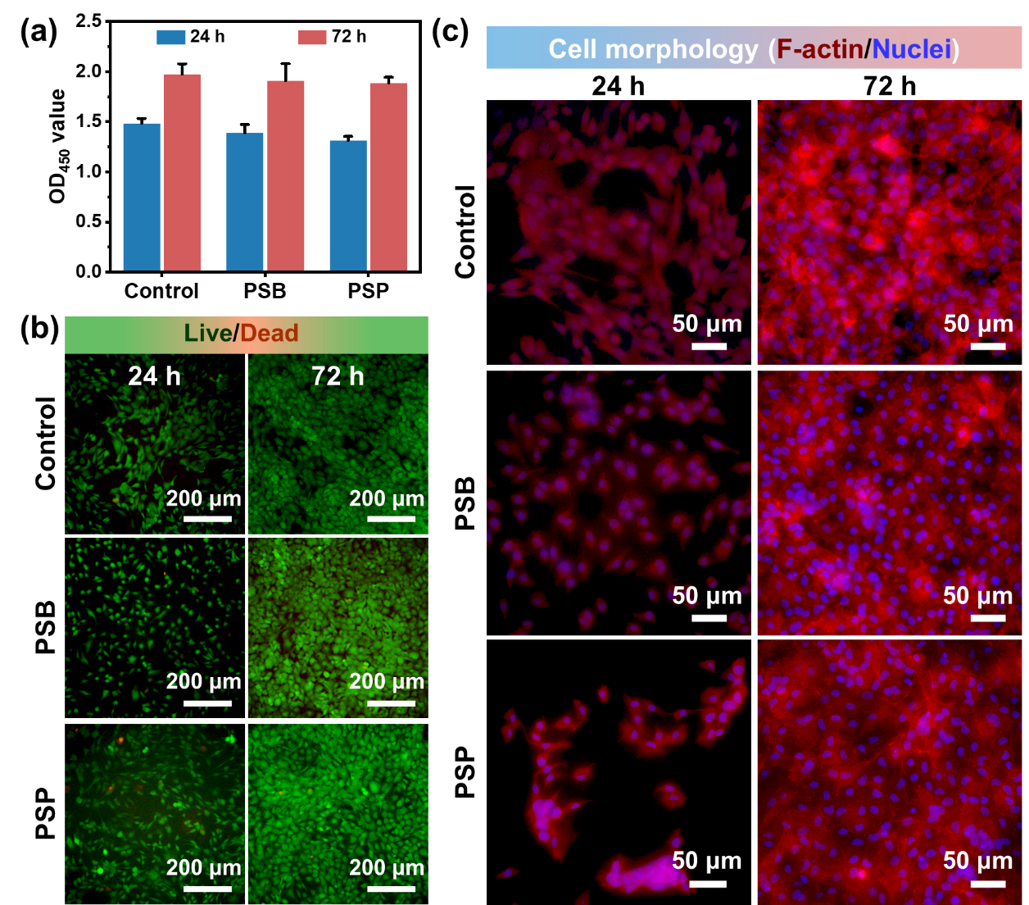
Fig. S28 The cytocompatibility of PSB and PSP towards chondrocytes. (a) Cell proliferation, (b) live/dead staining images and (c) TRITC–phalloidin/DAPI staining images at 24 and 72 h. The green and red spots in (b) indicate live and dead cells, respectively. As for cell morphology, the nuclei were stained blue and the F–actin were stained red.

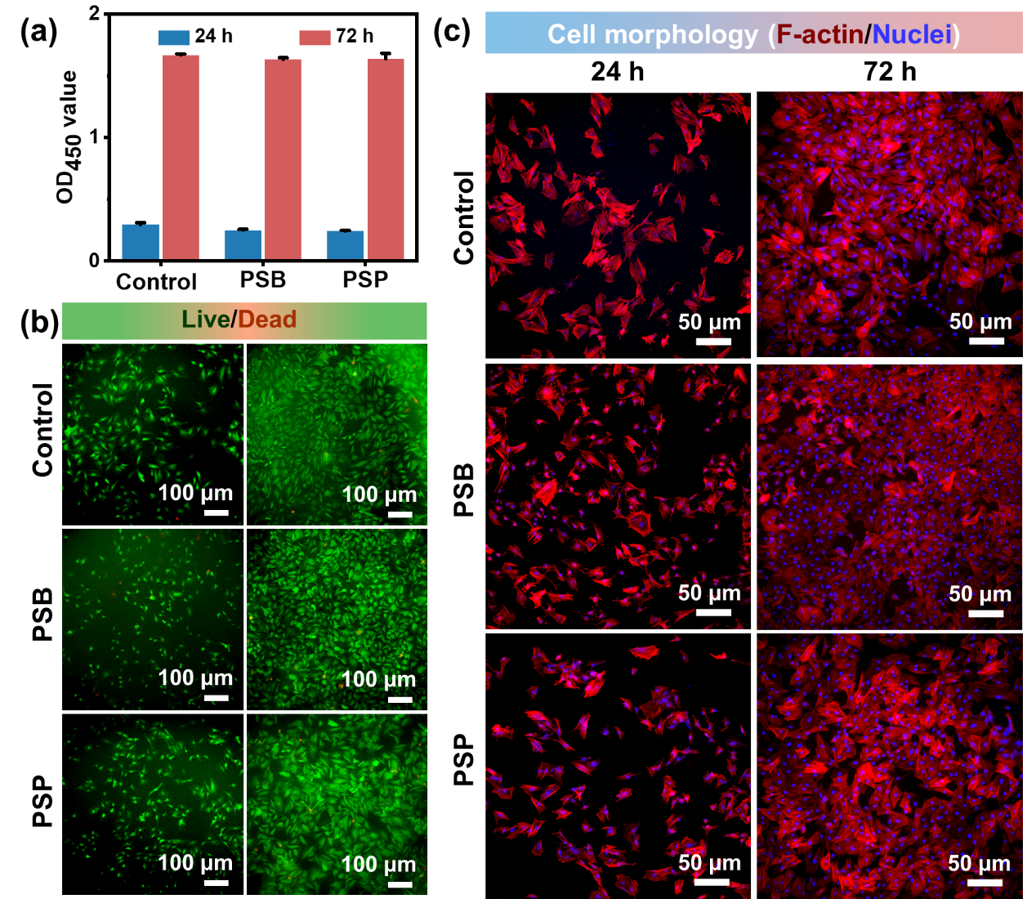
Fig. S29 The cytocompatibility of PSB and PSP towards BMSCs. (a) Cell proliferation, (b) live/dead staining images and (c) TRITC–phalloidin/DAPI staining images at 24 and 72 h. The green and red spots in (b) indicate live and dead cells, respectively. As for cell morphology, the nuclei were stained blue and the F–actin were stained red.

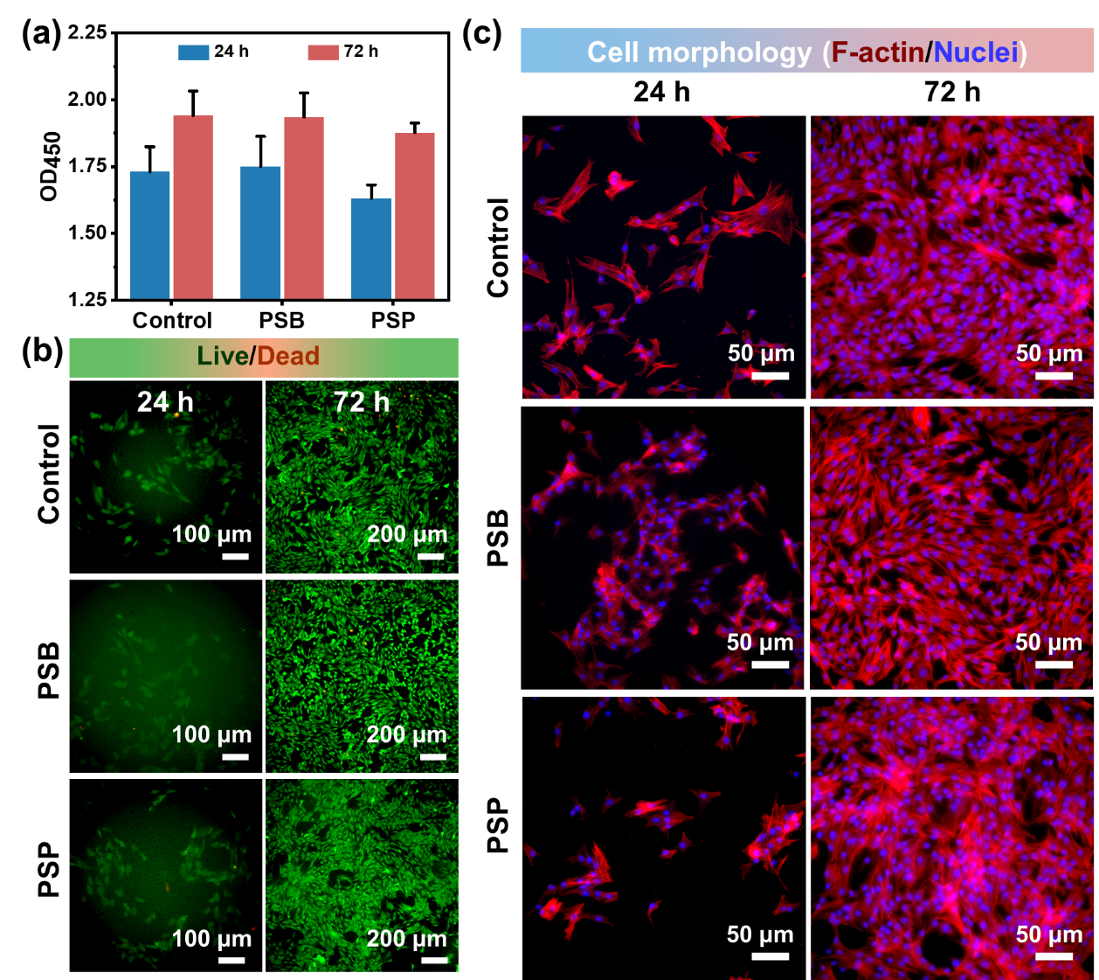
Fig. S30 The cytocompatibility of PSB and PSP towards SMSCs. (a) Cell proliferation, (b) live/dead staining images and (c) TRITC–phalloidin/DAPI staining images at 24 and 72 h. The green and red spots in (b) indicate live and dead cells, respectively. As for cell morphology, the nuclei were stained blue and the F–actin were stained red.

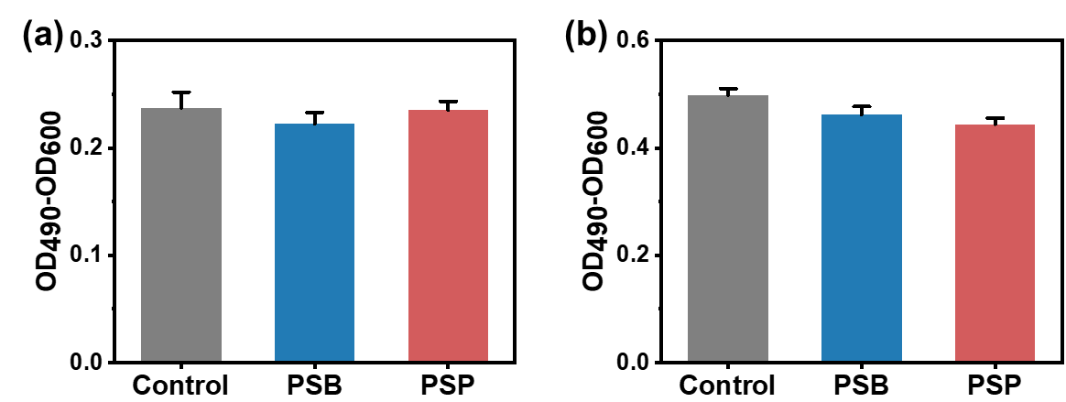
Fig. S31 LDH release of (a) chondrocytes and (b) SMSCs incubated with PSB and PSP.
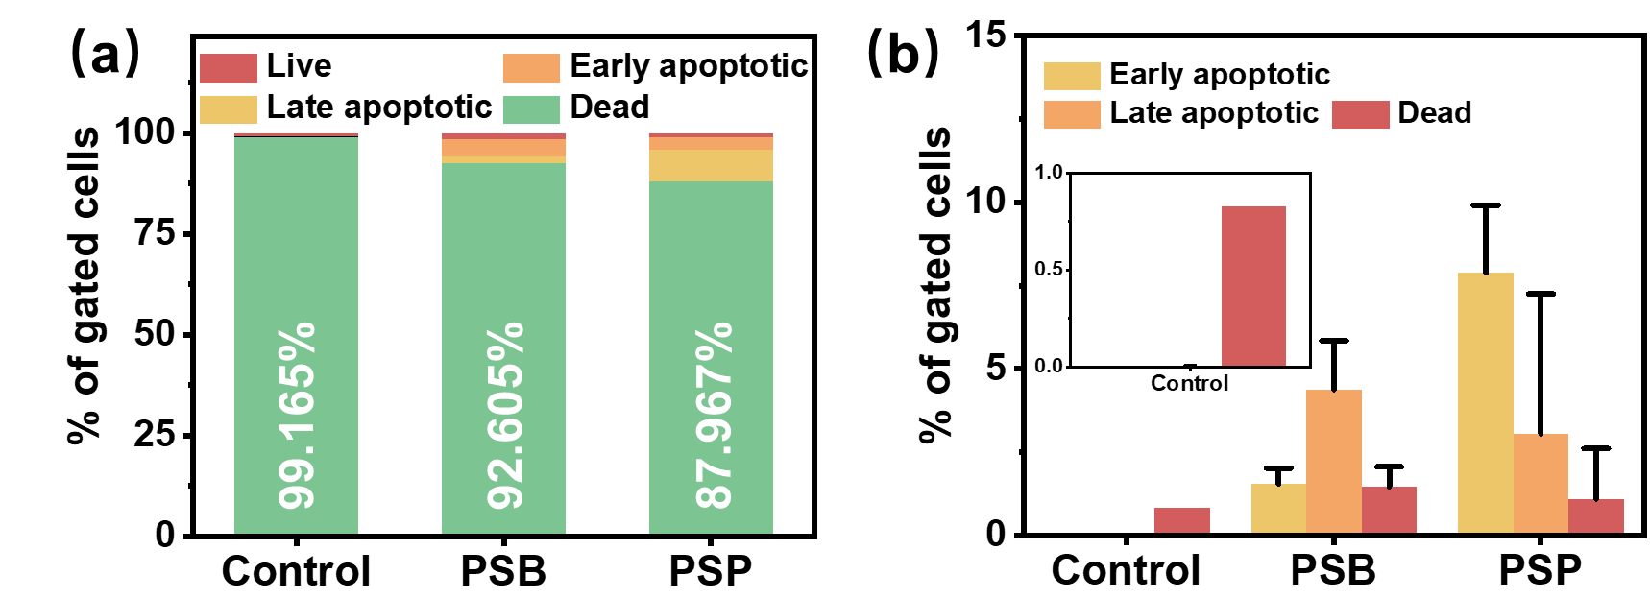
Fig. S32 The flow cytometry analysis of chondrocytes incubated with PSB and PSP. (a) Percentage of live, early apoptotic, late apoptotic and dead cells, and (b) the quantitative illustration of percentage of apoptotic cells.
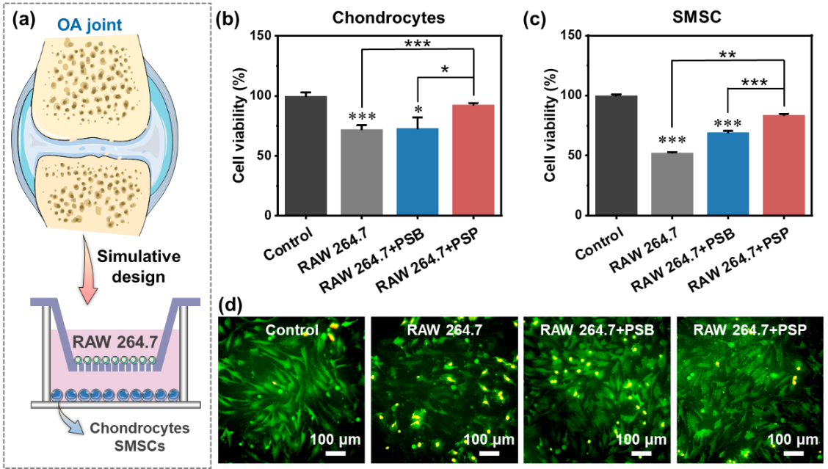
Fig. S33 (a) Concept in designing co–culture system of RAW 264.7 cells and chondrocyte (or SMSCs) to evaluate the resistance of PSP towards inflammatory cells. The cell viability of (b) chondrocytes and (c) SMSCs when cocultured with RAW 264.7 cells in presence of PSP. (d) Live/Dead staining images of chondrocytes in the co–culture system.
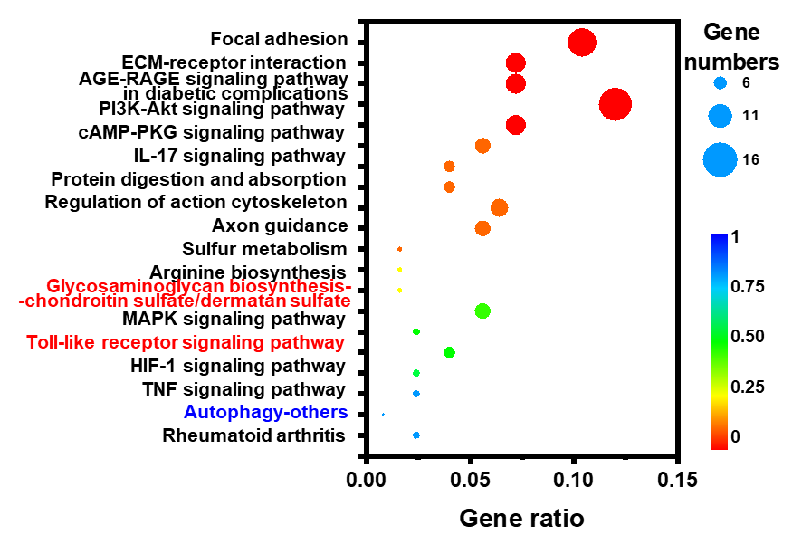
Fig. S34 KEGG enrichment analysis of up–regulated DEGs.

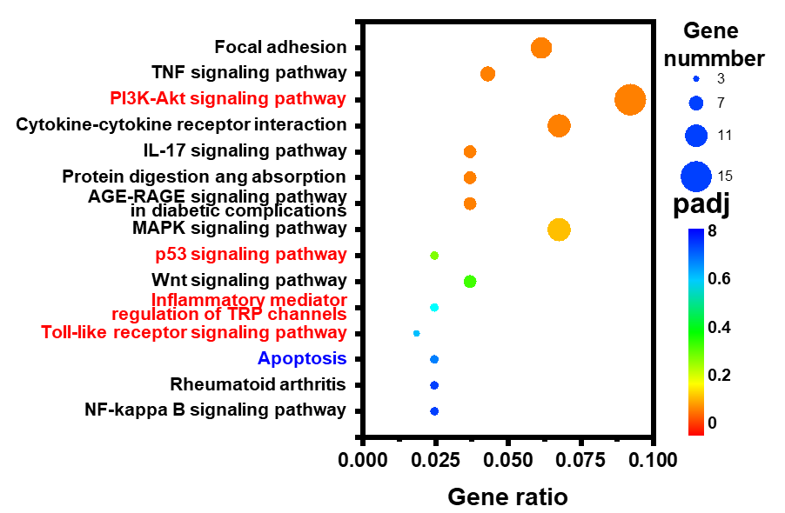
Fig. S35 KEGG enrichment analysis of down–regulated DEGs.

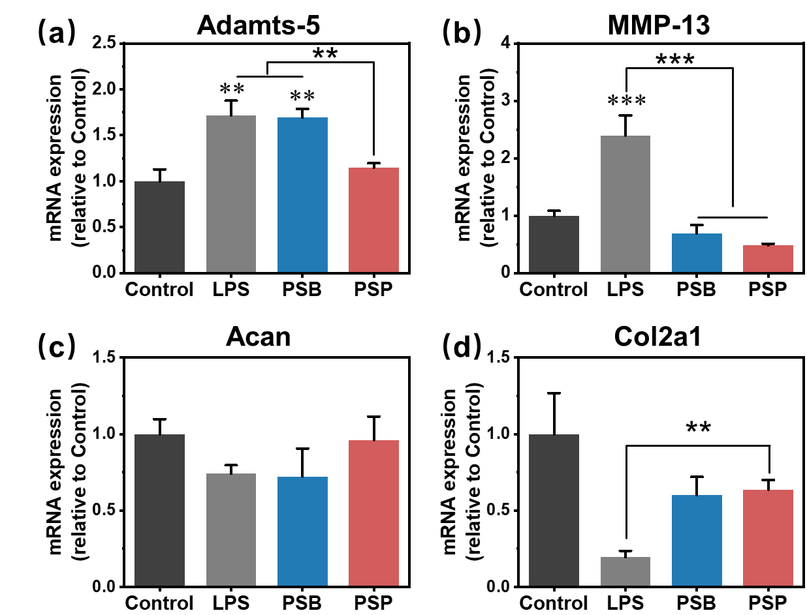
Fig. S36 RT–aPCR analysis of LPS–stimulated chondrocytes incubated with PSB and PSP: (a) Adamts–5, (b) MMP–13, (c) Acan and (d) Col2a1. ** (p<0.01) and *** (p<0.001) is regarded as significant difference compared to control group, ** (p<0.01) and *** (p<0.001) indicate statistical difference between other groups.
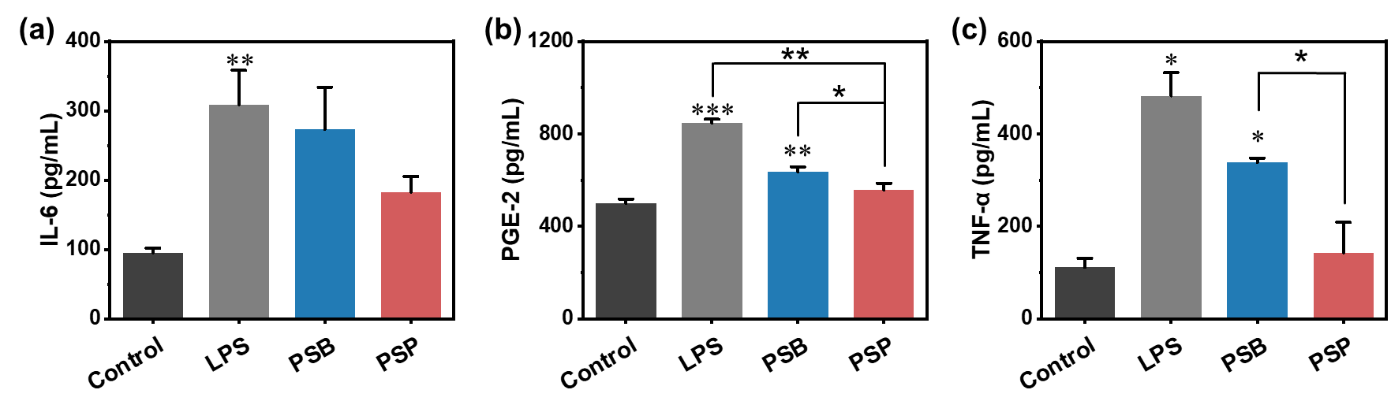
Fig. S37 The expression of intracellular (a) IL–6, (b) PGE–2 and (c) TNF–α. * (p<0.05), ** (p<0.01) and *** (p<0.001) is regarded as significant difference compared to control group, * (p<0.05) and ** (p<0.01) indicate statistical difference between other groups.

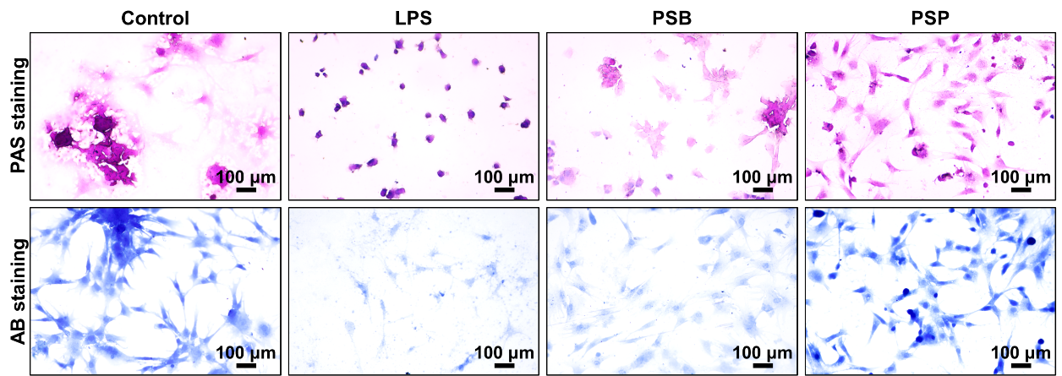
Fig. S38 The PAS and SB staining images of control, LPS, PSB and PSP groups.
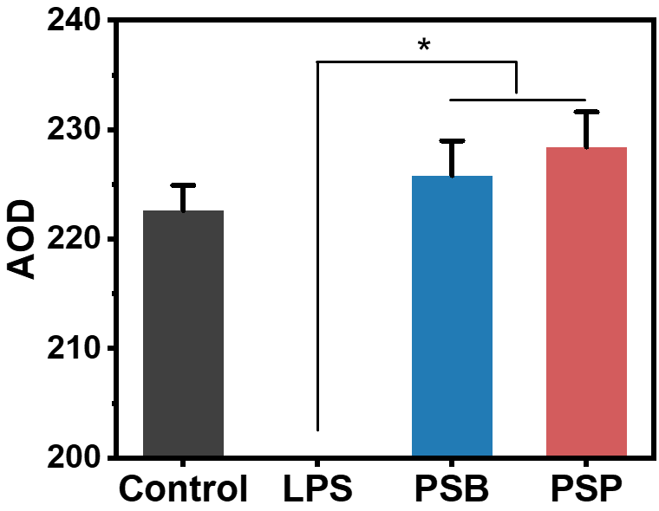
Fig. S39 Semi–quantitative analysis of immunohistochemical staining of aggrecan. * (p<0.05) indicates significant difference.

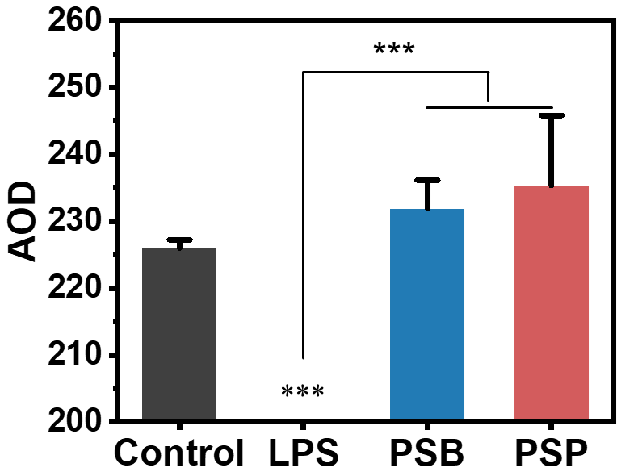
Fig. S40 Semi–quantitative analysis of immunohistochemical staining of Col II. *** (p<0.001) indicates significant difference.

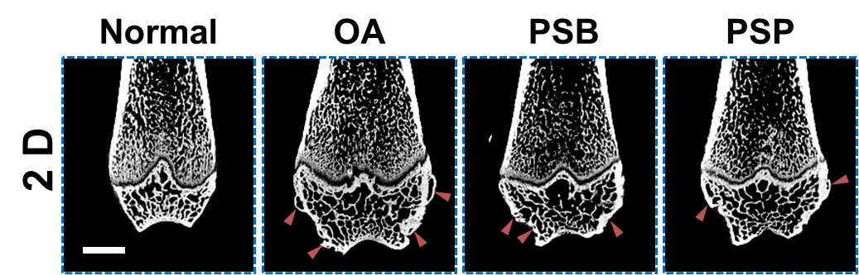
Fig. S41 The representative 2D images from Normal, OA, PSB and PSP groups. The scale bar is 2 mm. The dark–red triangles refer to osteophyte.
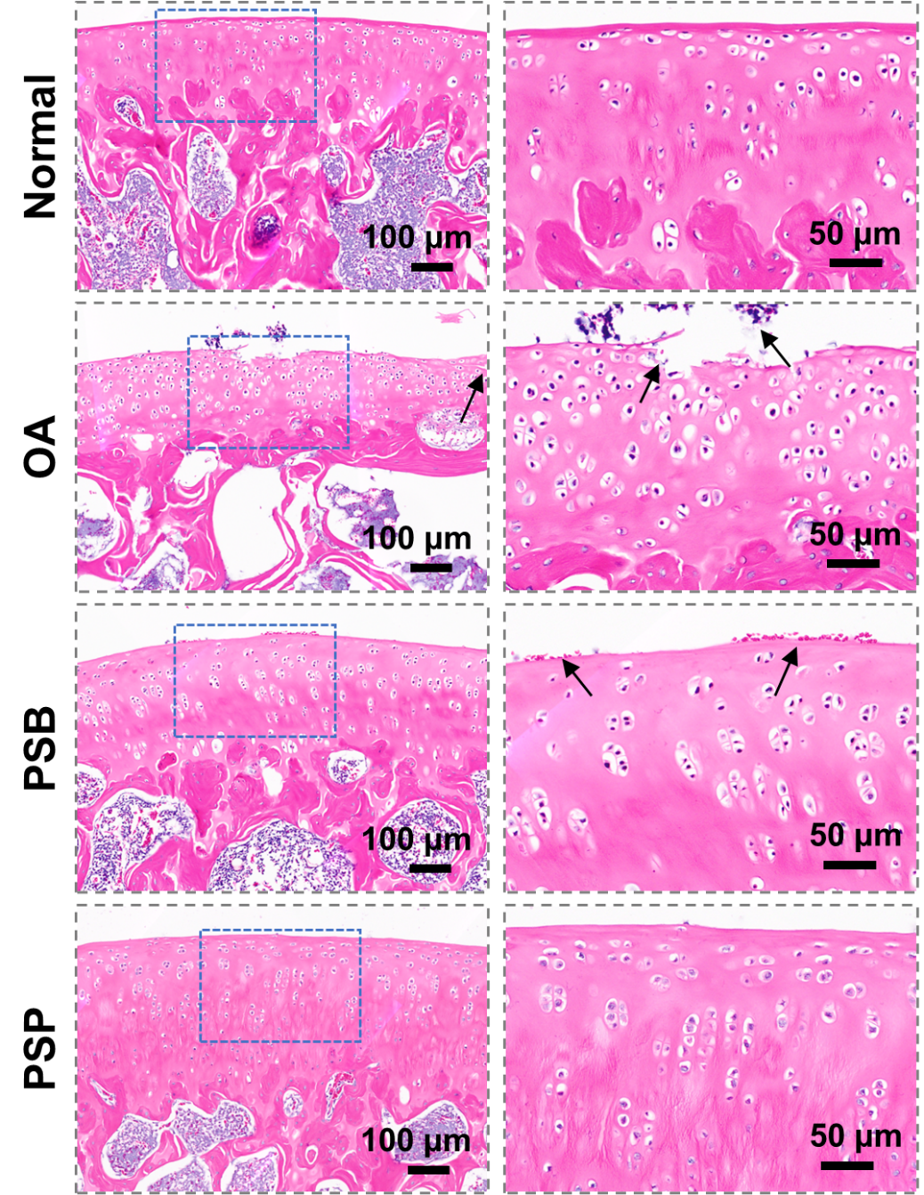
Fig. S42 H&E staining slices of Normal, OA, PSB and PSP groups. The black arrows suggest fissures of cartilage or clusters of cells.
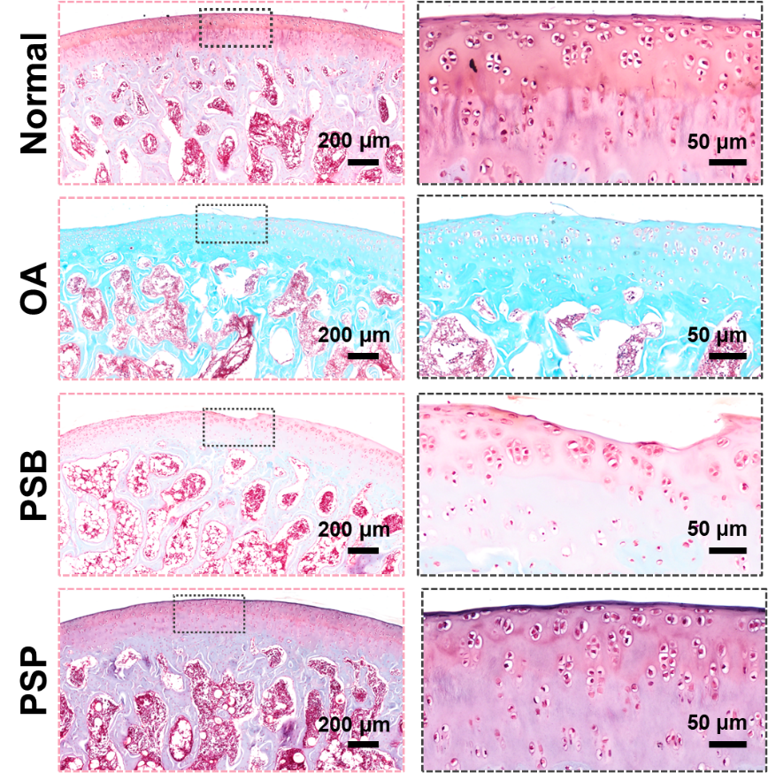
Fig. S43 Safranine O–Fast Green staining slices of Normal, OA, PSB and PSP groups.

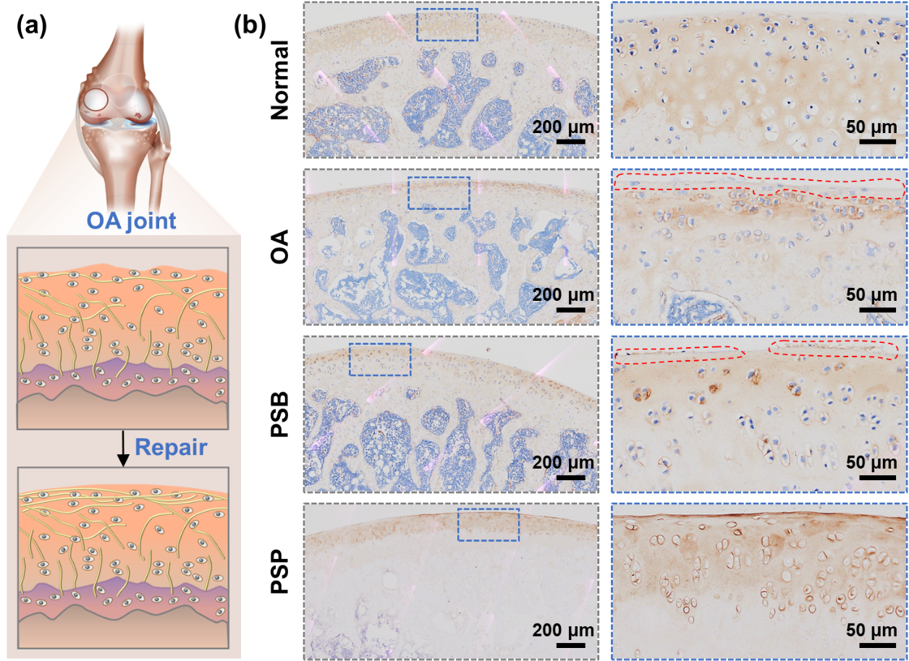
Fig. S44 Immunohistochemical staining of Col II of Normal, OA, PSB and PSP groups. (a) Schematic illustration of OA joint and repaired cartilage, and (b) representative images. The red cycles indicate areas with absence of Col II staining.

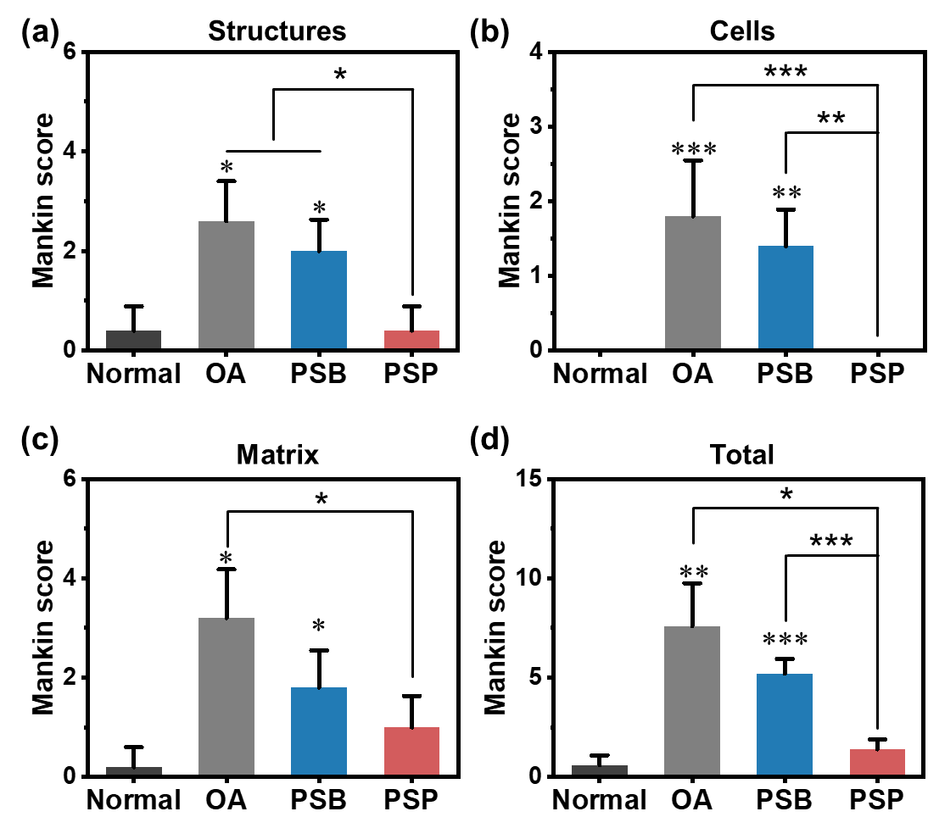
Fig. S45 Mankin score of normal, OA, PSB and PSP groups: (a) structures, (b) cells, (c) matrix and (d) total scores. * (p<0.05), ** (p<0.01) and *** (p<0.001) is regarded as significant difference compared to control group, * (p<0.05), ** (p<0.01) and *** (p<0.001) indicate statistical difference between other groups.
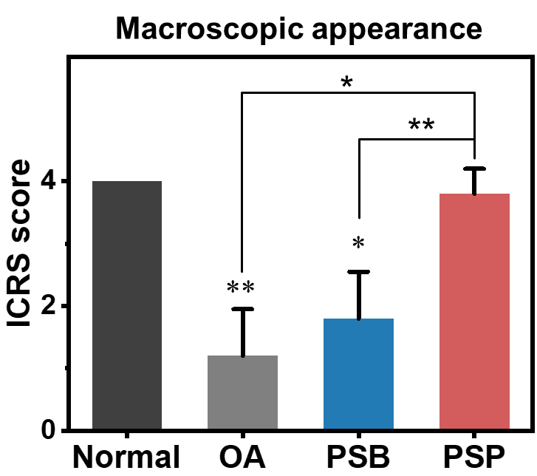
Fig. S46 ICRS score (macroscopic appearance) of normal, OA, PSB and PSP group. * (p<0.05) and ** (p<0.01) is regarded as significant difference compared to control group, * (p<0.05) and ** (p<0.01) indicate statistical difference between other groups.

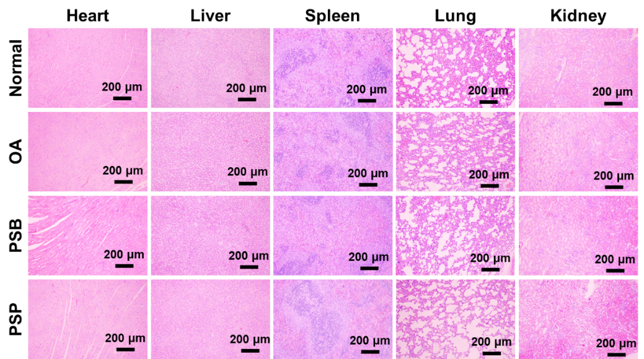
Fig. S47 H&E staining slices of major organs (heart, liver, spleen, lung and kidney) of SD rats from normal, OA, PSB and PSP groups.

S4. Supplementary Tables
Table S1. Chemical composition of PSB, PSN and PSP
 | C (%) | N (%) | O (%) | S (%)
PSB | 63.36 | 5.74 | 25.5 | 5.4
PSN | 64.29 | 5.92 | 24.57 | 5.21
PSP | 62.78 | 6.61 | 25.51 | 5.09

Table S2. Biosafety parameters analyzed by blood routine examination
 | Normal | OA | PSB | PSP
Gran# (×10⁹/L) | 0.52±0.12 | 0.42±0.10 | 0.46±0.08 | 0.48±0.21
WBC (×10⁹/L) | 2.15±0.25 | 2.2±0.19 | 1.88±0.08 | 2.36±0.41
Lymph# (×10⁹/L) | 1.68±0.29 | 1.75±0.15 | 1.26±0.16 | 1.7–±0.13
Mon# (×10⁹/L) | 0.10±0.00 | 0.1–±0.00 | 0.10±0.10 | 0.10±0.06
Gran% | 23.58±3.61 | 18.73±2.40 | 23.45±4.26 | 20.64±7.08
Lymph% | 71.94±3.80 | 77.70±2.90 | 69.64±6.31 | 75.04±8.21
Mon% | 4.48±0.47 | 4.36±0.69 | 4.55±0.47 | 4.26±1.15
RBC (×10¹²/L) | 7.81±0.17 | 8.03±0.25 | 7.96±0.23 | 7.70±0.28
HGB (g/L) | 155.40±5.61 | 154.00±3.85 | 150.80±4.71 | 149.80±3.54
MCHC (g/L) | 339.40±5.61 | 334.80±2.23 | 332.80±4.07 | 333.40±2.58
PLT (×10⁹/L) | 1024.60±198.85 | 1028.75±32.34 | 1212.00±155.04 | 1116.00±162.23
PDW | 16.72±0.13 | 16.72±0.17 | 16.54±0.16 | 16.60±0.26
HCT (%) | 45.70±1.63 | 45.94±3.84 | 45.28±1.78 | 44.88±0.82
MCV (fL) | 58.56±1.65 | 57.30±1.96 | 56.92±1.84 | 58.38±1.76
MCH (pg) | 19.84±0.74 | 19.14±0.65 | 18.86±0.49 | 19.40±0.49
RDW (%) | 12.38±0.54 | 12.30±0.88 | 12.52±1.08 | 12.02±0.40
MPV (fL) | 6.52±0.27 | 6.36±0.21 | 6.28±0.27 | 6.24±0.50
Gran#, granulocyte; WBC, white blood cell count; Lymph#, lymphocyte count; Mon#, monocyte count; Gran%, percentage of granulocyte; Lymph%, percentage of lymphocyte; Mon%, percentage of monocyte; RBC, red blood cell count; HGB, hemoglobin; MCHC, mean corpusular hemoglobin concerntration; PLT, plateletocrit; PDW, platelet distribution widt; HCT, hematocrit; MCV, mean corpusular volume; MCH, mean corpusular hemoglobin; RDW, red blood cell volume distribution width; MPC, mean platelet volume.
Table S3 Primer sequences for RT–qPCR
Target gene | Forward primer sequence | Reverse primer sequence
ACTB | GAAGATCAAGATCATTGCTCCT | TACTCCTGCTTGCTGATCCACA
Adamts–5 | GCAGAACATCGACCAACTCTACTC | CCAGCAATGCCCACCGAAC
MMP 13 | GGTGATGAAGATGATTTGTCTGAGG | CGTCAAGTTTGCCAGTCACCT
Acan | CTGAACGACAGGACCATCGAA | CGTGCCAGATCATCACCACA
Col2a1 | CACTCAAGTCCCTCAACAACCAG | GGGGTCAATCCAGTAGTCTCCAC

Tables S4 The OA therapeutic effect of various polymeric biomaterials.
Polymeric biomaterials | Drugs | Score reduction ª | Number ^{b} | Ref.
MSNs–NH₂@PMPC | – | 4.64 | A1 | 6
MSNs–NH₂@PMPC | +DS | 30.55 | D1 | 6
PEG–PPG–PEG | – | 5.74 | A2 | 7
PEG–PPG–PEG | +ASTA | 50.76 | D5 | 7
PEG–PTK–PEG | – | 66.02 | A19 | 7
PEG–PTK–PEG | +ASTA | 75.79 | D13 | 7
MSNs–NH₂@PSPMK | – | 6.60 | A3 | 8
MSNs–NH₂@PSPMK | +DS | 35.38 | D3 | 8
MHS | – | 8.90 | A4 | 9
MHS | +PPKHF | 71.77 | D11 | 9
MSNs | – | 11.00 | A5 | 6
MSNs | – | 19.15 | A8 | 8
HA@MPC | – | 17.96 | A6 | 10
HA@MPC | +DS | 62.80 | D9 | 10
MMSP | – | 18.61 | A7 | 11
MMSP | +DS | 55.13 | D7 | 11
TPP–MMSP | – | 39.20 | A13 | 11
TPP–MMSP | +DS | 79.30 | D15 | 11
GelMA@DMA–MPC | – | 23.73 | A9 | 12
GelMA@DMA–MPC | +DS | 31.92 | D2 | 12
PMS | – | 24.70 | A10 | 13
PMS | +NF | 59.59 | D8 | 13
BB | – | 25.34 | A11 | 14
BB | +Cur & LXP | 71.80 | D12 | 14
CB | – | 60.03 | A17 | 14
CB | +Cur & LXP | 87.52 | D17 | 14
PMPC–Lipo | – | 31.18 | A12 | 15
PMPC–Lipo | +GA | 64.69 | D10 | 15
8–arm PEG–COLBP | – | 41.61 | A14 | 16
HABP2–8–arm PEG–ColBP | – | 46.49 | A16 | 16
– | Orthovisc | 22.45 | B1 | 16
P(DMA–b–SBMA) | – | 42.52 | A15 | 17
HA–MPC | – | 64.99 | A18 | 18
PTKU | – | 72.31 | A20 | 19
PTKU | +DEX | 86.82 | D16 | 19
– | HA | 25.19 | B2 | 10
– | HA | 40.03  59.57 | B3 | 18
– | HA | 40.03  59.57 | B4 | 20
– | PSO | 14.63 | C1 | 21
– | DS | 23.31 | C2 | 22
– | ASTA | 31.12 | C3 | 7
– | NF | 45.13 | C4 | 13
– | DEX | 50.09 | C5 | 19
MR–PPL | +PSO | 46.97273891 | D4 | 21
MRC–PPL | +PSO | 79.1117236 | D14 | 21
MoS₂–PDMPC | +DS | 51.26292212 | D6 | 22
PSB–b–PColBP | – | 76 | This work
ª Score reduction is chosen to valuate the therapeutic effect on OA, which is calculated by the reduced ratio of OARSI scores in comparison to the control (or normal) group.
^{b} The number is linked with the heat map in Figure 6f in the main text.
DS: diclofenac sodium; ASTA: astaxanthin; PPKHF: PEG–KGN–HSPC–fluorescein; Cur: curcumin; LXP: loxoprofen; GA: gallic acid; DEX: dexamethasone; PSO: psoralidin.

S5. Reference
1. Singh A, Corvelli M, Unterman SA, Wepasnick KA, McDonnell P, Elisseeff JH. Enhanced lubrication on tissue and biomaterial surfaces through peptide–mediated binding of hyaluronic acid. Nat. Mater. 13, 988–995 (2014).
2. Yu P, et al. A thermo–sensitive injectable hydroxypropyl chitin hydrogel for sustained salmon calcitonin release with enhanced osteogenesis and hypocalcemic effects. J. Mater. Chem. B 8, 270–281 (2020).
3. Yihan Liao, et al. Interleukin–6 signaling mediates cartilage degradation and pain in posttraumatic osteoarthritis in a sex–specific manner. Sci. Signal. 15, eabn7082 (2022).
4. Jin Y, et al. A novel prostaglandin E receptor 4 (EP4) small molecule antagonist induces articular cartilage regeneration. Cell Discov. 8, 24 (2022).
5. Yang G, et al. A multifunctional anti–inflammatory drug that can specifically target activated macrophages, massively deplete intracellular H₂O₂, and produce large amounts CO for a highly efficient treatment of osteoarthritis. Biomaterials 255, 120155 (2020).
6. Chen H, et al. Cartilage matrix–inspired biomimetic superlubricated nanospheres for treatment of osteoarthritis. Biomaterials 242, 119931 (2020).
7. Xiong H, et al. The ROS‐responsive scavenger with intrinsic antioxidant capability and enhanced immunomodulatory effects for cartilage protection and osteoarthritis remission. Appl. Mater. Today 26, 101366 (2022).
8. Yan Y, et al. Euryale Ferox Seed–Inspired Superlubricated Nanoparticles for Treatment of Osteoarthritis. Adv. Funct. Mater. 29, 1807559 (2019).
9. Yao Y, Wei G, Deng L, Cui W. Visualizable and Lubricating Hydrogel Microspheres Via NanoPOSS for Cartilage Regeneration. Adv. Sci. 10, 2207438 (2023).
10. Yang L, Sun L, Zhang H, Bian F, Zhao Y. Ice–Inspired Lubricated Drug Delivery Particles from Microfluidic Electrospray for Osteoarthritis Treatment. ACS Nano 15, 20600–20606 (2021).
11. Zhang L, et al. Reprogramming Mitochondrial Metabolism in Synovial Macrophages of Early Osteoarthritis by a Camouflaged Meta‐Defensome. Adv. Mater. 34, 2202715 (2022).
12. Han Y, et al. Biomimetic injectable hydrogel microspheres with enhanced lubrication and controllable drug release for the treatment of osteoarthritis. Bioac. Mater. 6, 3596–3607 (2021).
13. Han Z, et al. Nanofat functionalized injectable super–lubricating microfluidic microspheres for treatment of osteoarthritis. Biomaterials 285, 121545 (2022).
14. Zhang M, et al. A cyclic brush zwitterionic polymer based pH–responsive nanocarrier–mediated dual drug delivery system with lubrication maintenance for osteoarthritis treatment. Mater. Horizons 10, 2554–2567 (2023).
15. Yang H, et al. Functional nano drug delivery system with dual lubrication and immune escape for treating osteoarthritis. J. Colloid Interface Sci. 652, 2167–2179 (2023).
16. Faust HJ, et al. A hyaluronic acid binding peptide–polymer system for treating osteoarthritis. Biomaterials 183, 93–101 (2018).
17. Zhao W, Yu Y, Zhang Z, He D, Zhang H. Bioinspired Nanospheres as Anti–inflammation and Antisenescence Interfacial Biolubricant for Treating Temporomandibular Joint Osteoarthritis. ACS Appl. Mater. Interfaces 14, 35409–35422 (2022).
18. Zheng Y, et al. Self–Assembled Nanospheres with Enhanced Interfacial Lubrication for the Treatment of Osteoarthritis. ACS Appl. Mater. Interfaces 14, 21773–21786 (2022).
19. Zhang H, et al. Reactive oxygen species–responsive and scavenging polyurethane nanoparticles for treatment of osteoarthritis in vivo. Chem. Eng. J. 409, 128147 (2021).
20. Xie R, et al. Biomimetic cartilage–lubricating polymers regenerate cartilage in rats with early osteoarthritis. Nat. Biomed. Eng. 5, 1189–1201 (2021).
21. Lan Q, et al. MMP–13 enzyme and pH responsive theranostic nanoplatform for osteoarthritis. J. Nanobiotech. 18, 117 (2020).
22. Qiu W, et al. A Solid–Liquid Composite Lubricating “Nano‐Snowboard” for Long‐Acting Treatment of Osteoarthritis. Adv. Funct. Mater. 32, 2208189 (2022).

