Super-sorption Capacity and Multi-cycles Recovery of Urea by Vesicle-like Iron phosphate-based Carbon Nano-adsorbent from aqueous solutions.
Duc-Anh Nguyen¹, Yujae Jeon², Kim-Anh Thi Nguyen¹, Am Jang^{1,*}

¹Department of Global Smart City, Sungkyunkwan University (SKKU), 2066, Seobu-ro, Jangan-gu, Suwon-si, Gyeonggi-do 16419, Republic of Korea
²Department of Semiconductor Display Engineering, Sungkyunkwan University (SKKU)
2066, Seobu-ro, Jangan-gu, Suwon, Gyeonggi-do, 16419, Republic of Korea
*Corresponding author: +82-31-290-7526; Fax: +82-31-290-7549; Email: amjang@skku.edu

Authors’ emails: Duc-Anh Nguyen (nguyenducanh@g.skku.edu), Yujae Jeon (junyujae@g.skku.edu), Kim-Anh Thi Nguyen (toikimanh@gmail.com).
  - Adsorption methodology
The adsorption capacity (q_{e}) was determined based on the following Eq. (1):
q_{e} = $\frac{\left(C_{o}-C_{e}\right)V}{m}$ (1)
where m (g) is the mass of the adsorbent. C₀ (mg.L⁻¹) and C_{e} (mg.L⁻¹) are the initial and final concentrations of urea in the solution. V (L) is the volume of the urea solution.
    - Adsorption kinetics
The contact time was used for general adsorption investigations within the first 1440 minutes, and adsorption kinetics were examined. Applying Pseudo-first-order and second-order models according to Eq. (2), (3)
q_{t} = q_{e}(1–$\exp^{{-k}_{1}t}$) (2)
q_{t} = $\frac{k_{2}q_{e}^{2}t}{1+k_{2}tq_{e}}$ (3)
where k₁ (min⁻¹) and k₂ (g.mg⁻¹.min⁻¹) are first and second-order coefficients; q_{t} and q_{e} (mg.g⁻¹) are adsorption amounts at equilibrium time and t moment.
    - Adsorption isotherms
Similarly, urea concentrations from 1 to 5000 mg.L⁻¹ were used to examine adsorption isotherms. The adsorption was carried out for 24 hours at 25ºC, respectively. According to Eq. (4) and (5), the Freundlich and Langmuir models were used to reach adsorption equilibrium to fit the adsorption isotherms.
$q_{e}=k_{F}×C_{e}^{n}$ (4)
$q_{e}=\frac{q_{max}k_{L}C_{e}}{1+k_{L}C_{e}}$(5)
Where q_{e} (mg.g⁻¹) is the urea adsorbed amount, and Ce (mg.L⁻¹) is the urea concentration at the equilibrium time. q_{max} (mg.g⁻¹) is the Langmuir monolayer adsorption capacity; k_{L} (L.mg⁻¹) is the Langmuir coefficient, which involves binding site affinity and adsorption energy. k_{F} (mg.g⁻¹) is the Freundlich coefficient, and n is the heterogeneity factor concerning adsorption intensity and capacity
  - Material characterization
The morphologies of the samples were analyzed using high-resolution transmission electron microscopy (JEM-2100F, JEOL, Japan).
Fourier transform infrared (FT-IR) spectra were recorded using an infrared spectrometer (IFS-66/S, TENSOR27, Bruker Corporation, USA).
Thermogravimetric analysis (TGA) was conducted on all samples from 25 to 800 °C to investigate their thermal stability using a thermo gravimetry/differential thermal analyzer (STA7200RV, Hitachi, Japan)
X-ray diffraction (XRD) measurements were performed using an X-ray diffractometer (D8 Advance, Bruker Corporation, USA) under operating conditions of 40 kV and 40 mA, at a 2θ range spanning from 5° to 75°.
Brunauer–Emmett–Teller (BET) surface area and pore size assessments were performed via N₂ adsorption–desorption at 77 K using an ASAP-2460M instrument (Micromeritics Instrument Corporation, USA).
Urea concentration was measured using an LCMS-2020 liquid chromatography-mass spectrometer (Shimadzu, Japan) coupled with an ultraviolet detector. Each sample was carefully diluted until the concentration was less than 10 mg.L⁻¹ and carefully adjusted pH to neutral before analyzing using a Shim-pack GIST C18 (5 μm, 150 × 4.6 mm internal diameter, Shimadzu). The oven temperature, wavelength, mass-to-charge ratio, retention time, and flow rate were 40 °C, 203 nm, 60 m/z, 3.750 min, and 1.0 mL/min, respectively. The injection volume was 30 μg/L. Formic acid 0.3 % in water and methanol were used as the mobile phase, following guidelines given by Cosmosil for high-performance liquid chromatography.
The Fe and P concentrations were quantified using an inductively coupled plasma optical emission spectrometer (Optima 8300, PerkinElmer, USA).
The isoelectric point was determined using the pH method. This method involved mixing 0.2 g of the sample with 40 mL of 0.1 M NaNO₃ in various conical tubes. Subsequently, solutions of 0.1 M HNO₃ or 0.1 M NaOH were utilized alongside a pH meter (Hach, USA) to adjust the pH of the suspension to specific initial values ranging from 2 to 12. The suspension was then shaken for 24 hours, followed by meticulous pH measurement after filtration. The ∆pH values, indicating the difference between the final and initial pH values, were plotted against the initial pH values. The point of zero charge (PZC) is defined as the initial pH at which the final pH reaches zero.
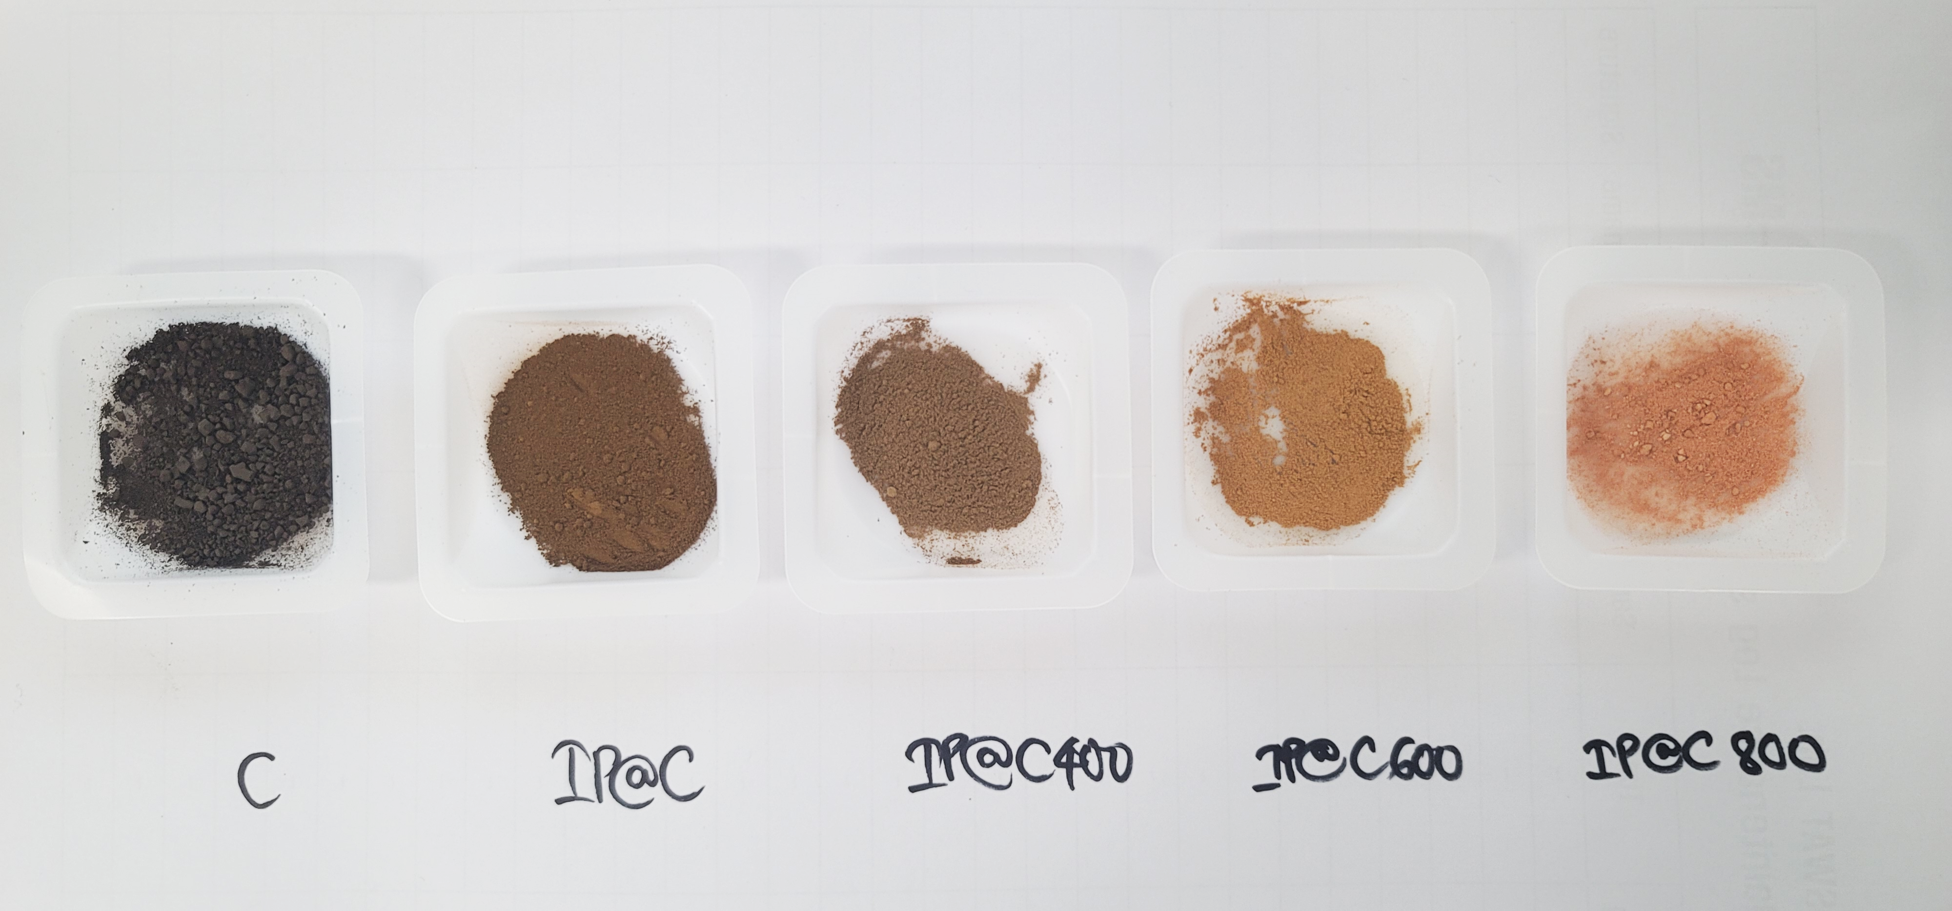
Figure S1. Actual colors of C, IP@C, IP@C400, IP@C600, and IP@C800 samples.
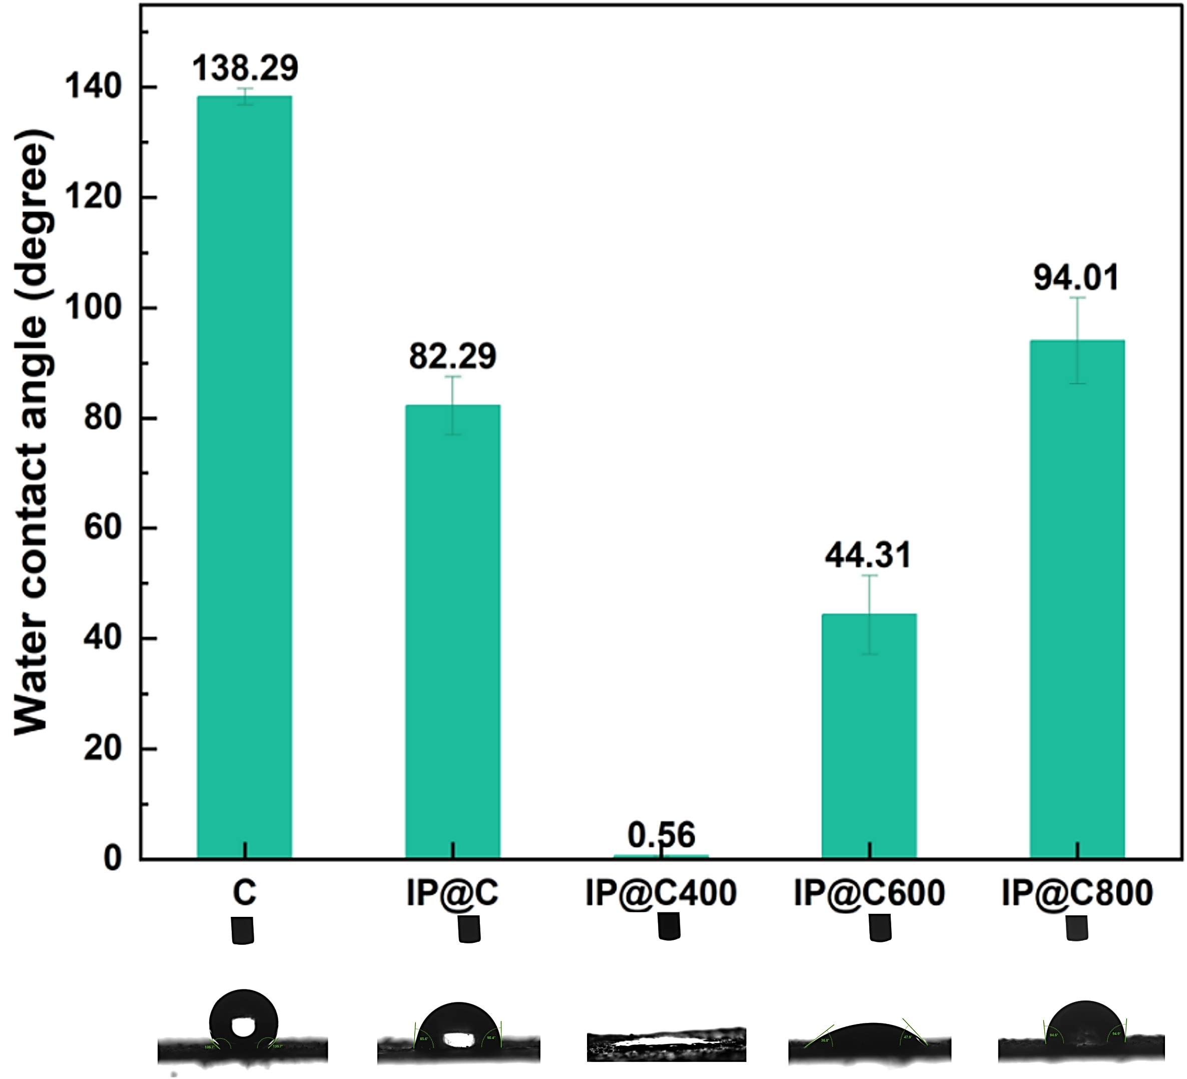 | 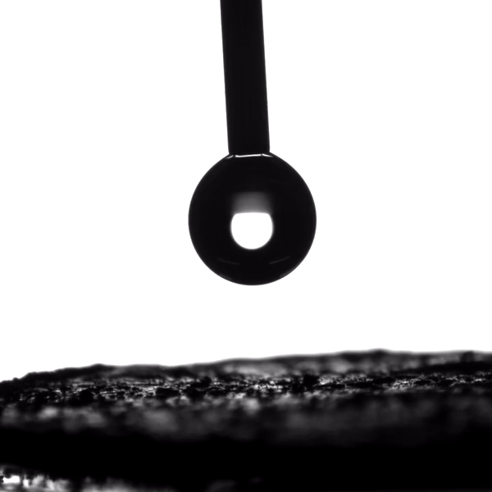
Figure S2. (A) Water contact angles of C, IP@C, IP@C400, IP@C600 and IP@C800 and (B) Illustration video of hydrophilic properties of IP@C400.
(B)
(A)
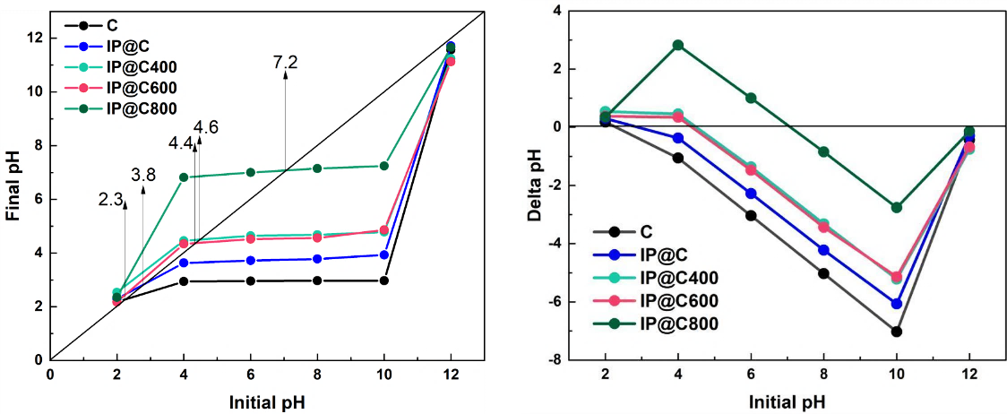
Figure S3. Zeta potential of C, IP@C, IP@C400, IP@C600 and IP@C800.
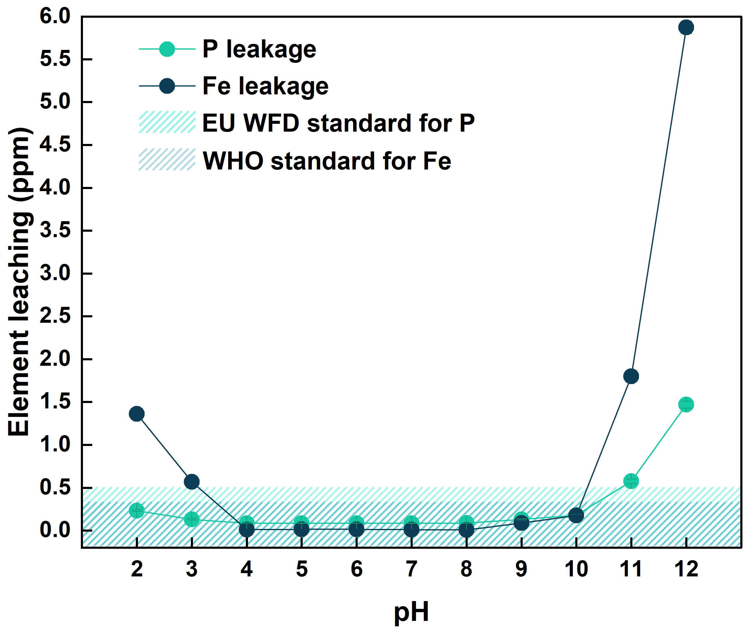
Figure S4. Effect of pH on the leaching of Fe and P from IP@C400 after urea adsorption by IP@C400
Table S1. Comparison between C, IP@C, IP@C400, IP@C600, IP@C800, and conventional adsorbents for urea removal. Data was taken from [1]
Type | Adsorbent | Q_{max} (mg/g)
Carbonaceous | BC-SC | 0.5
Carbonaceous | AC (1) | 0.6
Carbonaceous | AC (2) | 0.9
Carbonaceous | SAC_{60°C} | 0.9
Carbonaceous | SAC_{10°C} | 1.6
Carbonaceous | Graphene_{oxalic+citric} | 3.5
Carbonaceous | AC_{5.7°C} | 8.2
Carbonaceous | AC (3) | 13.6
Carbonaceous | AC-PKS_{400°C} | 140.0
Carbonaceous | AC-CS_{MW-100W, 10min} | 195.0
Carbonaceous | AC-WS_{MW} | 208.3
Carbonaceous | ACF-EFB_{Citric} | 210.0
Carbonaceous | AC-CS_{MW} | 256.41
Carbonaceous | AC-CS_{MW-360W, 10min} | 285.0
Carbonaceous | AC-CS_{MW-360W, 15min} | 312.0
Carbonaceous | AC-BS_{MW} | 312.5
Carbonaceous | ACF-EFB_{Phosphoric} | 320.0
Carbonaceous | GAC | 349.0
Carbonaceous | AC-PKS_{600°C} | 525.0
Carbonaceous | ACF-EFB_{Sulphuric, 1.5:19} | 543.6
Carbonaceous | ACF-EFB_{Sulphuric} | 545.0
Carbonaceous | ACF-EFB_{Sulphuric, 0.75:19} | 877.9
Inorganic | Zeolite 3A | 0.7
Inorganic | GAA | 2.9
Inorganic | Zeolite 5A | 5.4
Inorganic | MXene (Ti₃C₂Tx) | 7.8
Inorganic | Zeolite ZSM5-400 | 48.0
Inorganic | Zeolite HFAU | 218.0
Inorganic | Mesoporous SBA-15 | 250.0
Inorganic | Nanocomposite SBA-15/Fe₃O₄ | 490.0
Inorganic | Mesoporous SBA-15 | 500.0
Inorganic | Mesoporous SBA-15 | 710.0
Inorganic | Zeolite NaX (unmodified) | 1101.0
Inorganic | Nano-FePh | 1200.0
Inorganic | GABA modified Zeolite NaX | 1322.0
Inorganic | SBA-15-APTES-0.1 | 1605.0
Inorganic | SBA-15-APTES-0.2 | 1644.0
Organic | Chitosan-Magnetite nanocomposites | 3.3
Organic | Oxystarch | 3.3
Organic | Oxycellulose; 14 (COOH %) | 6.3
Organic | Gelatin-modified oxy starch | 6.4
Organic | Albumin-modified oxy starch | 8.2
Organic | Oxycellulose; 0.7 (COOH %) | 13.4
Organic | Chitosan/Cu²⁺ membrane | 20.3
Organic | Chitosan/Cu²⁺ | 22.0
Organic | Chitosan/Zn²⁺– glutaraldehyde microspheres | 41.6
Organic | Chitosan | 45.0
Organic | Macroporous chitosan/Cu²⁺ affinity membrane | 78.8
Organic | Chitosan/Cu²⁺; DD 54.23%, MW 10 × 10⁵ M | 83.6
Organic | Chitosan/Cu²⁺; DD 54.23%, MW 9.3 × 10⁵ M | 98.8
Organic | Chitosan/Cu²⁺; DD 72.47%, MW 6.5 × 10⁵ M | 109.1
Organic | Chitosan-glutaraldehyde copolymer (Chi: Glu; 1:0.0835) | 160.0
Organic | Oxidized starch nanoparticles | 168.0
Organic | Chitosan/Cu²⁺ glutaraldehyde complex (Chi: Glu; 1:0.585) | 262.0
This study | IP@C800 | 715.1
This study | C | 1073.9
This study | IP@C600 | 1398.2
This study | IP@C | 1604.0
This study | IP@C400 | 2242.9

Table S2. Characteristics of Irwol lake water (Irwol lake in Suwon, Korea. Coordinates: 37°17'17"N 126°58'23"E.)
Tur. (UNT) | TOC (ppm) | pH | Urea (ppm) | TN (ppm) | Anion concentration (mM) |  |  |  |  | Cation concentration (mM)
 |  |  |  |  | F⁻ | Cl⁻ | NO₃⁻ | SO₄²⁻ | CO₃²⁻ | PO₄³⁻ | Na⁺ | K⁺ | Mg²⁺ | Ca²⁺
7.80 | 7.62 | 8.20 | 0.91 | 2.12 | 0.48 | 0.09 | 0.02 | 0.20 | 0.31 | 0.33 | 0.49 | 0.16 | 0.11 | 0.48

- References
[1] D. Weerakoon, B. Bansal, L.P. Padhye, A. Rachmani, L. James Wright, G. Silyn Roberts, S. Baroutian, A critical review on current urea removal technologies from water: An approach for pollution prevention and resource recovery, Sep Purif Technol. 314 (2023) 123652. https://doi.org/10.1016/J.SEPPUR.2023.123652.

