Supplementary material
Supplementary material 1 The Absolute standardized mean differences to evaluate the balance of covariates between the two groups
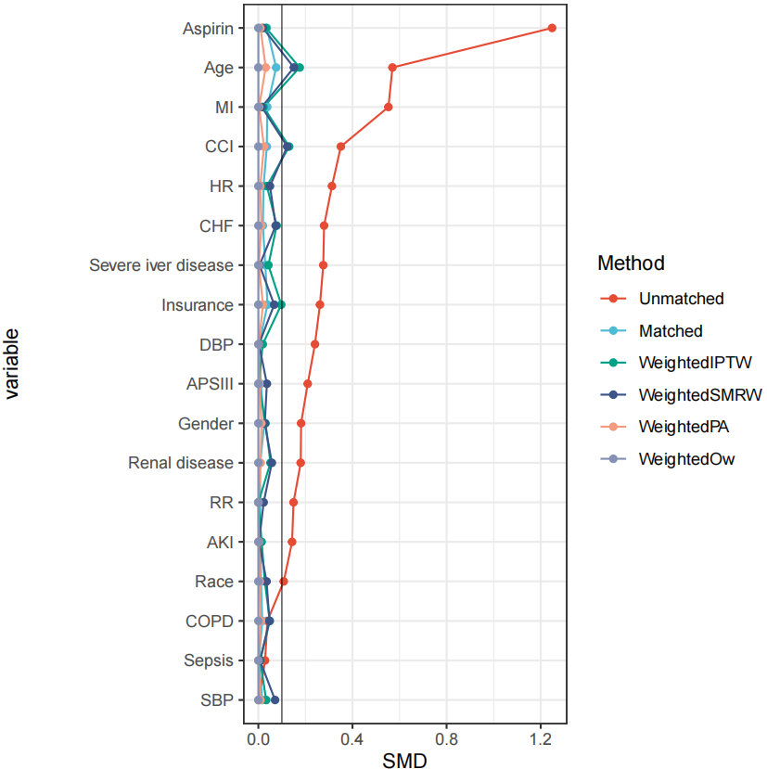

Supplementary material 2 Multivariable analysis in the entire cohort (N = 50624)
Variable | n.total | 28-day Mortality% | HR(95%CI) | P_value
Model 1:Statin use
No statins | 34994 | 5232 (15) | 1(Ref)
Statins | 15630 | 1236 (7.9) | 0.66 (0.61~0.7) | <0.001
Model 2: Type of statin
No statins | 34994 | 5232 (15) | 1(Ref)
Atorvastatin | 9593 | 822 (8.6) | 0.71 (0.66~0.78) | <0.001
Rosuvastatin | 1152 | 68 (5.9) | 0.57 (0.45~0.72) | <0.001
Simvastatin | 3710 | 248 (6.7) | 0.54 (0.48~0.62) | <0.001
Other statins | 1175 | 98 (8.3) | 0.68 (0.56~0.83) | <0.001

