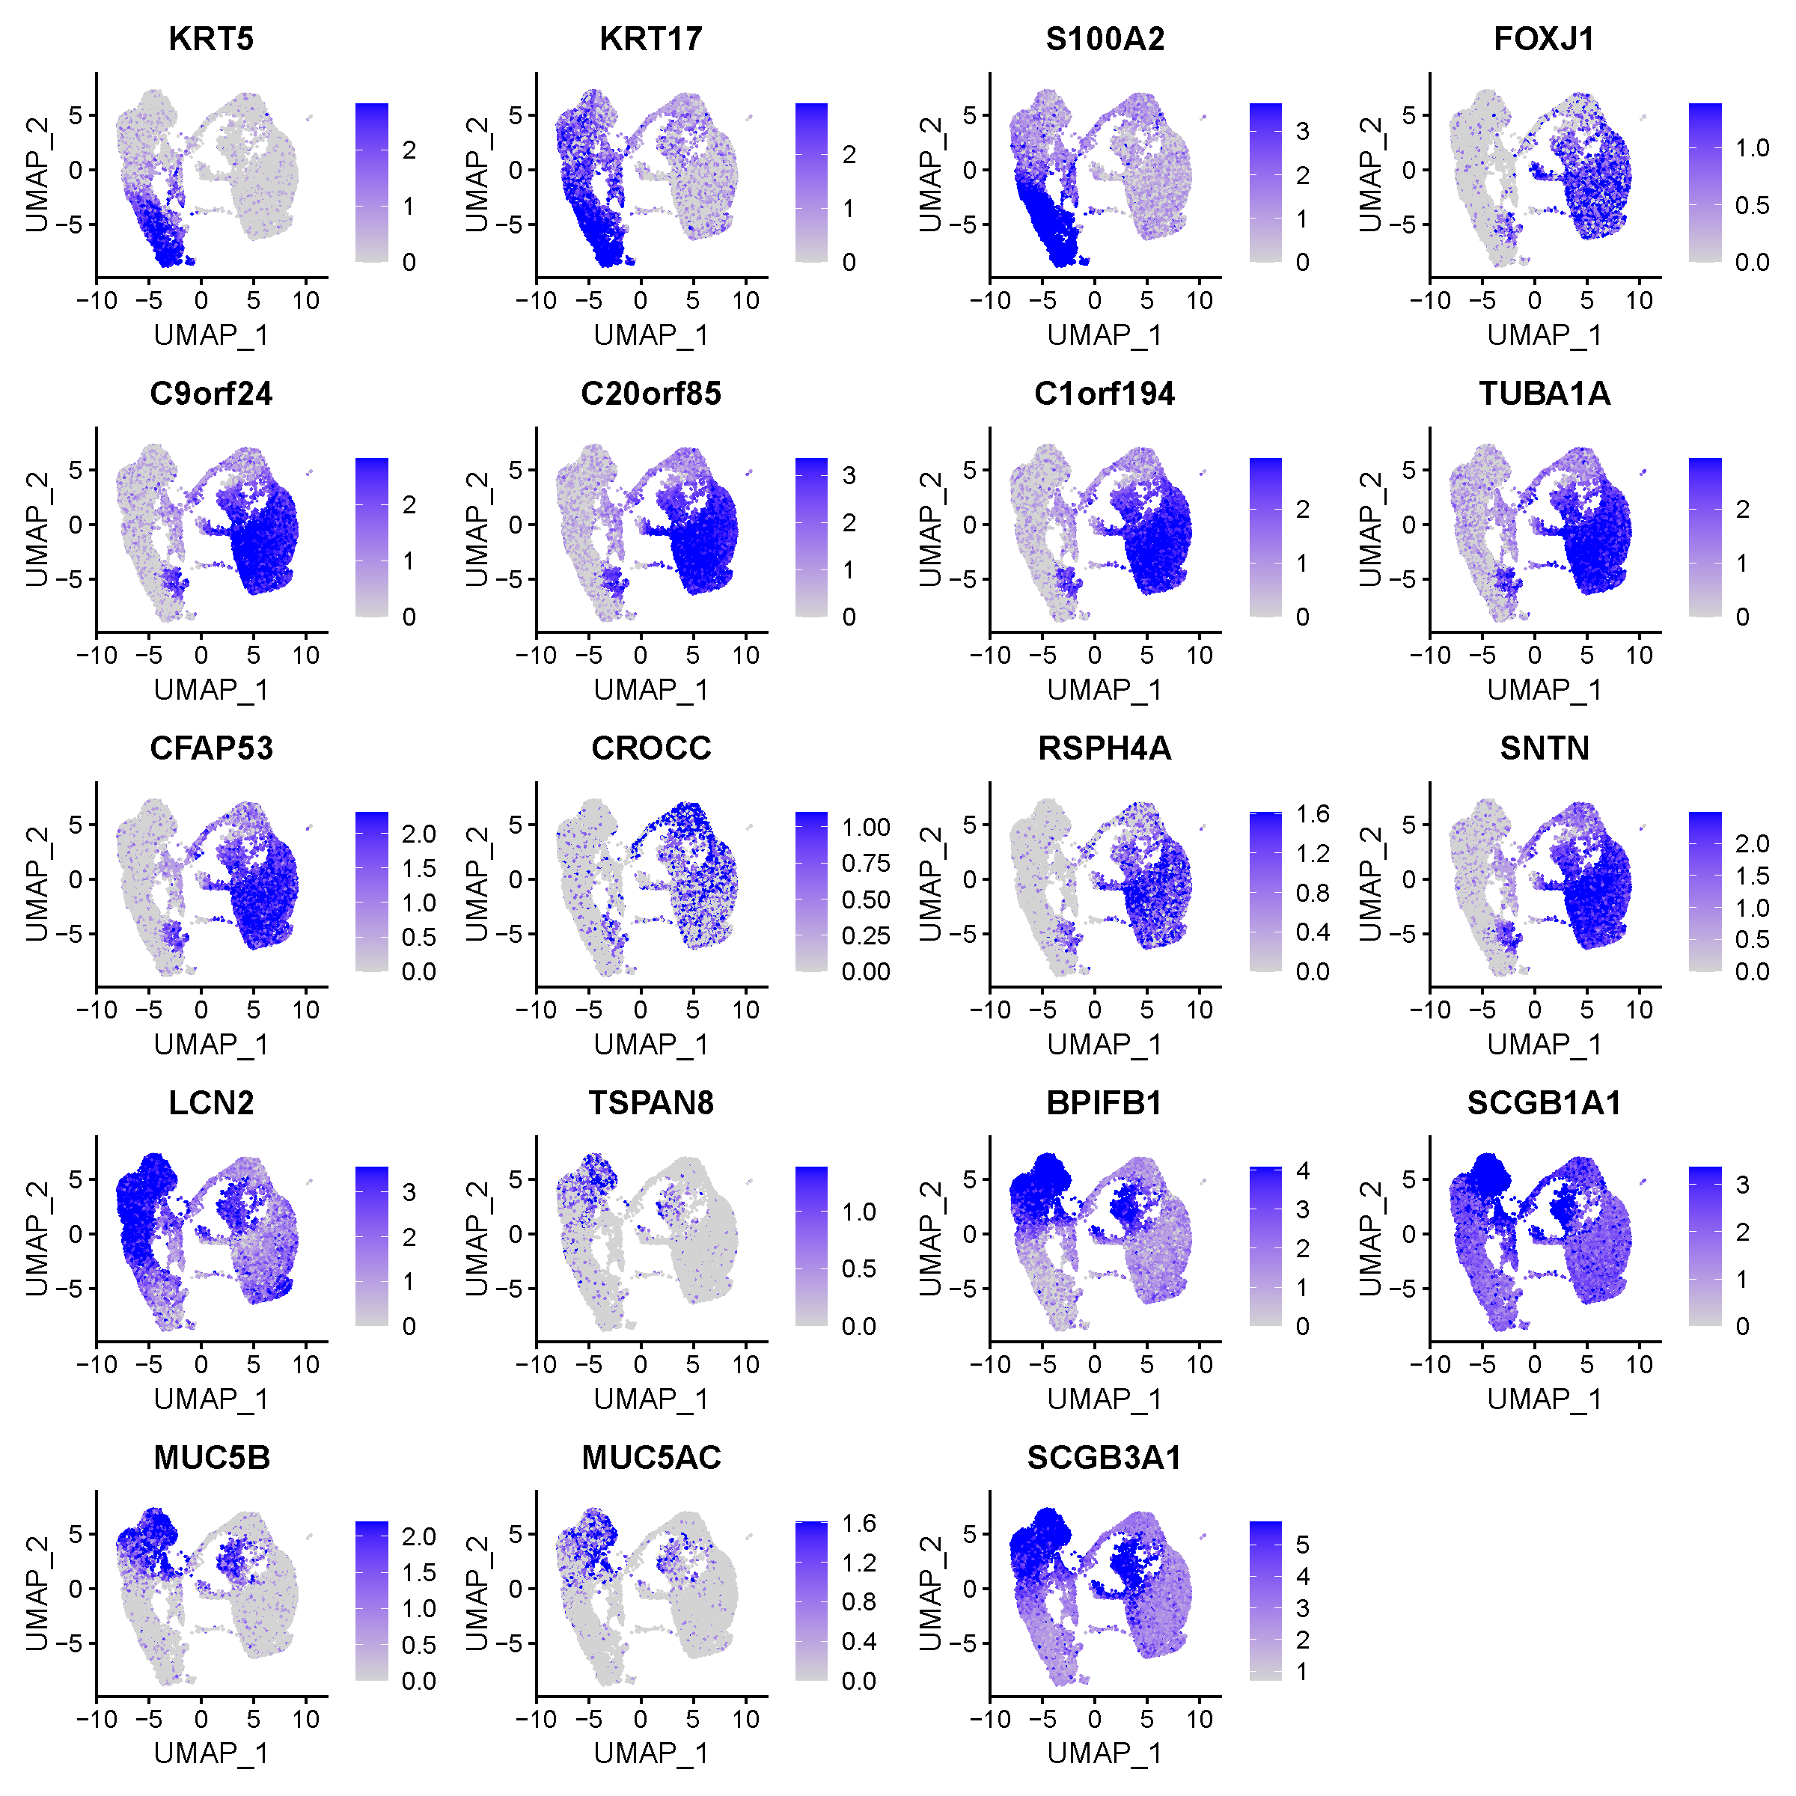
Figure S1. The expression of top marker genes of ALI-HBE.

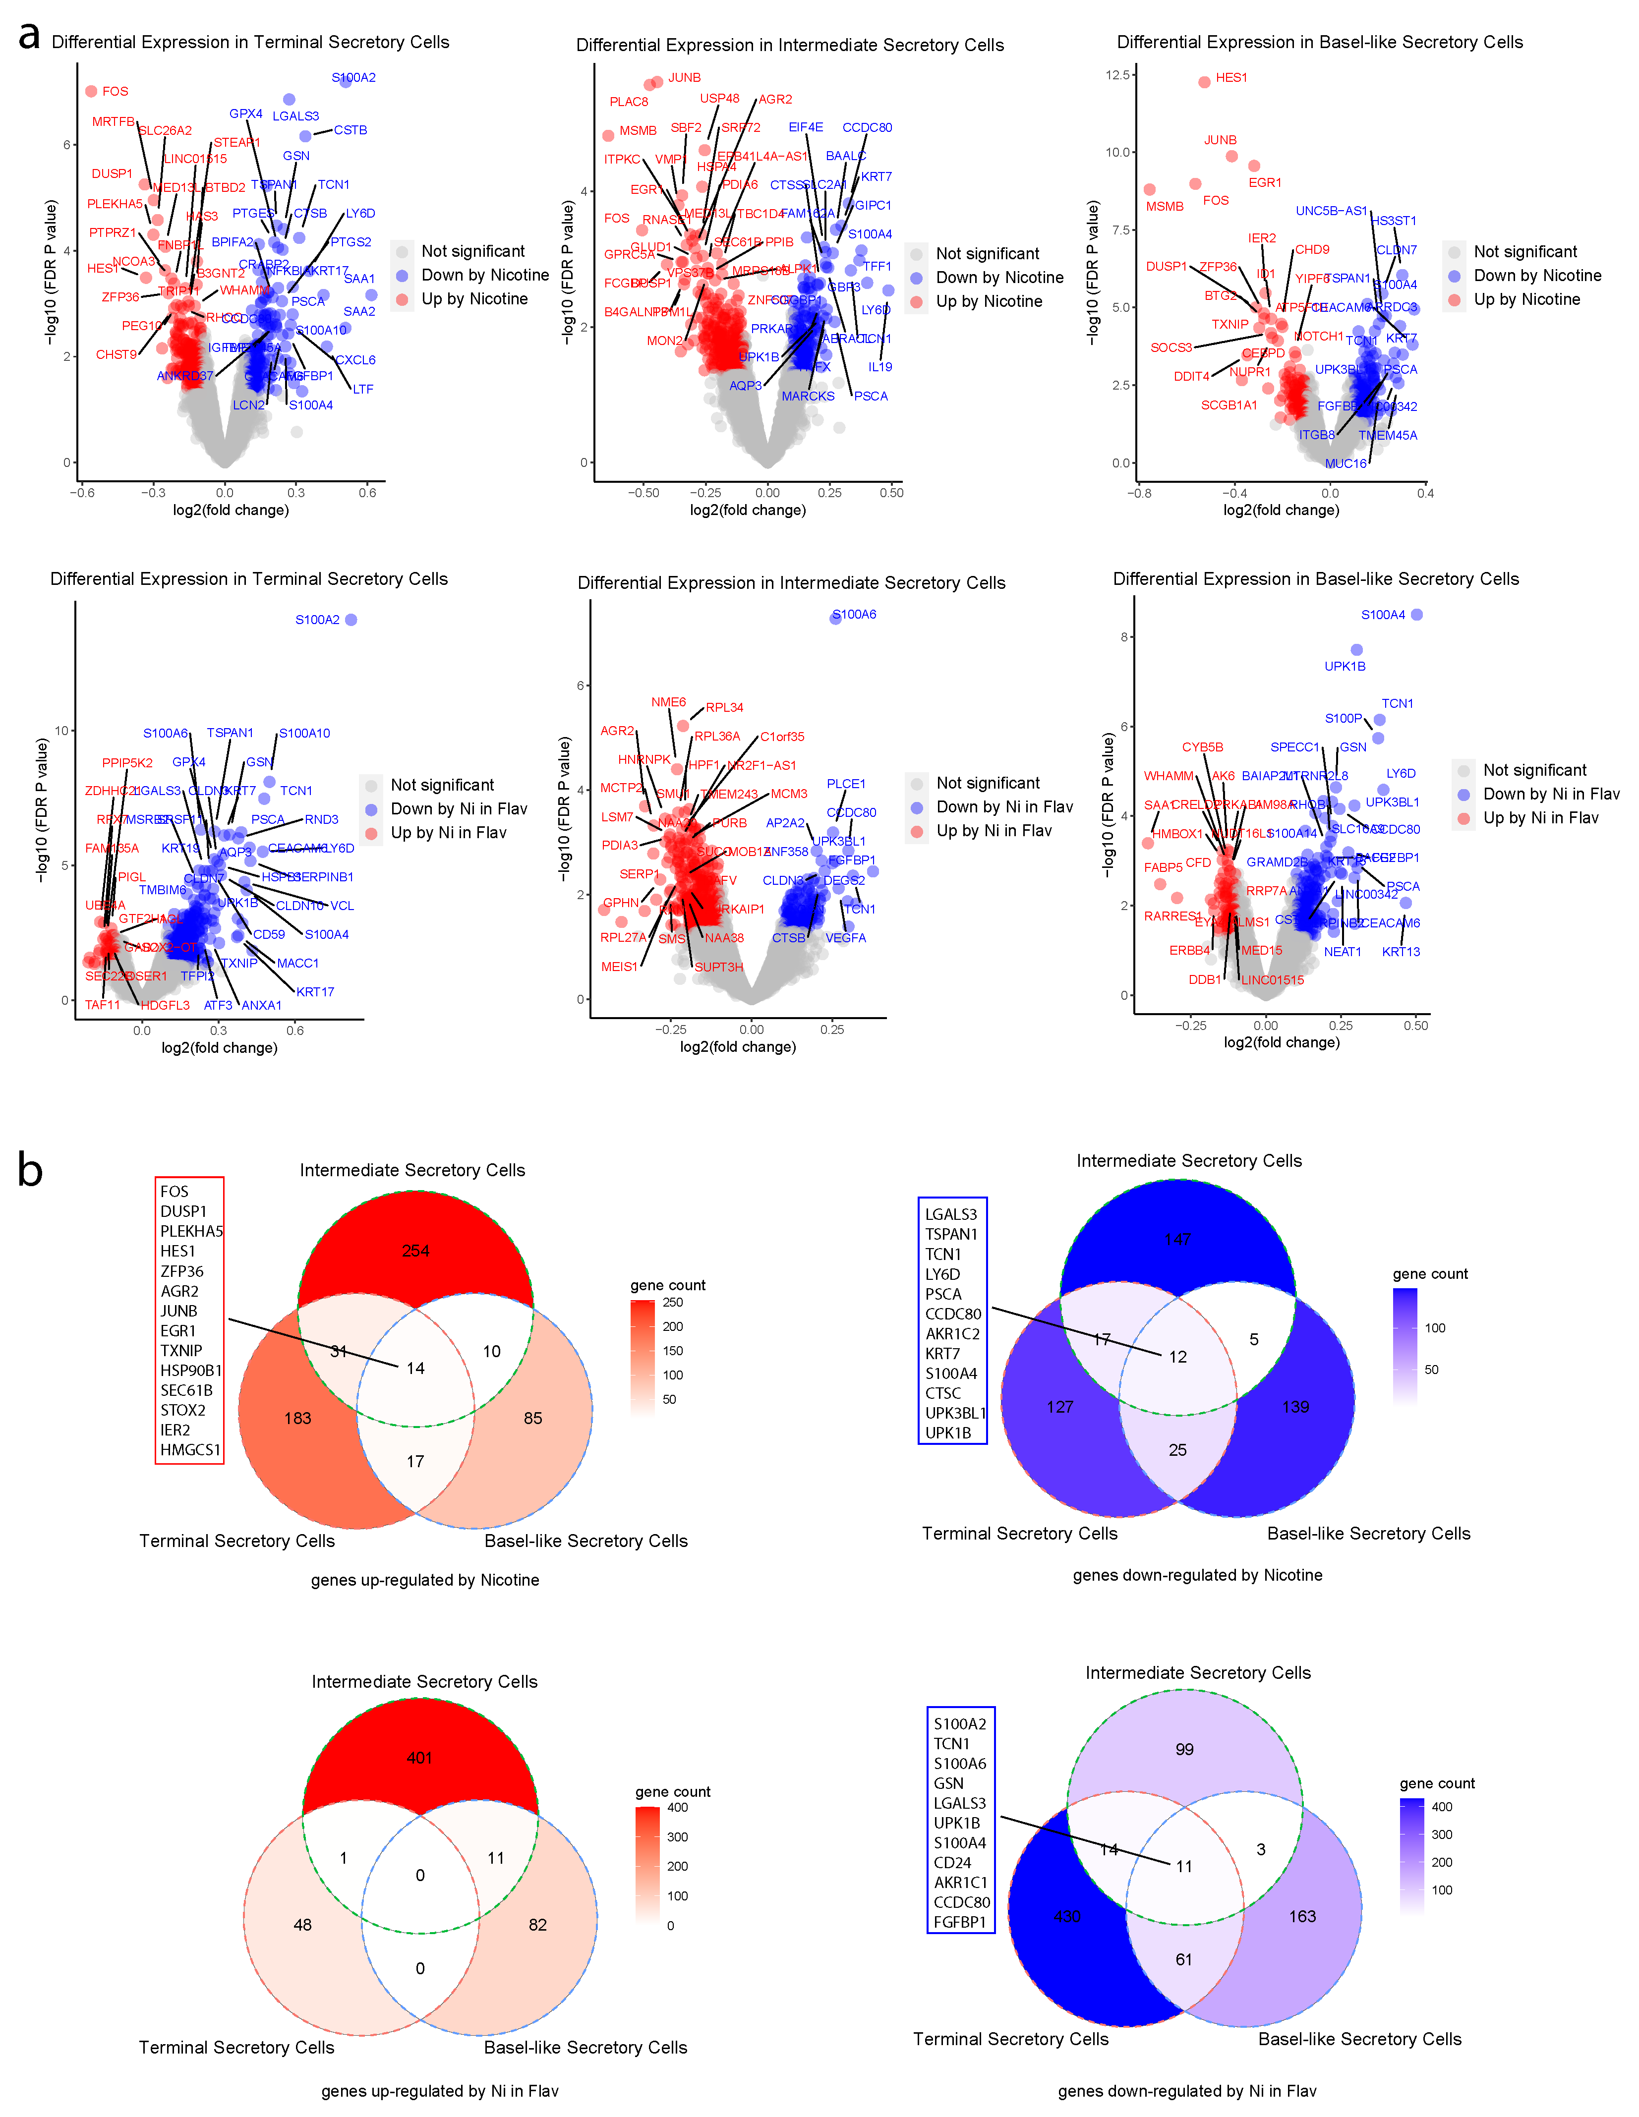
Figure S2. Gene differential expressions among subtypes of secretory cells. (a) Volcano plots of gene differential expressions between samples treated with or without nicotine. (b) Venn diagrams of nicotine regulated genes among all subtypes in secretory cells.

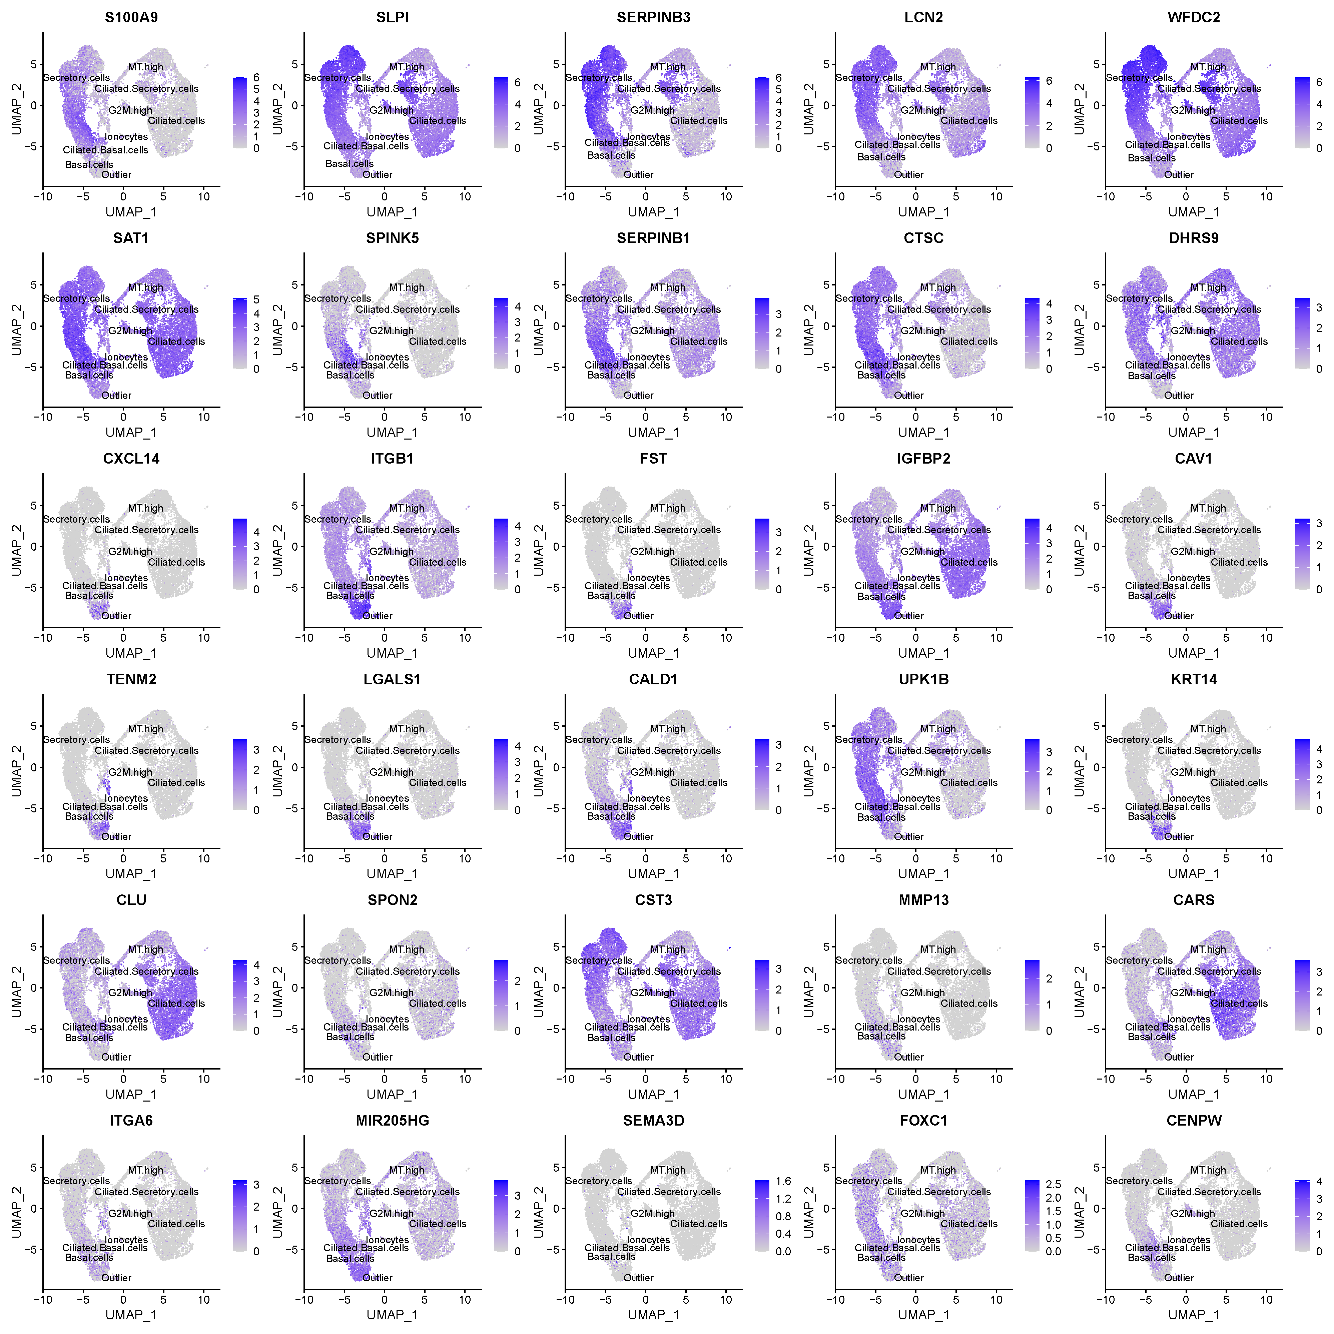
Figure S3. The expression of top marker genes of basal cell subgroups.

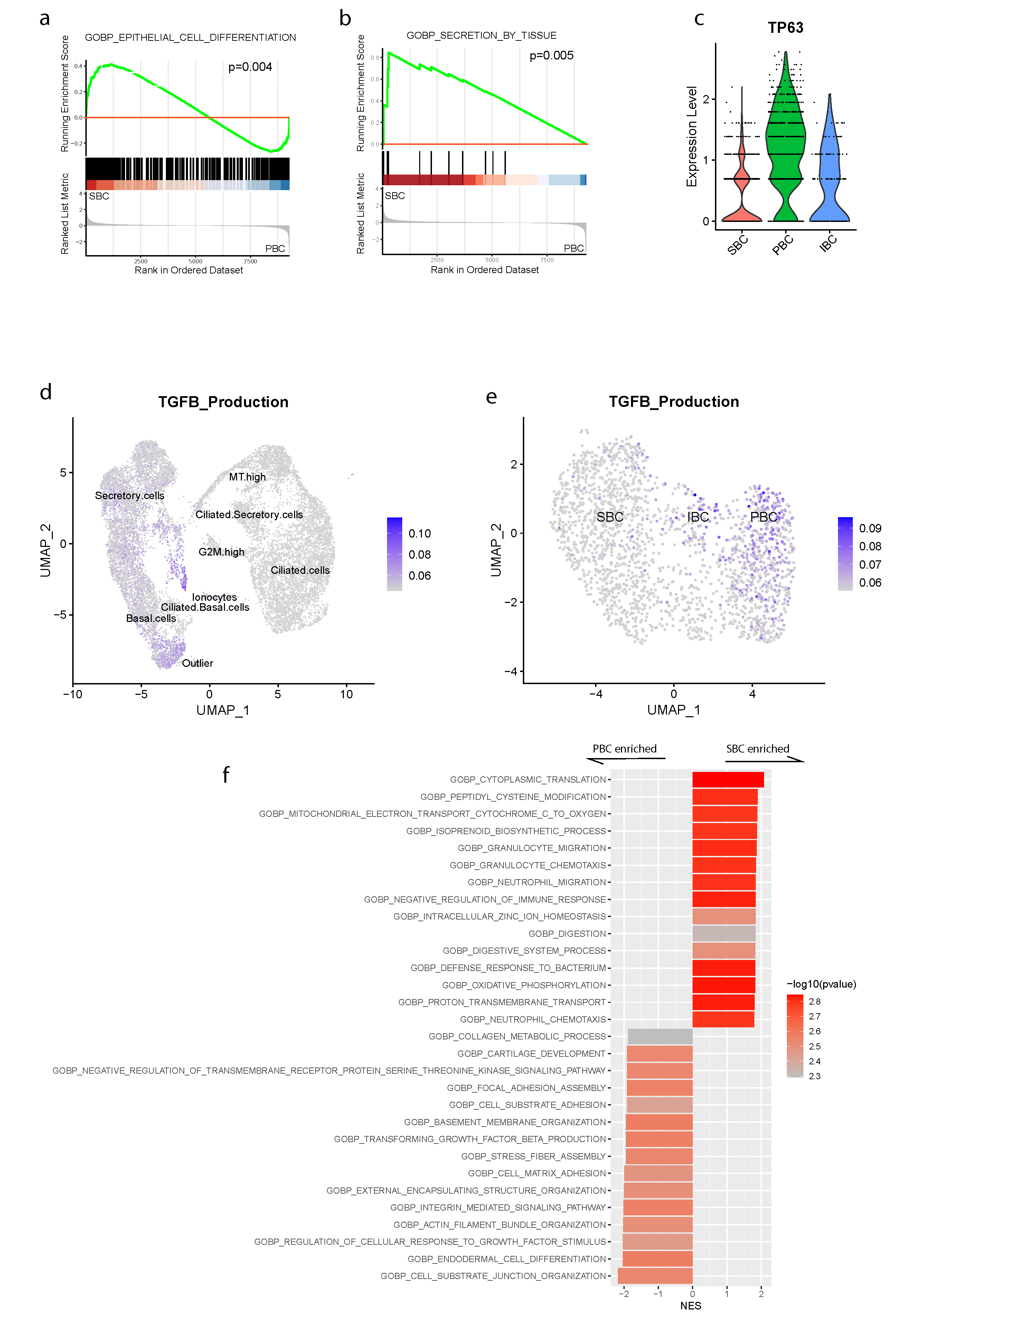
Figure S4. Gene set enrichments in basal cell subgroups. (a) Enrichment plot of GO biological process: epithelial cell differentiation; (b) Enrichment plot of GO biological process: secretion by tissue; (c) Violin plot of TP63 in basal cell subgroups; (d) UMAP plot of TGFB production scores in total cells; (e) UMAP plot of TGFB production scores in basal cells; (f) Barplot of enriched GO biological processes.

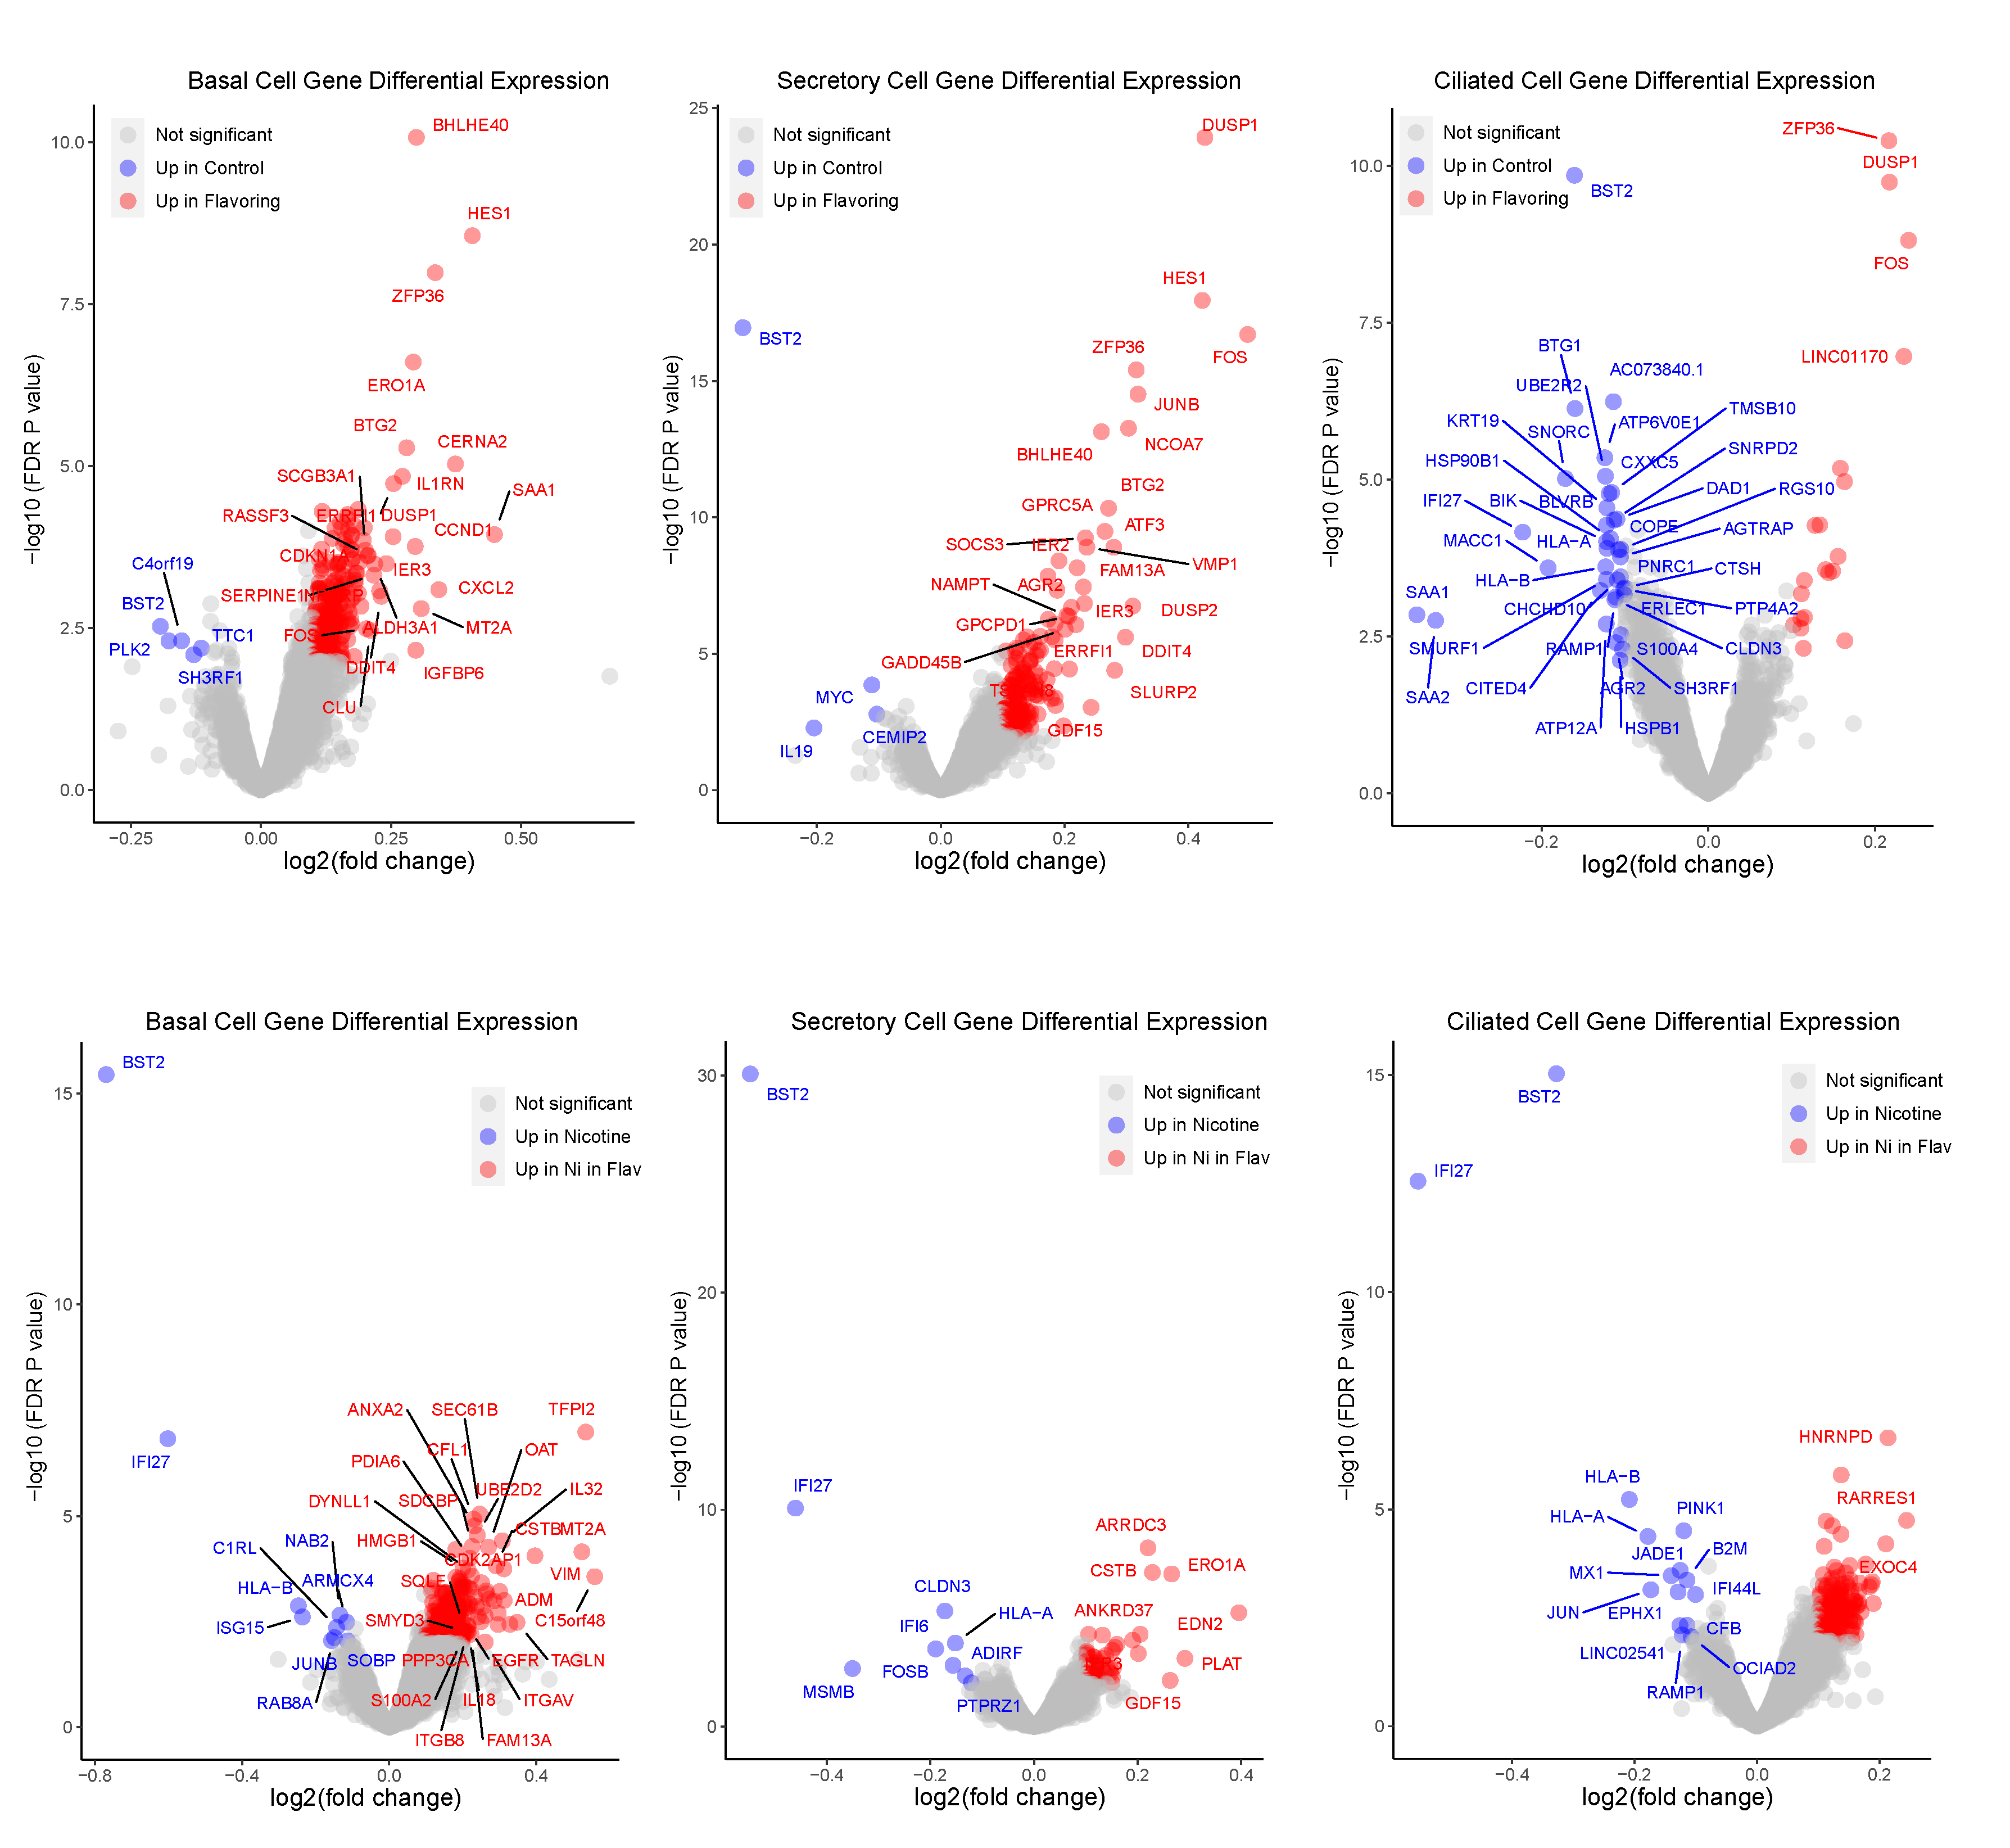
Figure S5. Volcano plots of gene expressions after exposure to flavoring with or without nicotine.

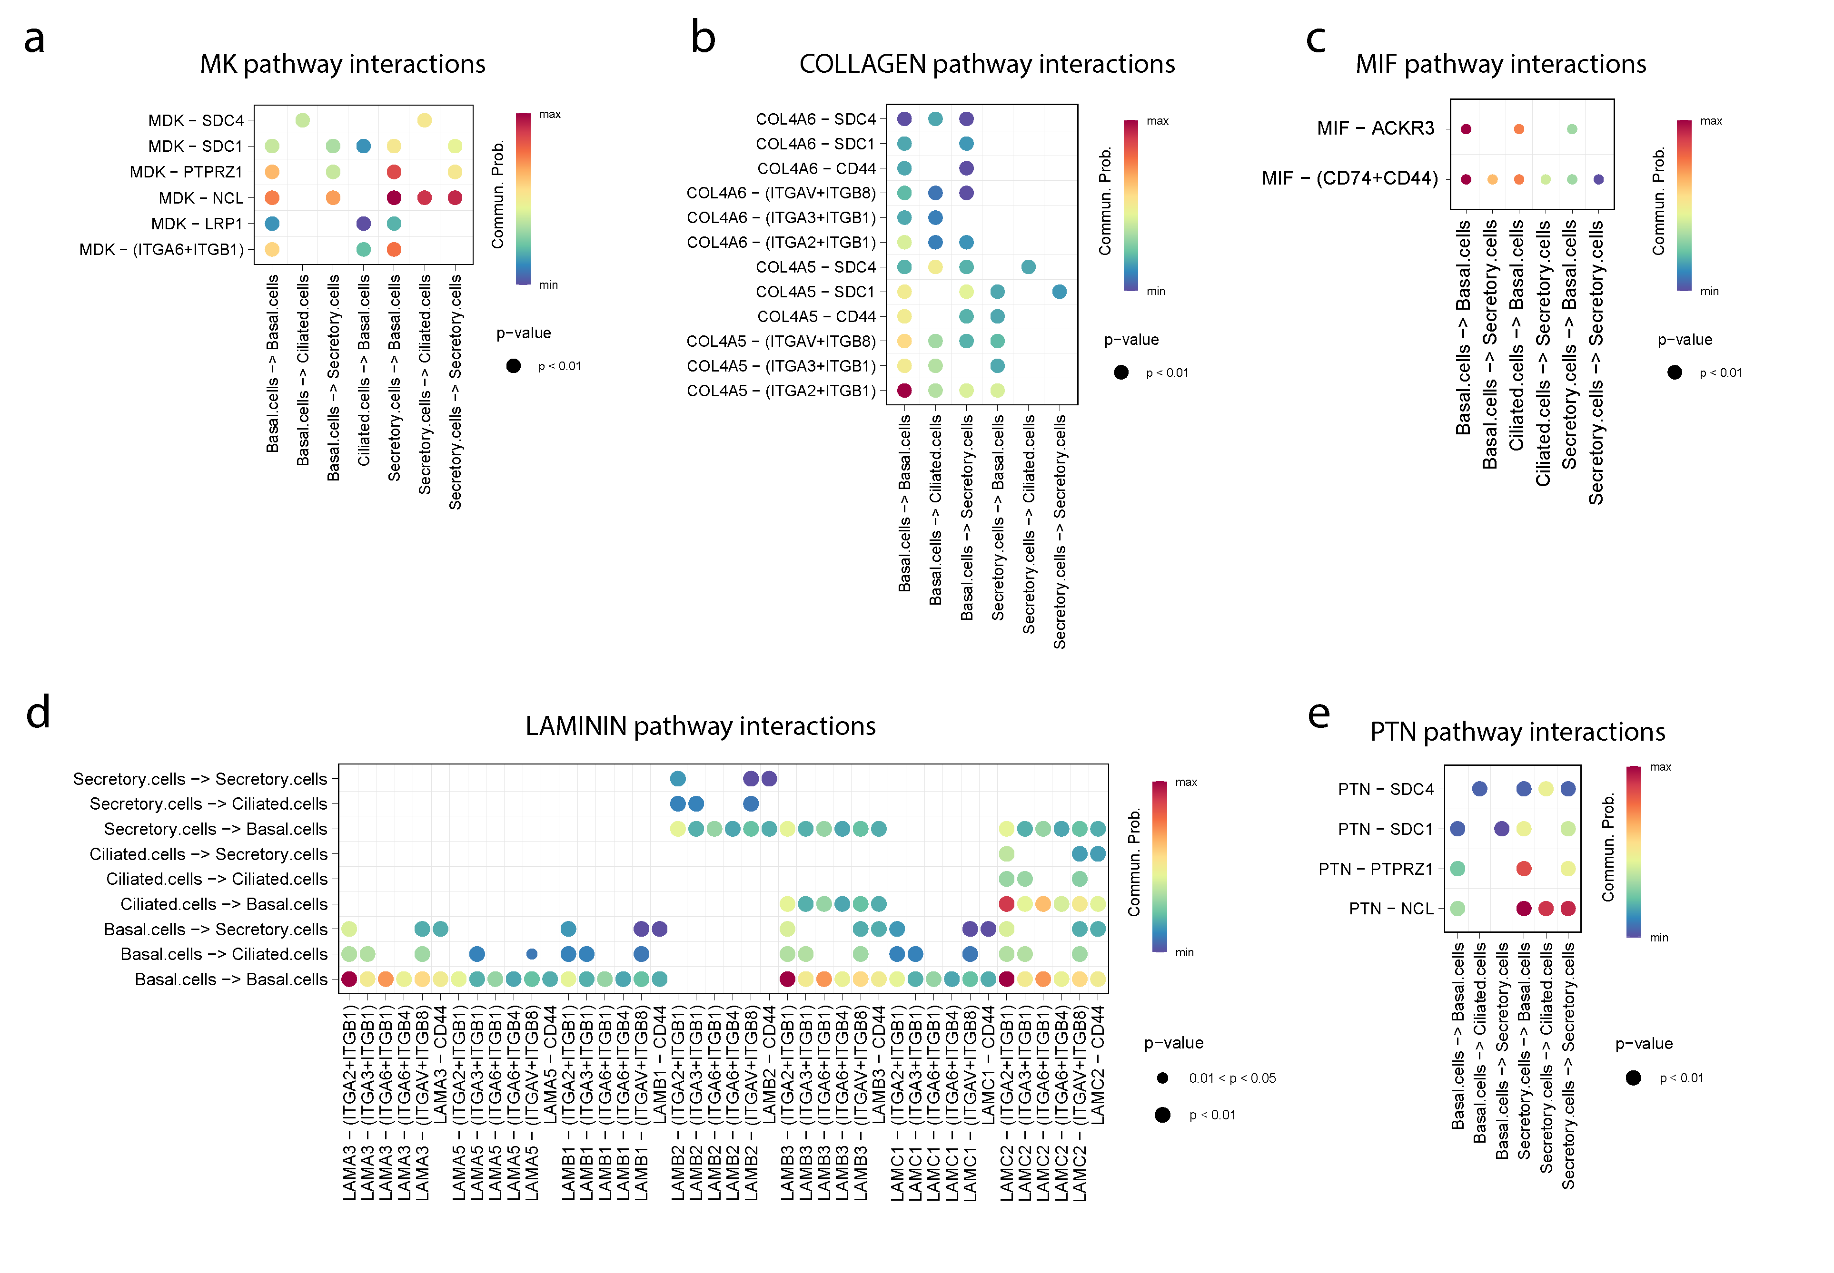
Figure S6. Dot plots of cell interactions between cell types. (a) MK pathway interactions. (b) COLLAGEN pathway interactions; (c) MIF pathway interactions; (d) LAMININ pathway interactions; (e)PTN pathway interactions.

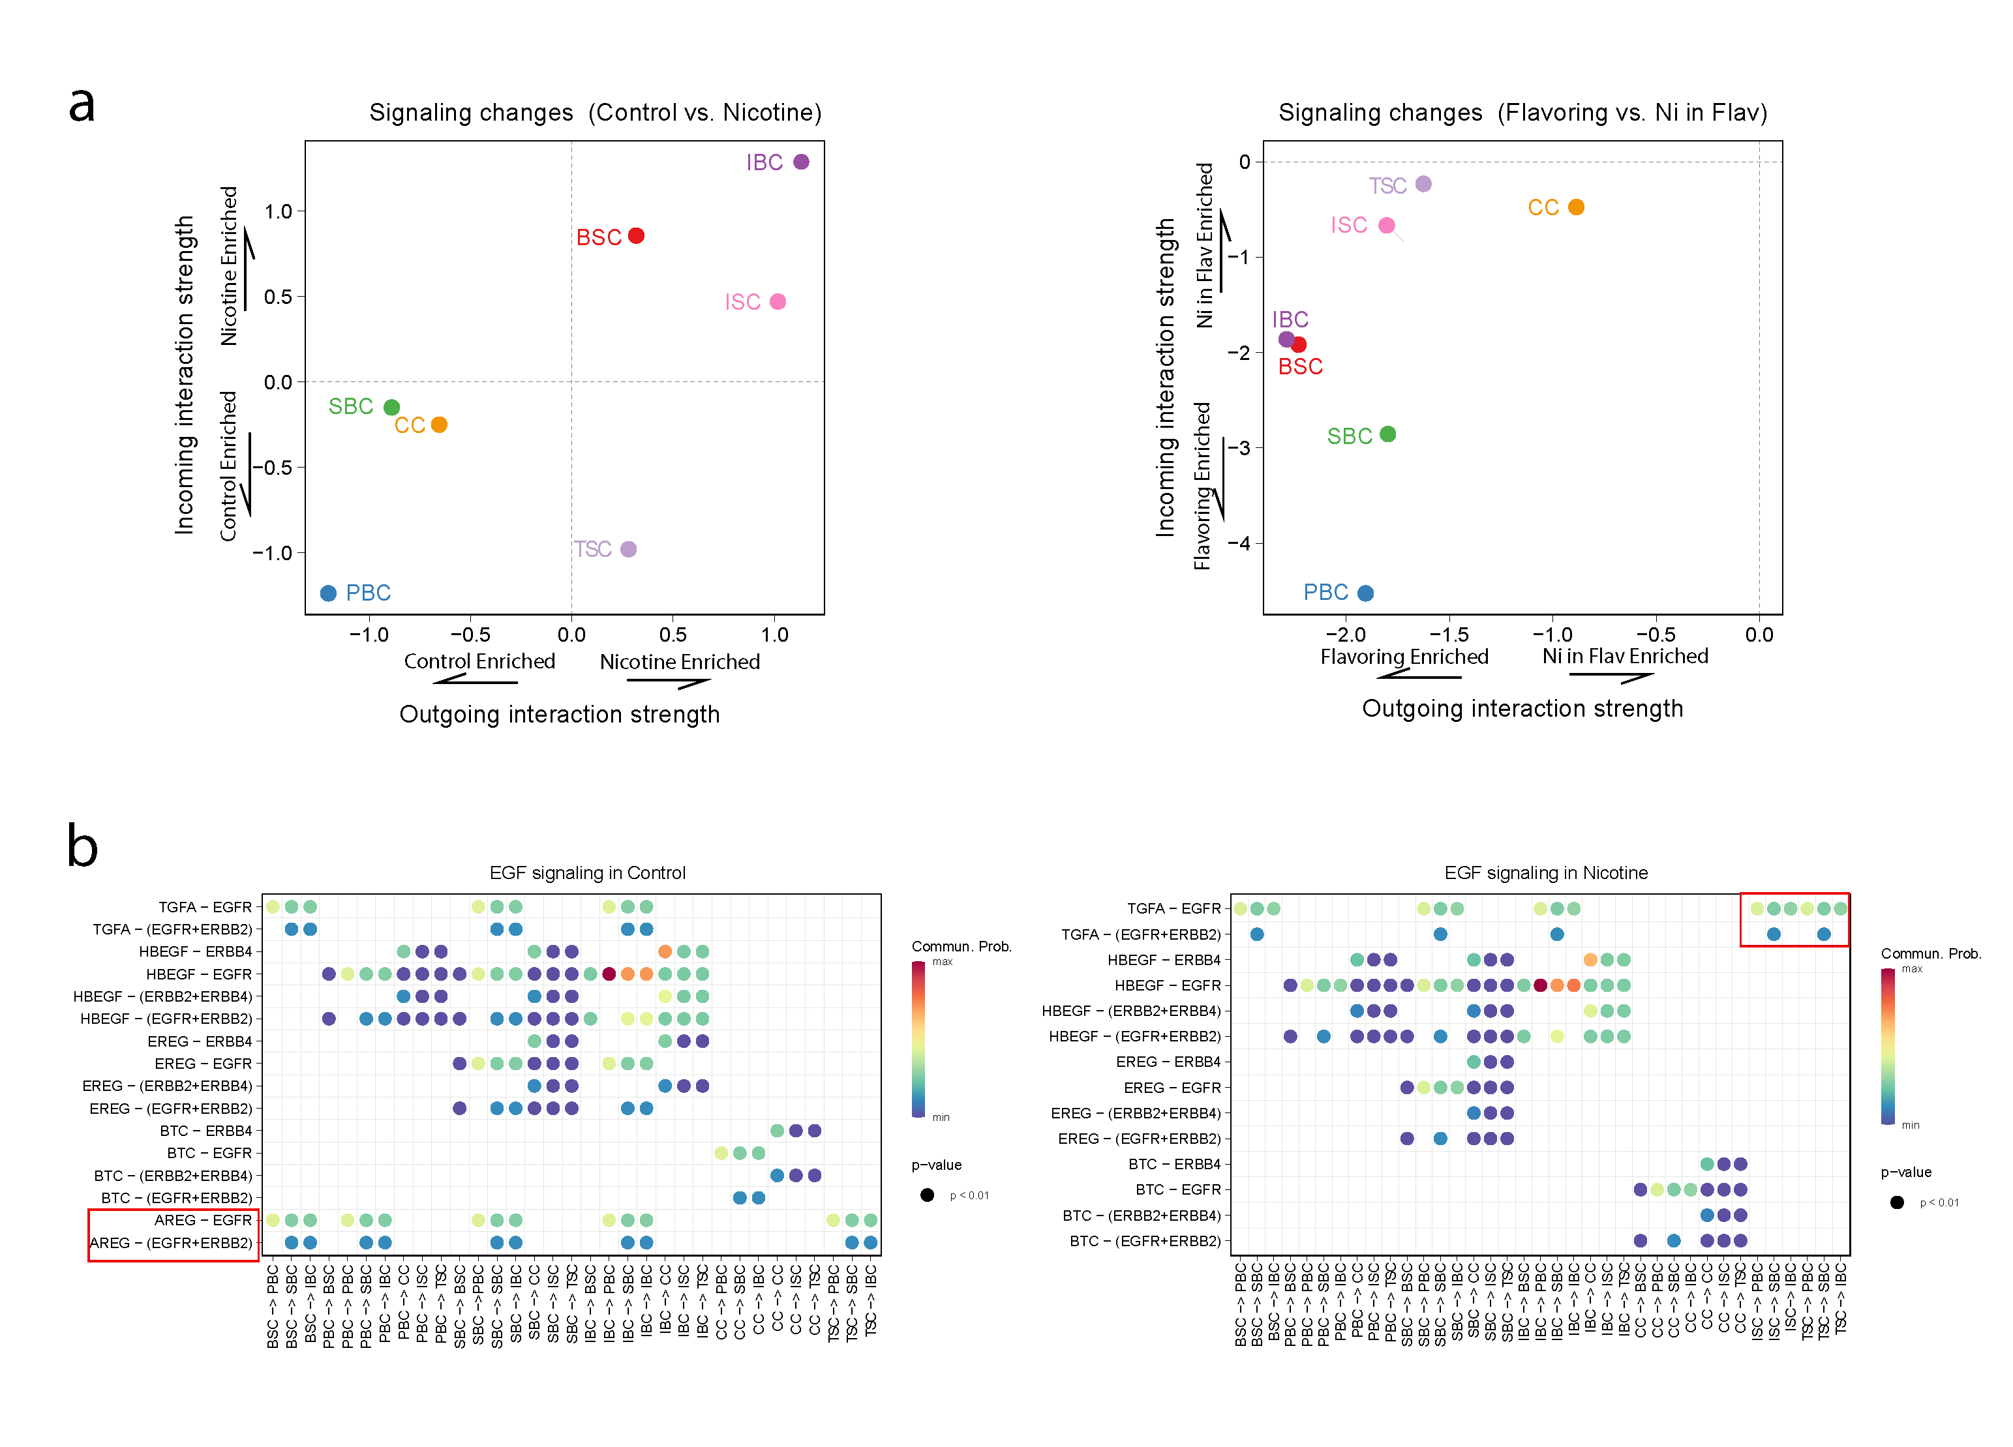
Figure S7. Cell role switching after exposure to nicotine. (a) Dot plot of cell role changing after exposure to nicotine. (b) Dot plot comparing EGF signaling interactions after exposure to nicotine.

