Figure S1: Association between treatment with TDF vs. ETV in HPMH patients who underwent hepatectomy stratified by baseline characteristics and prognostic factors: OS
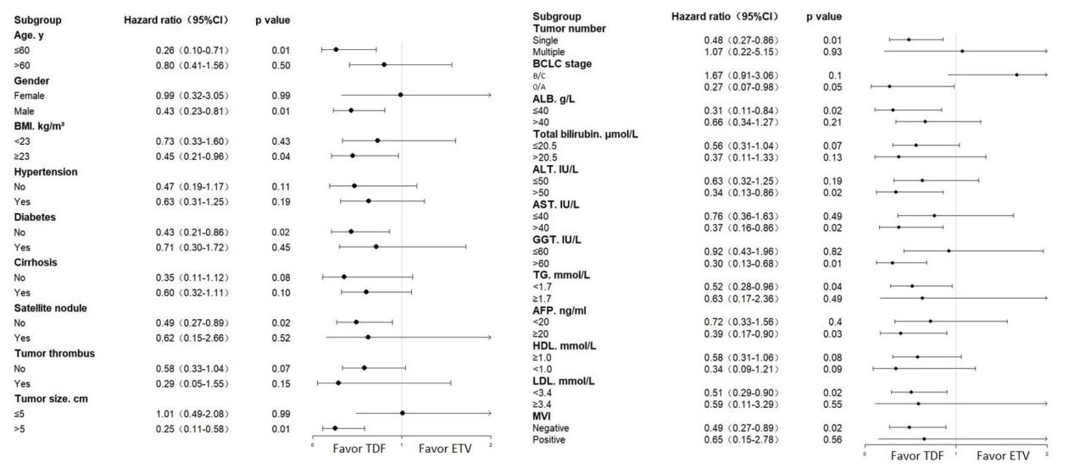
Figure S2: Association between treatment with TDF vs. ETV in HPMH patients who underwent hepatectomy stratified by baseline characteristics and prognostic factors: RFS
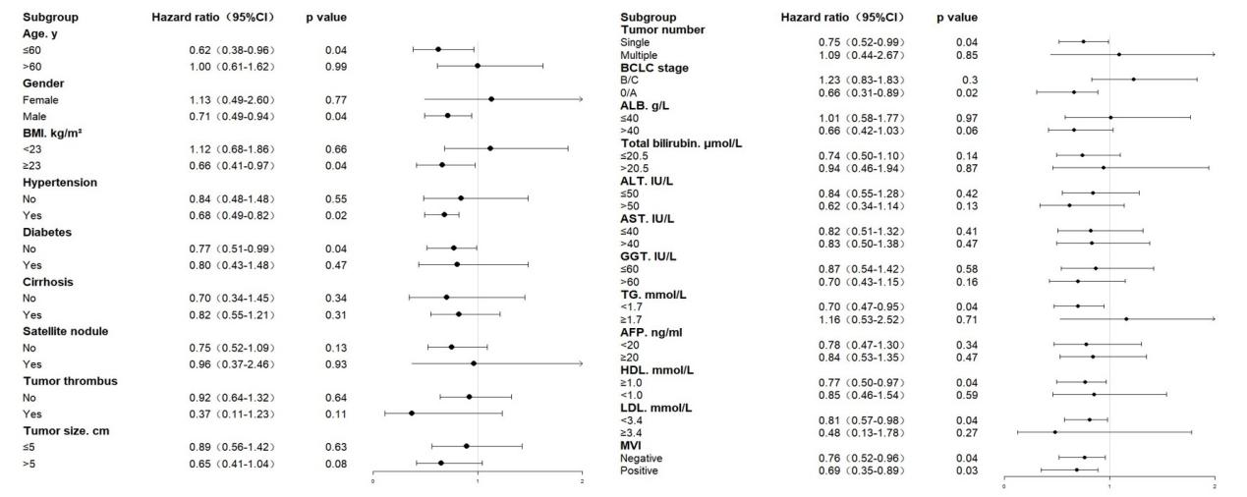

Figure S3: Kaplan–Meier curves of HCC early recurrence (E) and late recurrence (F) in the two groups. HCC recurrence is typically stratified as either early or late recurrence, with a postoperative period of 2 years frequently serving as the definitive cutoff
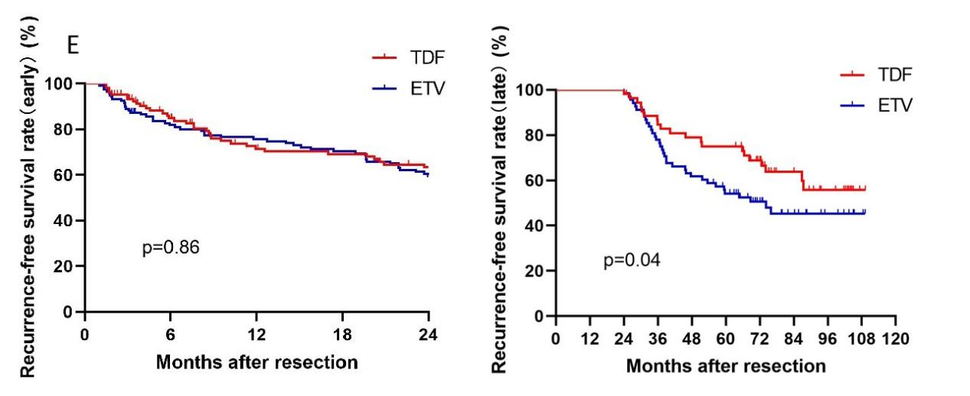

Figure S4: Bar chart depicting changes in TG (triglyceride) and LDL (low-density lipoprotein) levels in patients before and 6 months after surgery, with asterisks (*) indicating p-values less than 0.05.
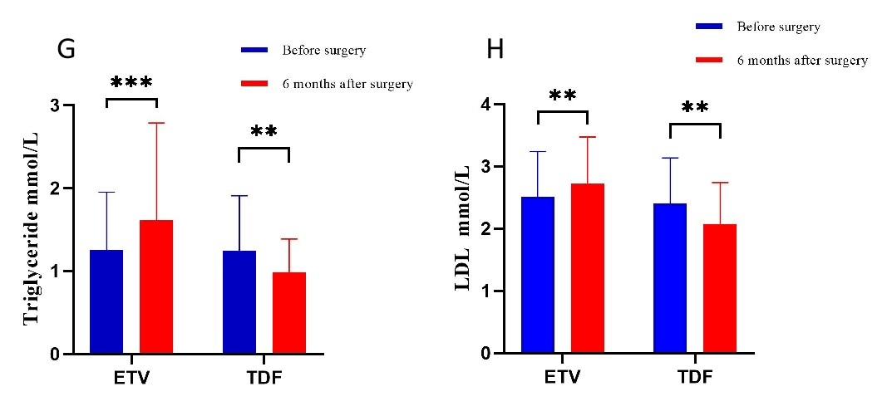

Details of the approval document from the Ethics Committee of West China Hospital, Sichuan University.
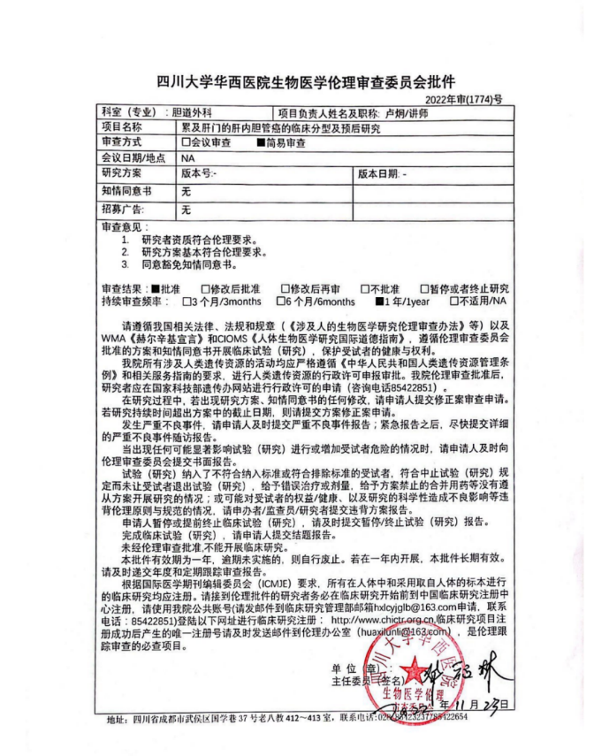

A sample informed consent form

