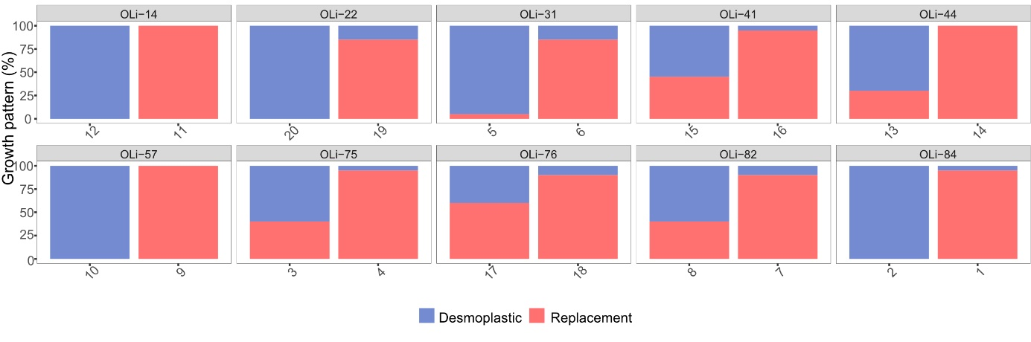
Supplementary Fig 1: HGP distribution. For each patient, we selected two slides from the metastasis with more than 30% of each growth pattern. Blue= desmoplastic; Red= Replacement.

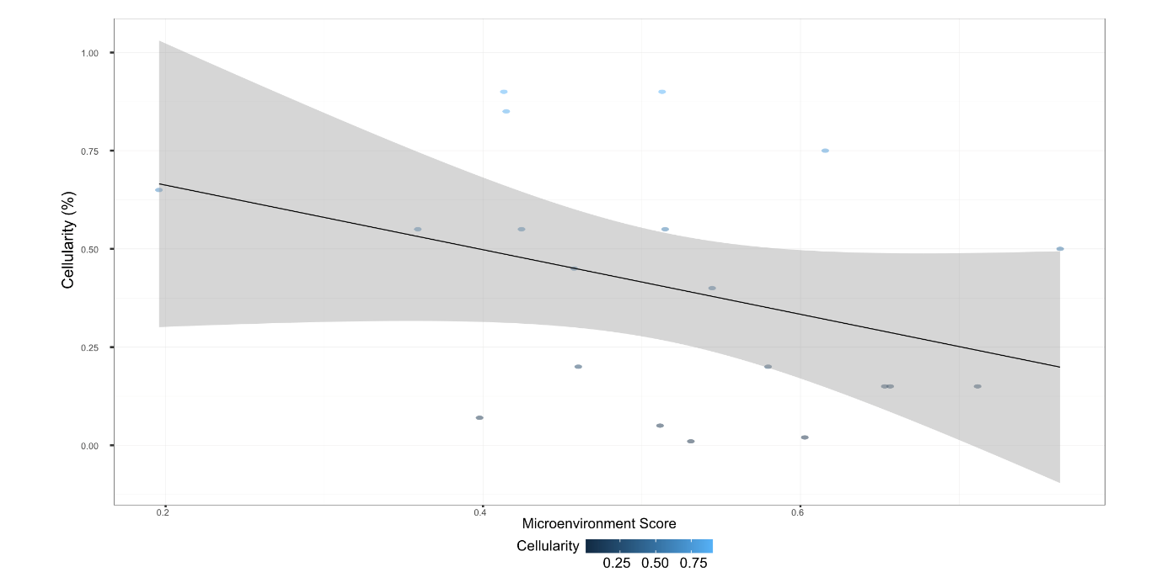
Supplementary Fig 2: Correlation between Tumor Cellularity and Microenvironment Score (MES) (Spearman correlation coefficient= -0.376; p-value=0.102).

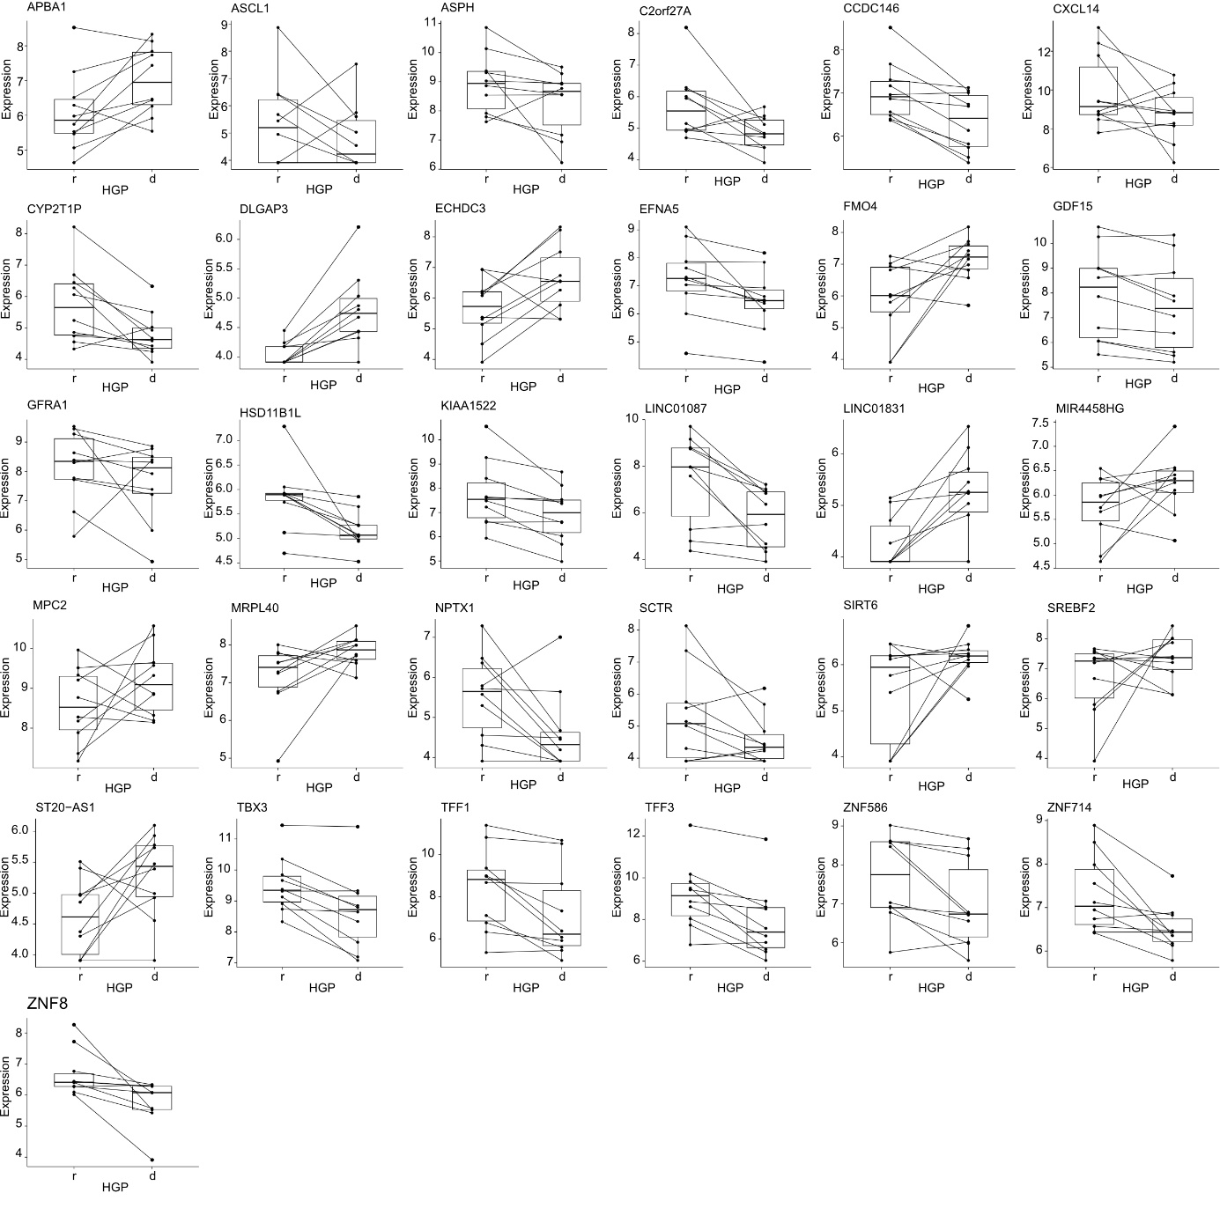
Supplementary Fig 3: Normalized expression of the 31 differential genes according to HGP detected by differential gene expression analyses. Genes with |logFC| > 0.5 and a p-value < 0.01 in analysis with cellularity as covariate were shown. Additionally, genes with |logFC| > 0.5 and p-value < 0.01 in both analyses (cellularity as covariate, and MES as covariate) were also shown. . Abbreviations: r= replacement; d= desmoplastic.

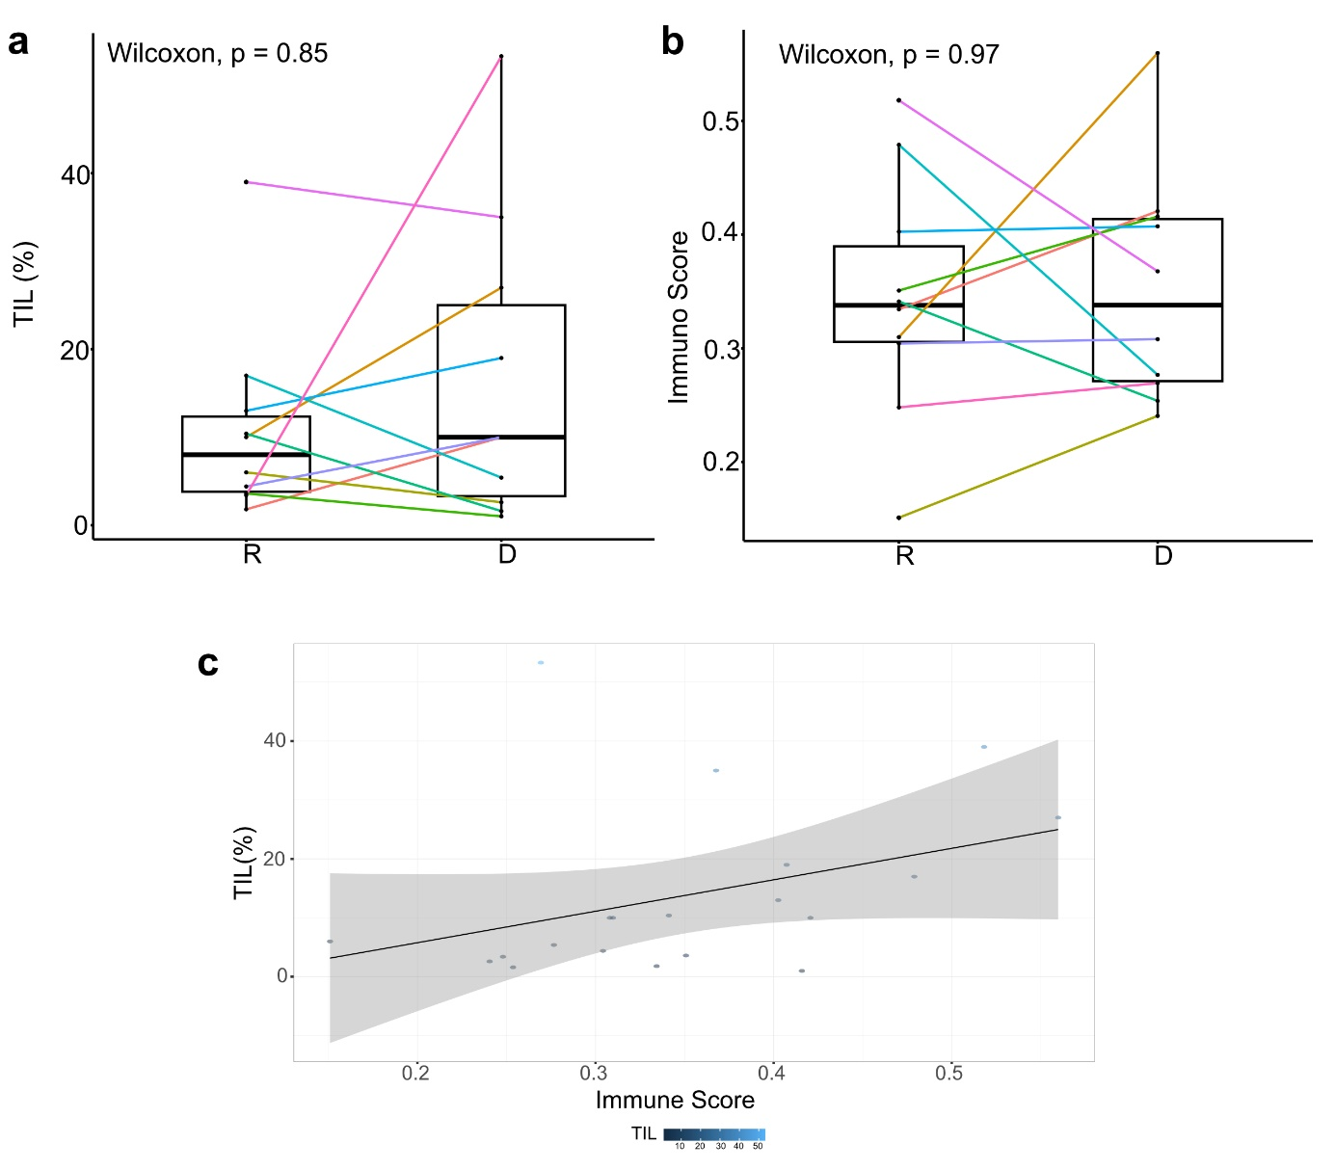
Supplementary Fig 4: TIL distribution and Correlation between TIL and ImmunoScore. a. TIL scores according to the HGP (Wilcoxon p-value=0.85). b. Immune Score according to the HGP (Wilcoxon p-value=0.97). c. Correlation between the TIL score and the Immune Score calculated by xCell (Spearman correlation coefficient = 0.464; p-value = 0.039). Abbreviations: R= Replacement; D= Desmoplastic; One color per patient ID.
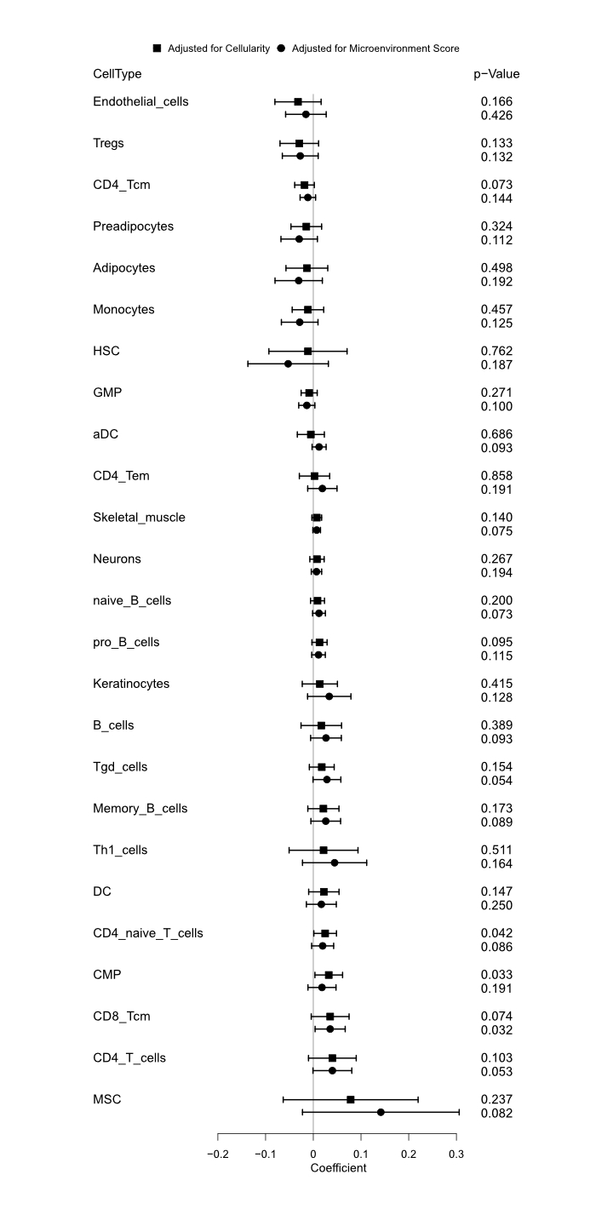
Supplementary Figure 5: Association of immune cell types with HGP. The associations were estimated by linear mixed models adjusted for the Cellularity and the Microenvironment Score (MES). Cell types with a p-value < 0.2 in one of the two models are shown. A positive estimate indicates a positive association with the r-HGP. Abbreviations: Tcm = central memory T cells; HSC =Hematopoietic stem cells; GMP = Granulocyte-macrophage progenitors; Th1= Type 1 T-helper cells; DC= dendritic cells; aDC = activated dendritic cells; Tgd cells = gamma-delta T cells; CMP = common myeloid progenitor; MSC = mesenchymal stem cells.

