Appendix-A

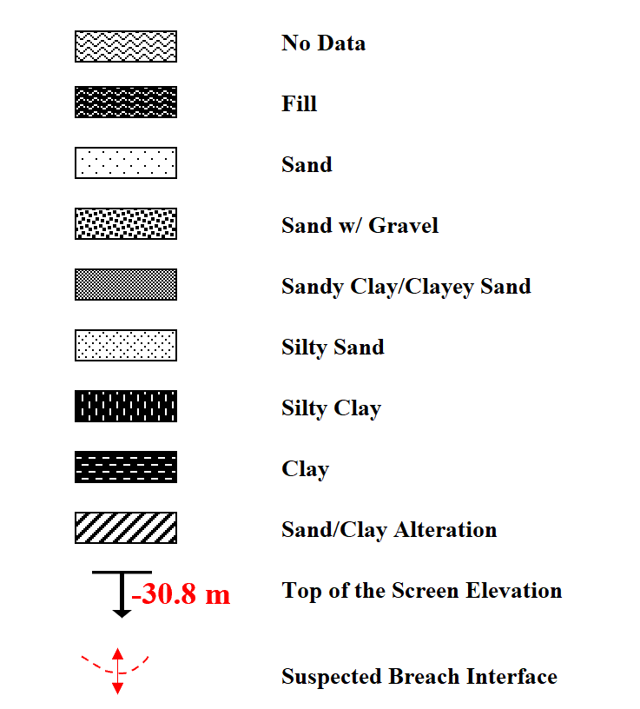
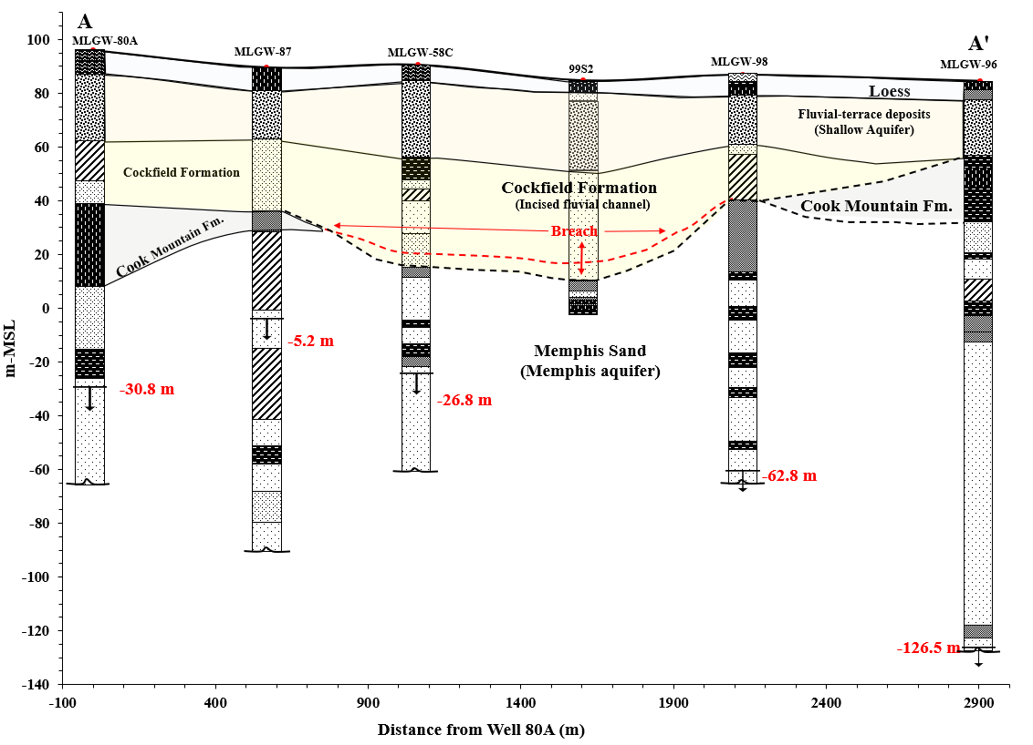
Figure A1: Cross section A-A' displays the hydrostratigraphy from north to south through the Sheahan well field.

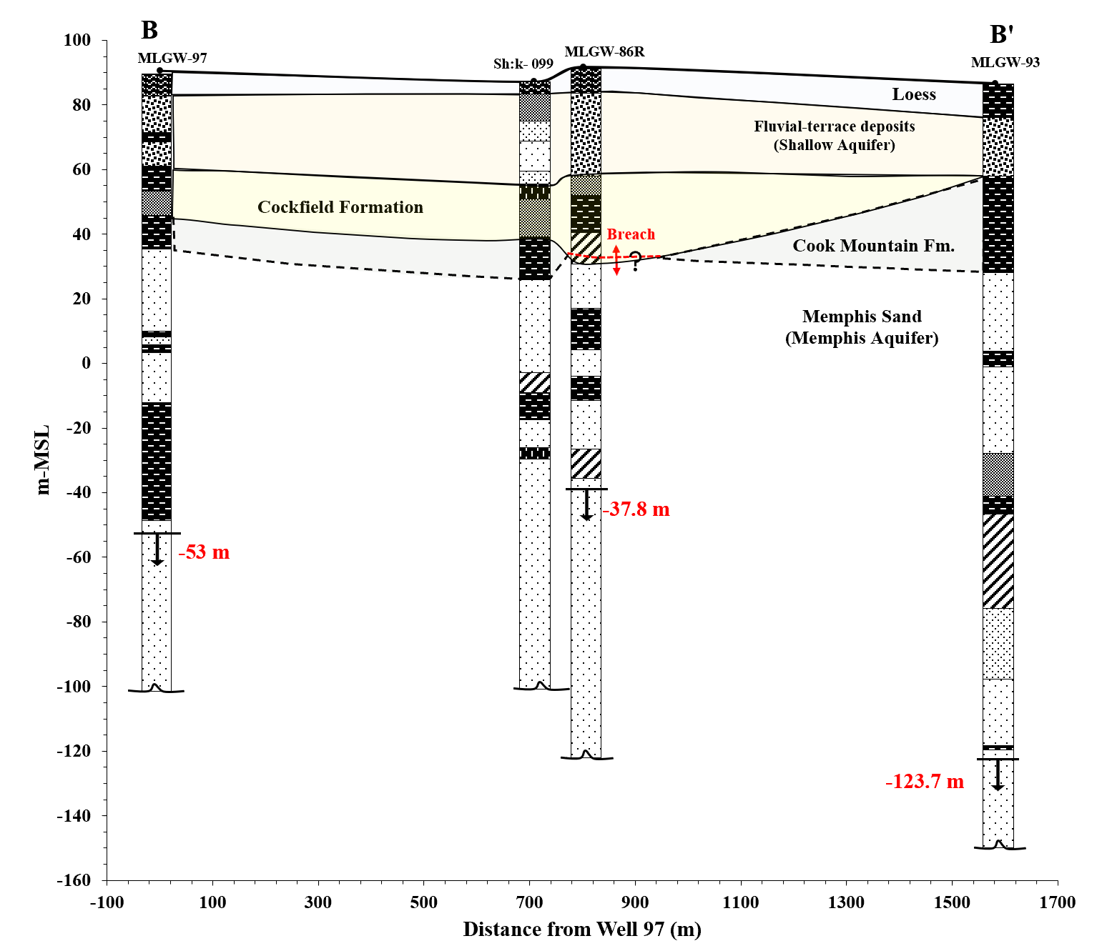
Figure A2: Cross section B-B' displays the hydrostratigraphy from north to south through the eastern part of the Sheahan well field.

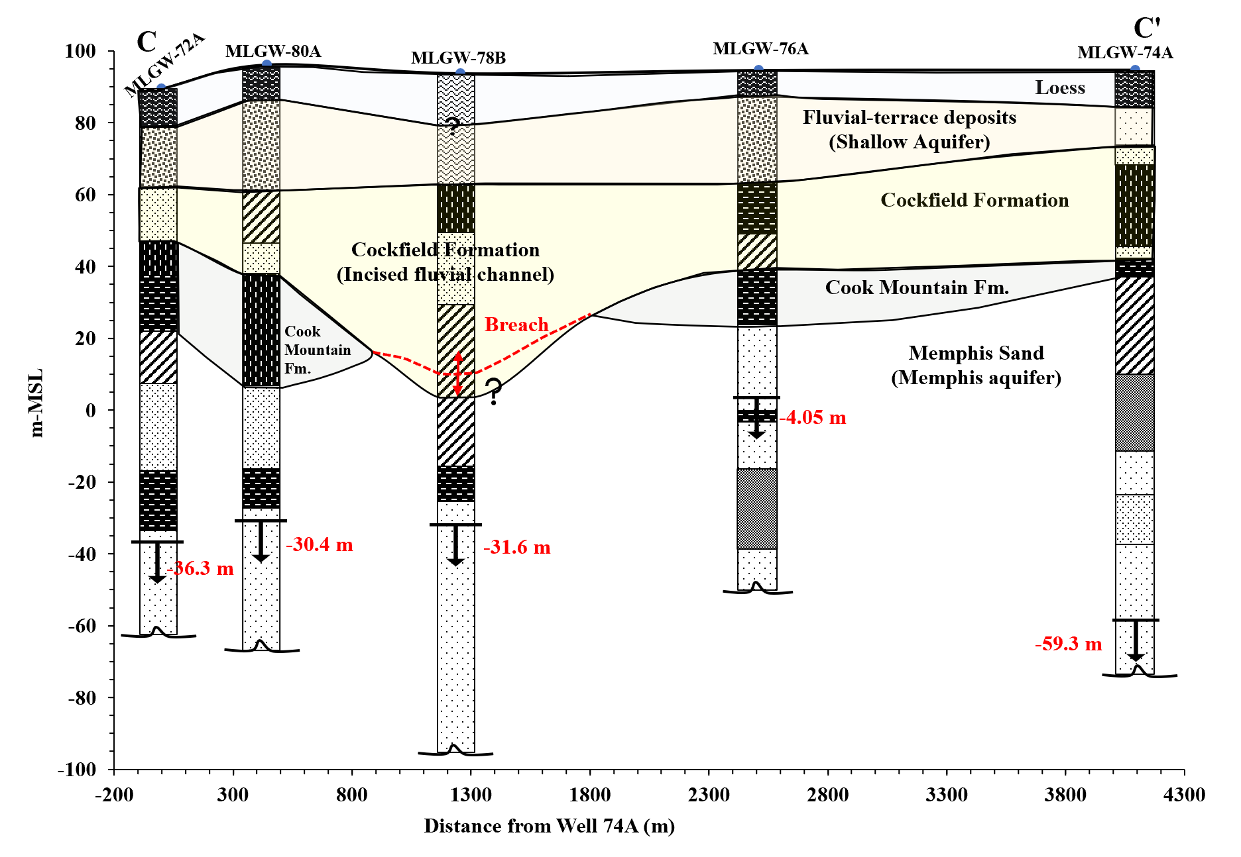
Figure A3: Cross section C-C' displays the hydrostratigraphy from west to east through the northern part of the Sheahan well field.

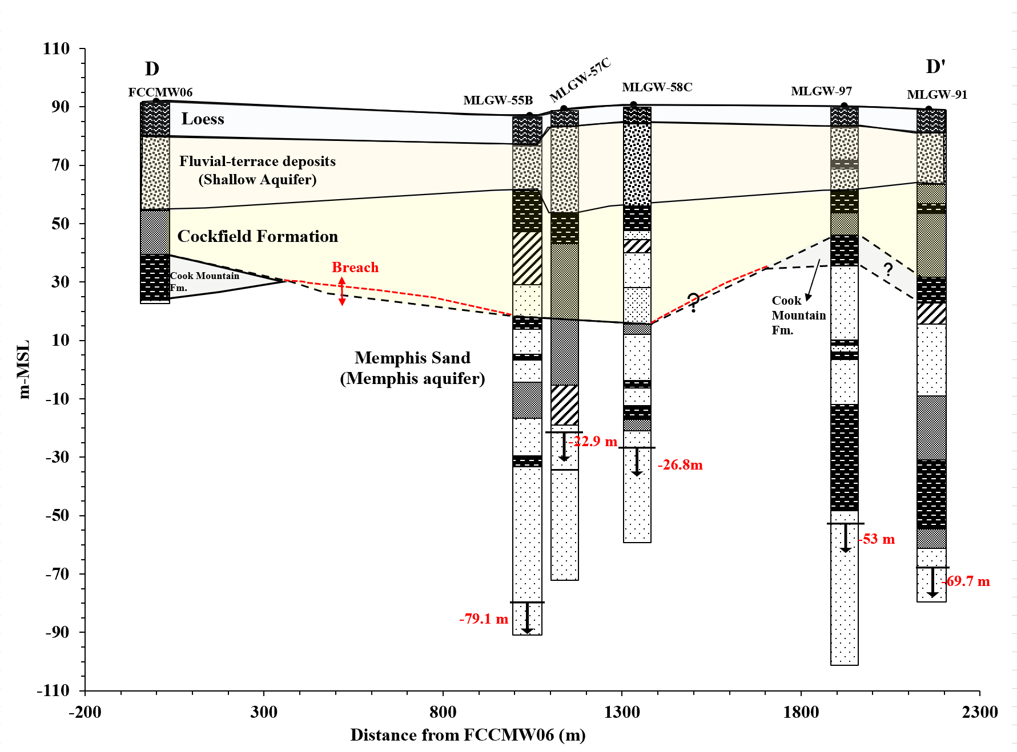
Figure A4: Cross section D-D' displays the hydrostratigraphy from west to east through the middle part of the Sheahan well field.

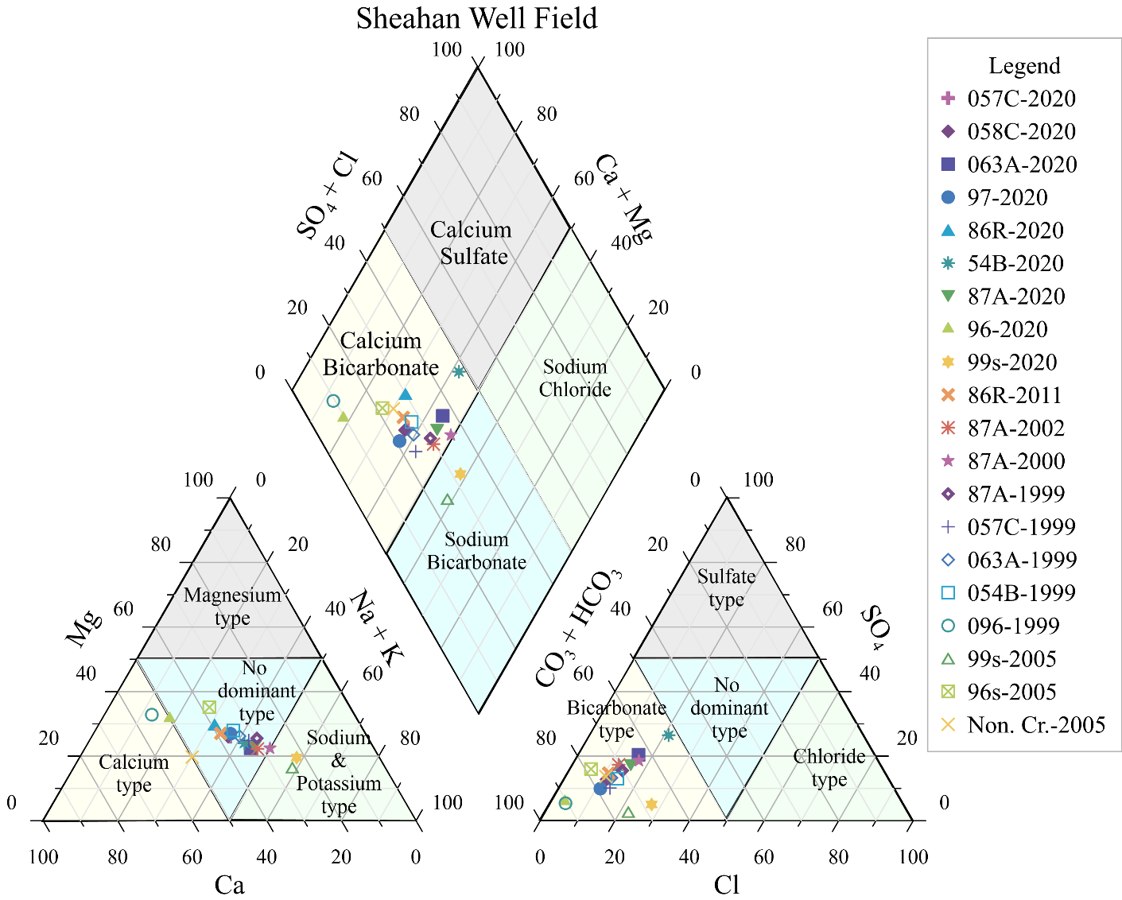
Figure A5: Piper diagram showing hydrochemical water types for Sheahan well field groundwater samples from 1999, 2000, 2002, 2005, 2011 and 2020. Here, Non. Cr. is Nonconnah Creek water point and 96s (Sh:K-156) is shallow monitoring well shown in Figure A8 (Appendix-A).

(a)
Figure A6: Molar concentration solute plot for samples from this study as well as from previous studies (Larsen et al. 2003, 2013; Gentry et al. 2006). (a) alkalinity vs Calcium (b) magnesium vs calcium. The black line represents the mixing relationship between shallow groundwater and Memphis aquifer water. The red line indicates dolomite equilibrium line (Figure A6a).
Figure A7: Grain size analysis of the core sample returns 99s2 at a depth of 22.5m, an area at the top of UCCU (Cockfield Formation) presumed to be paleochannel sediments.

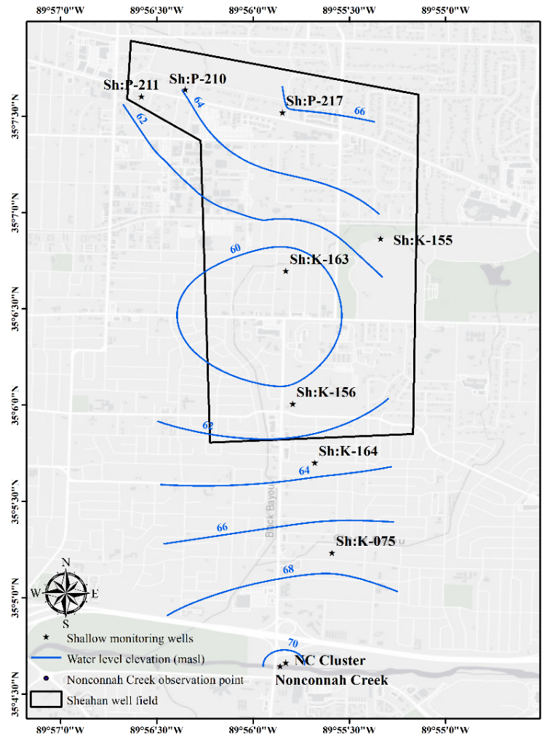  (a) | 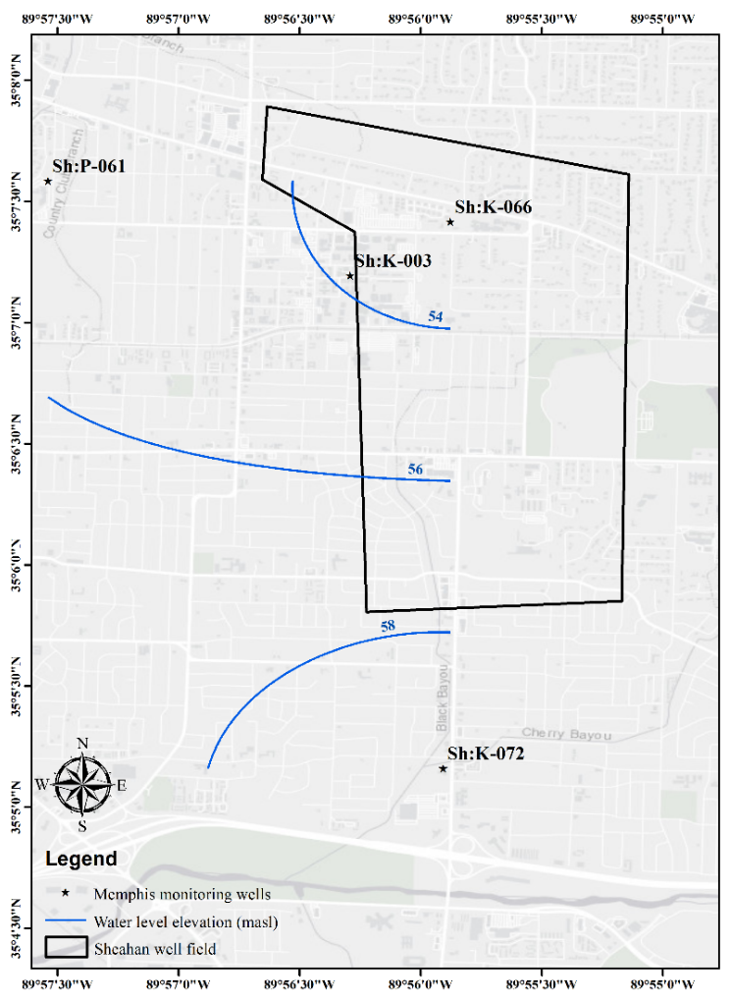  (b)
Figure A8: Water level contour map in and around Sheahan well field in July 2020. (a) Water-table surface map (b) Memphis aquifer potentiometric surface map.

