Supporting Information

Time-resolved Fluorescent Nanoparticle-based Dual Mode Lateral Flow Immunoassay for Sensitive Analysis of Chloroacetamide Herbicides with Broadened Detection Range

Yonghong Zha^{ab†} , Yansong Li^{a†} Jianhua Zhou^{b}, Ki Soo Park^{c}, Yu Zhou^{ad}*

ª State Key Laboratory for Diagnosis and Treatment of Severe Zoonotic Infectious Diseases, Key Laboratory for Zoonosis Research of the Ministry of Education, Institute of Zoonosis, and College of Veterinary Medicine, Jilin University, Changchun 130062, China.

^{b} School of Biomedical Engineering, Shenzhen Campus of Sun Yat-Sen University, Shenzhen 518107, China.

^{c} Department of Biological Engineering, Konkuk University, Seoul 05029, Republic of Korea

^{d} College of Animal Science and Technology, Yangtze University, Jingzhou 434023, China.

*Corresponding author
- mail address: zhouyurunye@sina.com (Yu Zhou).

† These authors contributed equally to the work

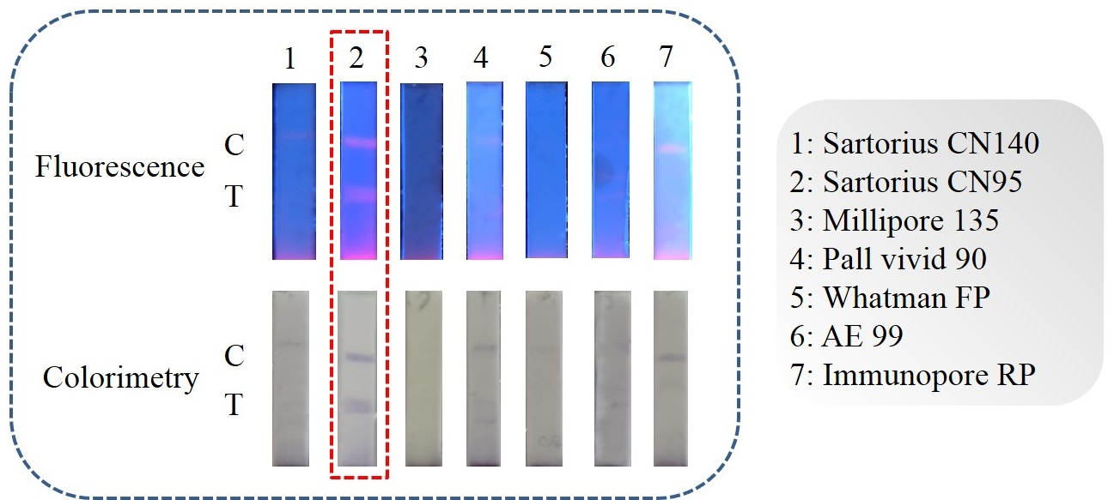

Figure S1. Selection of the NC membrane (in the absence of ATC).

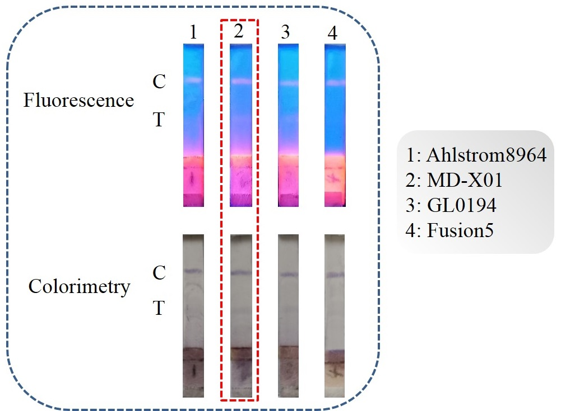

Figure S2. Selection of the glass fiber pad (in the absence of ATC).

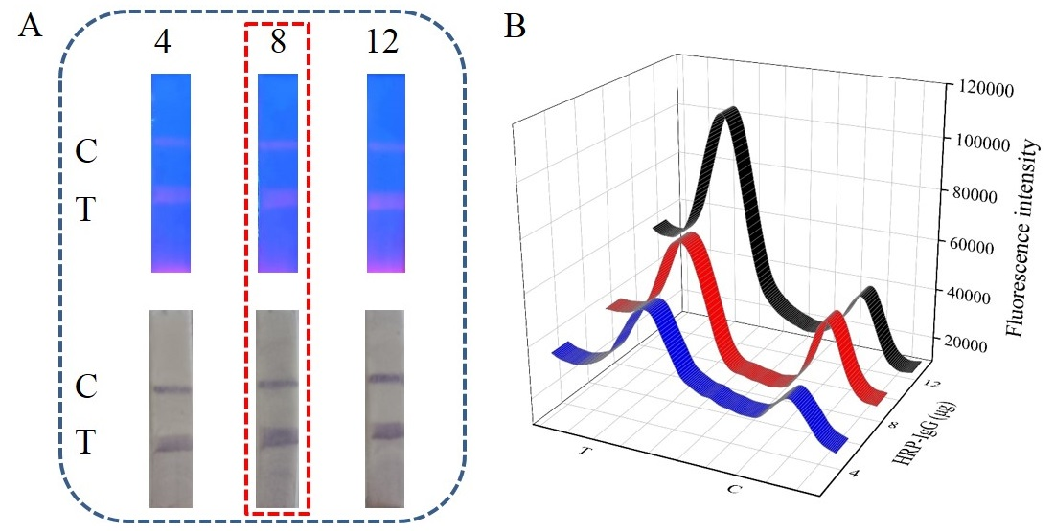

Figure S3. (A) Fluorescence and colorimetric images of the dual mode LFIA and (B) fluorescence intensity of T and C lines in each test strip with varying amounts of HRP-IgG (μg).

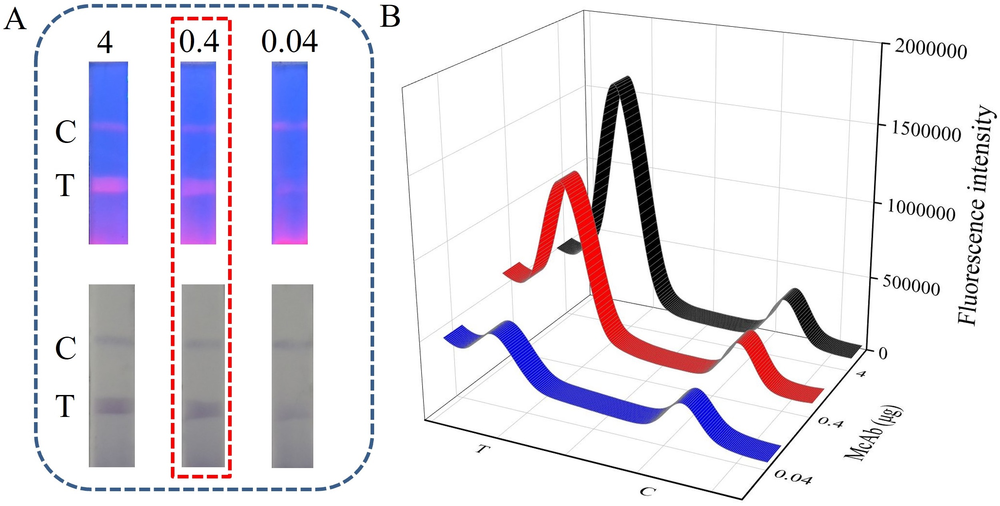

Figure S4. (A) Fluorescence and colorimetric images of the dual mode LFIA and (B) fluorescence intensity of T and C lines in each test strip with varying amounts of McAb (μg).

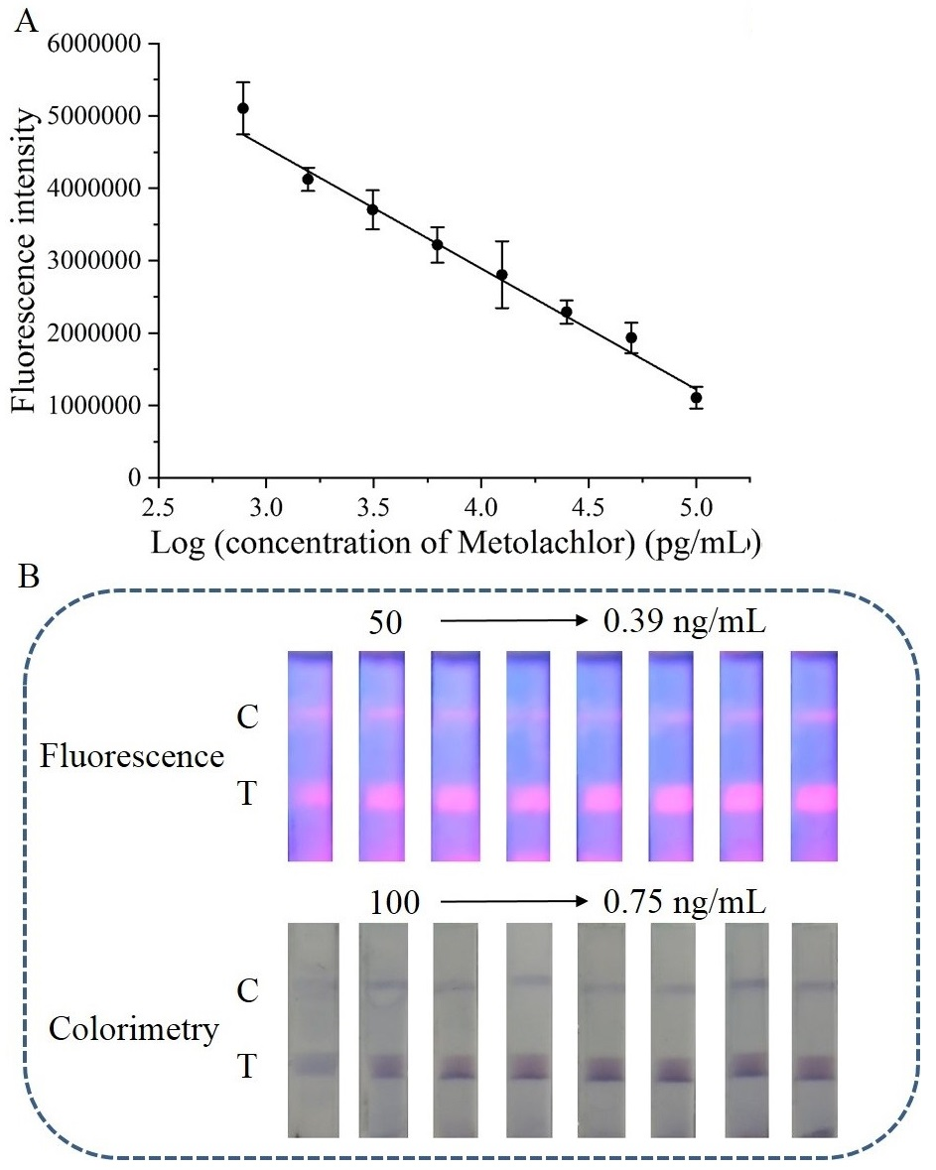
Figure S5. (A) Curve of fluorescence intensity versus different concentrations of metolachlor. (B) Fluorescence and colorimetric images of the dual mode LFIA in the presence of different concentrations of metolachlor.

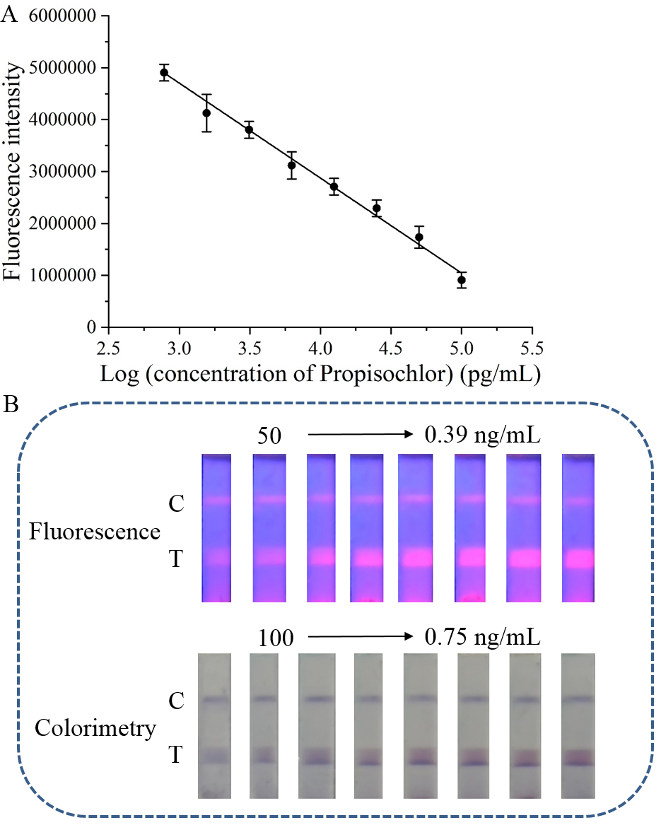
Figure S6. (A) Curve of fluorescence intensity versus different concentrations of propisochlor. (B) Fluorescence and colorimetric images of the dual mode LFIA in the presence of different concentrations of propisochlor.

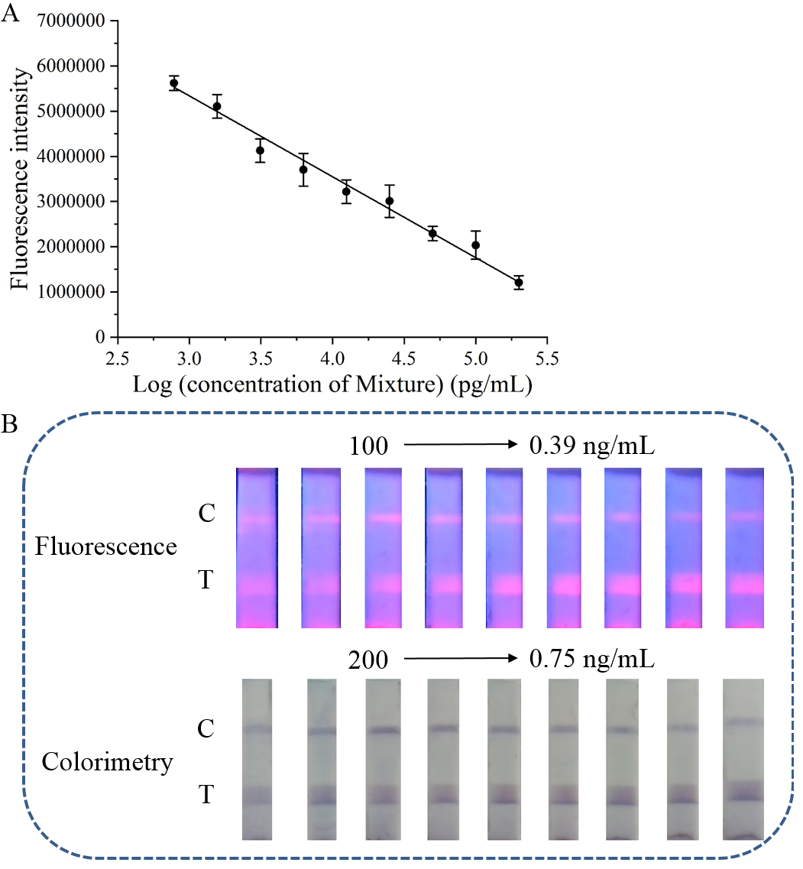
Figure S7. (A) Curve of fluorescence intensity versus different concentrations of mixture. (B) Fluorescence and colorimetric images of the dual mode LFIA in the presence of different concentrations of mixture that contains ATC, metolachlor, and propisochlor in the same concentrations.

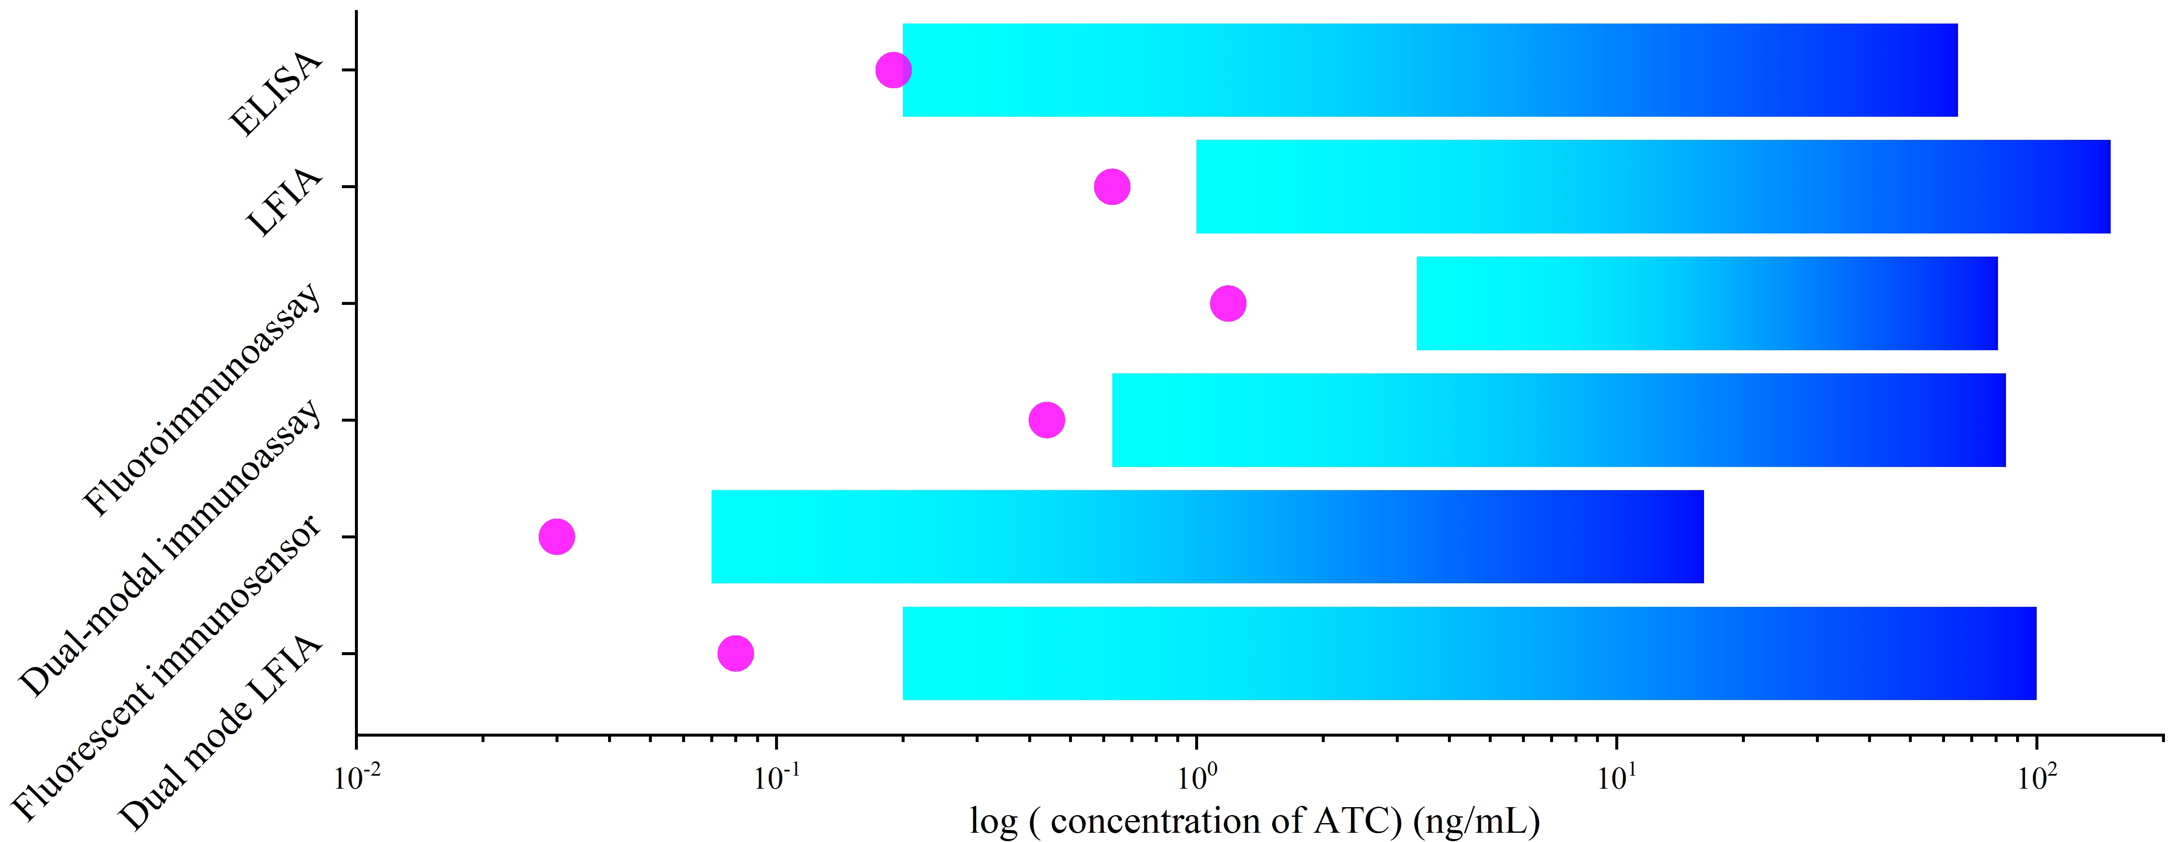

Figure S8. Comparison of the dual mode LFIA with previous reports (representative ones from Table 1) (Hegedűs, Krikunova, Bélai, Eremin, & Székács, 2002) (Cheng, Shi, Zhu, Li, Lin, & Du, 2019) (Yonghong Zha et al., 2020) (Y. Zha, Lu, et al., 2021) (Y. Zha, Li, et al., 2021) for chloroacetamide herbicides detection. The red circle and blue bar represent LOD and the detection range, respectively.

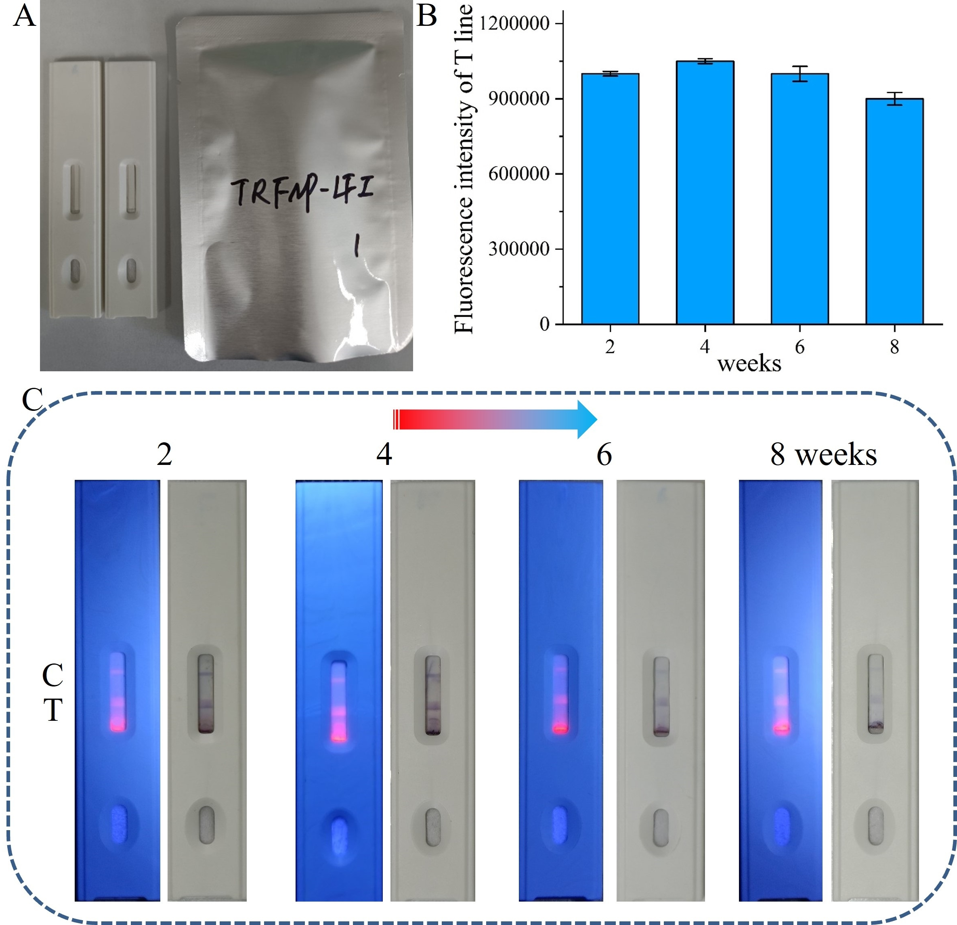
Figure S9. (A) The LFIA strips packed in aluminum foil bags. (B - C) The stability of LFIA strip after storage at 4 °C for different duration time. (50 ng/mL of ATC)

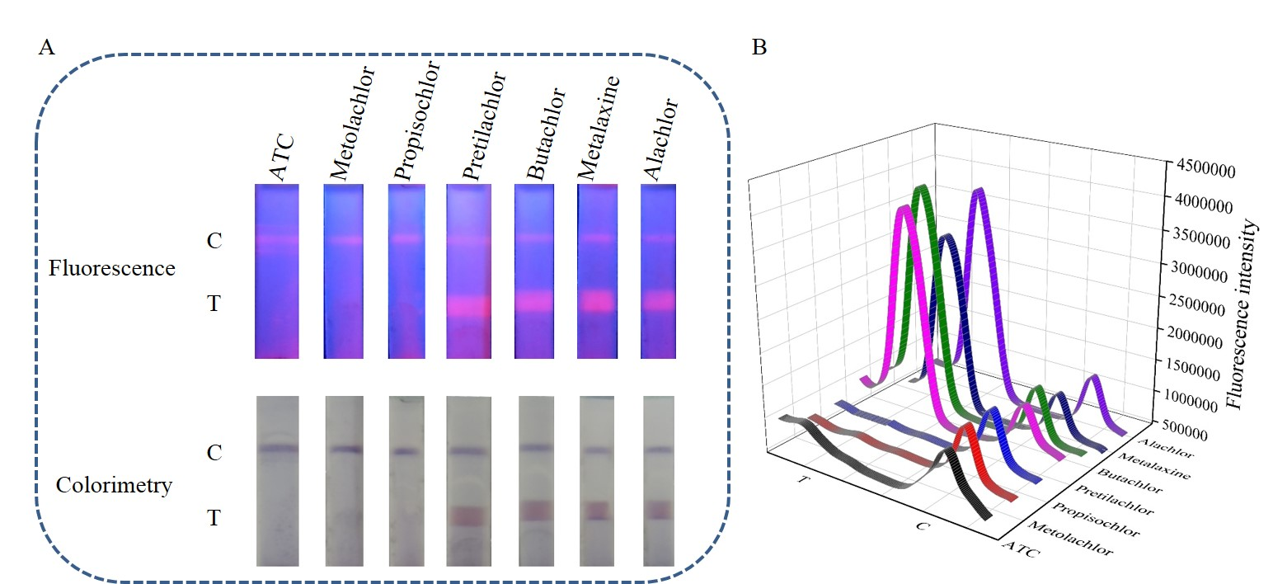
Figure S10. (A) Fluorescence and colorimetric images of the dual mode LFIA and (B) fluorescence intensity of T and C line in each test strip with seven structural analogues. The concentration of all herbicides was 200 ng/mL.

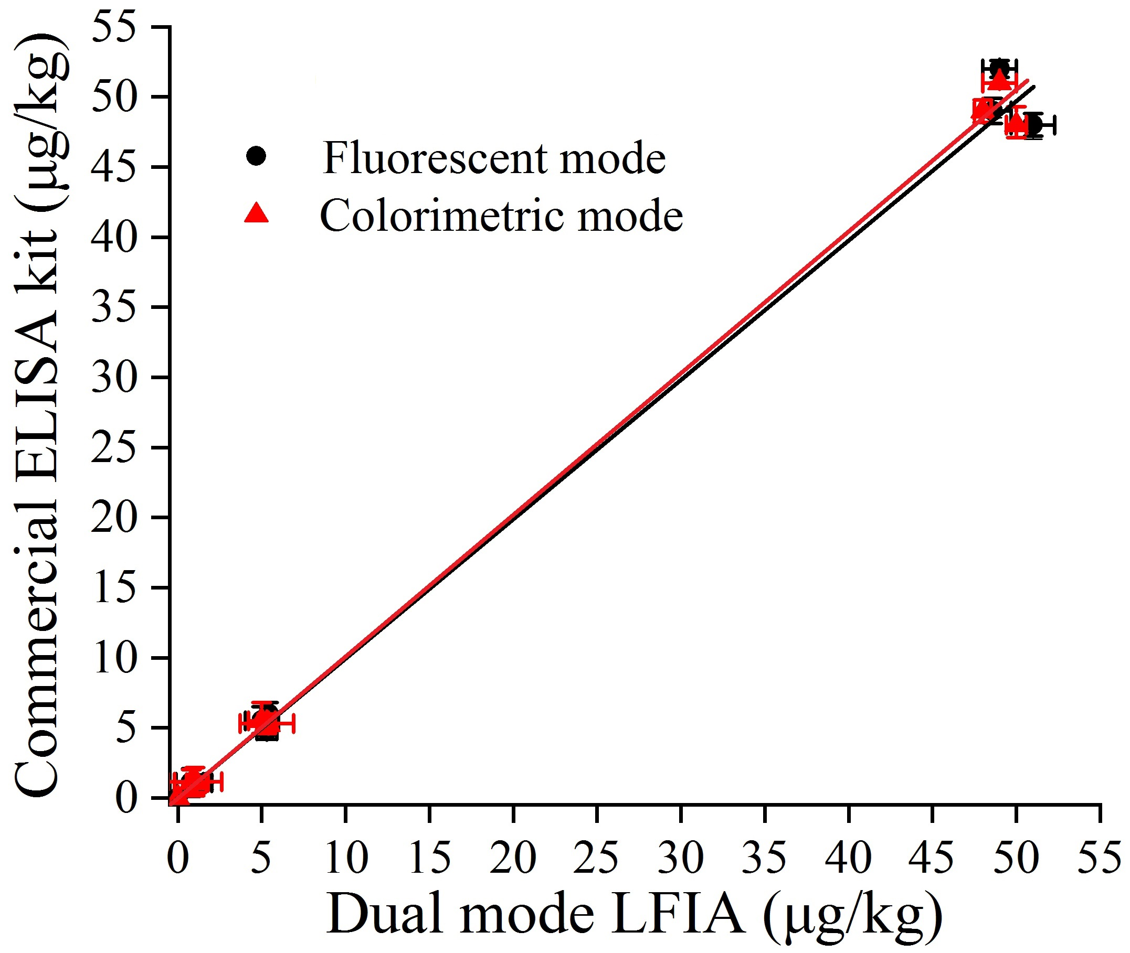
Figure S11. Relationship between the dual mode LFIA and commercial ELISA kit for the detection of ATC (1, 5 and 50 µg/kg). The linear regression equations for fluorescent and colorimetric modes were Y = 0.997X + 0.107 (R² = 0.9889) and Y = 1.005X + 0.008 (R² = 0.9971), respectively.
Herbicides | Linear equation | R²
ATC | Y = -1.79 × 10⁶X + 1.02 × 10⁷ | 0.9949
Metolachlor | Y = -1.67 × 10⁶X + 0.96 × 10⁷ | 0.9879
Propisochlor | Y = -1.83 × 10⁶X + 1.02 × 10⁷ | 0.9935
Mixture | Y = -1.79 × 10⁶X + 1.07 × 10⁷ | 0.9927
Table S1. Linear equations of fluorescent mode.

Y: Fluorescence intensity.

X: Logarithm of herbicide concentration.

References:
Cheng, N., Shi, Q., Zhu, C., Li, S., Lin, Y., & Du, D. (2019). Pt-Ni(OH)2 nanosheets amplified two-way lateral flow immunoassays with smartphone readout for quantification of pesticides. Biosens Bioelectron, 142, 111498. https://doi.org/10.1016/j.bios.2019.111498.
Hegedűs, G., Krikunova, V., Bélai, I., Eremin, S., & Székács, A. (2002). An Enzyme-Linked Immunosorbent Assay (Elisa) for the Detection of Acetochlor. International Journal of Environmental Analytical Chemistry, 82(11-12), 879-891. https://doi.org/10.1080/0306731021000102338.
Zha, Y., Li, Y., Hu, P., Lu, S., Ren, H., Liu, Z., . . . Zhou, Y. (2021). Duplex-Specific Nuclease-Triggered Fluorescence Immunoassay Based on Dual-Functionalized AuNP for Acetochlor, Metolachlor, and Propisochlor. Anal Chem, 93(41), 13886-13892. https://doi.org/10.1021/acs.analchem.1c02736.
Zha, Y., Liu, X., Hu, P., Lu, S., Ren, H., Liu, Z., . . . Zhou, Y. (2020). Alkaline Phosphatase–Triggered Immunoassay Based on Fluorogenic Reaction for Sensitive Detection of Acetochlor, Metolachlor, and Propisochlor. Food Analytical Methods, 13(4), 1008-1016. https://doi.org/10.1007/s12161-020-01706-6.
Zha, Y., Lu, S., Hu, P., Ren, H., Liu, Z., Gao, W., . . . Zhou, Y. (2021). Dual-Modal Immunosensor with Functionalized Gold Nanoparticles for Ultrasensitive Detection of Chloroacetamide Herbicides. ACS Appl Mater Interfaces, 13(5), 6091-6098. https://doi.org/10.1021/acsami.0c21760.

