Online Supplementary Material

Higher adiposity predicts greater intra-individual inconsistencies in postprandial glycemic measurements – An analysis of three randomized controlled trials
Darel Wee Kiat Toh, Shalini Ponnalagu, Stefan Gerardus Camps, Joseph Lim, Melvin Xu Nian Koh, Christiani Jeyakumar Henry

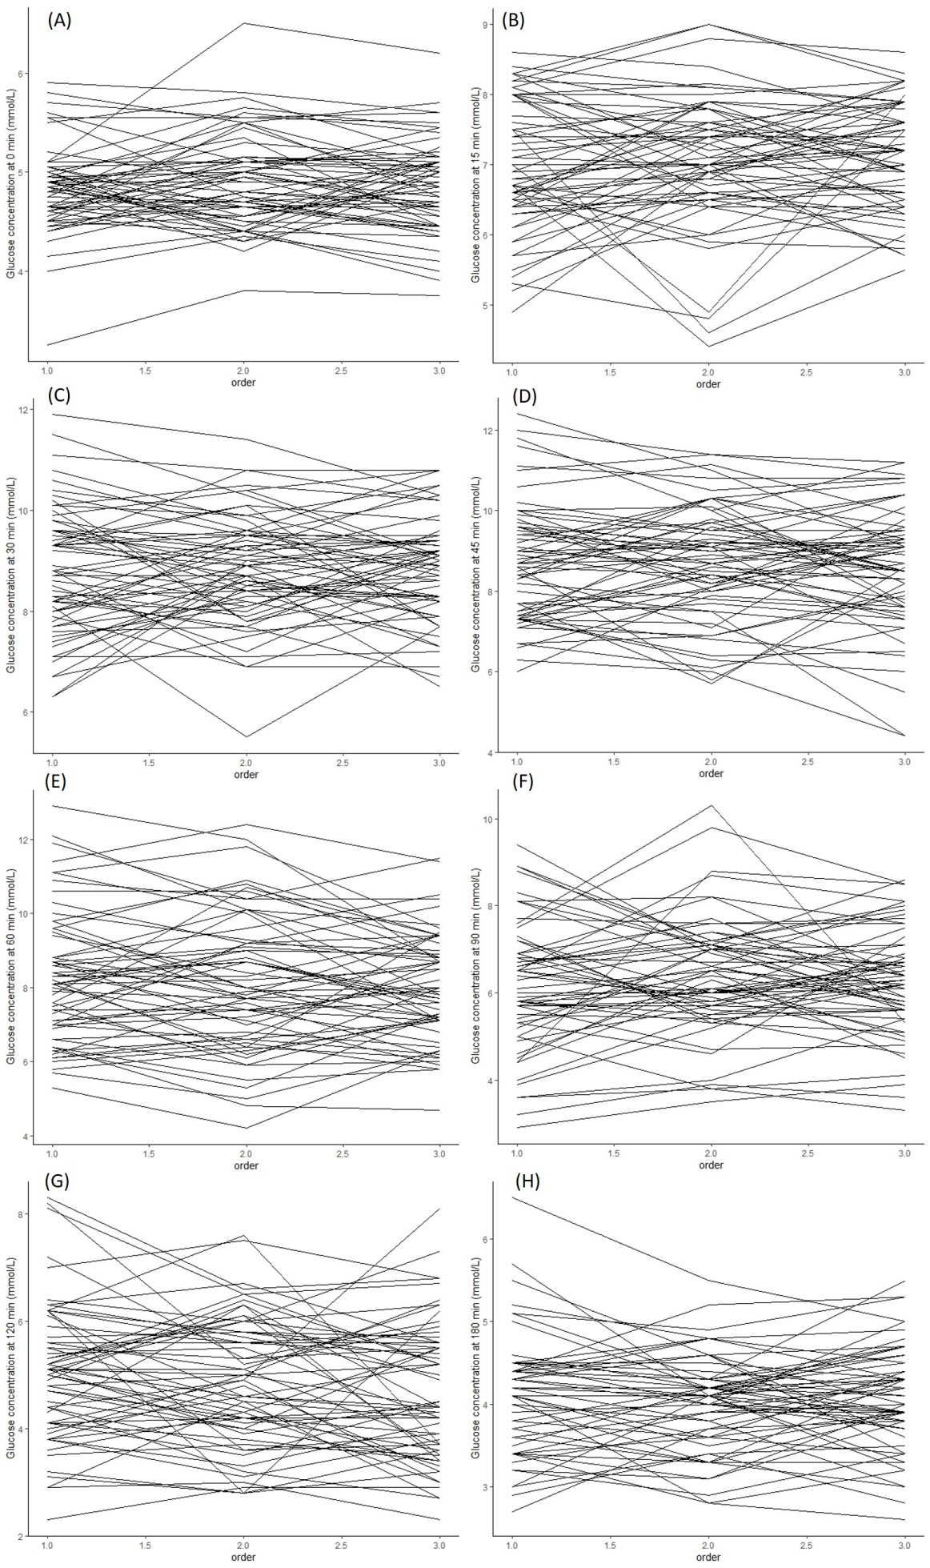

  - Supplementary Figure 1 Inter- and intra-individual variability for (A) Glucose_{0 min}, (B) Glucose_{15 min}, (C) Glucose_{30 min}, (D) Glucose_{45 min}, (E) Glucose_{60 min}, (F) Glucose_{90 min}, (G) Glucose_{120 min}, (H) Glucose_{180 min}, (I) Peak glucose concentration, (J) Glucose iAUC_{120 min}, (L) Glucose iAUC_{180 min}, (M) Insulin_{0 min}, and (N) HOMA-IR.
Abbreviations: HOMA-IR, Homeostatic model assessment for insulin resistance; iAUC, incremental area under curve

(J)
(I)
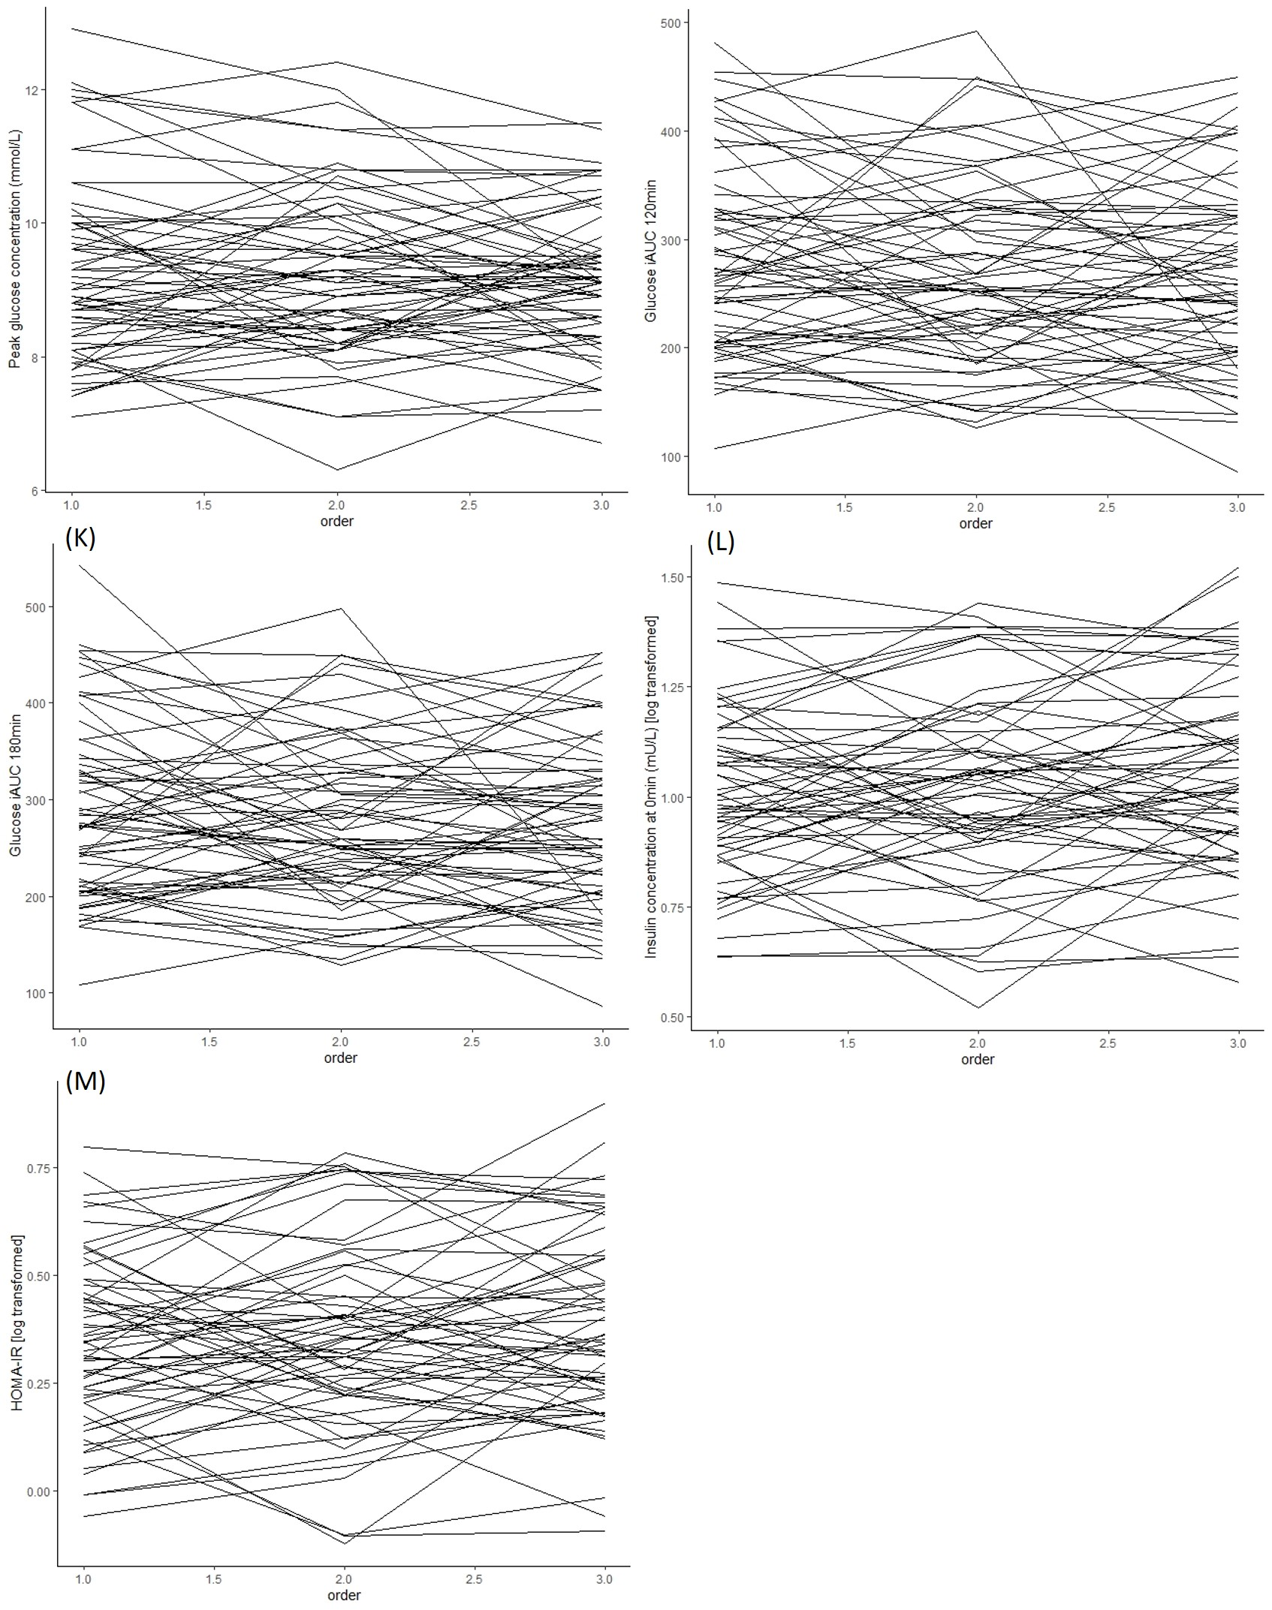

Supplementary Figure 1 (Continued)

