Supplementary Figure 1. Systemic inflammation and neutrophil activation are elevated in peripheral blood from patients with AD. (A) GSEA of biological processes of differently expressed proteins. (B) GSEA of cellular component in differently expressed proteins. (C) GSEA of molecular function in differently expressed proteins. (D) Kyoto Encyclopedia of Genes and Genomes analysis in differently expressed proteins. (E) GSEA showed the hallmark pathways enriched in the patients with AD including leukocyte cell-cell adhesion, and positive regulation of cytokine production. KEGG: Kyoto Encyclopedia of Genes and Genomes; GSEA: Gene set enrichment analysis.

Supplementary Figure 2. Single-cell transcriptomic analyses show cell populations with expression patterns in aortic lesions in AD. (A) Heatmap showing the most upregulated genes (ordered by decreasing p-value) in each cluster and selected enriched genes used for biological identification of each cluster (scale: log2 fold change). (B). Log-transformed gene expression patterns projected onto UMAP plots of CD68, FCGR3A, S100A9, OLR1, C1QA, HLA-DPB1, NAMPT, CD3D, MS4A1, and COL1A2.
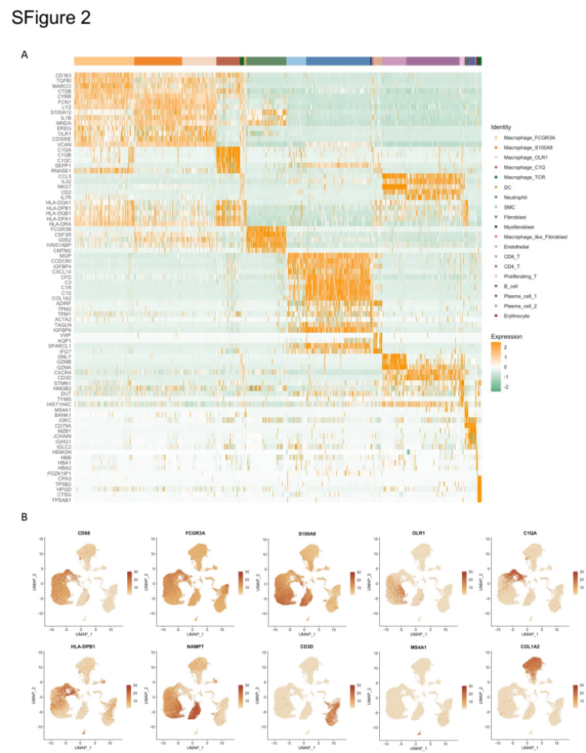

Supplementary Figure 3. Single-cell transcriptomic analyses show cell populations with putative functions in aortic lesions in AD. (A) Dot plot of log-transformed gene expression of selected genes showing statistically significant upregulation in inflammatory macrophages (Macrophage_FCGR3A), atherosclerosis-like macrophages (Macrophage_OLR1), MDSCs-like macrophages (Macrophage_S100A9), tissue resident macrophages (Macrophage_C1Q), TCR+ macrophages (Macrophage_TCR). (B) Gene ontology enrichment analysis of biological processes in FCGR3A⁺ macrophages in single-cell sequencing data. (C) Gene ontology enrichment analysis of biological processes in MSDCs-like macrophages in single-cell sequencing data. (D) Gene ontology enrichment analysis of biological processes in OLR1⁺ macrophages in single-cell sequencing data. (E) Gene ontology enrichment analysis of biological processes in tissue resident macrophages in single-cell sequencing data. (F) Gene ontology enrichment analysis of biological processes in TCR⁺ macrophages in single-cell sequencing data. (G) Volcano plot shows the differentially expressed genes between patients with AD (n = 7) and healthy individuals (n = 5). (H) Histogram indicates the proportion of Scissor-selected cells in aortic tissue of each analyzed patient with AD (n = 3) and healthy individual (n = 3). AD: aortic dissection; FCGR3A: Fc fragment of IgG receptor 3a; MDSCs: myeloid-derived suppressor cells; S100A9: S100 calcium binding protein A9; OLR1: oxidized low density lipoprotein receptor 1.

Supplementary Figure 4. Cell-cell interactions in aortic lesions in AD. (A) Cellphone DB analysis shows the number of ligand-receptor interactions between all cell populations. (B) Cellphone DB analysis shows the difference of number of ligand-receptor interactions between all cell populations across patients with AD and healthy individuals. (C) Cellphone DB analysis indicates ligand-receptor interactions between macrophages and neutrophils. (D) The expression level of CXCL3 between patients with AD and healthy individuals. (E) The expression level of CXCL3 among all cell populations. (F) The maximally selected log-rank statistic indicates the cut-off value of CitH3 level. (G) The HE images show the longitudinal section of dissected and normal aortas. The black box represents the location of immunofluorescence staining. HE: hematoxylin and eosin.

Supplementary Figure 5. CXCL3^{hi} Macrophages dominate the cell populations in aortic lesions in AD. (A) Confocal images showing the presence of CXCL3^{hi} within aorta from patients with AD, determined by CD68 (green) and CXCL3 (red) staining. Scale bars, 100 μm. (B) The immunohistochemistry images showing NETs formation within aortas in mice with AD and NETs-inhibited mice, determined by CitH3 and Ly6G staining. Scale bar, 100 μm.
