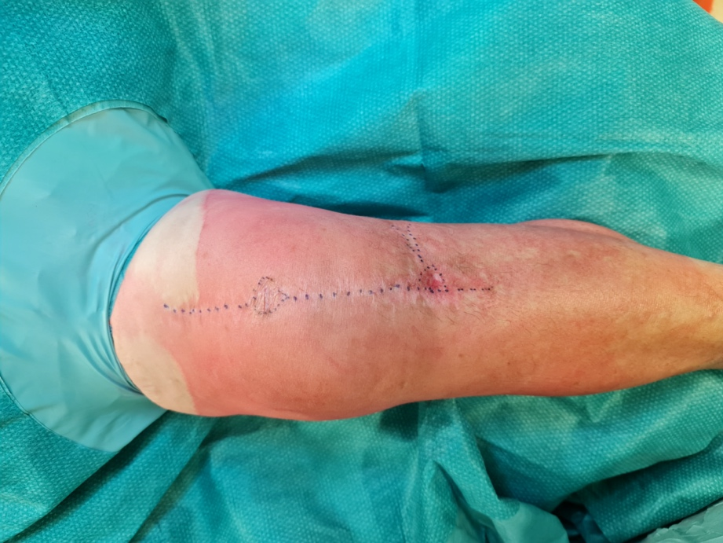

Fig.1 Re-implantation surgery: appearence of the knee preoperatively with marked scars of previous intervention

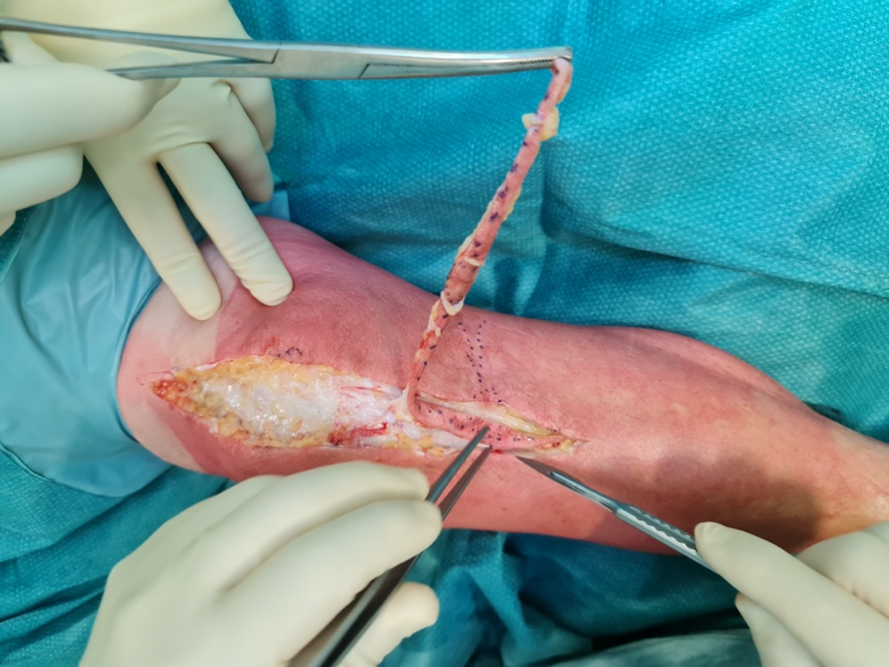

Fig.2 Re-implantation surgery: recision following previous surgical scar

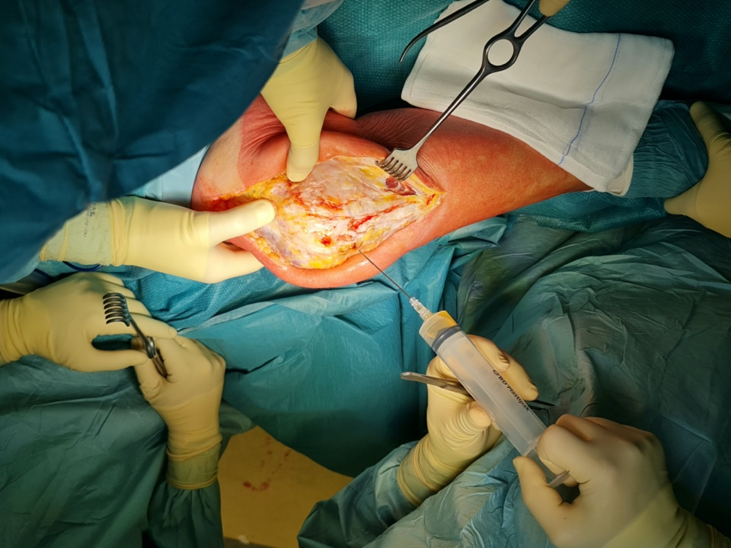

Fig. 3 Re-implantation surgery: sinovial liquid aspiration

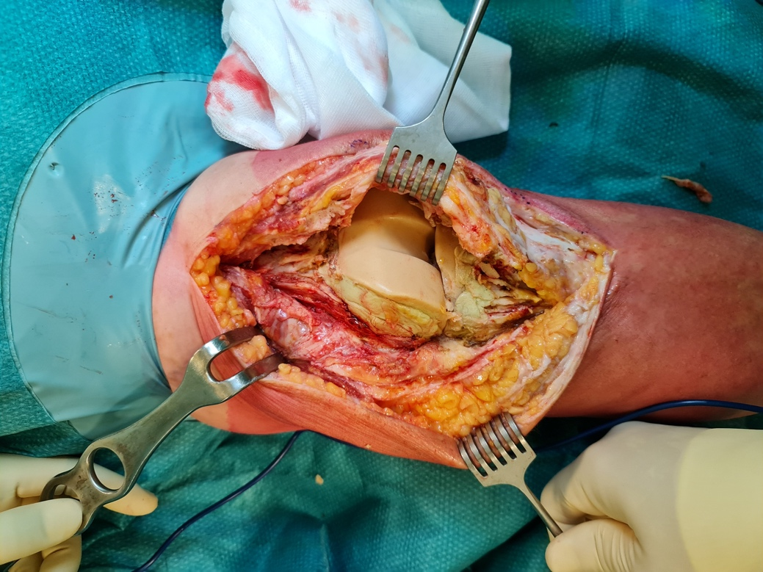

Fig. 4 Re-implantation surgery: articulated spacer exposition

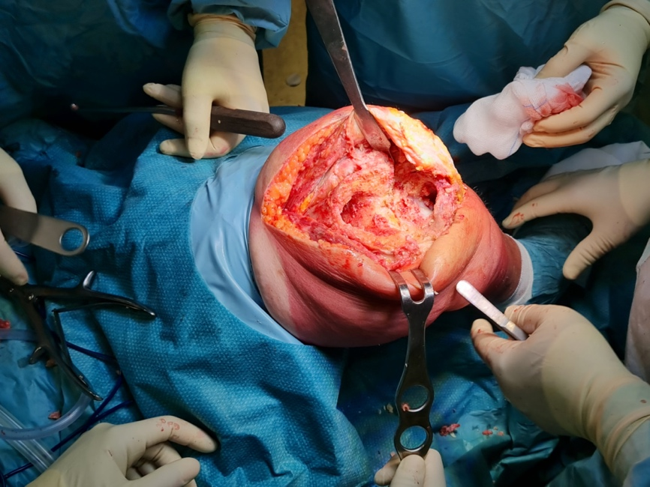

Fig. 6 Re-implantation surgery: articulated spacer removal

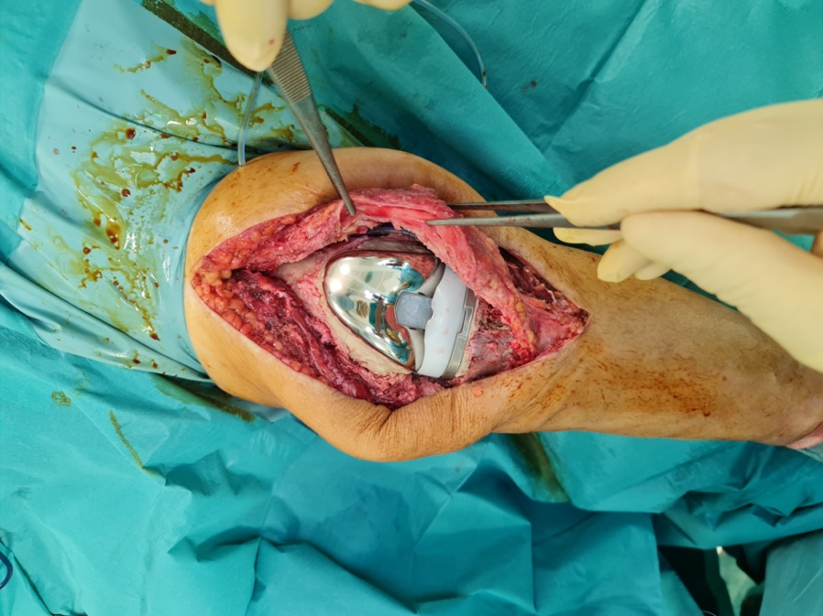

Fig. 7 Re-implantation surgery: re-implanted condylar knee prosthesis

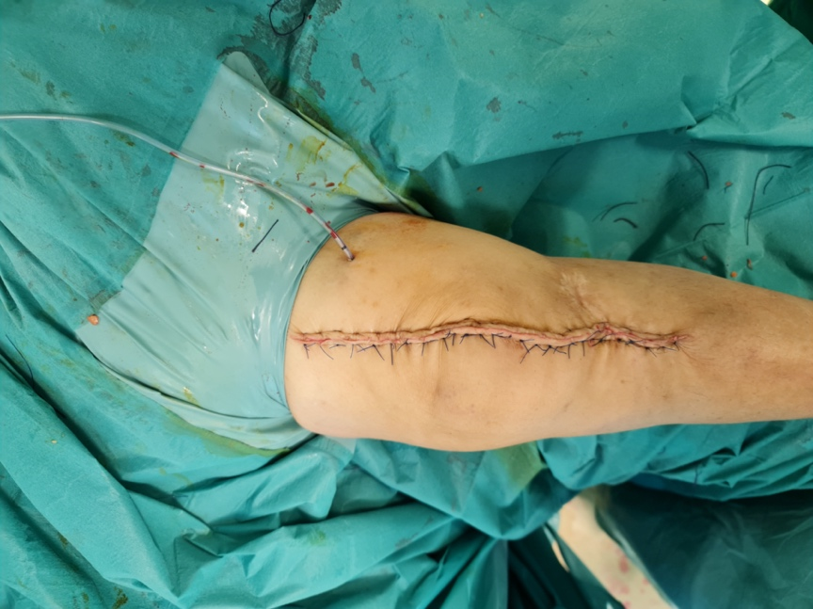

Fig. 8 Knee appearance after re-implantation surgery, with post-operative drainage

