Protective effect of puerarin esters against oxygen and glucose deprivation-reoxygenation-induced microglial cells damage
Lan Mo ^{1,2}, Guang-lei Zhao ³, Xiao-feng Li ^{1,}* , Ning He ⁴, Xing-long Xiao ¹, Hai-xia Xu ¹, Yi-gang Yu ^{1,} *
¹ School of Food Sciences and Engineering, Guangdong Province Key Laboratory for Green Processing of Natural Products and Product Safety, South China University of Technology, Guangzhou 510641, China
² College of Food Science and Technology, Hunan Agricultural University, Changsha, Hunan 410128, China
³ State Key Laboratory of Pulp and Paper Engineering, South China University of Technology, Guangzhou 510641, China
⁴ The Laboratory of Advanced Design and Manufacturing for Precision Biomedical Devices, College of Mechanical and Vehicle Engineering, Hunan University, Changsha, 410082, China

*Corresponding author: Xiao-feng Li*, Yi-gang Yu*
Mailing address: South China University of Technology, Wushan Road 381, Guangzhou 510641, China
Tel: +86-20-22236819; FAX: +86-20-87112853
Mobile phone: 13660376201
E-mail: xflibio@scut.edu.cn (Xiao-feng Li); yuyigang@scut.edu.cn. (Yi-gang Yu)

Materials and methods
Materials
Puerarin (98 % purity) was purchased from Aladdin (Shanghai, China). PA (puerarin acetate ester), PP (puerarin propanoate ester), PB (puerarin butyrate ester), PH (puerarin hexanoate ester), PO (puerarin octanate ester), PL (puerarin laurate ester), PM (puerarin myristate ester) were synthesized in our lab (purity >98%). Microglia cells were purchased from Kunming Cell Bank, Committee for Typical Culture Preservation, Chinese Academy of Sciences (Number: KCB200770YJ). Mouse IL-10, IL-1β, TNF-α, TGF-β ELISA kits were purchased from Neobioscience Biotechnology Co., LTD. (Shenzhen, China). Annexin V-FITC/PI Apoptosis Detection Kit was purchased from Meilun Biotechnology Company (Dalian, China). AnaeroPack-Anareo (anaerobic 5%) anning pack, oxygen indicator and 2.5 L anaerobic tank were purchased from Mitsubishi Corporation, Japan. Trypsin without EDTA was purchased from Gibco Life Technologies Inc., USA. Anti-Cleaved Caspase-3 (ab214430), BCA Protein Assay Kit (ab102536) were purchased from Abcam, Cambridge, MA, USA. NF-κB p65 Rabbit Monoclonal Antibody (AF1234), P38 MAPK Rabbit Monoclonal Antibody (AF7668) and Dimethyl sulfoxide (DMSO) were purchased from Beyotime Co., LTD. (Shanghai, China). P-P38 Mouse Monoclonal Antibody (Thr180/Tyr182, WLP1576), P-JNK (Thr183/Tyr185, WL01813) were purchased from Wanlei Biotechnology. BAX Polyclonal antibody (50599-2-Ig), Bcl2 Polyclonal antibody (26593-1-AP), INOS Polyclonal Antibody (18985-1-AP), BDNF Monoclonal Antibody (66292-1-Ig), NRF2, NFE2L2 Polyclonal Antibody (16396-1-AP), JNK Monoclonal Antibody (66210-1-Ig), AKT Monoclonal Antibody (60203-2-Ig), Phospho-AKT (Ser473) Monoclonal Antibody (66444-1-Ig), SOD1 Polyclonal Antibody (10269-1-AP), MMP2 Monoclonal Antibody (66366-1-Ig), MMP9 (N-terminal) Rabbit Polyclonal antibody (10375-2-AP) and ultrasensitive ECL kit (PK10003) were purchased from Proteintech Group, Inc. Polyvinylidene fluoride (PVDF, 0.45 μM, IPVH00010) and PVDF (0.22 μM, ISEQ00010) were purchased from Miillipore Inc (Shanghai, China).
Potential Targets Preparation
The candidate targets of puerarin and PAES were retrieved from Traditional Chinese Medicine Systems Pharmacology (TCMSP) (https://tcmsp-e.com/) and Swiss Target Prediction Data Bank (http://www.swisstargetprediction.ch/index.php). Relevant proteins about ischemic stroke were chosen as potential targets from OMIM (https://omim.org/), Disgenet Data Bank (https://www.disgenet.org/).
Network construction and analysis
Venny was used to draw venn diagram between ischemic cerebrovascular disease and drugs. The protein-protein interaction information (PPI) was constructed using String Data Bank (https://www.string-db.org/). The network model of “disease-target-pathway-drug” interaction was constructed by Cytoscape 3.8.2. To elucidate the function of the compounds and its role in signal transduction, Gene Ontology (GO) clustering analysis and KEGG pathway enrichment were performed on the intersection targets by the Database for Annotation, Visualization and Integrated Discovery (DAVID) Data Bank (https://david.ncifcrf.gov/tools.jsp). The biological processes (BP), cellular components (CC) and molecular functions (MF) were also described.
Cell activation and viability assay
Microglia cells were cultured in complete culture medium, containing DMEM high‐glucose medium, 1% penicillin and streptomycin and 10% fetal bovine serum (FBS). Then, microglia cells were inoculated at a concentration of 1×10⁵ cells/mL for 24 h in 96-well plates, incubated in a 37 ℃ incubator containing 5% CO₂. After seeding for 24 h, the culture medium was replaced. Puerarin and PAES were added in 96-well plates and then co-cultured for 24 h. Meanwhile, the fresh complete culture medium was added, which served as control group (C group). Finally, 10% counting kit 8 (CCK-8) was co-cultured with cells for 1.5 h, and the absorbance was detected at 450 nm. The cell viability was calculated based on the equation:
Cell viability (%) = ([A_{a}-A_{b}]/[A_{c}-A_{b}]) ×100
where, A_{a} was the absorbance of puerarin and PAES treatment, A_{b} was the absorbance of negative control and A_{c} represented the absorbance of C group.
Cell viability assay in different time of OGD
Microglia cells were inoculated at a concentration of 1×10⁵ cells/mL for 24 h in 96-well plates, incubated in a 37 ℃ incubator containing 5% CO₂. Then, sugar-free serum-free DMEM medium was added in 96-well plates. The plates were placed in an anaerobic incubator with AnaeroPack-Anareo anning pack and oxygen indicator (95% nitrogen, 5% carbon dioxide), and incubated in a 37 °C cell incubator for a certain time. After different time of OGD treatment, the cell viability was calculated by 10% CCK-8.
Establishment of OGD model in vitro
In the pretreatment group (Figure 4a), after seeding for 24 h, the fresh complete culture medium supplemented with 25 μM puerarin and its ester derivatives was added for 4 hours. Then, the cell viability of microglia cells treated by OGD was measured with CCK-8 kit.
Establishment of OGD/R model in vitro
Treatment group (Figure 4c): After OGD for 2h, the fresh complete culture medium supplemented with 25 μM puerarin and its ester derivatives was added to the treatment group. In the control group, the cells were cultured under normal conditions. Finally, cell viability was measured using a CCK-8 kit. After establishment of OGD and OGD/R model, the microglia cells were stained by a staining solution of 5 μL PI and Calcein AM, and observed by fluorescence microscope.
Enzyme-Linked Immunosorbent Assay (ELISA)
The concentrations of IL-10, IL-1β, TGF-β and TNF-α in culture supernatants were measured by ELISA kit according to the manufacturer’s protocol, and the OD values were measured at 450 nm. The concentration of each cytokine was calculated by the linear equation derived from the standard curve of the cytokine.
Isolation of total RNA and Realtime PCR Analysis
After establishment of OGD and OGD/R model, total RNA from microglia cells was extracted using Trizol, according to the manufacturer’s instructions. Primer sequence (5’→3’) of β-actin was ：FTTTCCAGCCTTCCTTCTTGGGTAT, RTGTTGGCATAGAGGTCTTTACGG；Primer sequence (5’→3’) of Arginase-1was: FTCTCAAAAGGACAGCCTCG, RGGGACATCAACAAAGGCCAG. Realtime PCR condition was applied: 40 cycles of denaturation at 95 ℃ 2 min, annealing at 95 ℃ for 15 s and extended at 60 ℃ for 1 min.
Western blotting analysis
Western blotting experiment was performed to detect protein expression as previously described. After establishment of OGD and OGD/R model, cells were harvested and washed twice with ice-cold PBS, and lysed using the RIPA protein extraction solution. The protein concentrations were determined using BCA protein assay kit. Proteins were separated by sodium dodecyl sulfate poly-acrylamide gel electrophoresis (SDS-PAGE) and transferred onto polyvinylidene difluoride (PVDF) membranes. After being blocked with 5% (W/V) skim milk, the membranes were incubated with the primary antibodies and then incubated with goat anti-mouse/rabbit IgG (1:6000) for 1 hour at room temperature. The primary antibodies used were as follows: against cleaved-caspase 3 (1:5000), Bax (1:5000-1:12000), Bcl-2 (1:1000-1:4000), NF-κB p65 (1:1,000-1:2,000), INOS (1:500-1:4000), BDNF (1:1000-1:4000), Nrf2 (1:500-1:2000), JNK (1:3000-1:20000), P-JNK (1:300-1:1000), P38 (1:500-1:2000), P-P38 (1:750), AKT (1:5000-1:50000), P-AKT (1:2000-1:10000), SOD1 (1:1000-1:8000), MMP2 (1:1000-1:6000), MMP9 (1:500-1:1000). The immunoreactive bands were detected using ECL Detection Kit.
Statistical analysis
Data were repeated for three times and presented as mean ± standard deviation (SD). All data were analyzed using Origin 8.5 software. Statistical analyses were carried out with Duncan's multiple-range test using SPSS 18.0 software (SPSS, Inc., Chicago, IL, USA). Values of p<0.05 were considered statistically significant.

Table S1 The results of GO enrichment analysis
 | GO-ID | GO-Name | Genes
BP | GO:0050901 | Leukocyte tethering or rolling | SELP、VCAM1、TNF
CC | GO:0005615 | Extracellular space | SELP、VCAM1、 MMP2、PLAT、TNF
CC | GO:0009897 | External side of plasma membrane | SELP、VCAM1、TNF
CC | GO:0005794 | Golgi apparatus | VCAM1、 NOS3、 ESR1
MF | GO:0004252 | Serine-type endopeptidase activity | MMP2、PLAT、F2

Table S2 KEGG enrichment pathways after ranked by Count
Term | Pathways | Count
hsa05200 | Pathways in cancer | 11
hsa05417 | Lipid and atherosclerosis | 10
hsa04933 | AGE-RAGE signaling pathway in diabetic complications | 9
hsa05418 | Fluid shear stress and atherosclerosis | 7
hsa05022 | Pathways of neurodegeneration - multiple diseases | 6
hsa05161 | Hepatitis B | 6
hsa04668 | TNF signaling pathway | 6
hsa05170 | Human immunodeficiency virus 1 infection | 5
hsa04932 | Non-alcoholic fatty liver disease | 5
hsa05168 | Herpes simplex virus 1 infection | 5
hsa05163 | Human cytomegalovirus infection | 5
hsa04915 | Estrogen signaling pathway | 5
hsa04657 | IL-17 signaling pathway | 5
hsa05169 | Epstein-Barr virus infection | 5
hsa05206 | MicroRNAs in cancer | 5
hsa05205 | Proteoglycans in cancer | 5
hsa05152 | Tuberculosis | 5
hsa04071 | Sphingolipid signaling pathway | 5
hsa05165 | Human papillomavirus infection | 5
hsa05130 | Pathogenic Escherichia coli infection | 5
hsa04210 | Apoptosis | 5
hsa05132 | Salmonella infection | 5
hsa01522 | Endocrine resistance | 5
hsa04064 | NF-κB signaling pathway | 4
Note: the count represents the number of genes enriched in the pathway.

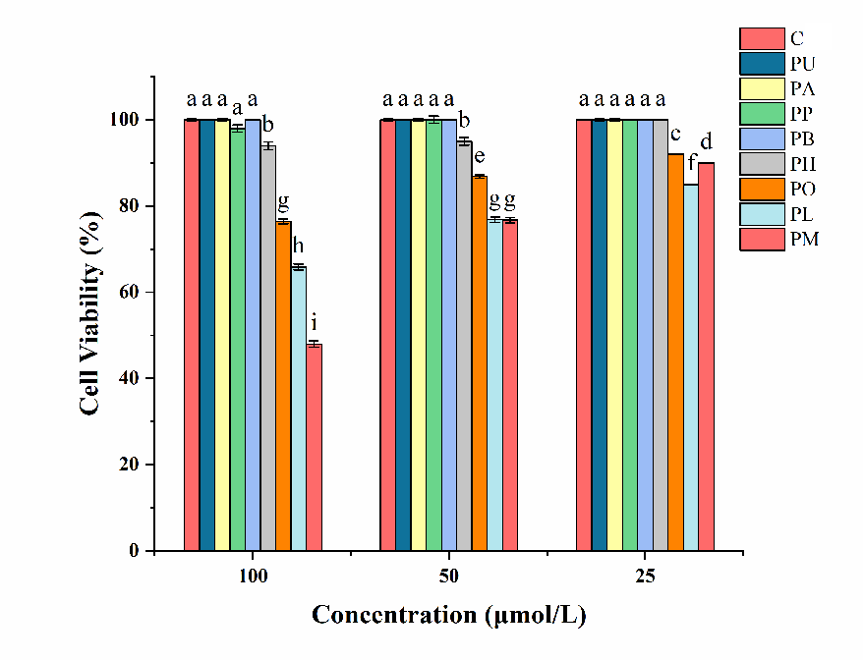
Fig. S1 Effects of different concentrations of puerarin and its derivatives on the survival rate of BV-2 cells
Note: Values of different groups with different lower-case letters (a-f) was significantly different at p < 0.05. PU: puerarin, PA: puerarin acetate ester, PP: puerarin propanoate ester, PB: puerarin butyrate ester, PH: puerarin hexanoate ester, PO: puerarin octanate ester, PL: puerarin laurate ester, PM: puerarin myristate ester.

Fig. S2 Cellular viability of BV-2 cells treated with OGD at different time
Note：compared with control group，∗ represents p < 0.05

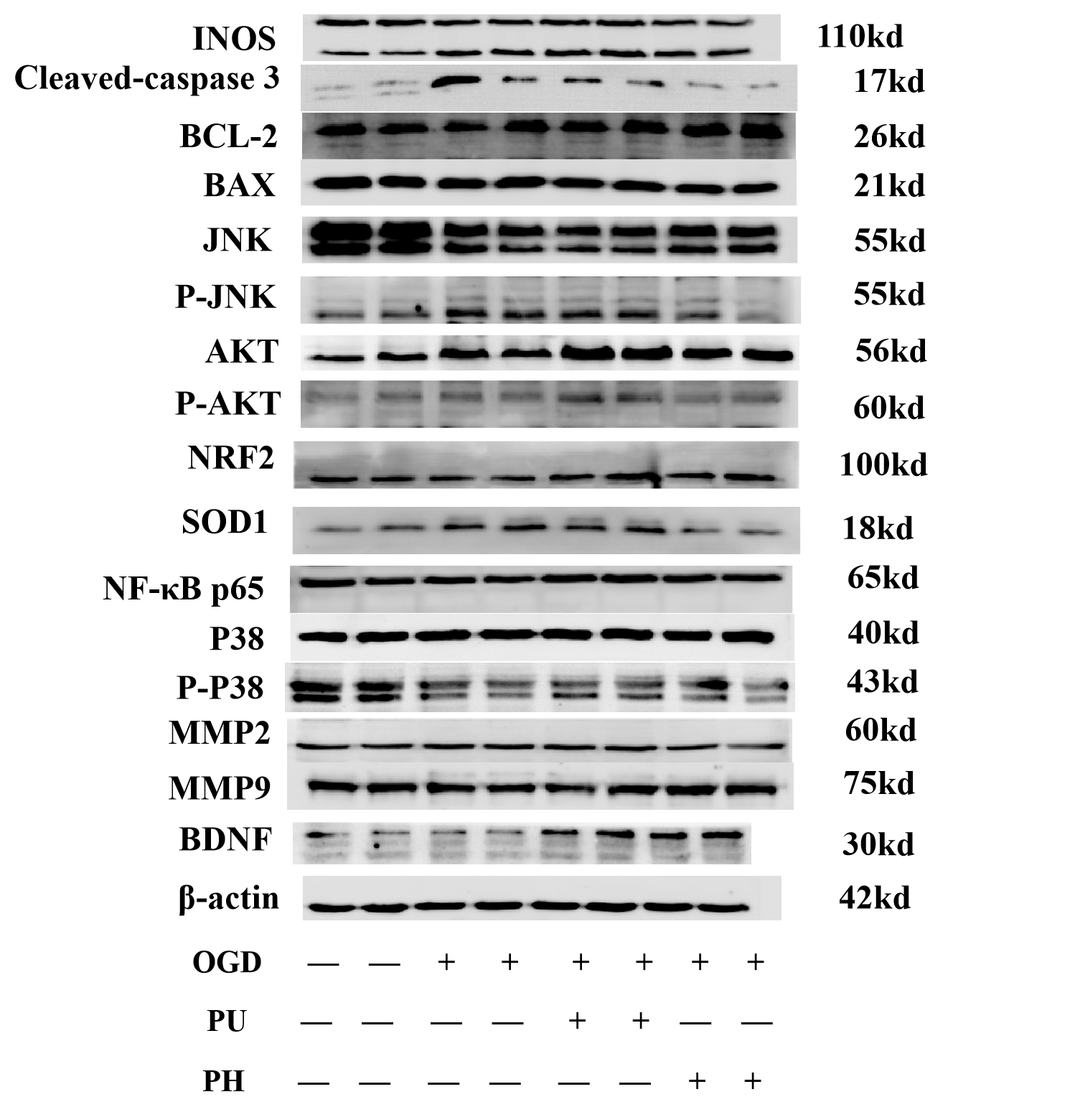
Fig. S3 Images of the western blots

