Comparison of chest radiological findings between coronavirus disease 2019 pneumonia and anti-melanoma differentiation-associated gene 5 antibody-positive interstitial pneumonia by artificial intelligence-based quantitative computed tomography image analysis

Nobuyoshi Hamao, Isao Ito, Masatoshi Yamazoe, Yoshinori Hasegawa, Shungo Yamamoto, Masahito Emura, Kazuo Endo, Masataka Hirabayashi, Naoya Tanabe, Kiminobu Tanizawa, Tomohiro Handa, Ran Nakashima, Issei Oi, Masahiro Shirata, Kensuke Nishioka, Toyohiro Hirai.

e-Figure 1. Representative images of AI-based quantitative CT analysis. (A) and (C) CT images before the AI-based quantitative CT analysis.
(B) and (D) Visualization of lung parenchymal lesions using AI-based quantitative CT analysis, corresponding to (A) and (C), respectively.

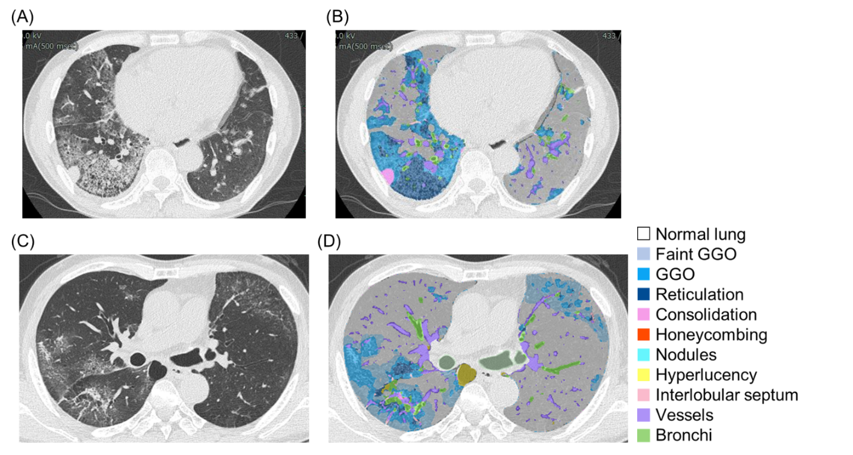
e-Figure 1

