Supplementary Informations

Chirality Hierarchical Transfer in Homochiral Polymer Crystallization Under High-pressure CO₂

Lei Zhang, Guoqun Zhao*
Key Laboratory for Liquid-Solid Structural Evolution and Processing of Materials (Ministry of Education), Shandong University; Jinan, Shandong 250061, PR China

* Corresponding author: Guoqun Zhao, zhaogq@sdu.edu.cn

The PDF file includes:

Supplementary Text
Figs. S1 to S19
Table S1
References 1 to 12

Supplementary Text
Sanchez-Lacombe Equation of State
The Sanchez-Lacombe (S-L) equation of state (1, 2) was employed to determine the relation between pressure$P$, temperature$T$ and density $ρ$ of mixture system. The S-L equation expressed as:
${\tilde{ρ}}^{2}+\tilde{P}+\tilde{T}\left[\ln\left(1-\tilde{ρ}\right)+\left(1-\frac{1}{r}\right)\tilde{ρ}\right]=0$ (S1)
Where $\tilde{P}$, $\tilde{T}$, and $\tilde{ρ}$ are the reduced pressure, reduced temperature, and reduced density, respectively, which can be calculated by $\tilde{P}=P/{P^{*}}$, $\tilde{T}=T/{T^{*}}$ and $\tilde{ρ}=ρ/{ρ^{*}}$, respectively. $r$ is the size parameter representing the number of lattice sites occupied by a polymer molecule. $P^{*}$, $T^{*}$, $ρ^{*}$ are the characteristic parameters of the mixture system calculated by the characteristic parameters of polymer and CO₂ according to the mixing rules.
In the following equations, $P_{i}^{*}$, $T_{i}^{*}$ and $V_{i}^{*}$ represent the characteristic molar pressure, temperature, and volume of neat polymer and CO₂, respectively. The subscript $i=1$ stands for CO₂ and $i=2$ for polymer.
$V^{*}=ϕ_{1}^{0}V_{1}^{*}+ϕ_{2}^{0}V_{2}^{*}$ (S2)
$ϕ_{i}^{0}=\frac{ϕ_{i}}{ϕ_{1}+(\frac{V_{1}^{*}}{V_{2}^{*}})ϕ_{2}}$ (S3)
$ϕ_{1}+ϕ_{2}=1$ (S4)
$P^{*}=ϕ_{1}P_{1}^{*}+ϕ_{2}P_{2}^{*}-RTϕ_{1}ϕ_{2}χ_{12}$ (S5)
$χ_{12}=\frac{P_{1}^{*}+P_{2}^{*}-2{(P_{1}^{*}P_{2}^{*})}^{0.5}\left(1-k_{12}\right)}{RT}$ (S6)
$T^{*}=P^{*}\left(\frac{ϕ_{1}^{0}T_{1}^{*}}{P_{1}^{*}}+\frac{ϕ_{2}^{0}T_{2}^{*}}{P_{2}^{*}}\right)$ (S7)
$\frac{1}{r}=\frac{ϕ_{1}^{0}}{r_{1}^{0}}+\frac{ϕ_{2}^{0}}{r_{2}^{0}}$ (S8)
$r_{i}^{0}=\frac{V_{i}^{*}P_{i}^{*}}{RT_{i}^{*}}$ (S9)
where the binary interaction parameter between the PLLA and CO₂, $k_{12}$, is obtained from literature (3) by correlating the solubility data with the S-L model. $ϕ_{1}$ and $ϕ_{2}$ are the volume fractions of CO₂ and polymer, respectively.
When the polymer/CO₂ system reaches the solution equilibrium, the chemical potentials of CO₂ in gas phase, $μ_{1}^{G}$, and that in polymer phase, $μ_{1}^{P}$, achieve a balance, which is expressed as:
$μ_{1}^{G}=μ_{1}^{P}$ (S10)
where
$μ_{1}^{G}=RTr_{1}^{0}\left[-\frac{ρ_{1}T_{1}^{*}}{ρ_{1}^{*}T}+\frac{Pρ_{1}^{*}T_{1}^{*}}{P_{1}^{*}ρ_{1}T}+\left(\frac{ρ_{1}^{*}}{ρ_{1}}-1\right)\ln\left(1-\frac{ρ_{1}}{ρ_{1}^{*}}\right)+\frac{1}{r_{1}^{0}}\ln\left(\frac{ρ_{1}}{ρ_{1}^{*}}\right)\right]$
$= RTr_{1}^{0}\left[-\frac{\tilde{ρ_{1}}}{\tilde{T_{1}}}+\frac{\tilde{P_{1}}}{\tilde{ρ_{1}}\tilde{T_{1}}}+\left(\frac{1}{\tilde{ρ_{1}}}-1\right)\ln\left(1-\tilde{ρ_{1}}\right)+\frac{1}{r_{1}^{0}}\ln\left(\tilde{ρ_{1}}\right)\right]$ (S11)

$$μ_{1}^{P}=RT\ln{ϕ_{1}}+RTϕ_{2}\left(1-\frac{r_{1}^{0}T_{1}^{*}P_{2}^{*}}{r_{2}^{0}T_{2}^{*}P_{1}^{*}}\right)+\frac{Rr_{1}^{0}ρT_{1}^{*}ϕ_{2}^{2}}{P_{1}^{*}ρ^{*}}\left[P_{1}^{*}+P_{2}^{*}-2\left(1-k_{12}\right){\left(P_{1}^{*}P_{2}^{*}\right)}^{0.5}\right]$$
$$+RTr_{1}^{0}\left[-\frac{ρT_{1}^{*}}{ρ^{*}T}+\frac{Pρ^{*}T_{1}^{*}}{P_{1}^{*}ρT}+\left(\frac{ρ^{*}}{ρ}-1\right)\ln\left(1-\frac{ρ}{ρ^{*}}\right)+\frac{1}{r_{1}^{0}}\ln\left(\frac{ρ}{ρ^{*}}\right)\right]$$
$=RT\{\ln{ϕ_{1}}+ϕ_{2}\left(1-\frac{V_{1}^{*}}{V_{2}^{*}}\right)+V_{1}^{*}ρϕ_{2}^{2}χ_{12}+r_{1}^{0}\left[-\frac{\tilde{ρ}}{\tilde{T_{1}}}+\frac{\tilde{P_{1}}}{\tilde{ρ}\tilde{T_{1}}}+\left(\frac{1}{\tilde{ρ}}-1\right)\ln\left(1-\tilde{ρ}\right)+\frac{1}{r_{1}^{0}}\ln\left(\tilde{ρ}\right)\right]\}$ (S12)
Under the phase equilibrium condition, the volume fraction of CO₂, $ϕ_{1}$, in the polymer/CO₂ mixture phase can be obtained by solving equation (S10). Table S1 shows the parameters used in S-L equation of state of PLLA/CO₂ mixture system.
This work used MATLAB R2018b software to perform mathematical modeling and calculations, the calculation process of the secondary nucleation rate model established in this paper is as follows:
Step 1, the data in Table S1 and the SL equation of state shown as equation (S1) were used to solve the equilibrium density of pure CO₂ at different pressures and temperatures, then the equation (S11) was used to solve the chemical potential of CO₂ in the gas state, $μ_{1}^{G}$.
Step 2, by using the mixing rule shown as equations (S2)-(S9), the characteristic parameters of PLA/CO₂ mixed system in the SL equation of state were solved. Then, the $μ_{1}^{G}$ obtained from the step 1 and equation (S12) were substituted into equation (S10).
Step 3, the SL equation of state of the mixed system and the chemical equilibrium equation (S10) were assembled into an equation set. The ‘fsolve’ function of MATLAB was called, and the Levenberg-Marquardt algorithm was used to iteratively solve the nonlinear equation set, and the density of CO₂ in the mixed system was finally obtained.
High-pressure Visualization Results
In this study, the growth behavior of PLA crystals under high-pressure CO₂ was studied, and the growth process of dendritic under different crystallization temperatures and CO₂ pressures was recorded using a self-developed in-situ high-pressure visualization system.
As mentioned in the main text, we found three types of dendritic crystals with different morphologies during the high-pressure crystallization process of homochiral PLA, including vortex-like dendritic crystals whose spiral chirality is the same as molecular chirality, vortex-like dendritic crystals whose spiral chirality is opposite with molecular chirality, and snowflake-like dendritic crystals without spiral. Taking PLLA as an example, the growth directions of these three types of dendrites are clockwise bending growth, counterclockwise bending growth, and non-bending linear growth, respectively. The most interesting one is that the snowflake-like dendrites grow linearly without bending. This crystallization behavior from homochirality to achirality is rare in crystallography behavior. Fig. S4 also shows the growth process of a snowflake-like PLLA dendrite without a helix. During the entire process, the branches did not bend significantly, forming hexagonal dendrites. This type of dendrite consists of six main branches and lots of secondary branches.
Figure S5 shows the growth process of hexagonal PLLA dendrites. The growth process of this dendrite is not a complete linear growth process. As shown in Fig. S5F, there is a slight clockwise bending of branches, but this case can help us understand the growth and formation process of hexagonal (snowflake-shaped) dendrites. From these six figures, the growth process of this crystal is not the same as that of the snowflake crystal of water (H₂O).
The crystal of water will expand outward synchronously in six directions of a hexagonal prism crystal according to the principle of tip priority. However, the six main crystals in Fig. S5 were not formed simultaneously. The crystal first grows along two main directions, forming a rhombic or elongated crystal, and then gradually forms four other branches, and finally six main branches. As the crystal expands, lots of secondary branches will form, ultimately forming snowflake-like dendrites. This growth process was discussed in detail in our previous paper (4). It can be believed that the snowflake crystal of PLA developed from a rhombic single crystal, and the secondary branches, including the four main branches, formed later. The twin crystal structure was found at the root of the daughter crystal. The angle between the long axis of the daughter crystal and that of the mother crystal is 60°.
In addition to snowflake-like dendrites, PDLA and PLLA also form vortex-like dendrites and the crystal branches are synchronously bent. As shown in Fig. S6, a kind of vortex-shaped dendrite structure was obtained from the isothermal crystallization of PDLA under high-pressure CO₂. This vortex-shaped dendrite includes six main branches and lots of secondary branches. The growth direction of all these branches is synchronously bent, and the bending direction is counterclockwise, forming curved branches.
The influence of molecular chirality on the deflection of the growth direction of PLA dendritic crystals in this study cannot be ignored. Fig. S7 shows the growth process of dendritic crystals in isothermal crystallization of PLLA under high-pressure CO₂. With the growth of dendrites, the branches gradually show obvious clockwise bending, which is opposite to the bending direction shown in Fig. S6. Fig. S8 shows another set of experimental observations for the clockwise bending growth of PLLA dendrites.
When the CO₂ pressure and crystallization temperature were changed, it was found that the bending direction of PDLA or PLLA dendritic was reversed. Fig. S9 shows the images of the crystal growth process of PDLA film with the crystallization temperature of 60℃ and the CO₂ pressure of 1250Psi, and Fig. S10 shows the images of the crystal growth process of PLLA film with the crystallization temperature of 60℃ and the CO₂ pressure of 1200Psi. Comparing Fig. S6 and Fig. S9, when the pressure is increased to 1250Psi, the bending direction of the PDLA dendrites changes from counterclockwise to clockwise. In addition, it can also be seen from Fig. S10 that the bending direction of the PLLA dendrites is counterclockwise, which is opposite to the bending direction of the PLLA crystals shown in Fig. S7.
To study the effect of gas pressure and crystallization temperature on the growth direction of PLA dendrites in more detail, isothermal crystallization experiments of PDLA and PLLA were carried out in the crystallization temperature range of 50-80℃ and in the pressure range of 0-1600psi of CO₂. It should be noted here that the PDLA and PLLA used in this study have a relatively low weight average molecular weight of about 1700g/mol. The high pressure of CO₂ will reduce the crystallization temperature range of the polymer, so the crystallization temperature range selected in this study is 50~80℃, which is significantly lower than the crystallization temperature range of commercial PLA at atmospheric pressure. A total of 60 sets of images were obtained by the above orthogonal experiment, and the complete shot images are given in Fig. S11 and Fig. S12.
It can be seen from Fig. S11 that the bending direction of the PDLA dendrites was counterclockwise at a higher crystallization temperature, such as 70℃. However, the bending direction of dendrites changed clockwise at lower crystallization temperatures, such as 50°C. At the middle crystallization temperature, that is 60℃, the growth direction of dendrites bends counterclockwise under lower pressure, while the growth direction of dendrites bends clockwise under higher pressure. So, the growth direction of PDLA dendrites can be reversed by changing temperature or pressure under high-pressure CO₂.
Crystallization temperature and CO₂ pressure not only affect the bending direction of the PLA dendrites, but also affect the bending curvature of the PLA dendrites. Fig. S13 shows the variation of the bending direction and curvature of PLLA dendrites with temperature and pressure according to the statistics of the crystal images shown in Fig. S12. In Fig. S13, the higher the pressure is, the smaller the bending curvature of the dendrites is. When the pressure is 1600 Psi, the growth direction of the dendrites is almost straight, no longer bending. In addition, under the conditions of 60℃ and 800 Psi, the snowflake crystals with almost straight growth of branches were obtained, and the bending of branches was not obvious. According to Fig. S13, the crystallization condition of 60℃ and 800Psi is close to a critical point where the crystal bending direction is reversed, when the temperature is lower than the critical temperature and the pressure is higher than the critical pressure, the PLLA dendrites bend counterclockwise, while under other conditions, the PLLA dendrites bend clockwise. Therefore, in addition to critical conditions and very high pressure and temperature conditions, PLLA dendrites will be composed of bent branches. The vortex-shaped crystal with bent branches is the more common crystal morphology of PLA in a high-pressure CO₂ environment.
Taking the results of samples at 60℃ with different pressures as an example, with the increase of pressure, the bending direction of PLLA dendrites underwent seven different stages: clockwise bending with large curvature, clockwise bending with small curvature, no bending, counterclockwise bending with small curvature, counterclockwise bending with large curvature, counterclockwise bending with small curvature, and no bending. These seven stages constitute a relatively complete bending direction change process. Under other temperature conditions, the change of the bending direction of PLLA dendrites with the increase of pressure can only complete part of the change process shown at 60℃. This change process means that the reversal of the bending direction of the PLLA dendrites is not a mutation, but an intermediate state without bent dendrites exists between two opposite directions.
Crystal Morphology and Structure
To observe the crystal morphology of the samples, the crystallized PLA samples were removed from the sample cell of the in-situ high-pressure visualization system, and then the surface morphology of the samples was characterized by AFM. Fig. S14 shows the AFM height images of PDLA curved dendrites. The curved branches are composed of flat-on lamellae and no obvious edge-on lamellae.
The molecular weight of PDLA and PLLA selected in this study is about 1700 g/mol, including about 23 lactic acid segments (molecular weight of chain segments is about 72g/mol) and the ester group at the end of the chain. According to the length data given by Wang et al (5), the length of the 23 segments is about 6.7~6.9nm. Considering the ester group at the end of the chain, the actual chain length of PLA will be greater than this value. The lamellar thickness assembled by these PLAs is about 7~8nm, measured by the height data given in Fig. 2 and Fig. 3 in the main text of this research. According to Unger's theory (6), the extended chain state or integer fold of a molecular chain has lower energy and higher stability. Therefore, the PLA molecules will be in a state of extended straight chain to form the lamellae of dendrites. Since the molecular weight polydispersity of PLA used in this study is about 1.2, some molecules will exceed the average thickness of lamellae, and the excess part will exist in the form of amorphous cilia segments. Therefore, the lamellar surface is mainly composed of amorphous cilia.
Figure S15 shows the local morphology of two similar multi-layer PDLA crystals, with the formation conditions corresponding to the vortex-like dendrites with the left-hand spiral and the vortex-like dendrites with the right-hand spiral, respectively. From the height data shown in Fig. S15 (C) and (D), the two sides of the left-handed dendritic crystal remain symmetrical, while the inclination angles of the two sides of the right-handed helical crystal are significantly different. This means that the molecular chains inside the right-handed dendrites are arranged obliquely.
The diffraction patterns given in Fig. S16 have the same characteristics though the scales are different: 1) The diffraction spots are hexagonally symmetric, which indicates that the unit-cell is trigonal; 2) According to the crystal face index, two landmark reflections (arrowed) are indexed 120 and 210 and located between the 300 and 030 reflections. These two characteristics indicate that the observed PLA crystals are β crystals (7). Compared with PLA α crystal, the chain helix conformation changes from 10/3 to 3/1 in PLA β crystal. In the unit cell of PLA β, two stems can establish favorable interactions, but the third stem must adapt to unfavorable environments. Its azimuthal setting and/or position along the c-axis are different.
Control of Crystal Morphology Chirality
Figure S17 shows a set of observation images of online isothermal depressurization experiments. The crystallization temperature is maintained at 60°C, and the pressure of CO₂ decreases from 1250Psi to 750Psi after t₀. Accordingly, the bending growth direction of the dendritic changes from clockwise to counterclockwise, forming a Z-shaped branch. According to Fig. S11, PDLA dendrites grow in a clockwise direction at 60°C and 1250Psi, and in a counterclockwise direction at 60°C and 750Psi. When the CO₂ pressure decreases, the growth direction reverses accordingly. Another set of observations is shown in Fig. S18, demonstrating that it is no accident that adjusting the pressure can reverse the direction of dendritic bending growth.
In addition to the flexible regulation of CO₂ pressure, thanks to the 3D printed high throughput cooling pipe and intelligent temperature control system, the in-situ high-pressure visualization system can also flexibly control the crystallization temperature in real-time. Fig. S19 shows the crystal morphology obtained after changing crystallization temperature and CO₂ pressure during the growth of PDLA dendrites. Compared with the dendrite morphology shown in Fig. S18, the dendrite in Fig. S19 presents a reversal of bending direction with a larger curvature, forming a more obvious zigzag shape. It is not difficult to speculate that if we choose PLLA, the S-shaped dendrites will be also easily obtained. Since the principle is the same, this paper will not be repeated here.

Fig. S1. DSC, AFM data of PLA samples used in this research. (A) DSC curves of the secondary heating process after the first heating to eliminate the thermal history and a quick cooling process with a rate of -60 °C/min, (B) height curves extracted from (C) AFM data of PDLA film with a scratch.
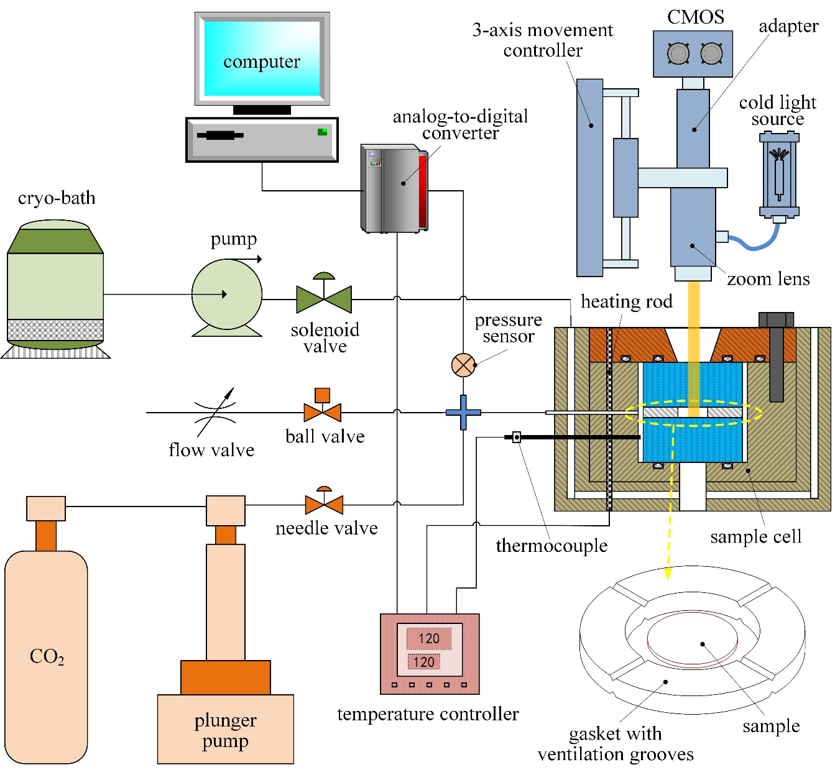

Fig. S2. Schematic diagram of the control system of in-situ high-pressure visualization system. This system was introduced in our authorized patents and published papers (8-11). In this research, we have built a new system and upgraded the light source, high-pressure pipeline, cooling system, and control module.

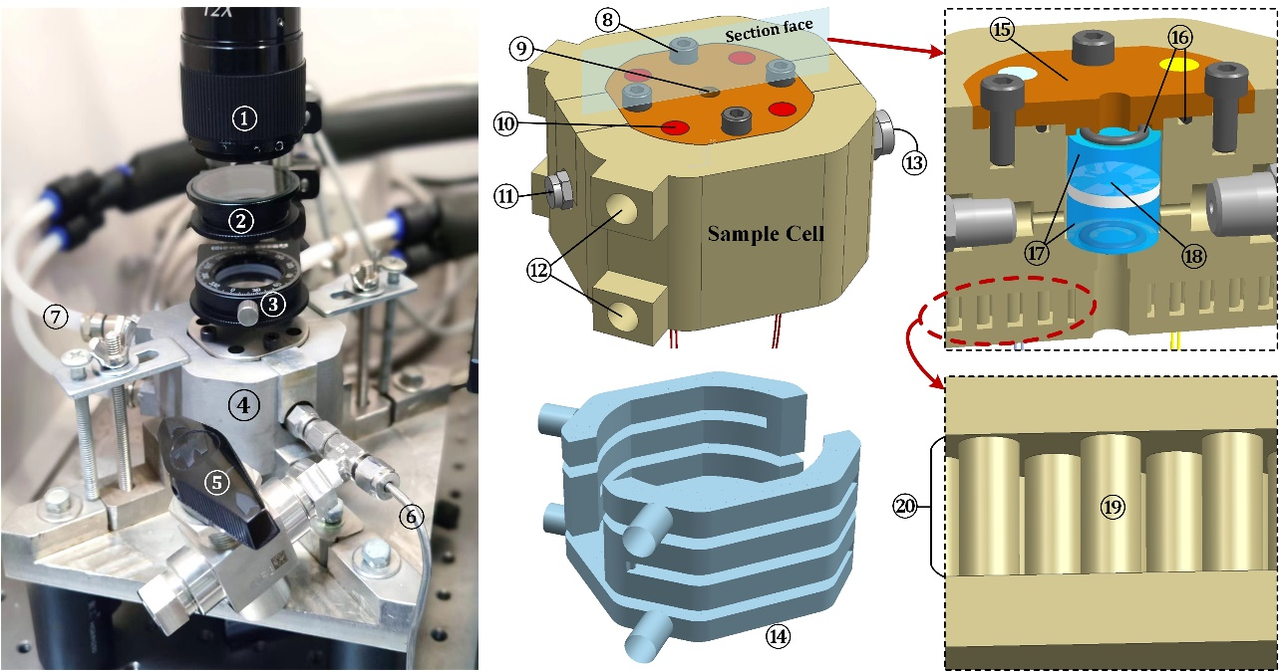

Fig. S3. 3D-printed sample cell structure of in-situ high-pressure visualization system. 1-lens, 2-polarizer, 3-color complementary lens, 4-sample cell, 5-pressure relief valve, 6-high pressure fluid pipeline, 7-coolant pipeline, 8-screw bolt, 9-light hole, 10-heating rod, 11-thermocouple, 12-in/outlet of coolant, 13-in/outlet of high pressure fluid, 14-conformal cooling channel in sample cell, 15-sealing cover, 16-sealing ring, 17-sapphire, 18-sample, 19-turbulence column, 20-coolant channel.

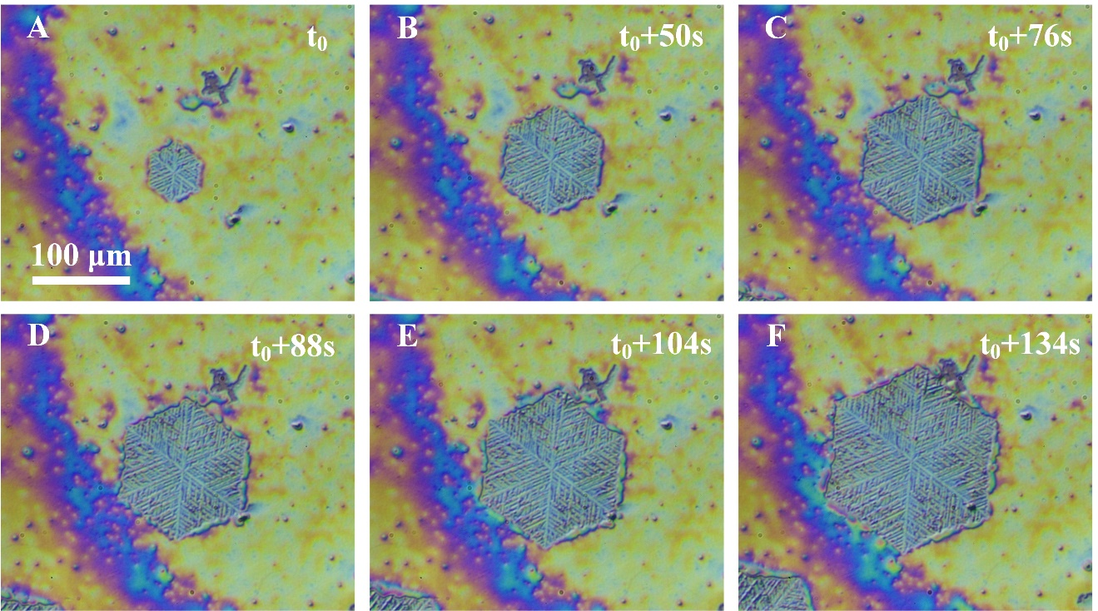

Fig. S4. In-situ high-pressure microscopy images of the crystal growth process of PLLA film. The crystallization temperature is 60℃ and the CO₂ pressure is 1400Psi. The scale bar is given in the first figure.

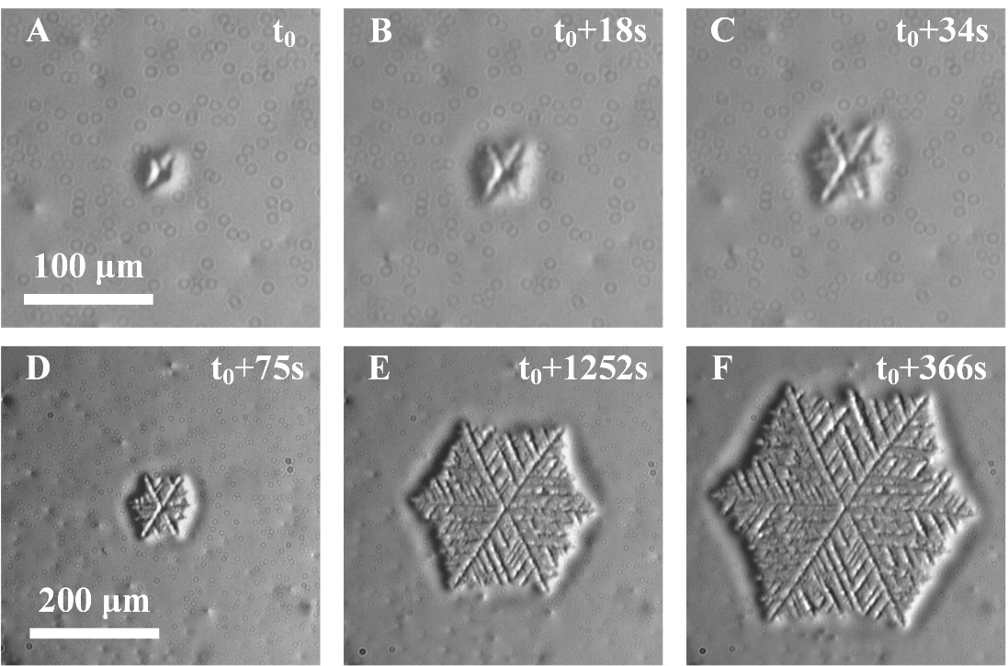

Fig. S5. In-situ high-pressure microscopy images of the crystal growth process of PLLA film. The crystallization temperature is 80℃ and the CO₂ pressure is 1090Psi. The scale bar of (A)-(C) is given in (A), and the scale bar of (D)-(F) is given in (D).

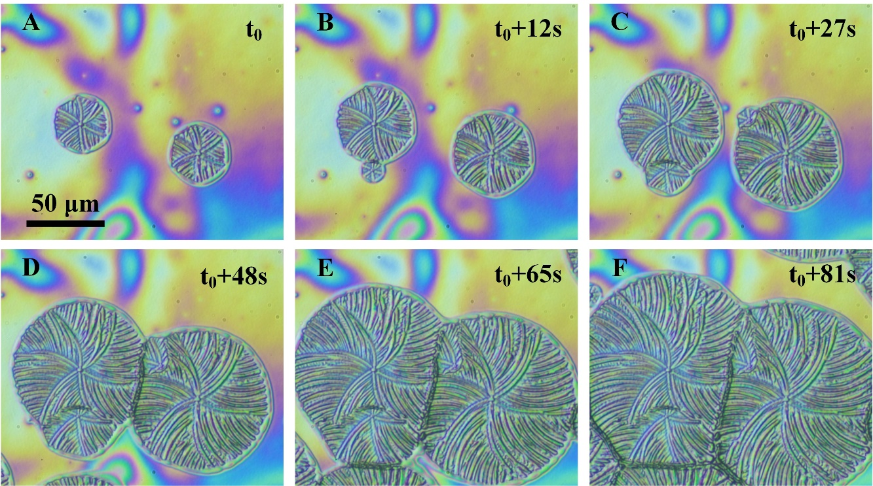

Fig. S6. In-situ high-pressure microscopy images of the crystal growth process of PDLA film. The crystallization temperature is 60℃ and the CO₂ pressure is 750Psi. The scale bar is given in the first figure.

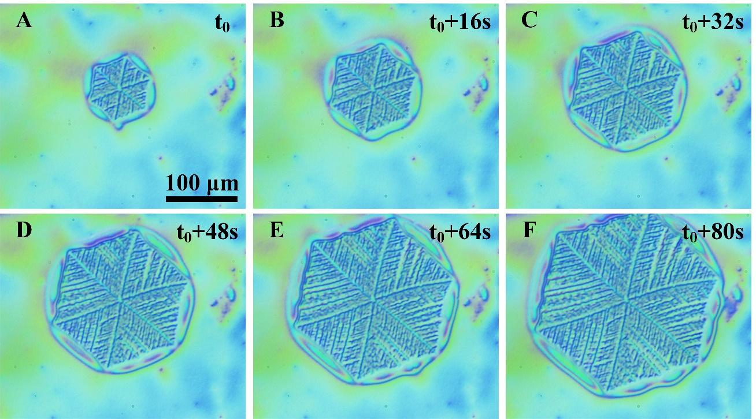

Fig. S7. In-situ high-pressure microscopy images of the crystal growth process of PLLA film. The crystallization temperature is 70℃ and the CO₂ pressure is 1000Psi. The scale bar is given in the first figure.

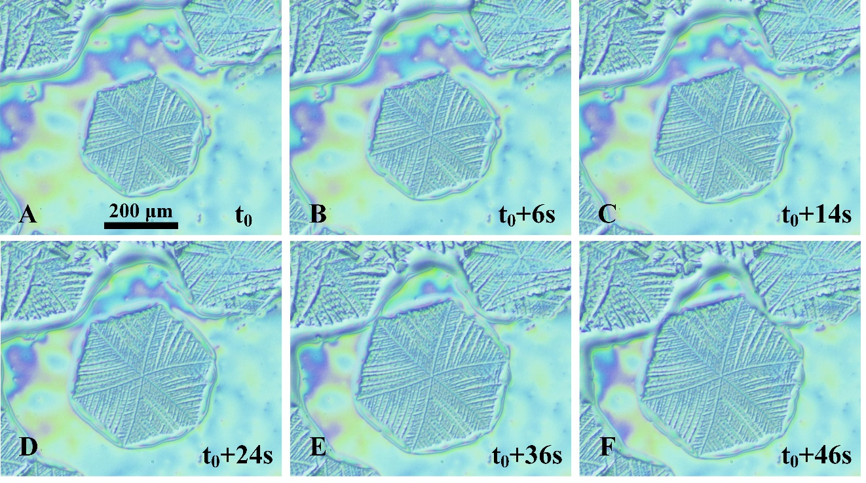

Fig. S8. In-situ high-pressure microscopy images of the crystal growth process of PLLA film. The crystallization temperature is 70℃ and the CO₂ pressure is 1000Psi. The scale bar is given in the first figure. (Another example)

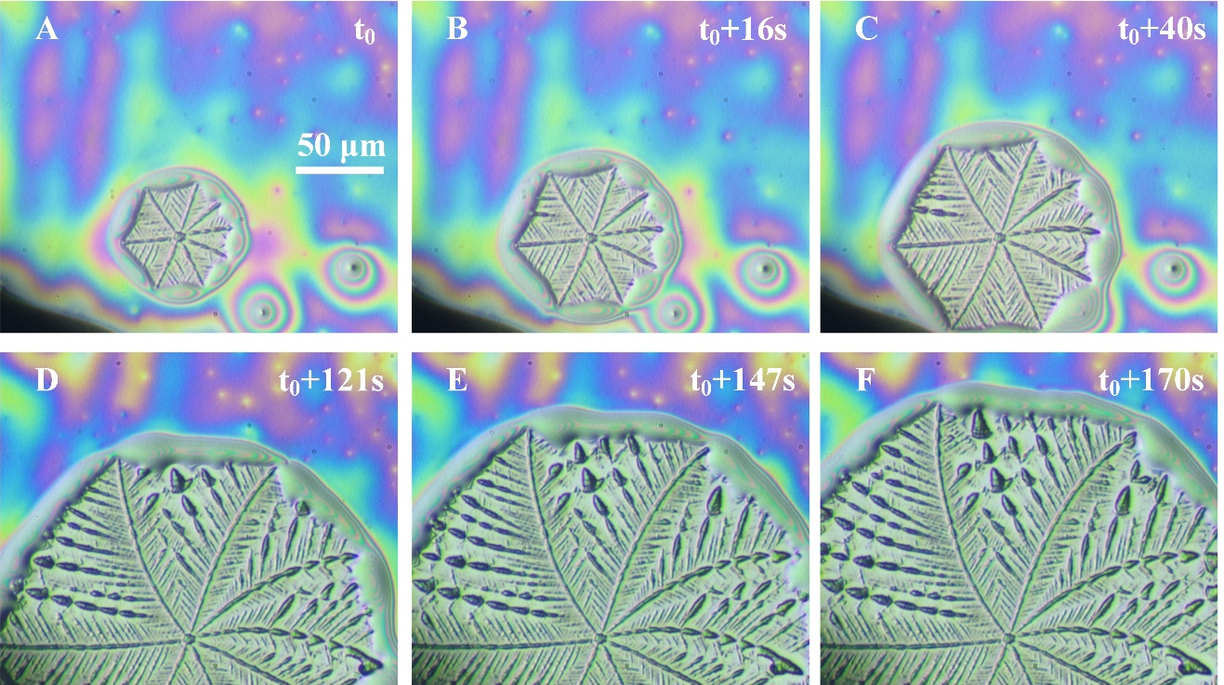

Fig. S9. In-situ high-pressure microscopy images of the crystal growth process of PDLA film. The crystallization temperature is 60℃ and the CO₂ pressure is 1250Psi. The scale bar is given in the first figure.

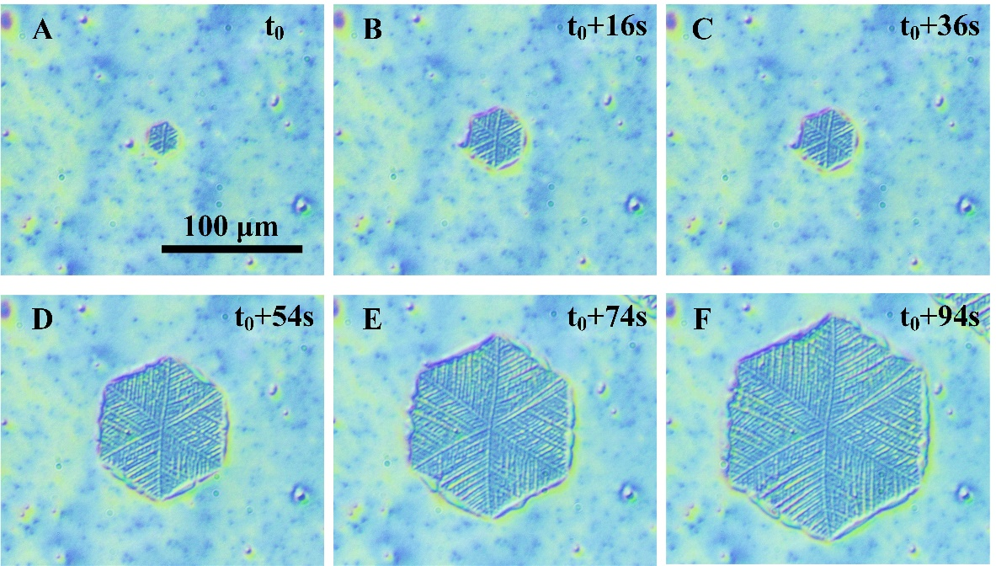

Fig. S10. In-situ high-pressure microscopy images of the crystal growth process of PLLA film. The crystallization temperature is 60℃ and the CO₂ pressure is 1200Psi. The scale bar is given in the first figure.

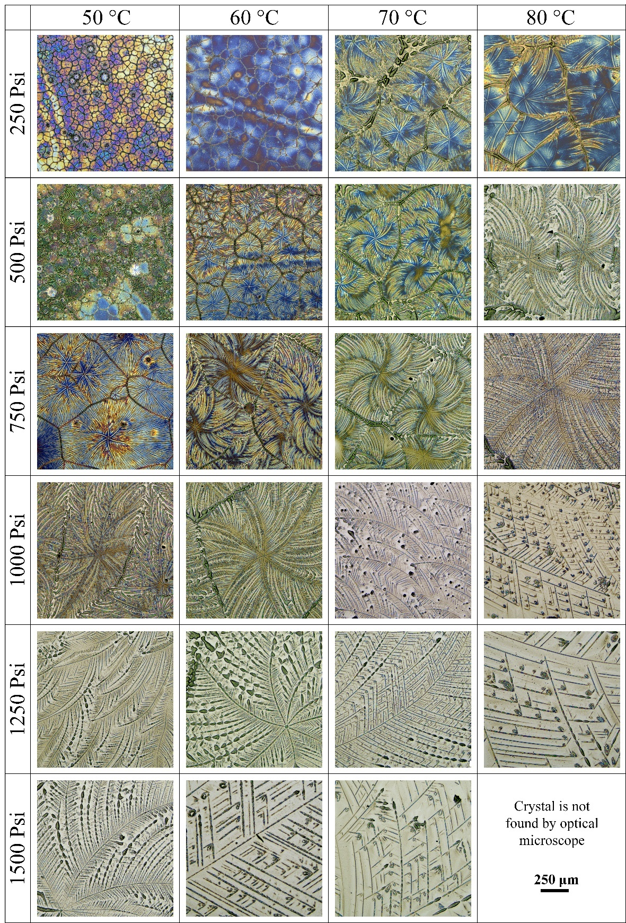

Fig. S11. High-pressure microscopy images of PDLA sample after isothermal crystallization treatment with different crystallization temperature and different CO₂ pressure. The scale bar is given in the lower right corner
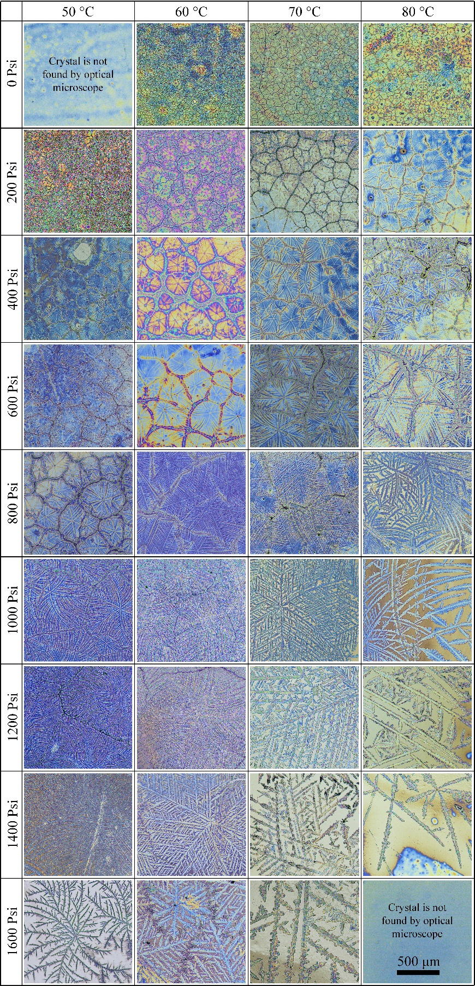

Fig. S12. High-pressure microscopy images of PLLA sample after isothermal crystallization treatment with different crystallization temperature and different CO₂ pressure. The scale bar is given in the lower right corner.
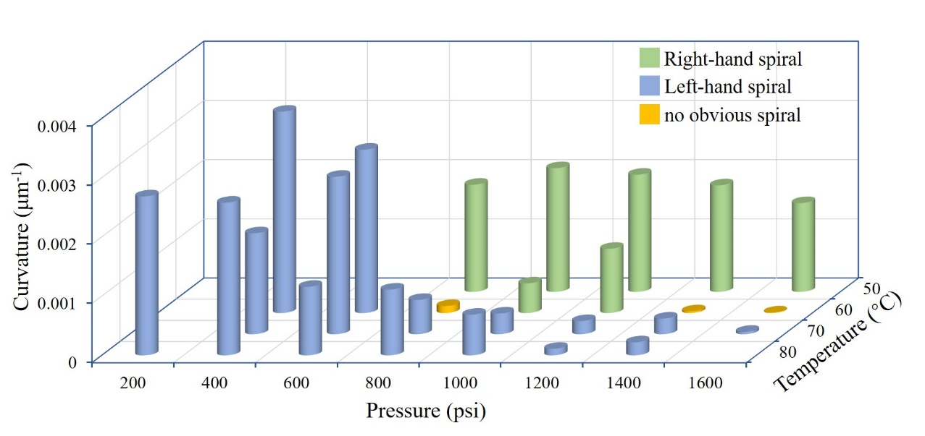

Fig. S13. Bending direction and curvature of PLLA crystal after isothermal crystallization treatment with different crystallization temperature and different CO₂ pressure. The curvature of bent crystal in Figure S12 is measured by three-point method, with five randomly measured branches for each crystal, and then take the average value.

Fig. S14. The AFM height images and height curves of PDLA crystals formed in a CO₂ environment. The pressure is 1250Psi and temperatures are (A) 50℃, (B) 60 ℃, (C) 70 ℃, respectively.

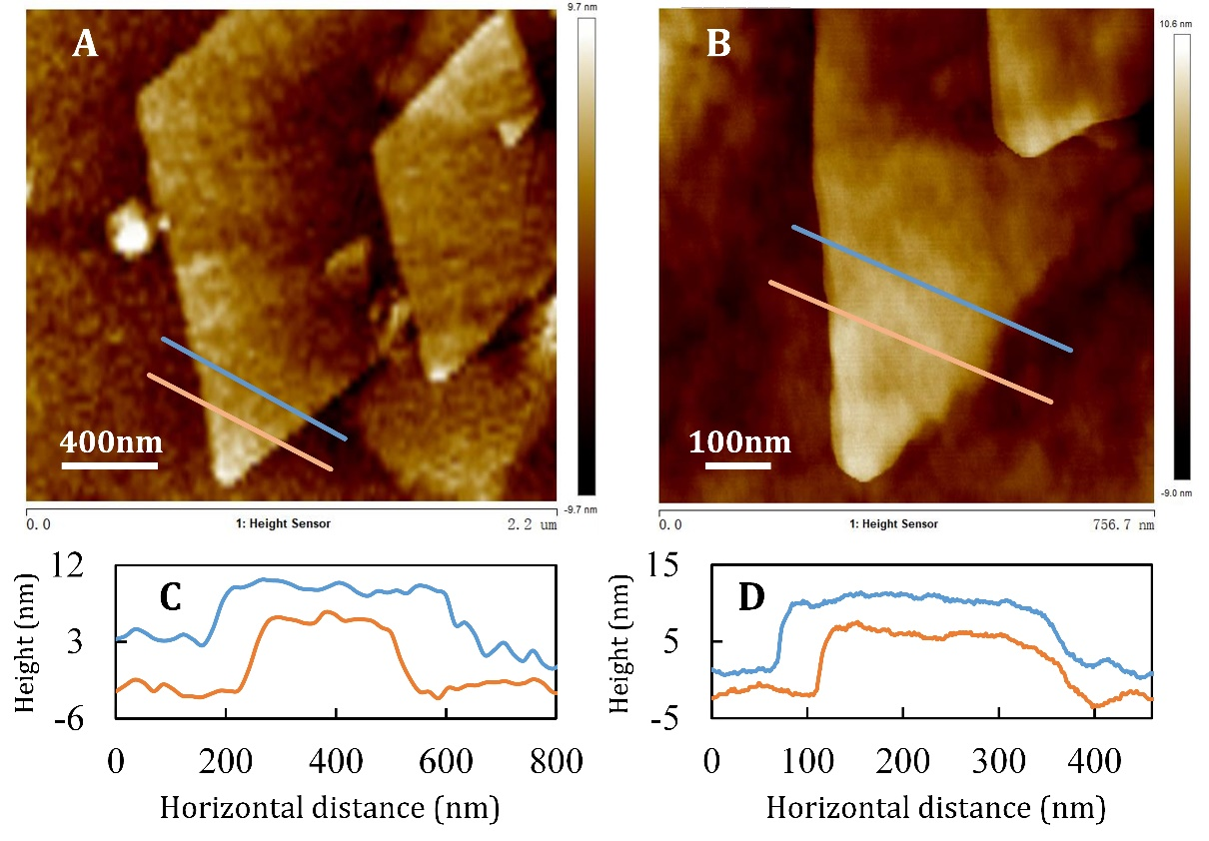

Fig. S15. The AFM height images and height curves of PDLA crystals formed in CO₂. The pressure is 1500Psi and the temperatures are 50℃ (A) and 1000Psi 70℃ (B), respectively. (C) and (D) show the height curves on the line labeled in (A) and (B), respectively.

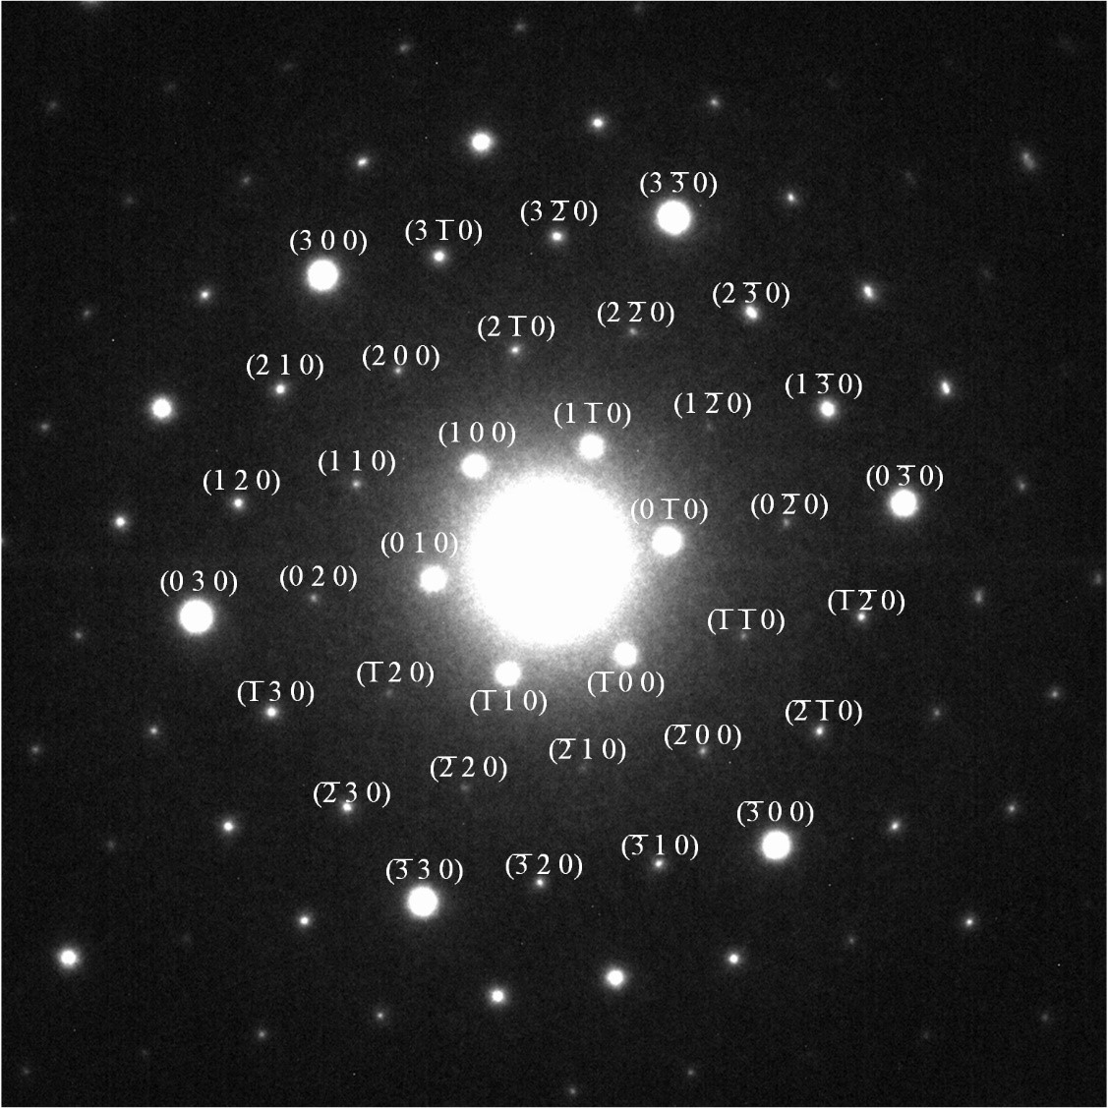

Fig. S16. hk0 diffraction patterns of the trigonal, frustrated β phase.

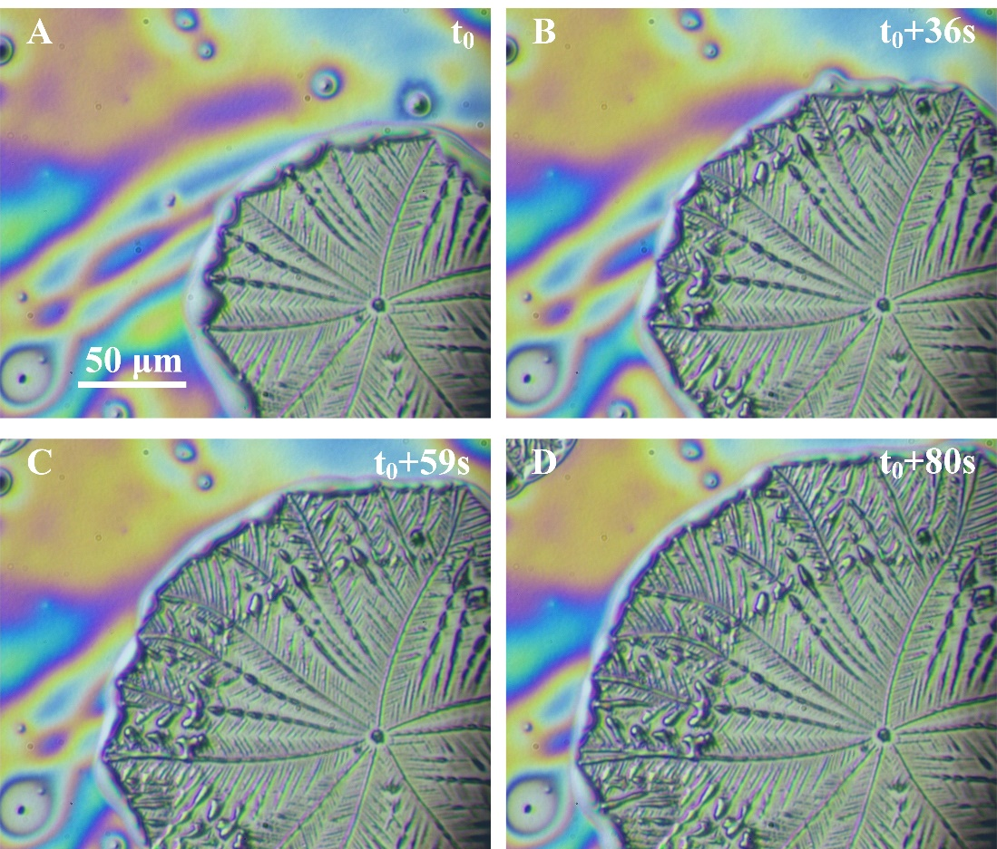

Fig. S17. In-situ high-pressure microscopy images of the crystal growth process of PDLA film. The crystallization temperature is 60℃ and the CO₂ pressure changed from 1250 Psi to 750 Psi after t₀, the scale bar is given in the first figure.

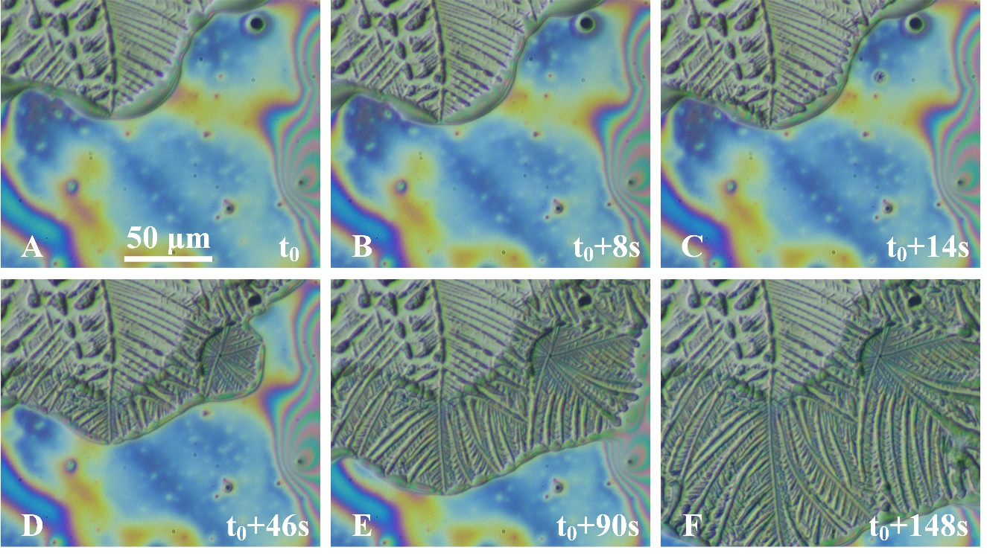

Fig. S18. In-situ high-pressure microscopy images of the crystal growth process of PDLA film. The crystallization temperature is 60℃ and the CO₂ pressure changed from 1300Psi to 750 Psi after t₀+8s, the scale bar is given in the first figure.

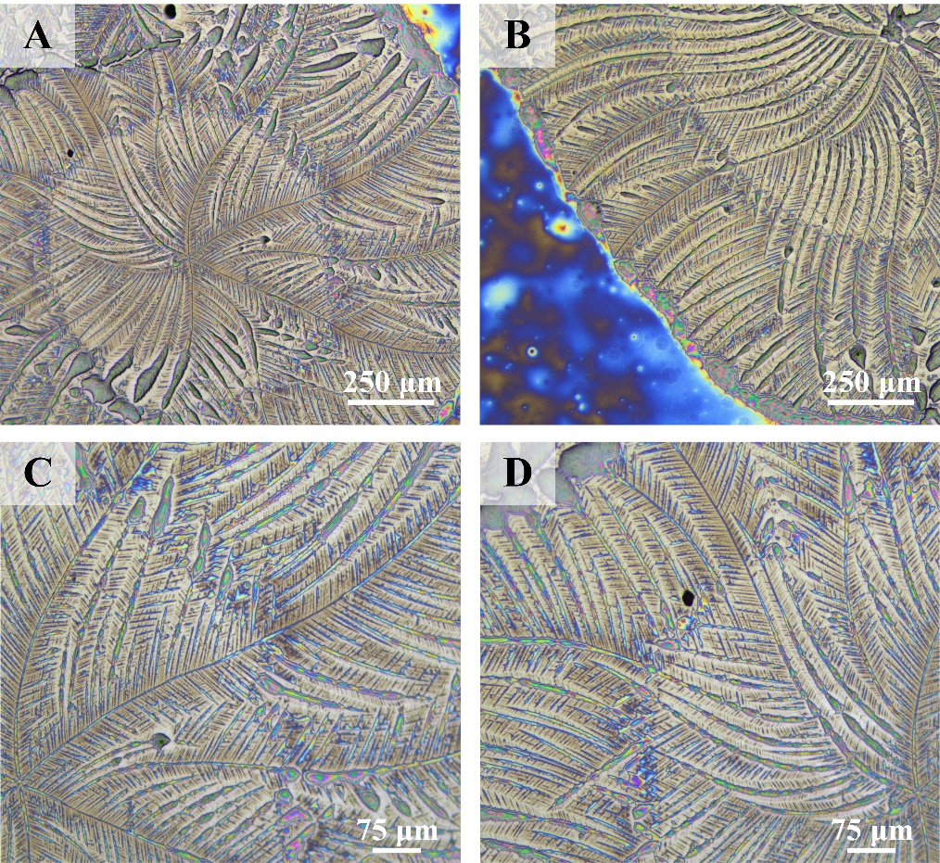

Fig. S19. Control the bending direction of PDLA crystal by simultaneously changing crystallization temperature and CO₂ pressure. The temperature is changed from 50 to 70℃, and the pressure is changed from 1300 to 1000 psi.

Table S1. Parameters used in S-L equation of state of PLLA/CO₂ mixture system

Quantity | Value | Ref.
$h$, Planck constant | 6.626×10⁻³⁴ J·s
$k$, Boltzmann constant | 1.381×10⁻²³ J·K⁻¹
$N_{a}$, Avogadro constant | 6.022×10²³ mol⁻¹
$R$, gas constant | 8.314 J⋅mol⁻¹·K⁻¹
$M$, CO₂ molar mass | 0.044 kg·mol⁻¹
$k_{12}$, binary interaction parameter | -0.115 | (3)
Parameters about CO₂ |  | (3)
$P_{1}^{*}$, characteristic pressure | 720.3 MPa | (3)
$T_{1}^{*}$, characteristic temperature | (208.9+0.459T-0.000756T²) K | (3)
$ρ_{1}^{*}$, characteristic density | 1.58 g/cm³ | (3)
$r_{1}^{0}$, characteristic size | 8.4 | (12)
Parameters about polymer (PLLA) |  | (3)
$P_{2}^{*}$, characteristic pressure | 560.2 MPa | (3)
$T_{2}^{*}$, characteristic temperature | 592.2 K | (3)
$ρ_{2}^{*}$, characteristic density | 1.35 g/cm³ | (3)
$r_{2}^{0}$, characteristic size | $$∞$$ | (12)

References
- C. Sanchez, R. H. Lacombe, An elementary molecular theory of classical fluids. Pure fluids. The Journal of Physical Chemistry 80, 2352–2362 (1976).
- R. H. Lacombe, I. C. Sanchez. Statistical thermodynamics of fluid mixtures. The Journal of Physical Chemistry 80, 2568–2580 (1976).
- H. Mahmood, M. Keshtkar, C. B. Park, Determination of carbon dioxide solubility in polylactide acid with accurate PVT properties. The Journal of Chemical Thermodynamics 70: 13–23 (2014).
- L. Zhang, G. Q. Zhao, G. L. Wang, Investigation on the growth of snowflake-shaped poly (L-Lactic Acid) crystal by in-situ high-pressure microscope. Polymer 177, 25–34 (2019).
- H. Wang, J. Zhang, K. Tashiro, Phase transition mechanism of poly (l-lactic acid) among the α, δ, and β forms on the basis of the reinvestigated crystal structure of the β form. Macromolecules 50, 3285–3300 (2017).
- G. Ungar, J. Stejny, A. Keller, I. Bidd, M. C. Whiting, The crystallization of ultralong normal paraffins: the onset of chain folding. Science 229, 386–389 (1985).
- B. Lotz, Single Crystals of the Frustrated β-Phase and Genesis of the Disordered α′-Phase of Poly (l-lactic acid). ACS Macro Letters 4, 602–605 (2015).
- G. Q. Zhao, L. Zhang, G. L. Wang, Microscopic observation system with temperature-pressure-controllable sample cell and methods. U.S. Patent 11060965. 2021–7–13.
- G. Q. Zhao, L. Zhang, G. L. Wang, Small angle laser scatterometer with temperature-pressure-controllable sample cell and characterization method. U.S. Patent 11067505. 2021–7–20.
- L. Zhang, G. Q. Zhao, G. L. Wang, Investigation of the influence of pressurized CO₂ on the crystal growth of poly (l-lactic acid) by using an in situ high-pressure optical system. Soft Matter 15, 5714–5727 (2019).
- L. Zhang, G. Q. Zhao, Poly (l-lactic acid) Crystallization in Pressurized CO₂: An in-situ microscopic study and a new model for secondary nucleation in supercritical CO₂. The Journal of Physical Chemistry C 124, 9021–9034 (2020).
- L. Chen, G. Cao, R. Zhang, F. He, T. Liu, L. Zhao, W. Yuan, G. W. Roberts, In-situ visual measurement of poly(methyl methacrylate) swelling in supercritical carbon dioxide and interrelated thermodynamic modeling. CIESC Journal 60, 2351–2358 (2009).

