Supplementary Materials:
Figure S1 Flow chart of records selection
Figure S2 Annual citation frequency
Figure S3 Visual map of countries and regions. (A) Network map of top 30 countries. (B) Dynamics and trend diagram of top 30 countries/regions.
Figure S4 Visual map of universities and institutions. (A) Network map of the top 100 universities/institutions. (B) Dynamics and trend diagram of the top 100 universities/institutions.
Figure S5 Visualization diagram of keywords. (A) Network map of the top 100 keywords. (B) Dynamics and trends of the top 100 keywords.
Table S1 Top 10 productive authors
Table S2 Analysis of top journals and their citations
Table S3 Top 10 co-citations
Table S4 Occurrences and total link strength of the top 10 keywords
Table S5 Analysis of keywords from 2021 to 2022

Figure S1 Flow chart of records selection

Figure S2 Annual citation frequency

Figure S3 Visual map of countries and regions. (A) Network map of top 30 countries. (B) Dynamics and trend diagram of top 30 countries/regions.

Figure S4 Visual map of universities and institutions. (A) Network map of the top 100 universities/institutions. (B) Dynamics and trend diagram of the top 100 universities/institutions.

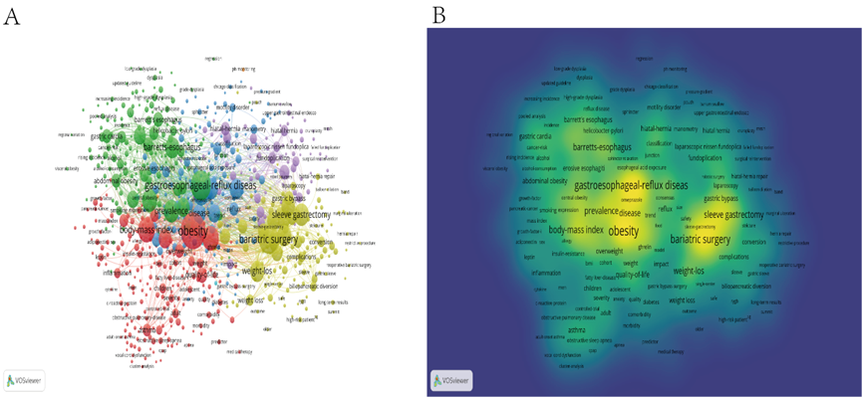
Figure S5 Visualization diagram of keywords. (A) Network map of the top 100 keywords. (B) Dynamics and trends of the top 100 keywords.

Table S1 Top 10 productive authors
Rank | Author | Documents, n | Citations, n | Average citations | Total link strength
1 | Lagergren J | 34 | 1,452 | 42.7 | 73
2 | Corley DA | 25 | 1,998 | 79.9 | 146
3 | Whiteman DC | 25 | 1,082 | 43.3 | 170
4 | Vaughan TL | 24 | 1,397 | 58.2 | 167
5 | Patti MG | 22 | 452 | 20.5 | 27
6 | El-serag HB | 19 | 1,185 | 62.4 | 30
7 | Silecchia G | 15 | 345 | 23.0 | 28
8 | Ye W | 15 | 713 | 47.5 | 132
9 | Nedelcu M | 14 | 282 | 20.1 | 32
10 | Thrift A | 14 | 565 | 40.4 | 43

Table S2 Analysis of top journals and their citations
Rank | Top productive journals |  |  |  | Top cited journals |  |  |  | Top average citations
Rank | Journals (IF&Q) | Total number  (n) | Percentage (%) |  | Journals  (IF&Q) | Total number  (n) | Total Citations |  | Journals  (IF&Q) | Total number  (n) | Average times
1 | Obesity Surgery（3.5，Q2） | 364 | 21.6% |  | Obesity Surgery （3.5，Q2） | 364 | 141861 |  | American Journal of Respiratory and Critical Care Medicine(30.5,Q1) | 6 | 206.0
2 | Surgery for Obesity and Related Diseases（3.7，Q1） | 159 | 9.4% |  | Surgery for Obesity and Related Diseases（3.7，Q1） | 159 | 90623 |  | Gastroenterology(33.9,Q1) | 24 | 142.7
3 | Surgical Endoscopy and Other Interventional Techniques（3.5，Q2） | 119 | 7.1% |  | Surgical Endoscopy and Oher Interventional Techniques（3.5，Q2） | 119 | 60154 |  | Journal of Allergy and Clinical Immunology(14.3,Q1) | 6 | 137.8
4 | World Journal of Gastroenterology（5.4，Q2) | 46 | 2.7% |  | Gastroenterology(33.9,Q1) | 24 | 24593 |  | Annals of Surgery(13.8,Q1) | 22 | 105.3
5 | Digestive Diseases and Sciences(3.5,Q3) | 43 | 2.6% |  | Gut(31.8,Q1) | 32 | 33511 |  | Thorax(9.2,Q1) | 6 | 94.7
6 | Diseases of the Esophagus(2.8,Q4) | 40 | 2.4% |  | American Journal of Gastroenterology(12.0,Q1) | 34 | 30162 |  | Gut(31.8,Q1) | 32 | 91.8
7 | Journal of Gastrointestinal Surgery(3.3,Q2) | 37 | 2.2% |  | World Journal of Gastroenterology（5.4，Q2) | 46 | 45568 |  | American Journal of Gastroenterology(12.0,Q1) | 34 | 85.4
8 | Journal of Laparoendoscopic & Advanced Surgical Techniques(1.8,Q3) | 37 | 2.2% |  | Annals of Surgery(13.8,Q1) | 22 | 16977 |  | Nature Reviews Gastroenterology & Hepatology(73.1,Q1) | 7 | 76.1
9 | American Journal of Gastroenterology(12.0,Q1) | 34 | 2.0% |  | Alimentary Pharmacology & Therapeutics(9.5,Q1) | 34 | 28021 |  | Cancer Epidemiology Biomarkers & Prevention(4.1,Q2) | 15 | 75.4
10 | Alimentary Pharmacology & Therapeutics(9.5,Q1) | 34 | 2.0% |  | Clinical Gastroenterology and Hepatology(13.6,Q1) | 30 | 926 |  | World Journal of Gastroenterology（5.4，Q2) | 46 | 60.8

Table S3 Top 10 co-citations
Rank | Author | Number of citations | Title | Journal
1 | Hampel H (2005) | 392 | Meta-analysis: Obesity and the risk for gastroesophageal reflux disease and its complications | Annals of Internal Medicine
2 | Lagergren J (1999) | 232 | Symptomatic gastroesophageal reflux as a risk factor for esophageal adenocarcinoma | New England Journal of Medicine
3 | El-serag HB (2005) | 229 | Obesity is an independent risk factor for GERD symptoms and erosive esophagitis. | American Journal of Gastroenterology
4 | Vakil N (2006) | 194 | The Montreal definition and classification of gastroesophageal reflux disease: A global evidence-based consensus | American Journal of Gastroenterology
5 | Jacobson BC (2006) | 183 | Body-mass index and symptoms of gastroesophageal reflux in women | New England Journal of Medicine
6 | Pandolfino JE (2006) | 182 | Obesity: A challenge to esophagogastric junction integrity | Gastroenterology
7 | Dent J (2005) | 173 | Epidemiology of gastro-oesophageal reflux disease: a systematic review | Gut
8 | Nilsson M (2003) | 172 | Obesity and estrogen as risk factors for gastroesophageal reflux symptoms | JAMA-Journal of the American Medical Association
9 | Wilson LJ (1999) | 167 | Association of obesity with hiatal hernia and esophagitis | American Journal of Gastroenterology
10 | Locke GR (1999) | 154 | Risk factors associated with symptoms of gastroesophageal reflux | American Journal of Medicine

Table S4 Occurrences and total link strength of the top 10 keywords
Rank | Keyword | Occurrences | Total link strength
1 | Obesity | 950 | 8,508
2 | Gastroesophageal-reflux disease | 608 | 5,408
3 | Bariatric surgery | 577 | 5,268
4 | Body-mass index | 418 | 4,053
5 | Symptom | 367 | 3,449
6 | Prevalence | 344 | 3,273
7 | Sleeve gastrectomy | 334 | 3,070
8 | Risk-factor | 324 | 3,109
9 | Weight-loss | 290 | 2,861
10 | Barrett's esophagus | 286 | 2,719

Table S5 Analysis of keywords from 2021 to 2022
Rank | Year | Frequency | Keyword
1 | 2021 | 7 | Weight regain
2 | 2021 | 5 | Sleep apnea
3 | 2021 | 5 | Diabetes mellitus
4 | 2022 | 3 | Revisional bariatric surgery
5 | 2022 | 2 | pH monitoring
6 | 2022 | 2 | Lung function
7 | 2022 | 2 | Abdominal obesity
8 | 2022 | 2 | Life style
9 | 2022 | 2 | Sleeve gastrectomy
10 | 2022 | 2 | Endoscopy

