Supplementary results
Table I: Volumes and volume overlaps for rattlesnakes, their selected backgrounds, and random backgrounds calculated for each visual system. Percentage overlap was calculated as the quotient of the overlap volume divided by the smaller volume.
Visual model | Volume C. atrox | Volume selected background | Volume random background | Overlap volume | % overlap
Human | 0.0008308973 | 0.001176634 | - | 0.0007055243 | 84.91%
Human | 0.0008308973 | - | 0.0009448275 | 0.000471972 | 56.80%
Peafowl | 6.696731e-05 | 5.27578e-05 | - | 4.295264e-05 | 81.41%
Peafowl | 6.696731e-05 | - | 4.164338e-05 | 2.327596e-05 | 55.89%
Blue tit | 0.0001991265 | 0.0001765359 | - | 0.0001380121 | 78.17%
Blue tit | 0.0001991265 | - | 0.0001114216 | 6.497264e-05 | 58.31%
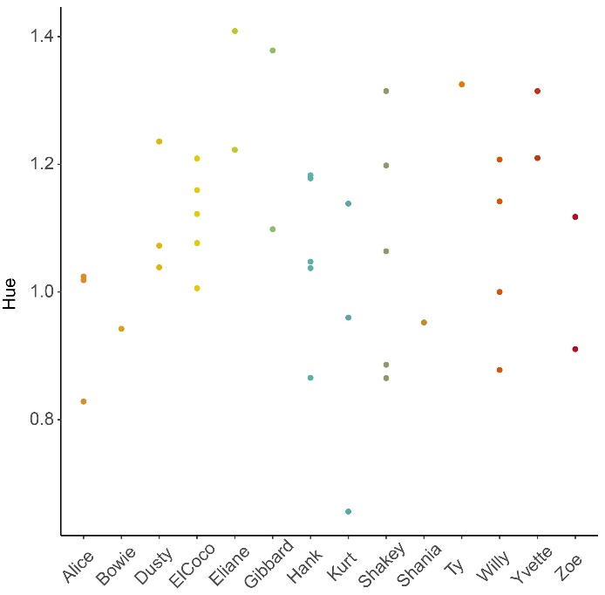
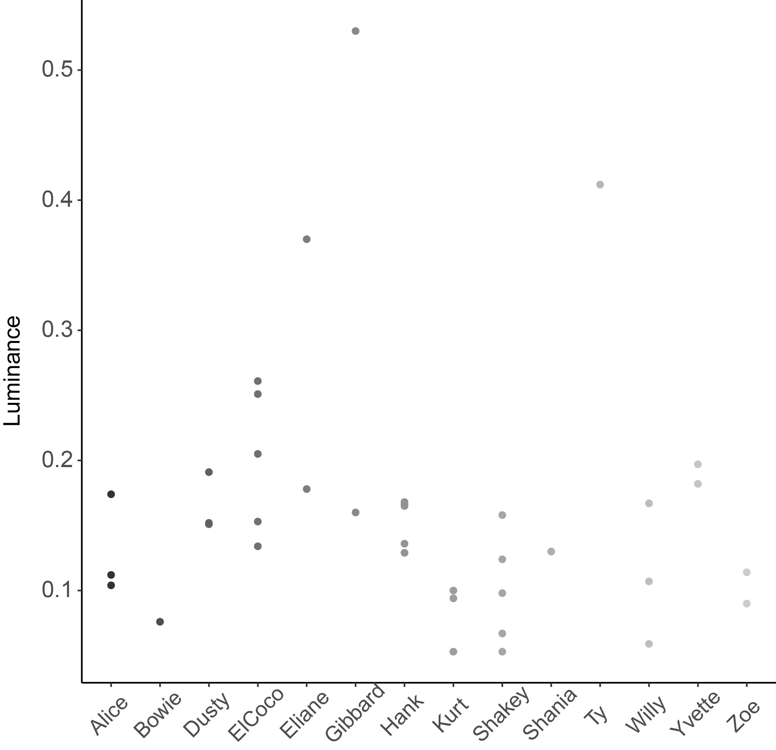
Figure 1: Dot plots showing the variation in hue (A) and luminance (B) observed for each snake during this study. Each dot represents one observation.
A
B

