Rapid, Sensitive, and Selective "ON-OFF" Detection of Fe³⁺ Ions Using Novel Acetalophanes and Their Applications in Real Samples

Leila Sobhaniª, Hossein Reza Darabiª, Leila Atasbiliª, Kioumars Aghapoorª, Saeed Rastgarª, and Khosrow Jadidi^{b}

*Corresponding author. E-mail addresses: darabi@ccerci.ac.ir; r_darabi@yahoo.com (H.R. Darabi)

Fig S1: ¹HNMR of 1a

Fig S2: ¹³CNMR of 1a

Fig S3: ¹HNMR of 1b

Fig S4: ¹HNMR of 1b (Expand)

Fig S5: ¹³CNMR of 1b

Fig S6: ¹HNMR of 1c

Fig S7: ¹HNMR of 1c (Expand)

Fig S8: ¹³CNMR of 1c

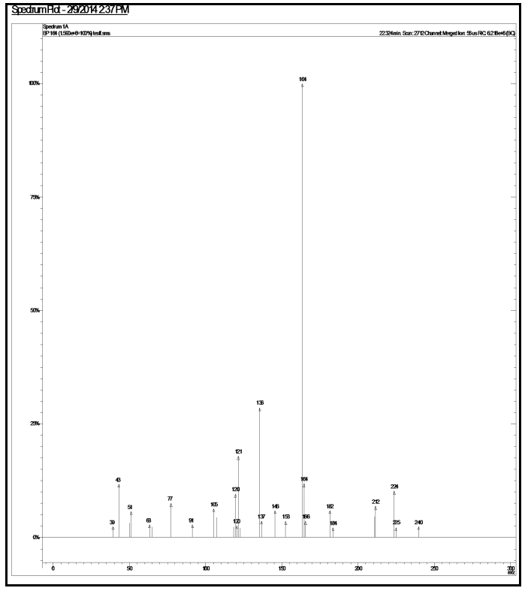
Fig S9: Mass spectroscopy of 1a

Fig S10: Mass spectroscopy of 1b

Fig S11: Mass spectroscopy of 1c

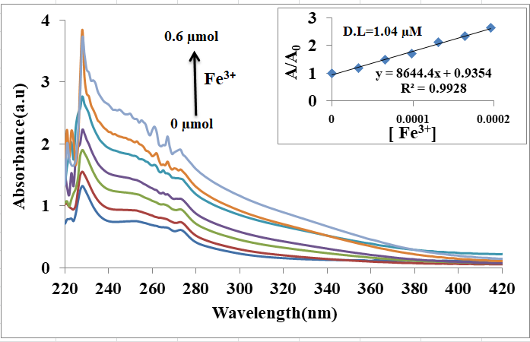
Fig S12 UV-vis spectra 1a with Fe³⁺

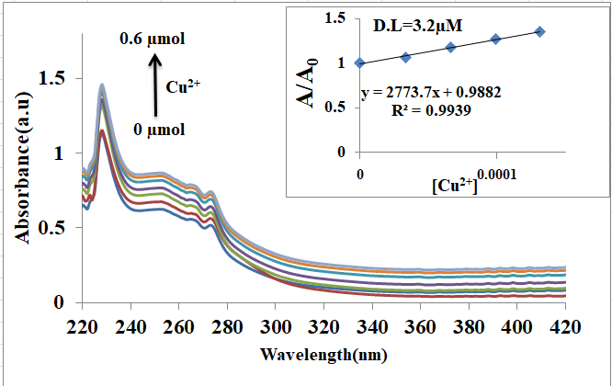
Fig S13 UV-vis spectra 1a with Cu²⁺
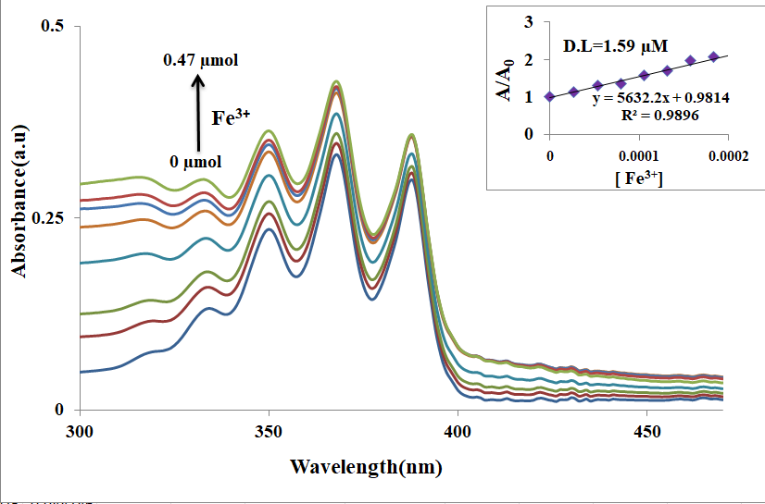
Fig S14 UV-vis spectra 1b with Fe³⁺
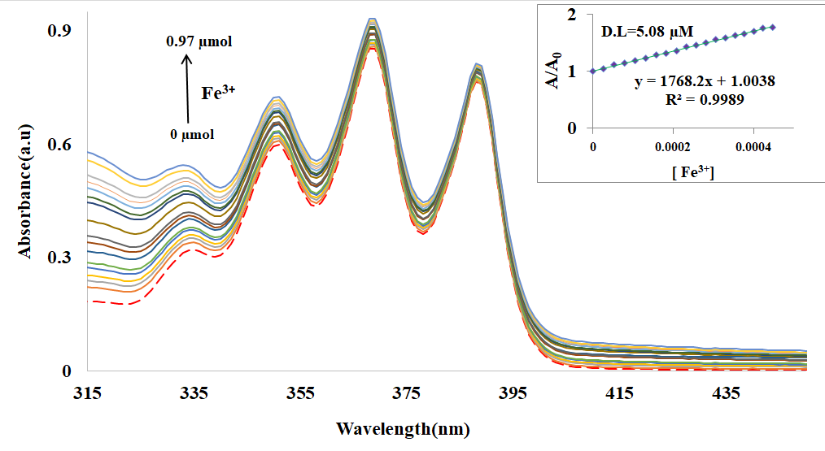 Fig S15 UV-vis spectra 1c with Fe³⁺

Fig S16 IR spectra: (a) probe 1c, (b) obtained product

Fig. S17 IR spectra: (a) probe 1a, (b) 1a+CuCl₂ and (c) 1a+FeCl₃

