SUPPLEMENTAL MATERIAL - TABLE OF CONTENTS

Supplementary Figure 1 p. 2
Supplementary Figure 2 p. 3
Supplementary Figure 3 p. 4
Supplementary Figure 4 p. 5
Supplementary Table 1 [xlsx file attached] p. 6
Supplementary Table 2 [xlsx file attached] p. 6
Supplementary Table 3 [xlsx file attached] p. 6
Supplementary Table 4 [xlsx file attached] p. 6
Supplementary Table 5 [xlsx file attached] p. 6
Supplementary Table 6 [xlsx file attached] p. 6
Supplementary Table 7 [xlsx file attached] p. 6
Supplementary Table 8 [xlsx file attached] p. 6
Supplementary Table 9 [xlsx file attached] p. 6
Supplementary Table 10 [xlsx file attached] p. 6

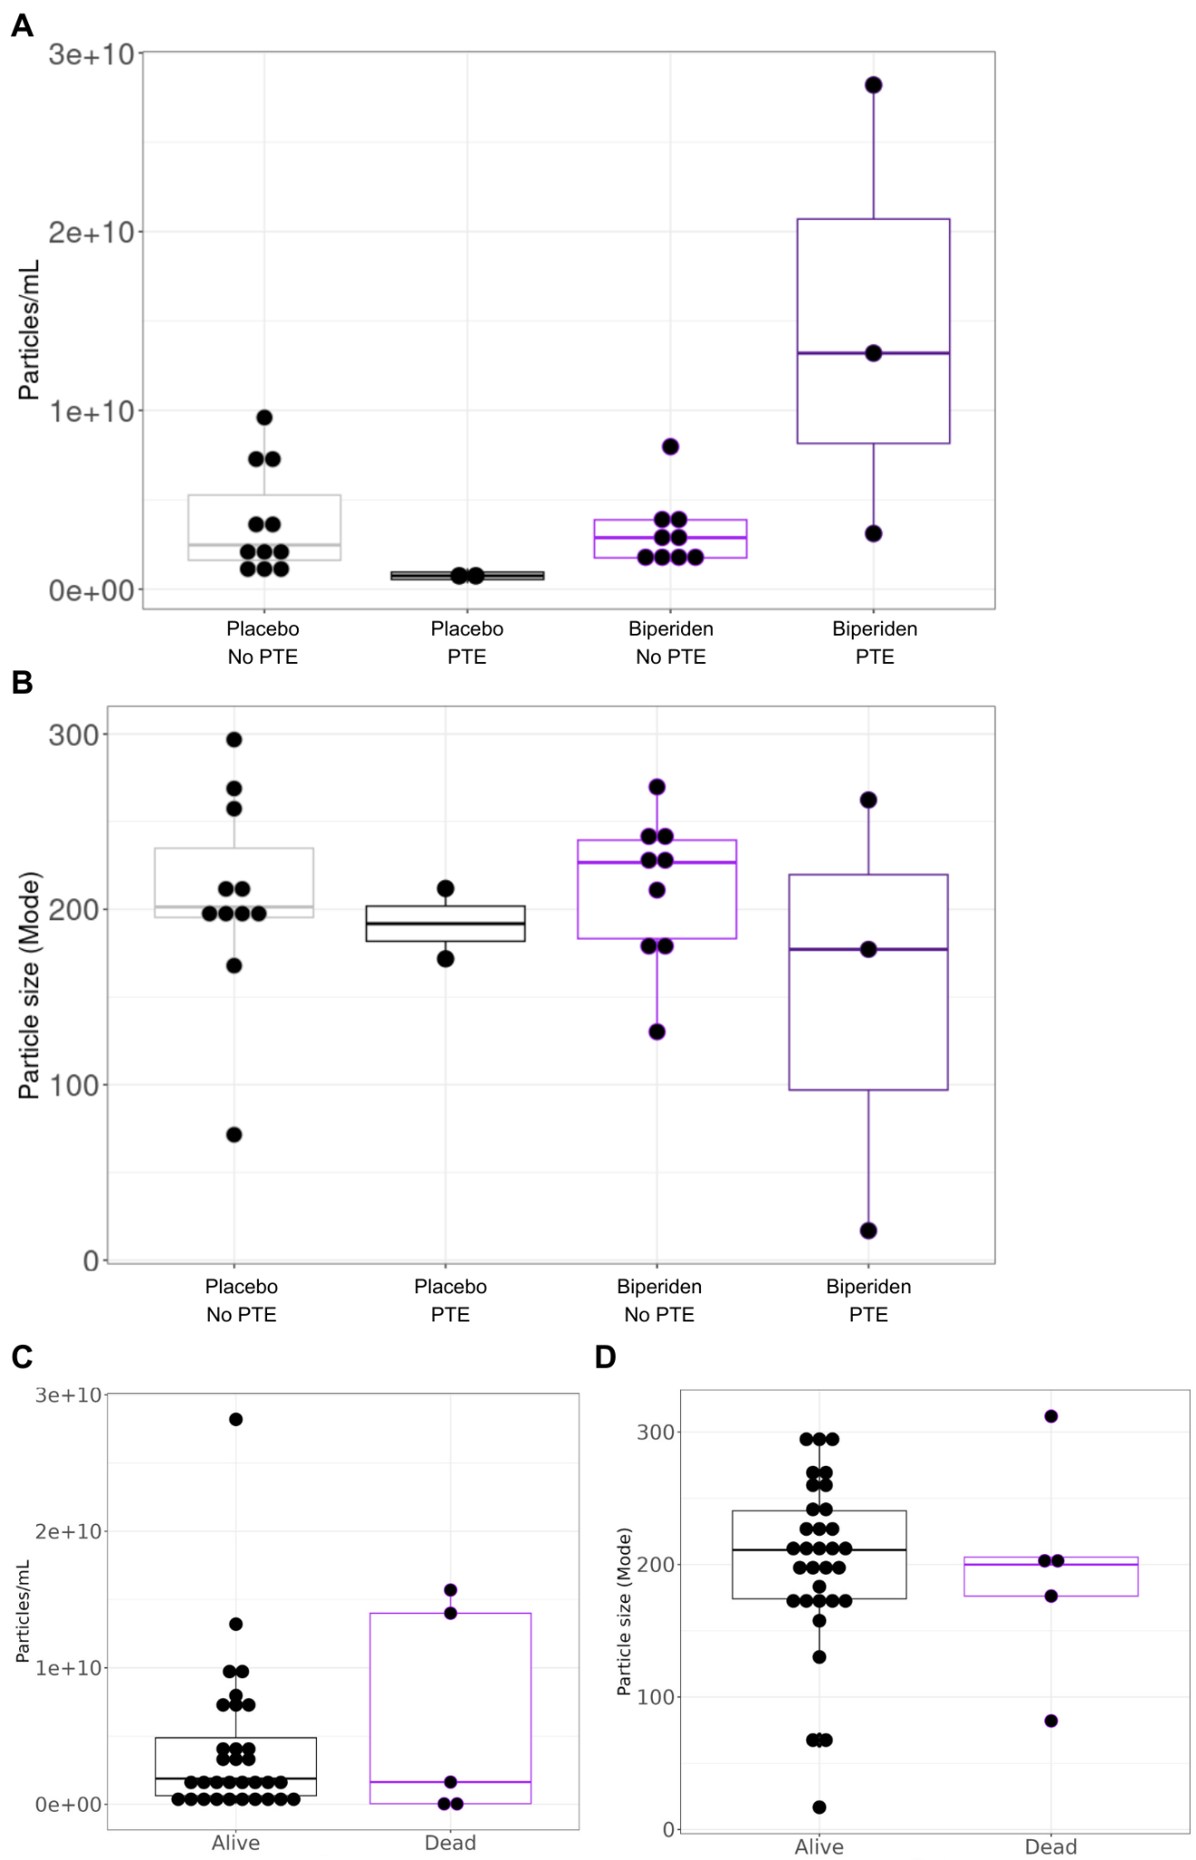
Supplementary Figure 1. Extracellular vesicle comparison between experimental and outcome groups. Particles per mL (A) and particle size mode (B) are compared between different treatment and PTE development group combinations. Particles per mL (C) and size mode (D) are compared between patient outcomes.
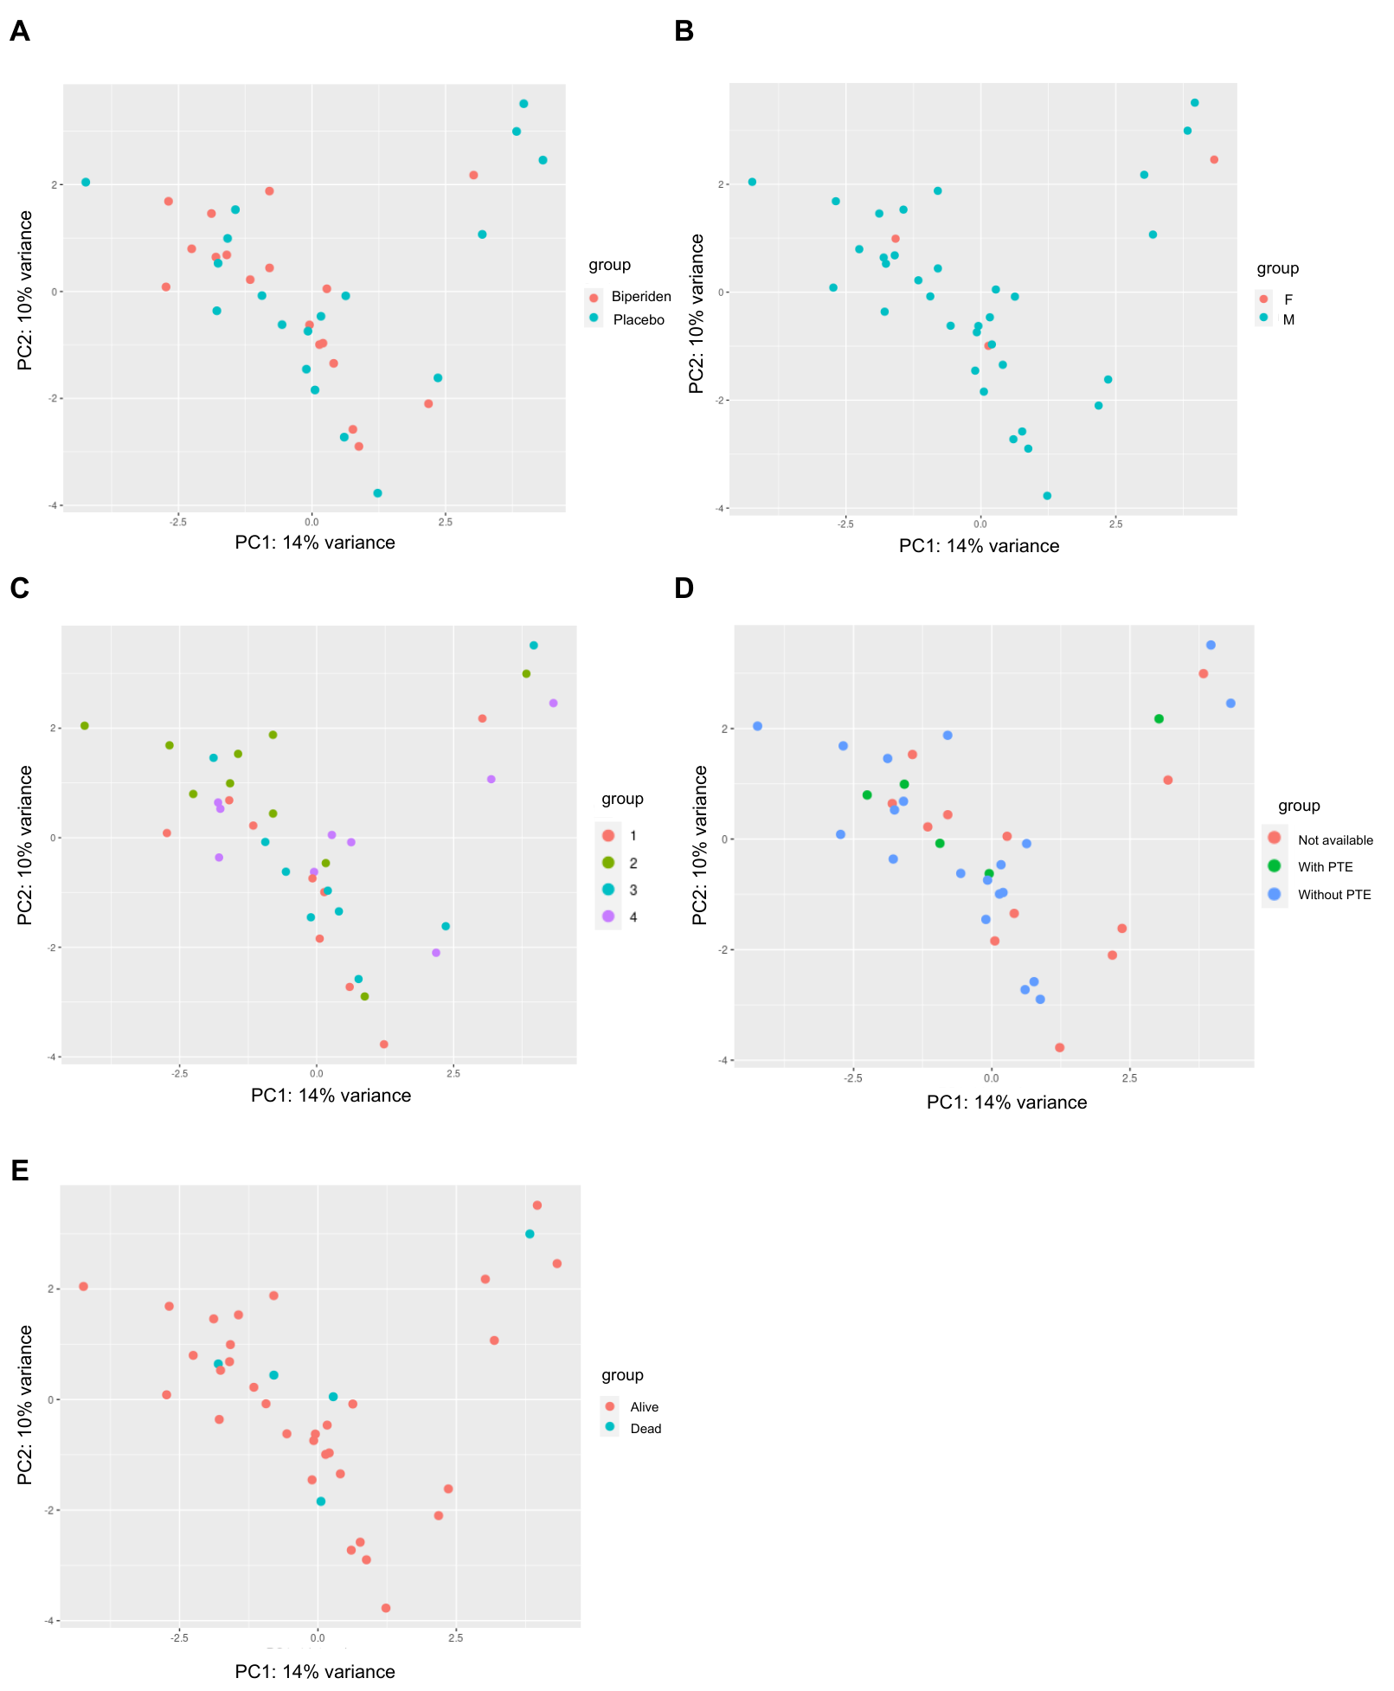
Supplementary Figure 2. Principal component analysis of patient blood serum miRNA-seq aligned using exceRpt. Sample colors represent (A) biperiden treatment regimen, (B) biological sex, (C) sequencing batch, (D) PTE development and (E) Outcome.

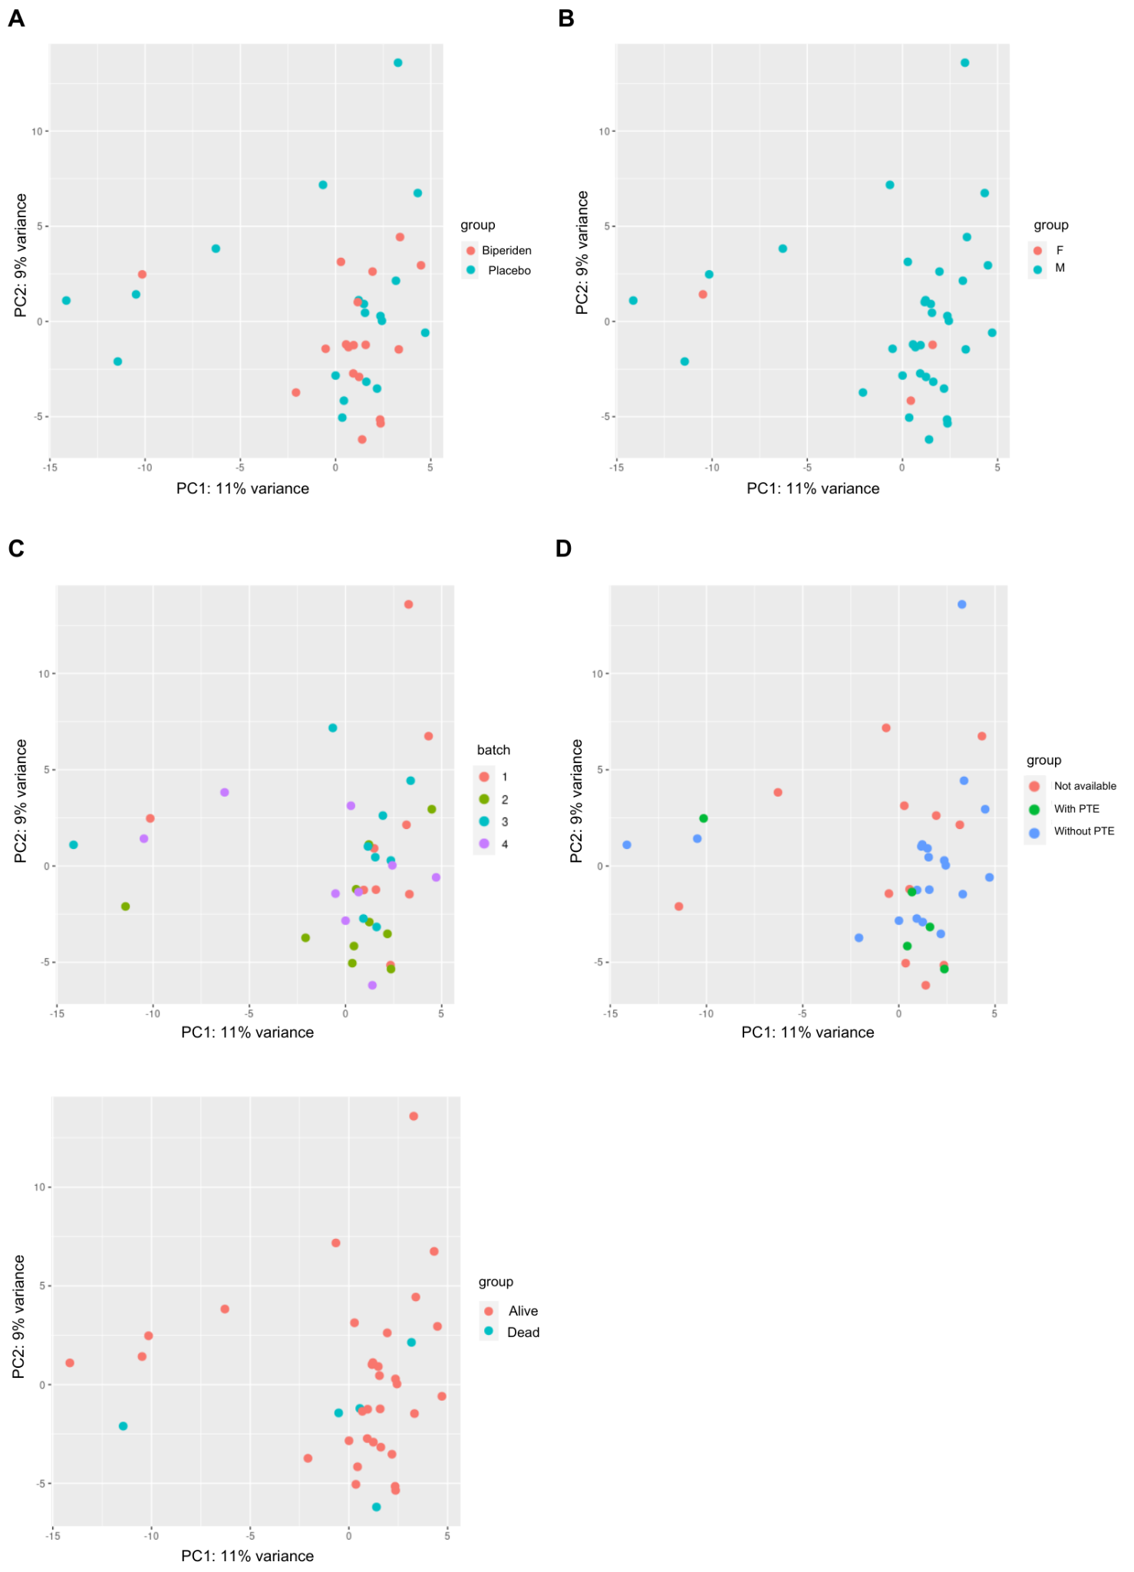
Supplementary Figure 3. Principal component analysis of patient blood serum miRNA-seq aligned using miRge3.0. Sample colors represent (A) biperiden treatment regimen, (B) biological sex, (C) sequencing batch, (D) PTE development and (E) Outcome.

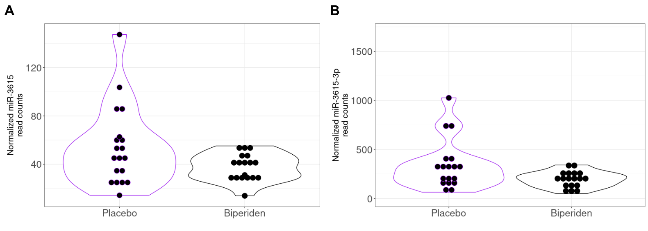
Supplementary Figure 4. miR-3615 and miR-3615-3p expression, depicted as violin plots using either (A) exceRpt or (B) miRge3.0 alignment softwares, respectively, normalized and analyzed using DESeq2.

Supplementary Table 1. Logistic regression results between biperiden treatment and other clinical parameters.
Supplementary Table 2. Patients characteristics.
Supplementary Table 3. miRNA expression comparison between biperiden- and placebo-treated groups. Read counts were obtained using exceRpt and analyzed using DESeq2.
Supplementary Table 4. miRNA expression comparison between biperiden- and placebo-treated groups. Read counts were obtained using miRge3.0 and analyzed using DESeq2.
Supplementary Table 5. Linear regression results between miR-9-5p expression and clinical parameters
Supplementary Table 6. miR-9-5p target genes.
Supplementary Table 7. Gene Ontology: Biological Process enrichment analysis of miR-9-5p target genes.
Supplementary Table 8. miRNA expression comparison between groups of patients that either developed or did not develop PTE. Read counts were obtained using exceRpt and analyzed using DESeq2.
Supplementary Table 9. miRNA expression comparison between groups of patients that either developed or did not develop PTE. Read counts were obtained using miRge3.0 and analyzed using DESeq2.
Supplementary Table 10. Logistic regression results between PTE development and other clinical parameters

