Electronic Supplementary Information for

Synthesis of photoresponsive phenanthroimidazole-based S,S-dioxide dithienylethene for information storage and encryption

Jiaxian Lu,^{a,b} Qing Yan,^{b}* Miao Luo,^{b} Jun Ren,ª* Sheng Wang^{a,b}*

ªMinistry of Education Key Laboratory for the Synthesis and Application of Organic Functional Molecules & Hubei Collaborative Innovation Center for Advanced Organic Chemical Materials, Hubei University, Wuhan, 430062, P.R. China.
^{b}School of Chemistry and Chemical Engineering, Lingnan Normal University, Zhanjiang, 524048, China.

1. Absorption Spectra

Figure S1 The absorption changes of DTE-P1O4 in a) DCM, b) MeCN, c) DMSO (1 × 10⁻⁵ M) under 254 nm irradiation. Inset: corresponding color changes before and after irradiation.

2. Fluorescence Spectra

Figure S2 Fluorescence spectra changes (λ_{ex} = 360 nm) of DTE-PIO4 in a) DCM, b) MeCN, c) DMSO (1 × 10⁻⁵ M) under 254 nm light irradiation. Inset: corresponding fluorescence changes before and after irradiation. d) Color changes before and after irradiation in solid state.

3. NMR spectra and HRMS：
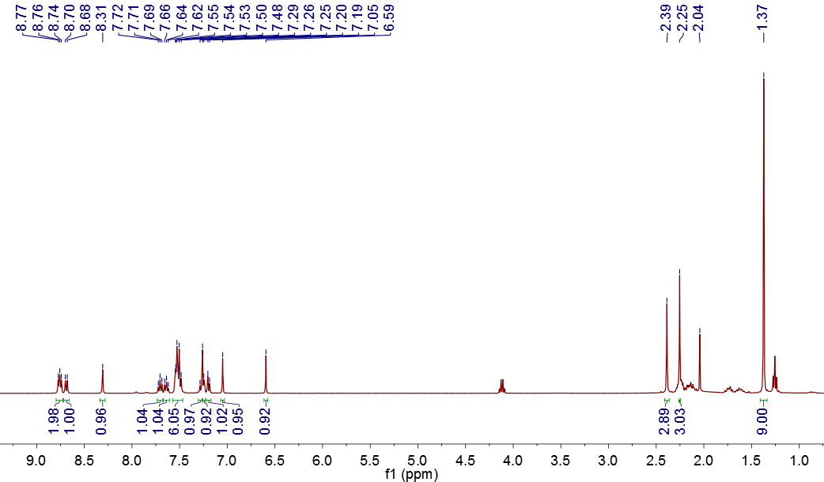
Figure S3 ¹H MNR of DTE-PIO4 in CDCl₃.

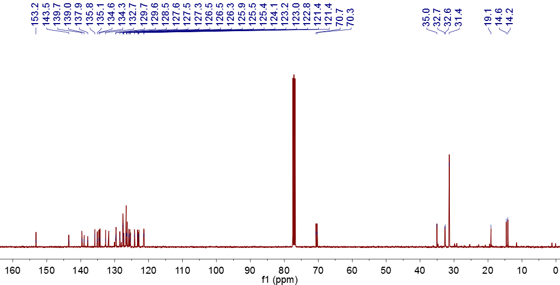
Figure S4 ¹³C MNR of DTE-PIO4 in CDCl₃.

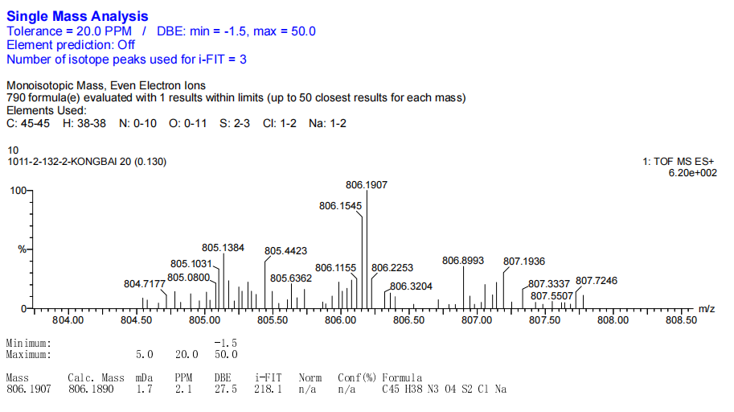
Figure S5 HRMS of DTE-PIO4.

