Morphological and microstructural characterization of an ancient Chola bronze statuette by neutron based non-invasive techniques
SUPPLEMENTARY MATERIALS
S.1 RECONSTRUCTION ARTEFACTS
As can be seen in figure 2 in the main text some areas in the bulk of the figurine are darker than the surrounding metal (Fig. S 1, Fig. S 2, Fig. S 3) . This effect, that could be related to morphological and microstructural features, also depends on the strong differences in the thickness of the metal that the beam had to pass through for each different orientation of the statue. This led to poor statistic for specific areas. The shielding parts (such as the halo, or the arms) cause the central section of the statuette to be under-sampled. The resulting images misleadingly represent these areas as less attenuating. Moreover, this generates a reconstruction artefact that appear as a projecting shadow.
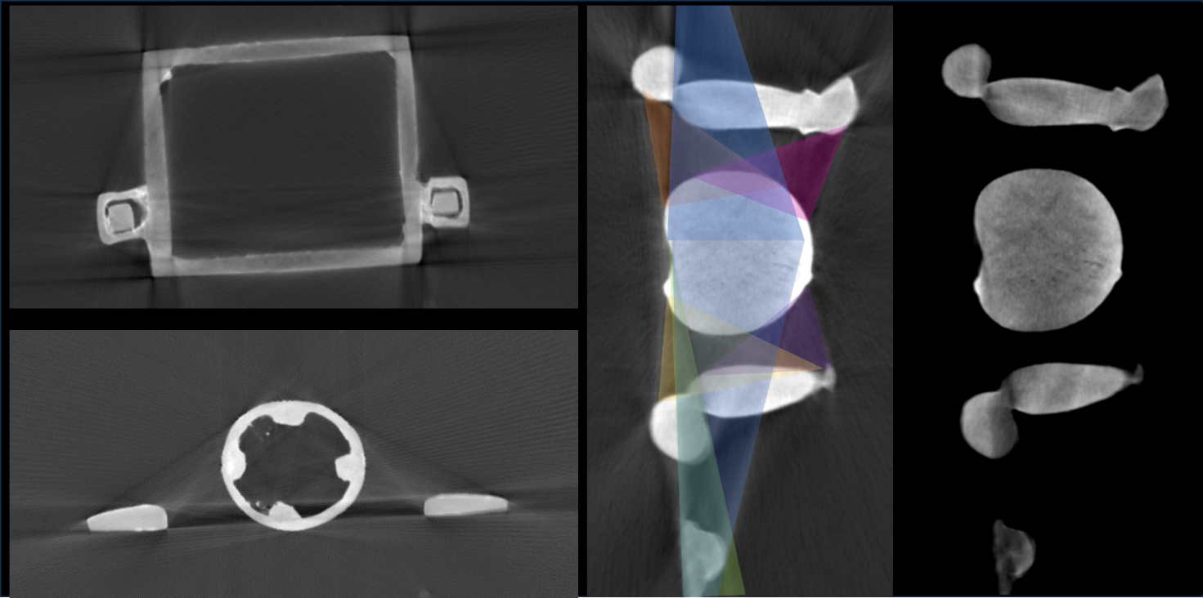
Fig. S 1 Neutron Tomography axial slices. Reconstruction artefacts
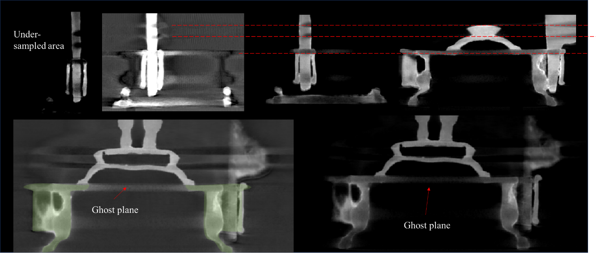
Fig. S 2 Neutron Tomography axial slices. Reconstruction artefacts
Areas affected by this artefact show lower grey value than the surrounding areas, by approximately 15%. Furthermore, the scattering effect coming from the irregular edges of the complex shaped figurine produces linear shades in the reconstructed images. This artefact cannot be removed without risking the loss of precious morphological and microstructural information, from the whole areas. Notwithstanding we can quantify the average grey value decrease, it is impossible to correct this value in the whole stack because of the too complex geometry and the uneven variation of the parameters from slide to slide. Luckily the areas interested by this problem are clearly identifiable (Fig. S 3, Fig. S 4), the origin is mainly related to the projection of the Halo and the arms on the body of the figurine.
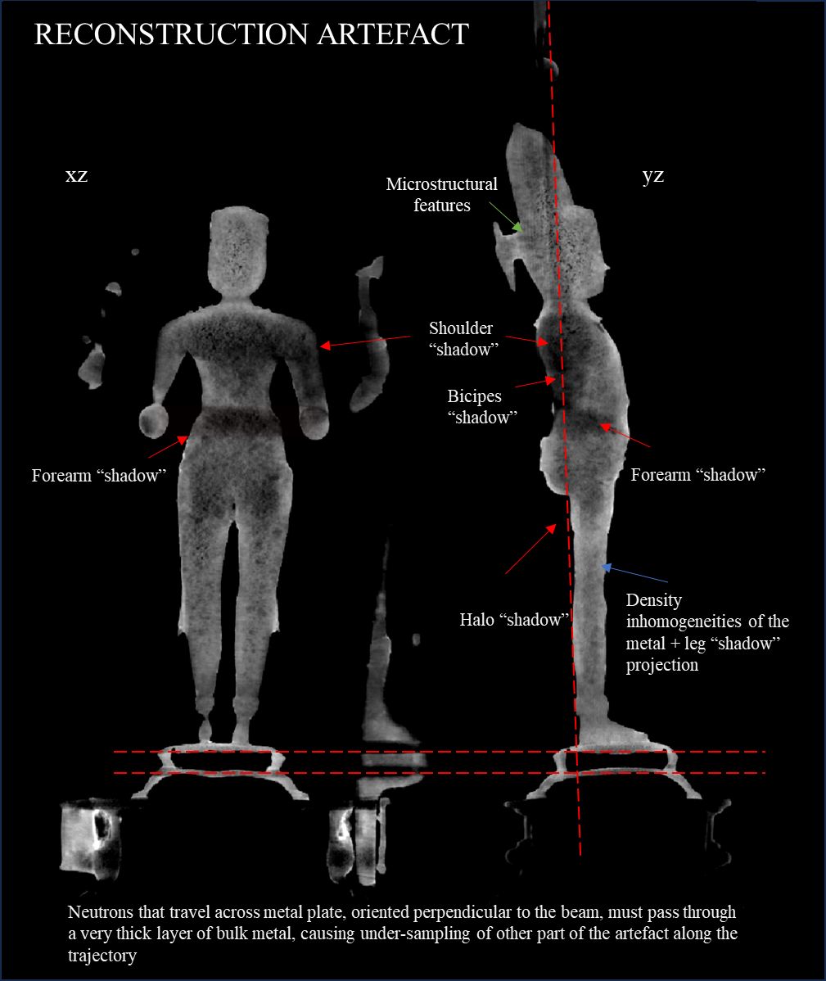
Fig. S 3 Neutron Tomography axial slices. Reconstruction artefacts
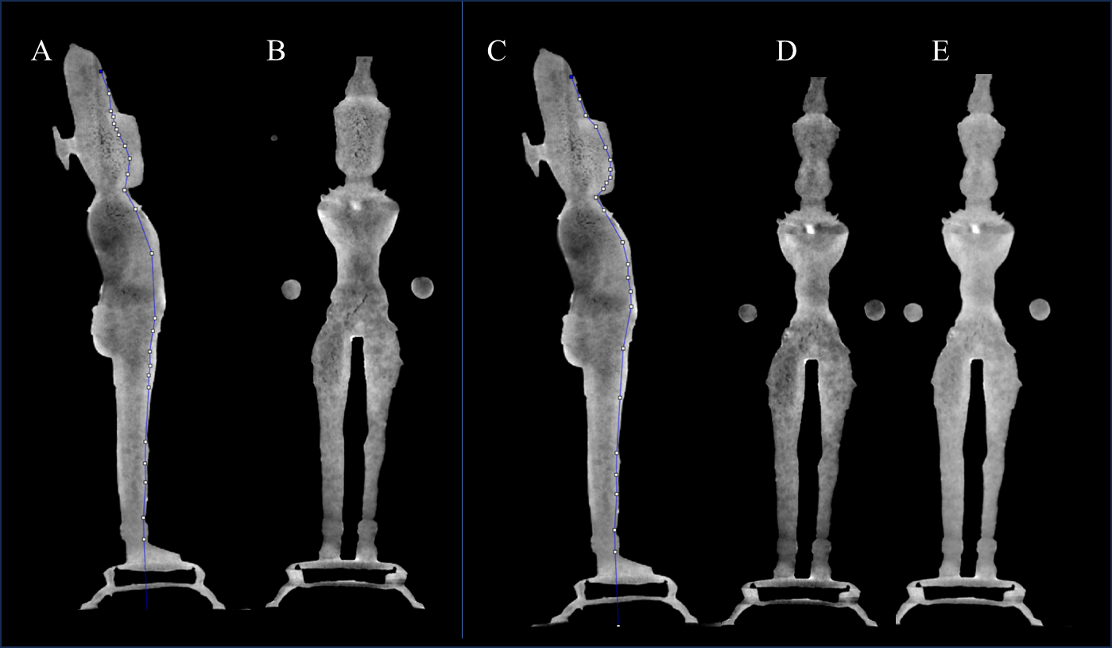
Fig. S 4 Neutron tomography. The two sagittal slices (A) and (B) were resliced using the segmented line tool and Dynamic Reslice provided by ImageJ software, which allowed us to obtain view of different planes in a single image (resliced images B, D, E). In this way it was also possible to evaluate contrast differences in artifact - free areas.

S.2 HALO / PEDESTAL CONNECTION
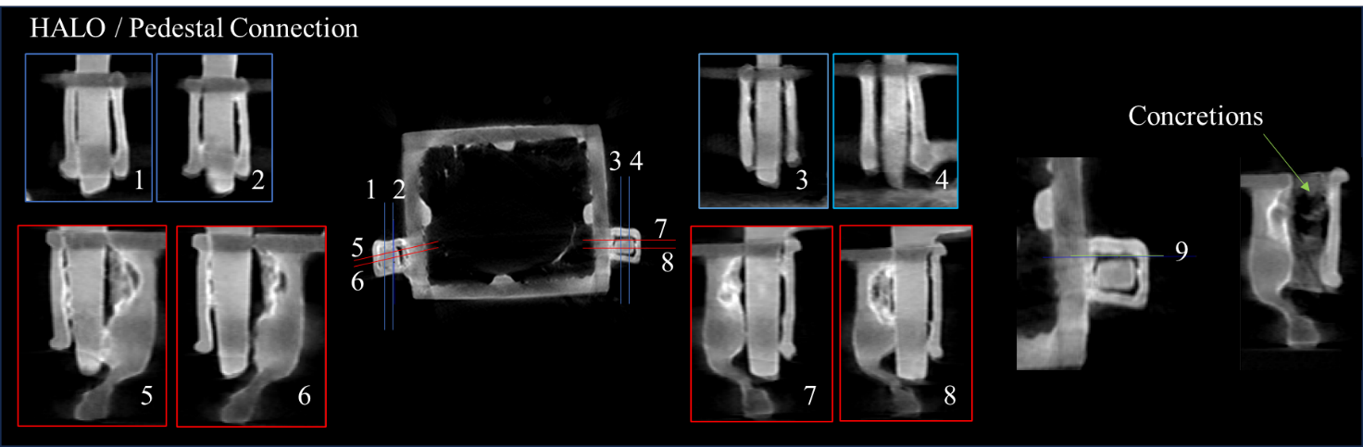
Fig. S 5 Shiva statuette (AK-MAK-1291), neutron tomography details of the halo connection with the pedestal: (1), (2), (3), (4) sagittal slices. (5), (6), (7), (8) normal slices.

S.3 FIGURINE / PEDESTAL CONNECTION
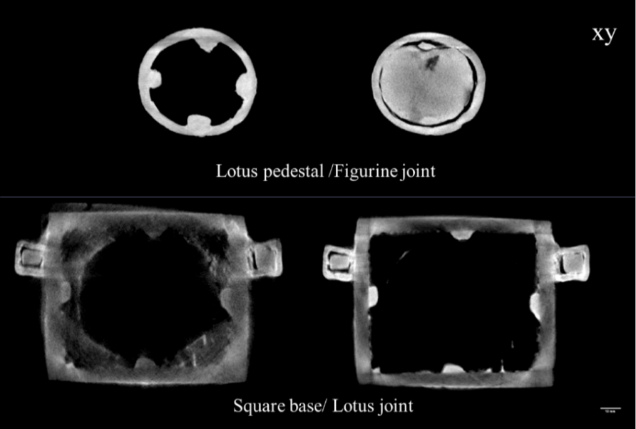

Fig. S 6 Shiva statuette (AK-MAK-1291). Neutron tomography details of the halo pins connection with the pedestal; axial slices

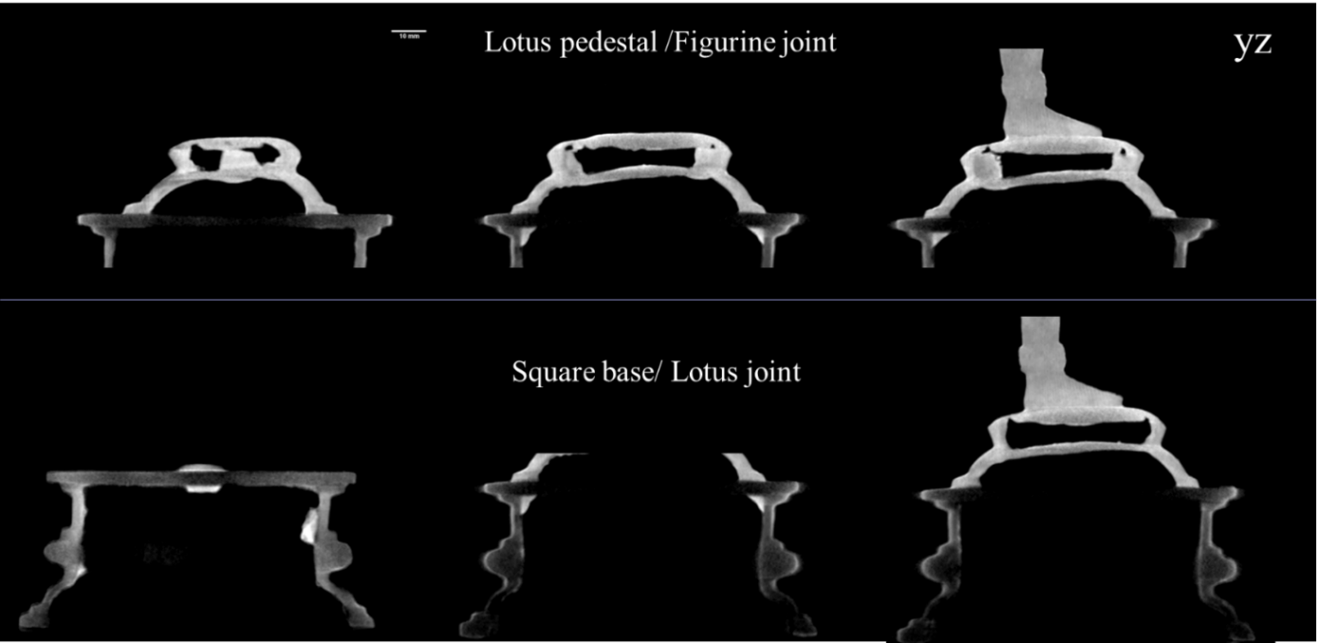
Fig. S 7 Shiva statuette (AK-MAK-1291). Neutron tomography details of the two section of the pedestal: the square base and the lotus flower; sagittal slices
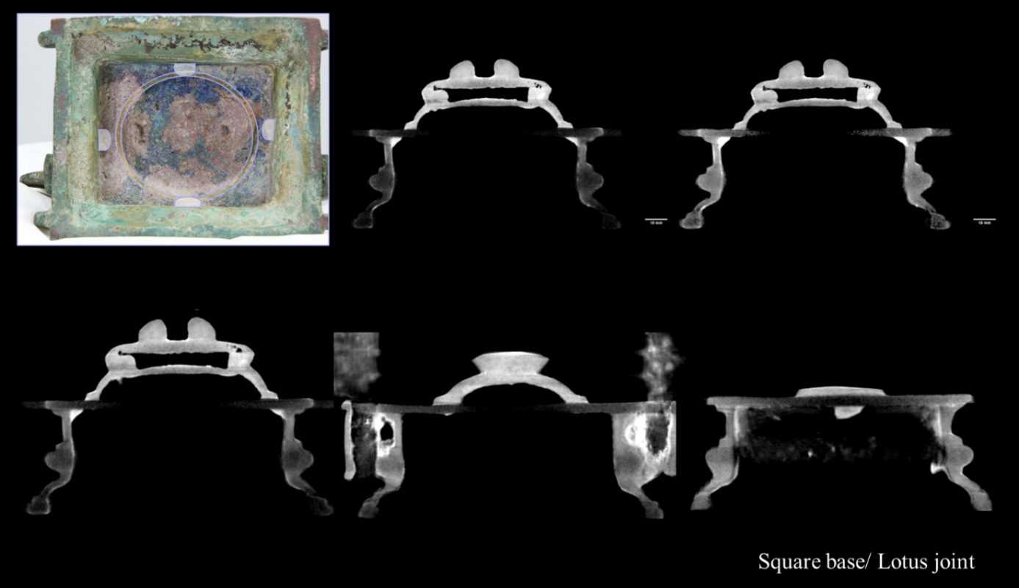
Fig. S 8 Shiva statuette (AK-MAK-1291). Neutron tomography details of the two sections of the pedestal: the square base and the lotus flower; normal slices. Shown at the top left is a photograph of the internal surface of the pedestal, where the connection points between the two parts of the pedestal are highlighted.

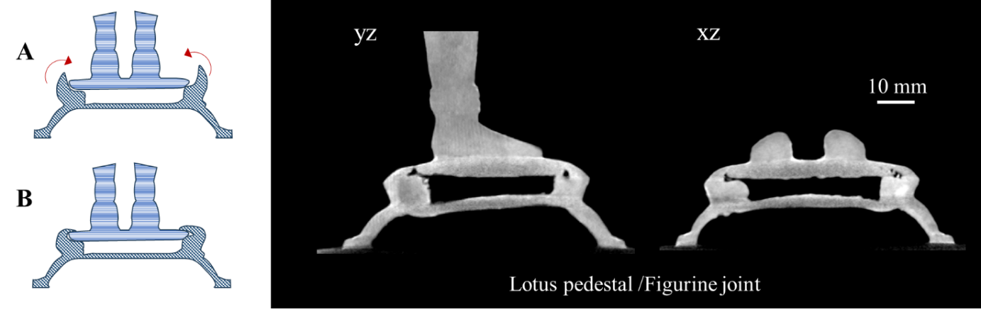
Fig. S 9. Drawings A) and B), and yz, xz tomographic slices show how the flattered round base under the feet of Shiva figurine was fixed to the lotus pedestal. The rim of the circular housing of the Lotus flower was probably cast in open position and then folded over the round base of the statuette by hammering.
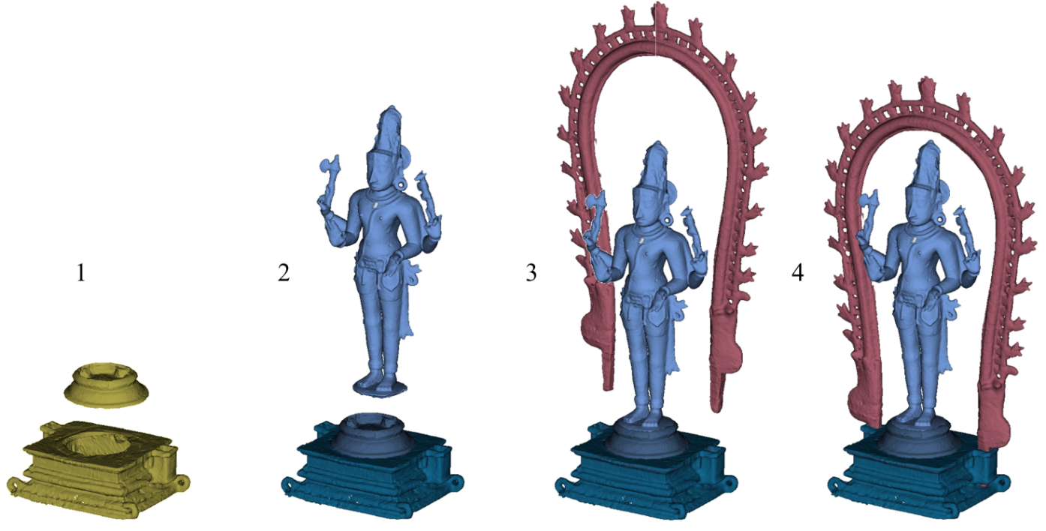
Fig. S 10. 1) Wax on wax joint; 2) mechanical joint; 3) mechanical Joint/ hard soldering.
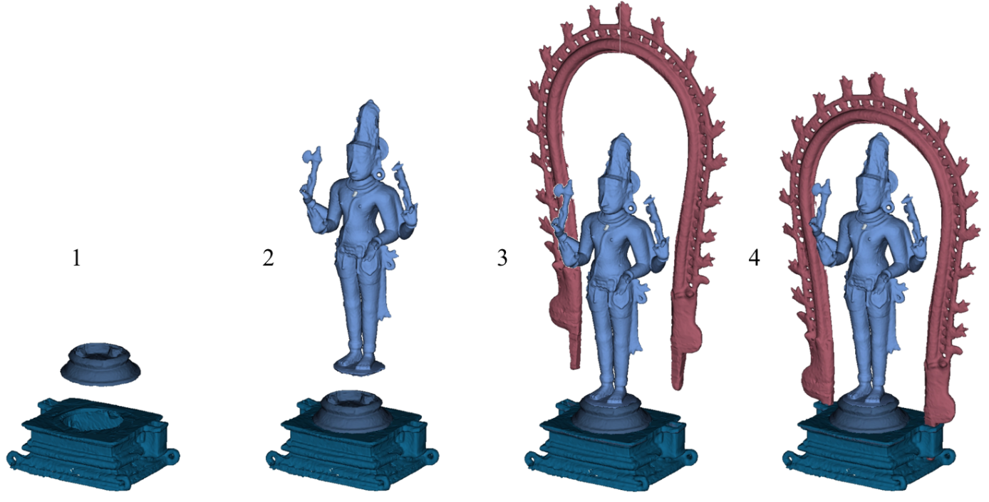
Fig. S 11. 1)Hard soldering; 2) mechanical joint; 3) mechanical Joint/hard soldering.
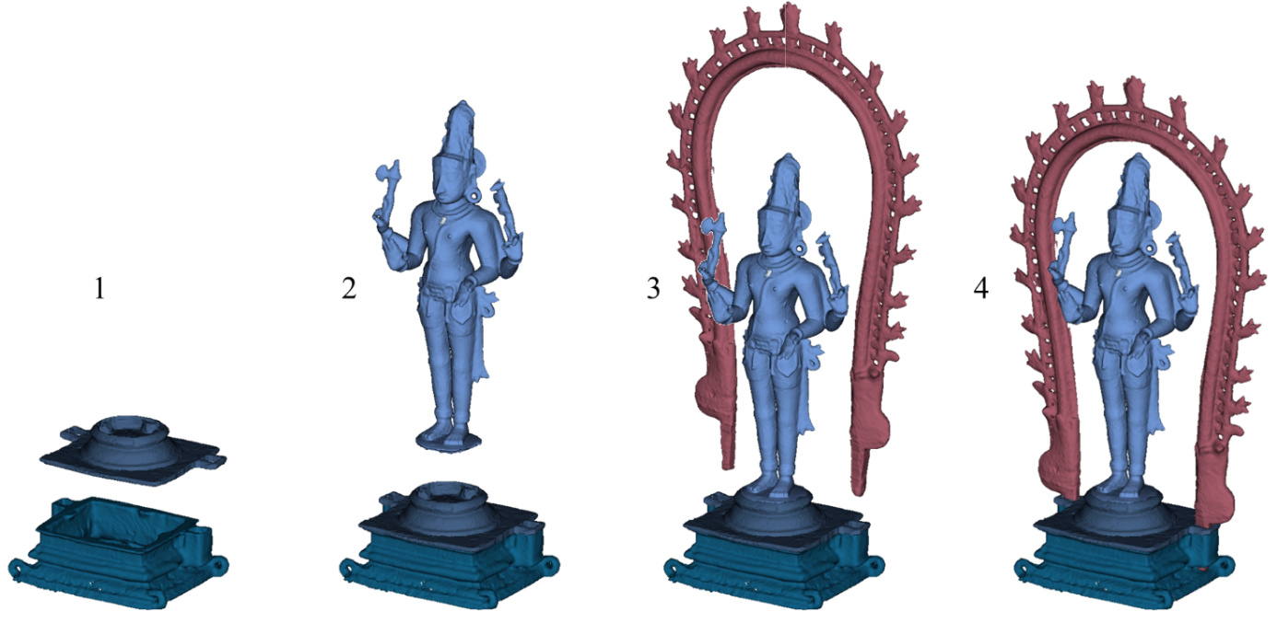
Fig. S 12 1) Hard soldering; 2) mechanical joint; 3) mechanical joint, hard soldering

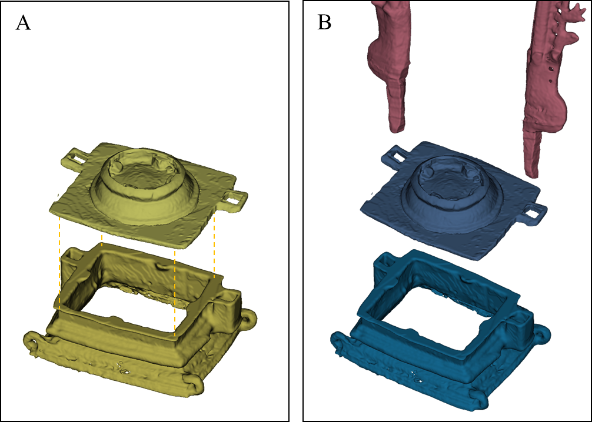
Fig. S 13 Assembling hypothesis of the pedestal: A) Wax-wax joint. The base would then be cast and mechanically assembled to the Shiva figurine and Halo B) Independent casting for the square base and the plate topped by the lotus flower pedestal; the two parts would be soldered together and the whole basic structure completed by inserting halo pins into brackets.

S.4 ToF-ND RESULTS: QUANTITATIVE ANALYSIS OF THE ALLOY
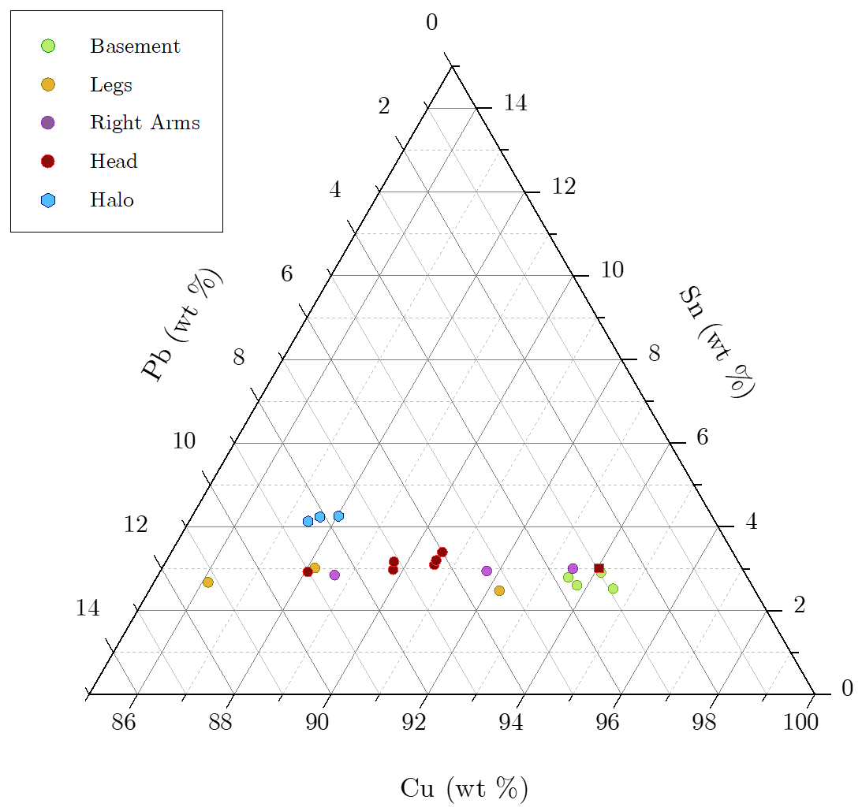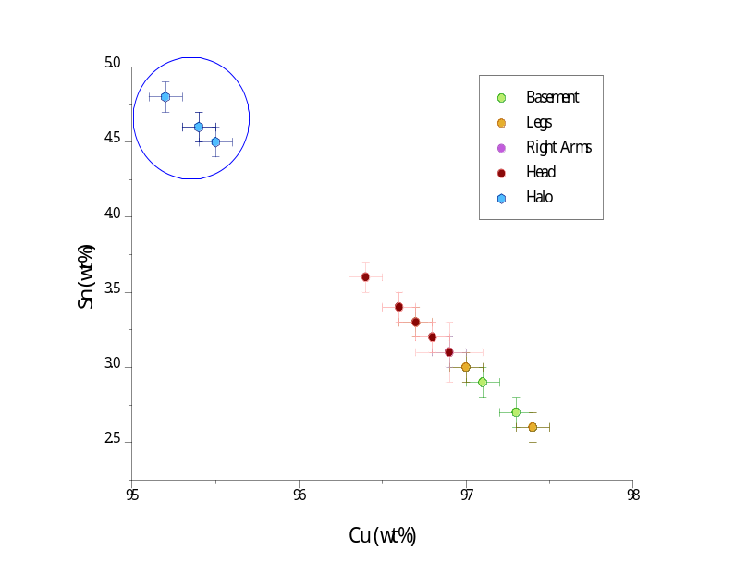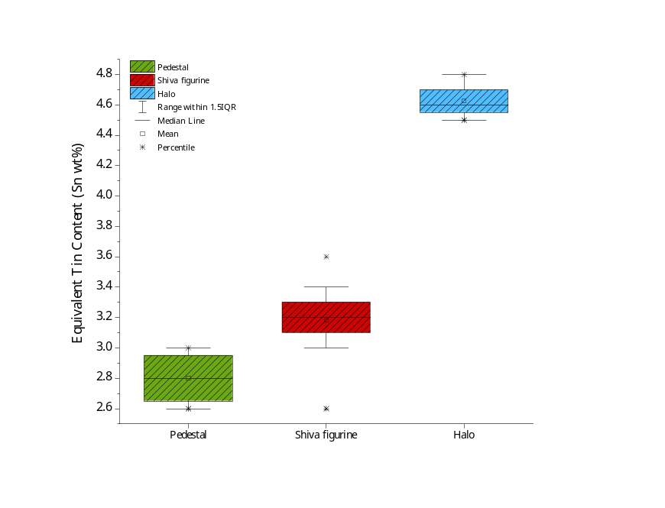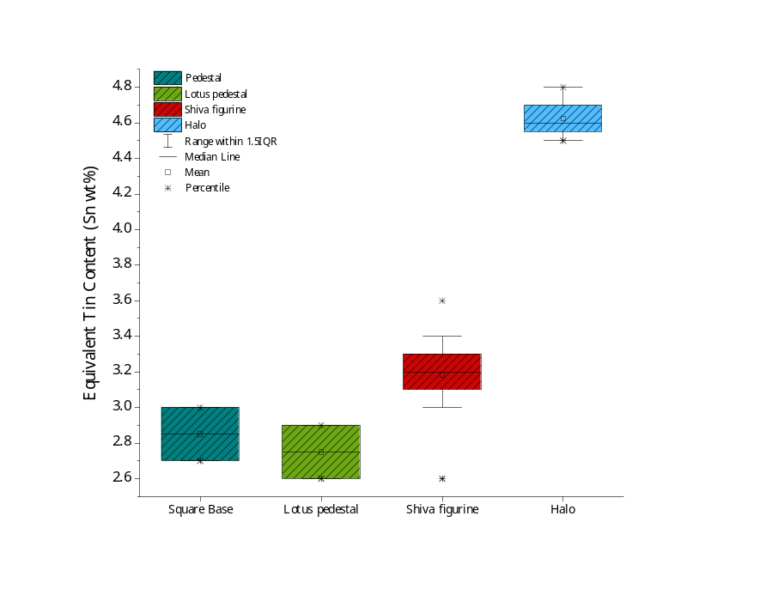
D
C
A
B

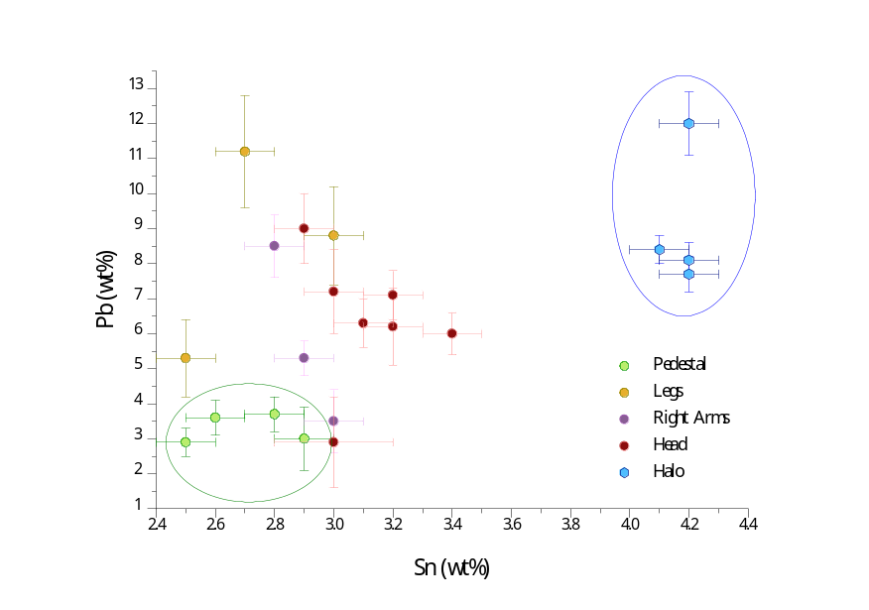
E
Fig. S 14 ToF-ND result. Elemental composition of the measured areas of the Shiva bronze statuette (AK-MAK-1291). A) Triangular diagram of the 3 main elements of the alloy Cu, Sn, Pb. B) Equivalent tin content plot. C) Box plot of the composition of the different parts of the artefact: the figurine, the pedestal, and the halo; D) Box plot showing the main parts of the statuette keeping the square base and the lotus pedestal separate. E) diagram showing the plot of the content (%wt) of Sn vs Pb.
S.5 ENERGY SELECTIVE NEUTRON RADIOGRAPHY
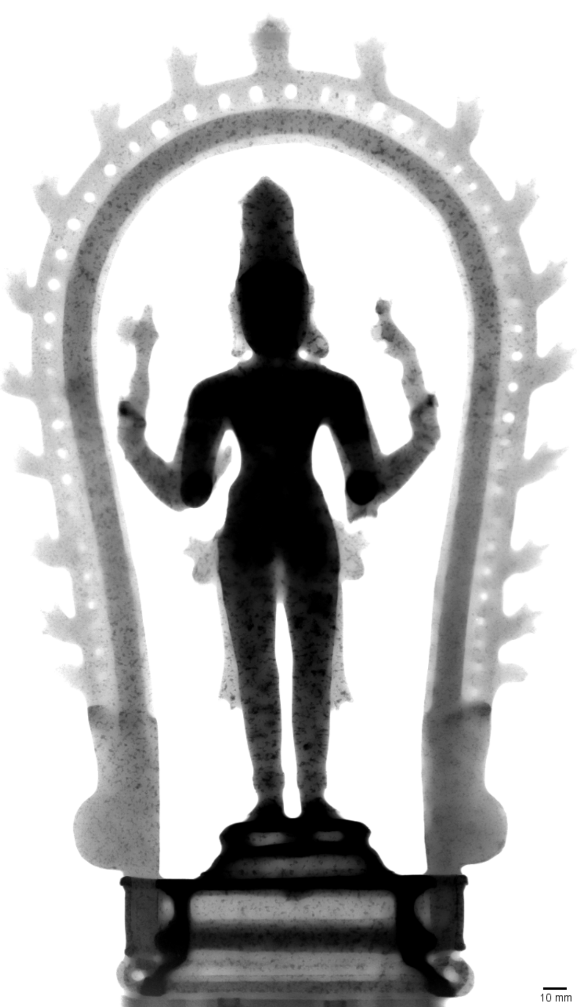
Fig. S 15 Shiva (AK-MAK-1291) - Energy Selective Neutron Radiography λ= 3.55 Å (before FCC alpha bronze 111 Bragg edge).
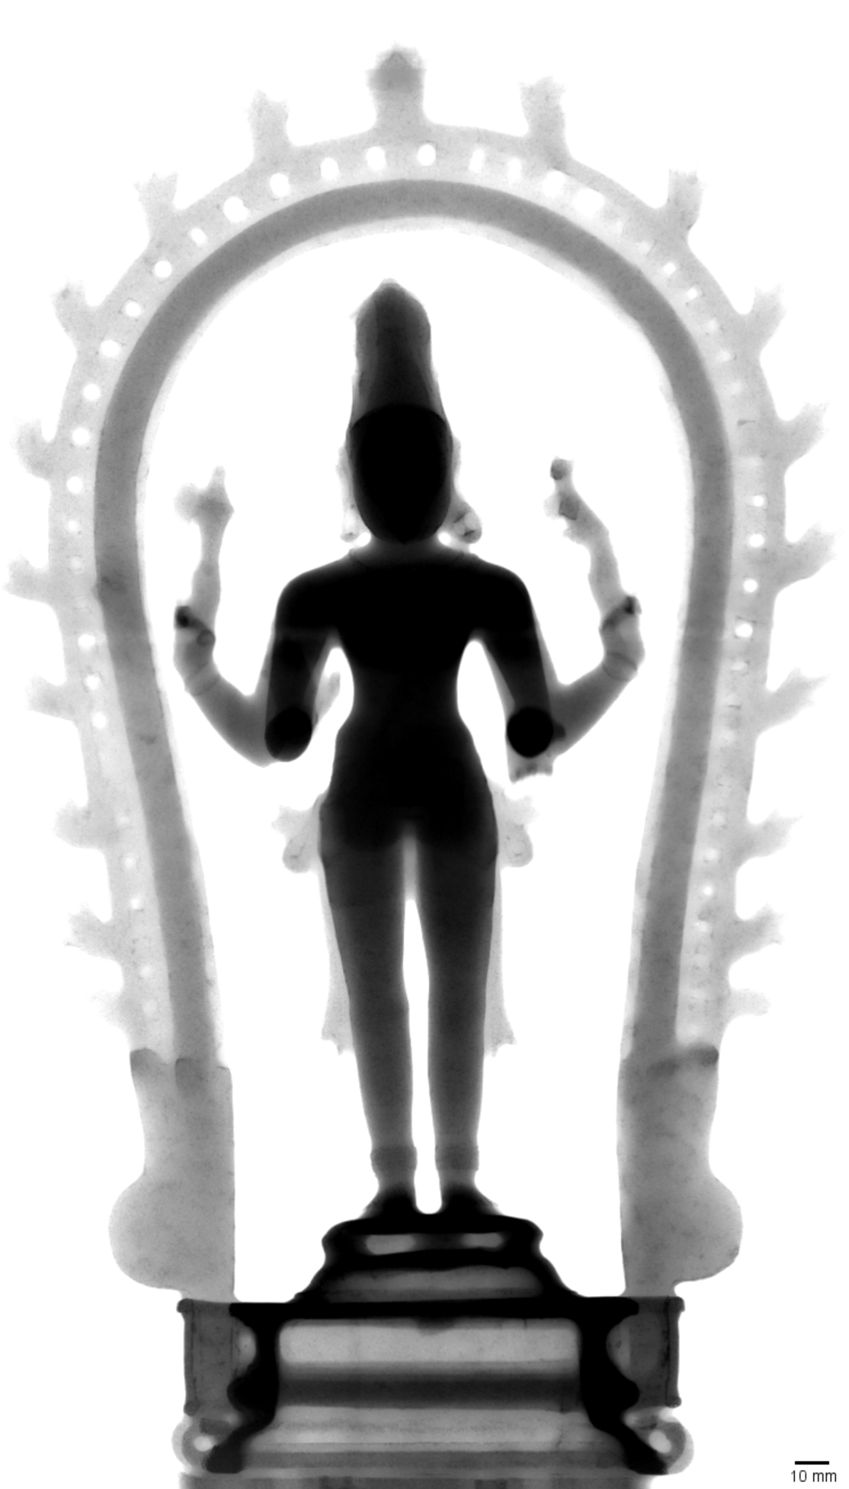
Fig. S 16 Shiva (AK-MAK-1291) - Energy Selective Neutron Radiography λ= 4.45 Å (after FCC alpha bronze 111 Bragg edge).
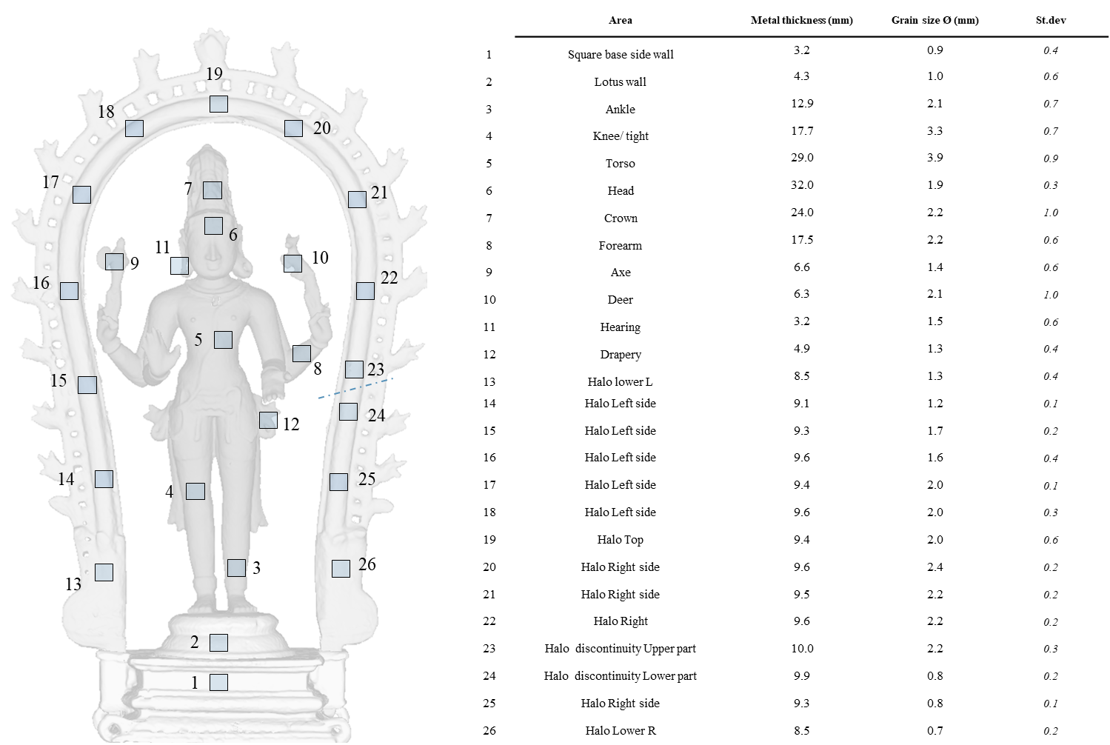
Fig. S 17 Oligocrystals grain size. On the right, the position of the 26 areas analysed. Within each area, the diameter of three grains was measured. On the left, in the table, the average value of the oligo crystal size is compared with the thickness of the metal of the relative section of the statuette. The different metal thickness influenced the formation of different size oligo crystal due to the different cooling rate.
B
A
Fig. S 18 Oligocrystals grain size. The different metal thickness influenced the formation of different size oligo crystal due to the different cooling rate. Plot A) shows the relationship between the size of the grains compared to the thickness (in the analysed area) of the Shiva figurine, while B) shows in the plot only the relationship between the size of the grains and the thickness of the halo.

S.6 HALO CASTING HYPOTHESIS
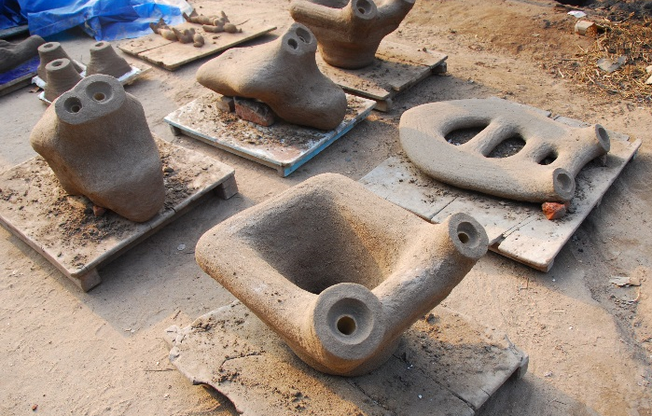
Fig. S 19 Some examples of the traditional casting moulds, Tamil Nadu, India. Courtesy of Rijksmuseum.
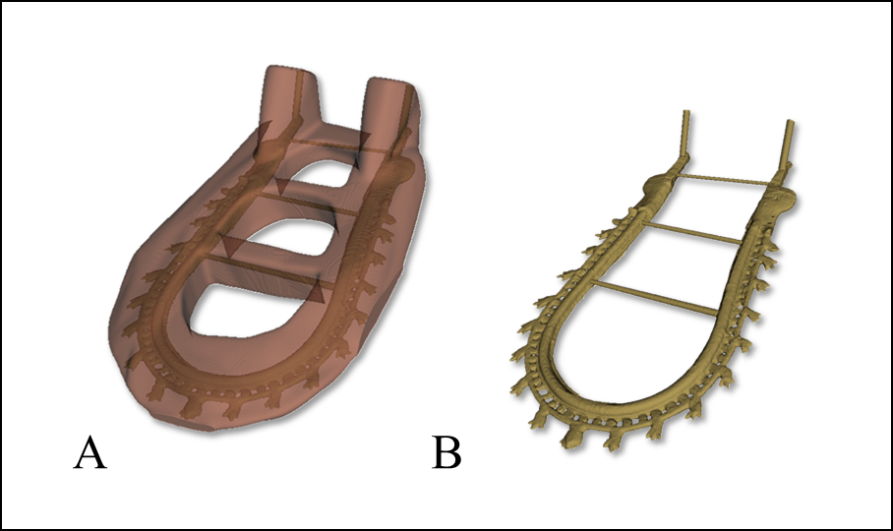
Fig. S 20 Casting techniques reconstruction hypothesis: 3d schematic diagram of the mould and the wax model of the halo.
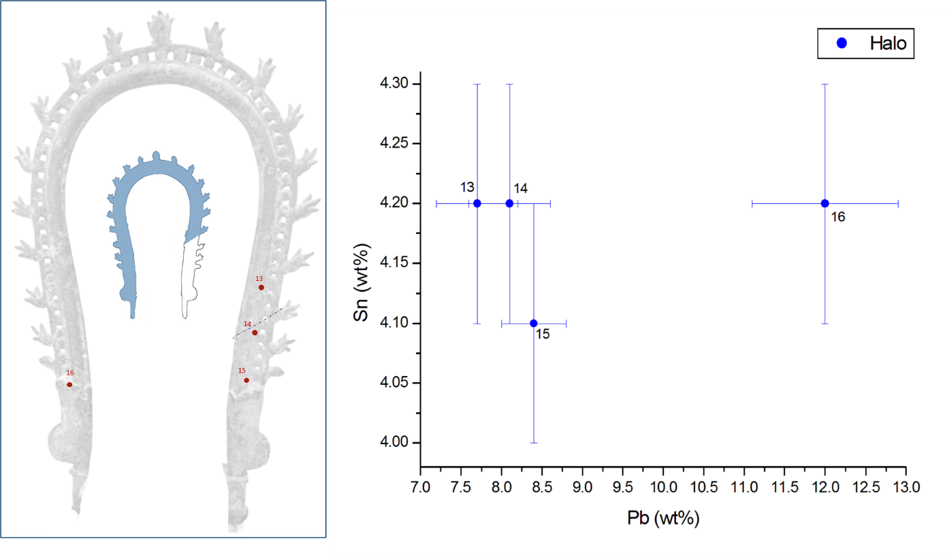
A
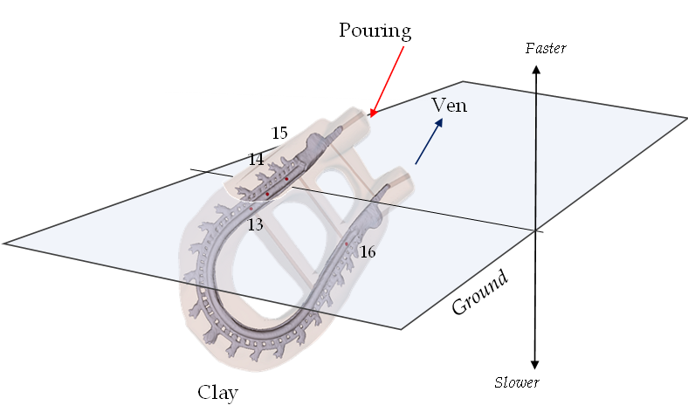
B
Fig. S 21 A) ToF-ND Analysis. Pb content (%wt). B) Position of the ND-ToF measurement points relating to the Halo, displayed in the 3D model of the casting position

