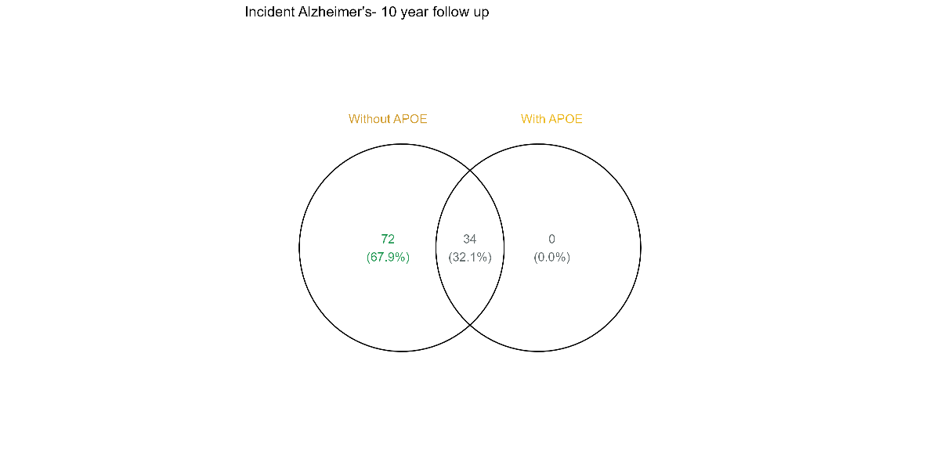
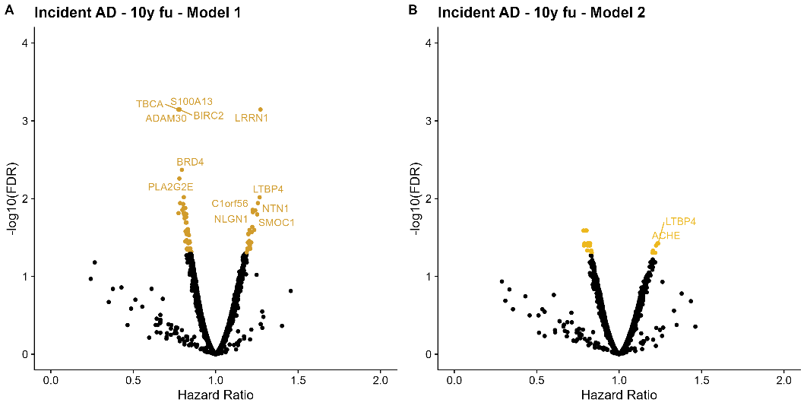
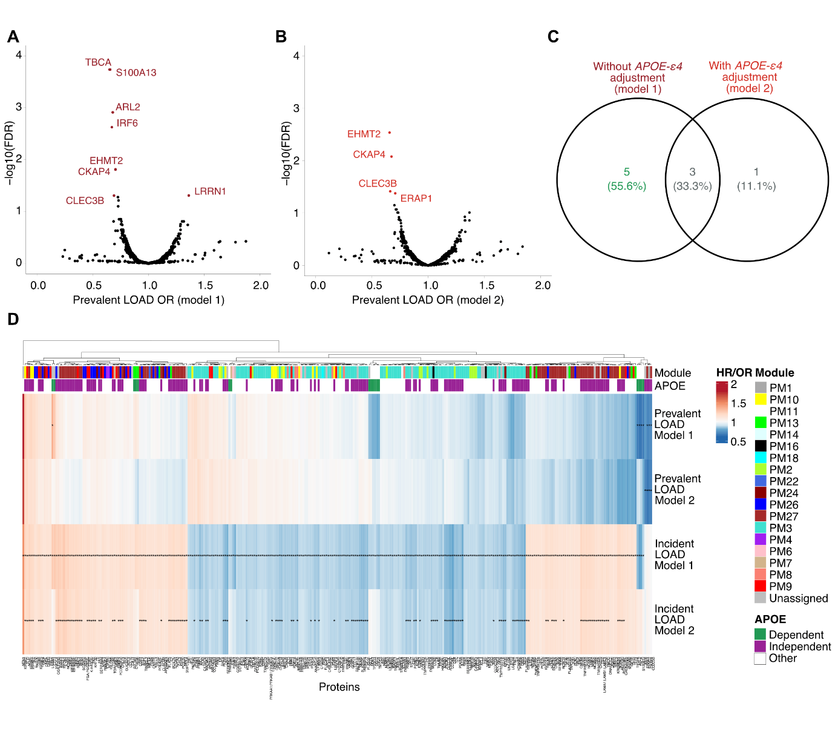
A B C
Extended Data Fig. 1 – a-b) Volcano plots showing the protein association profile for incident LOAD, restricted to 10-year follow-up a) without APOE e4 adjustment (model 1) and b) with APOE-ε4 adjustment (model 2). c) Venn diagram for the SOMAmer overlap between models 1 and 2 for incident AD, restricted to 10-year follow-up.
Extended Data Fig. 2 – a-b) Volcano plots showing the protein association profile for prevalent LOAD, a) without APOE-ε4 adjustment (model 1) and b) with APOE-ε4 adjustment (model 2). c) Venn diagram for the SOMAmer overlap between models 1 and 2 for prevalent LOAD. d) Heatmap comparing the effect sizes for models 1 and 2 and both prevalent (odds ratio) and incident LOAD (hazard ratio). Serum protein module membership and APOE-dependence (see Methods for definition) are annotated at the top.
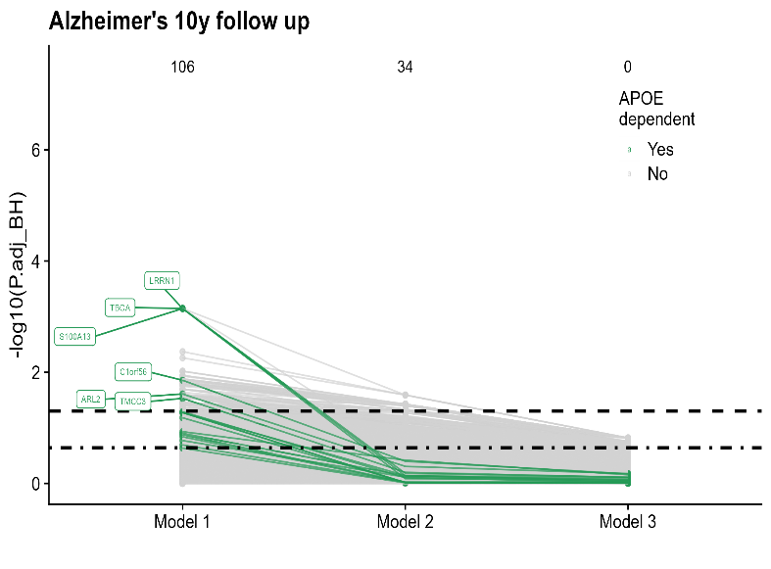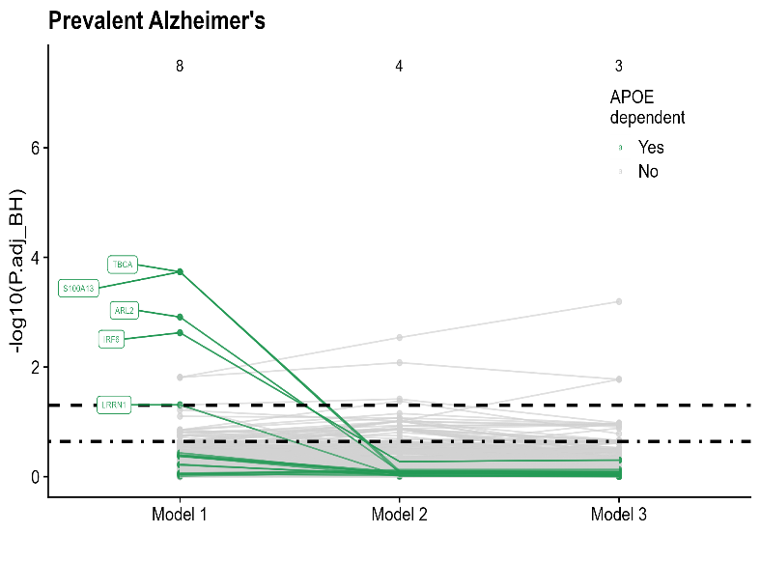
Extended Data Fig. 3 – Spaghetti plots showing the statistical significance of protein associations with a) prevalent LOAD and b) incident LOAD restricted to 10-year follow-up across the three models, highlighting the 17 APOE-dependent proteins (green) defined as those whose association with incident LOAD is attenuated with APOE-ε4 adjustment for incident AD using full follow-up (Fig 2a).
A B
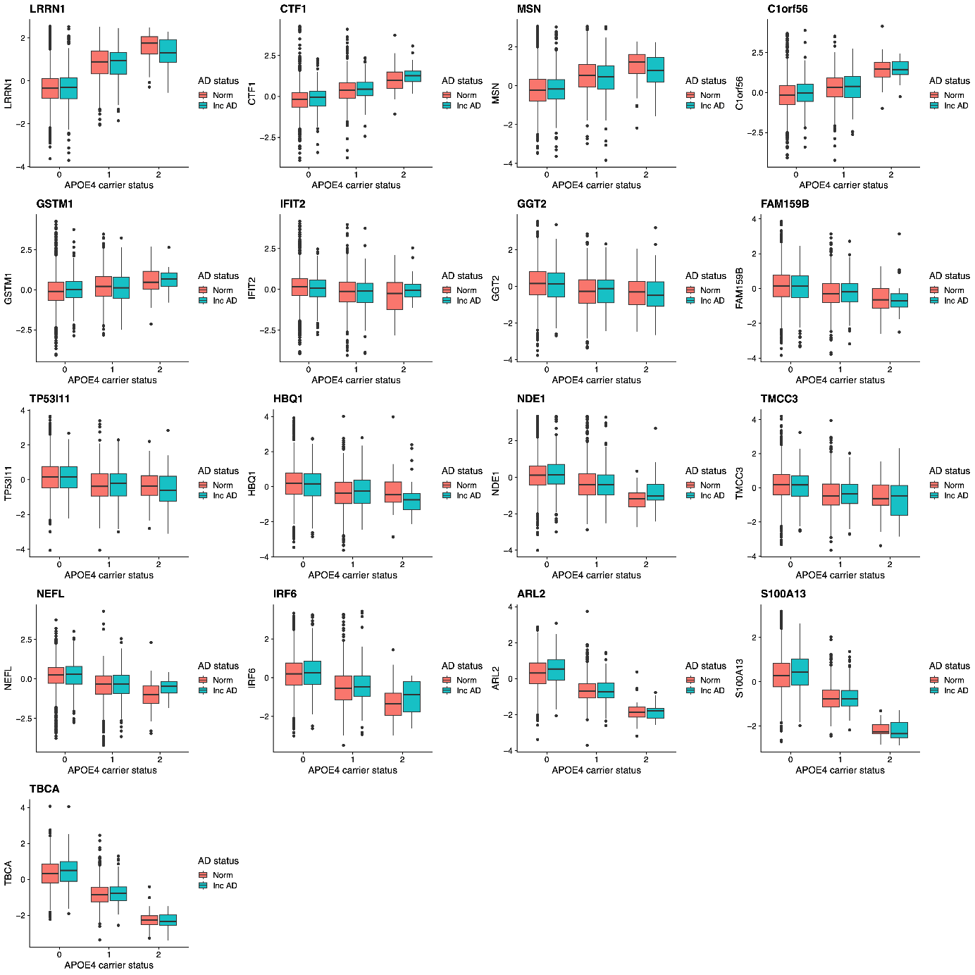
A
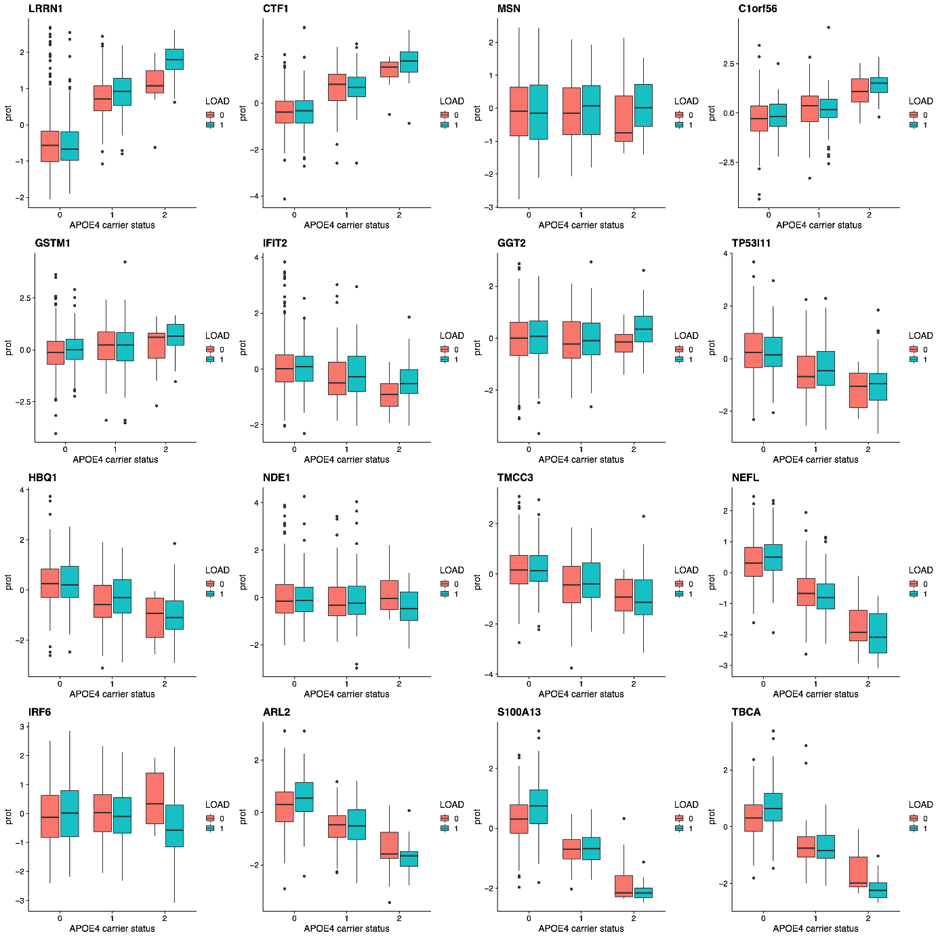
B
Extended Data Fig. 4 – Boxplots visualizing protein levels in a) AGES serum samples, see Supplementary Table 9 for statistical evaluation and b) ACE plasma samples, stratified by APOE-ε4 allele carrier and incident LOAD status, for the 17 proteins with APOE-dependent association to incident LOAD in AGES.
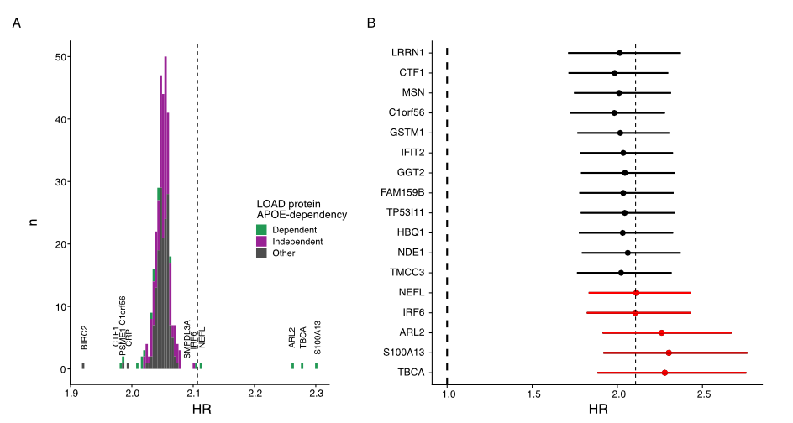
Extended Data Fig. 5 – a) Histogram showing the incident LOAD HR for APOE-ε4 allele count in AGES from Cox proportional hazard regression models adjusted for a single LOAD-associated protein at a time, in addition to age and sex. The dashed line indicates the HR for APOE-ε4 when only adjusting for age and sex. The proteins with the largest effect on the APOE-ε4 HR when included in the model are denoted. b) Forest plot showing the incident LOAD HR with 95% confidence intervals for APOE-ε4 when adjusting for each of the 17 APOE-dependent model in the Cox proportional hazard regression.
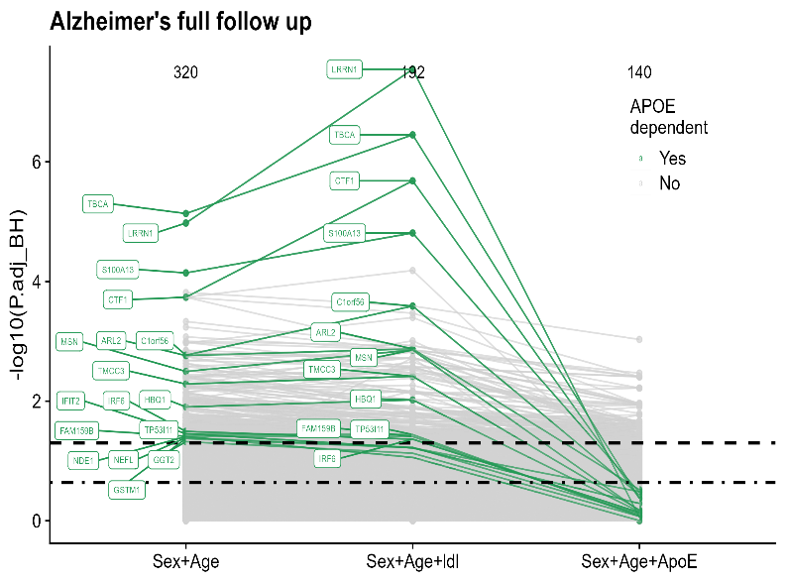
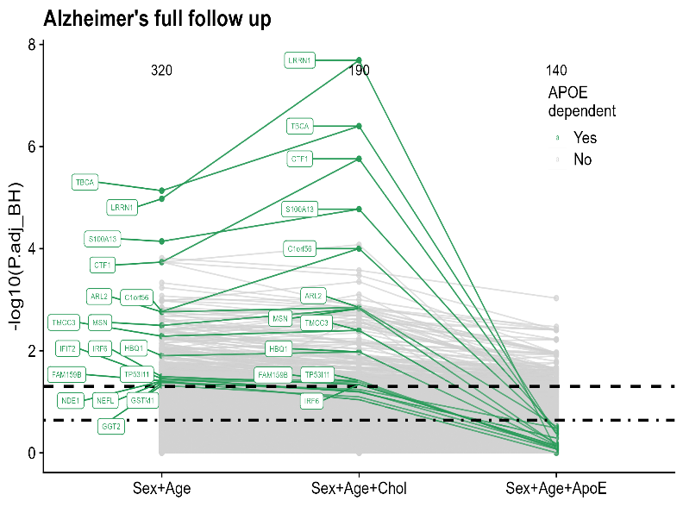
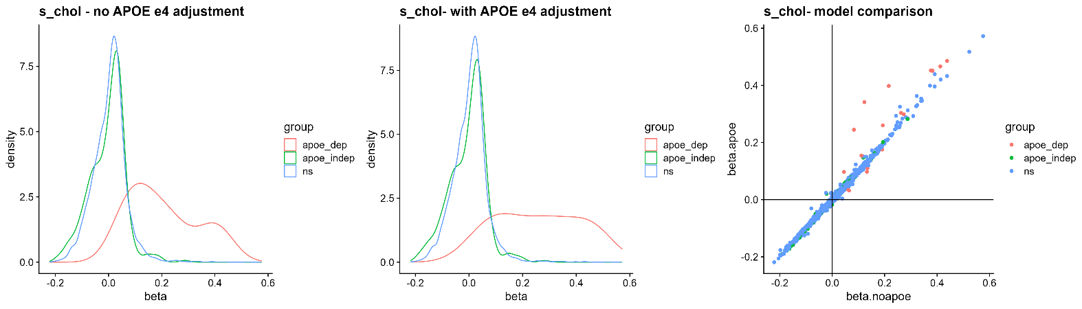
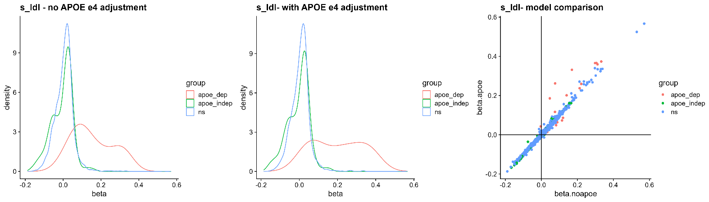
Extended Data Fig. 6 – a-b) Spaghetti plots showing the statistical significance of protein associations with incident LOAD across three statistical models, adjusting for age and sex, and then additionally either serum a) total cholesterol or b) LDL cholesterol, and finally APOE-ε4 carrier status. The LOAD association of the 17 APOE-dependent proteins (green) is not attenuated when adjusting for total cholesterol or LDL but only when adjusting for APOE-ε4 carrier status. c-h) Protein associations with serum total cholesterol (c-e) and LDL cholesterol (f-h). The density plots show the effect size for the associations between cholesterol levels and all measured proteins stratified by their AD association, adjusting for age and sex (c and f), and additionally APOE-ε4 carrier status (d and g). e) and h) Comparisons of the effect sizes for association with cholesterol levels in the models with (y-axis) and without (x-axis) APOE-ε4 adjustment shows that the effect size is often increased for the APOE-dependent proteins (red) after APOE-ε4 adjustment.
A
B
C
D
E
F
G
H
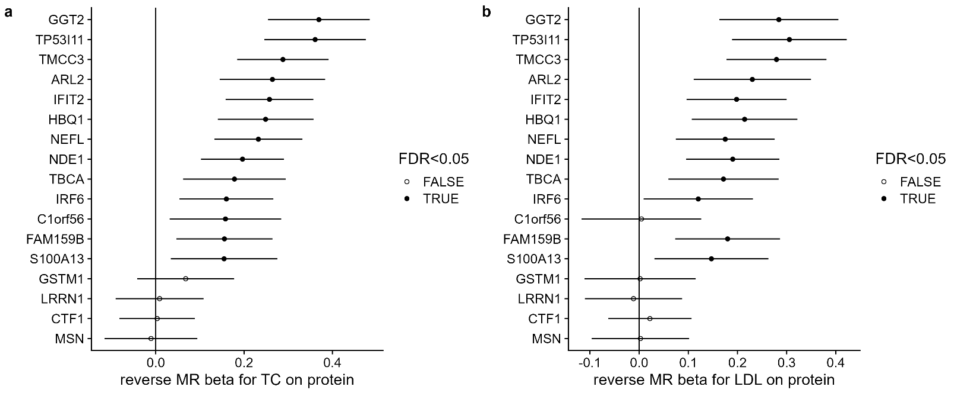
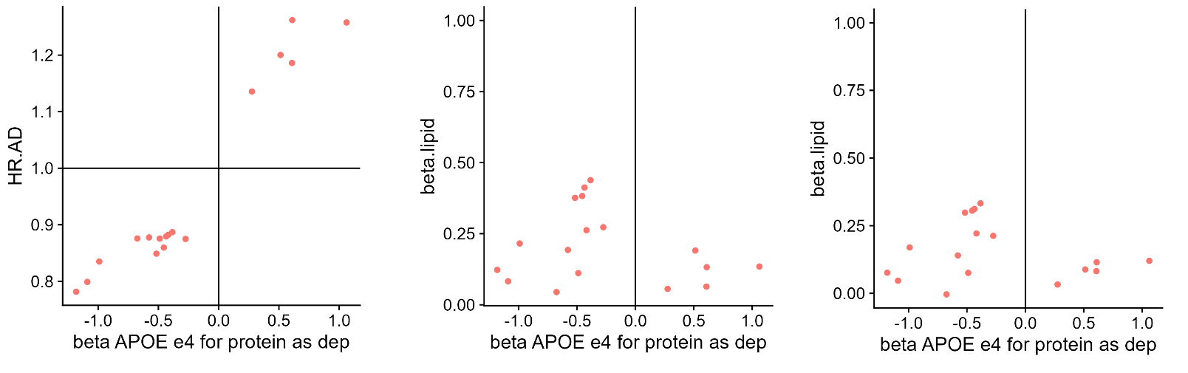
Extended Data Fig. 7 – Reverse MR analysis (excluding the APOE locus) for the causal effect of a) total cholesterol and b) LDL cholesterol on serum levels of the 17 APOE-dependent proteins. c-e) For each protein, a comparison of the effect sizes for the association with the APOE-ε4 genotype (x-axis) and c) incident LOAD, d) total cholesterol and e) LDL cholesterol (y-axis). TC, total cholesterol; LDL, low density lipoprotein cholesterol.
A
B
LOAD HR
TC Beta
LDL Beta
APOE-ε4 Beta
APOE-ε4 Beta
APOE-ε4 Beta
C
D
E
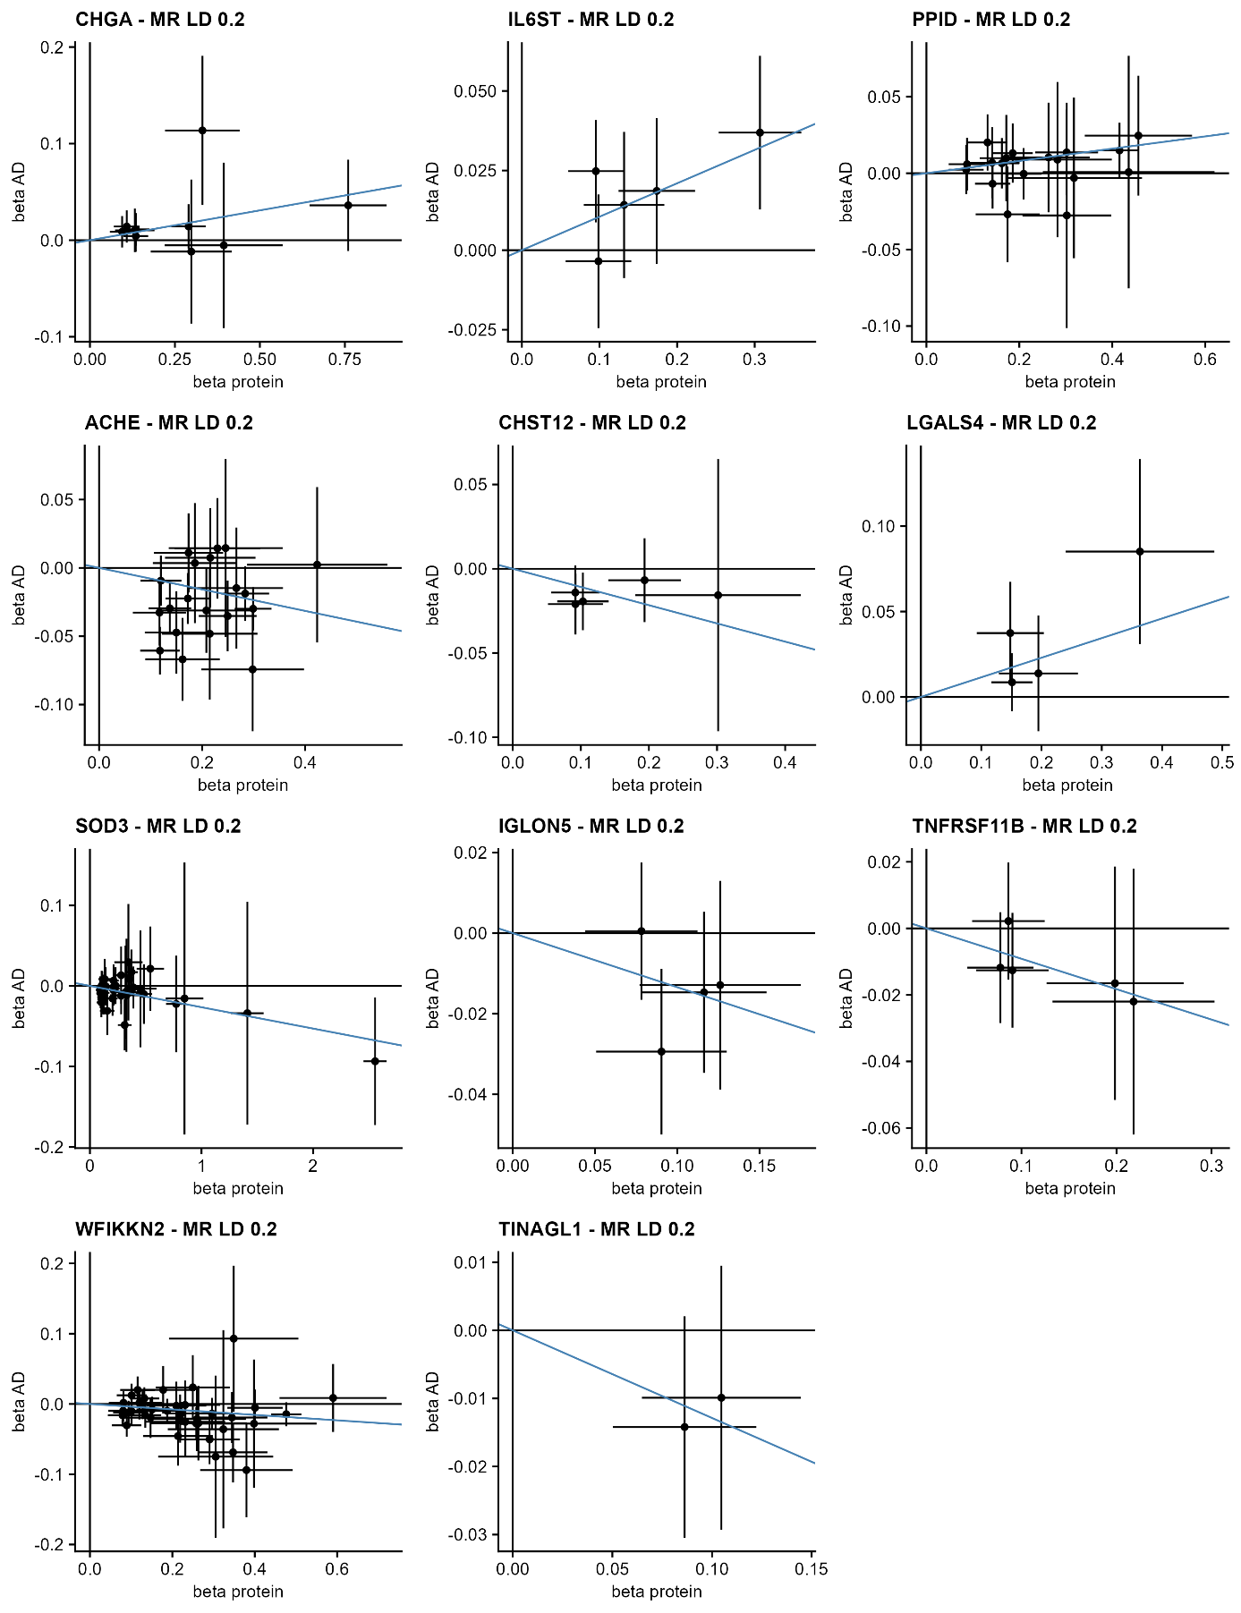
Extended Data Fig. 8 – MR scatterplots for all proteins with more than one genetic instrument and with P<0.05 in the MR analysis for a causal effect of protein levels on AD. Each point represents a genetic instrument (SNP) and shows its effect on serum protein levels (x-axis) and AD (y-axis). The slope of the blue line indicates the inverse variance weighted MR effect.
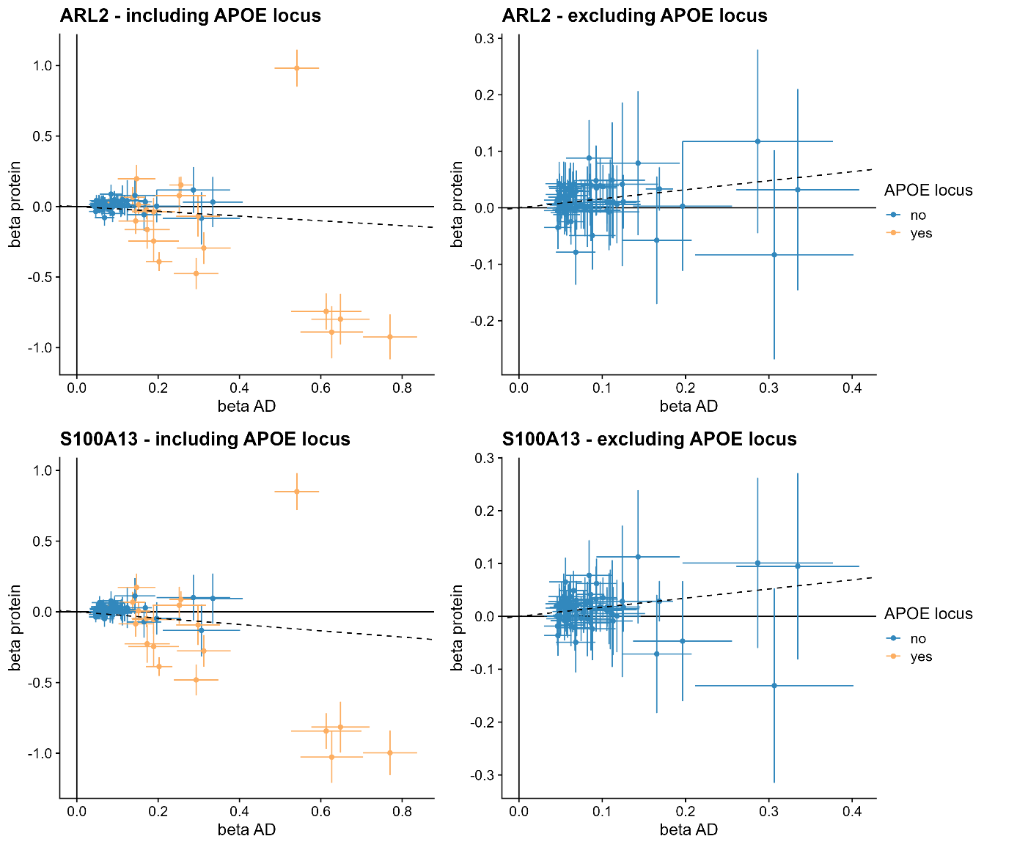
Extended Data Fig. 9 – Example MR scatterplots from the reverse MR analysis for a causal effect of AD on serum protein levels, showing discordant direction of effect (inverse variance weighted method indicated by slope of dashed line) when including (left) or excluding (right) APOE genetic variants. Each point represents a genetic instrument (SNP) and shows its effect on AD (x-axis) and serum protein levels (y-axis).
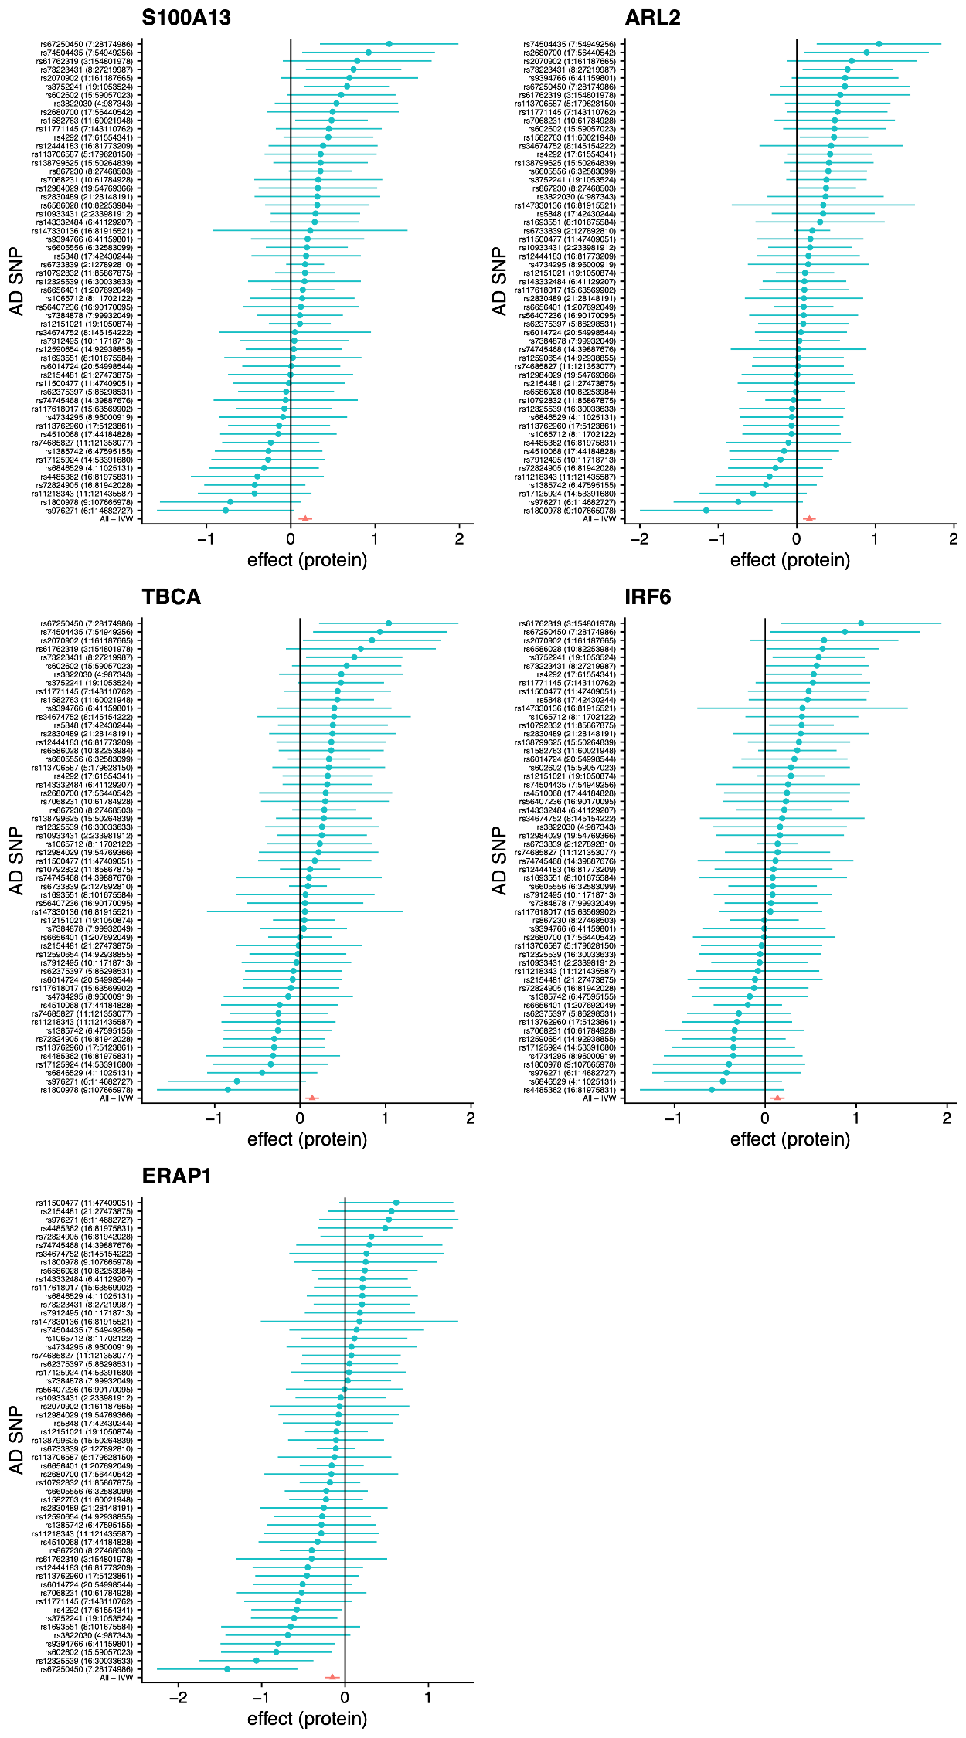
Extended Data Fig. 10 – A forest plot showing the results for individual SNPs in the reverse MR analysis for a causal effect of AD on serum protein levels, together with the full multi-SNP IVW estimate (red). Plots are shown for the five proteins with FDR<0.1 in the primary reverse MR analysis, excluding variants from the APOE locus.
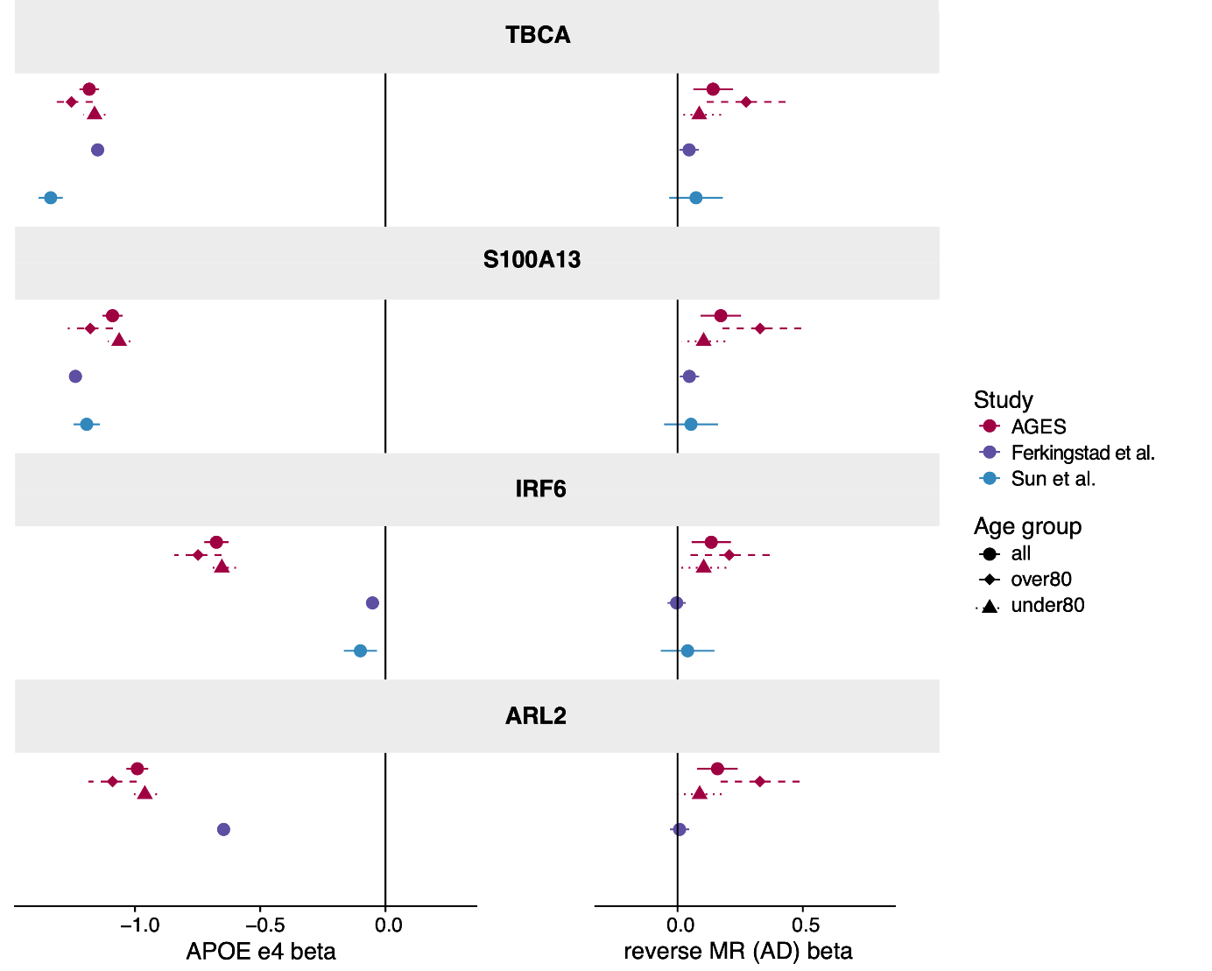
Extended Data Fig. 11 – Comparison of the effects of APOE-ε4 (left) versus AD, as evaluated through reverse MR analysis excluding APOE variants, (right) on serum protein levels in AGES and two additional cohorts. Results are shown for the four APOE-dependent proteins with opposite direction of effect in the two analyses. The AGES results are shown for the full cohort and two age strata.
Supplementary Table 1 - Baseline characteristics of the AGES cohort stratified by LOAD status. P values are obtained from t-test for continuous variables, and chi-square test for categorical variables. P and FDR values <0.05 are highlighted in bold.
Supplementary Table 2 – Proteins significantly associated with incident LOAD after FDR (Benjamini-Hochberg) correction are displayed. The full Cox proportional hazards regression model (Model 3) was adjusted for baseline age, sex, APOE-ε4 genotype, body mass index, diabetes, education, hypertension, smoking history, and eGFR as denoted below. P and FDR values <0.05 are highlighted in bold. Abbreviations: HR, Hazard ratio; CI, Confidence Interval, Zph: proportional hazard test statistic. Estimates represent difference in LOAD risk per standard deviation increase of aptamer level.
Supplementary Table 3 – Proteins significantly associated with incident LOAD with 10-year follow-up after FDR (Benjamini-Hochberg) correction are displayed. The full Cox proportional hazards regression model (Model 3) was adjusted for baseline age, sex, APOE-ε4 genotype, body mass index, diabetes, education, hypertension, smoking history, and eGFR. P and FDR values <0.05 are highlighted in bold. Abbreviations: HR, Hazard ratio; CI, Confidence Interval, Zph: proportional hazard test statistic. Estimates represent difference in LOAD risk per standard deviation increase of aptamer level.
Supplementary Table 4 – Comparisons of the Cox models with full follow-up vs 10 year follow up using ANOVA. P and FDR values <0.05 are highlighted in bold. Abbreviations: df, degrees of freedom
Supplementary Table 5 – Proteins significantly associated with prevalent LOAD after FDR (Benjamini-Hochberg) correction. The full logistic regression model (Model 3) was adjusted for baseline age, sex, APOE-ε4, body mass index, diabetes, education, hypertension, smoking history, and eGFR. P and FDR values <0.05 are highlighted in bold. Abbreviations: OR, odds ratio; SE, standard error. Estimates represent difference in LOAD risk per standard deviation increase of aptamer level.
Supplementary Table 6 – Replication of the LOAD associated proteins from Supplementary Table 5 in the ACE cohort. Proteins significantly associated with prevalent LOAD after FDR (Benjamini-Hochberg) correction are displayed. Logistic regression models were adjusted for baseline age + sex (Model 1) and additionally for APOE-ε4 in Model 2. P and FDR values <0.05 are highlighted in bold. Abbreviations: OR, odds ratio; SE, standard error. Estimates represent difference in LOAD risk per standard deviation increase of aptamer level.
Supplementary Table 7 – Results from Gene Set Enrichment Analysis (GSEA) and Overrepresentation Analysis (ORA) of the prevalent LOAD associated proteins against protein-coding gene sets labeled below using the R packages listed below. P values were adjusted for multiple comparisons using FDR (Benjamini Hochberg). Abbreviations: ES, Enrichment score; NES, Enrichment score normalized
Supplementary Table 8 – Gene Set Enrichment Analysis and Overrepresentation Analysis of incident LOAD associated proteins in AGES against protein-coding gene sets labeled below using the R packages listed below. P values were adjusted for multiple comparisons using FDR (Benjamini Hochberg). P and FDR values <0.05 are highlighted in bold. Abbreviations: ES, Enrichment score; NES, Enrichment score normalized; size of the pathway after removing missing genes; leadingEdge, vector of genes that drive the enrichment.
Supplementary Table 9 – Replication of the incident LOAD associated proteins from Supplementary Table 2 in the ACE cohort. Proteins significantly associated with incident LOAD after FDR (Benjamini-Hochberg) correction are displayed. Linear and Cox proportional regression models were adjusted for baseline age, sex (Model 1) and additionally for APOE-ε4 genotype in Model 2. P and FDR values <0.05 are highlighted in bold. Abbreviations: HR, Hazard ratio; CI, Confidence Interval, Zph: proportional hazard test statistic. Estimates represent difference in LOAD risk per standard deviation increase of aptamer level.
Supplementary Table 10 – First-degree protein partners of the APOE-dependent proteins from the InWeb database (Li et al. (2016), Nature Methods 2016 14:1 14, 61–64. 10.1038/nmeth.4083). Abbreviations: CS, confidence score.
Supplementary Table 11 – Gene Set Enrichment Analysis and Overrepresentation Analysis of the first-degree protein partners of the APOE-dependent LOAD associated proteins against protein-coding gene sets labeled below using the R packages listed below. P values were adjusted for multiple comparisons using FDR (Benjamini Hochberg).
Supplementary Table 12 – Forward MR analysis examining the causal effects of the protein partners of the AGES-defined APOE-dependent LOAD-associated proteins on AD. P and FDR values <0.05 are highlighted in bold. Abbreviations: OR, odds ratio; SE, standard error; eggerPass, passes Egger pleiotropy sensitivity analysis; wmPass, passes weighted median sensitivity analysis
Supplementary Table 13 – Reverse MR analysis examining the causal effects of blood cholesterol (total and LDL) on the AGES-defined APOE-dependent LOAD-associated proteins. P and FDR values <0.05 are highlighted in bold. Abbreviations: OR, odds ratio; SE, standard error.
Supplementary Table 14 – Overview of the genetic instruments and their associations with serum levels in AGES
Supplementary Table 15 - Baseline characteristics of the ACE cohort stratified by LOAD status. P values are obtained from t-test for continuous variables, and chi-square test for categorical variables. P and FDR values <0.05 are highlighted in bold.
Supplementary Table 16 – Forward MR analysis examining the causal effects of all LOAD-associated proteins in AGES on AD. P and FDR values <0.05 are highlighted in bold. Abbreviations: OR, odds ratio; SE, standard error; eggerPass, passes Egger pleiotropy sensitivity analysis; wmPass, passes weighted median sensitivity analysis
Supplementary Table 17 – Reverse MR analysis examining the causal effects of AD or its genetic liability on all LOAD-associated proteins in AGES. The primary analysis was performed without the APOE locus included, but results including the APOE locus are also shown. P and FDR values <0.05 are highlighted in bold. Abbreviations: OR, odds ratio; SE, standard error; Q_pval, Cochran's Q p-value for instrument heterogeneity
Supplementary Table 18 – Replication of reverse MR analysis results in data from Ferkingstad et al. and Sun et al, examining the causal effects of AD on all AGES-defined LOAD-associated proteins. The analysis was performed with and without the APOE locus included for instrument selection. One protein, ARL2, was not available in the Sun et al. data. P and FDR values <0.05 are highlighted in bold. Abbreviations: SE, standard error.
Supplementary Table 19 – Proteins associated with prevalent or incident LOAD in AGES that are also associated with AD in either CSF or brain. AGES results are shown for all outcomes and models from which significant proteins were obtained from. P and FDR values <0.05 are highlighted in bold. Abbreviations: HR, Hazard ratio; CI, Confidence Interval; OR, Odds ratio; SE, Standard error.
Supplementary Table 20 – Protein association with AD in brain when adjusting for APOE-ε4 count (0,1,2) in multinominal logistic regression. Data was obtained from Johnson et al, Nature Neuroscience 2022. Proteins with any association to LOAD in AGES and available data are included in the table, and the HR for incident LOAD in Model 1 and Model 2 are shown for comparison and used to evaluate directional consistency. P and FDR values <0.05 are highlighted in bold. Abbreviations: OR, Odds ratio; SE, Standard error; APOE, APOE-dependent proteins in AGES.
Supplementary Table 21 – Serum, CSF and brain protein module membership for all proteins measured in serum in the AGES study.
CSF modules were obtained from an extended analysis compared to Dammer et al, Alzheimer's Research & Therapy 2022 (manuscript in preparation), and brain modules from Johnson et al., Nature Neuroscience 2022. The same protein can occur in more than one module when measured by more than one aptamer (serum and CSF), by different platforms (CSF) or when different peptides are quantified by MS (CSF, brain)
Supplementary Table 22 – Overlaps between protein modules (defined from serum, CSF or brain) and proteins associated with AD (in serum, protein or brain) tested by Fisher's exact test. Serum modules were additionally tested for overlap with proteins detected/measured in CSF and brain, irrespective of their AD association. FDR was calculated using Benjamini-Hochberg. P and FDR values <0.05 are highlighted in bold. Abbreviations: OR, odds ratio; CI, Confidence Interval.

