Supplementary Fig. S₁
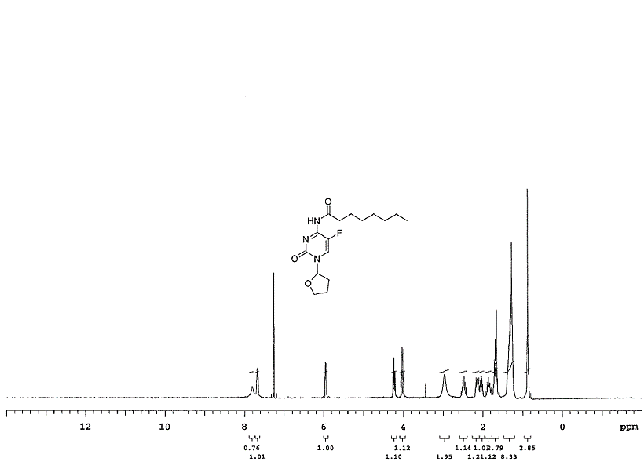
¹H NMR spectra for XYZ-I-71
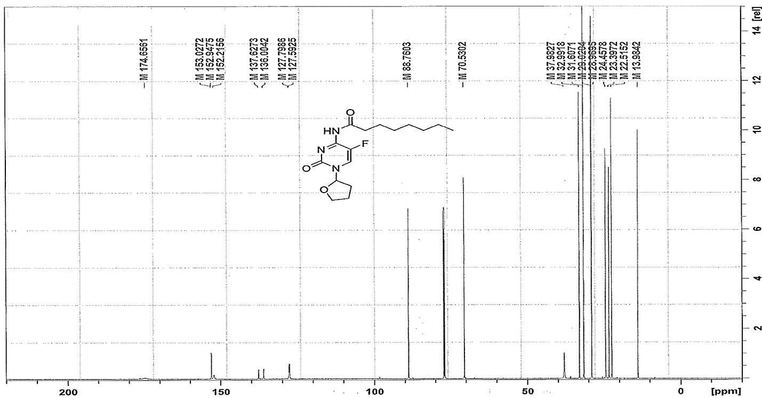
C-13 NMR spectra for XYZ-I-71

Supplementary Fig. S₂
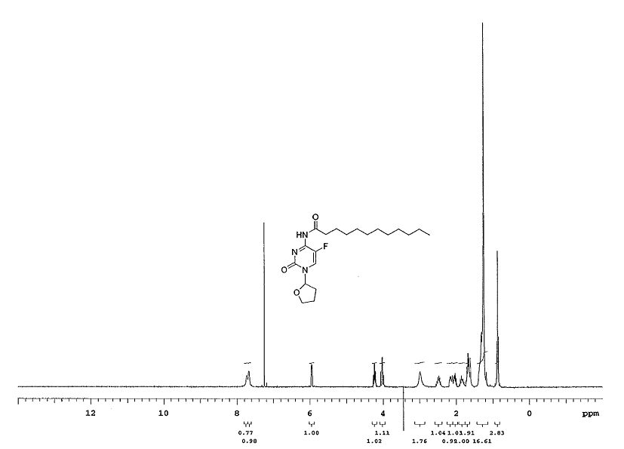
¹H NMR spectra for XYZ-I-73
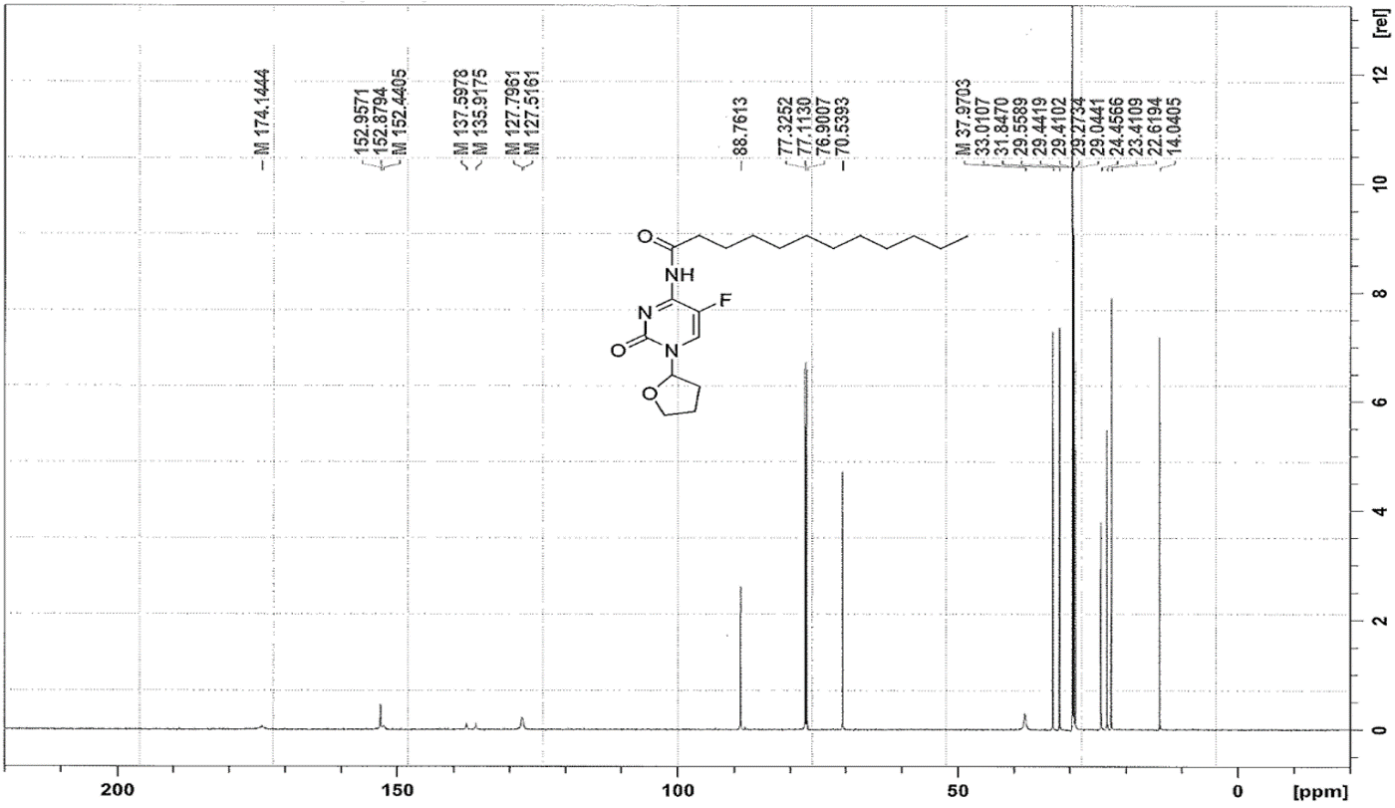
C-13 NMR spectra for XYZ-I-73

Supplementary Fig. S₃

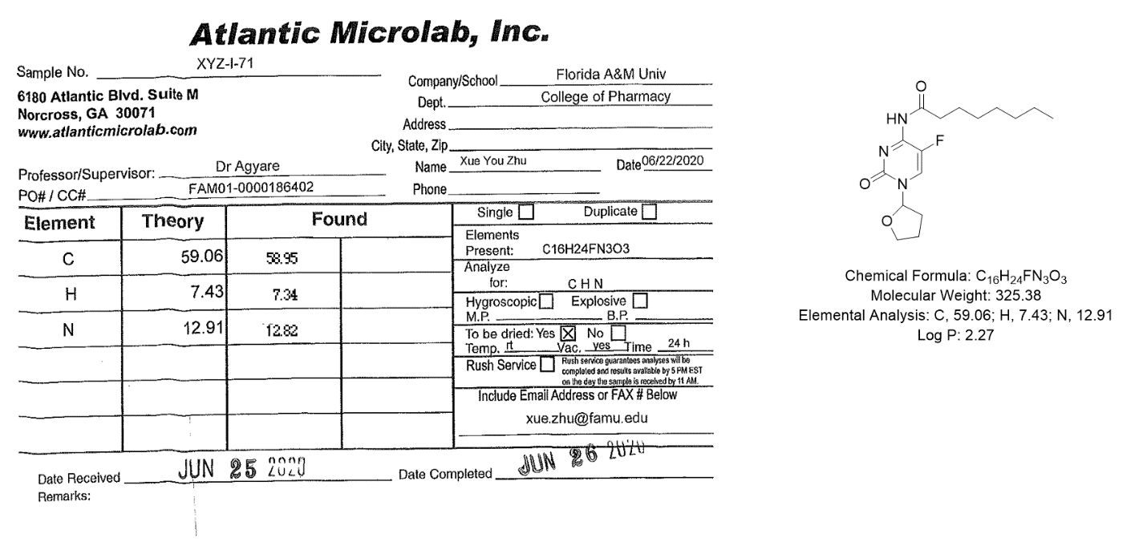

Micro-elemental analysis of XYZ-I-71showing the percent by mass of the elements carbon, hydrogen, and nitrogen in the structure of XYZ-I-71compared to theoretical estimates.

Supplementary Fig. S₄
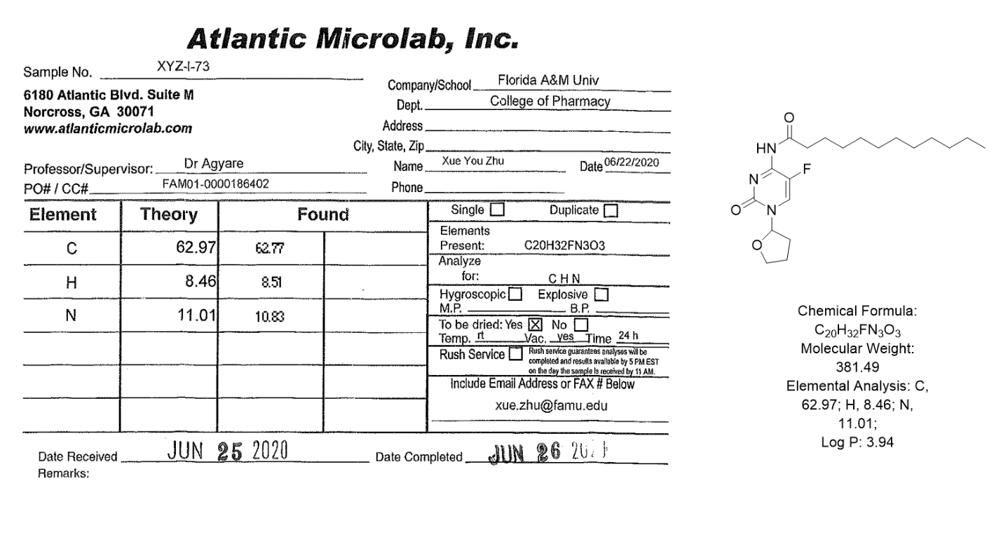

Micro-elemental analysis of XYZ-I-73 showing the percent by mass of the elements carbon, hydrogen, and nitrogen in the structure of XYZ-I-73 compared to theoretical estimates.

Supplementary Fig. S₅

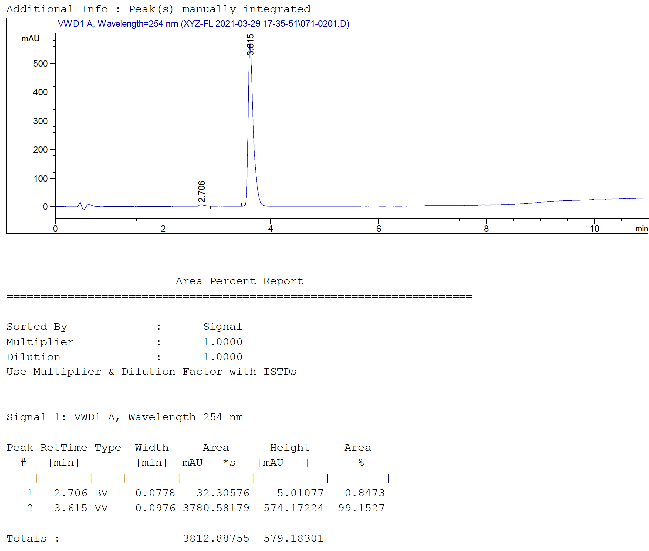

HPLC analysis of XYZ-I-71 showing a sharp peak at retention time of 3.615, performed by an independent laboratory.

Supplementary Fig. S₆
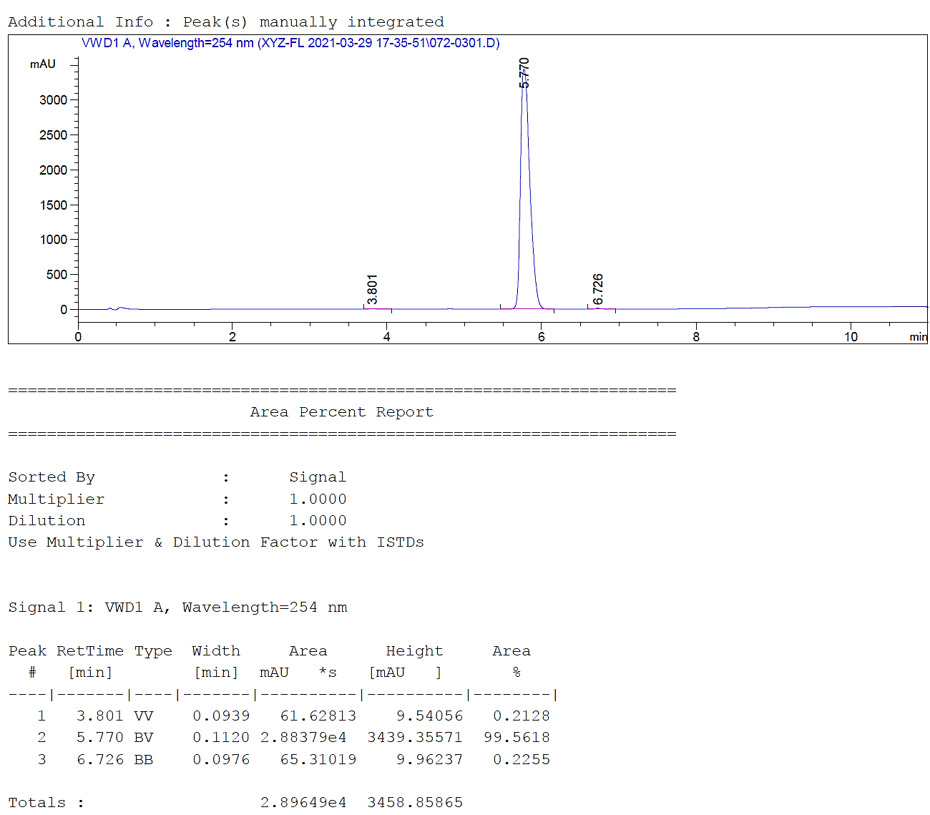

HPLC analysis of XYZ-I-73 showing a sharp peak at retention time of 5.770, performed by an independent.

Supplementary Fig. S₇

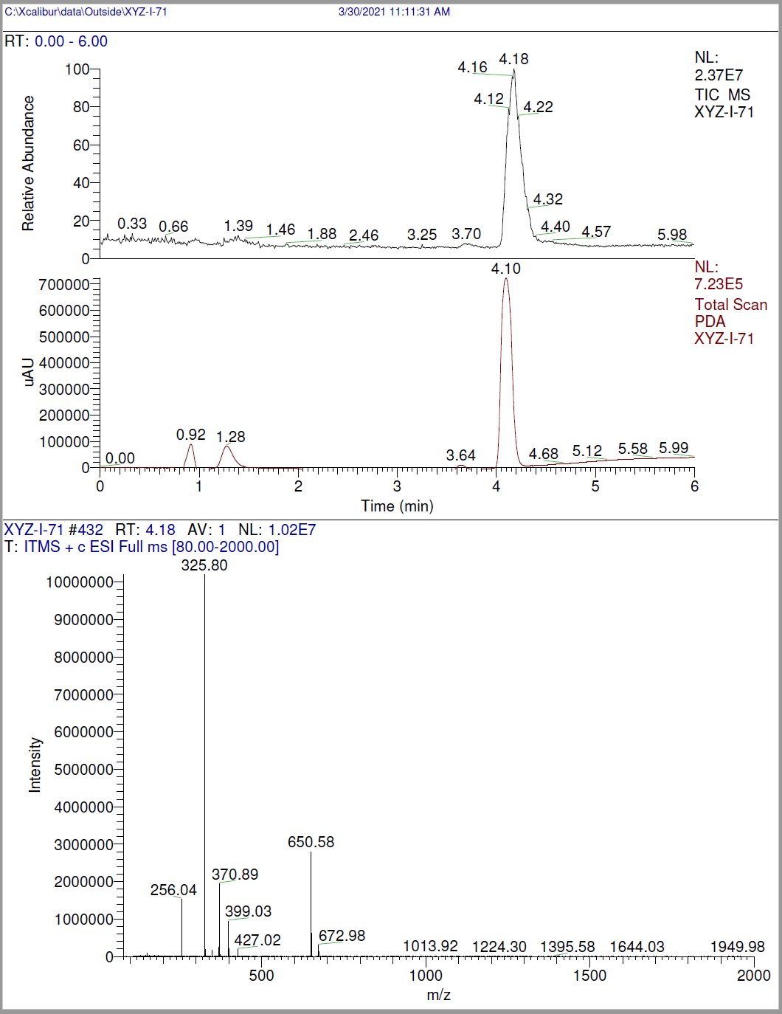

LCMS analysis of XYZ-I-71

Supplementary Fig. S₈

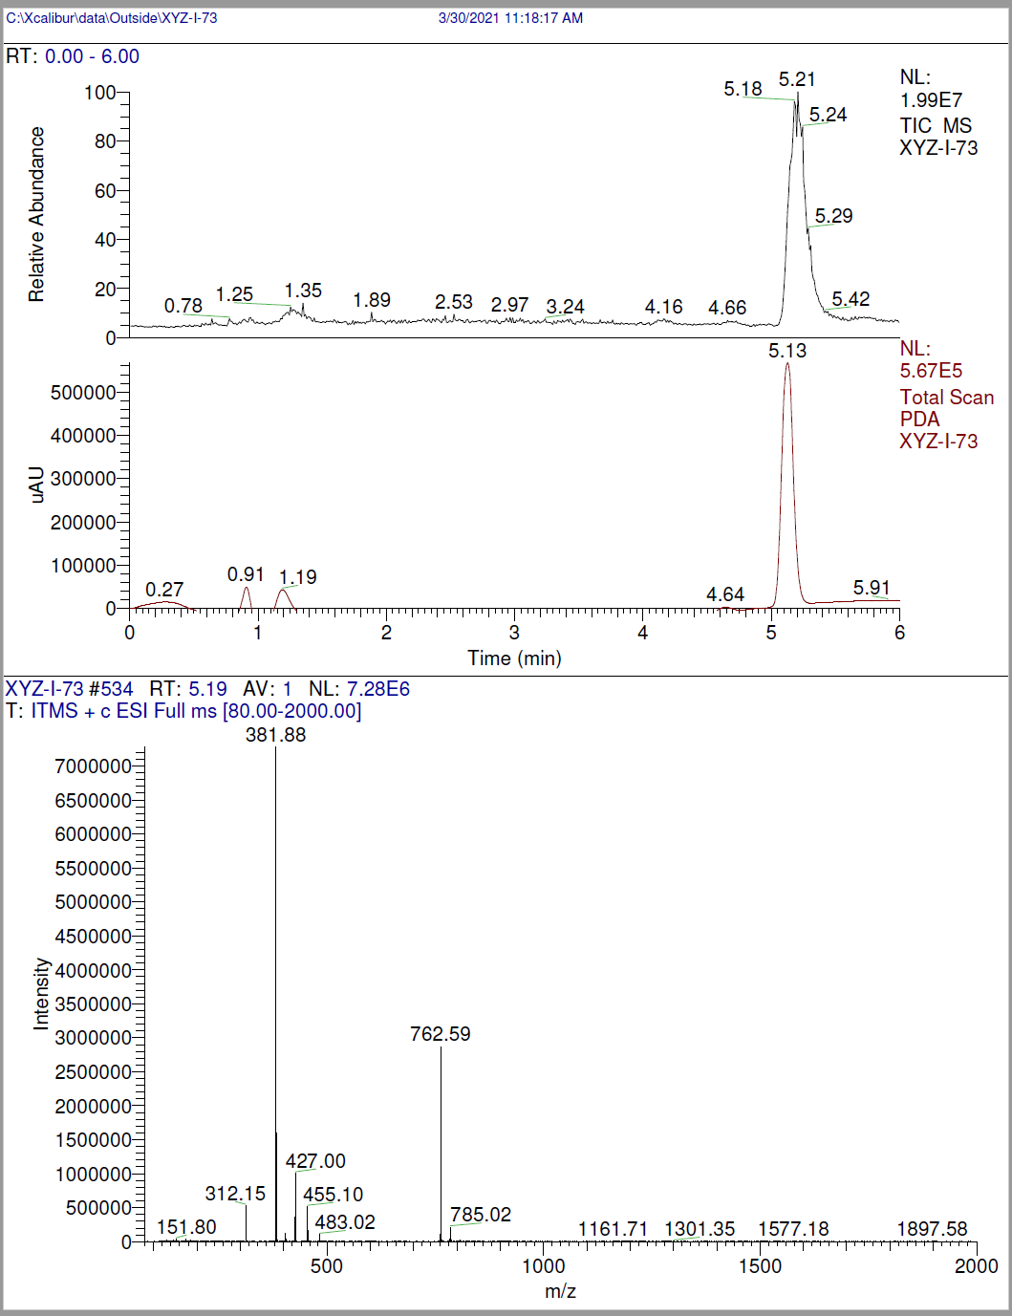
LCMS analysis of XYZ-I-73

Supplementary Fig. S₉

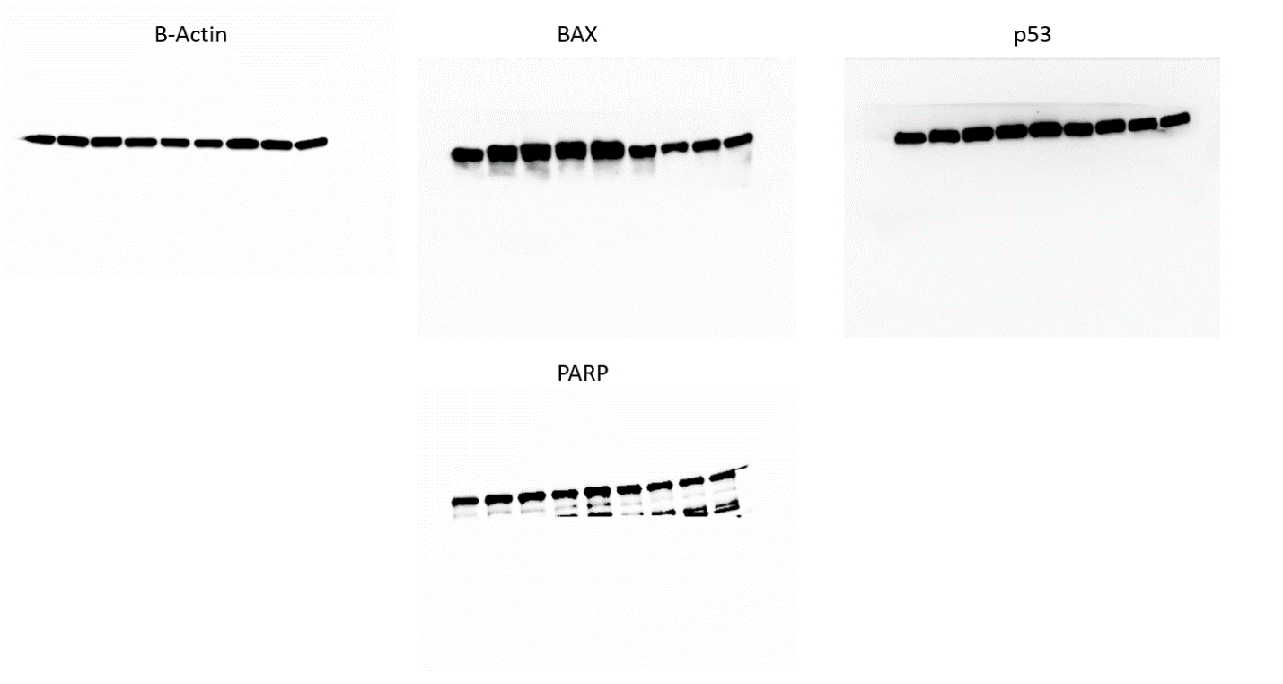
Full-length blots of protein expression after treatment of MiaPaca-2 cells with IC₅₀ and IC₅₀/2 concentrations of XYZ-I-71, XYZ-1-73 and 5-FU

