The ignition and evolution of a giant submarine gravity flow
Supplementary material

Knickpoint Profiles
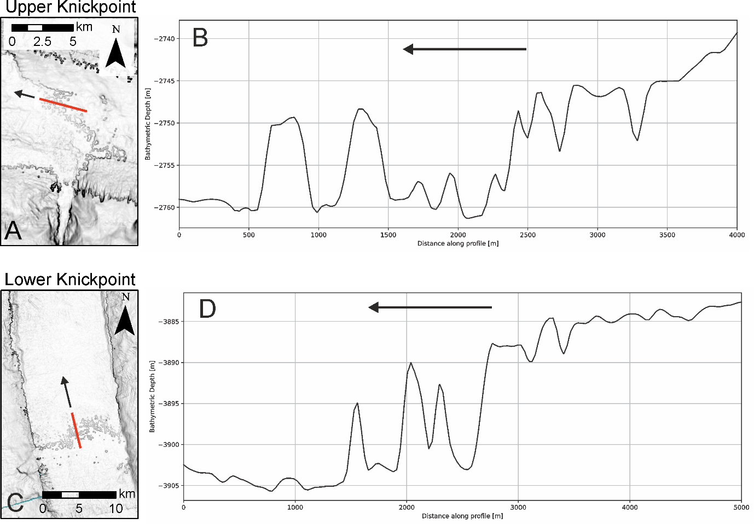
Figure S1. Bathymetric slope maps of the Agadir Canyon’s upper and lower knickpoints. Black is high slope gradient, white is low slope gradient. (A) Slope Gradient map of the upper knickpoint with indicated depth profile (red line) shown in (B). (C) Slope Gradient map of lower Knickpoint with indicated profile (red line) shown in (D). Location of A and C are given in Figure 1.

Trimline & Knickpoint
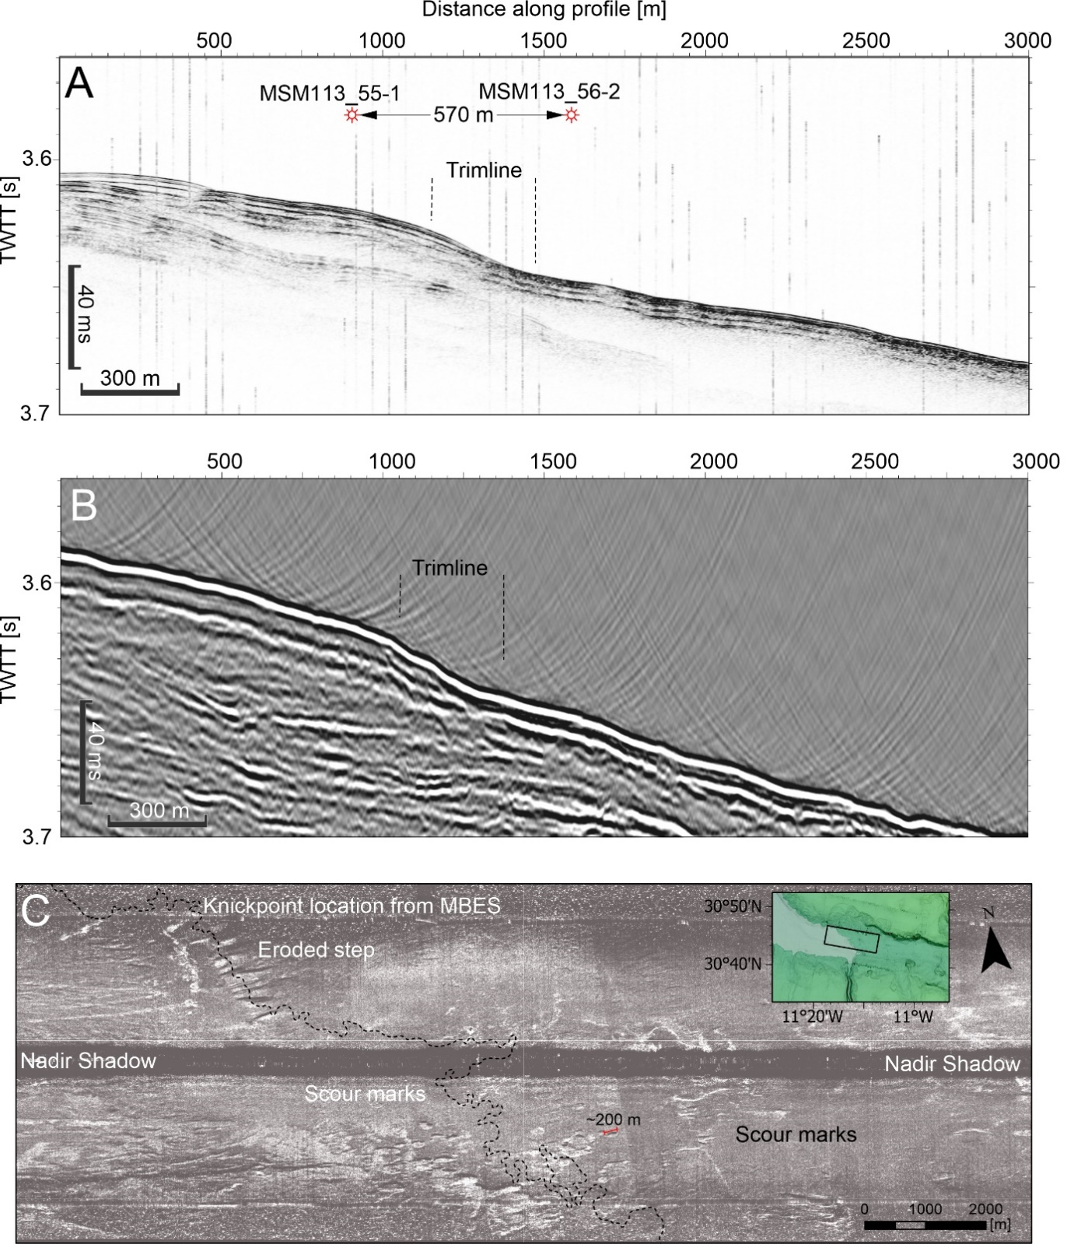
Figure S2. (A) 3.5 kHz parametric echosounder data across the trimline in the upper canyon. The profile covers the locations of cores MSM113-55-1 and MSM113-56-1 (see Fig. 1 for position). (B) High-resolution seismic image across the same location as in (A), showing the trimline is also visible in seismic data despite being close to the resolution limit (~5 m vertical resolution @ 80 Hz, 1500 m/s). (C) Side-Scan Sonar data showing detailed morphology of the upper knickpoint with numerous erosional scours (up to 200 m long) forming a composite scarp (~60 m high). Note the highly irregular crestline of the scarp and the large V-shaped cut, which incises upslope from the main scarp crestline by 1-2 km.

Core: MSM113-58
MSM113-58 is situated in the Northern Tributary and records ~8m of hemipelagic sediments with only one very fine sand gravity flow deposit dated to ~82 ka (Supplementary Figure S3). The deposit sits below the G.Mullerae/E.Huxlyei biozone and so is confidently older than 72 ka. Hence, this core rules out Bed 5 originating from the Northern Tributary.

Bed 5 grain sizes
Core | D₅₀ (mm) | D₉₀ (mm) | D_{max} (mm)
MSM113-61 | 1 | 2 | 12
MSM32-53 | 1 | 2 | 15
JC27-13 | 0.5 | 1 | 2
Table S1: Grain size information for Bed 5 deposits used to reconstruct parent flow speeds (see Methods). Note in the Canyon Head region deposits comprise a coarse-grained matrix with one or two much larger outsized particles. Hence, the large difference between D₅₀, D₉₀ and D_{max}. Speed estimates from grain size use D₉₀ and the D_{max} values.

Core Age Models
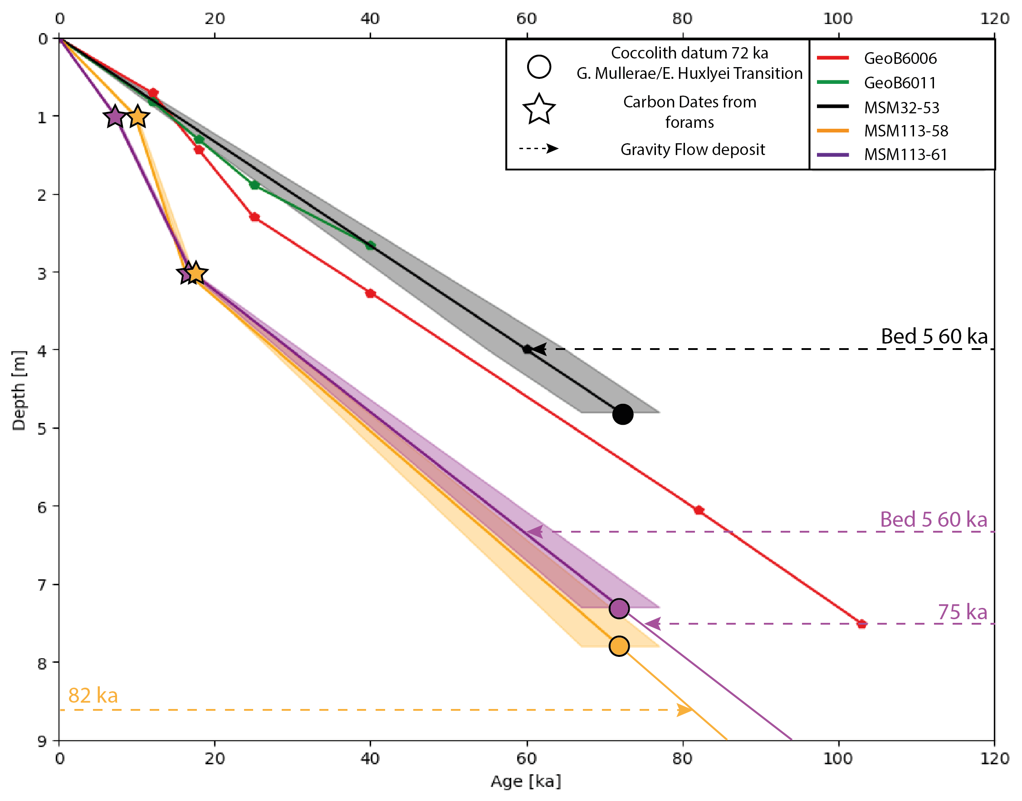
Figure S3. Age models for cores across the Canyon Head region (Fig. 5), which include GeoB cores situated on the open slope ~10 km away from the tributary thalwegs (after Kuhlmann et al., 2004). These GeoB cores help constrain the age models for the MSM cores. MSM cores dated in this study show similar age trajectories to the GeoB records: MSM32-53 showing a similar sedimentation rate of ~7 cm/kyr, and MSM113-58 and 61 having slightly higher sedimentation rates of ~10 cm/kyr. The error envelopes are derived from the E.Huxleyi/G. Mullerae coccolith biozone (72 ka), which has a ±5000 year error. Gravity flow deposits found in these cores are shown with dashed arrows and corresponding age of emplacement. Bed 5 is identified in MSM32-53 and MSM113-61. Note that the only event bed found in MSM113-58 (in the Northern Tributary) is 82 ka, which rules it out as being Bed 5.

Shear Strength Profiles
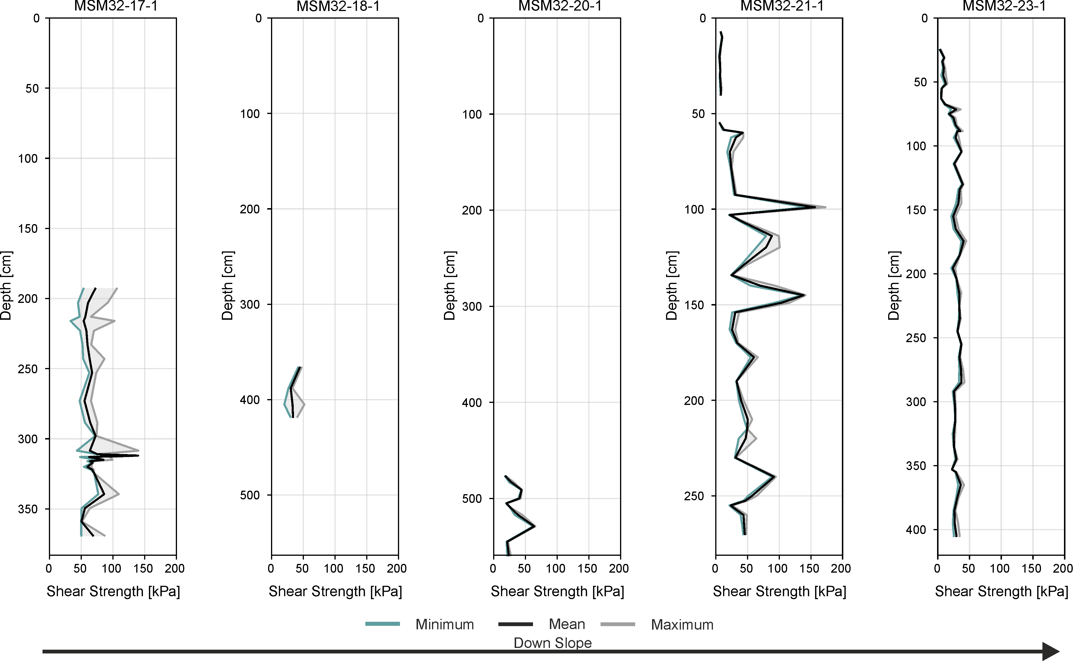
Figure S4. Plot showing the shear strength profiles of five sediment core in downslope order (see Fig. 1). The cores comprise remobilized sediments with destroyed consolidation profile compared to in-situ seafloor sediments (Peakall et al., 2020).

Coccolith assemblages of Bed 5
The coccolith assemblages within Bed 5 are distinct from surrounding event beds (Hunt, 2017). They contain both E.Huxlyei (young) and a small proportion of P.Lacunosa (old). This mixture of species indicates that the Bed 5 event was sourced from a failure at least 35 m thick (assuming uninterrupted hemipelagic sedimentation between 450 ka and 60 ka) or the parent flow was able to erode down up to 35 m along its pathway. Canyon floor scours up to 100 m deep in the Southern Tributary suggest that flows were powerful enough to erode significantly into the canyon floor. However, it is not possible to determine how much of that scouring was produced by Bed 5 alone.
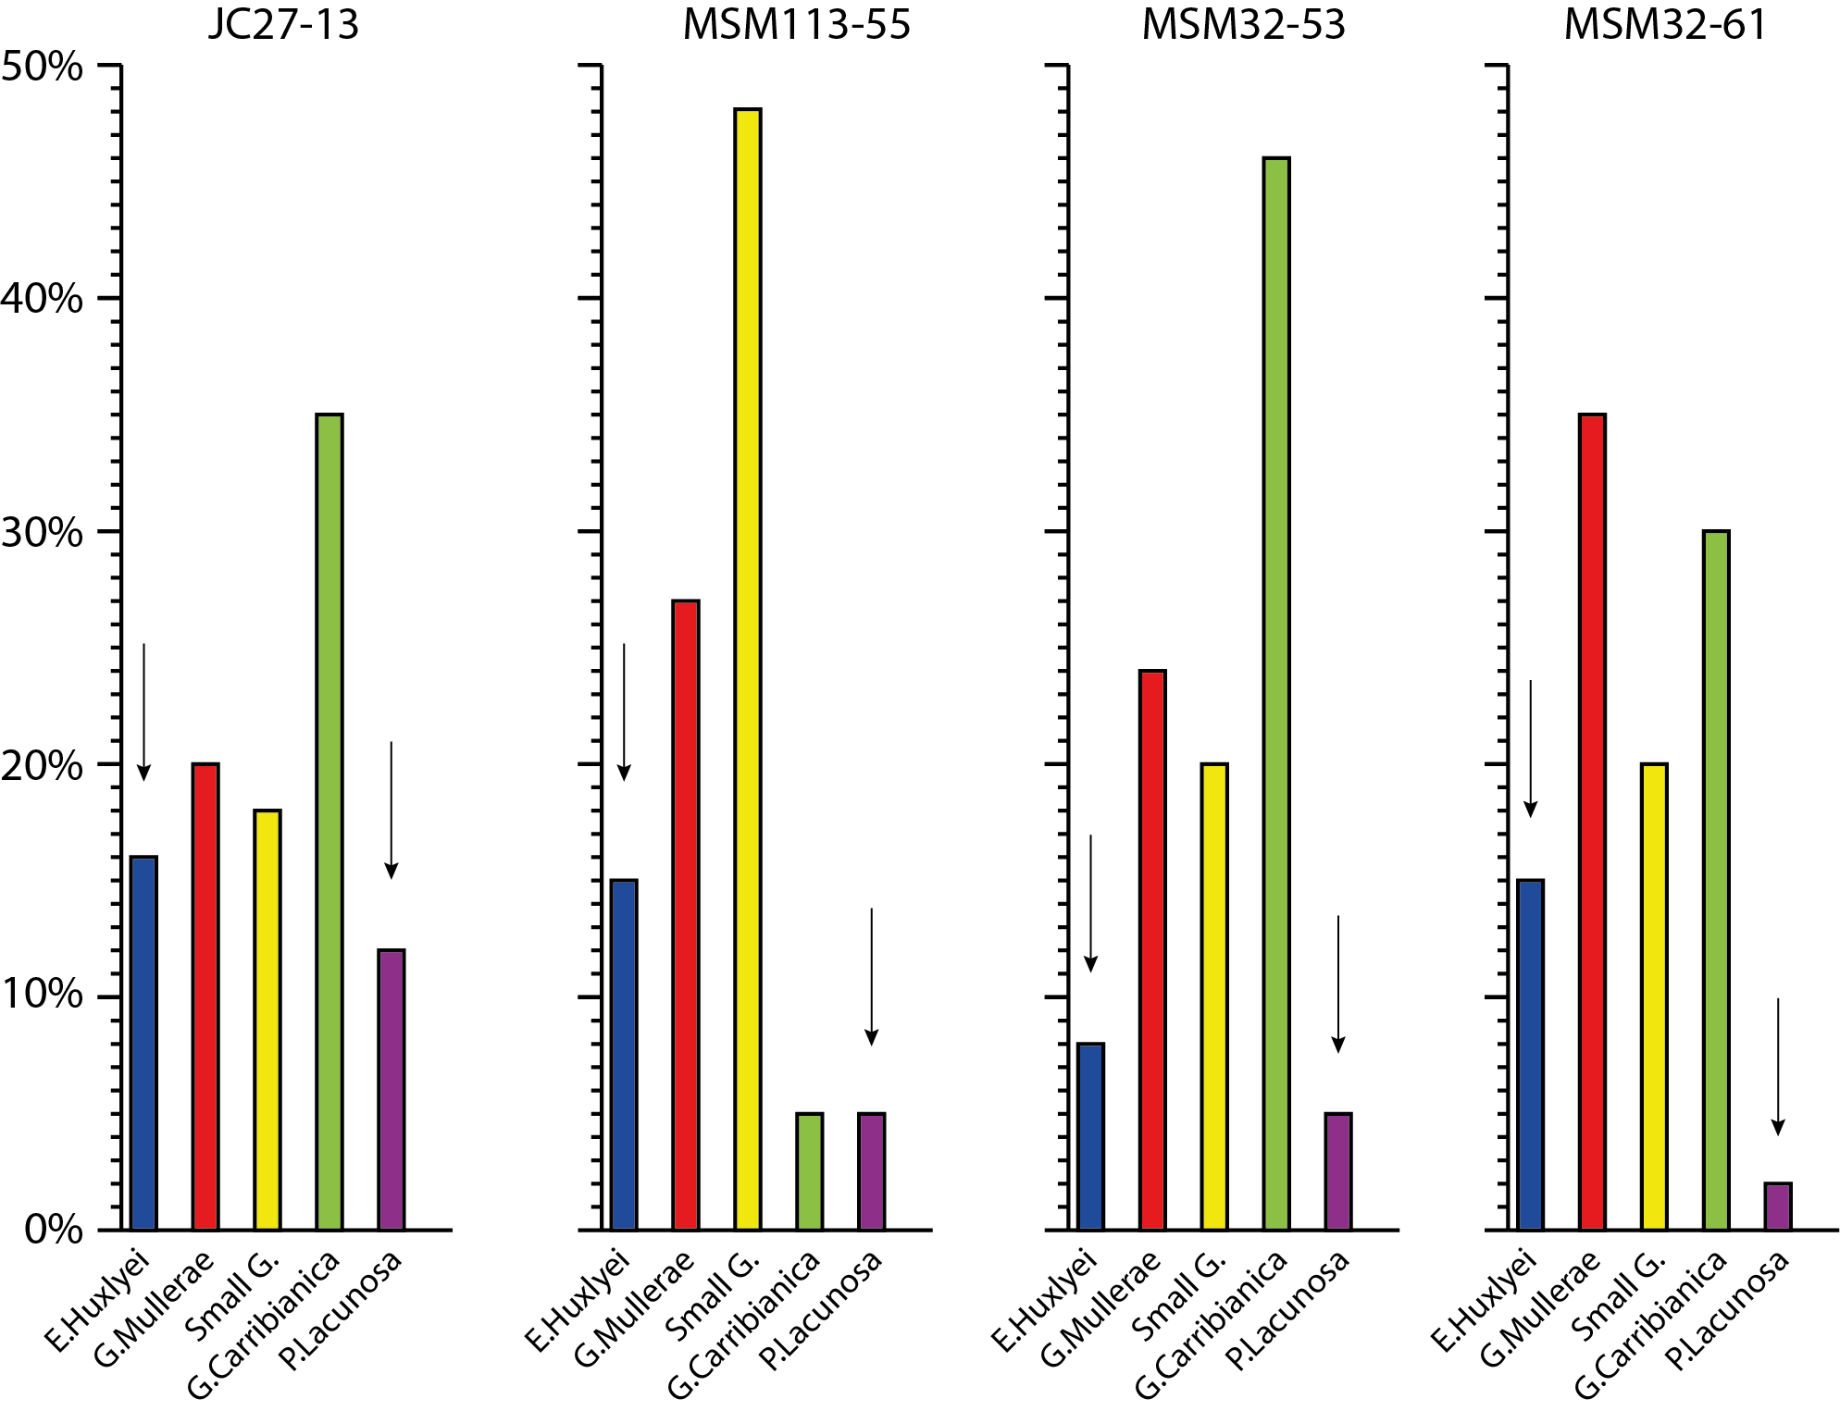
Figure S5. Coccolith assemblages for select cores from the Canyon Mouth (JC27-13; After Hunt, 2017), Main Canyon (MSM113-55), Tributary Confluence (MSM32-53) and Southern Tributary (MSM113-61). Bed 5 coccolith assemblages are distinct from other events because they characteristically contain both E.Huxlyei (8-15%) and a limited amount of much older P.Lacunosa (2-12%). The intervening Gephyrocapsa assemblages typically show a significant proportion of G.Mullerae (~20-30%), Small G. (~20%) and a dominance of G.Carribianica (30-48%). Core 55 is different with only 5% G.Carribianica and a dominance of Small G. (48%). However, it still records the diagnostic species of E.Huxlyei and P.Lacunosa. No other events younger or older than Bed 5 capture both E.Huxlyei and P.Lacunosa (see Hunt, 2017).

The canyon erosion surface
The widespread erosion surface recorded in all cores in the Agadir Canyon is interpreted to have been generated by the Bed 5 Event. Two lines of evidence support this interpretation. First, Bed 5 is the only large-volume event to record significant erosion in the Lower Agadir Canyon and Agadir Basin over the past 200 kyr (Fig. 3B; Talling et al., 2007; Hunt, 2017). Second, the erosion surface throughout the canyon is always draped by Bed 5 deposits (identified by age, composition and coccolith assemblages), even in cores elevated above the canyon floor (Fig. 3B; Core 55). This indicates a close temporal relationship and likely genetic link between the canyon erosion and subsequent emplacement of Bed 5 ~60 ka.
An alternative interpretation is that Bed 5 passively drapes an older erosion surface, hence is not genetically related to the incision. If this were the case, we would expect to record a variety of stratigraphy >60 ka between the erosion surface and Bed 5, particularly in cores on the canyon margins that are more likely to preserve hemipelagic sediments between event beds (e.g. Core 55). However, Bed 5 always immediately overlies the erosion surface in any position within the canyon (see also Talling et al., 2007 for canyon margin cores across the lower canyon). Hence, we interpret the erosion surface as being generated by the Bed 5 Event.

Initial failure volume estimates
Bathymetry across the Southern Tributary catchment shows no significant landslide scars of appropriate age to be the source of the Bed 5 event. Hence, the only area it could have originated was from the tributary thalweg itself. We use the contemporary Kaikoura Canyon as an analogue (after Mountjoy et al., 2018), where an earthquake triggered widespread canyon thalweg failure with an average of 15-25 m thickness sediments failing along ~15 km of the canyon floor. We do not have constraints on either the length of thalweg affected by failure or the average failure thickness. The length of the thalweg is assumed to be similar to that documented for the Kaikoura Canyon (Mountjoy et al., 2018). There are no other documented cases to validate this assumption further. The average thickness of the thalweg failure is calculated using values between 10 and 100 m as the extreme end members, with 30 m assumed to be a reasonable estimate given the failure thicknesses (erosional scouring) documented in other canyons around the world (e.g., Hughes-Clarke et al., 1990; Mountjoy et al., 2018;). Critically, the range in volume estimates from thin skinned (0.2 km³) to thick skinned (3.6 km³) failure scenarios are all relatively small compared to the total deposit volume of Bed 5.

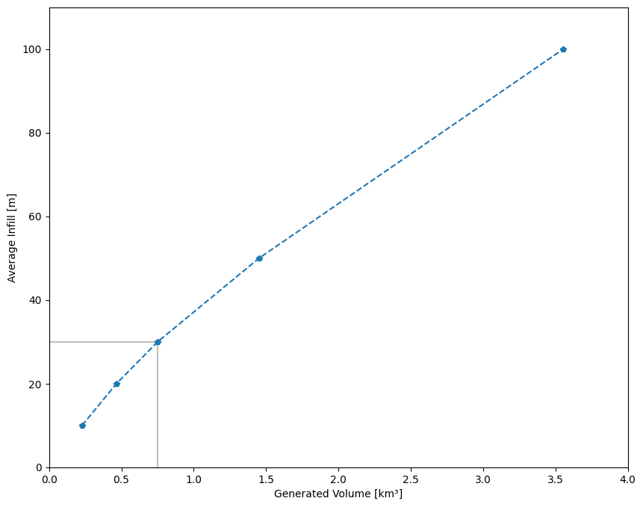
Figure S6. Plot showing the relationship between thickness of the initial thalweg failure and the resultant volume generated by the failure (Fig. 5B for area). Table SX below provides some scenarios.

Average thickness of failure (m) | Volume of sediment failed (km³) | Ignition factor  (162 km³/initial failure volume)
10 | 0.2283 | 710
20 | 0.4664 | 347
30 | 0.7510 | 216
50 | 1.4252 | 114
100 | 3.5546 | 46
Table S2. Showing a range in the average thickness of thalweg failure in the Southern Tributary, and how this corresponds to variations in the estimated initial failure volume. Note that the range in estimated volumes (1-3 km³) is relatively minor compared to the total deposit volume down slope of 162 km³.

Supplementary References
Hughes-Clarke, J. E., Shor, A. N., Piper, D. J., & Mayer, L. A. (1990). Large‐scale current‐induced erosion and deposition in the path of the 1929 Grand Banks turbidity current. Sedimentology, 37(4), 613-629.
Hunt, J. E. (2017). Identifying and quantifying erosion beneath the deposits of long-runout turbidity currents along their pathway. Marine Geology, 389, 32-51.
Kuhlmann, H., Meggers, H., Freudenthal, T., & Wefer, G. (2004). The transition of the monsoonal and the N Atlantic climate system off NW Africa during the Holocene. Geophysical Research Letters, 31(22).
Mountjoy, J. J., Howarth, J. D., Orpin, A. R., Barnes, P. M., Bowden, D. A., Rowden, A. A., ... & Kane, T. (2018). Earthquakes drive large-scale submarine canyon development and sediment supply to deep-ocean basins. Science advances, 4(3), eaar3748.
Peakall, J., Best, J., Baas, J. H., Hodgson, D. M., Clare, M. A., Talling, P. J., ... & Lee, D. R. (2020). An integrated process‐based model of flutes and tool marks in deep‐water environments: Implications for palaeohydraulics, the Bouma sequence and hybrid event beds. Sedimentology, 67(4), 1601-1666.
Talling, P. J., Wynn, R. B., Masson, D. G., Frenz, M., Cronin, B. T., Schiebel, R., ... & Amy, L. A. (2007). Onset of submarine debris flow deposition far from original giant landslide. Nature, 450(7169), 541-544.

