Supplementary Information
Fig. 1: Typical EDS spectrum. Results of EDS analysis for Sample A1 confirming the presence of carbon in the fault gouge.
Table 1: Peaks of Raman spectral bands associated with Fig. 2.
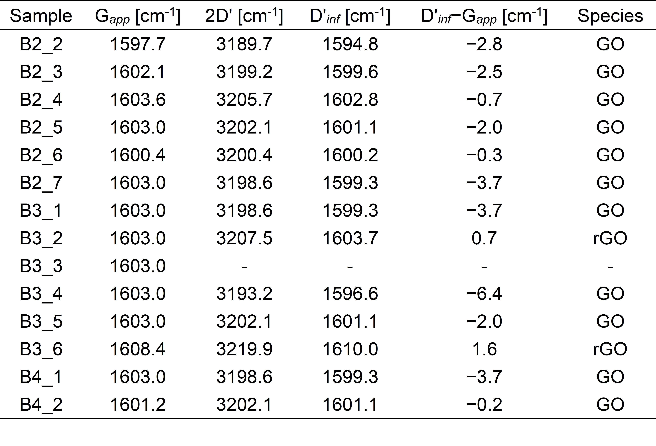

Effects of polishing during sample preparation on the Raman spectra
It is presumed that the original microstructure of graphite was easily deformed by shearing during polishing; therefore, careful attention should be paid to sample preparation ¹. In this study, we examined the fault gouge sample exposed on the surface of a thin-section during sample preparation using laser Raman spectroscopy in order to investigate the effects of shearing due to polishing. To compare the polished and unaffected surfaces, we analysed the Raman spectra from the sample surface to deeper positions in the sample. For the measurements, the stage of the Raman spectrometer was moved up and down, and the laser was focused on a deeper position than the sample surface.
Raman spectra were acquired via a JASCO NRS-4100TOR Raman spectrometer at the Department of Earth and Planetary Materials Science, Faculty of Science, Tohoku University, Sendai, Japan. Analyses were conducted using 532.3 nm laser excitation, adjusted to an on-sample intensity of 3.1 mW, collected in the frequency range of 1000–4500 cm⁻¹, and scanned twice with an exposure time of 30 s. The wavenumber resolution was 2 cm⁻¹. The Raman spectra were analysed in the same way as described above to acquire the position of the D1, G, and 2Dʹ peaks.
The intensity of the Raman spectrum decreases as the laser focus becomes deeper below the sample surface (Fig. 2). We evaluated the associated changes in the positions of the D1, G, and 2Dʹ peaks (Fig. 3). There is no significant change in the Raman shifts of these peaks, as the standard deviation (SD) and standard error (SE) are within the range of the variation caused by the wavenumber resolution (2 cm⁻¹) of the Raman spectrometer (Table 2). Therefore, the effect of shearing by polishing on our results is negligible and does not invalidate the identification of GO.
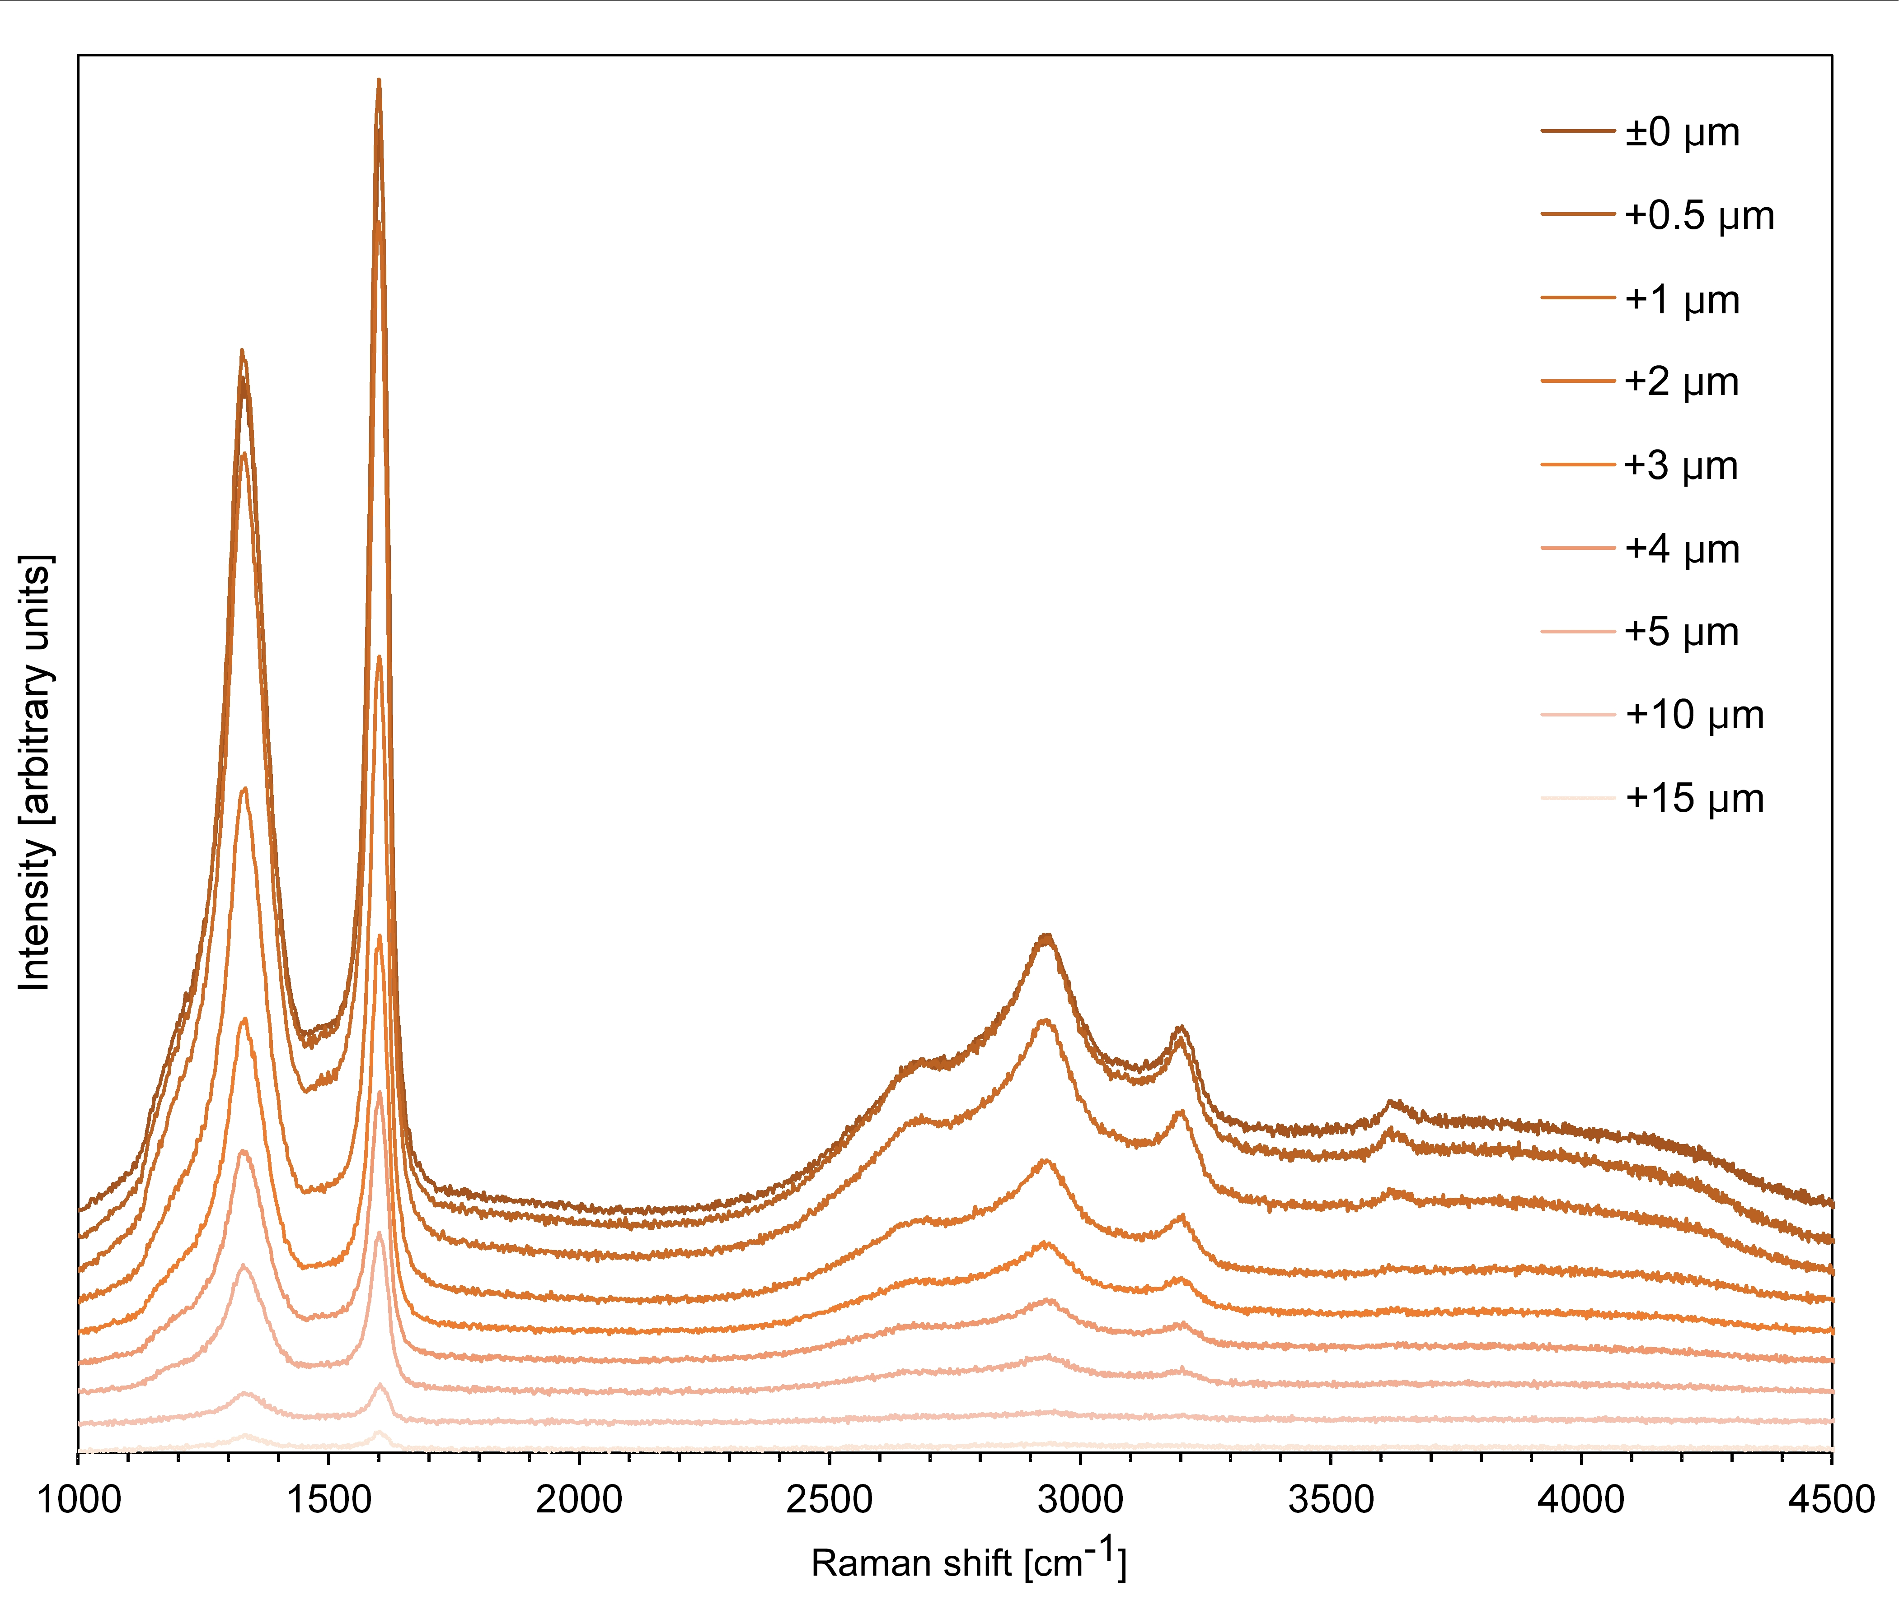
Fig. 2: Typical changes in Raman spectra with depth. Changes in the Raman spectra for Sam-ple A1.
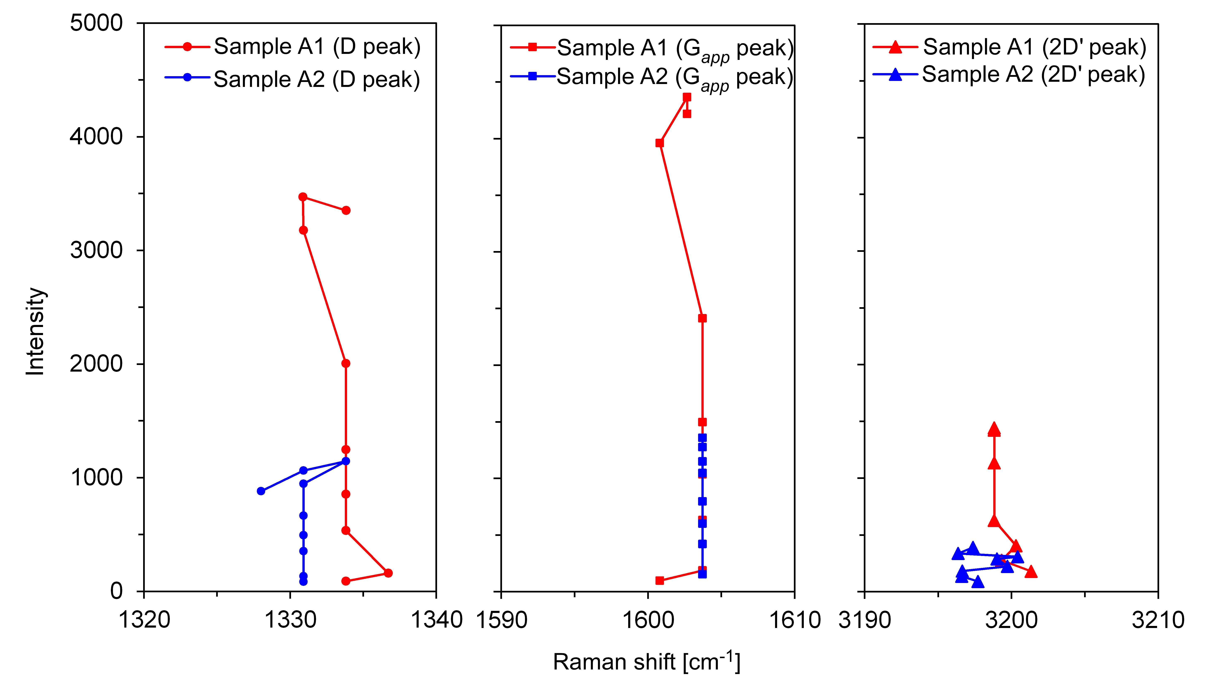
Fig. 3: Change of each peak associated with Fig. 2. The D1, apparent G (G_{app}), and 2Dʹ peaks obtained from the Raman spectra used to investigate the effects of polishing on the identification of GO.

Table 2: Summary statistics for examining the changes of each peak associated with Fig. 2.
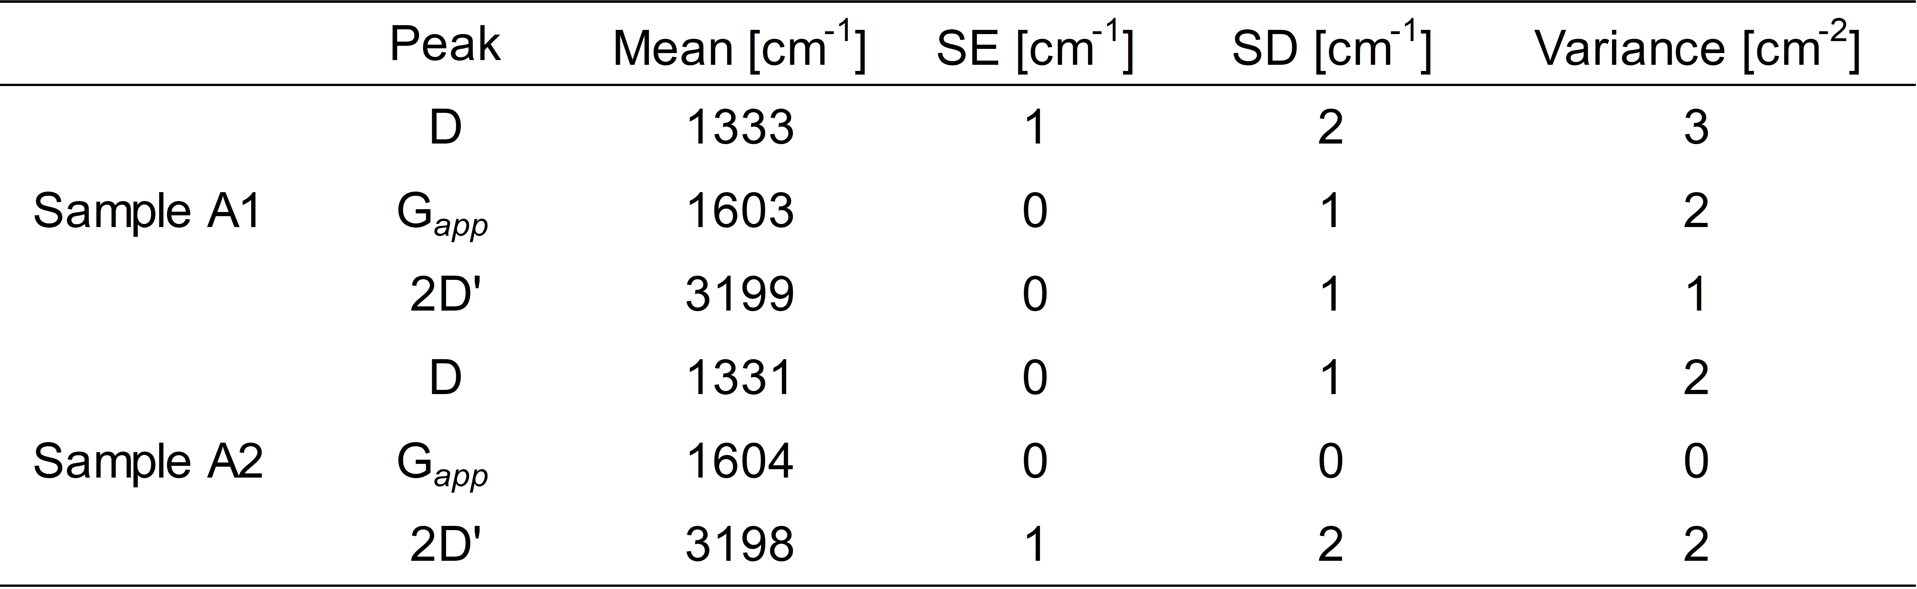

Reference
- Kouketsu, Y., Miyake, A., Igami, Y., Taguchi, T., Kagi, H. & Enami, M. Drastic effect of shearing on graphite microtexture: attention and application to Earth science. Prog. Earth Planet. Sci. 6, 23 (2019).

