SUPPLEMENTARY MATERIAL
CHEMISTRY METHODOLOGY
The crude Simpson’s oil from flowers of Cannabis sativa chemotype CBD (OCs-CBD) was produced and kindly provided by Associação Brasileira de Cannabis medicinal (ABRACAM, Ceará, Brazil).
The ¹H and ¹³C NMR profiles for OCs-CBD were obtained using a Bruker AVANCE DRX 500 MHz spectrometer (Bruker, Germany). Results are shown in figures A1-A4.

CBD PURIFICATION
Briefly, OCs-CBD was adsorbed onto silica gel for flash chromatography and submitted to gravitational column chromatography to yield a pooled fraction [OCs-CBD (3-8)], after ¹H NMR and TLC screening, that was further chromatographed, by the same method, to afford the pooled fraction [OCs-CBD (3-8)(4-5)], designated CBD-pur. (purified CBD), that has formed needle crystals after standing. CBD-pur. was also characterized by ¹H & ¹³C NMR. Results are shown in figures A5-A8.

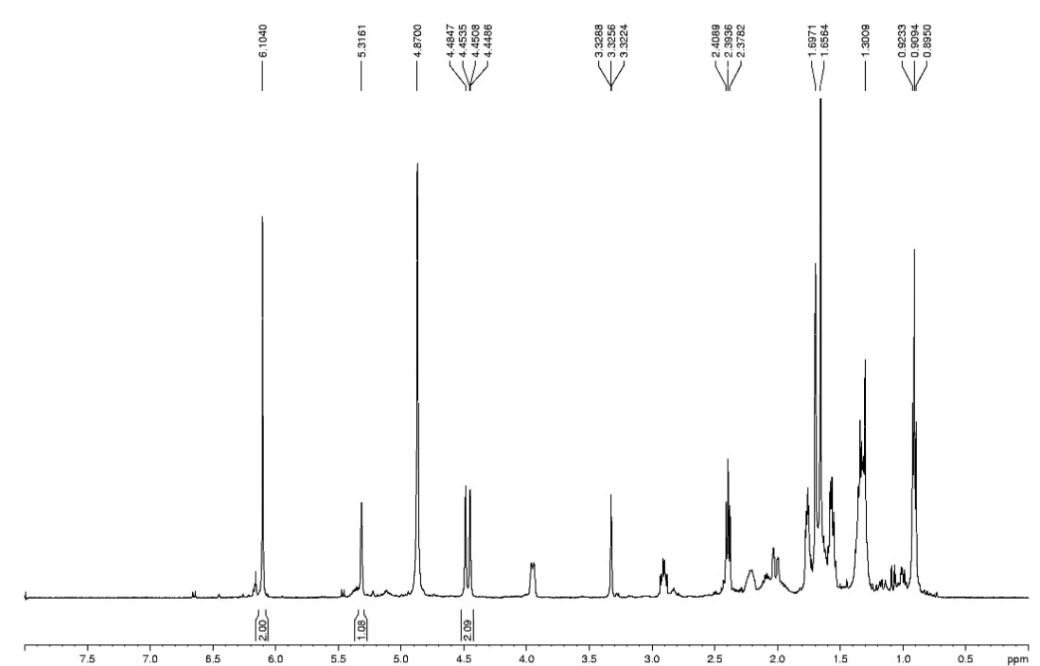

Figure A1. ¹H NMR spectrum (500 MHz, MeOD) of CsO-CBD.

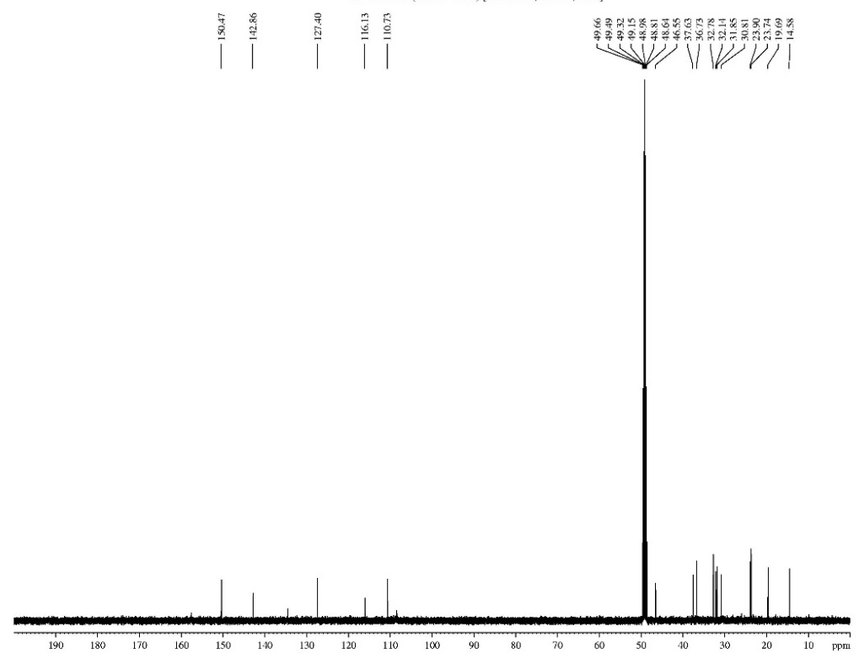

Figure A2. ¹³C NMR spectrum (125 MHz, MeOD) of CsO-CBD.

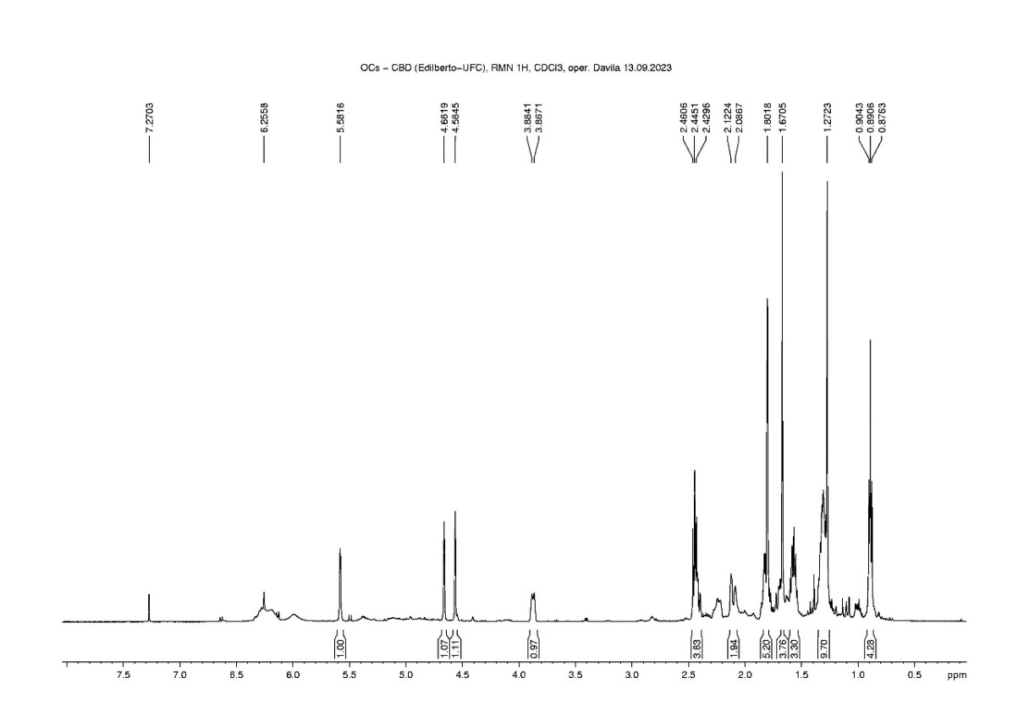
Figure A3. ¹H NMR spectrum (500 MHz, CDCl₃) of CsO-CBD.

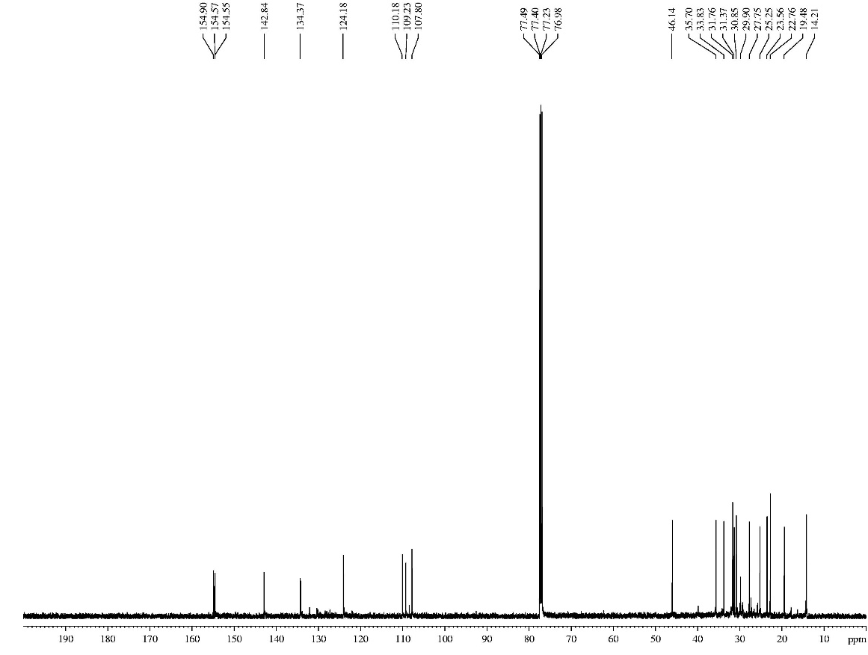

Figure A4. ¹³C NMR spectrum (125 MHz, CDCl₃) of CsO-CBD.

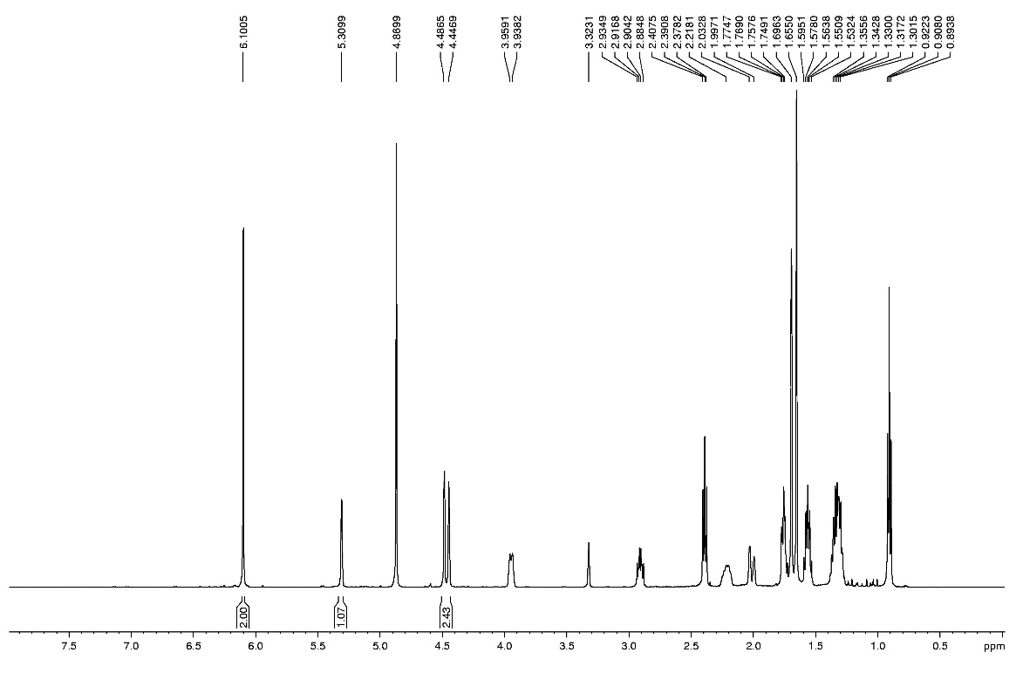

Figure A5. ¹H NMR spectrum (500 MHz, MeOD) of CBD-pur.

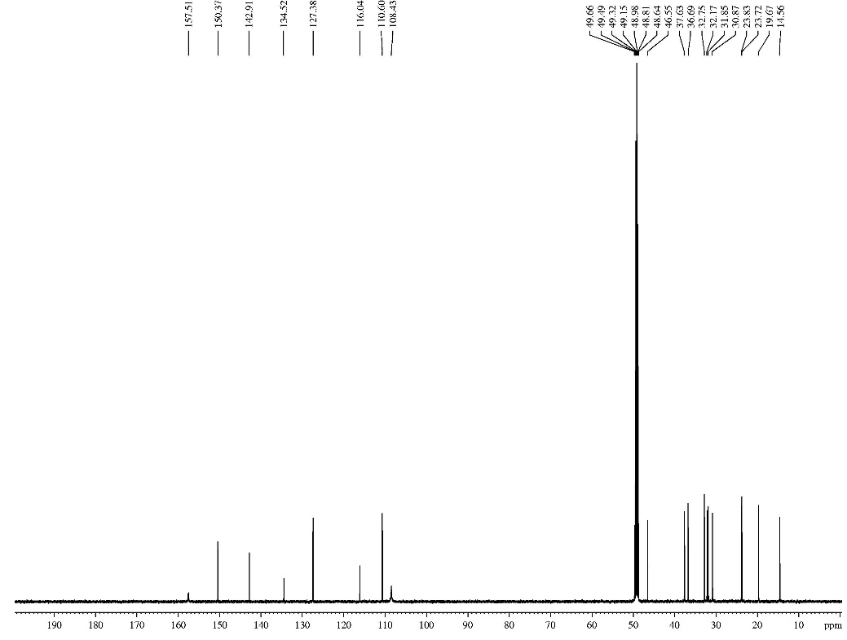

Figure A6. ¹³C NMR spectrum (125 MHz, MeOD) of CBD-pur.

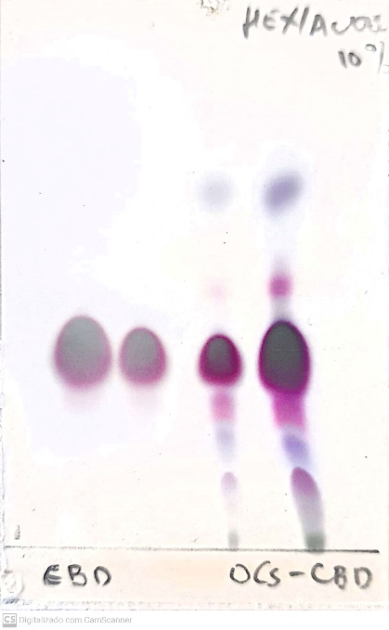

Figure A7. TLC plate comparing OCs-CBD, in two different concentrations (two spots at the right-side), and CBD-pur. (two spots at the left-side), also in two different concentrations.

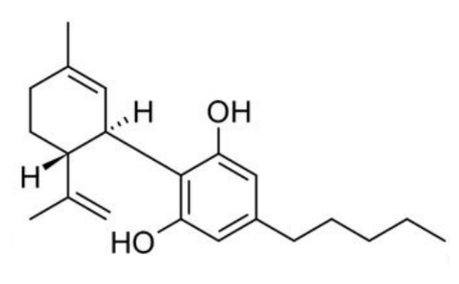
Figure A8: Cannabidiol (CBD) Structure.

CBD NANOEMULSION
Materials
Licuri oil (Syagrus coronata oil) was purchased from Licuri Brasil (Brazil). The non-ionic surfactant used was the triblock copolymer poly (ethylene oxide) – poly (propylene oxide) – poly (ethylene oxide) (Pluronic® F127) from Sigma-Aldrich (USA). All reagents were of analytical purity.

Characterization of Licuri oil
Fatty acid profile of the oil was determined by gas chromatography coupled mass spectrometry (GC-MS) in a SHIMADZU QP-2010 ULTRA (Japan) equipped with a (5%-phenyl)-methylpolysiloxane (DB-5) capillary column (30 m × 0.25 mm) using helium as carrier gas (at a flow rate of 0.6 mL/min) in a splitless mode (injection volume of 1 uL of 1 mg/mL solutions of each product diluted in ethyl acetate). The oven temperature was initially set at 120 ˚C and programmed at 10 ˚C/min to 300 ˚C, then held for 10 min. The temperatures of the injector and the detector were, respectively, 250 and 300 ˚C. The quadrupole analyser was set to electron ionization (EI) and scanned in a range between 50 to 450 m/z.

Preparation of CBD nanoemulsions

The aqueous phase (FA) and the organic phase (FO) were prepared and homogenized separately. Pluronic® F127 hydrophilic surfactant (0.2 g) was added to the FA (90% of the formulation). Licuri oil (1 g) and CBD (0.1 g) made up the FO (10% of the formulation). For the preparation of each primary emulsion (10 g), the previously prepared FA was added slowly to the FO and stirred at 1000 rpm for 30 min. For the preparation of CBD nanoemulsions, each primary emulsion was probe sonicated (Digital Sonifier W-450D, Branson, USA) for 3 min (10 s on/ 10 s off), 70% amplitude, in an ice bath.

Particle size and zeta potential measurement

Nanodroplet size, polydispersity index (PDI) and zeta potential (ZP) of the CBD nanoemulsion were determined using the dynamic light scattering (DLS) instrument at 25 °C using Zetasizer (Malvern Instruments, UK). Nanoemulsions were diluted 1000 times with deionized water. Means and standard deviations were calculated for triplicate measurements.

Licuri oil characterization
Licuri oil was analized by CG-MS and presents the composition (%) of the fatty acids shown in Table 1. Results indicate that 80.48% of its molar composition consists of saturated fatty acids and 19.52% of unsaturated fatty acids. The major compounds are lauric acids (42.13%). Approximate values have been found in a recent study (Santos Souza et al, 2021).

Table 1 - Fatty Acid Composition of Licuri Oil
Fatty acid | Area (%) | Area (%)*
Decanoic acid (C10:0 - capric acid) | 7.87 | 6.40
Dodecanoic acid (C12:0 - lauric acid) | 42.13 | 43.64
Tetradecanoic acid (C14:0 - myristic acid) | 16.14 | 14.32
Hexadecanoic acid (C16:0 - palmitic acid) | 9.18 | 6.89
Octadec-9-enoic acid (C18:1 - oleic acid) | 19.52 | 11.78
Octadecanoic acid (C18:0 - stearic acid) | 5.15 | 3.83
Octanoic acid (C8:0 - caprylic acid) | - | 10.05
Octadeca-9,12-dienoic acid (C18:2 - linoleic acid) | - | 3.1
*Values found by Dos Santos Souza et al, 2021.

Particle size and zeta potential measurement

Nanoemulsion characterization showed that the droplet size were in the nanoemulsion range (Gupta et al., 2016), as shown in Table 2. The mean droplet size of the THC formulation was 237.5 ± 1.457 nm. The mean droplet size of the CBD formulation was 247.2 ± 1.153 nm.
The PDI is a dimensionless measurement that ranges from 0 to 1.0 and reflects the particle size distribution. The lower the PDI value, the more concentrated the particle size distribution and the less dispersed the emulsion (Zhao et al., 2020). A low PDI value (< 0.1) indicates that the emulsion is narrowly monodispersed (Tang et al, 2013).
The zeta potential results of the nanoemulsion showed values of – 33.9 to –32.4 mV, being classified as stable. The greater the droplet surface charge, in module, the greater the stability of the emulsion, since the inter droplet repulsive forces prevent destabilization mechanisms (Liu et al., 2006). In the present work, despite the non-ionic surfactant used, the negative zeta potential values may be related to the adsorption of hydroxyl ions (OH⁻) at the oil-water interface, due to hydrogen bonds of the ethylene oxide blocks of the Pluronic® F127.

Table 2 – Characterization of cannabidiol (CBD) nanoemulsion.
Formulation | Droplet size (nm) | PDI | ZP (mV)
CBD nanoemulsion | 247.2 ± 1.153 | 0.082 ± 0.016 | -32.4 ± 1.37

REFERENCES

Romano LL, Hazekamp A. Cannabis Oil: Chemical Evaluation of an Upcoming Cannabis-Based Medicine. Cannabinoids,1(1):1–11, 2013.
Gupta A, Burak Eral H, Alan Hatton T, Doyle PS. Nanoemulsions: Formation, properties and applications. Soft Matter, 12(11): 2826–2841, 2016. doi: 10.1039/C5SM02958A.
Liu W, Sun D, Li C, Liu Q, Xu J. Formation and stability of paraffin oil-in-water nano-emulsions prepared by the emulsion inversion point method. J Colloid Interface Sci. 303(2):557-63, 2006. doi: 10.1016/j.jcis.2006.07.055
Dos Santos Souza TG, da Silva MM, Feitoza GS, de Melo Alcântara LF, da Silva MA, de Oliveira AM, de Oliveira Farias de Aguiar JCR, do Amaral Ferraz Navarro DM, de Aguiar Júnior FCA, da Silva MV, Chagas CA. Biological safety of Syagrus coronata (Mart.) Becc. Fixed oil: Cytotoxicity, acute oral toxicity, and genotoxicity studies. J Ethnopharmacol. 272:113941, 2021. doi: 10.1016/j.jep.2021.113941.
Tang SY, Shridharan P, Sivakumar M. Impact of process parameters in the generation of novel aspirin nanoemulsions--comparative studies between ultrasound cavitation and microfluidizer. Ultrason Sonochem. 20(1):485-97, 2013. doi: 10.1016/j.ultsonch.2012.04.005.
Zhao C, Wei L, Yin B, Liu F, Li J, Liu X, Wang J, Wang Y. Encapsulation of lycopene within oil-in-water nanoemulsions using lactoferrin: Impact of carrier oils on physicochemical stability and bioaccessibility. Int J Biol Macromol. 153:912-920, 2020. doi: 10.1016/j.ijbiomac.2020.03.063.

