Read me.
PSADynamics220623_4parademo.zip
PSADynamics220623_4paraEqdemo.zip

Results
If the correlation Equation is not provided, the rate of success as well as the rate of performance is largely decreased (PSADynamics220623_4parademo). The final variations of the ratio of a and b, were distributed as evident in panel H.
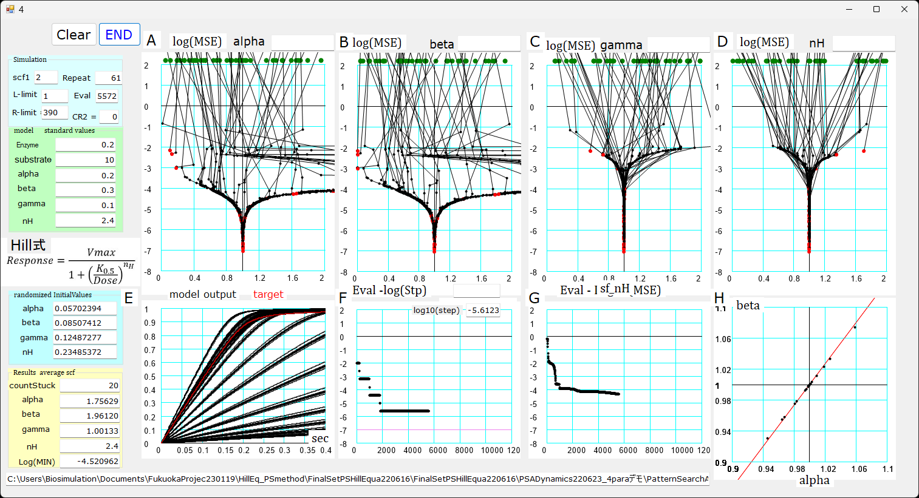
When provided with the correlation equation, the performance was accelerated by nearly 30 times (PSADynamics220623_4paraEqdemo).
