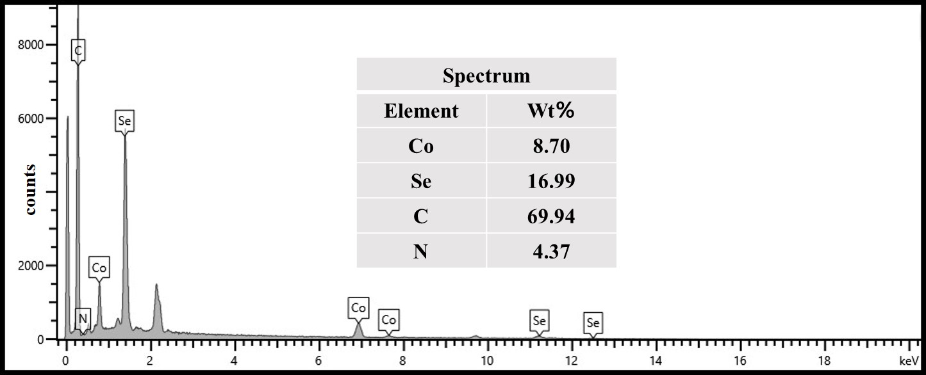
Fig. S1. SEM-EDS mapping of CoSe₂@NC/CNTs
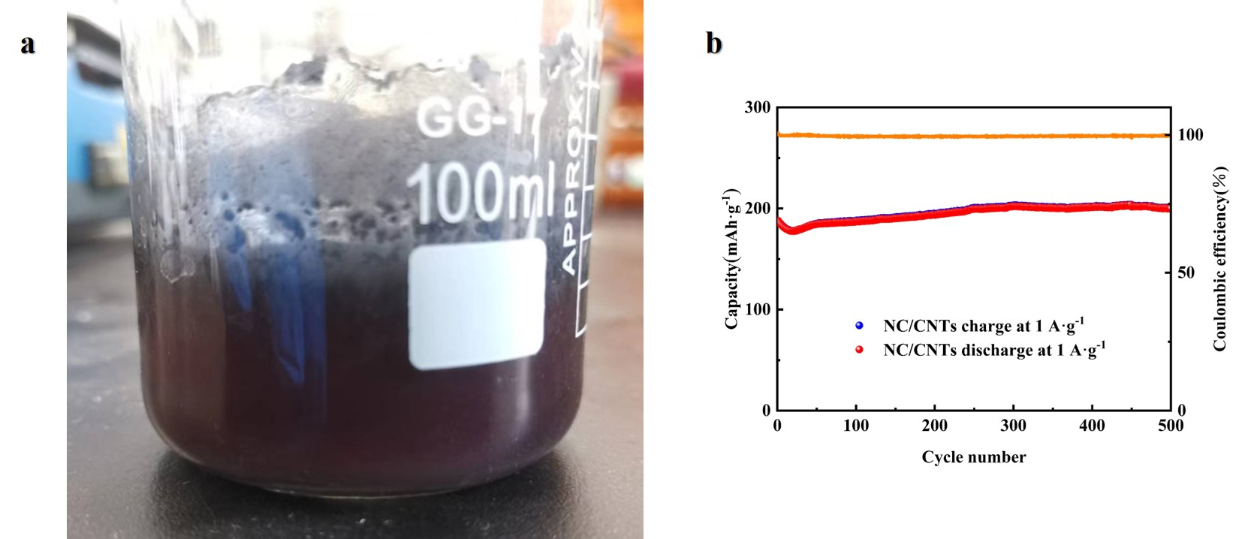
Fig. S2. (a) Acid leaching solution of NC/CNTs (b) Long-life cyclability of NC/CNTs
Fig. S3. TEM-EDS-HAADF mapping of CoSe₂@NC/CNTs

