Supplementary Information

Table of Contents
Supplementary Table 1 | Atopic dermatitis demographic and clinical characteristics of the patient population at baseline 2
Supplementary Table 2 | Efficacy durability in REZPEG 24 μg/kg cohort 3
Supplementary Table 3 | Rescue medications for the indication of Atopic Dermatitis 3
Supplementary Table 4 | Psoriasis patient numbers at continuous endpoints 3
Supplementary Table 5 | Atopic dermatitis patient numbers at continuous endpoints 4
Supplementary Table 6 | Table of statistically significant and list of non-significant serum proteomic biomarkers 5
Supplementary Table 7 | Table of statistically significant REZPEG-modulated proteins grouped by pathway 8
List of Investigators – Psoriasis 9
List of Investigators – Atopic Dermatitis 9
Supplementary Methods 9
AD full inclusion and exclusion criteria 9
References 14

Supplementary Table 1 | Atopic dermatitis demographic and clinical characteristics of the patient population at baseline

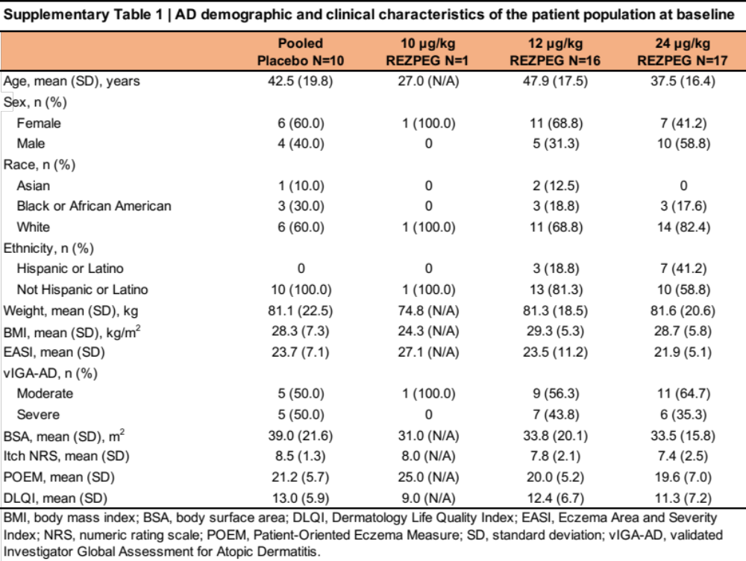

Supplementary Table 2 | Efficacy durability in REZPEG 24 μg/kg cohort

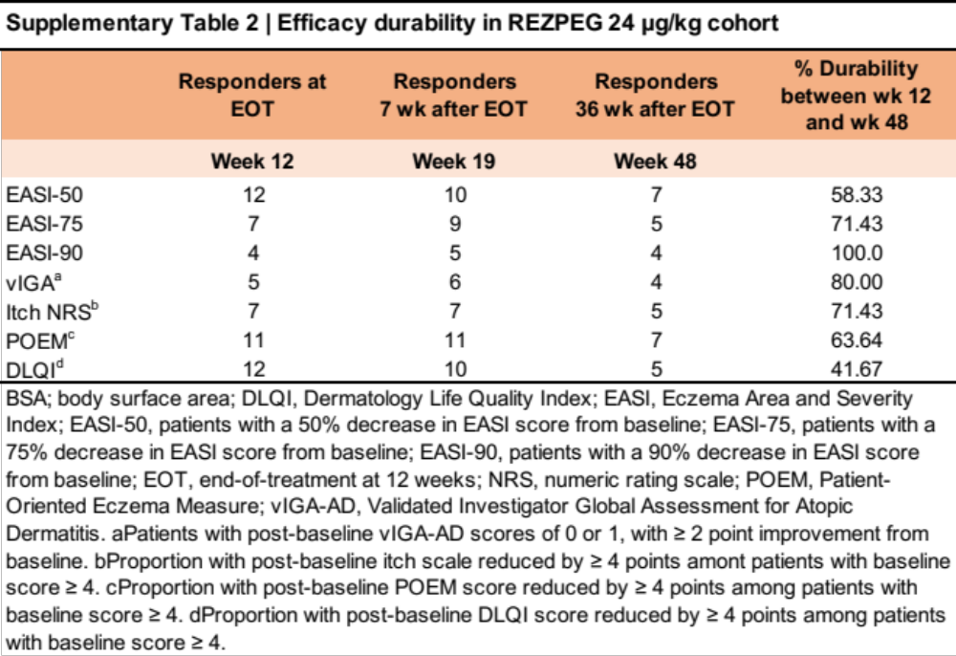

Supplementary Table 3 | Rescue medications for the indication of Atopic Dermatitis

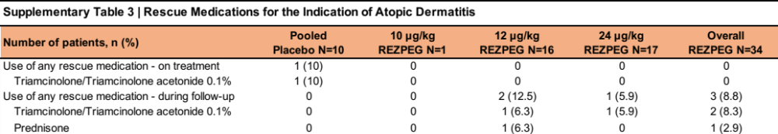

Supplementary Table 4 | Psoriasis patient numbers at continuous endpoints

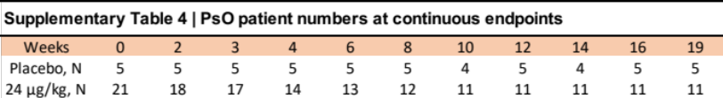

Supplementary Table 5 | Atopic dermatitis patient numbers at continuous endpoints

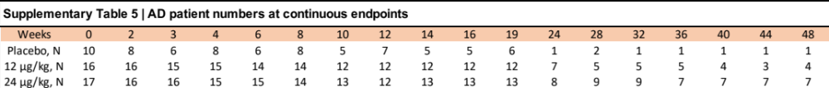

Supplementary Table 6 | Table of statistically significant and list of non-significant serum proteomic biomarkers

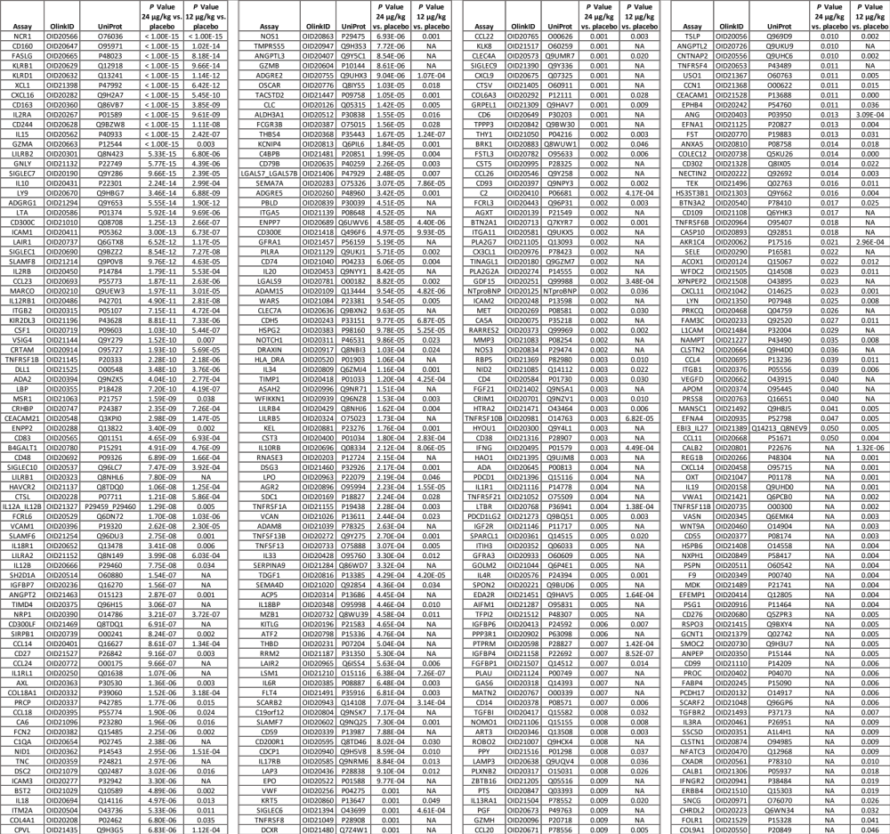

AARSD1, ABHD14B, ABL1, ACAA1, ACAN, ACE2, ACP6, ACTA2, ACTN4, ACVRL1, ACY1, ADAM22, ADAM23, ADAMTS13, ADAMTS15, ADAMTS16, ADAMTS8, ADCYAP1R1, ADGRB3, ADGRG2, ADH4, ADM, AFP, AGER, AGR3, AGRN, AGRP, AHCY, AHSP, AIF1, AK1, AKR1B1, AKT1S1, AKT3, ALCAM, ALDH1A1, ALPP, AMBN, AMBP, AMFR, AMIGO2, AMN, AMY2A, AMY2B, ANGPT1, ANGPTL1, ANGPTL4, ANGPTL7, ANKRD54, ANXA10, ANXA11, ANXA3, ANXA4, AOC1, AOC3, APBB1IP, APEX1, APLP1, APOH, APP, APRT, AREG, ARG1, ARHGAP1, ARHGEF12, ARID4B, ARNT, ARSA, ARSB, ARTN, ASGR1, ATG4A, ATOX1, ATP5IF1, ATP5PO, ATP6AP2, ATP6V1D, ATP6V1F, ATXN10, AXIN1, AZU1, B4GAT1, BACH1, BAG3, BAG6, BAIAP2, BAMBI, BANK1, BAX, BCAM, BCAN, BCL2L11, BCR, BGN, BID, BIN2, BIRC2, BLMH, BLVRB, BMP4, BMP6, BOC, BPIFB1, BSG, BST1, BTC, C1QTNF1, C2CD2L, CA1, CA11, CA12, CA13, CA14, CA2, CA3, CA4, CA9, CALCA, CALCOCO1, CAMKK1, CANT1, CAPG, CARHSP1, CASP1, CASP2, CASP3, CASP8, CBLIF, CBLN4, CC2D1A, CCDC80, CCL13, CCL15, CCL16, CCL17, CCL19, CCL2, CCL21, CCL25, CCL27, CCL28, CCL3, CCL5, CCL7, CCL8, CCN2, CCN3, CCN4, CCN5, CCS, CCT5, CD164, CD177, CD1C, CD200, CD207, CD209, CD22, CD274, CD28, CD2AP, CD300LG, CD33, CD34, CD40, CD40LG, CD46, CD5, CD58, CD63, CD69, CD70, CD84, CD8A, CD99L2, CDC27, CDC37, CDH1, CDH15, CDH17, CDH2, CDH3, CDH6, CDHR1, CDHR2, CDHR5, CDKN1A, CDKN2D, CDNF, CDON, CDSN, CEACAM3, CEACAM5, CEACAM8, CEBPB, CELA3A, CEP164, CEP20, CEP43, CEP85, CERT, CES1, CES2, CES3, CETN2, CFC1, CGA, CGREF1, CHAC2, CHEK2, CHGB, CHI3L1, CHIT1, CHL1, CHMP1A, CHRDL1, CIAPIN1, CKAP4, CKMT1A_CKMT1B, CLEC10A, CLEC11A, CLEC14A, CLEC1A, CLEC1B, CLEC4C, CLEC4D, CLEC4G, CLEC5A, CLEC6A, CLIP2, CLMP, CLPP, CLPS, CLSPN, CLTA, CLUL1, CNDP1, CNPY2, CNPY4, CNST, CNTN1, CNTN2, CNTN3, CNTN4, CNTN5, COL1A1, COMP, COMT, COPE, CORO1A, COX5B, CPA1, CPA2, CPB1, CPE, CPM, CPPED1, CPXM1, CR2, CRACR2A, CRADD, CREG1, CRELD2, CRH, CRHR1, CRIP2, CRISP2, CRKL, CRLF1, CRNN, CRTAC1, CRX, CSF2RA, CSF3, CST6, CST7, CSTB, CTF1, CTRB1, CTRC, CTSB, CTSC, CTSD, CTSF, CTSH, CTSO, CTSS, CTSZ, CXCL1, CXCL10, CXCL12, CXCL13, CXCL17, CXCL3, CXCL5, CXCL6, CXCL8, DAB2, DAG1, DAPP1, DARS1, DBI, DBNL, DCBLD2, DCN, DCTN1, DCTN2, DCTN6, DCTPP1, DDAH1, DDC, DDR1, DDX58, DECR1, DEFA1_DEFA1B, DEFB4A_DEFB4B, DFFA, DGKZ, DIABLO, DKK1, DKK3, DKK4, DKKL1, DLK1, DNAJA2, DNAJB1, DNAJB8, DNER, DNMBP, DNPH1, DOK2, DPEP1, DPEP2, DPP10, DPP4, DPP6, DPP7, DPT, DPY30, DRG2, DSG2, DSG4, DTX3, DUOX2, DUSP3, EBAG9, ECE1, EDAR, EDIL3, EGF, EGFL7, EGFR, EGLN1, EIF4B, EIF4EBP1, EIF4G1, EIF5A, ELOA, ENAH, ENG, ENO1, ENO2, ENPP5, ENTPD2, ENTPD5, ENTPD6, EPCAM, EPHA1, EPHA10, EPHA2, EPHB6, EPHX2, EPS8L2, ERBB2, ERBB3, ERBIN, EREG, ERP44, ESAM, ESM1, EZR, F11R, F2R, F3, F7, FABP1, FABP2, FABP5, FABP6, FABP9, FADD, FAM3B, FAP, FAS, FBP1, FCAR, FCER2, FCGR2A, FCGR2B, FCRL1, FCRL2, FCRL5, FCRLB, FEN1, FES, FETUB, FGF19, FGF2, FGF23, FGF5, FGFR2, FGR, FHIT, FIS1, FKBP1B, FKBP4, FKBP5, FKBP7, FLI1, FLRT2, FLT1, FLT3, FLT3LG, FMNL1, FMR1, FOLR2, FOLR3, FOSB, FOXO1, FOXO3, FRZB, FUCA1, FURIN, FUS, FUT3_FUT5, FUT8, FXN, FXYD5, FYB1, GAL, GALNT10, GALNT2, GALNT3, GALNT7, GBP2, GBP4, GCG, GDF2, GDNF, GFAP, GFER, GFOD2, GFRA2, GGA1, GGH, GGT1, GGT5, GH1, GH2, GHRHR, GHRL, GKN1, GLB1, GLO1, GLOD4, GLRX, GLT8D2, GMPR, GNE, GOPC, GP1BA, GP2, GP6, GPA33, GPC1, GPC5, GPKOW, GPNMB, GPR37, GRAP2, GRK5, GRN, GSAP, GSTA1, GSTA3, GSTP1, GUCA2A, GUSB, GYS1, HAGH, HARS1, HAVCR1, HBEGF, HBQ1, HCLS1, HDGF, HEBP1, HEXIM1, HGF, HGS, HK2, HLA_E, HMBS, HMOX1, HMOX2, HNMT, HNRNPK, HPCAL1, HPGDS, HS6ST1, HSD11B1, HSP90B1, HSPA1A, HSPB1, HYAL1, ICA1, ICAM4, ICAM5, ICOSLG, IDI2, IDS, IDUA, IFNGR1, IFNL1, IFNLR1, IGF1R, IGFBP1, IGFBP2, IGFBP3, IGFBPL1, IGSF3, IGSF8, IKBKG, IKZF2, IL10RA, IL11, IL13, IL15RA, IL16, IL17A, IL17C, IL17D, IL17F, IL17RA, IL18RAP, IL1A, IL1B, IL1R2, IL1RAP, IL1RL2, IL1RN, IL20RA, IL22RA1, IL24, IL32, IL4, IL5, IL5RA, IL6, IL6ST, IL7, IL7R, ILKAP, IMPA1, ING1, INHBC, INPP1, INPPL1, IPCEF1, IQGAP2, IRAG2, IRAK1, IRAK4, ISLR2, ISM1, ITGA6, ITGAM, ITGAV, ITGB1BP1, ITGB1BP2, ITGB5, ITGB6, ITGB7, IVD, JAM2, JCHAIN, JUN, KAZALD1, KDR, KIFBP, KIR3DL1, KIRREL2, KIT, KLB, KLK1, KLK10, KLK11, KLK12, KLK13, KLK14, KLK4, KLK6, KRT14, KRT18, KRT19, KYAT1, KYNU, LACTB2, LAG3, LAMA4, LAMP2, LAT, LAT2, LAYN, LBR, LCN2, LDLR, LEFTY2, LEP, LEPR, LGALS1, LGALS3, LGALS4, LGALS8, LGMN, LHB, LHPP, LIF, LIFR, LILRA5, LPCAT2, LPL, LRIG1, LRP1, LRP11, LRPAP1, LRRC25, LRRN1, LSP1, LTA4H, LTBP2, LTBP3, LTO1, LXN, LY6D, LY75, LY96, LYAR, LYPD1, LYPD3, LYPD8, MAD1L1, MAEA, MAGED1, MANF, MAP2K6, MAP3K5, MAP4K5, MAPK9, MAPT, MASP1, MATN3, MAVS, MAX, MB, MCAM, MCFD2, MDGA1, MED18, MEGF10, MEGF9, MEP1B, MEPE, MERTK, MESD, METAP1, METAP1D, METAP2, MFAP3, MFAP5, MFGE8, MGLL, MGMT, MIA, MICB_MICA, MIF, MILR1, MITD1, MLN, MME, MMP1, MMP10, MMP12, MMP13, MMP7, MMP8, MMP9, MNDA, MOG, MPHOSPH8, MPI, MPIG6B, MPO, MRPL46, MSLN, MSMB, MSRA, MSTN, MTPN, MUC13, MUC16, MVK, MYO9B, MYOC, MZT1, NAAA, NADK, NBL1, NBN, NCAM1, NCAM2, NCAN, NCF2, NCK2, NCLN, NCS1, NDRG1, NDUFS6, NECTIN4, NEFL, NELL1, NELL2, NFASC, NFATC1, NFKBIE, NGF, NINJ1, NME3, NMNAT1, NOTCH3, NPDC1, NPM1, NPPB, NPPC, NPTN, NPTX1, NPTXR, NPY, NRCAM, NRP2, NRTN, NSFL1C, NT5C3A, NT5E, NTF3, NTF4, NTRK2, NTRK3, NUB1, NUCB2, NUDC, NUDT2, NUDT5, OBP2B, ODAM, OGFR, OGN, OLR1, OMD, OMG, OPTC, OSM, OSMR, P4HB, PADI2, PADI4, PAEP, PAG1, PAK4, PAM, PAMR1, PAPPA, PARK7, PARP1, PCDH1, PCOLCE, PCSK9, PDCD5, PDCD6, PDGFA, PDGFB, PDGFC, PDGFRA, PDGFRB, PDLIM7, PDP1, PEAR1, PEBP1, PECAM1, PFDN2, PFKFB2, PGLYRP1, PHOSPHO1, PI3, PIGR, PIK3AP1, PIK3IP1, PILRB, PKLR, PLA2G10, PLA2G15, PLA2G1B, PLA2G4A, PLAT, PLAUR, PLIN1, PLIN3, PLPBP, PLTP, PLXDC1, PLXNA4, PLXNB3, PM20D1, PMVK, PNLIPRP2, PNPT1, PODXL, PODXL2, POLR2F, PON2, PON3, PPCDC, PPIB, PPM1A, PPME1, PPP1R12A, PPP1R2, PPP1R9B, PQBP1, PRDX1, PRDX3, PRDX5, PRDX6, PREB, PRELP, PRKAB1, PRKAR1A, PRKRA, PRL, PROK1, PRSS2, PRSS27, PRTFDC1, PRTG, PRTN3, PSIP1, PSMA1, PSMD9, PSME1, PSME2, PSMG3, PSRC1, PTEN, PTGDS, PTH1R, PTK7, PTN, PTPN1, PTPN6, PTPRF, PTPRN2, PTPRS, PTX3, PVALB, PVR, PXN, QDPR, QPCT, RAB37, RAB6A, RAB6B, RABEPK, RABGAP1L, RAD23B, RANGAP1, RARRES1, RASA1, RASSF2, RBKS, RBP2, RCOR1, REG1A, REG3A, REG4, RELT, REN, RET, RETN, RGMA, RGMB, RGS8, RHOC, RILP, RNASET2, RNF41, ROBO1, ROR1, RP2, RRM2B, RSPO1, RTBDN, RTN4R, RUVBL1, RWDD1, S100A11, S100A12, S100A16, S100A4, S100P, SAMD9L, SCAMP3, SCARA5, SCARB1, SCARF1, SCG2, SCG3, SCGB1A1, SCGB3A2, SCGN, SCLY, SCP2, SCRN1, SDC4, SELP, SELPLG, SEMA3F, SEMA4C, SEPTIN9, SERPINA11, SERPINA12, SERPINB1, SERPINB5, SERPINB6, SERPINB8, SERPINB9, SERPINE1, SESTD1, SETMAR, SEZ6L, SEZ6L2, SF3B4, SFRP1, SFTPA1, SFTPA2, SFTPD, SH2B3, SHMT1, SIAE, SIGLEC15, SIGLEC5, SIRPA, SIRT2, SIRT5, SIT1, SKAP1, SKAP2, SLAMF1, SLC16A1, SLC27A4, SLC39A14, SLC39A5, SLIT2, SLITRK2, SLITRK6, SMAD5, SMARCA2, SMOC1, SMPD1, SMPDL3A, SNAP23, SNAP29, SNX9, SOD1, SOD2, SORCS2, SORD, SORT1, SOST, SPARC, SPINK1, SPINK4, SPINK5, SPINK6, SPINT1, SPINT2, SPOCK1, SPON1, SPP1, SPRY2, SRC, SRP14, SRPK2, SSB, SSC4D, ST3GAL1, ST6GAL1, STAMBP, STAT5B, STC1, STC2, STIP1, STK11, STK24, STK4, STX16, STX4, STX6, STX8, STXBP3, SUGT1, SULT1A1, SULT2A1, SUMF2, SUSD1, SUSD2, TACC3, TAFA5, TANK, TARBP2, TBC1D17, TBC1D23, TBC1D5, TBCB, TBCC, TBL1X, TCL1A, TCL1B, TCN2, TDRKH, TFF1, TFF2, TFF3, TFPI, TFRC, TGFA, TGFB1, TGFBR3, TGM2, THBS2, THOP1, THPO, TIA1, TIE1, TIGAR, TIMP3, TIMP4, TJAP1, TLR3, TMPRSS15, TMSB10, TNF, TNFAIP8, TNFRSF10A, TNFRSF10C, TNFRSF11A, TNFRSF12A, TNFRSF13B, TNFRSF13C, TNFRSF14, TNFRSF19, TNFRSF9, TNFSF10, TNFSF11, TNFSF12, TNFSF14, TNNI3, TNR, TNXB, TP53, TP53INP1, TPMT, TPP1, TPSAB1, TPT1, TRAF2, TREM2, TREML2, TRIAP1, TRIM21, TRIM5, TSHB, TSPAN1, TST, TXLNA, TXNDC15, TXNDC5, TXNRD1, TYMP, TYRO3, UBAC1, ULBP2, UMOD, USP8, UXS1, VAMP5, VASH1, VAT1, VEGFA, VEGFC, VIM, VMO1, VNN2, VPS37A, VPS53, VSIR, VSTM1, VSTM2L, VTA1, VTCN1, VWC2, WAS, WASF1, WASF3, WFDC12, WFIKKN2, WIF1, WWP2, XG, XRCC4, YES1, YTHDF3, ZBTB17

Supplementary Table 7 | Table of statistically significant REZPEG-modulated proteins grouped by pathway
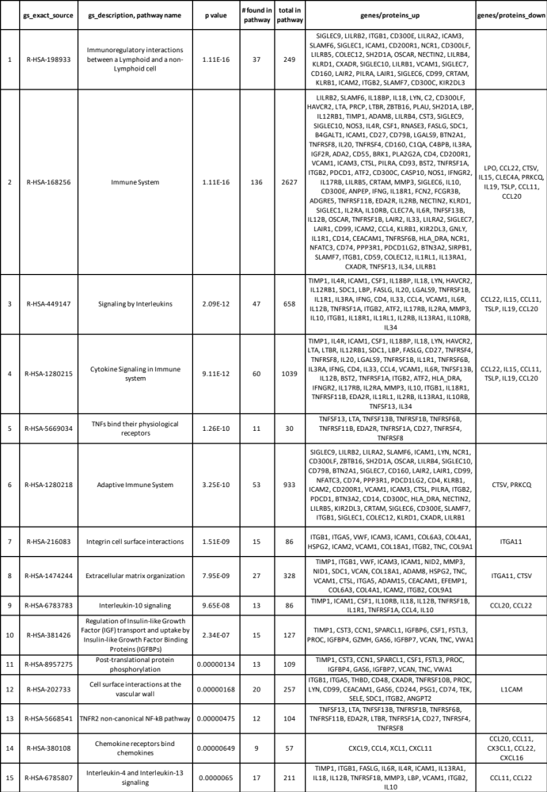

List of Investigators – Psoriasis

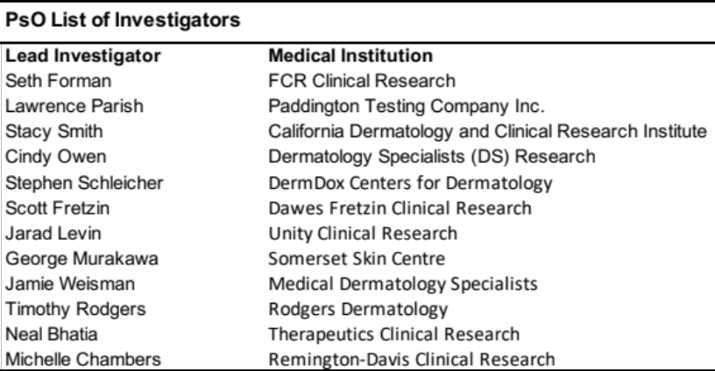

List of Investigators – Atopic Dermatitis

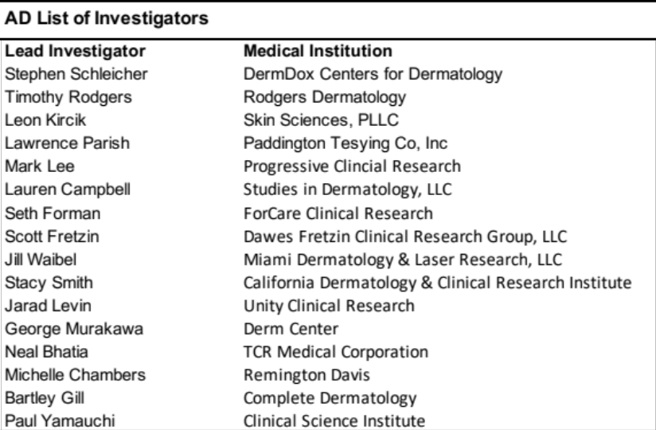

Supplementary Methods

AD full inclusion and exclusion criteria

Patients were enrolled if all the following inclusion criteria applied:
- Present with a diagnosis of AtD at least 12 months prior to screening, as defined by the American Academy of Dermatology: Guidelines of care for the management of atopic dermatitis; Section1. Diagnosis and assessment of moderate to severe atopic dermatitis¹, including all of the following:
  - EASI score ≥ 16 at baseline (day 1)
  - Investigator Global Assessment (IGA) score of ≥ 3 at baseline (day 1)
  - ≥ 10% of body surface area (BSA) involvement at baseline (day 1)
- History, documented by a physician and/or investigator, of inadequate response to existing topical medications within 6 months preceding screening, or history of intolerance to topical therapy as defined by at least 1 of the following:
  - Inability to achieve good disease control defined as mild disease or better (e.g., IGA ≤ 2) after use of at least a medium potency topical corticosteroid (TCS) for at least 4 weeks, or for the maximum duration recommended by the product prescribing information (e.g., 14 days for super potent TCS), whichever is shorter. Note: a TCS may be used with or without topical calcineurin inhibitors (TCNIs).
  - Or documented history of clinically significant adverse reactions with the use of TCS, such as skin atrophy, allergic reactions, or systemic effects that, in the opinion of the investigator, outweigh the benefits of retreatment, and/or
  - Failed systemic therapies intended to treat AD, such as cyclosporine, methotrexate, azathioprine, and mycophenolate mofetil, within 6 months preceding screening (will be considered as having inadequate response to topical therapy).
- Agree to discontinue use of the following excluded medications for at least 2 weeks prior to baseline (day 1) and throughout the study:
  - Topical corticosteroids or topical immune modulators (e.g., tacrolimus or pimecrolimus)
  - And topical phosphodiesterase type 4 (PDE4) inhibitor (crisaborole).
- Have applied emollients daily for at least 14 days prior to baseline (day 1) and agree to use emollient daily throughout the treatment period.
- Males and females aged 18 through 70 years at the time of screening, who agree to adhere to the contraception requirements (combination of 1 highly effective [< 1% failure rate] with 1 effective method, or 2 effective methods of contraception)
- Females of child-bearing potential must test negative for pregnancy prior to initiation of treatment and within 24 hours prior to each exposure to the study drug and agree to the contraception requirements for the entire study and for 30 days following the last dose.
- Body mass index (BMI) of 18.0 to 45.0 kg/m², inclusive
- Clinical laboratory test results within normal reference range for the population or study site, or results with acceptable deviations that are judged to be not clinically significant by the investigator.
- Venous access sufficient to allow for blood sampling.
- Reliable and willing to make themselves available for the duration of the study and are willing to follow study procedures.
- Willing and able to undergo skin lesion biopsies on study days 1, 22, and 85.
- Willing and able to give signed informed consent.
- Willing and able to participate in the study for a duration of up to 6 months.

Patients were not eligible if any of the following exclusion criteria applied:
- Study site personnel directly affiliated with this study and their immediate families (spouse, biological or legal guardian, child, or sibling).
- Employees of one of the study sponsors or of a third-party organization involved with the study.
- Currently enrolled in a clinical study involving an investigational production (IP) or any other type of medical research judged not to be scientifically or medically compatible with this study.
- Previously completed or withdrawn from this study or any other study investigating REZPEG and have previously received the IP.
- Known allergies to REZPEG, related compounds, or any components of the formulation.
- Clinically significant ECG abnormalities including QT interval corrected using Fridericia’s formula > 450 msec for males and > 470 msec for females.
- History of additional risk factors for Torsades de Pointes (e.g., heart failure, hypokalemia, family history of long QT syndrome).
- Use of concomitant medications (excluding medications which could be used to treat depression) that prolong the QT/QTc interval.
- Clinically relevant abnormally blood pressure and/or heart rate as determined by the investigator.
- Evidence of significant liver or kidney dysfunction, including any of the following at screening:
  - Estimated glomerular filtration rate of ≤ 60 mL/min, using the Modification of Diet in Renal Disease equation.
  - Aspartate aminotransferase (AST), alanine aminotransferase (ALT), or alkaline phosphatase (ALP) > 1.5X upper limit of normal (ULN); or
  - Total bilirubin level (TBL) > 1.5X ULN
- History of any significant cardiovascular disease (e.g., myocardial infarction, congestive heart failure, uncontrolled hypertension, cerebrovascular accident), thrombotic episode, or any severe medical illness, in the opinion of the investigator, within the previous 1 year.
- Evidence of significant hematologic dysfunction, including any of the following at screening:
  - Hemoglobin < 10.0 g/dL
  - Absolute neutrophil count < 1.8 x 10⁹/L
  - Total white blood cell (WBC) < 3.6 x 10⁹/L
  - Absolute lymphocyte count ≤ 0.8 x 10⁹/L
  - Platelet count < 100 x 10⁹/L or
  - Eosinophil count > 3000 μL
- Currently experiencing or have a history of other concomitant skin conditions (e.g., psoriasis or cutaneous lupus) that would interfere with evaluations of the effect of study drug on AtD.
- Patients who are currently experiencing or have a history of erythrodermic, refractory, or unstable skin disease that requires frequent hospitalizations and/or IV treatment for skin infections that may interfere with participation in the study.
- History of eczema herpeticum within 12 months prior to screening.
- History of 2 or more episodes of eczema herpeticum.
- Patients who are currently experiencing a skin infection that requires treatment, or is currently being treated, with topical or systemic antibiotics.
- Any serious concomitant illness that is anticipated to require the use of systemic corticosteroids or otherwise interfere with study participation or require active frequent monitoring, such as unstable chronic asthma.
- History of any disease apart from AtD that has required treatment with oral or parenteral corticosteroids for more than 2 weeks within the past 24 weeks prior to signing the informed consent form (ICF).
- History of primary immunodeficiency, splenectomy, or any underlying condition that predisposes the subject to infection.
- History of major surgery within 12 weeks of screening or will require major surgery during the study.
- Considered to be at significant risk for suicide.
- Regularly use known drugs of abuse and/or show positive findings from drug screening.
- History of alcohol or other drug abuse within the last year.
- Evidence of HIV infection and/or positive human HIV antibodies.
- Evidence of hepatitis B and/or hepatitis B surface antigen and/or are positive for hepatitis B core antibody at screening.
- Evidence of hepatitis C and/or positive hepatitis C antibody at screening.
- Women who are breastfeeding.
- Donated blood of more than 500 mL within the previous 4 weeks of study screening.
- Received blood products within 6 months prior to screening.
- Symptomatic herpes zoster within 3 months of screening.
- Show evidence of active or latent TB.
- Received live vaccines (including live attenuated vaccines) within 4 weeks of screening or intend to receive during the study and for 5 drug half-lives after the last dose of the study drug through week 19.
- Received BCG vaccine within 12 months of screening or intend to during the study and for 5 drug half-lives after the last dose of study drug.
- Received treatment with biologic agents (such as monoclonal antibodies, including marketed drugs) within 3 months or 5 half-lives (whichever is longer) prior to dosing.
- Received any small molecule IP within 4 weeks or 5 half-lives before screening, whichever is greater.
- History of clinically significant drug hypersensitivity reactions that may predispose the patient to a clinically significant hypersensitivity reaction to REZPEG or its formula excipients.
- History of clinically significant intolerance to TCS.
- Received any parenteral corticosteroid administered through intra-articular injection or intramuscular or IV injection within 2 weeks prior to study entry or within 6 weeks prior to planned baseline (day 1) or are anticipated to require parenteral injection of corticosteroids during the study.
- Received aldesleukin or any investigational IL-2 analog at any time.
- Received the following medications/treatments within 4 weeks prior to baseline (day 1) or plan to continue use throughout the study:
  - Oral systemic corticosteroids and leukotriene inhibitors
  - Systemic immunomodulators, including, but not limited to, cyclosporine, methotrexate, mycophenolate mofetil, azathioprine, and Janus kinase (JAK) inhibitors (tofacitinib, ruxolitinib)
  - Any other systemic therapy used to treat AtD or symptoms of AtD (approved or off-label use), or
  - Phototherapy, including therapeutic phototherapy (psoralen plus ultraviolet A, ultraviolet B), excimer laser, or tanning beds.
- History of organ or bone marrow transplant.
- Lymphoma, leukemia, or any malignancy within the past 5 years, with the exception of basal cell or squamous epithelial carcinomas of the skin that have been resected with no evidence of metastatic disease for 3 years, or cervical carcinoma in situ, with no evidence of recurrence within the 5 years prior to baseline.
- Breast cancer within the past 10 years.
- Have a current or recent acute active infection. For at least 30 days prior to screening, patients must have no significant symptoms including fever of 100.5F (38C) or above, at screening or baseline, and/or signs of confirmed or suspected infection, and must have completed any appropriate anti-infective treatment.
- Have had, within 6 months of screening, any of the following types of infection: serious infections, opportunistic infections, chronic infections, recurring infection.

References

1. Eichenfield, L.F., et al. Guidelines of care for the management of atopic dermatitis: section 1. Diagnosis and assessment of atopic dermatitis. J Am Acad Dermatol 70, 338-351 (2014).

