Supplemental figures 1-4, exploratory correlation analysis matrices
Article: “Glycemic control in women with GDM: Insights from a randomized controlled pilot trial on plant-based Nordic Healthy diet versus moderately carbohydrate restricted diet”

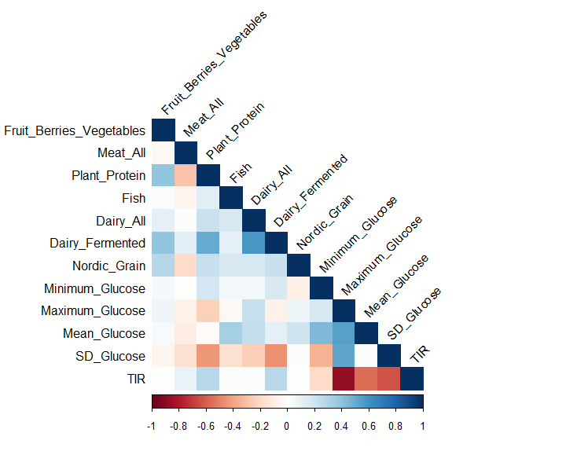
Supplemental figure 1. Correlation matrix of food group intake in relation to CGM variables. Pooled data from both groups. Stronger color saturation indicates a stronger correlation. CGM: continuous glucose monitoring. TIR: time in range. SD: standard deviation

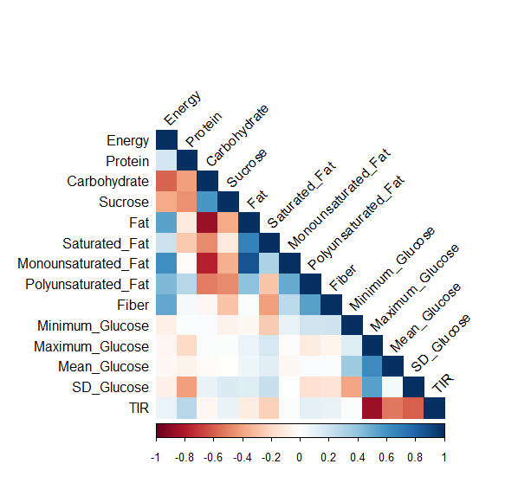
Supplemental figure 2. Correlation matrix of macronutrient intake in relation to CGM variables. Pooled data from both groups. Stronger color saturation indicates a stronger correlation. CGM: continuous glucose monitoring. TIR: time in range. SD: standard deviation

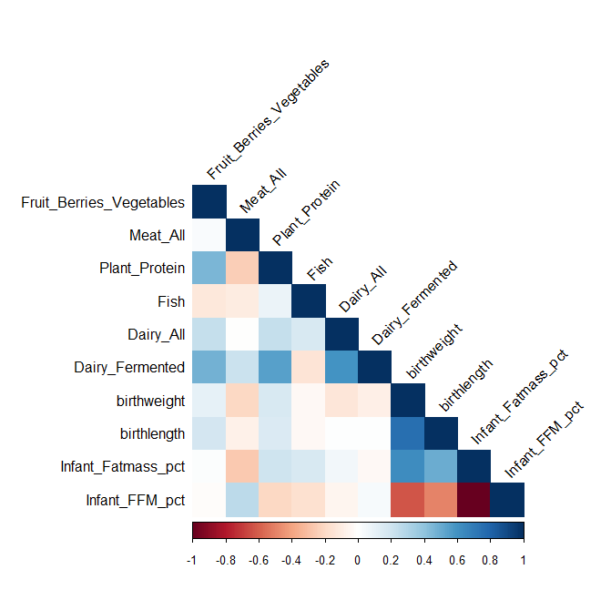
Supplemental figure 3. Correlation matrix of food group intake in relation to newborn body composition variables. Pooled data from both groups. Stronger color saturation indicates a stronger correlation. CGM: continuous glucose monitoring. FFM: fat-free mass. Pct: percentage

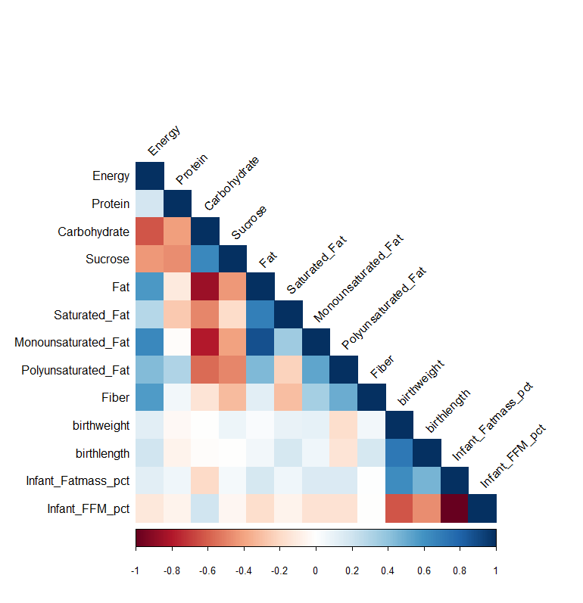
Supplemental figure 4. Correlation matrix of macronutrient intake in relation to newborn body composition variables. Pooled data from both groups. Stronger color saturation indicates a stronger correlation. CGM: continuous glucose monitoring. FFM: fat-free mass. Pct: percentage

