Supplementary Figures:

Supplementary Figure 1. Examples of seafloor categories with indications of potential microbial activity on the Gakkel Ridge. All images collected with the OFOS and OFOBS systems during the PS86 and PS101 expeditions are available on the PANGAEA archive. Where these images show indications of potential microbial life these have been categorized as (a) small vents, (b) sulfur mats, (c) diffuse fuid flow (shimmering water) (d) pockmarks / crevices, (e) blackened sediment, (f) stained cliff. White boxes represent 50 cm.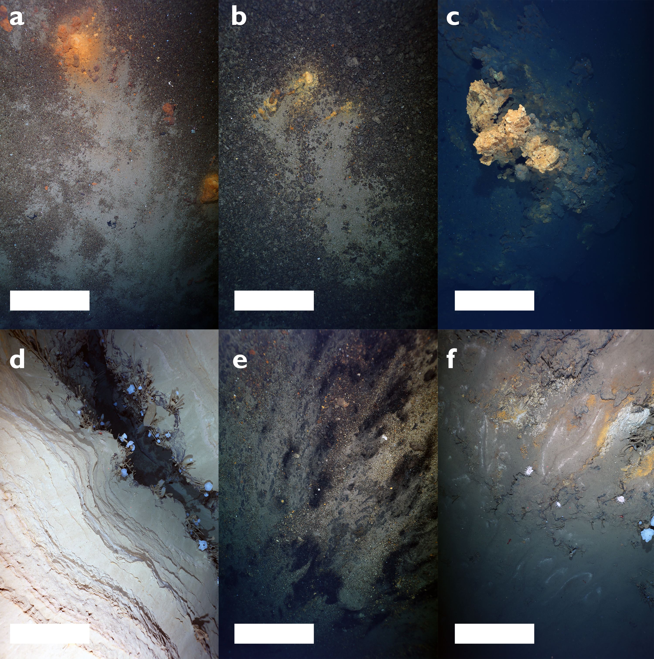

Supplementary Fig. 2: Scatter plot of methane and hydrogen vs. δ³He isotope values in the hydrothermal plume of the Polaris vent field
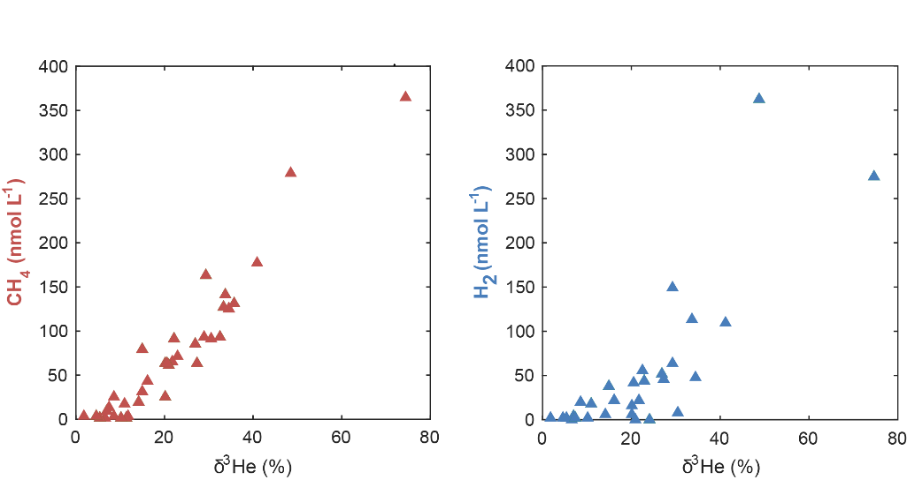

Supplementary Fig. 3: Relative abundance 16S rRNA transcripts in the different water masses of Polaris and Aurora. In brackets: numbers of analyzed samples and sum of all listed taxa.
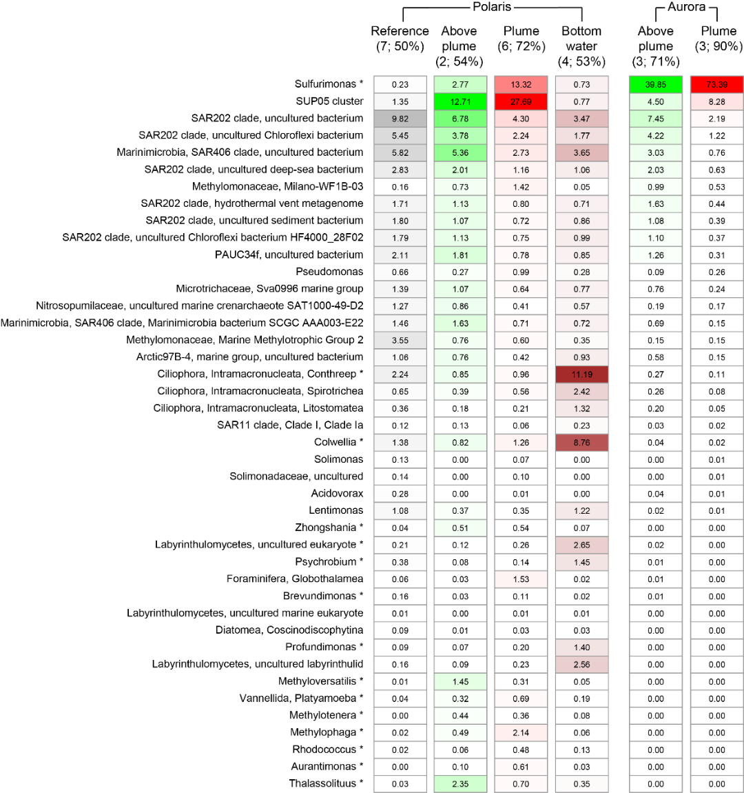

Supplementary Fig. 4. Comparison of similarity of microbial communities within and between in-plume and out-plume samples. a, nMDS based on Bray-Curtis similarity calculated on 16S rRNA gene (V3−V4 region) counts (Hellinger transformed). b, nMDS based on Jaccard similarity calculated on 16S rRNA gene (V3−V4 region) counts (PA transformed). c, nMDS based on Bray-Curtis similarity calculated on 16S and 18S rRNA reads (cDNA) counts (Hellinger transformed). d, nMDS based on Bray-Curtis similarity calculated on reconstructed genes transcripts counts (Hellinger transformed). Analysis of similarity (ANOSIM) is reported in Supplementary Table 4.
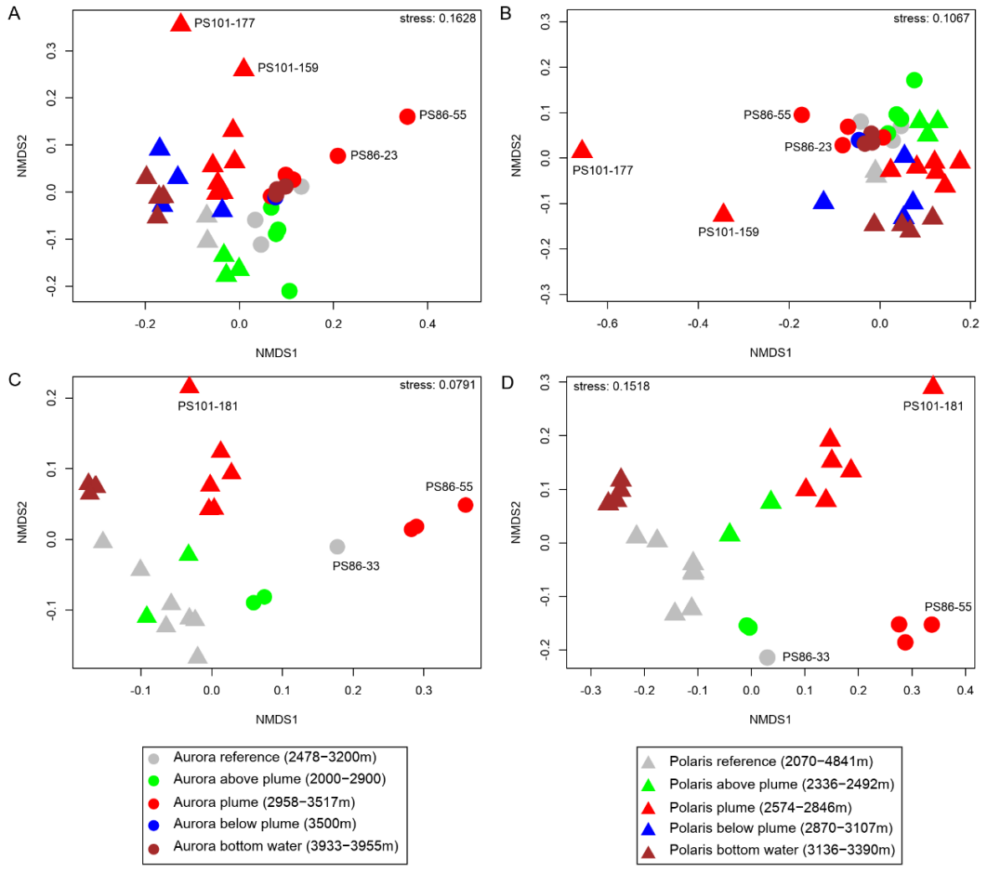

Supplementary Figure 5. Statistical analyses of bacterial diversity of different water type collected at Aurora and Polaris mounds. a, Species richness as number of OTUs vs water type, b, exponential Shannon index c, inverse Simpson index of samples from the different water types. REF: reference; AP: above plume; P: plume; BP: below plume; BW: bottom water.
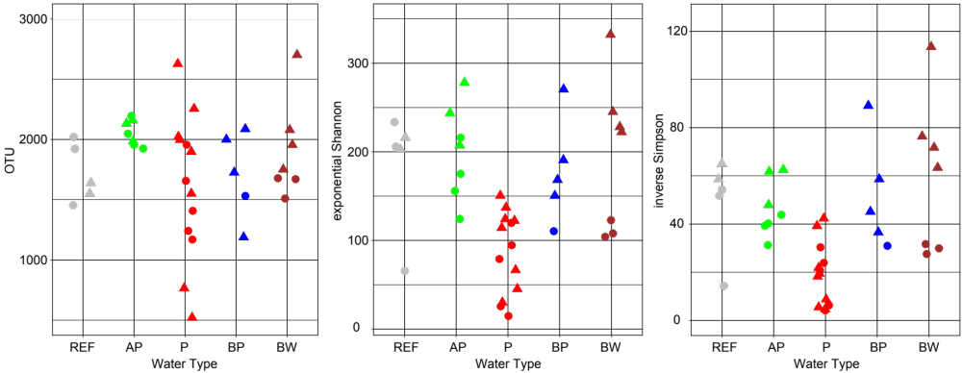

Supplementary Figure 6: Phylogenetic analysis of SUP05 bacteria from the two vent sites and other locations based on the 16SrRNA gene.
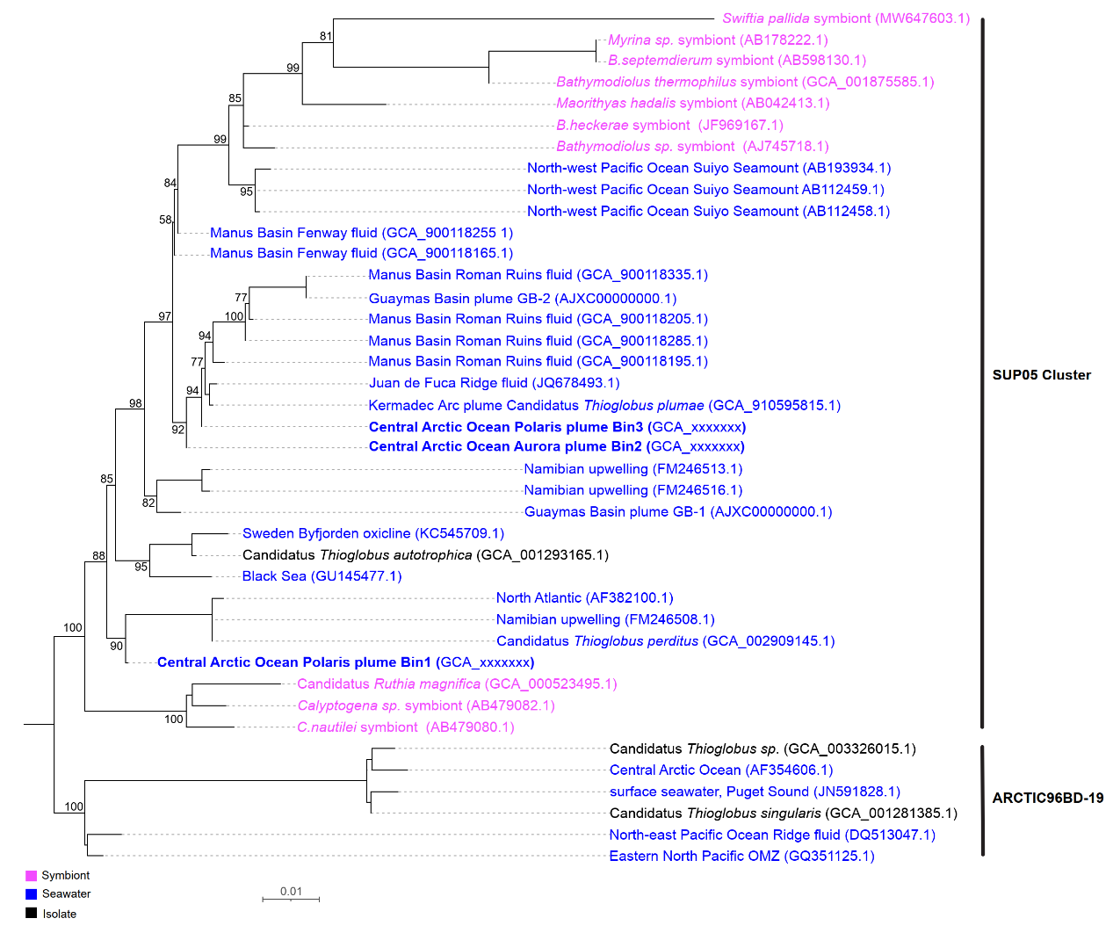

Supplementary Fig. 7. Phylogenetic analysis of the NiFe hydrogenase of Ca. S. pluma and SUP05 bacteria.

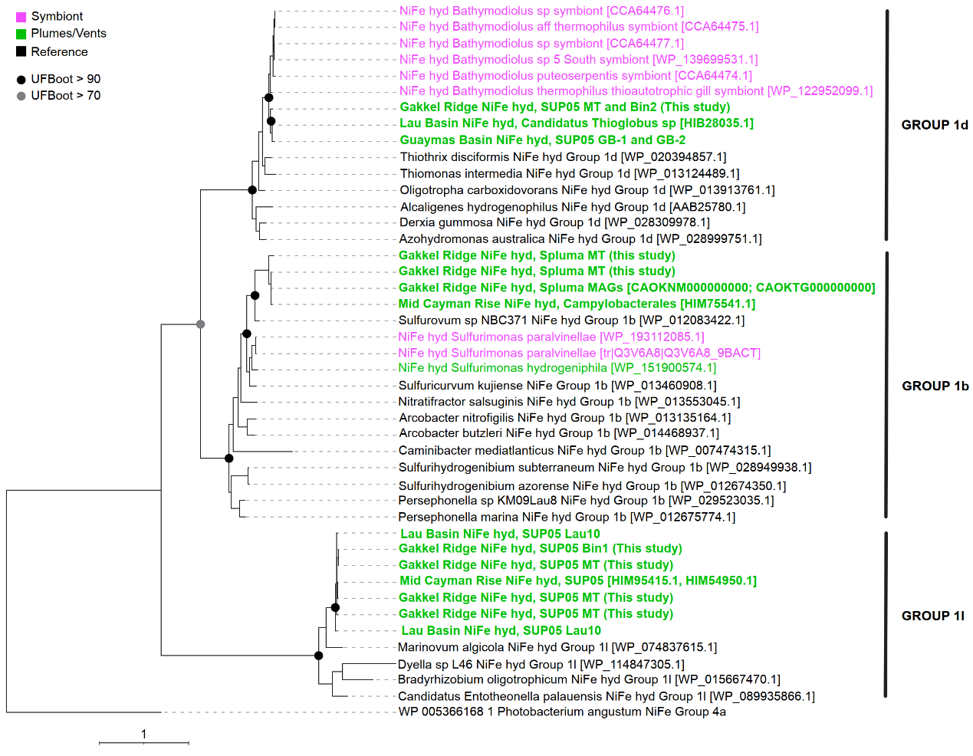

Supplementary discussion:
Supplementary discussion 1: Calculation of energy and mass fluxes from the Polaris and Aurora vent
Hot, buoyant fluid from hydrothermal vent ascents as a plume while entraining ambient fluid. In a stratified ocean, the plume rises until a height is reached where the diluted fluid has the same density as the surrounding water. The rise height z_{max} depends on the buoyancy flux F from the source and the stratification N². It can be expressed as
- z_{max} = 5.0 (F / π)^{1/4} N^{−3/4} (e.g. McDougal, 1990).
Using the vent source volume flux Q_{v}, the buoyancy flux F is defined as
- F = g Q_{v} [α (θ_{v} − θ_{b}) − β (S_{v} − S_{b})],
where g is the gravitational acceleration, α is the thermal expansion coefficient, and β the haline contraction coefficient. Assuming that the emanating fluid has the same salinity as the environment and neglecting the background temperature θ_{b} that is close to zero degrees Celsius, Eq. (2) can be used to estimate the vent’s output
(3) Q_{v} = F / (g α θ_{v}) = P / (c_{p} ρ₀ θ_{v})).
and
- P = c_{p} ρ₀ α⁻¹ g⁻¹ F = c_{p} ρ₀ α⁻¹ g⁻¹ π (z_{max} / 5)⁴ N³
using
c_{p} = 3890 J kg ⁻¹ K⁻¹
ρ₀ = 1000 kg m⁻³
α = 1.3 ×10⁻⁴ K⁻¹
g = 9.8 m s⁻²
gives
 | Polaris | Aurora
Rise height z_{max} (m) | 600 | 800
Stratification N² (s⁻²) | 1.63 ×10⁻⁷ | 0.25 ×10⁻⁷
Vent power P (MW) | 130 | 24
Vent temperature θ_{v} (°C) | 250 | 370
Volume flux Q_{v} (L s⁻¹) | 135 | 17
McDougall, T. J. (1990). Bulk properties of “hot smoker” plumes. Earth and Planetary Science Letters, 99(1-2), 185-194.

