Supplementary Materials
Lysosome Passivation Triggered by Ag Nanoparticles Enhances Subcellular-Targeted Drug Therapy
Xueqian Wang^{1,4}, Shulin Zhao^{1,4}, Guiqian Fang^{1,4}, Ran Wang^{2,4}, Xinxing Lyu⁴, Xintian Shao^{3,4}, Peixue Ling², CaiCai Meng^{∗3}, Yanling Mu^{∗1}, Qixin Chen^{1,4}, Jia Chen^{∗4}
- School of Pharmaceutical Sciences & Institute of Materia Medica, National Key Laboratory of Advanced Drug Delivery System, Medical Science and Technology Innovation Center, Key Laboratory for Biotechnology Drugs of National Health Commission, Shandong First Medical University & Shandong Academy of Medical Sciences, Jinan, Shandong 250117, PR China
- Shandong Academy of Pharmaceutical Science, Key Laboratory of Biopharmaceuticals, Engineering Laboratory of Polysaccharide Drugs, National-Local Joint Engineering Laboratory of Polysaccharide Drugs, Jinan 250101, PR China
- School of Life Sciences, Medical Science and Technology Innovation Center, Shandong First Medical University & Shandong Academy of Medical Sciences, Jinan, Shandong 250117, PR China
- Medical Science and Technology Innovation Center, Shandong First Medical University & Shandong Academy of Medical Sciences, Jinan, Shandong 250117, PR China

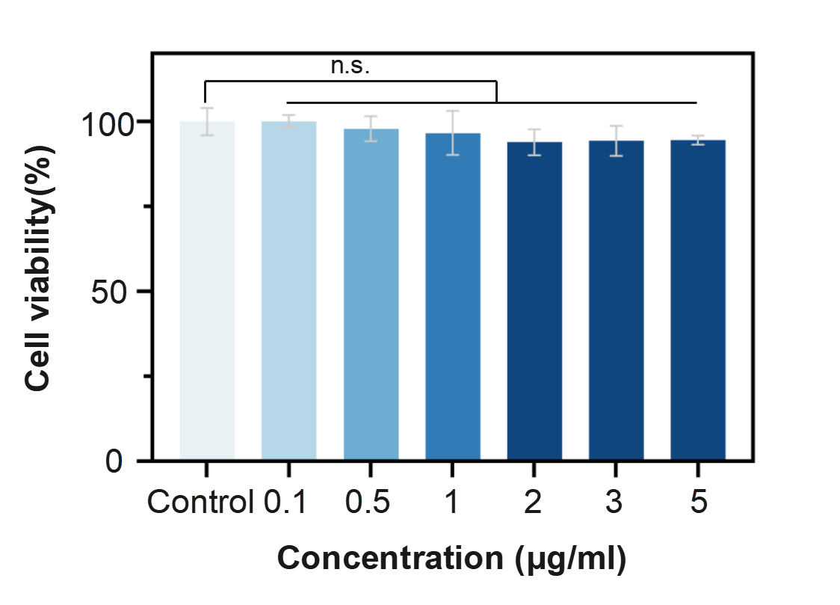
Supplementary Figure 1. HeLa cells viability treated with different concentration of Cy3.5@Ag NPs for 24 h via CCK-8 assay. Data are presented as mean ± standard error of mean (SEM) (n.s. for no significant difference).

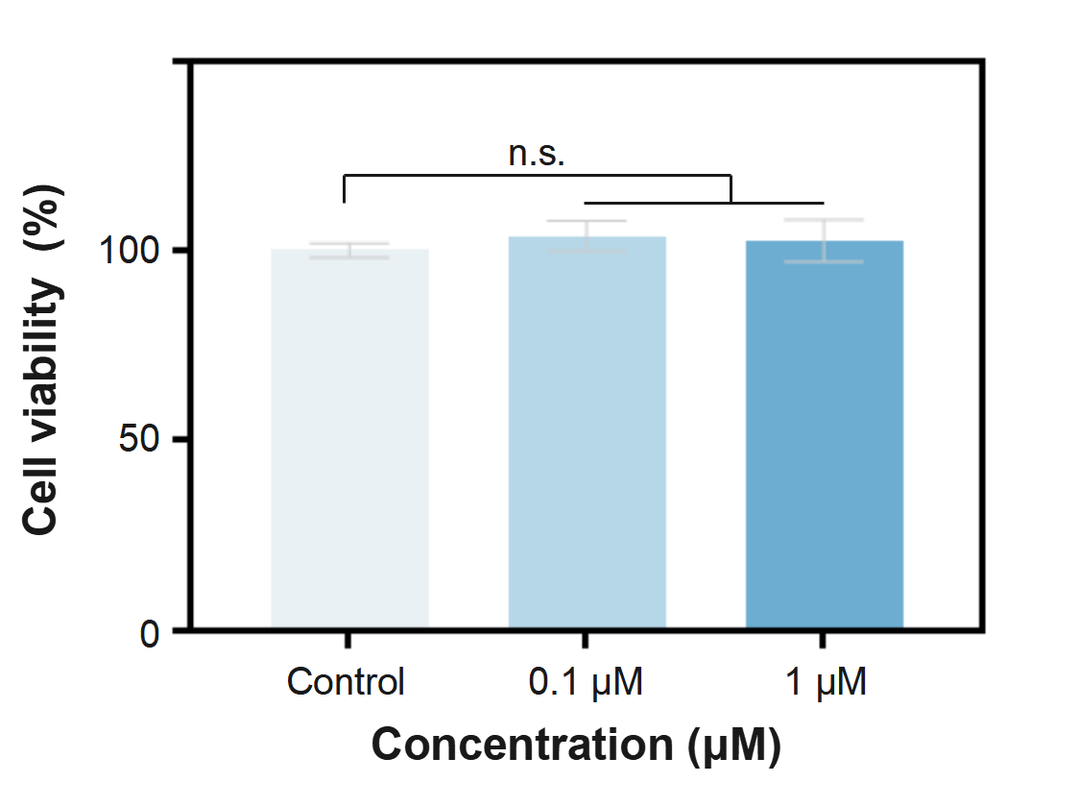
Supplementary Figure 2. Cell viability of Cy3.5 (0.1 μM, 1.0 μM) for 24 h via CCK-8 assay. Data are presented as mean ± SEM (n.s. for no significant difference)

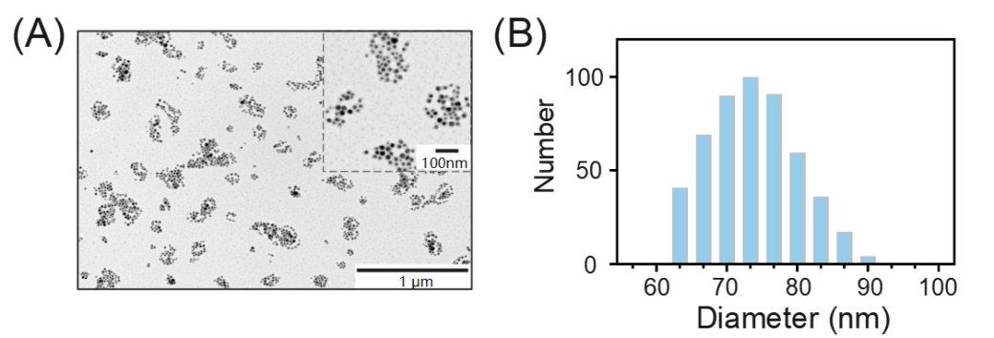
Supplementary Figure 3. Morphology characterization of Cy3.5@Ag NPs. (A) TEM images of the Cy3.5@Ag NPs. (B) DLS results of Cy3.5@Ag NPs from 3 independent experiments.

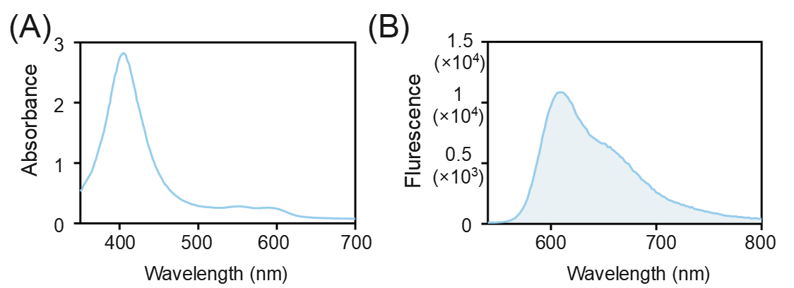
Supplementary Figure 4. Photophysical properties of Cy3.5@Ag NPs. (A) Absorption spectrum of Cy3.5@Ag NPs (1 mg/mL). (B) Fluorescence of Cy3.5@Ag NPs (1 mg/ml) solution, Ex=500 nm, Em=610nm.

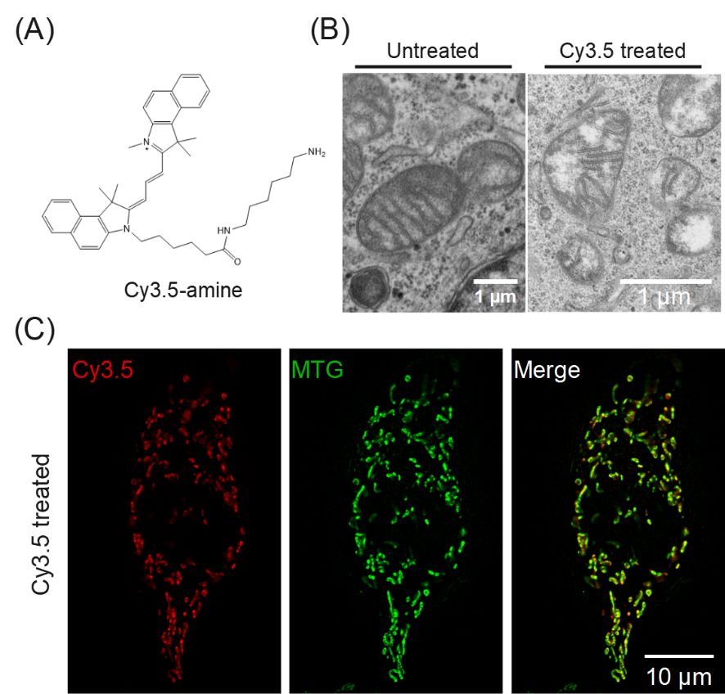
Supplementary Figure 5. The chemical structure and cell imaging of Cy3.5. (A) The chemical structure of Cy3.5. (B) TEM images of mitochondria with Cy 3.5 (0.1 μM, 6 h) treatment. (C) Colocalization images of HeLa cells stained by Cy 3.5 (0.1 μM) for 1 h and MTG (100 nM) for 30min.

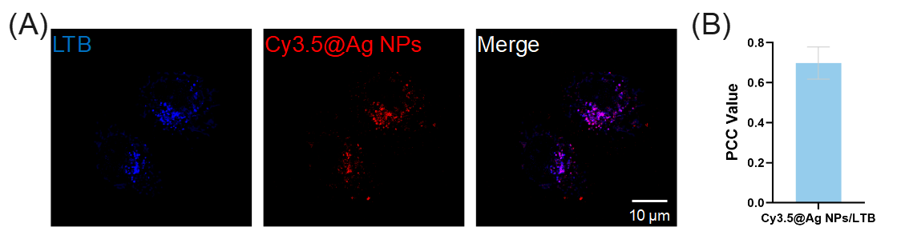
Supplementary Figure 6. Colocalization of Cy3.5@Ag NPs and LTB. (A) HeLa cells co-stained with Cy3.5@Ag NPs (0.5 μg/ml, 1 h) and Lyso-Tracker Blue (LTB, 100 nM, 30 min). (B) PCC values of Cy3.5@Ag NPs⁴⁸⁸⁻⁵⁹⁰/ LTB⁴⁰⁵⁻⁴⁸⁸.

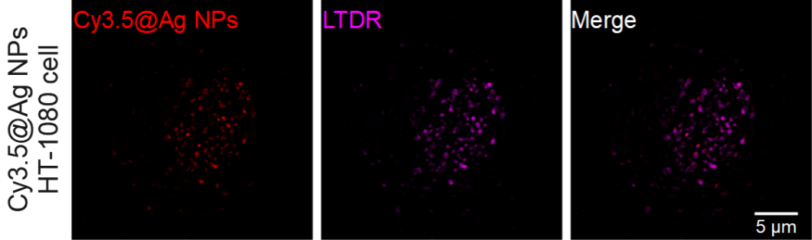
Supplementary Figure 7. Representative images of HT-1080 cells co-stained with Cy3.5@Ag NPs (0.5 μg/ml, 1 h) and LTDR (100 nM, 30min).

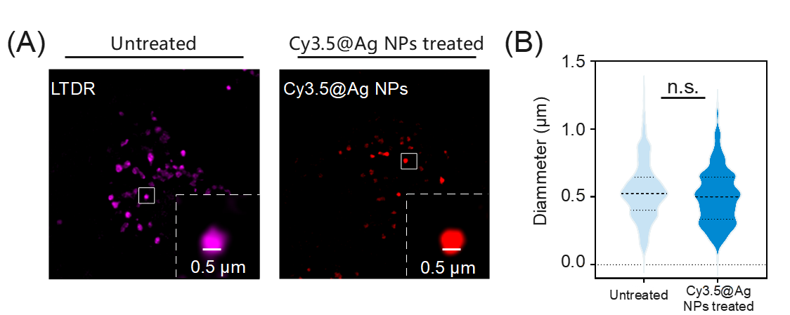
Supplementary Figure 8. (A) Fluorescence images of lysosome in HeLa cells incubated with LTDR (100 nM) and Cy3.5@Ag NPs (0.5 μg/mL). (B) The size distribution of lysosomes in HeLa cells with or without Cy3.5@Ag NPs treatment. Data are presented as mean ± SEM (n.s. for no significant difference).

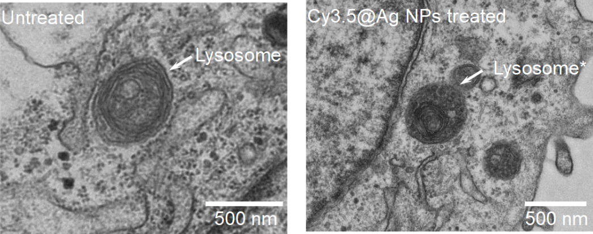
Supplementary Figure 9. Representative TEM images of lysosomes for HeLa cells with or without Cy3.5@Ag NPs (0.5 μg/ml, 1 h) treatment.

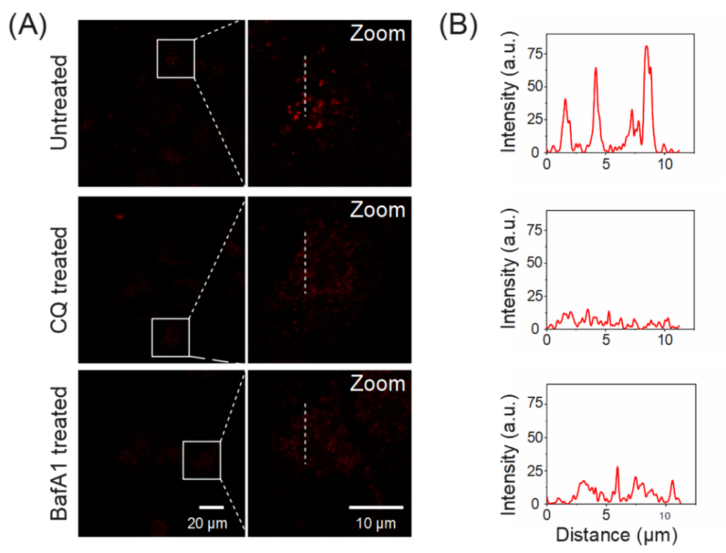
Supplementary Figure 10. Specific localization of Cy3.5@Ag NPs in lysosomes. (A) Confocal images of HeLa cells treated with CQ (100 nm, 3 h) or BafA1 (50 mM, 3 h) and Cy3.5@Ag NPs (0.5 μg/ml, 1 h). Zoom-in images of regions of interest are presented in white rectangles. (B) Fluorescence intensity of Cy3.5@Ag NPs in white line from zoom images.

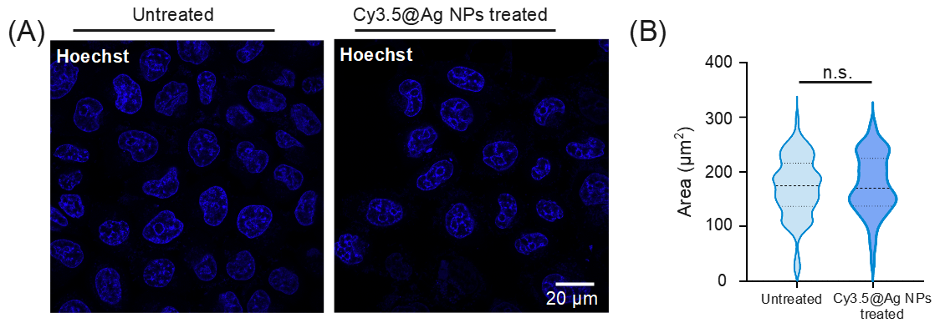
Supplementary Figure 11. Effect of Cy3.5@Ag NPs on the nucleus. (A) Confocal imaging of Hoechst-labeled nucleus in HeLa cells with or without Cy3.5@Ag NPs (0.5 μg/ml, 1 h) treatment. (B) The plot shows the fluorescence area of nucleus for HeLa cells. Data are presented as mean ± SEM (n=50 cells for each group, n.s. for no significant difference).

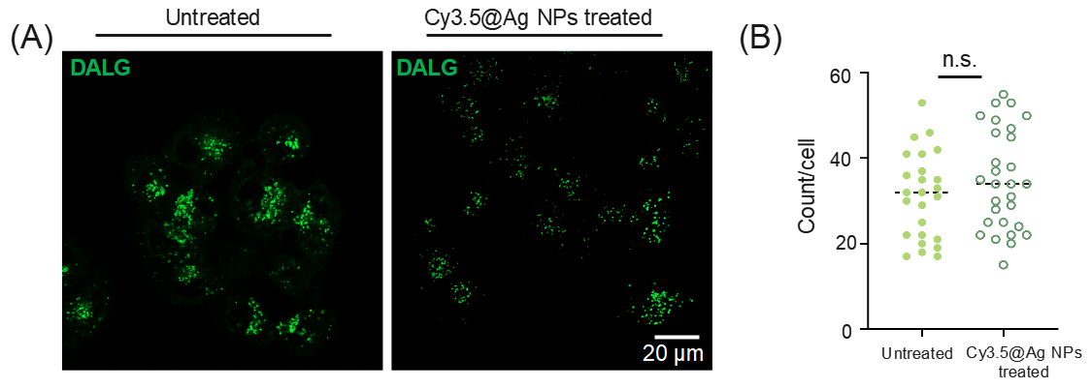
Supplementary Figure 12. Effect of Cy3.5@Ag NPs on autophagolysosome (ALs). (A) Confocal imaging of DALG-labeled Als in HeLa cells with or without Cy3.5@Ag NPs (0.5 μg/ml, 1 h) treatment. (B) The plot shows the count of autophagolysosome for HeLa cells. Data are presented as mean ± SEM (n=25 for untreated cells, n=29 for Cy3.5@Ag NPs treated cells, n.s. for no significant difference).

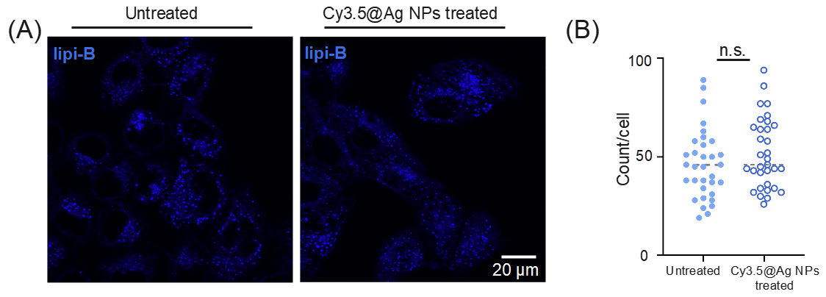
Supplementary Figure 13. Effect of Cy3.5@Ag NPs on lipid droplets (LDs). (A) Confocal imaging of Lipi-Blue-labeled LDS in HeLa cells with or without Cy3.5@Ag NPs (0.5 μg/ml, 1 h) treatment. (B)The plot shows the count of LDS for HeLa cells. Data are presented as mean ± SEM (n=33 cells, n.s. for no significant difference).

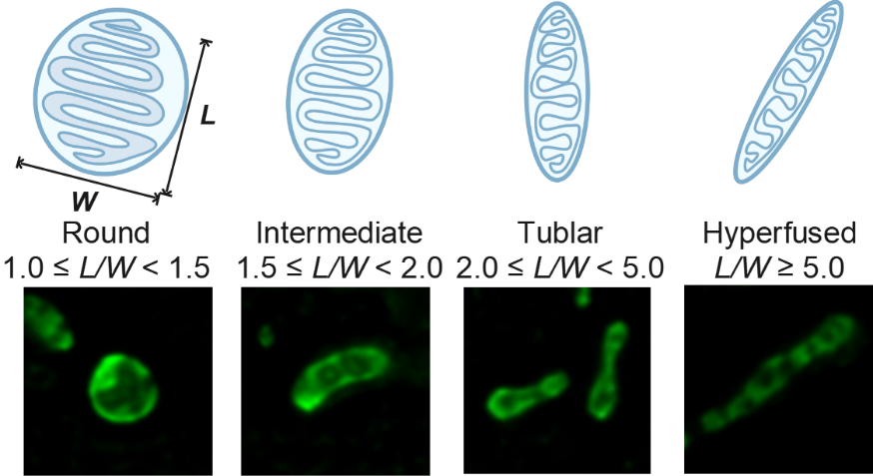
Supplementary Figure 14. Representative images of mitochondrial structure and definition of L/W parameters for description of mitochondrial morphology description.

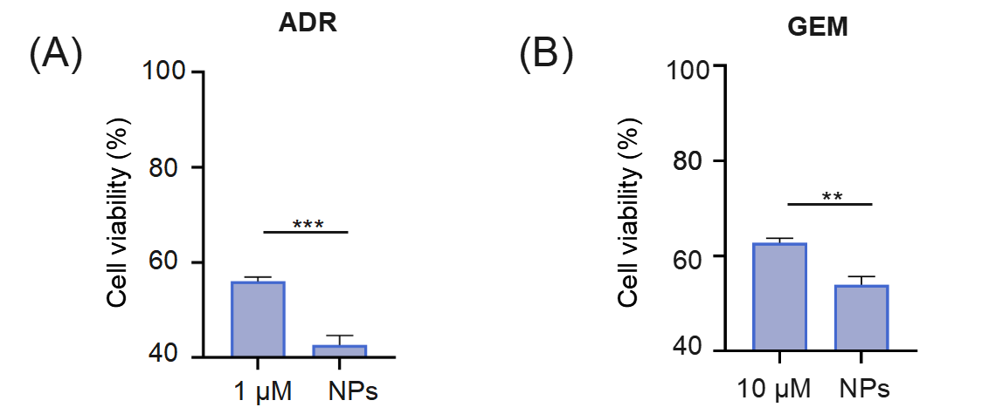
Supplementary Figure 15. Cytotoxicity assay of ADR (A) and GEM (B) for HeLa cells with or without Cy3.5@Ag NPs treatment. Data are presented as mean ± SEM. P < 0.05 is considered significant (**P < 0.01, ***P< 0.001).

∗ Corresponding author. E-mail address: chenjia@sdfmu.edu.cn

