SUPPLEMENTARY INFORMATION
Article title: SiO₂/WO₃/ZnO Based Self-cleaning Coatings for Solar Cells
Journal name: Journal of Sol-Gel Science and Technology
Author names: Ozcan Koysurenª*, Klodian Dhoska^{b}* Hafize Nagehan Koysuren^{c}, Irida Markja^{b}, Savas Yaglikciª,, Bilge Tuncelª, Elena Bebi^{d}
Affiliation: ªDepartment of Energy Systems Engineering, Ankara University, Ankara, 06830, TURKEY
^{b}Polytechnic University of Tirana, Faculty of Mechanical Engineering, Department of Production and Management, Tirana, 1001, ALBANIA
^{c}Department of Environmental Engineering, Kirsehir Ahi Evran University, Kirsehir, 40100, TURKEY
^{d}Polytechnic University of Tirana, Faculty of Mechanical Engineering, Energy Department, Tirana, 1001, ALBANIA
e-mail address of the corresponding authors: O. Koysuren (koysuren@ankara.edu.tr) or K. Dhoska (kdhoska@fim.edu.al)

Fig. S1 Transmittance spectrum of (a) SiO₂/WO₃(30/70) (1-fold coating), (b) SiO₂/WO₃(30/70) (2-fold coating), (c) SiO₂/WO₃(30/70) (3-fold coating), (d) SiO₂/WO₃/ZnO(70/30) (1-fold coating), (e) SiO₂/WO₃/ZnO(70/30) (2-fold coating), (f) SiO₂/WO₃/ZnO(70/30) (3-fold coating) films and (g) uncoated glass slide

Fig. S2 Tauc plot of (a) SiO₂, (b) WO₃ and (c) ZnO films
Fig. S3 Tauc plot of (a) SiO₂/WO₃(80/20), (b) SiO₂/WO₃(70/30), (c) SiO₂/WO₃(60/40), (d) SiO₂/WO₃(50/50), (e) SiO₂/WO₃(40/60), (f) SiO₂/WO₃(30/70) and (g) SiO₂/WO₃(20/80) films
Fig. S4 Tauc plot of (a) SiO₂/WO₃/ZnO(90/10), (b) SiO₂/WO₃/ZnO(80/20) and (c) SiO₂/WO₃/ZnO(70/30) films

Fig. S5 The variation in the UV-Vis absorption spectrum of methylene blue with time in the presence of (a) SiO₂, (b) WO₃ and (c) ZnO films
Fig. S6 The variation in the UV-Vis absorption spectrum of methylene blue with time in the presence of (a) SiO₂/WO₃(80/20), (b) SiO₂/WO₃(70/30), (c) SiO₂/WO₃(60/40), (d) SiO₂/WO₃(50/50), (e) SiO₂/WO₃(40/60), (f) SiO₂/WO₃(30/70) and (g) SiO₂/WO₃(20/80) films
Fig. S7 Photocatalytic degradation kinetics of methylene blue on pure SiO₂, WO₃, ZnO and SiO₂/WO₃ composite films under the UVA light irradiation

Fig. S8 The variation in the UV-Vis absorption spectrum of methylene blue with time in the presence of (a) SiO₂/WO₃/ZnO(90/10), (b) SiO₂/WO₃/ZnO(80/20) and (c) SiO₂/WO₃/ZnO(70/30) films
Fig. S9 Photocatalytic degradation kinetics of methylene blue on SiO₂/WO₃/ZnO composite films under the UVA light irradiation

Fig. S10 Effect of the number of the dip-coating cycle on the current-voltage characteristics of the solar cell coated with (a) SiO₂/WO₃(30/70) (1-fold coating), (b) SiO₂/WO₃(30/70) (2-fold coating), (c) SiO₂/WO₃(30/70) (3-fold coating), (d) SiO₂/WO₃/ZnO(70/30) (1-fold coating), (e) SiO₂/WO₃/ZnO(70/30) (2-fold coating), (f) SiO₂/WO₃/ZnO(70/30) (3-fold coating) and including (g) uncoated glass slide
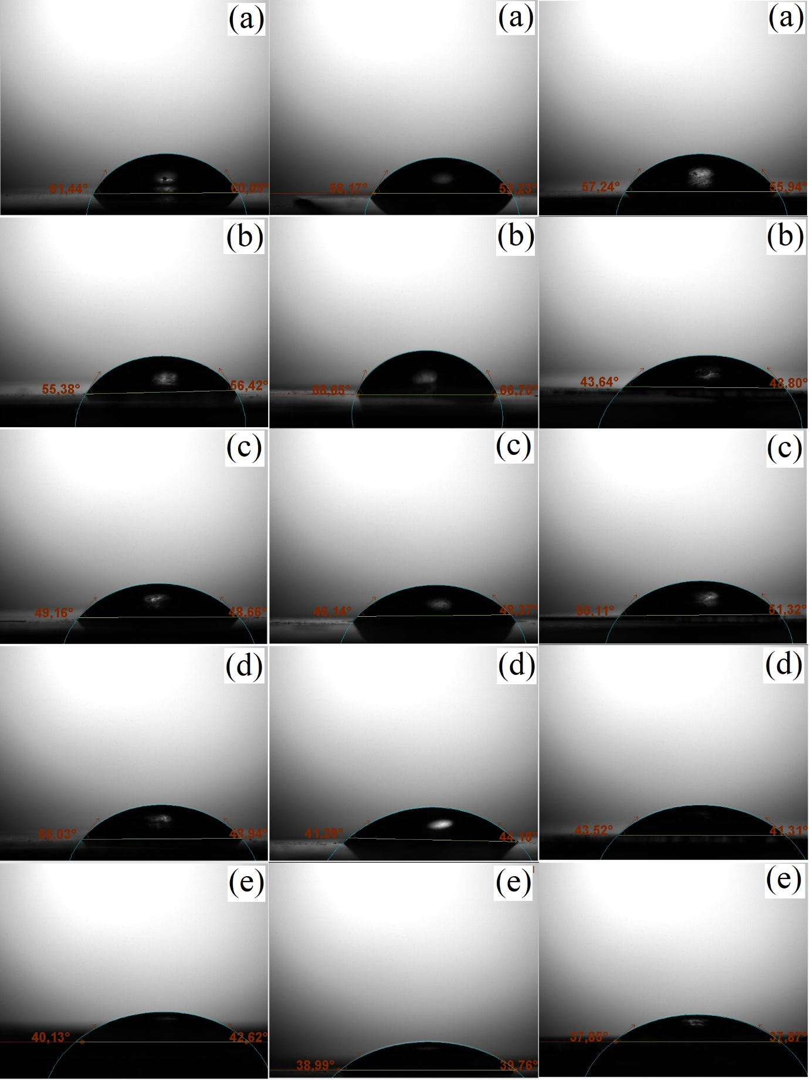
Fig. S11 Images of the water droplets on SiO₂/WO₃(30/70) film with the irradiation time: (a) 0 min, (b) 60 min, (c) 120 min, (d) 180 min and (e) 240 min
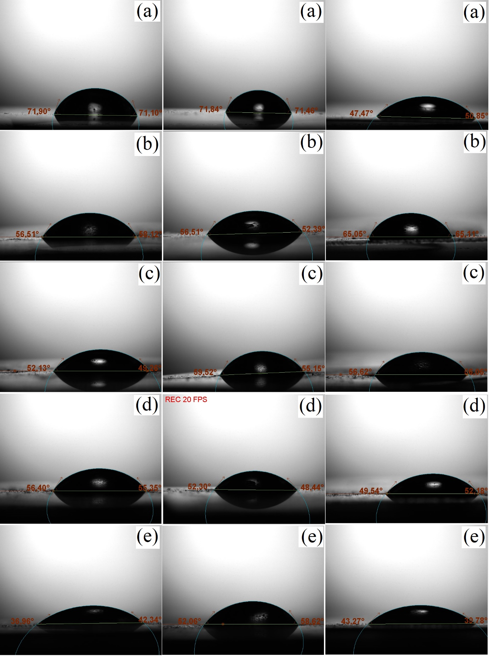
Fig. S12 Images of the water droplets on SiO₂/WO₃/ZnO(70/30) film with the irradiation time: (a) 0 min, (b) 60 min, (c) 120 min, (d) 180 min and (e) 240 min

