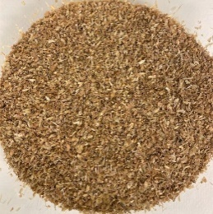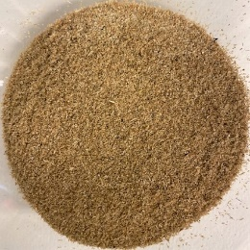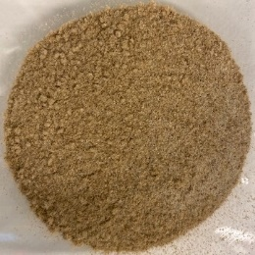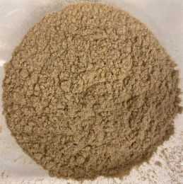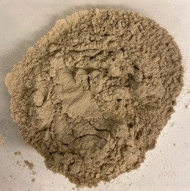
5
4
3
2
1
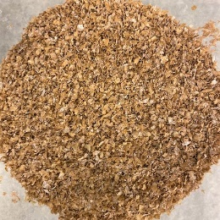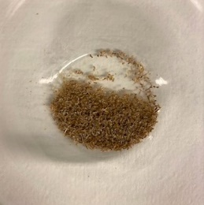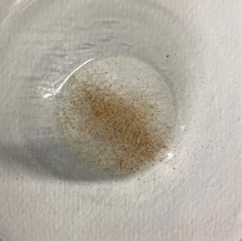
7
8
6

Picture 1. 1-5 sieved industrial wheat grain processing residues fractions, 6-8 wheat bran fractions.

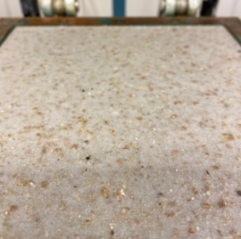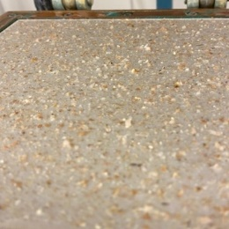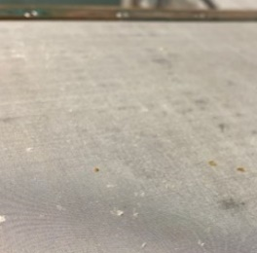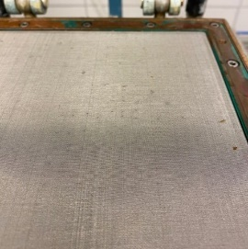
4
3
2
1

Picture 2. 1, 2 – upper / non-wire paper sheet samples surface before removal from sheet former. 3, 4 – agricultural residues and pulp leftovers after paper sheet removal.

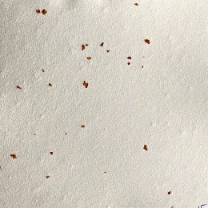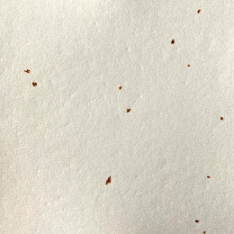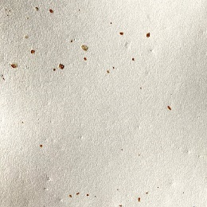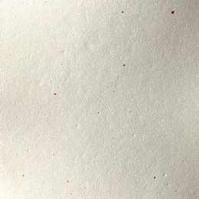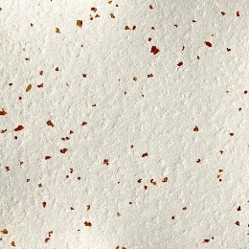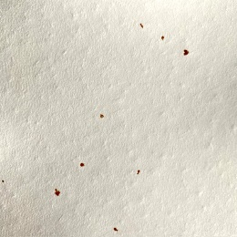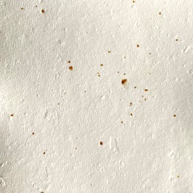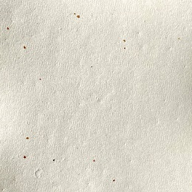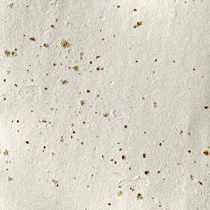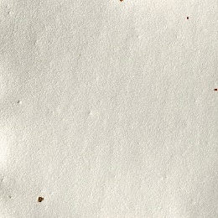
10
9
8
7
6
5
4
3
2
1

Picture 3. 1, 2 paper sheet samples filed with 15wt% wheat bran (wire side and non-wire side); 3,4 paper sheet samples filed with 15wt% industrial wheat grain processing residues (wire side and non-wire side); 5,6 paper sheet samples filed with 40wt% wheat bran (wire side and non-wire side); 7,8 paper sheet samples filed with 40wt% industrial wheat grain processing residues (wire side and non-wire side); 9,10 CTMP pulp paper sheet sample filed with 40wt% industrial wheat grain processing residues.

