Supplementary material for “Tuning weight values by resolving imbalances at nodes in an augmented artificial neural network”

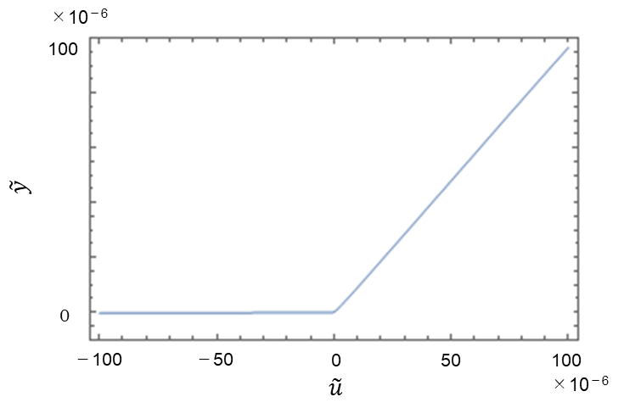
Supplementary Fig. 1. Mapping between $\tilde{u}$ and $\tilde{y}$.
If one chooses a different I_{B} in the circuit shown in the inset of Fig. 1d, the mapping between $\tilde{u}$ and $\tilde{y}$ may have a ramp-like slope. This mapping means that the activation function in the AANN can be designed.

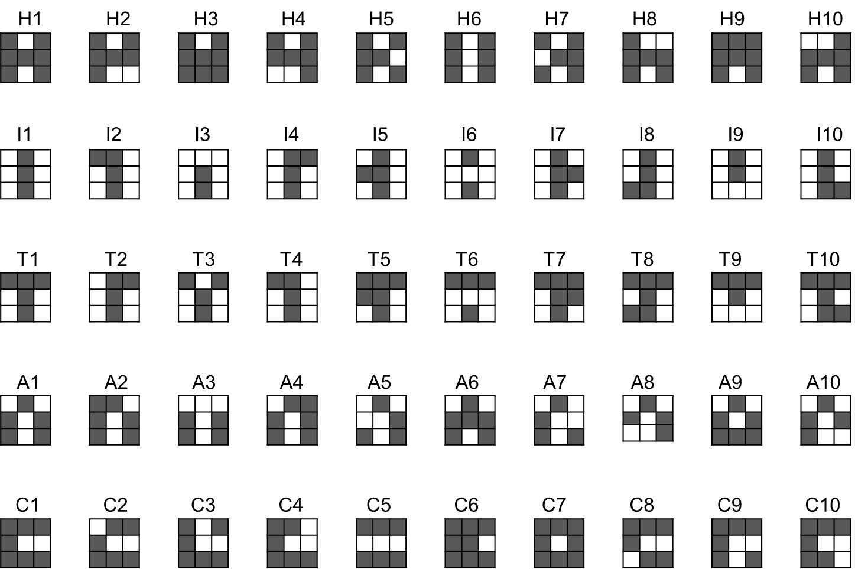
Supplementary Fig. 2. True images and images with one flipped pixel.
These 50 black-and-white images are used for the calculation of the RMSE in Fig. 4a and b.

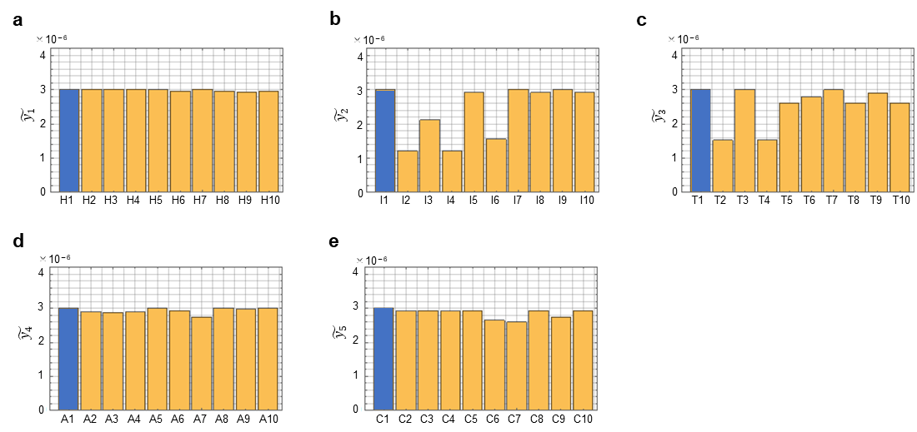
Supplementary Fig. 3. Recognition of images by the two-layered ANN after tuning by the corresponding AANN.
a The computed ${\tilde{y}}_{1}$ values for each image among H1~H10 are shown as bars. The target ${\tilde{y}}_{1}$ for H1 is 3$×$10⁻⁶. Here, ${\tilde{y}}_{2}$~${\tilde{y}}_{10}$ for those images are not shown. b-e Similarly, ${\tilde{y}}_{2}$~${\tilde{y}}_{5}$ for I1~I10, T1~T10, A1~A10 and C1~C10 are shown. The computed output values for the true images (H1, I1, T1, A1 and C1) are shown as dark blue bars.

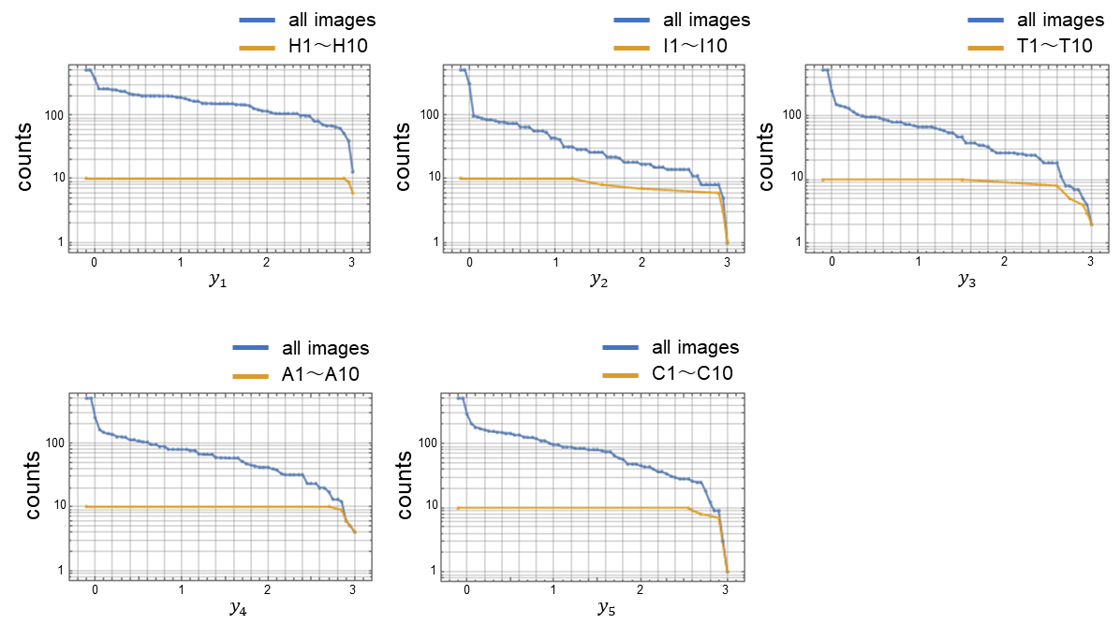
Supplementary Fig. 4. Counts of recognised images against the ANN output threshold.
The number of images recognised as “H”, “I”, “T”, “A” and “C” against the threshold values, y₁~y₅, are shown. The blue lines show the counts of images among all black-and-white images with 3$×$3 pixels. Orange indicates the counts of images among H1~ H10, I1~I10, T1~T10, A1~A10 and C1~C10.

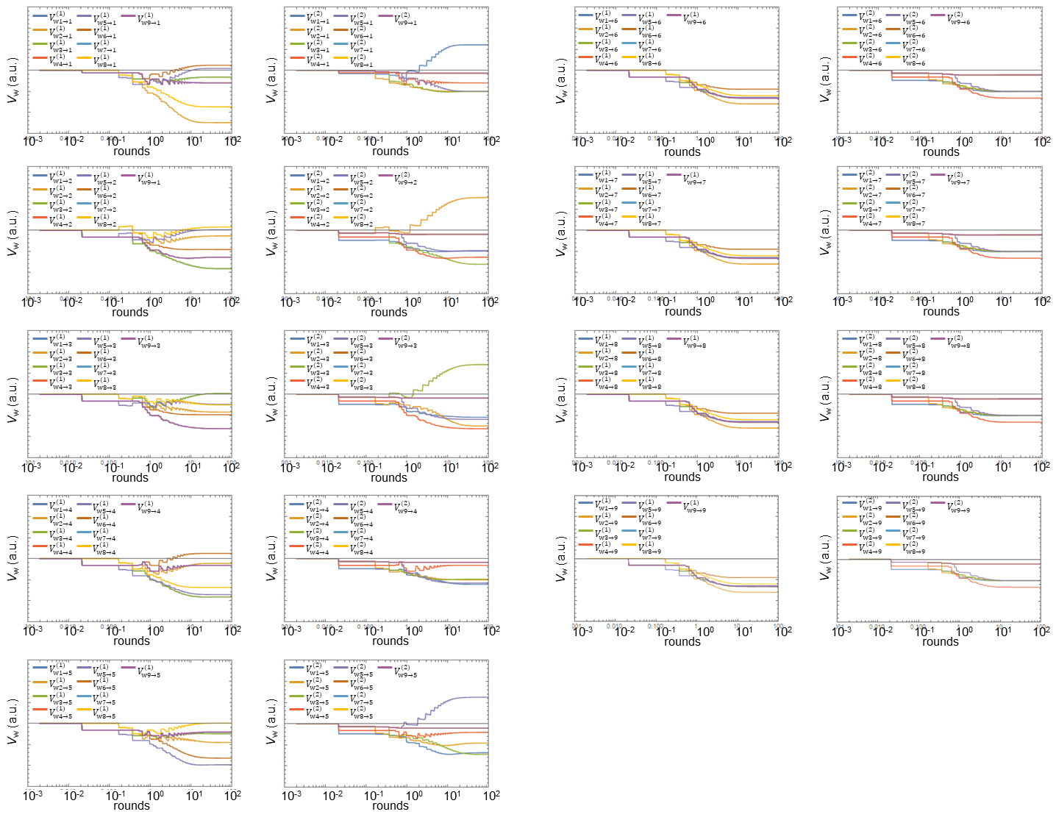
Supplementary Fig. 5. Time evolution of V_{w}.
Time evolution of V_{w} in the two-layered AANN.

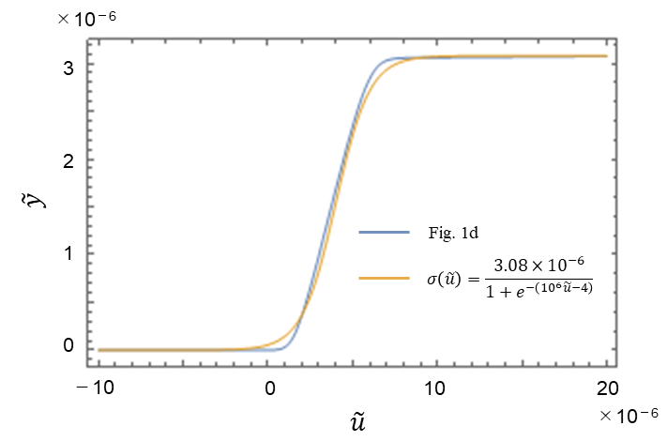
Supplementary Fig. 6. Activation function used for ADAM tuning.
For the ADAM tuning in Fig. 4, the sigmoid function shown by the orange line is used. The blue line is the same line shown in Fig. 1d, which is given for comparison.

