Table S1 The location wise treatment details environment code used during the complete experiment.
Environment | Location | Experimental condition | Sowing schedule | Number of irrigation
E1 | Dharwad | Terminal heat stress | First fortnight December | 5
E2 | Niphad | Terminal heat stress | First fortnight December | 5
E3 | Pune | Terminal heat stress | First fortnight December | 5
E4 | Dharwad | Normal-no stress | First fortnight November | 5
E5 | Niphad | Normal-no stress | First fortnight November | 5
E6 | Pune | Normal-no stress | First fortnight November | 5
E7 | Dharwad | Drought stress | First fortnight November | 1
E8 | Niphad | Drought stress | First fortnight November | 1
E9 | Pune | Drought stress | First fortnight November | 1

Table S2. Soil and weather conditions of individual location during the course of study for the year 2020-21
Location | Pune |  |  |  |  | Niphad |  |  |  |  | Dharwad
Location details
Altitude | 548.6 |  |  |  |  | 569 M
Latitude | 18.04 ͦ N 74.21 ͦ N |  |  |  |  | 20°5′0″N 74°7′0″E |  |  |  |  | 15 ͦ 26' N 75 ͦ 07' E
MSL | 548.6 m |  |  |  |  | 546.6 m |  |  |  |  | 678 m
Annual Avg Rain fall | 573 mm |  |  |  |  | 552 mm
Cropping season weather parameters (Monthly)
Months/ Parameters | Temp (Max) | Temp (Min) | RH (Max) | RH (Min) | Rain | Temp (Max) | Temp (Min) | RH (Max) | RH (Min) | Rain | Temp (Max) | Temp (Min) | RH (Max) | RH (Min) | Rain
Oct-2020 | 33.6 | 17.5 | 87 | 52 | 311.3 | 31.5 | 22.3 | 89.4 | 59.0 | 63.3 | 29.1 | 20.0 | 87.9 | 76.0 | 202
Nov-2020 | 33.6 | 17.1 | 81 | 47 | 0 | 30.5 | 15.1 | 86.3 | 45.1 | 0.6 | 29.4 | 17.0 | 75.2 | 50.1 | 0.6
Dec-2020 | 39 | 14 | 89 | 46 | 0 | 28.3 | 12.5 | 88.9 | 43.6 | 1.2 | 28.9 | 14.6 | 75.4 | 46.0 | 0.0
Jan-2021 | 29.5 | 13.4 | 94 | 51 | 0 | 29.9 | 13.4 | 88.6 | 46.9 | 15 | 29.4 | 15.9 | 77.1 | 49.7 | 27.2
Feb-2021 | 31.2 | 13.5 | 87 | 37 | 0 | 30.1 | 9.9 | 87.6 | 39.3 | 16.5 | 30.3 | 15.2 | 67.9 | 37.7 | 10.0
Mar-2021 | 36.1 | 16.7 | 74 | 27 | 0 | 35.3 | 13.5 | 88.2 | 31.1 | 2.4 | 34.8 | 18.5 | 61.9 | 27.1 | 0.4
Apr-2021 | 37.3 | 19.4 | 72 | 26 | 1 | 36.3 | 16.4 | 84.3 | 29 | 0.3 | 35.4 | 20.5 | 75.6 | 41.4 | 103.0
Soil parameters
Soil group | Black cotton soil |  |  |  |  | Vertisol |  |  |  |  | Clay
Sand, (%) | 9.60 |  |  |  |  | 20.4 |  |  |  |  | 20
Silt, (%) | 48.80 |  |  |  |  | 34.2 |  |  |  |  | 26
Clay, (%) | 24.20 |  |  |  |  | 45.4 |  |  |  |  | 50
Bulk density, Mg m⁻³ | 1.38 |  |  |  |  | 1.29 |  |  |  |  | -
Organic Carbon, (%) | 0.94 |  |  |  |  | 0.62 |  |  |  |  | 0.5
Available N, kg ha⁻¹ | 226.00 |  |  |  |  | 157.42 |  |  |  |  | 187
Available P₂O₅, kg ha⁻¹ | 9.87 |  |  |  |  | 23.61 |  |  |  |  | 42.8
Available K₂O, kg ha⁻¹ | 735.00 |  |  |  |  | 304.45 |  |  |  |  | 418
pH (1:2) | 8.23 |  |  |  |  | 8.24 |  |  |  |  | 7.8
EC (1:2) | 0.43 |  |  |  |  | 0.27 |  |  |  |  | 0.3
Na (ME/lit.) | 2.52 |  |  |  |  | - |  |  |  |  | -
Calcium (%) | 10.56 |  |  |  |  | 13.2 |  |  |  |  | -
Iron (PPM) | 0.09 |  |  |  |  | 4.3 |  |  |  |  | 6.34
Magnesium (PPM) | 0.01 |  |  |  |  | - |  |  |  |  | -
Zinc (PPM) | 0.07 |  |  |  |  | 0.48 |  |  |  |  | 2.64
Copper (PPM) | 0.09 |  |  |  |  | 0.79 |  |  |  |  | -
Boron (PPM) | 0.44 |  |  |  |  | 0.77 |  |  |  |  | -
Sulphur (PPM) | 14.82 |  |  |  |  | - |  |  |  |  | -

Table S3 Descriptive statistics for the various grain quality traits of 15 wheat genotypes under variable environments
a. Descriptive statistics
variable | cv | gmean | hmean | max | min | mean | median | av.dev
Fe | 12.88 | 40.51 | 39.99 | 56.80 | 12.60 | 40.90 | 40.45 | 3.93
GY | 35.70 | 1201.34 | 1123.91 | 2451.00 | 340.00 | 1280.50 | 1160.00 | 375.91
Moisture | 7.21 | 10.77 | 10.74 | 13.50 | 9.70 | 10.79 | 10.60 | 0.58
Protein | 8.82 | 14.00 | 13.95 | 17.40 | 11.60 | 14.05 | 13.90 | 0.99
Starch | 2.07 | 64.84 | 64.82 | 67.90 | 60.20 | 64.85 | 65.05 | 1.08
TGW | 12.63 | 40.73 | 40.43 | 58.05 | 28.20 | 41.05 | 40.20 | 4.02
Wet.gluten | 10.83 | 33.89 | 33.69 | 44.10 | 24.30 | 34.09 | 34.00 | 2.92
Zn | 13.70 | 40.42 | 40.03 | 58.10 | 24.60 | 40.80 | 40.55 | 4.44
b. Mean values for the various traits under 3 major field conditions across 3 locations
ENV | Protein | Moisture | Starch | Wet.gluten | Fe | Zn | GY | TGW
Control | 14.15 | 10.68 | 64.83 | 34.49 | 41.38 | 43.02 | 1488.11 | 42.29
Drought stress | 13.86 | 10.35 | 64.65 | 34.01 | 42.77 | 39.24 | 929.11 | 40.092
Heat stress | 14.15 | 11.35 | 65.07 | 33.78 | 38.55 | 40.15 | 1424.27 | 40.77
c. Mean values for the various traits under 9 variable environments across 3 locations
ENV | Protein | Moisture | Starch | Wet.gluten | Fe | Zn | GY | TGW
E1 | 15.86 | 12.58 | 64.05 | 37.50 | 38.68 | 42.55 | 997.57 | 43.32
E2 | 13.53 | 10.98 | 65.43 | 32.60 | 39.12 | 35.12 | 1214.17 | 37.48
E3 | 13.06 | 10.49 | 65.74 | 31.24 | 37.83 | 42.77 | 2061.07 | 41.50
E4 | 14.99 | 10.76 | 64.39 | 37.19 | 43.02 | 42.21 | 1543.73 | 44.65
E5 | 13.60 | 10.77 | 65.44 | 32.57 | 41.11 | 40.68 | 1140.67 | 39.46
E6 | 13.86 | 10.52 | 64.66 | 33.71 | 39.99 | 46.18 | 1779.93 | 42.77
E7 | 14.23 | 10.16 | 64.72 | 35.17 | 42.55 | 40.32 | 783.03 | 43.82
E8 | 13.67 | 10.23 | 64.46 | 33.66 | 38.95 | 34.43 | 1011.00 | 37.73
E9 | 13.68 | 10.67 | 64.76 | 33.20 | 46.80 | 42.98 | 993.30 | 38.73
d. Mean values for the various traits for 15 genotypes over 9 variable environments across 3 locations
GEN | Protein | Moisture | Starch | Wet.gluten | Fe | Zn | GY | TGW
G1 | 13.29 | 10.65 | 65.09 | 31.57 | 39.02 | 40.53 | 1198.00 | 39.41
G2 | 14.02 | 10.46 | 64.12 | 33.97 | 42.22 | 41.62 | 1186.33 | 39.18
G3 | 13.97 | 10.96 | 65.92 | 34.29 | 39.91 | 38.25 | 1381.39 | 42.21
G4 | 13.67 | 10.89 | 64.32 | 31.71 | 41.42 | 38.86 | 1448.28 | 37.72
G5 | 13.75 | 10.78 | 65.64 | 33.02 | 42.41 | 40.67 | 1319.78 | 40.43
G6 | 14.15 | 10.67 | 64.69 | 35.35 | 42.40 | 40.60 | 1526.22 | 39.03
G7 | 14.27 | 10.95 | 64.77 | 34.96 | 41.50 | 43.09 | 1293.44 | 43.22
G8 | 13.91 | 10.87 | 64.55 | 33.38 | 40.17 | 41.13 | 1259.28 | 44.94
G9 | 13.78 | 10.66 | 65.22 | 33.32 | 39.63 | 42.45 | 1333.22 | 42.19
G10 | 13.95 | 10.77 | 64.85 | 34.03 | 41.28 | 41.29 | 1261.94 | 42.65
G11 | 14.33 | 10.58 | 63.44 | 34.80 | 39.57 | 45.23 | 1049.50 | 46.18
G12 | 14.98 | 10.88 | 64.55 | 36.67 | 42.09 | 38.22 | 1368.89 | 41.34
G13 | 14.35 | 10.95 | 64.91 | 34.83 | 43.78 | 39.52 | 1294.00 | 39.71
G14 | 14.01 | 10.89 | 64.79 | 34.32 | 37.31 | 38.16 | 1208.11 | 37.98
G15 | 14.34 | 10.96 | 65.88 | 35.16 | 40.73 | 42.44 | 1079.06 | 39.59

Table S4 BLUP based statistics calculated for the 15 wheat genotypes tested across the 9 environments
Statistic | Protein | Moisture | Starch | Wet gluten | Fe | Zn | GY | TGW
Heritability | 0.545 | 0.505 | 0.779 | 0.595 | 0.557 | 0.759 | 0.811 | 0.704
Genotype Variance | 0.080 | 0.012 | 0.336 | 1.063 | 1.766 | 3.635 | 13140.256 | 4.351
Gen × Loc Variance | 0.402 | 0.086 | 0.499 | 4.415 | 3.074 | 3.230 | 17775.565 | 15.885
Residual Variance | 0.395 | 0.044 | 0.716 | 4.216 | 16.351 | 12.002 | 19577.627 | 1.176
Grand Mean | 14.052 | 10.795 | 64.850 | 34.092 | 40.158 | 40.532 | 1280.496 | 41.051
LSD | 0.540 | 0.221 | 0.775 | 1.861 | 2.497 | 2.626 | 141.471 | 3.181
CV | 4.474 | 1.945 | 1.305 | 6.022 | 10.069 | 8.547 | 10.927 | 2.642
Genotype significance | 0.035 | 0.061 | 0.000 | 0.014 | 0.026 | 0.000 | 0.000 | 0.000
Gen × Env significance | 0.000 | 0.000 | 0.000 | 0.000 | 0.102 | 0.025 | 0.000 | 0.000

Table S5 Traitwise winners across the 9 environments obtained by who won where analysis in GGE biplots.
ENV | Protein | Moisture | Starch | Wet.gluten | Fe | Zn | GY | TGW
E1 | G6 | G12 | G15 | G6 | G5 | G15 | G4 | G11
E2 | G1 | G3 | G5 | G1 | G2 | G10 | G6 | G14
E3 | G12 | G14 | G10 | G12 | G5 | G11 | G6 | G7
E4 | G12 | G3 | G9 | G13 | G5 | G11 | G6 | G11
E5 | G12 | G4 | G13 | G12 | G4 | G7 | G6 | G2
E6 | G11 | G8 | G10 | G12 | G6 | G11 | G9 | G11
E7 | G13 | G5 | G3 | G13 | G5 | G11 | G4 | G7
E8 | G7 | G7 | G15 | G7 | G13 | G5 | G1 | G1
E9 | G2 | G13 | G7 | G2 | G10 | G4 | G3 | G10

Table S6 Homogeneity of the variances among the traits tested using the Bartlett test
Traits | Bartlett's K-squared | p-value
GY | 17.622 | 0.02424
Protein | 23.922 | 0.002362
Fe | 48.976 | 6.43E-08
TGW | 62.522 | 1.49E-10
Moisture | 28.707 | 0.0003569
Starch | 30.278 | 0.0001888
Zn | 29.875 | 0.0002224
Wet gluten | 16.722 | 0.03314

Table S7 Multitrait stability index

Ranking Genotypes | Genotype | Scores for genotypes-ideotype |  |  | Multitrait stability index
 |  | FA1 | FA2 | FA3 | MTSI
1 | G10 | -3.565 | -0.8984 | -3.092 | 4.193
2 | G7 | -3.269 | -2.548 | -4.647 | 4.213
3 | G8 | -3.758 | -2.535 | -1.555 | 4.319
4 | G15 | -5.441 | -2.58 | -4.398 | 4.372
5 | G5 | -3.554 | -1.029 | -5.285 | 4.729
6 | G12 | -4.332 | -3.075 | -3.472 | 4.757
7 | G6 | -3.982 | -3.7 | -3.991 | 4.957
8 | G3 | -1.916 | -1.591 | -4.188 | 5.011
9 | G4 | -3.803 | -2.677 | -5.73 | 5.172
10 | G13 | -3.683 | -4.203 | -4.139 | 5.191
11 | G11 | -3.228 | -4.153 | -4.193 | 5.579
12 | G1 | -1.47 | -3.344 | -4.365 | 6.441
13 | G9 | -5.047 | -2.09 | -4.792 | 6.835
14 | G2 | -3.697 | -3.14 | -5.201 | 6.869
15 | G14 | -4.008 | -3.125 | -3.942 | 7.197

Fig S1: Q plots for the various quality and yiled traits tested under drought and heat treatment and analysed using BLUP_{g}, BLUP_{ge} and BLUP_{g+ge} statistical alogorithms.
Fig. S2 Grain micronutrient concentrations were regressed on grain yield and thousand kernel weight in wheat germplasm in response to environmental stresses (heat and drought).
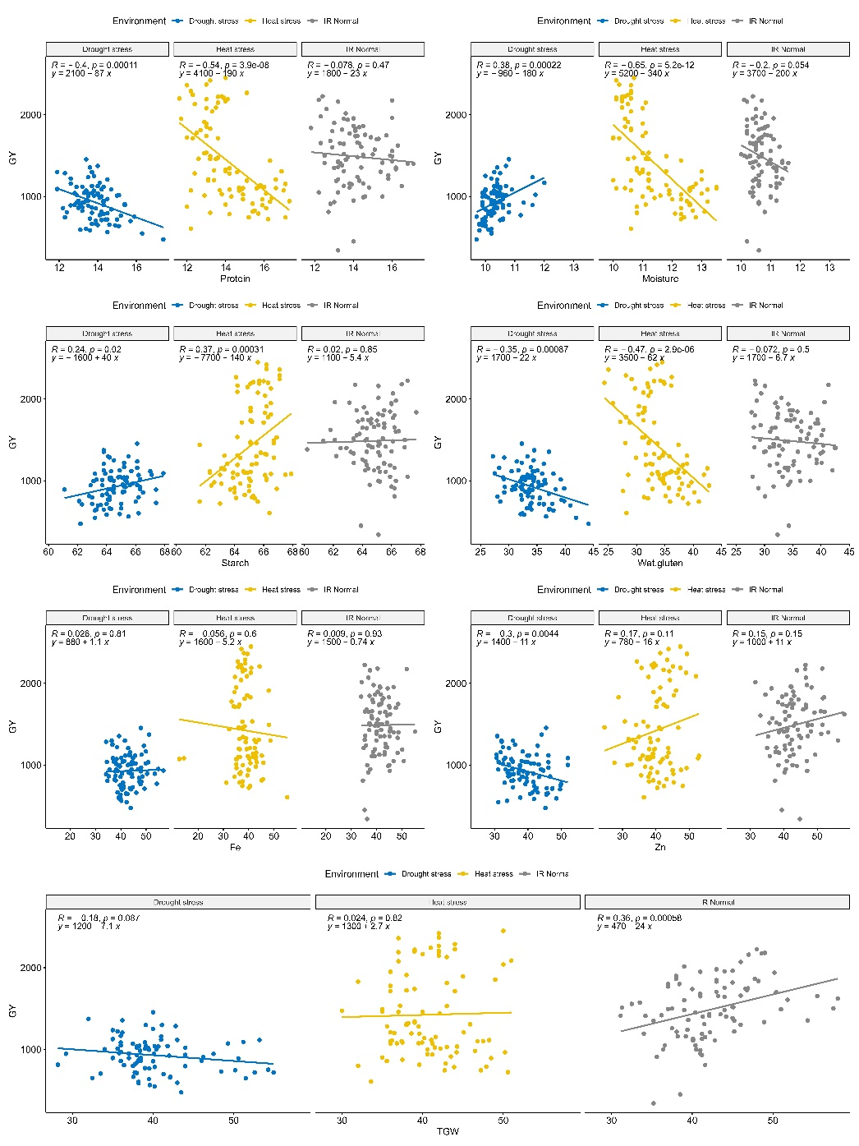

Fig S3. Mean versus stability analysis of the indvidual quality and grain yield traits for the 15 genotypes tested under 9 different environments (Normal, drought and heat conditions at 3 locations).
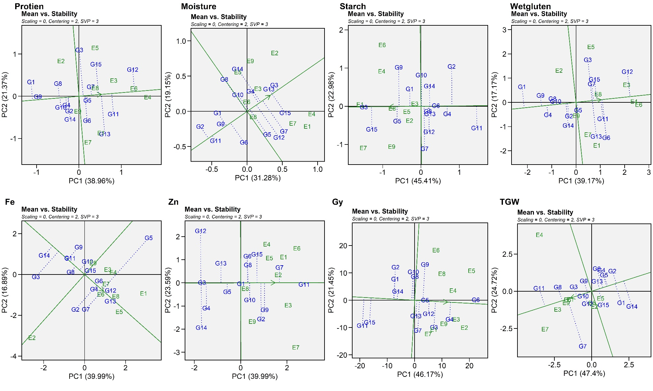

Fig S4 GGE biplot for grain micronutrient, quality and yield traits for wheat germplasm in response to environmental stresses (heat and drought)

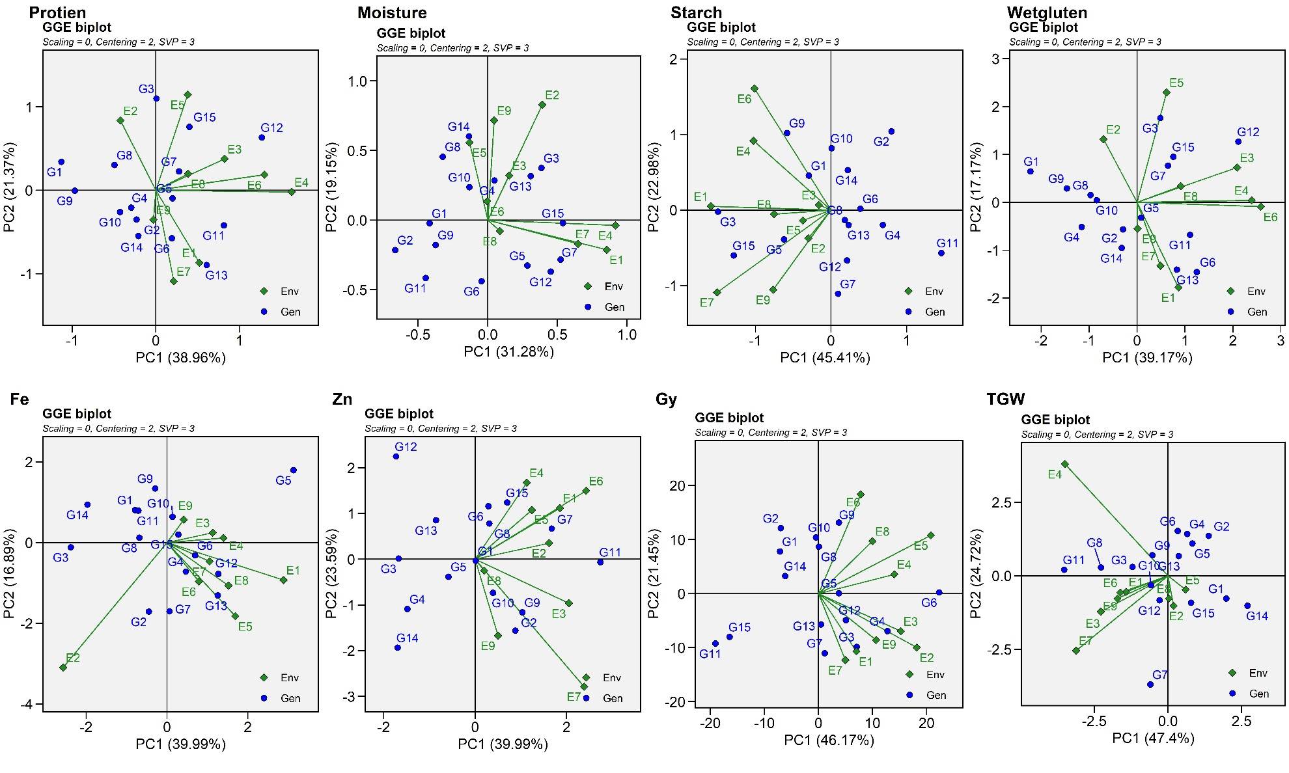

Fig.S5 GGE biplots for ranking the various 9 environments influencing quality and yield traits.
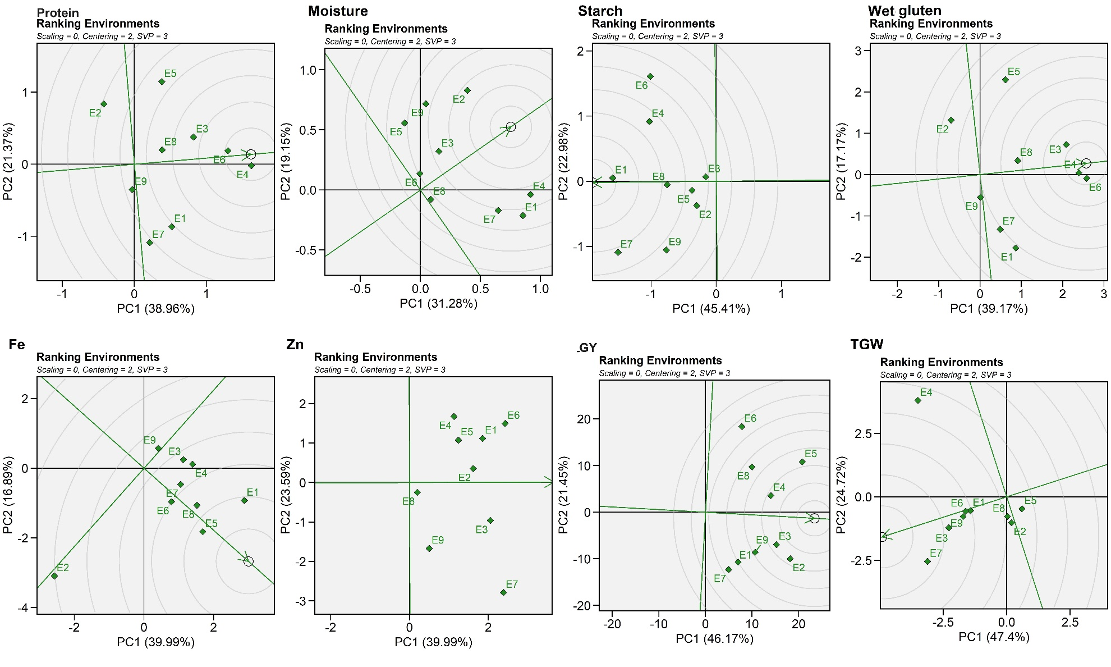

Fig.S6 AMMI1 plots for grain micronutrient, quality and yield traits for wheat germplasm in response to environmental stresses (heat and drought)
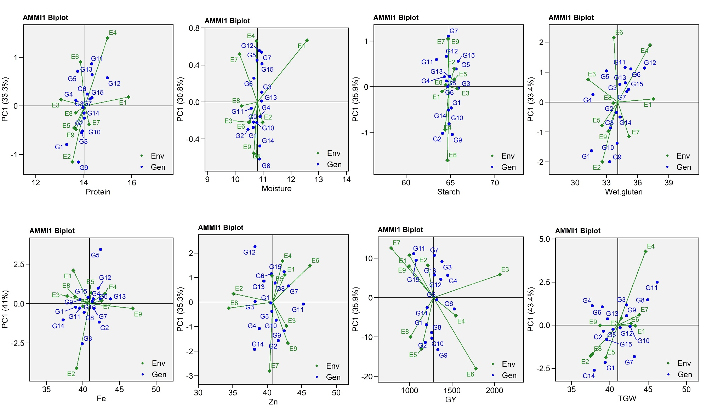

Fig S7 Cluster dendrogram for the 15 genotypes evaluated for grain micronutrient, quality and yield traits for wheat germplasm in response to environmental stresses (heat and drought)
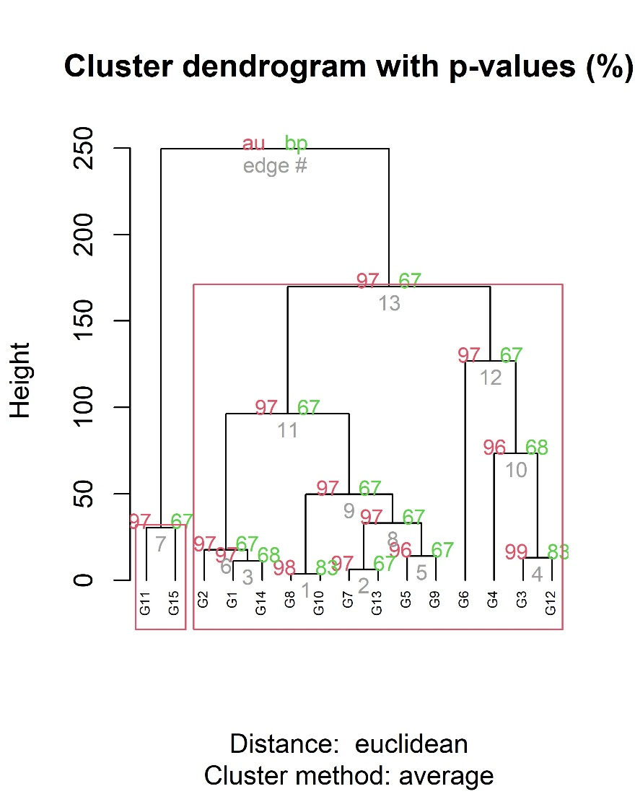

Fig. S8 Multitrait stability index for the 15 genotypes tested under 9 contrast environments.
