- Supplementary material
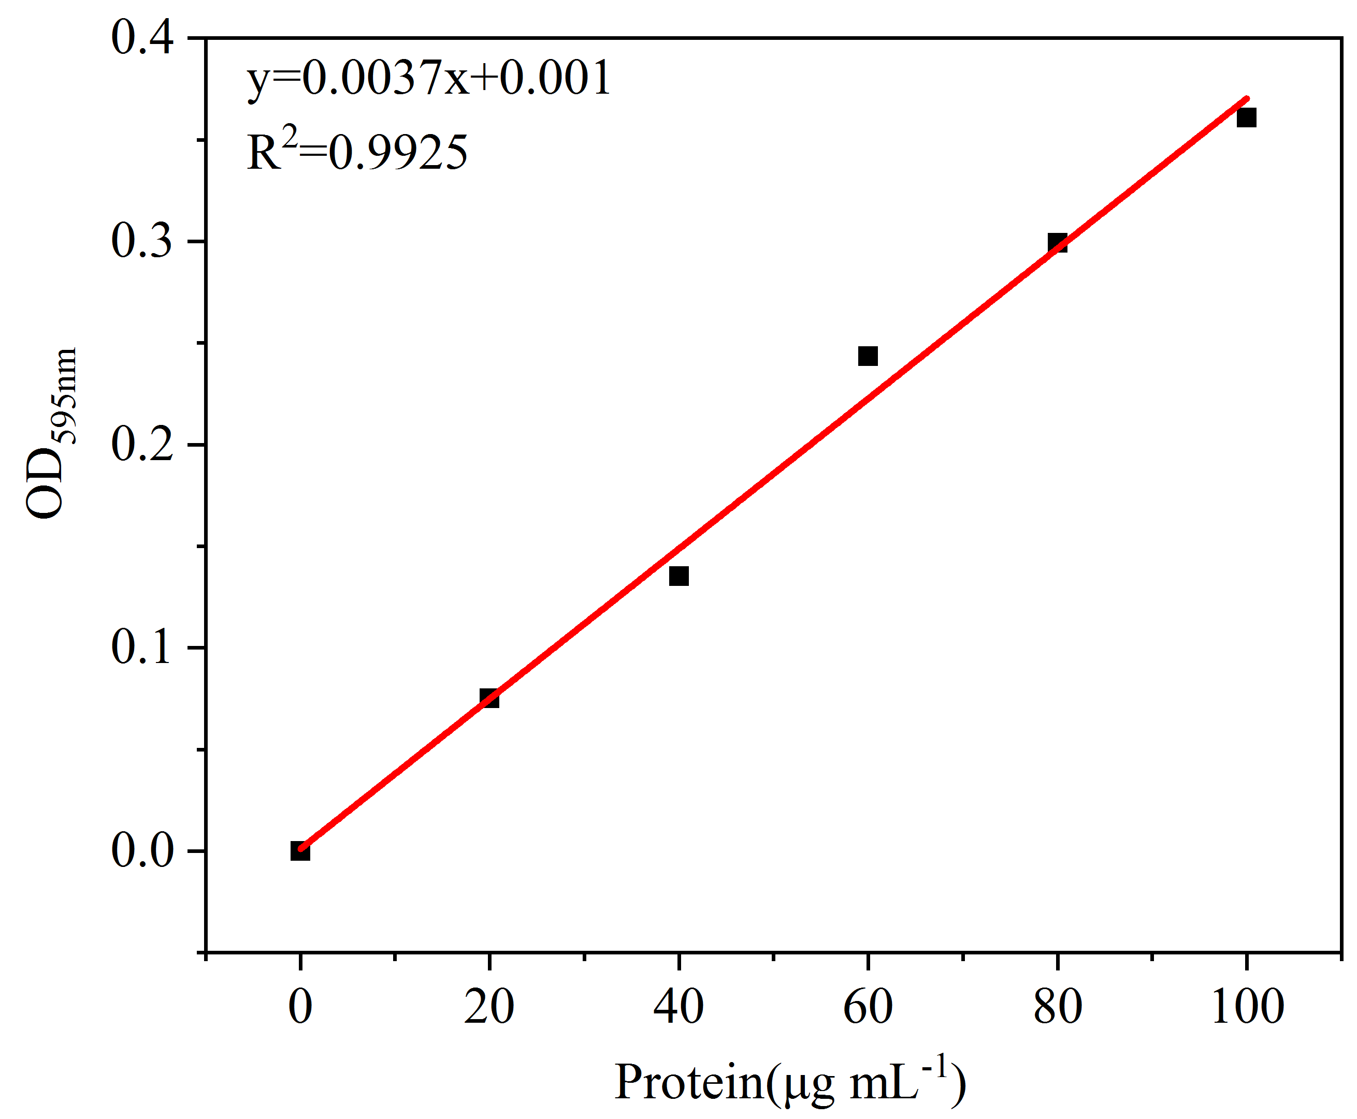

Fig. S1 The standard curve of bovine serum albumin (BSA)

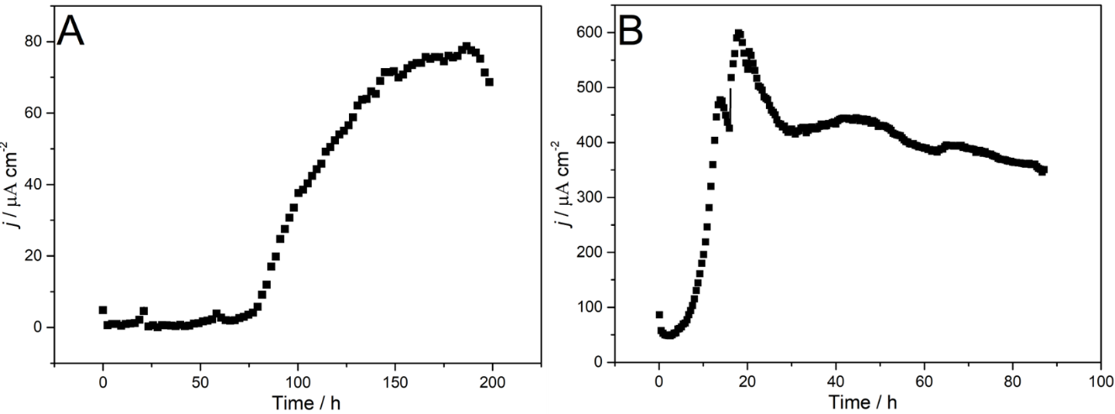
Fig. S2 Chronoamperometric curves of the first (A) and second (B) enrichment procedure with acetate sodium as carbon source at constant potential of 0.3 V

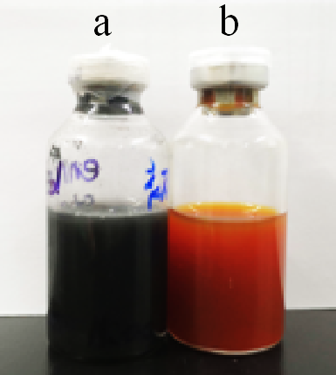

Fig. S3 The change in color of enrichment medium with ferric citrate as electron acceptor inoculated into mixed exoelectrogens after 72 h (a, inoculation with mixed exoelectrogens; b, inoculation without any microorganisms)

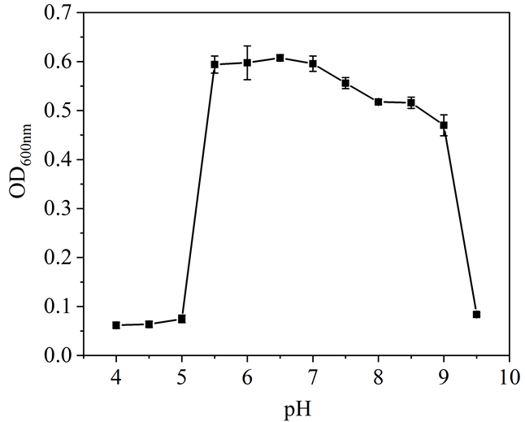

Fig. S4 The maximum OD_{600nm} of EHN cultured at different pH at 37 ℃with starch as electron donor and fumaric acid as electron acceptor within 120 h (with 1% inoculation dosage)

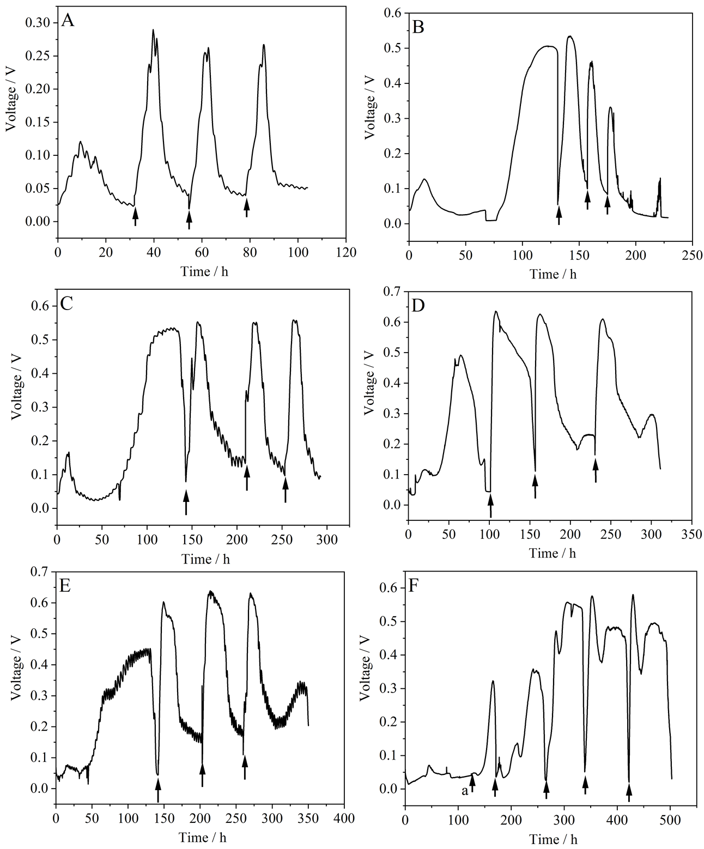
Fig. S5 The relationship between output voltage and running time in MFC with 1000 ohm in the circuit at 7.2 (A), 8.0 (B), 8.5 (C), 9.0 (D), 9.2 (E) and 9.5 (F) (arrow “a” represents adding fresh medium and other arrow represent medium replacement)

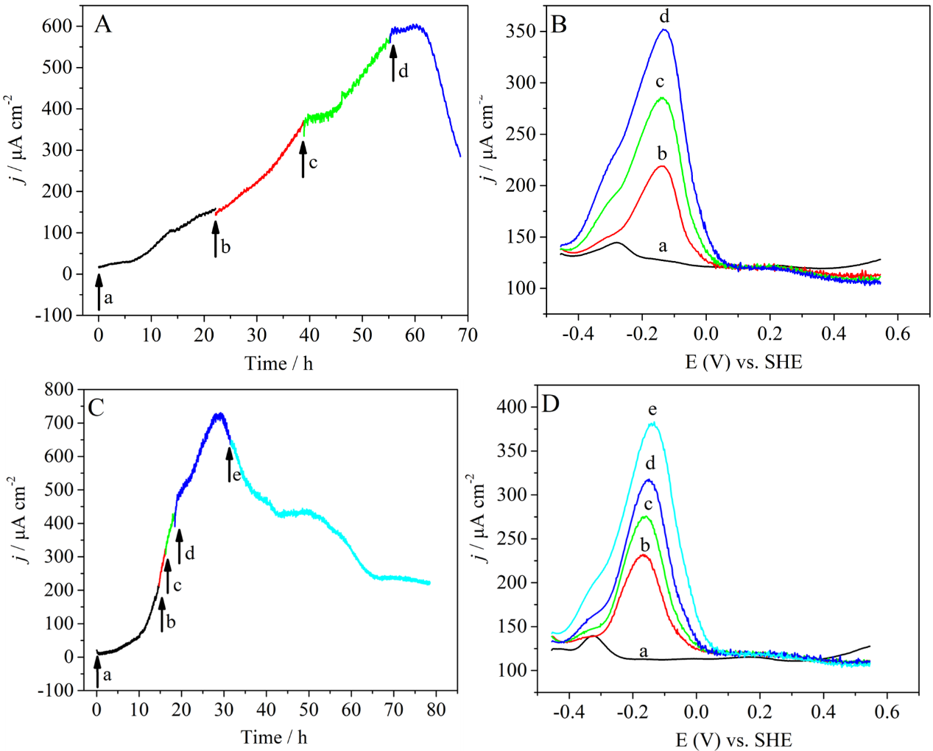
Fig. S6 Chronoamperometric curves and differential pulse voltammetry (DPV) of EHN at pH 7.2 (A and B) and pH 9.0 (C and D) at different stage (arrows represent DPV analysis; a, b, c, d and e represent the different stages of electricity generation in the state of current rising)

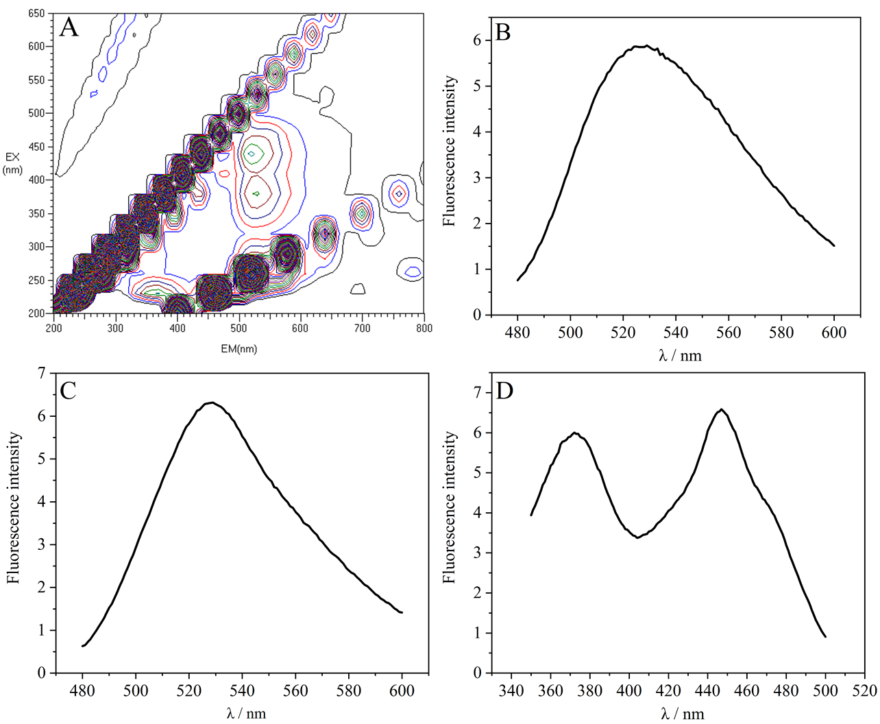
Fig. S7 Images of 3-D scanning analysis of riboflavin standard sample performed by fluorescence spectrophotometer (A). The emission spectrum with excitation wavelength at 370 nm (B) and 450 nm (C) and excitation spectrum with emission wavelength at 525 nm (D)

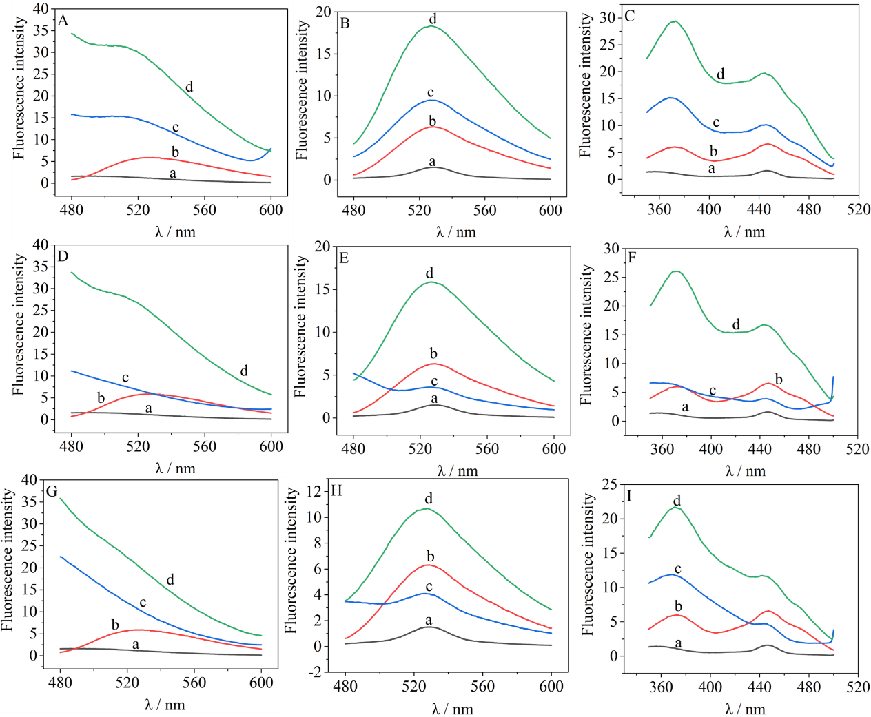
Fig. S8 Detection of riboflavin existed in the three-electrode system at different pH. Emission spectrum with excitation wavelength at 370 nm at pH 5.5(A), pH 7.2 (D) and pH 9.0 (G). Emission spectrum with excitation wavelength at 450 nm at pH 5.5(B), pH 7.2 (E) and pH 9.0 (H). Excitation spectrum with emission wavelength at 525 nm at pH 5.5(C), pH 7.2 (F) and pH 9.0 (I) (curve a, deionized water; curve b, riboflavin; c, solution collected from three-electrode system in the initial phase; d, solution collected from three-electrode system with maximum current density)

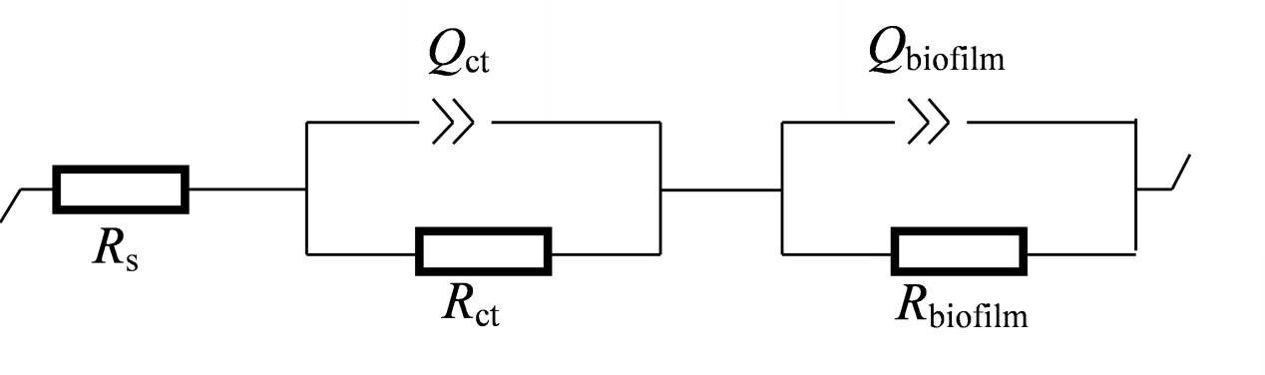

Fig. S9 Schematic diagram of equivalent circuit of biofilm used for electrochemical impedance spectroscopy analysis (R_{s}, resistance of solution; R_{ct}, charge transfer resistance; Rbiofilm, resistance of biofilm)

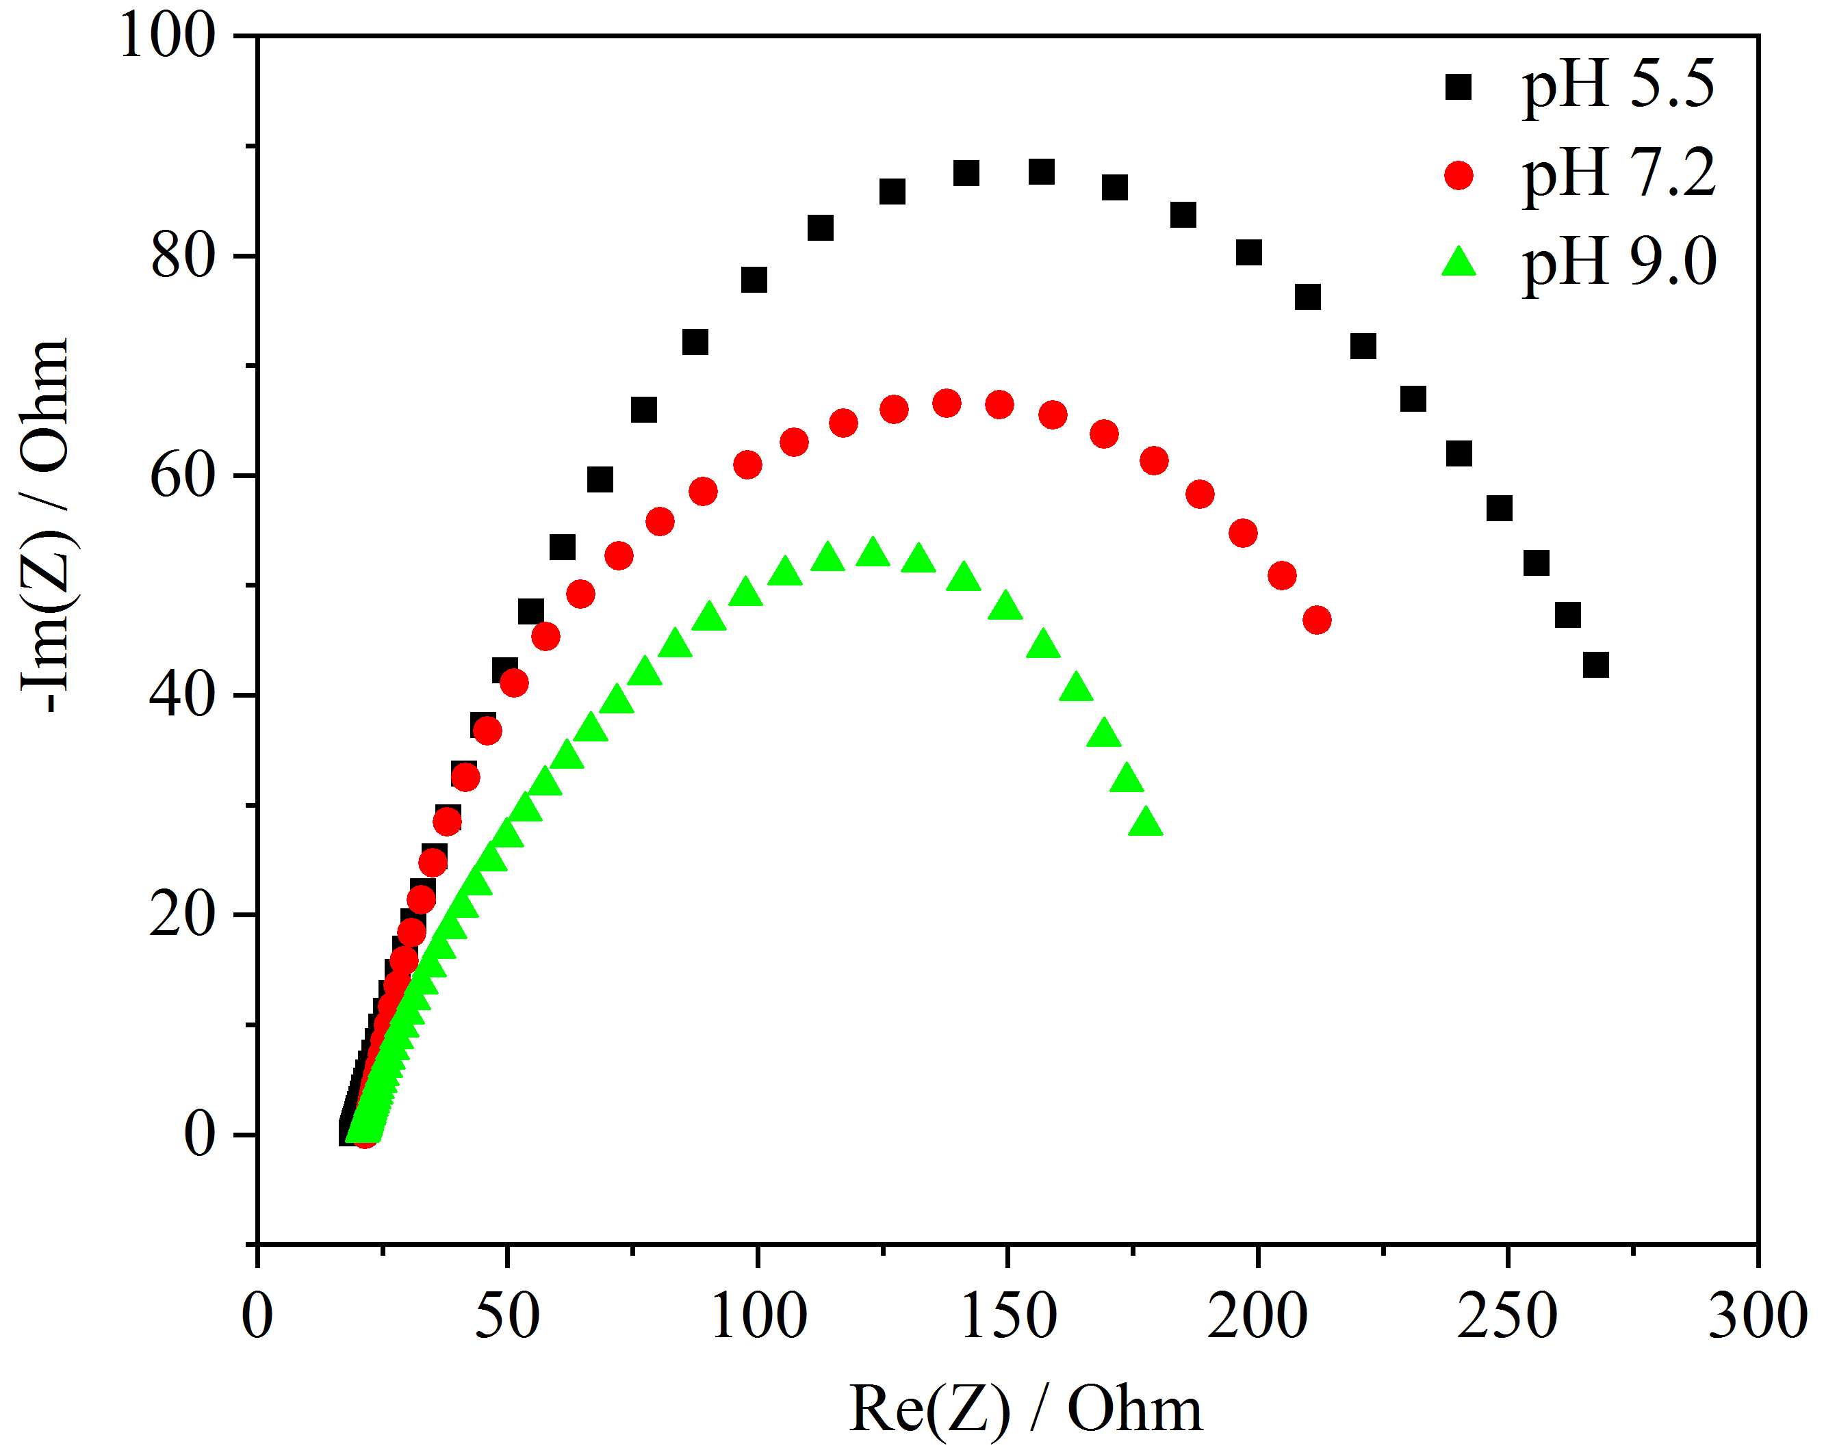

Fig.S10 Nyquist of the biofilm formed by EHN producing maximum current density at three different pH (frequency: 100 kHz~ 10 MHz; amplitude: 5 mV; potential: -0.45 V)

Fig.S11 Chronoamperometric curves of pH5.5 before and after change medium with starch as carbon source at 0.3V constant potential (arrows representing medium changing)

Table S1 The maximum current density and its average of three-electrode system inoculated into EHN at different pH (All experiments were performed in at least three replicates )
pH | times of repetition | Maximum current density  （μA cm⁻²） | The average of maximum current density  （μA cm⁻²）
5.5 | No.1 | 432.18 | 465.15 ± 34.48
5.5 | No.2 | 462.30 | 465.15 ± 34.48
5.5 | No.3 | 500.96 | 465.15 ± 34.48
7.2 | No.1 | 514.19 | 536.89 ± 40.58
7.2 | No.2 | 512.73 | 536.89 ± 40.58
7.2 | No.3 | 583.74 | 536.89 ± 40.58
8.0 | No.1 | 676.79 | 661.63 ± 13.16
8.0 | No.2 | 653.15 | 661.63 ± 13.16
8.0 | No.3 | 654.94 | 661.63 ± 13.16
8.5 | No.1 | 680.52 | 671.50 ± 50.19
8.5 | No.2 | 617.42 | 671.50 ± 50.19
8.5 | No.3 | 716.57 | 671.50 ± 50.19
9.0 | No.1 | 648.17 | 689.89 ± 38.72
9.0 | No.2 | 696.85 | 689.89 ± 38.72
9.0 | No.3 | 724.66 | 689.89 ± 38.72
9.2 | No.1 | 687.99 | 753.14 ± 88.44
9.2 | No.2 | 717.62 | 753.14 ± 88.44
9.2 | No.3 | 853.82 | 753.14 ± 88.44
9.5 | No.1 | 646.18 | 652.39 ± 6.07
9.5 | No.2 | 658.31 | 652.39 ± 6.07
9.5 | No.3 | 652.69 | 652.39 ± 6.07

Table S2 The performance of electricity generation of dual-chamber MFC inoculated into EHN at different initial pH

pH | The average of maximum output voltage（mV） | The average of maximum power density （mW m⁻²）
7.2 | 331.33 ± 30.55 | 350.86 ± 1.09
8.0 | 561.00 ± 35.00 | 741.08 ± 2.66
8.5 | 583.33± 40.41 | 1513.93 ± 48.30
9.0 | 631.00 ± 9.64 | 1499.93 ± 48.30
9.2 | 631.67 ± 34.67 | 1333.34 ± 47.86
9.5 | 614.67 ± 30.89 | 1465.04 ± 82.06

Table S3 The maximum current density and its average of the three-electrode system inoculated into EHN before and after medium completely exchanging using fresh medium containing starch
pH | times of repetition |  | Maximum current density  （μA cm⁻²） |  |  | The average of maximum current density  （μA cm⁻²）
pH |  |  | Before changing medium |  | After changing medium | Before changing  medium | After  changing medium
5.5 | No.1 | 505.52 |  | 0 |  | 527.66 ± 31.80 | 0
5.5 | No.2 | 549.79 |  | 0 |  | 527.66 ± 31.80 | 0
7.2 | No.1 | 542.78 |  | 273.01 |  | 572.97 ± 42.69 | 289.99 ± 24.01
7.2 | No.2 | 603.15 |  | 306.97 |  | 572.97 ± 42.69 | 289.99 ± 24.01
9.0 | No.1 | 630.06 |  | 463.41 |  | 600.80 ± 41.38 | 457.11 ± 8.91
9.0 | No.2 | 571.54 |  | 450.81 |  | 600.80 ± 41.38 | 457.11 ± 8.91

Table S4 The maximum current density and its average of it of the three-electrode system inoculated into EHN before and after medium exchanging (remaining 20% original medium)
pH | times of repetition | Maximum current density  （μA cm⁻²） |  |  | The average of maximum current density  （μA cm⁻²）
pH | times of repetition | Before  changing medium |  | After changing medium | Before  changing medium | After  changing medium
5.5 | No.1 | 432.18 | 271.97 |  | 477.24 ± 21.30 | 259.92 ± 17.04
5.5 | No.2 | 462.30 | 247.87 |  | 477.24 ± 21.30 | 259.92 ± 17.04
7.2 | No.1 | 512.73 | 367.94 |  | 548.24 ± 50.21 | 356.68 ± 15.92
7.2 | No.2 | 583.74 | 345.42 |  | 548.24 ± 50.21 | 356.68 ± 15.92
9.0 | No.1 | 648.17 | 635.53 |  | 672.51 ± 34.42 | 649.51 ± 19.76
9.0 | No.2 | 696.85 | 663.48 |  | 672.51 ± 34.42 | 649.51 ± 19.76

Table S5 The biomass attached on the work electrode at different initial pH
pH | The repeated times. | Current density  （μA cm⁻²） | biomass  （μg mL⁻¹） | The average of the biomass  （μg mL⁻¹）
5.5 | No.1 | 412.87 | 336.00 | 331.25 ± 6.72
5.5 | No.2 | 456.28 | 326.50 | 331.25 ± 6.72
7.2 | No.1 | 617.08 | 268.00 | 274.25 ± 8.84
7.2 | No.2 | 595.93 | 280.50 | 274.25 ± 8.84
9.0 | No.1 | 741.04 | 728.00 | 733.05 ± 7.14
9.0 | No.2 | 743.06 | 738.10 | 733.05 ± 7.14

Table S6 The value of electron transfer resistance (R_{ct}) of biofilm formed under different pH
pH | repeated times | R_{ct}（Ω） | The average of the R_{ct}（Ω）
5.5 | No.1 | 276.70 | 278.40 ± 1.70
5.5 | No.2 | 280.10 | 278.40 ± 1.70
7.2 | No.1 | 247.10 | 227.70 ± 27.44
7.2 | No.2 | 208.30 | 227.70 ± 27.44
9.0 | No.1 | 180.40 | 191.65 ± 11.25
9.0 | No.2 | 202.90 | 191.65 ± 11.25

