Supplementary Materials for Asymmetry of Winter Precipitation Event Predictions in South China
Shixin Zhen¹, Zhaolu Hou^{1*}, Jianping Li^{1,2*}, Yina Diao¹, Yazhou Zhang¹
¹ College of Oceanic and Atmospheric Sciences/ Frontiers Science Center for Deep Ocean Multi-spheres and Earth System (DOMES)/ Key Laboratory of Physical Oceanography/ Academy of Future Ocean/ Center for Ocean Carbon Neutrality, Ocean University of China, Qingdao 266100, China
² Laoshan Laboratory, Qingdao 266237, China

*Correspondence to: Jianping Li (ljp@ouc.edu.cn) & Zhaolu Hou (hzl@ouc.edu.cn)

Summitted to Climate Dynamics
December 3, 2023

Contents of this file:
Figures S1 to S4

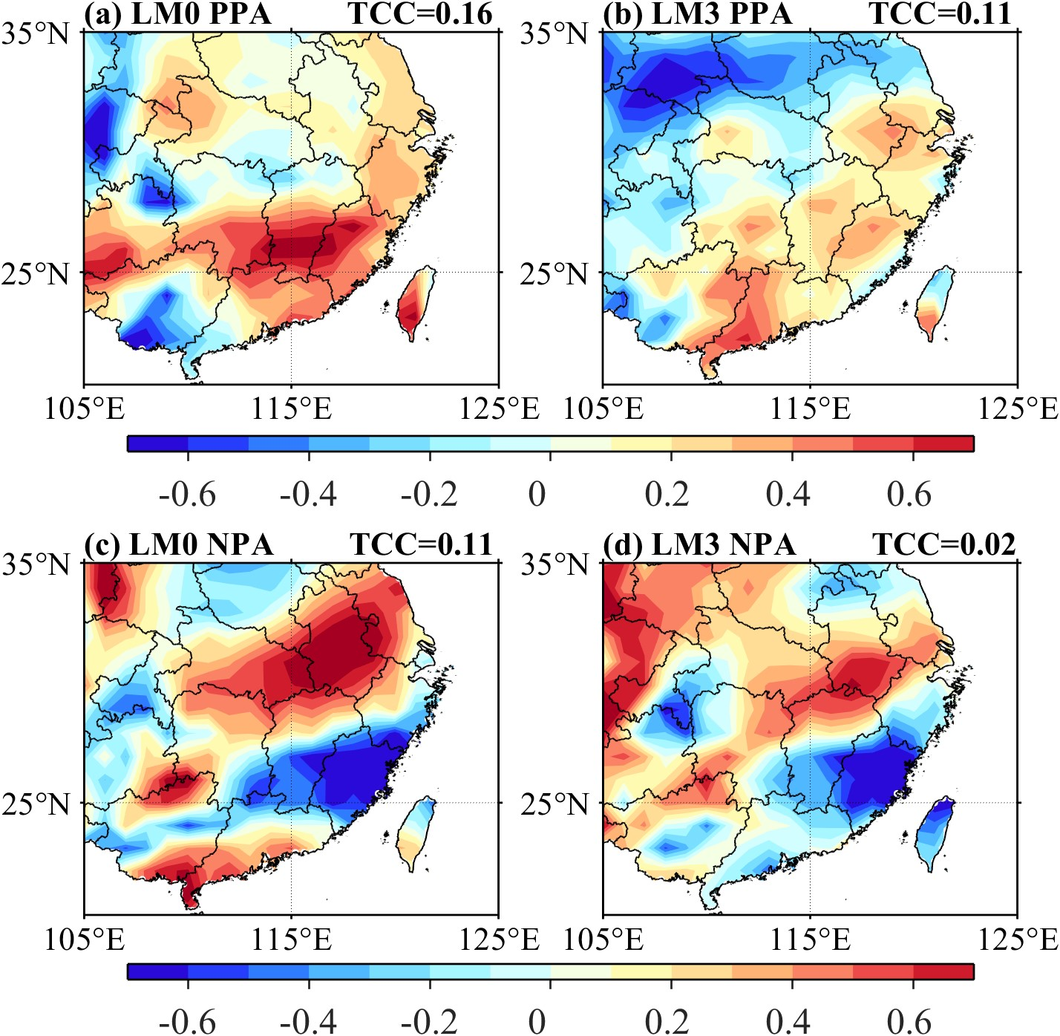
Fig. S1 Temporal anomaly correlation coefficient (TCC) for positive precipitation anomaly events (PPA) between observations and prediction with a lead time of 0 (a) and 3 (b) months during boreal winter (December–January–February) from 1983 to 2021. (c, d) is the same as (a, b), but for negative precipitation anomaly events (NPA). PPA (NPA) is defined as the years when the regional average precipitation anomalies in South China (107°–123°E, 22°–32°N) are higher (lower) than +(−)1 standard deviation. Observations are from the ECMWF fifth-generation reanalysis (ERA5), and predictions are from the Climate Forecast System version 2 (CFSv2)

Fig. S2 (a) Composites of 500 hPa geopotential height anomalies in the northern hemisphere for observed positive precipitation anomaly events (PPA) during boreal winter (December–January–February) from 1983 to 2021. (b) is the same as (a), but for observed negative precipitation anomaly events (NPA). (c–d) are the same as (a–b) but for predictions with a lead time of 0 month. (e–f) are the same as (c–d) but for predictions with a lead time of 3 months. The dashed red line corresponds to the area with statistical significance at the 95% confidence level, using a student-t test. PPA (NPA) is defined as the years when the regional average precipitation anomalies in South China (107°–123°E, 22°–32°N) are higher (lower) than +(−)1 standard deviation. PCC and the 2-norm value are used to measure the spatial similarity and distance, respectively, of mid-to-high latitude circulation in the Northern Hemisphere between predicted and observed precipitation anomaly events, shown in upper right corner of (c–d). Observations are from the ECMWF Fifth-generation Reanalysis (ERA5), and predictions are from the Climate Forecast System version 2 (CFSv2). ENSO variability has been removed utilizing the partial correlation method

Fig. S3 (a) Composites of 500 hPa geopotential height anomalies in the northern hemisphere for observed positive precipitation anomaly events (PPA) during boreal winter (December–January–February) from 1983 to 2021. (b) is the same as (a), but for observed negative precipitation anomaly events (NPA). (c–d) are the same as (a–b) but for predictions with a lead time of 0 month. (e–f) are the same as (c–d) but for predictions with a lead time of 3 months. The dashed red line corresponds to the area with statistical significance at the 95% confidence level, using a student-t test. PPA (NPA) is defined as the years when the regional average precipitation anomalies in South China (107°–123°E, 22°–32°N) are higher (lower) than +(−)1 standard deviation. PCC and the 2-norm value are used to measure the spatial similarity and distance, respectively, of mid-to-high latitude circulation in the Northern Hemisphere between predicted and observed precipitation anomaly events, shown in upper right corner of (c–d). Observations are from the ECMWF Fifth-generation Reanalysis (ERA5), and predictions are from the Climate Forecast System version 2 (CFSv2). Chukchi Sea ice variability has been removed utilizing the partial correlation method

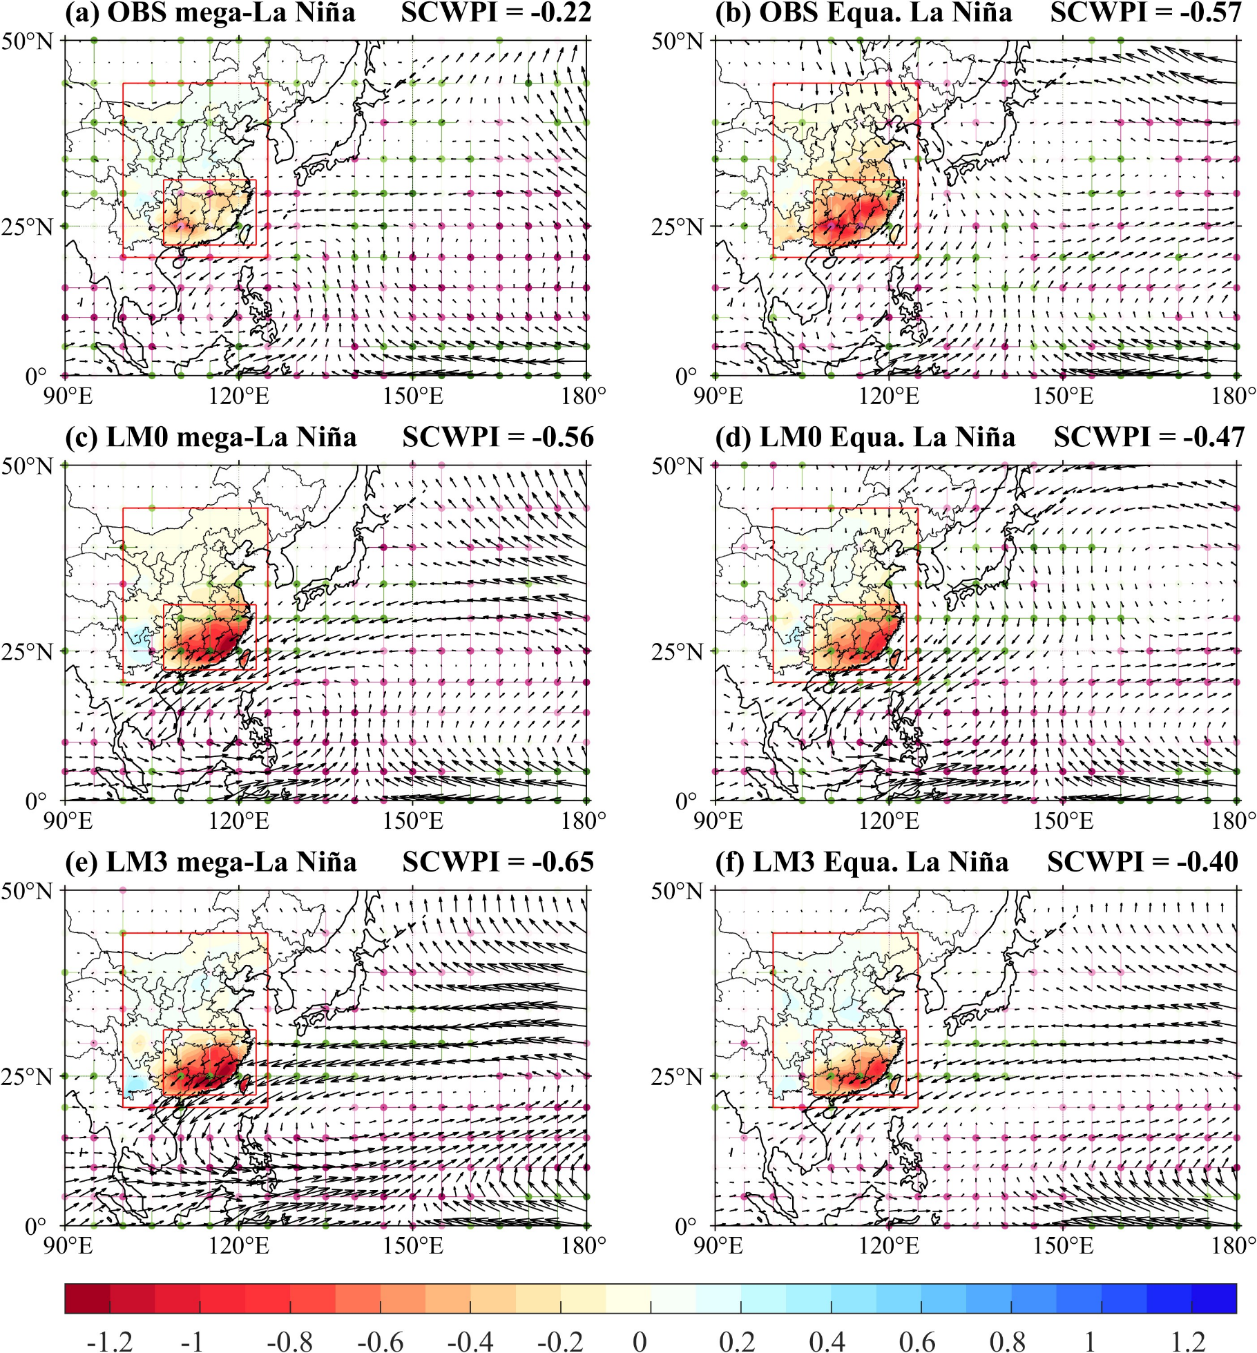
Fig. S4 (a) Composites of the 850 hPa horizontal wind (vectors), 700 hPa vertical velocity (colored dots), and precipitation (shaded) anomalies for mega-La Niña events during boreal winter (December–January–February) from 1983 to 2021. (b) is the same as (a), but for Equa. La Niña events. (c–d) are the same as (a–b), but for predictions with a lead time of 0 months. (e–f) are the same as (a–b), but for predictions with a lead time of 3 months. The specific definitions for mega-La Niña and Equa. La Niña can be found in Wang et al.'s 2013 publication. The numerical annotations in the upper right corner of each subfigure represent the regional average values of precipitation anomalies over South China (107°–123°E, 22°–32°N). Observations are from the ECMWF Fifth-generation Reanalysis (ERA5), and predictions are from the Climate Forecast System version 2 (CFSv2)

