Supporting information
Powdered Activated Carbon (PAC)-Assisted Peroxymonosulfate Activation for Efficient Urea elimination in Ultrapure water Production from Reclaimed Water

Chaelin Kim, Heeji Yoo, Gyubin Lee, Hye-Jin Hong*

Department of Environmental Engineering, Chungbuk National University, Chungdae-ro 1, Seowon-Gu, Cheongju, Chungbuk 28644, Republic of Korea

*Corresponding author
Prof. Hye-Jin Hong
Tel: +82-43-261-2469; fax: +82-43-264-2465. e-mail: hyejiny@chungbuk.ac.kr
Table S1. Compositions of reclaimed water
 | Components [mg/L]
 | Cations |  |  |  |  | Anions |  |  |  | Urea
 | Ca²⁺ | K⁺ | Mg²⁺ | Na⁺ | Si⁴⁺ | F⁻ | Cl⁻ | SO₄²⁻ | NO₃⁻ | Urea
Reclaimed water | 16.6 | 15.0 | 4.60 | 26.0 | 2.60 | 0.02 | 8.60 | 3.00 | 3.00 | 0.889

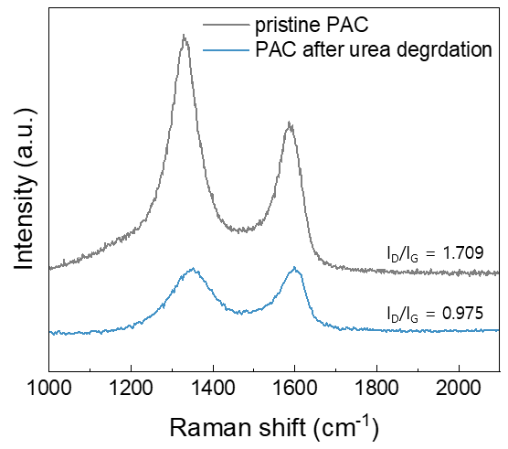
Fig. S1. Raman spectra of the PAC before and after urea degradation

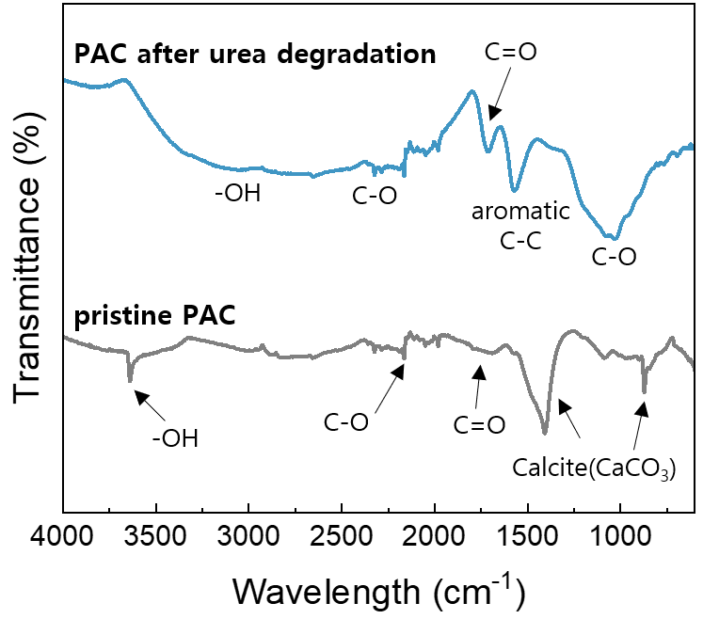
Fig. S2. FTIR spectra of the PAC before and after urea degradation

[Reaction Kinetic Models]
First-order kinetic model can be written as:

$\ln\left[C\right]= -kt + {[C]}_{0}$ (1)

Where C₀ (mg/L) denotes the initial concentration of urea solution, and C (mg/L) is the final concentration after degradation. k is the reaction rate constant of first-order and second-order kinetic models.

