Supplementary Information
Strong electron-phonon coupling and predicted high superconducting transition temperature of MXenes revealed in 2H-Mo₂N under biaxial stress.
Komsilp Kotmool,^{1,∗} Prutthipong Tsuppayakorn-aek,^{2,3} Thiti Bovornratanaraks, ^{2,3} Thanayut Kaewmaraya,^{4,5} Rachsak Sakdanuphab,^{1,6} Aparporn Sakulkalavek,^{7,8} Rajeev Ahuja,^{8,9} and Wei Luo⁸
¹College of Advanced Manufacturing Innovation, King Mongkut’s Institute of Technology Ladkrabang, Bangkok 10520, Thailand
²Extreme Conditions Physics Research Laboratory and Center of Excellence in Physics of Energy Materials (CE:PEM), Department of Physics, Faculty of Science, Chulalongkorn University, Bangkok 10330, Thailand
³Thailand Center of Excellence in Physics, Ministry of Higher Education, Science, Research and Innovation, 328 Si Ayutthaya Road, Bangkok, 10400, Thailand
⁴Integrated Nanotechnology Research Center, Department of Physics, Khon Kaen University, Khon Kaen, 40002, Thailand
⁵Institute of Nanomaterials Research and Innovation for Energy (IN-RIE), NANOTEC-KKU RNN on Nanomaterials Research and Innovation for Energy, Khon Kaen University, Khon Kaen, 40002, Thailand
⁶Research Center for Quantum Technology, Faculty of Science, Chiang Mai University, Chiang Mai 50200, Thailand
⁷Department of Physics, School of Science, King Mongkut’s Institute of Technology Ladkrabang, Bangkok 10520, Thailand
⁸Condensed Matter Theory Group, Materials Theory Division, Department of Physics and Astronomy, Uppsala University, Box 516, SE-75120, Uppsala, Sweden
⁹Department of Physics, Indian Institute of Technology (IIT), Ropar, Rupnagar 140001, Punjab, India

Stress-strain calculation
The atomic configurations of the 1T- and 2H-Mo₂N are displayed in Fig. 1S. The vacuum-slab model of Mo₂N is constructed with a vacuum thickness of 20 Å to prevent the interaction between the the nearest layers. The unstressed 1T- and 2H-Mo₂N were performed by fully relaxing to get the free-strain crystal structures consisting of lattice parameter ($a_{0}$) and layer thickness (d). To get the real thickness of two-dimensional materials, the covalent radius (1.45 Å) of Mo atoms is accounted. Therefore, the d value was measured between the topmost and bottommost of the electron distribution. The stress tensor ($σ_{xx}$) was calculated after optimizing atomic positions under a fixed biaxial strain ($ε_{b}$) as defined by Equation (1S). The biaxial stress ($σ_{b}$) is rescaled following Equation (2S).
$ε_{b}=\frac{(a-a_{0})}{a_{0}}$ (1S)

$σ_{b}=\frac{σ_{xx}.c}{d}$ (2S)

where $a$ and $c$ are the lattice constants of Mo₂N at given biaxial strains.

Critical superconducting temperature (T_{c})
Critical superconducting temperature (T_{c}) is calculated using the Allen-Dynes formula, as shown in equation (3S). The integration of electron-phonon coupling strength (λ) and the logarithmic average of the spectral function (ω_{log}) solved by the isotropic Eliashberg theory [1], are obeyed by equations (4S) and (5S), respectively.
$T_{C}=\frac{ω_{log}}{1.2}exp\left[-\frac{1.04(1+λ)}{λ-μ^{*}(1+0.62λ)}\right]$ (3S)
$λ=2\int_{0}^{∞}{\frac{dω}{ω}α^{2}F(ω)}=\sum_{qv}{λ_{qv}}$ (4S)
$ω_{log}=exp\left(\frac{2}{λ}\int_{0}^{∞}{\frac{dω}{ω}α^{2}F(ω)lnω}\right)$ (5S)
where $λ_{qv}$ is electron-phonon coupling constant for mode $v$ at wavevector $q$ defined as
$λ_{qv}=\frac{γ_{qv}}{π\overline{h}N_{Ef}ω_{qv}^{2}}$ (6S)

while $γ_{qv}$ is phonon linewidth, and the spectral function ($α^{2}F(ω)$) is defined as

$α^{2}F\left(ω\right)=\frac{1}{2π\overline{h}N_{Ef}}\sum_{qv}{\frac{γ_{qv}}{\overline{h}ω_{qv}}δ(ω-ω_{qv})}$ (7S)

Since λ > 1.5, it is classified as strong electron-phonon coupling [2]. The Allen-Dynes formula is needed to be modified by adding the strong coupling correction as written as

$T_{cs}=f_{1}f_{2}\frac{ω_{log}}{1.2}exp\left[-\frac{1.04(1+λ)}{λ-μ^{*}(1+0.62λ)}\right]$ (8S)
where $f_{1}={\left[1+{\left(\frac{λ}{2.46(1+3.8μ^{*})}\right)}^{\frac{3}{2}}\right]}^{\frac{1}{3}}$, $f_{2}=\left[1+\left(\frac{(\frac{ω_{rms}}{ω_{log}}-1)λ^{2}}{λ^{2}+3.31(1+6.3μ^{*})\frac{ω_{rms}}{ω_{log}}}\right)\right]$, and $ω_{rms}={\left[\frac{2}{λ}\int_{0}^{∞}{{ωα}^{2}F(ω)dω}\right]}^{\frac{1}{2}}$.

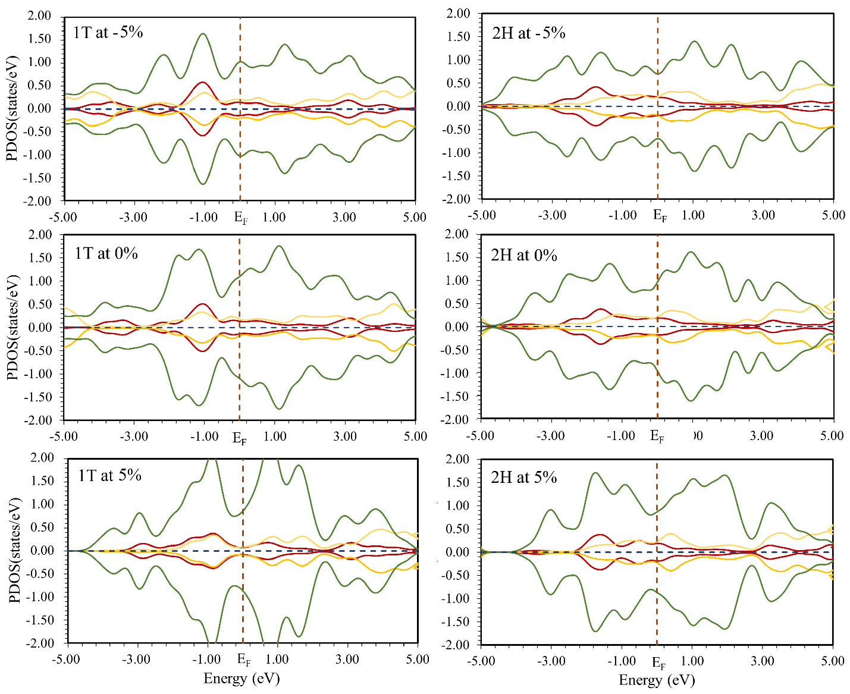
Figure 1S. Partial density of states (PDOS) of 1T and 2H phases of Mo2N at -5%, 0%, and 5% of strains.

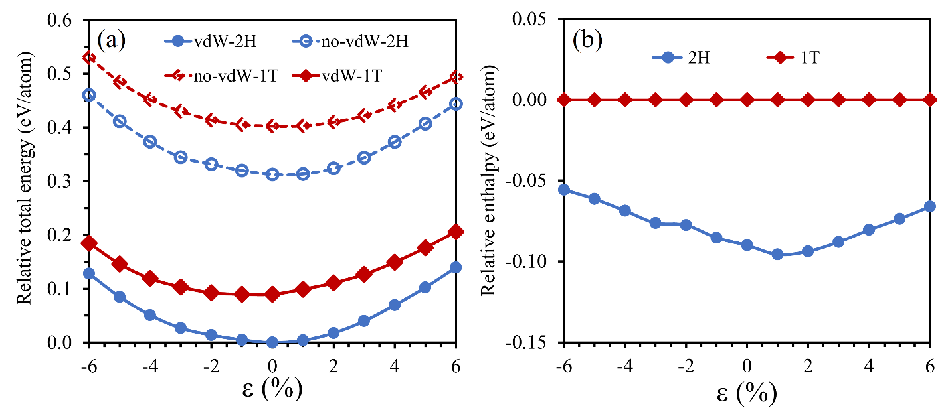
Figure 2S. (a) Relative total energy respecting the energy of the 2H- Mo₂N at e = 0%, and (b) relative enthalpy respecting those of the 1T- Mo₂N via biaxial strain from -6% to 6%. The enthalpy ($H$) is calculated from the equation; $H = E + P_{eq}V$, where $E$ is total energy, $V$ is volume of cell, and $P_{eq}$ is the equivalent pressure calculated from the stress tensors.

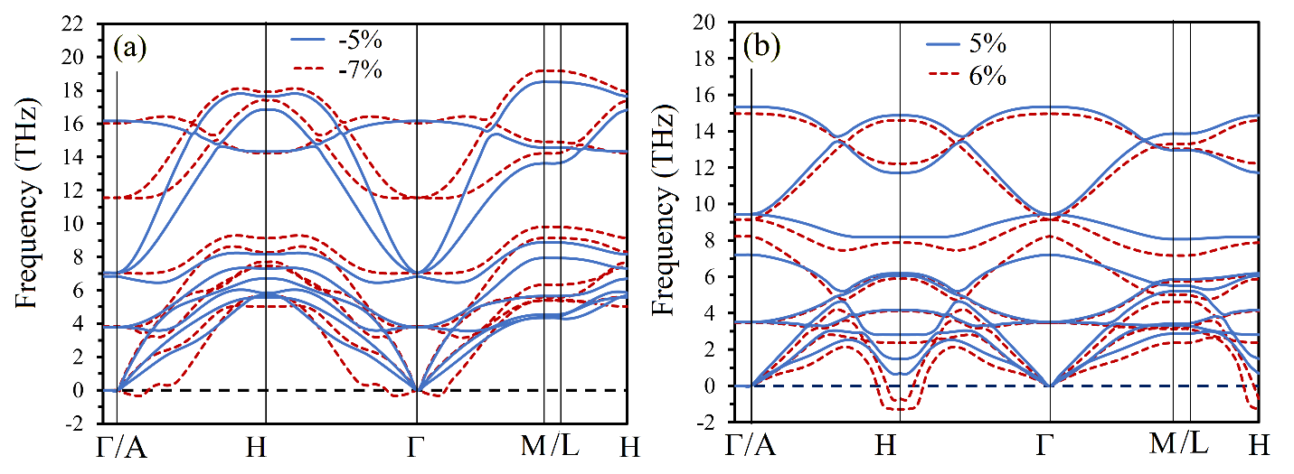
Figure 3S. Phonon dispersions derived by finite displacement method of 2H-Mo2N at (a) compressive strains of -5% and -7%, and (b) tensile strains of 5% and 6%.

Table 1S. Lattice parameter (a), numbers of electron density at the Fermi level (N_{Ef}), logarithmic average of the spectral function (ω_{log}), integration of the lambda (λ), and critical temperature (T_{c}) of Mo₂N and Mo₂C at certain biaxial strains (ε).

 | a (Å) | ε (%) | N_{Ef} (Ry⁻¹) | ω_{log} (cm⁻¹) | λ | T_{c} (K)
2H-Mo₂C | 2.835 | 0 | 17.3 | 213 | 0.58 | 4.3
1T-Mo₂N | 2.786 | 0 | 17.8 | 248 | 0.98 | 16.8
2H-Mo₂N | 2.818 | 0 | 17.6 | 227 | 1.32 | 22.7
2H-Mo₂N | 2.677 | -5.0 | 19.7 | 215 | 1.51 | 24.7
2H-Mo₂N | 2.705 | -4.0 | 23.2 | 240 | 2.00 | 34.5
2H-Mo₂N | 2.747 | -2.5 | 22.9 | 195 | 2.22 | 30.1
2H-Mo₂N | 2.790 | -1.0 | 20.9 | 213 | 1.54 | 25.0
2H-Mo₂N | 2.846 | 1.0 | 19.4 | 220 | 1.19 | 19.4
2H-Mo₂N | 2.888 | 2.5 | 20.0 | 212 | 1.25 | 20.0
2H-Mo₂N | 2.931 | 4.0 | 21.6 | 183 | 1.56 | 21.6
2H-Mo₂N | 2.959 | 5.0 | 25.3 | 158 | 2.24 | 24.4

Table 2S. Root mean square of frequency (ω_{rms}), strong-coupling correctness factors (f₁ and f₂), and superconducting temperatures (T_{c} and T_{cs}) of 2H-Mo2N at -4%, -2.5%, and 5% of strain obtained by using the modified Allen-Dynes formula.
ε (%) | ω_{rms} (cm⁻¹) | f₁ | f₂ | f_{1×}f₂ | T_{c} (K) | T_{cs} (K)
-4.0 | 222 | 1.13 | 0.97 | 1.09 | 34.5 | 37.8
-2.5 | 203 | 1.15 | 1.02 | 1.18 | 30.1 | 35.4
5.0 | 166 | 1.15 | 1.03 | 1.18 | 24.4 | 28.9

References
[1] Philip B. Allen. Neutron spectroscopy of superconductors. Phys. Rev. B, 6:2577–2579, Oct 1972.
[2] P. B. Allen and R. C. Dynes. Transition temperature of strong-coupled superconductors reanalyzed. Phys. Rev. B, 12:905–922, Aug 1975.

