Graphic Abstract
Study of oil biodegrading by expanded perlite Loaded by oil-eating bacteria
Seyyed. Reza. Mortazavi¹, Amir H. M. Sarrafi^{1, *}, Afshar Alihosseini^{2,} `Ali Niazi¹
- Department of Chemistry, Central Tehran Branch, Islamic Azad University, P.O. Box.
1496969191, Tehran, Iran
- Department of Chemical Engineering, Central Tehran Branch, Islamic Azad University, P.O. Box.1496969191, Tehran, Iran

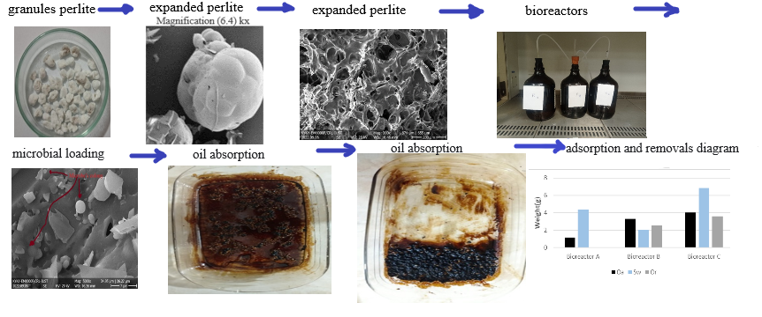

Corresponding Author Email: Afs.alihosseini@iauctb.ac.ir

